Least Squares
Overview |  |  | 03 Feb 2026
- Extend the 1-D DFT to higher dimensions, and understand two-dimensional frequencies
- Get a geometric intuition of projection onto a subspace.
- Learn about least squares optimization and how they are solved using the Normal Equation.
- Learn about weighted least squares and how the normal equation is modified.
- How to use numerical libraries to solve linear least squares problems.
- How to generalize least squares to higher order polynomials as well as exponential and power fits.
Async
2D FFT
2D Discrete Fourier Transform | - a vector space is a space where you can add and scale elements  - vectors are just elements of a vector space  - two identify orthogonal elements, inner product is needed  - 2D arrays (tensors) are vectors whose inner product is the sum of the pairwise products of the elements  - create and array/vector  $$v^{k_{1},k_{2}}∈R^{N_{1}×N_{2}}$$  - with two dimensions  $v_{j_{1},j_{2}}^{k_{1},k_{2}}$ $=$ $\exp{!\left(i\frac{2πj_{1}k_{1}}{N_{1}}\right)}$ $\exp{!\left(i\frac{2πj_{2}k_{2}}{N_{2}}\right)}$
Visualizing Waves | - this vector is both two-dimensional as well as complex  - the components are waves  $$v_{j_{1},j_{2}}^{k_{1},k_{2}}=\sin{!\left(\frac{2πj_{1}k_{1}}{N_{1}}\right)}\sin{!\left(\frac{2πj_{2}k_{2}}{N_{2}}\right)}$$  - normalized index coordinates  $$\left(\frac{j_{1}}{N_{1}},\frac{j_{2}}{N_{2}}\right)$$  - as a point in a unit square  $$x=\frac{j_{1}}{N_{1}}, y=\frac{j_{2}}{N_{2}}$$  - continuous domain representation  $$v^{k_{1},k_{2}}\left(x,y\right)=sin\left(2πk_{1}x\right)sin\left(2πk_{2}y\right)$$  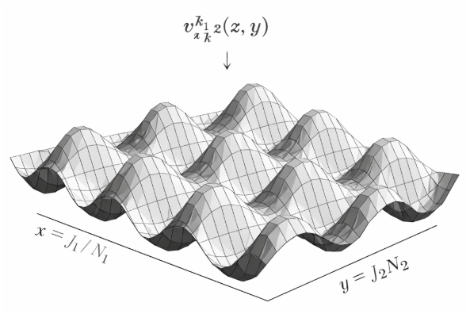  ChatGPT 5.2 1
Orthogonal Vectors | - the vectors are orthogonal to each other  $$v_{j_{1},j_{2}}^{k_{1},k_{2}}=\exp{!\left(\frac{2πij_{1}k_{1}}{N_{1}}\right)}\exp{!\left(\frac{2πij_{2}k_{2}}{N_{2}}\right)}$$  - orthogonality condition  $$v^{r_{1},r_{2}}⋅v^{s_{1},s_{2}}=0$$  $$\text{if} \left(r_{1},r_{2}\right)≠\left(s_{1},s_{2}\right)$$  - and the length of all the vectors are the same (vector norm)  $$\left.|v^{k_{1},k_{2}}\right.|^{2}=v^{k_{1},k_{2}}⋅v^{k_{1},k_{2}}=N_{1}N_{2}$$  - the dot product is defined by listing all of the entries in a single list
Projection
Solution | - the closest point p has the property that,  $$\left(x-p\right)⋅v=0$$  - for every vector v in V, but that happens if,  $$\left(x-p\right)⋅v_{i}=0$$  - for every vector in the basis for V,  $$v_{i}^{T}x=v_{i}^{T}p$$  - since,  $$A=\left[v_{1} ⋯ v_{n}\right]$$  - that means,  $$A^{T}x=A^{T}p$$
QR Factorization | - to help with this, we use a very important factorization — QR.  - given a matrix A with linearly independent columns, we can factor  $$A = QR$$  - example:  $$A = \left[{{2 \atop 0} \atop {2 \atop 2}} {{1 \atop 1} \atop {0 \atop 2}}\right]= QR$$  $$Q=\frac{1}{\sqrt{3}}\left[{{1 \atop 0} \atop {1 \atop 1}} {{1 \atop 1} \atop {-1 \atop 1}}\right], R=\sqrt{3}\left[\begin{matrix}2 & 1 \\ 0 & 1\end{matrix}\right]$$  $$v_{1}=r_{11}q_{1}$$  $$v_{2}=r_{12}q_{1}+r_{22}q_{2}$$
Julia | julia> using LinearAlgebra  julia> A = [2 1; 0 1; 2 0; 2 2];  julia> qrf = qr(A);  julia> Matrix(qrf.Q)  4×2 Matrix{Float64}:  -0.57735 2.29738e-17  -0.57735 -0.57735  -0.57735 0.57735  -0.57735 -0.57735  julia> R = qrf.R  2×2 Matrix{Float64}:  -3.4641 -1.73205  0.0 -1.73205  julia> Q = qrf.Q  4×2 Matrix{Float64}:  2.0 1.0  0.0 1.0  2.0 0.0  2.0 2.0  julia> Q'*Q  2×2 Matrix{Float64}:  1.0 -2.01213e-17  -2.01213e-17 1.0
Use QR for Projection | - combine  $$A^{T}z=A^{T}x$$  $$A = QR$$  - get,  $$R^{T}Q^{T}z=R^{T}Q^{T}x$$  $$Q^{T}z=Q^{T}p$$  - p is in the span of Q columns  $$p = Qc$$  $$Q^{T}z=Q^{T}Qc=c$$  $$p=Qc=QQ^{T}z$$

