Location Approximation
Overview |  |  | 10 Feb 2026
- how to extend linear least squares to multivariable and multidimensional fits
- how to use a local least squares fit to create LOESS fits to come up with a non-parametrized least squares approximation
- how to interpolate data in higher dimensions onto a uniform grid for analysis and visualization
- how to compute eigenvalues and eigenvectors and diagonalize matrices using numerical libraries. Discuss the power method to find the largest eigenvalue
LOESS: Locally estimated scatterplot smoothing
Multiple Variables
Multivariable Fit | - so far fits have been of the form  $$y_{i}=f_{p}\left(x_{i}\right)$$  - where (x, y) is the input data and p is a vector of parameters.  $$y_{i}∈R, x_{i}∈R, p∈R^{r}$$  - the functional form has been a function of x only  $$f_{p}\left(x\right)=a+bx$$  $$p=\left(a,b\right)$$  $$f_{p}\left(x\right)=a+bx+cx^{2}$$  $$p=\left(a,b,c\right)$$  - multi-variable functions are fitting functions of the form  $$z=f_{p}\left(x,y\right)=a+bx+cy$$
Formulation | 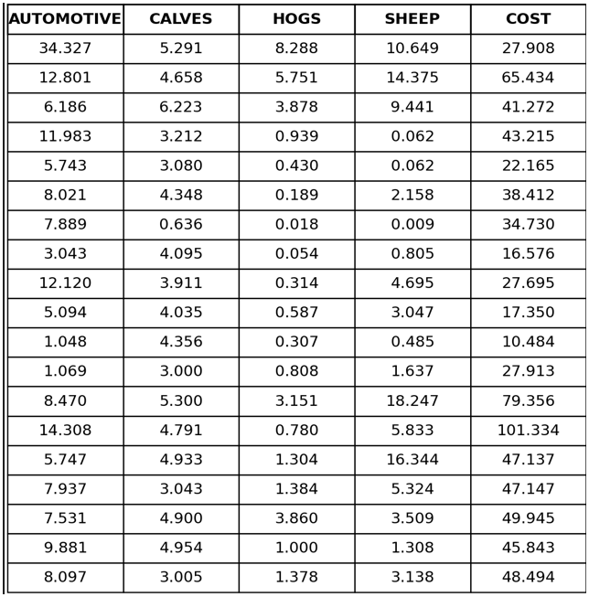  ChatGPT 5.2 1  - linear model  $$\text{Cost}=b+a_{1} \text{Cattle}+a_{2} \text{Calves}+a_{3} \text{Hogs}+a_{4} \text{Sheep}$$  - in terms of a vector input with five parameters  $$f\left(x\right)=b+a_{1}x_{1}+a_{2}x_{2}+a_{3}x_{3}+a_{4}x_{4}$$  - handled the same way as if you had a polynomial fit  $$f\left(x\right)=b+a_{1}x^{1}+a_{2}x^{2}+a_{3}x^{3}+a_{4}x^{4}$$
Julia | julia> D  19×5 Matrix{Float64}:  3.437 5.791 3.268 10.649 27.698  12.801 4.558 5.751 14.375 57.634  6.136 6.223 3.175 2.811 47.172  11.685 3.212 0.639 0.694 49.295  5.733 3.222 0.534 2.052 24.115  3.021 4.348 0.839 2.356 33.612  1.689 0.634 0.318 2.209 9.512  2.339 1.895 0.610 0.605 14.755  1.025 0.834 0.734 2.825 10.57  2.936 1.419 0.331 0.231 15.394  5.049 4.195 1.589 1.957 27.843  1.693 3.602 0.837 1.582 17.717  1.187 2.679 0.459 18.837 20.253  9.733 3.951 3.78 0.524 37.465  14.325 4.3 10.781 36.863 101.334  7.737 9.043 1.394 1.524 47.427  7.538 4.538 2.565 5.109 45.944  9.211 4.994 3.081 3.681 45.945  8.697 3.005 1.378 3.138 48.494  julia> A = [ones(19,1) D[:,1:4]];  Here, A is the design matrix with a bias column and four predictors,  p is the response vector, and c contains the least-squares regression coefficients.  julia> p = D[:,5];  julia> c = A \ p  5-element Vector{Float64}:  2.28842457684378  3.215524802749412  1.6131476138283969  0.8148494909933895  0.8025786215025017
Residual | - residual is computed the same way  $$y ≈Ac ⇒ r = y – Ac$$  - input data is four dimensional but can be projected onto one axis at a time for display purposes  - dark points are data, white fit  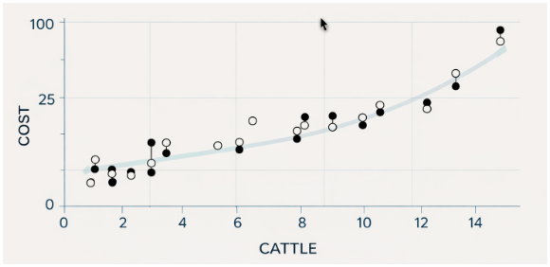  ChatGPT 5.2 2
Spatial | - values given in space, fit with  $$z\left(x,y\right)=a_{0}+b_{1}x+b_{2}y+c_{1}x^{2}+c_{2}xy+c_{3}y^{2}$$  - test on data with known coefficients and added noise  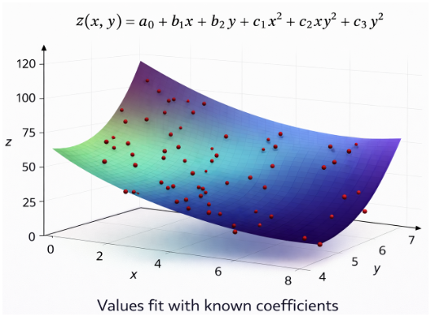  ChatGPT 5.2 3  Here, A is the quadratic design matrix constructed from x and y,  and the vector returned by A \ val contains the least-squares estimates  of the coefficients for the quadratic surface model.
Julia | julia> D  100×3 Matrix{Float64}:  0.798487 0.692338 -6.78094  -0.388154 -0.325195 -0.200116  0.780487 0.693793 2.52178  0.305096 -0.99705 6.87936  ⋮  -0.869882 0.406619 1.99625  0.589563 0.109922 2.85972  0.22768 0.474297 3.69185  julia> X = D[:,1]; y = D[:,2]; val = D[:,3];  julia> A = [ones(size(X)) x y x.^2 y.^2];  julia> A \ val  6-element Vector{Float64}:  -1.0624840106609321  2.072135382571392  3.045593968296301  0.502595092034594  1.885286192068896  0.992137812166206

Local Approximations
Simplifying for Complicated Function | - when dealing with large functions, it is difficult to find parametrized fit that works well globally  - 3rd and 6th degree polynomial fit  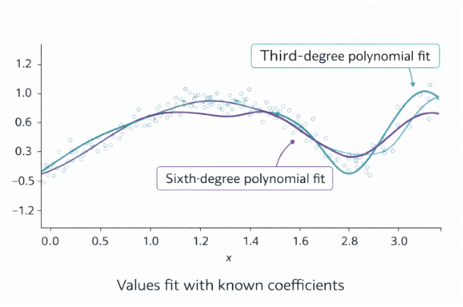  ChatGPT 5.2  - this pattern only gets worse as polynomial degrees rise
Local Regression  Scatterplot Smoothing | - separate graph into chunks that can be graphed with lower degree polynomials  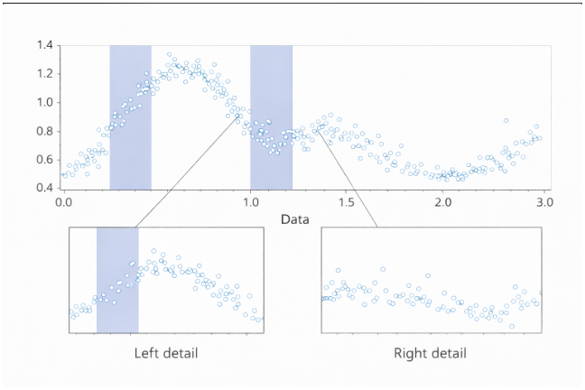  ChatGPT 5.2  - concatenate smaller-range, lower-degree graphs
Details | - for every x value, we do a linear fit of a windowed portion of the data  - apply a weight to that window, tapered down to 0  - do a least squares fit of that sub-set of the data  - evaluate the fit at the point  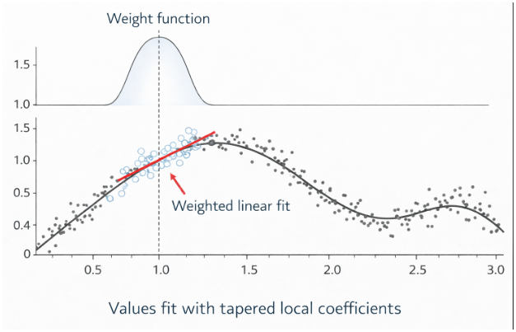  ChatGPT 5.2
Julia | julia> D  67×3 Matrix{Float64}:  0.67 0.80302 8.58312e-5  0.68 0.75711 0.00211704  ⋮  1.32 1.2837 0.00211704  1.33 1.3288 8.58312e-5  julia> x = D[:,1]; y = D[:,2]; w = D[:,3];  This computes a locally weighted linear regression using a tapered weight function  centered at x = 1, and evaluates the fitted model at that point  julia> W = Diagonal(sqrt.(w));  julia> A = [ones(size(x)) x];  julia> c = (W*A)\(W*y)  2-element Vector{Float64}:  0.2330148228976884  0.85783827542484  julia> c[1] + c[2]*1  1.0917536504401724
Weight Function | - not a unique weight function, but a common one is the cubic  $${\left(1-{\left(\frac{\left|x-c\right|}{w}\right)}^{3}\right)}^{3}$$  - w is a parameter  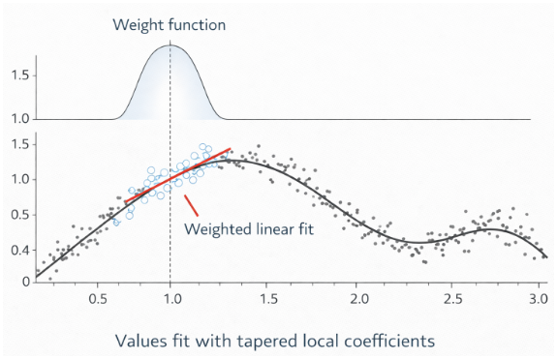  ChatGPT 5.2
Julia | julia> x = D[:,1]; y = D[:,2];  julia> w = ((1) .- abs.((x .- 1)./0.335).^3).^1.5;  julia> W = Diagonal(w);  This computes a locally weighted linear regression using a tapered weight function  centered at x = 1, and evaluates the fitted model at that point  julia> A = [ones(size(x)) x];  julia> c = (W*A)\(W*y)  2-element Vector{Float64}:  0.2330148228976884  0.8587388275424834  julia> c[1] + c[2]*1  1.091753650440172
Multiple Dimensions
Two Dimensions | - spatial data is a special case of multivariable input data consisting of a list of (x, y) points with a value v at each point  - first approximation is a linear fit  $$f\left(x,y\right)=a+bx+cy$$  - this is a standard multivariate fit  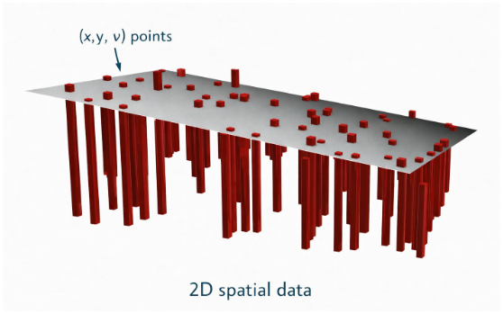  ChatGPT 5.2
Julia | julia> D  100×3 Matrix{Float64}:  0.89652 0.69851 2.22423  0.16441 0.47566 1.55573  0.68489 0.23571 0.59624  0.88108 0.15748 1.17562  ⋮  0.44704 0.93056 0.27164  0.20344 0.47266 1.47501  0.56538 0.99248 2.11564  0.34011 0.74739 1.09583  julia> x = D[:,1]; y = D[:,2]; v = D[:,3];  julia> A = [ones(size(x)) x y];  julia> A \ v  3-element Vector{Float64}:  0.82242157222637813  0.988772946529357  This is the tricube weight function expressed in terms of distance d and window width w  Typically used with the implicit condition |d| < w (weight = 0 outside the window)  1.2541980858432
Local Fit | - use a local fit to get a value for a point  based on the surrounding points  - the width function  $${\left(1-{\left(\frac{d}{w}\right)}^{3}\right)}^{3}$$  - d is the distance from the center, w is the radius of the region  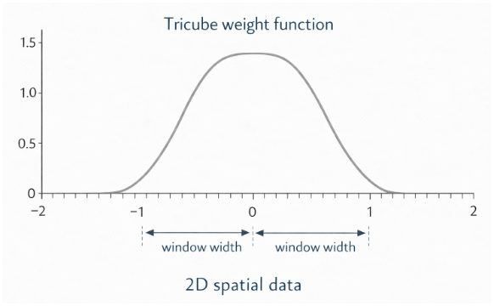  ChatGPT 5.2
Julia | julia> D  146×3 Matrix{Float64}:  -0.386386 -0.880319 -7.8  -0.392838 -0.61673 -1.9  0.273446 0.582663 -14.8  ⋮  0.49234 0.419114 -15.5  0.463917 0.374538 -13.8  julia> x = D[:,1]; y = D[:,2]; val = D[:,3];  Here, d is the radial distance from the origin, w is a tricube  weight function with window width 0.8, A is the local planar design matrix, and  the final vector gives the weighted least-squares surface fit coefficients  julia> d = norm.(x, y);  julia> w = (1 .- abs.(d ./ 0.8).^3).^1.5;  julia> W = Diagonal(w);  julia> A = [ones(size(x)) x y];  julia> (W*A) \ (W*val)  3-element Vector{Float64}:  -9.673136939747274  -4.650837446286345  -7.950323134280955
Overlay the Function | $f\left(x,y\right)=-9.67-4.61x-7.95y$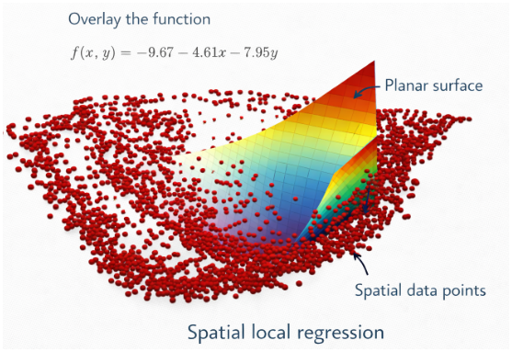
Other Weights | $$w\left(r\right)=\frac{1}{r^{2}+r^{4}}=\frac{1}{r^{2}\left(1+r^{2}\right)}$$  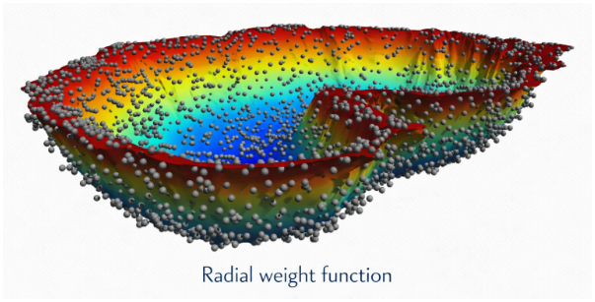
2D Fit | render 3-D surface on a 2-D plane  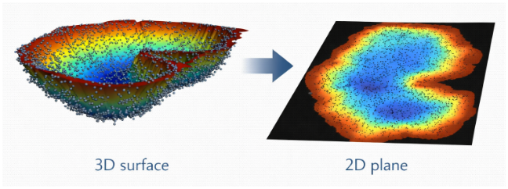
Eigenvalues and Eigenvectors
Mathematical Statement | - the mathematical statement is pretty straight forward  $$A x = λx, x ≠0$$  - x is an eigenvector of the matrix A  - λ is an eigenvalue  - A has to be a square matrix (A and x might be complex numbers)
Geometric Interpretation | - geometrically, A scales x by the number λ  λx  x
Quick Refresh | - the standard mathematical approach to find eigenvalues and eigenvectors  - define the characteristic equation  $$p\left(λ\right)=\det\left(A-λI\right)$$  $\left(λ\right)=det\left(\left[\begin{matrix}-4 & -2 \\ -3 & 1\end{matrix}\right]\right)-λ\left[\begin{matrix}1 & 0 \\ 0 & 1\end{matrix}\right]=det\left(\left[\begin{matrix}-4-λ & -2 \\ -3 & 1-λ\end{matrix}\right]\right)=λ^{2}+λ-10$  - If A is an $n×n$ matrix, this is an n-th degree polynomial in λ.  - The eigenvalues are the roots of this polynomial.  $$λ^{2}+3λ-10=\left(λ+5\right)\left(λ-2\right)→λ_{1}=-5, λ_{2}=2$$  - the eigenvector is a solution to the linear system  $$\left(A-λI\right)x=0$$  $$0=\left[\begin{matrix}-4-\left(-5\right) & -2 \\ -3 & 1-\left(-5\right)\end{matrix}\right]x=\left[\begin{matrix}1 & -2 \\ -3 & 6\end{matrix}\right]x→x=\left[{2 \atop 1}\right]$$  - the second eigenvector is similar  $$0=\left[\begin{matrix}-4-\left(2\right) & -2 \\ -3 & 1-\left(2\right)\end{matrix}\right]x=\left[\begin{matrix}-6 & -2 \\ -3 & -1\end{matrix}\right]x→x=\left[{1 \atop -3}\right]$$  - the eigenvector is not unique; you can scale by any constant  - all eigenvectors that match the dimension are placed in the matrix  $$S=\left[\begin{matrix}2 & 1 \\ 1 & -3\end{matrix}\right]$$  - this matrix has the following property  $AS=S$Λ $\bigwedge{=}\left[\begin{matrix}-5 & 0 \\ 0 & 2\end{matrix}\right]$
Julia | julia> A = [-4 -2; -3 1]  2×2 Matrix{Int64}:  These computations verify that [2,1] and [1,-3] are eigenvectors  of A with eigenvalues −5 and 2, respectively, and that A = SΛS⁻¹  -4 -2  -3 1  julia> A*[2,1] - (-5)*[2,1]  2-element Vector{Int64}:  0  0  julia> A*[1,-3] - 2*[1,-3]  2-element Vector{Int64}:  0  0
(Quick?) Refresh Cont. | - most of the time this matrix S is invertible  $$AS=SΛ ⇒ A=SΛS^{-1}$$  $$Λ=S^{-1}AS$$  - you will often get complex numbers and sometimes the matrix is not diagonalizable  - you can still find eigenvalues  - but not an invertible matrix S of eigenvectors.  - numerically, that last case is very hard to detect and handle.
Julia | julia> A  2×2 Matrix{Int64}:  -4 -2  -3 1  The first example verifies real diagonalization A = SΛS⁻¹.  The second example illustrates a matrix with complex eigenvalues,  requiring complex eigenvectors and a complex diagonal matrix Λ  julia> S \ A / inv(S)  2×2 Matrix{Float64}:  -4.0 -2.0  -3.0 1.0  julia> inv(S)*A*S  2×2 Matrix{Float64}:  -5.0 4.44089e-16  0.0 2.0  julia> A = [-1 5; -2 5]  2×2 Matrix{Int64}:  -1 5  -2 5  julia> S = [5 5-3im; 5+3im 3+1im]  2×2 Matrix{Complex{Int64}}:  5+0im 5-3im  5+3im 3+1im  julia> Lambda = diagm([2-im, 2+im])  2×2 Matrix{Complex{Int64}}:  2-im 0+0im  0+0im 2+im

(Quick!) Refresh Cont. | - previous approach will not give numerical solution  - it is very difficult to compute the determinant of  the characteristic polynomial.  $A - λI$  - analytical solutions  - exists for: $n=2, 3, 4$  need iterative methods  - none exist for: $n > 4$  - high degree polynomials are numerically very tricky  $$\left(A-λI\right)x=0$$
Basix Idea for Computing | - pick any x, call it: $x^{0}$  - apply A over and over  $$x_{1}=Ax_{0},x_{2}=Ax_{1},x_{3}=Ax_{2}, …$$  - if you start with an eigenvector you get  $$x_{n}=λ^{n}x_{0}$$  - if |λ| is small this goes to 0  - if |λ| is larger than 1 this goes to infinity  - direction is relevant here, not the magnitude, so we normalize each step.  $$x_{1}=\frac{Ax_{0}}{|\left|Ax_{0}\right||}, x_{2}=\frac{Ax_{1}}{\left||Ax_{1}\right||}, x_{3}=\frac{Ax_{2}}{\left||Ax_{2}\right||}, …$$
Julia | julia> A = [19 -6; 45 -14];  julia> x = [1,1];  This demonstrates the power method. Repeated normalization of A*x causes  x to converge in direction to the dominant eigenvector of A, with the ratio  x₂/x₁ approaching the eigenvector slope.  julia> v = A*x; x = v/norm(v)  2-element Vector{Float64}:  0.3867266762507425  0.922194381828531  julia> x/x[1]  2-element Vector{Float64}:  1.0  2.3846153846153846  julia> v = A*x; x = v/norm(v)
How to Call | - function ‘eigen’ finds eigenvalues and eigenvectors returns:  - list of eigenvalues  - eigenvectors  $$SΛS^{-1}=A$$  - computation scales like: $O\left(n^{2.7}\right)$
Julia | julia> A = rand(2000,2000); @time B = A*A;  shows eigenvalue computation is significantly  more expensive than matrix multiplication.  0.074313 seconds (2 allocations: 30.518 MiB)  julia> A = rand(4000,4000); @time B = A*A;  0.423728 seconds (2 allocations: 122.070 MiB)  julia> A = rand(2000,2000); @time f = eigen(A);  2.222281 seconds (22 allocations: 124.208 MiB)  julia> A = rand(4000,4000); @time f = eigen(A);  13.800373 seconds (28 allocations: 492.555 MiB, 0.05% gc time)
julia> using LinearAlgebra

julia> A = [19 -6; 45 -14];

julia> factor = eigen(A)
Eigen{Float64, Float64, Matrix{Float64}, Vector{Float64}}
values:
The second example verifies diagonalization:
A = SΛS⁻¹, with small numerical error due to floating-point arithmetic
2-element Vector{Float64}:
1.0000000000000053
3.9999999999999993
vectors:
2×2 Matrix{Float64}:
0.316228 0.371391
0.948683 0.928477

julia> Lambda = diagm(factor.values)
2×2 Matrix{Float64}:
1.0 0.0
0.0 4.0

julia> S = factor.vectors;

julia> S*Lambda*inv(S) – A
2×2 Matrix{Float64}:
7.10543e-15 -3.55271e-15
2.84217e-14 -1.06581e-14
What Can Happen | - For a non-symmetric matrix, eigenvalues and eigenvectors can be complex  - For matrices that are not diagonalizable, the return is invalid

Julia | julia> A = [2 1; 0 2]  2×2 Matrix{Int64}:  2 1  - 2  julia> eigen(A)  matrix is defective: it has repeated eigenvalues (λ = 2) and does  not have two independent eigenvectors  Eigen{Float64, Float64, Matrix{Float64}, Vector{Float64}}  values:  2-element Vector{Float64}:  2.0  2.0  vectors:  2×2 Matrix{Float64}:  1.0 -1.0  0.0 4.44089e-16
julia> A = rand(5,5)
5×5 Matrix{Float64}:
0.896989 0.928842 0.194495 0.56745 0.445895
0.833862 0.817736 0.784447 0.956141 0.757149
0.089797 0.585985 0.951922 0.342448 0.593538
0.283555 0.569285 0.15656 0.917266 0.58781
0.865177 0.415104 0.207601 0.759322 0.454219

julia> eigen(A)
Eigen{ComplexF64, ComplexF64, Matrix{ComplexF64}, Vector{ComplexF64}}
values:
illustrates that a general non-symmetric matrix
may have complex eigenvalues and complex eigenvectors
5-element Vector{ComplexF64}:
-0.0630614639921762 + 0.0im
0.21491356519522642 - 0.18293391221310967im
0.21491356519522642 + 0.18293391221310967im
0.8447011083491994 + 0.0im
2.7393605534814863 + 0.0im
vectors:
5×5 Matrix{ComplexF64}:
0.383351+0.0im 0.192263+0.141744im 0.258763+0.0im 0.515498+0.0im ...
-0.335414+0.0im -0.626591-0.297367im -0.105868+0.0im 0.646038+0.0im
0.032539+0.0im -0.146977+0.140434im -0.875045+0.0im 0.320683+0.0im
0.498739+0.0im 0.558948-0.210011im 0.358323+0.0im 0.389948+0.0im
-0.700528+0.0im -0.735823-0.0im 0.166535+0.0im 0.248999+0.0im

julia> eigen(A)
Eigen{ComplexF64, ComplexF64, Matrix{ComplexF64}, Vector{ComplexF64}}
values:
5-element Vector{ComplexF64}:
-0.0630614639921762 + 0.0im
0.21491356519522642 - 0.18293391221310967im
0.21491356519522642 + 0.18293391221310967im
0.8447011083491994 + 0.0im
2.7393605534814863 + 0.0im
vectors:
5×5 Matrix{ComplexF64}:
0.383351+0.0im 0.192263+0.141744im 0.258763+0.0im 0.515498+0.0im ...
-0.335414+0.0im -0.626591-0.297367im -0.105868+0.0im 0.646038+0.0im
0.032539+0.0im -0.146977+0.140434im -0.875045+0.0im 0.320683+0.0im
0.498739+0.0im 0.558948-0.210011im 0.358323+0.0im 0.389948+0.0im
-0.700528+0.0im -0.735823-0.0im 0.166535+0.0im 0.248999+0.0im

Symmetric Matrices | - symmetric matrices are  - always diagonalizable  - always real  - orthogonal to each other  $$S^{-1}=S^{T}$$  - normalize the vectors $= matrix 'Q'$
Julia | julia> B = rand(5,5); A = B + B'  5×5 Matrix{Float64}:  1.46841 0.217176 1.14759 1.77643 1.84304  0.217176 1.0952 1.14557 0.673613 1.22555  1.14759 1.14557 1.1925 0.83276 1.10775  1.77643 0.673613 0.83276 0.31743 1.02043  1.84304 1.22555 1.10775 1.02043 0.311548  julia> factors = eigen(A)  Eigen{Float64, Float64, Matrix{Float64}, Vector{Float64}}  values:  Because A is symmetric, the eigenvalues are real and the eigenvectors  form an orthonormal basis, so QᵀQ = I up to floating-point error.  5-element Vector{Float64}:  -1.479744357061945  -0.7384718547725923  -0.018271356454782802  1.2357763366272927  5.385759909664219  vectors:  5×5 Matrix{Float64}:  -0.59091 -0.200388 0.0384984 0.552359 -0.551442  -0.358851 -0.676396 0.462094 -0.730869 -0.343058  0.037868 0.0585515 -0.089259 -0.326998 -0.447297  0.339562 0.791801 0.198595 0.231927 -0.405452  0.636644 -0.568774 0.239608 -0.0035335 -0.462338  julia> Q = factors.vectors;  julia> Q' * Q  5×5 Matrix{Float64}:  1.0 1.71193e-16 -3.53161e-17 -3.18443e-17 ...  1.71193e-16 1.0 -2.86422e-17 2.47198e-17  -3.53161e-17 -2.86422e-17 1.0 4.60241e-17  -3.18443e-17 2.47198e-17 4.60241e-17 1.0  ...

