Principal Components & Intro to Non-Linear Solvers
Overview
- approximate tensors using the principal components
- create a k dimensional vectors using the first principal components to describe data
- approximate a function using an n-th order Taylor series with remainder
- Newtons method for scalar equations
- the secant method
- the convergence properties.
Principal Components
Principal Components
Motivating Example | - often when collapsing a higher dimensional vector space into a lower dimensional representation, structure inherent to the data is lost or unrecognizable  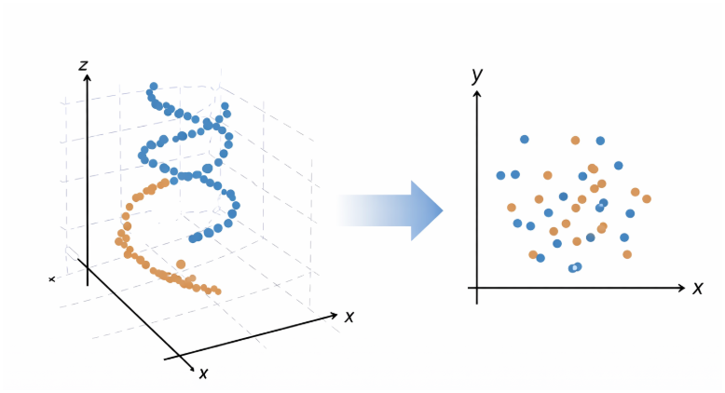  ChatGPT 5.3 Instant 1

PCA vs Least Squares | - principal components  - unsupervised learning  - finds directions (components) of maximum variance in predictors  - vertical least squares  - supervised learning  - minimizes squared vertical distances to predict $Y$from $X$  - orthogonal least squares  - supervised learning  - minimizes the sum of squared perpendicular distances  Gemini 3  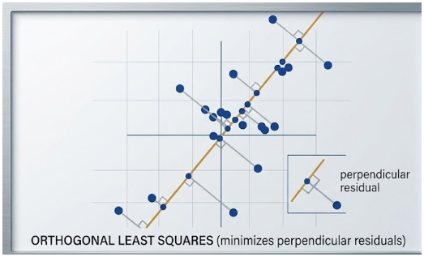  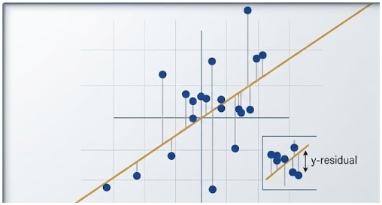  least squares  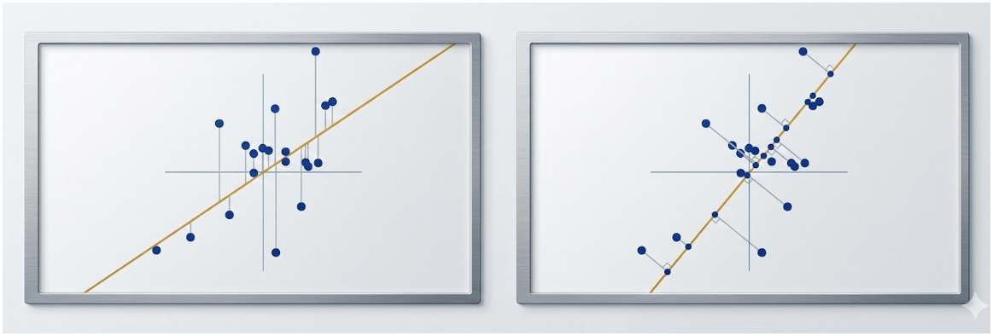  principal components projection
Numerics | - take the SVD of the data set  “best” in the sense of maximizing the first term  $$D= σ_{1}u_{1}v_{1}^{T} + σ_{2}u_{2}v_{2}^{T}$$  - the best one rank approximation is the first term  $$∥D∥_{F}^{2} = ∥σ_{1}u_{1}v_{1}^{T}∥_{F }^{2}+ ∥σ_{2}u_{2}v_{2}^{T}∥_{F}^{2}$$  which means minimizing the next term
julia> D
20×2 Matrix{Float64}:
0.0632719 -1.659
0.505667 0.376497
1.55698 1.27546
⋮
1.12682 0.0639133
-0.156161 0.402374

julia> fact = svd(D);

julia> U = fact.U; Vt = fact.V; S = fact.S;

julia> S[1]*U[:,1]*transpose(Vt[1,:])
20×2 Matrix{Float64}:
-0.797864 0.797864
0.441082 -0.441082
1.41622 -1.41622
⋮
0.595365 -0.595365
0.123107 -0.123107

julia> S
rank one approximation:
$v_{1}⟶$ principle direction in feature space
$u_{1}σ_{1}​→$ coordinates of observations along the direction $v_{1}$
2-element Vector{Float64}:
5.609571973558723
2.8092564856735898
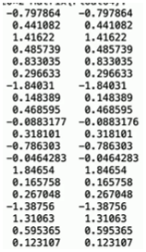  The First Term | - the first term in  $$∥D∥_{F}^{2} = ∥σ_{1}u_{1}v_{1}^{T}∥_{F }^{2}+ ∥σ_{2}u_{2}v_{2}^{T}∥_{F}^{2}$$  - Frobenius norm squared is the sum of the two norms of each row squared  $${\left|\left|A\right|\right|}_{F}^{2}=\sum{{\left|\left|r_{k}\right|\right|}^{2}}$$  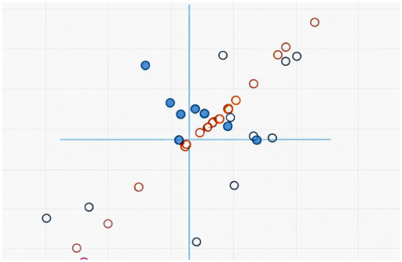  $$σ_{1}u_{1}v_{1}^{T}$$  the residual:  $$D-σ_{1}​u_{1}​v_{1}^{T}​$$  represents the remaining orthogonal variance  ChatGPT 5.3 Instant
The Second Term | - the second term  $$σ_{2 }​u_{2 }​v_{2}^{T}​$$  - the remaining SVD terms represent the residual structure not captured by the first principal component
The 3-D Case | - find the best rank $1$ and $2$  $$D=σ_{1}​u_{1}​v_{1}^{T}​+σ_{2}​u_{2}​v_{2}^{T}​+σ_{3}​u_{3}​v_{3}^{T}​$$  $$∥D∥_{F}^{2 } = ∥σ_{1}u_{1}v_{1}^{T}∥_{F}^{2} + ∥σ_{2}u_{2}v_{2}^{T} + σ_{3}u_{3}v_{3}^{T}∥_{F}^{2}$$  best rank 1matrix  $$∥D∥_{F }^{2}= ∥σ_{1}u_{1}v_{1}^{T} +{σ }_{2}u_{2}v_{2}^{T}∥_{F}^{2} + ∥σ_{3}u_{3}v_{3}^{T}∥_{F}^{2}$$  best rank 2 matrix  $$D=U\left[\begin{matrix}σ_{1} & 0 & 0 \\ 0 & σ_{2} & 0 \\ 0 & 0 & 0\end{matrix}\right]V^{T}$$
julia> D
1000×3 Matrix{Float64}:
5.43274 7.90601 1.91714
1.07729 5.89151 3.75612
⋮
1.2538 4.87763 10.9128

julia> fact = svd(D)

julia> U = fact.U

julia> S = fact.S

julia> Vt = fact.Vt

julia> S1 = Diagonal([S[1], 0, 0])

julia> S2 = Diagonal([S[1], S[2], 0])

julia> rank1 = U*S1*Vt

julia> rank2 = U*S2*Vt

julia> using DelimitedFiles

julia> writedlm("/tmp/rank1.csv", rank1, ',')

julia> writedlm("/tmp/rank2.csv", rank2, ',')

separate a matrix $D$ into rank one matrices
Intro to Nonlinear Solvers
Nonlinear Solvers in 1-D
Taylor Series
Taylor Series | - from calculus, we know that for smooth functions  $$f\left(x\right)=f\left(a\right)+f^{'}\left(a\right)\left(x-a\right)+\left(\frac{f^{''}\left(a\right)}{2!}\right){\left(x-a\right)}^{2}+\left(\frac{f^{'''}\left(a\right)}{3!}\right){\left(x-a\right)}^{3}+…$$  $$|x - a| < R$$  - this typically only holds inside a convergence radius $R$  - if the derivatives exist and are continuous then,  truncate after the $n$-th power  Taylor Series  “with a remainder”  $$f\left(x\right)=f\left(a\right)+f^{'}\left(a\right)\left(x-a\right)+…+\left(\frac{f^{\left(n\right)}\left(a\right)}{n!}\right){\left(x-a\right)}^{n}+\left(\frac{f^{\left(n+1\right)}\left(ξ\right)}{\left(n+1\right)!}\right){\left(x-a\right)}^{\left(n+1\right)}$$  Euler’s  Identity  Cosine  Taylor Series  Exponential  Taylor Series
Common Examples of Taylor Series  Complex Exponential  Expansion  Sine  Taylor Series | $$exp\left(x\right)= 1 + x+ \frac{x^{2}}{2} + \frac{x^{3}}{3!}+…$$  $$sin\left(x\right)=x - \frac{x^{3}}{3!} + \frac{x^{5}}{5!} -…$$  $$cos\left(x\right)=1 - \frac{x^{2}}{2} + \frac{x^{4}}{4!}-…$$  $$exp\left(ix\right)=1 + ix + \frac{{\left(ix\right)}^{2}}{2} + \frac{{\left(ix\right)}^{3}}{3!} + \frac{{\left(ix\right)}^{4}}{4!} + \frac{{\left(ix\right)}^{5}}{5!}+…$$  $$exp\left(ix\right)= 1 + ix - \frac{x^{2}}{2} - i\frac{x^{3}}{3!} + \frac{x^{4}}{4!} + i\frac{x^{5}}{5!}-…$$  $$=cos\left(x\right)+i sin\left(x\right)$$

Finding Roots | 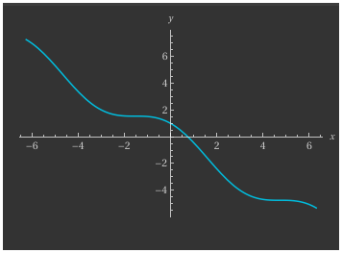  - How to solve $x=cos\left(x\right)$  $$f(x)=cos\left(x\right)-x$$  wolframalpha.com  $$f\left(x\right)=cos\left(x\right)-x$$  only one root  - approximate the root  $$f\left(x\right)≈f\left(x_{0}\right)+f^{'}\left(x_{0}\right)\left(x-x_{0}\right)$$  - find the exact root of the linearized model  $$f\left(x_{0}\right)+f^{'}\left(x_{0}\right)\left(x-x_{0}\right)=0$$  Newton’s  Method  $$x-x_{0}=-f\left(x_{0}\right)/f^{'}\left(x_{0}\right)$$  - use as next ‘guess’  $$x_{1}=x_{0}-f\left(x_{0}\right)/f^{'}\left(x_{0}\right)$$
Implementation | - Newton’s Method / Newton–Raphson iterates  with initial guess 0, the iteration converges quickly  $$x_{\left(n+1\right)}=x_{n}-f\left(x_{n}\right)/f^{'}\left(x_{n}\right)$$  $$f\left(x\right)=cos\left(x\right)-xf^{'}\left(x\right)=-sin\left(x\right)-1$$  second order convergence  - double the number of digits in each step  $$e_{\left(n+1\right)}≈Ce_{n}^{2}$$  error in the next step (n+1), is previous error squared times a constant C
julia> f(x) = cos(x) - x
f (generic function with 1 method)

julia> fp(x) = -sin(x) - 1
fp (generic function with 1 method)

julia> x0 = 0
0

julia> x1 = x0 - f(x0)/fp(x0)
1.0

julia> x2 = x1 - f(x1)/fp(x1)
0.7503638678402439

julia> x3 = x2 - f(x2)/fp(x2)
0.7391128909113617

julia> x4 = x3 - f(x3)/fp(x3)
0.739085133385284

julia> x5 = x4 - f(x4)/fp(x4)
0.7390851332151607

julia> x2 - x5
0.01127873462508322

julia> x3 - x5
2.775769620100288e-5

julia> x4 - x5
1.7012335984389892e-10

When Convergence is Messy | - sometimes convergence can “bounce around” – taking some time to settle into a convergent pattern  $$x_{\left(n+1\right)}=x_{n}-\frac{f\left(x_{n}\right)}{f^{'}\left(x_{n}\right)}$$  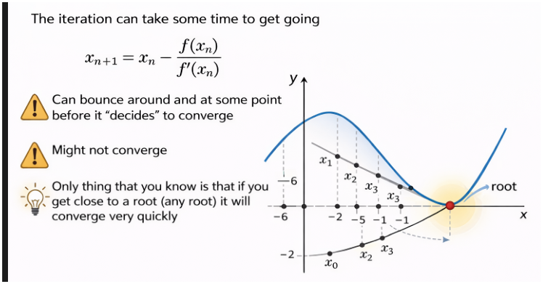  ChatGPT 5.3 Thinking
julia> x = x0
-6

julia> x = x - f(x)/fp(x)
-0.5598827773710564

julia> x = x - f(x)/fp(x)
2.441099878014685

julia> x = x - f(x)/fp(x)
0.49191148608506574

julia> x = x - f(x)/fp(x)
0.7564751611987038

julia> x = x - f(x)/fp(x)
0.7391506975713239

julia> x = x - f(x)/fp(x)
0.7390851341642681

julia> x = x - f(x)/fp(x)
0.7390851332151607

Secant Method | - there are some problems with Newton’s method  - you need both $f\left(x\right)$and $f’\left(x\right)$  - can have a complicated convergence pattern  - solution is to approximate the derivative by taking the slope between two points  $$x_{\left(n+1\right)}=\frac{x_{n}-f\left(x_{n}\right)}{\left(f\left(x_{n}\right)-f\left(x_{\left(n-1\right)}\right)/\left(x_{n}-x_{\left(n-1\right)}\right)\right)}$$  - convergence is slower, but only a single function is needed at each step  - similar to Newton’s method, if it starts to close convergence accelerates
julia> f(x) = cos(x) - x
f (generic function with 1 method)

julia> x0 = 0; x1 = 1; x2 = x1 - f(x1)*(x1-x0)/(f(x1)-f(x0))
0.6850733573260451

julia> x0 = x1; x1 = x2; x2 = x1 - f(x1)*(x1-x0)/(f(x1)-f(x0))
0.736298997613654

julia> x0 = x1; x1 = x2; x2 = x1 - f(x1)*(x1-x0)/(f(x1)-f(x0))
0.739119361912693

julia> x0 = x1; x1 = x2; x2 = x1 - f(x1)*(x1-x0)/(f(x1)-f(x0))
0.739085112274639

julia> x0 = x1; x1 = x2; x2 = x1 - f(x1)*(x1-x0)/(f(x1)-f(x0))
0.7390851332151607

