Julia Programming Language
Julia combines high-level expressive syntax with high-performance execution, making it particularly well-suited for scientific computing, data science, numerical analysis, and systems-level research workflows.
***created by Jeff Bezanson, Stefan Karpinski, Viral B. Shah, and Alan Edelman

Print | print to screen:  println("Hello, world!")
Markdown | markdown: used in julia to write text in Pluto notebooks by use ‘ md””” ‘ string inside Pluto cell  md"""  This text is in **bold** and _italic_.  """  Ctrl+M  keyboard shortcut:
Image in Markdown | method 1: access online image  target url: https://i.imgur.com/qHCI8RS.png  md"""  ![Description of the image](https://i.imgur.com/qHCI8RS.png)  """  method 2: local image  for a local image to render in the notebook, the image has to be packaged and stored in the same or child directory with the notebook  target image: ./image.png  using PlutoUI  PlutoUI.LocalResource("./images/image.png")
Control Flow | if statements: conditional evaluation  if x < y  println("x is smaller")  else  println("y is smaller")  end  for loop: range-restricted iteration  for i in 1:5  println(i)  end  while loop: conditional iteration  n = 0  while n < 3  n += 1  end
Data Structures | arrays:  push!  inserts items into a mutable collection by changing the existing collection instead of creatin a new one  arr = [1, 2, 3]  push!(arr, 4)  dict:  phonebook = Dict("Alice"=>"1234", "Bob"=>"5678")  type definition:  struct Point  x::Float64  y::Float64  end
Collection Manipulation | list comprehensions  squares = [i^2 for i in 1:10]  higher-order function  apply_twice(f, x) = f(f(x))  map / filter  evens = filter(x -> x % 2 == 0, 1:10)
Multiple Dispatch | core Julia design feature: the specific implementation of a function is chosen at runtime based on the data types of all of its arguments  f(x::Int) = "integer"  f(x::String) = "string"  this allows generic functions to have many specialized behaviors for different combinations of input types  method on type: defines a function using ‘ :: ‘ notation  distance(a::Point, b::Point) =  sqrt((a.x-b.x)^2 + (a.y-b.y)^2)  $$\sqrt{{\left(x_{1}-x_{2}\right)}^{2}+{\left(y_{1}-y_{2}\right)}^{2}}$$  Euclidean Distance Formula in Julia  Julia chooses which method to implement based on number of arguments  generic function with dispatch  area(x::Number, y::Number) = x*y  area(x::AbstractVector) = sum(x)
Tuple Unpacking | comma delineated dual assignment  a, b = 1, 2  equates to,  a = 1, b = 2
Interactivity UI Elements:  Sliders | @bing with PlutoUI  create interactive UI elements  using PlutoUI  @bind apples Slider(5:50)  apples  repeat(“🍎”, apples)  output:  the @bind command creates the slider with a range(5:50)  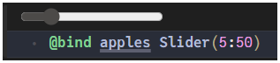  adjusting the slider adjust the number of apples displayed  “🍎🍎🍎🍎🍎🍎🍎🍎”
Plots | there are several plotting libraries available  examples: Makie.jl, PlutoPlotly.jl, Gadify.jl, Plots.jl  Plots.jl  using Plots  plot([4,5,8,2,3,1,0])  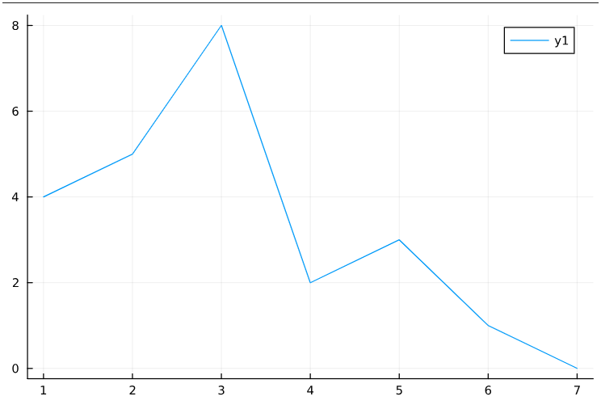  result  combining multiple plot calls in a single cell  data = rand(100)::Vector{Float64}  let  plot(data)  # use the ! exclamation mark to modify the previous plot  scatter!(data)  # add a horizontal line  mean = sum(data) / length(data)  hline!([mean]; label="Average value")  end  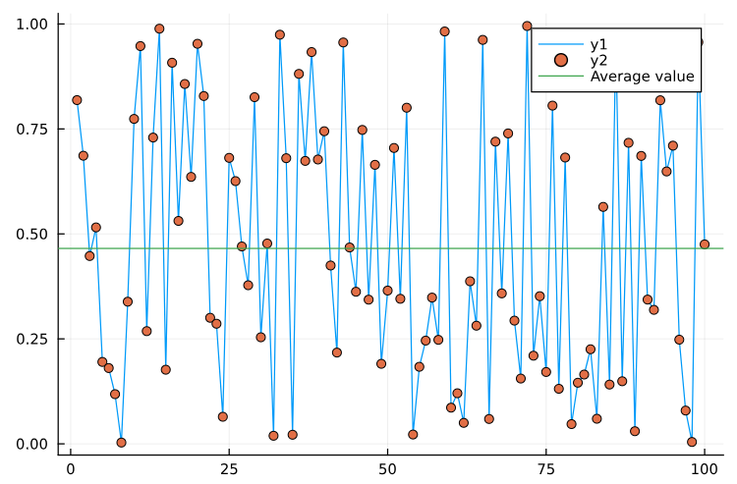  result
LaTeX  note: the legacy  LaTeX syntax:  $\frac{1}{2 \pi}$  is deprecated  . | Pluto has built-in LaTeX support for math equations for use inside markdown  notice double back-tics  method 1: inline math  md”””  inline equation: ``\frac{1}{2 \pi}``.  ”””  inline equation: $\frac{1}{2π}$  inline  result  method 2: block math  md"""  block equation:  block equation:  $$\frac{1}{2π}$$  ```math  \frac{1}{2 \pi}  ```  """  block  result
Links | the ‘#’ character can be used to link to specific sections in a Pluto notebook:  global variables: #variable_name  function definitions: #function_name  markdown headers: #header-text  inside the notebook:  md"""  Take a look at [the fruits variable](#fruits).  """  displayed text  link name
[item 3] | [Diagram 3]
[Textbook Title]
(authors)
[Section/Chapter]
[concept/term 1] | [definition 1]
[concept/term 2] | [definition 2]
[concept/term 3] | [definition 3]
References | Julia. (n.d.) Tutorials Point https://www.tutorialspoint.com/julia/julia_tutorial.pdf  Julia Documentation · The Julia Language. (n.d.). https://docs.julialang.org/en/v1/  Linking. (n.d.). https://plutojl.org/en/docs/linking/  Markdown. (n.d.). https://plutojl.org/en/docs/markdown/  Wikipedia contributors. (2026, February 11). Julia (programming language). Wikipedia. https://en.wikipedia.org/wiki/Julia_(programming_language)

