Classification II
Discriminative vs Generative Models
Discriminative Models | - directly look at estimating the likelihood of $y$ given $x$  Direct  $$P\left(Y | X\right)$$  - has no knowledge of the distribution of $X$  - cannot generate synthetic instances $P\left(X,Y\right)$  - these are the models we have studied in earlier chapters  - linear regression, logistic regression
Generative Models | - models the joint distribution between $x$ and $y$  Indirect  $$P\left(X, Y\right)$$  $$P\left(Y | X\right)=\frac{P\left(X,Y\right)}{\int{P\left(X,Y\right)dY}}$$  - can generate instances of $\left(X,Y\right)$
Optimal Classifier | - Bayes Rule  Discriminative approach  $$P\left(X | Y\right)=\frac{P\left(X | Y\right)P\left(Y\right)}{P\left(X\right)}$$  $$P\left(Y=y | X=x\right)=\frac{P\left(X=x | Y=y\right)P\left(Y=y\right)}{P\left(X=x\right)}$$  - optimal classifier  applying Bayes Rule (Generative)  $$f^{*}\left(x\right)=\underset{Y=y}{argmax}{P\left(Y=y | X=x\right)}$$  $$f*\left(x\right)=\underset{Y=y}{argmax}{P\left(X=x | Y=y\right)P\left(Y=y\right)}$$  - class prior: tells you the  liklihoods without any  knowledge of input  - class conditional: tells  distribution of input features given the label $y$  Class Conditional Density  Class Prior

Generative Approach with Gaussians
Gaussians | - we can now consider appropriate models for the two terms  - class probability $P\left(Y=y\right)$  - $Bernoulli\left(θ\right)$  - $P\left(Y=heads\right)=θ P\left(Y=tails\right)=1-θ$  - class conditional distribution of $P\left(X=x | Y=y\right)$  - Gaussian class contitional (two dimensions)  - $P(X = x | Y = y) = \frac{1}{\sqrt{2π|Σ_{y}}}exp⁡(\frac{\left(x-μ_{y}\right)Σ_{y}^{-1}{\left(x - μ_{y}\right)}^{T}}{2}$)  - parameters are dependant on the values we are conditioning  - for Gaussian, $mean$ and $covariance$ are dependant on $y$ value
Gaussian Bayes Classifier | - classifier that models the joint likelihood using class condition distributers by esitmating the marginal distribution of $y$  - gives probablity for of $y$ for all potential values  - then, we model $x$ given $y$ by fitting a Gaussian  - we are varying the mean and covariance matrix  depending on $y$  - each $y$ gets its own mean and covariance matrix
Decision Boundary of Gaussian Bayes | 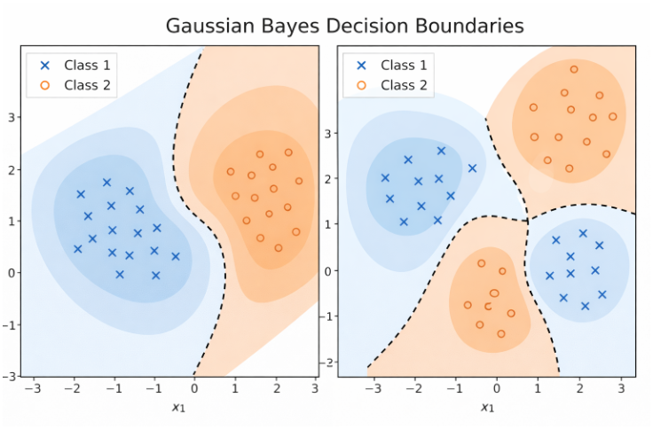  the decision boundary can take different forms (generally quadratic for Gaussians)

Gaussian Bayes Parameters | - as stated, for each potential value of $y$  - estimating probability  - estimating Gaussian  - estimating conditional Gaussian parameters  data is split into $c$ “buckets” given $c$ potential values  $${\left\{\left(x_{i},y_{i}\right)\right\}}_{i=1}^{n}$$  estimate mean and covariance parameters for each  $$y=1 y=2 … y=c$$  $$μ_{y1},ϵ_{y1} μ_{y2},ϵ_{y2} μ_{y3},ϵ_{y3}$$
How Many Parameters are Needed to Learn? | - class probability  $p_{0},p_{1}, …, p_{k}$ all sum to 1  - $P\left(Y=y\right)=p for all y in 0, 1, 2, …, k$  $$k-1 parmeters needed if k labels$$  $$μ_{y}-d∙dim vector$$  $$ϵ_{y}-d×d matrix$$  - class conditional distribution of features  $$P\left(X=x | Y=y\right)∼N\left(μ_{y},ϵ_{y}\right) for each y$$
Discrete Features
Binary Classification | - example: black and white image  - each image is represented as a vector of $d$ binary features  - black=1, white=0  - training data  - input, $X$  $n$ $images$  $$2$$  1  - label, $Y$  $1 2$ $n$ $labels$
Discrete Bayes Model | $$P\left(Y = y\right)= p_{y},$$  $$for all y ∈ \left\{0,1,2,…,9\right\},$$  $$Σ_{{\left\{y=0\right\}}_{y}^{\left\{9\right\}p}}= 1$$  $$P\left(X=x | Y y\right)$$  $$\sim For each label y, maintain a probability table with$$  $$2^d - 1 entries$$
Getting Rid of Parameters
What is wrong with too many parameters? | - even for a single parameter, to build an accurate representation, you need hundreds, or even thousands, of training samples  - generative models often use $10^x$ paramters where $x > 10000$
Conditional Independence | - $X$ is condtionally independent of $Y$ given Z:  - Probability distribution governing $X$is independent of the value of $Y$, given the value of $Z$  $$(∀ x, y, z) P(X = x | Y = y, Z = z) = P(X = x | Z = z)$$  Note: This does not mean thunder is independent of rain!  - equivelent to:  $$P(X, Y | Z) = P(X | Z) P(Y | Z)$$  - for example:  $$P(Thunder | Rain, Lightning) = P(Thunder | Lightning)$$
Naïve Bayes Classifier | - Bayes Classifier with additional “naive” assumption  $$X=\left[{X_{1} \atop X_{2}}\right]$$  $$P(X_{1}, X_{2} | Y) = P(X_{1} | X_{2}, Y) P(X_{2} | Y)$$  $$= P(X_{1} | Y) P(X_{2} | Y)$$  $X=\left[\begin{matrix}\begin{matrix}x_{1} \\ x_{2}\end{matrix} \\ … \\ x_{d}\end{matrix}\right]$  $$P(X_{1}, …, X_{d} | Y) = \prod_{i=1}^{d}{P(X_i | Y)}$$  - if conditional independence assumption holds, Naïve Bayes (NB) is an optimal classifier (but worse otherwise).  has fewer parameters, so less training data even though assumption may be violated  - Bayes classifier with additional “naive” assumption  features are independent given class:  $$P(X_{1}, …, X_{d} | Y) = \prod_{i=1}^{d}{P(X_i | Y)}$$  $$f_{NB}(x) = argmax_{y} P(x_{1}, ..., x_{d} | y) P(y)$$  $$= argmax_{y} \prod_{i=1}^{d}{P(x_{i} | y) P(y)}$$
Parameters Needed for  Bernoulli Conditionals | - how many parameters?  $K-1$ free parameters  $$if K labels$$  - class probabilities:  $$Y ∈ \{1, 2, ..., K\}$$  $$P(Y=y)=p_{y} for all y$$  - class conditional distribution of features  linear instead of exponential  in d!  (Naive Bayes assumption):  $$P(X_{i} = x_{i} | Y = y)$$
Naïve Bayes Algorithm: Discrete Features | - training data:  ${\left\{ \left(x^{j}, y^{j}\right)\right\}}_{j=1}^{n}$ $X^{j} = (X_{1}^{j} , ..., { X}_{d}^{j})$  - maximum liklihood estimates  - class probability:  $$P(y) = \frac{\#\{ j : Y^{j} = y \} }{n}$$  - class conditional distribution:  $$\frac{P(x_{i}, y)}{P(y)}=\frac{\#\{ j : X_{i}^{j}=x_{i}, Y^{j}=y \}}{\#\{ j : Y^{j} = y \}}$$  - Naive Bayes Prediction (Test Data)  $2Kd$ free parameters  $$if K labels$$  $$X = (x_{1}, ..., x_{d})$$  $$Y = argmax_{y} P\left(y\right)\prod_{i=1}^{d}{\frac{ P\left(x_{i}, y\right)}{P\left(y\right)}}$$
Gaussian Conditionals | - how many parameters  $$P(X_{i}=x_{i} | Y=y) \sim N(μ_{iy}, σ_{iy}^{2})$$  $$for each class yand each feature (pixel) i.$$

Class Probability (putting it all together)
Class Conditional Distribution | $$P\left(Y = y\right)= p_{y} \\ Free parameters: K - 1$$  - Gaussian Naïve Bayes  $$P(X_{i}=x_{i} | Y = y) \sim N(μ_{iy}, σ_{iy}^{2})$$  - for each class $y$and each feature $i:$  $$Parameters per class-feature pair: 2$$  $$Total class-conditional parameters: 2Kd$$  - Total Number of Parameters  $$\left(K - 1\right)+ 2 K d$$
Generative vs Naive Generative | - Generative Model for Classification  $$P(X_{i} = x_{i} | Y = y) P(Y=y)$$  - Naïve Bayes Algorithm  $$\prod_{i=1}^{d}{P(X_i | Y) P(Y=y)}$$
Case Study | - Classify e-mails  $$Y=\{\text{Spam},\text{NotSpam}\}$$  - Classify news articles  $$Y=\left\{\text{topic of the article}\right\}$$  - Classify webpages  $$Y=\{\text{Student},\text{Professor},\text{Project},… \}$$  - What about the features $X$?  $$The text!$$

Summary | - Optimal decision using Bayes classifier  - Naïve Bayes classifier  - What’s the assumption  - Why we use it  - How do we learn it  - Gaussian NB  - Features are still conditionally independent  - Each feature has a Gaussian distribution given class  - Text classification  - Bag-of-words model

