An Introduction to Statistical Learning
What this is
- the following are notes from Ch1 from ISLRv2
- Chapter 1: Introduction
- pp 1-6
- **/Spring_2026/DATA780/Unit1/ISLRv2_corrected_June_2023.pdf
An Overview of Statistical Learning
Statistical learning is a collection of methods used to understand, discover patterns, and make predictions in data and is widely used in business, medicine, science [sic], and public policy applications.`
What is Statistical Learning?
Supervised Learning | - used to predict or estimate the output (Y) using inputs (X)  - Common tasks include predicting numerical and categorical values and classifications
Unsupervised Learning | - only inputs are observed  - there is no output variable  - used to discover structure or relationships in the data  - common tasks include clustering and dimension reduction
Regression Example: Wage Data
Goal | - predict a man’s wage using information such as age, education level, and calendar year
Key Observations | - wages increase with age up to age 60, then decreases  - wages increase over time  - higher education is associated with higher wages  - there is substantial variability in wages
Insights | - no single variable predicts wage well on its own  - combining multiple variables improves prediction  - relationships can be non-linear (especially with age)
Classification Example: Stock Market Data
Goal | - predict trends in stock market
Data Used | - daily percentage changes in the S&P 500  - past 5 days of returns
Key Considerations | - the output is categorical, not numerical  - past returns show very weak predictive power
Results | - prediction accuracy of ~60% using statistical learning methods
Unsupervised Learning Example: Gene Expression
Goal | - identify groups of similar cancer cell lines using gene expression data
Data Used | - 64 cancer cell lines  - 6,830 gene measurements per cell line  - no output variable
Approach | - Reduce thousands of variables to a small number (dimension reduction)  - visualize the data in two dimensions  - look for natural groupings/clusters
Result | - cell lines form visible clusters  - clusters tend to correspond to actual cancer types  - cancer type information was not used to form the clusters  - evidence provided that unsupervised learning can uncover real structure
Supervised Learning: A Brief History
Early Developments | - 1800s: least squares >> linear regression  - 1936: linear discriminant analysis  - 1940s: logistic regression  - 1970s: generalized linear models
Major Advancements | - early methods were restricted by computational limits  - 1980s onward computing power enabled non-linear methods
Modern Era | - statistical learning is a distinct field  - methods have become widely available through tools such as R  - expanded far beyond statistics and computer science

NumPy: Broadcasting
What this is
- the following are notes from the NumPy v2.4 manual
- https://numpy.org/doc/stable/user/basics.broadcasting.html
An Overview of NumPy Broadcasting
What Broadcasting is | - a rule NumPy uses to let you do arithmetic on arrays with different shapes
What Broadcasting does | - when NumPy sees two arrays that do not match shape exactly it attempts to expand the smaller array
Result | - NumPy avoids loops and unnecessary data copying, making array math fast and efficient
Why Broadcasting Matters
NumPy without Broadcasting | - normally NumPy does element-by-element operations which traditionally only work with array with the same shape  - 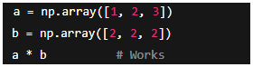
NumPy with Broadcasting | - let’s NumPy relax the constraints  - facilitates scalar and non-conformable array arithmetic
Scalar Multiplication Example
Problem | - a problem requires multiplying a 3 x 1 array by a scalar  - 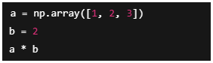
Solution | - NumPy conceptually “stretches” ‘b’ to match the shape of a  - this is achieved without duplicating the scalar in memory  - essentially makes the operation:  - 

How Broadcasting Works
Rules | - compare shapes from the trailing (rightmost) dimension  - two dimensions are compatible if  - they are equal  - one of them equals ‘1‘  - if neither condition is true  - NumPy raises ‘ValueError’
What it does | - If one array has fewer dimensions, NumPy treats missing dimension sizes as ‘1’  - If a dimension is ‘1’ in one array but larger in the other, NumPy expands that dimension
Resulting Array | - the resulting shape has the maximum number of dimensions from the input arrays  - each axis is the size of the larger of the two  - if shapes cannot be aligned NumPy raises an error
Examples | - NumPy expands the dimensions of ‘B’ so it is compatible with ‘A’  - 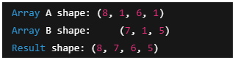  - when operation is with scalar and array ‘b’ is broadcasted into ‘a’  - 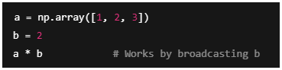  - when operation is with 1-D and 2-D arrays  - 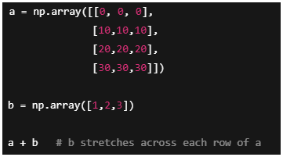  - a set of arrays are broadcast-able if all can be expanded to a common shape that meets the rules  - 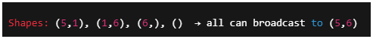  - scalar shape ‘()’ acts like a shape of ones  - the 1-D array ‘(6,) is treated like (1, 6)  - all arrays are conceptually expanded to (5, 6)  - this is all achieved with minimal memory use by NumPy
When Broadcasting Fails | - when two arrays do not satisfy the rules and broadcasting is not possible NumPy shows a broadcasting error  - 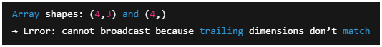
Broadcasting  Summary | - let’s NumPy combine arrays of different shapes avoiding loops and memory bloat  - compares shapes from trailing dimensions  - dimensions must either match or be ‘1’  - if conditions not met NumPy raises an error

Async Materials
Machine Learning | 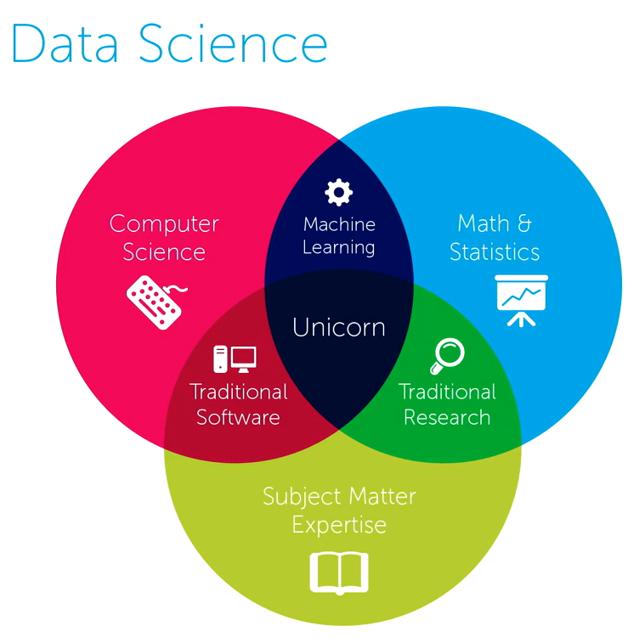
Machine Learning Terminology
Inputs to Models | - features – the individual measurable properties in a model  - covariates – input variables that are statistically related to the output  - dimensions – number of input variables or axes in a feature space  - parameters – learnable variables needed to compute the model’s output
Contents of a Dataset | - instances – a single unit of observation in a dataset  - samples – a single observed data point  - examples – a training or testing data point
  Concept Type | Term | Emphasis
  inputs | feature | measurable input variable
  inputs | covariate | input related to outcome
  inputs | dimension | number of input axes
  dataset unit | instance | one entity or case
  dataset unit | sample | observed data point
  dataset unit | example | labeled training/test case
Quick Reference
Training | - inference – using understood relationships to draw conclusions  - prediction – using data, machine learning, and statistical modeling to forecast future outcomes  - classification label – predefined category or class assigned to a data point correlating to output in supervised machine learning  - types of learning  - supervised – mapping input to output  - unsupervised – learn data characteristics  - reinforcement – learn how to interact with an environment through sequential ‘stacked’ learning
Types of Machine Learning
Supervised Learning | - inputs > outputs  - {example1, output1}  - {example2, output2}  - speech > text  - regression  - 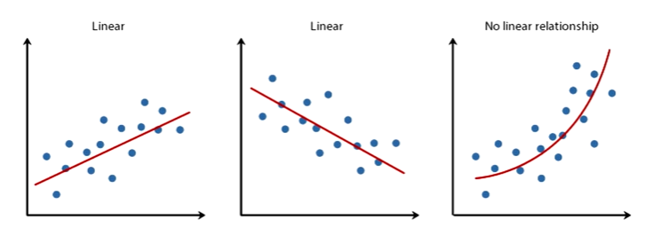
Unsupervised Learning | - does not make use of prespecified/annotated examples  - {example1, example2, example3…}  - {x_{i}}^{n}_{i=1}  - clustering  - attempting to discover the salient groups of the data  - dimensionality reduction  - identifies the degrees of freedom or core descriptors of the data  - generative models  - given training data, generate new samples from same distribution
Reinforcement Learning | - interact with an environment and assess the environment state to then output actions that change that state  - predictions build on one another to maximize ‘rewards’ through iterative application of the assessment, action, change state, assess, …
Keys to Success with Machine Learning
Three Pillars of Machine Learning | - big datasets  - fast processing  - innovative methods
Typical ML Model Lifecycle | - select loss/model-type for data task  - optimize model with training data  - evaluate on held-out data to validate choices  - use with unseen future data
Three Pillars to YOUR Success in Machine Learning | - statistics and mathematics  - computer engineering  - data analytics acumen
Philosophy: Intelligence Can Grow | 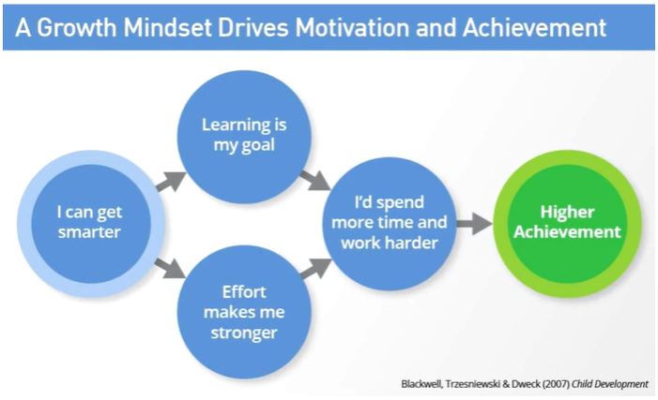

Mathematics Review
Differentiation | taking derivatives of functions  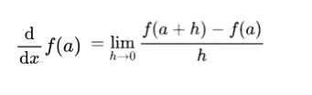  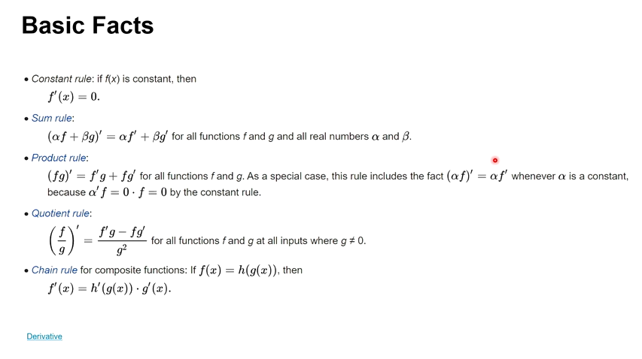
Gradients | derivatives that take in multiple variables and produce a real value output  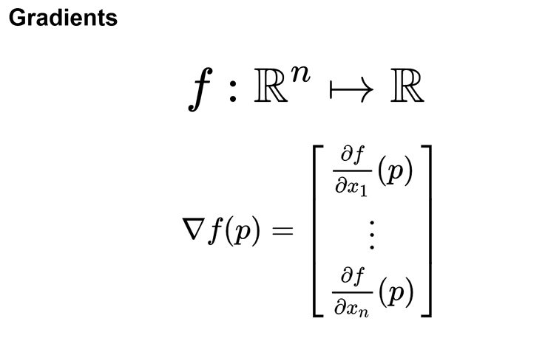  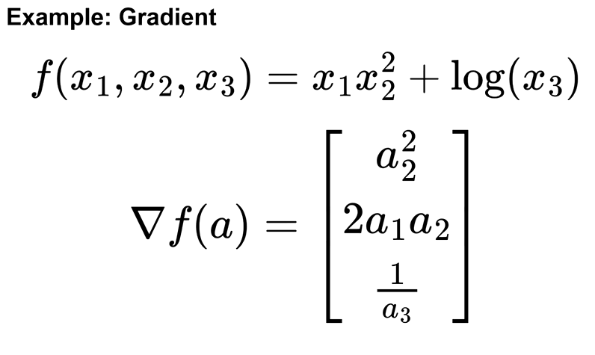
Derivatives as Approximators | 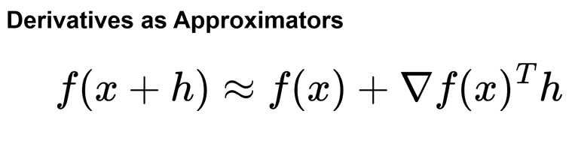
Integration | 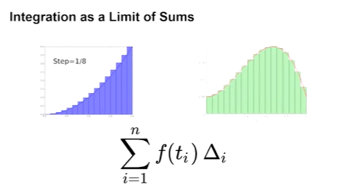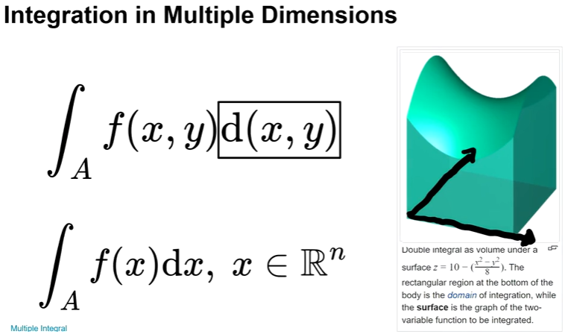
Antiderivative | integration and differentiation are inverse operations  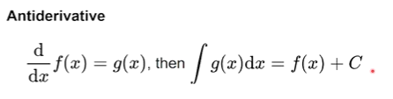

Live Session
Introduction |  | 05 Jan 2026
Instructor | Rei Sanchez-Arias
Email | reisanar@unc.edu
Website | https://www.reisanar.com/
Office Hours | Mondays 12:00 pm to 1:00 pm
What to expect |  | DATA780
Meeting Time | Monday 6:00 pm to 7:30 pm
Final Project | project deliverables:  - project writeup: ~8 pages NeruIPS format  - open-source repository with executable code for methods developed  - the github repo can be private or public  - spotlight presentation (last live session)  - 6 to 7 minutes for presentation  - 2 minutes for Q&A  - prepared slide deck  - optional live demo  - final project can be combined for DATA780 and DATA740 (if it applies to both)  - your project may innovate some new LM methodology, or make an improvement to an existing methodology
Final Project Proposal | - state the task, goals  - what methods do you plan to use?  - what datasets will you consider?  - evaluations metrics you plan to use
Assessments | Quizzes will be weekly
Syllabus | https://digitalcampus.instructure.com/courses/55373/assignments/syllabus
Live Session Summary | Meeting Notes found at the top of the Modules page on canvas https://digitalcampus.instructure.com/courses/55373/pages/meeting-notes?module_item_id=9295727

What to expect |  | DATA780
Resources  (free pdf downloads available) | - Mathematics for Machine Learning  - https://mml-book.github.io/book/mml-book.pdf  - Data-Driven Science and Engineering  - https://databookuw.com/  - Introduction to Statistical Learning  - https://www.statlearning.com/
Blogs/Websites | 3Blue1Brown Videos (by Grant Sanderson)  - Linear Algebra Series  - https://www.3blue1brown.com/topics/linear-algebra  - Calculus Series  - https://www.3blue1brown.com/topics/calculus
TODO
High Priority | - review linear algebra terminology  - finish CW-Data780-unit_01.ipynb
Low Priority | - review assignments  - Homework 1  - Final Project

