Linear Algebra Background
What this is
- recap of Linear Algebra concepts
- tools to apply toward ML implementation and methodology
Linear Algebra
scalar | a value having only magnitude and not direction  https://languages.oup.com/google-dictionary-en/
vector | a quantity with both magnitude and direction  https://en.wikipedia.org/wiki/Vector_(mathematics_and_physics)
subspace | A subset of W of n-space is a subspace if:  - the zero vector is in W  - x + y is in W whenever x and y are in W  - a*x is in W whenever x is in W and a is any scalar  https://www.math.kent.edu/~reichel/glossary
basis | A basis for a subspace W is a se of vectors v₁, …, v_{k} in W such that:  - v₁, …, v_{k} are linearly independent  - v₁, …, v_{k} span W  https://www.math.kent.edu/~reichel/glossary
system of equations | a linear system is a collection of two or more linear equations involving the same variables. For example:  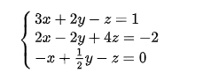  https://en.wikipedia.org/wiki/System_of_ 1
vector spaces | a linear space is a set whose elements (i.e. vectors) can be added together and multiplied by scalars  https://www.math.kent.edu/~reichel/glossary
outer product | u ⊗ v = uv^{T :} the tensor product is the matrix whose entries are all products of an element in the first vector with an element in the second vector so that taking the outer product of two vectors of length n and m will result in an n x m matrix
inner product | a generalization of the dot product and is a way to multiply vectors together resulting in a scalar and satisfies the following properties:  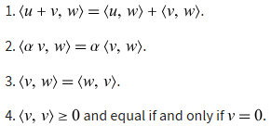  https://mathworld.wolfram.com/InnerProdu 1
Hadamar product | the element-wise product of two matrices
matrix multiplication | if A is an m x n matrix and B is an n x p matrix, the matrix product C = AB is defined to be an m x p matrix such that:  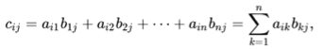
norm | given a vector space X over a subfield F of the complex numbers C, a norm on X is a real-valued function p : X -> R with the following properties:  (where |s| denotes the usual absolute value of a scalar s)  - positive definiteness for all  https://en.wikipedia.org/wiki/Norm_(math 1
transpose | an operator that flips a matrix over its diagonal denoted A^{T}  https://en.wikipedia.org/wiki/Transpose
Eigenvalue | an eigenvalue of a n-by-n matrix A is a scalar c such that A*x = c*x holds for some nonzero vector x (where x is an n-tuple)  https://www.math.kent.edu/~reichel/glossary
Eigenvector | an eigenvector of an n-by-b matrix A is a nonzero vector x such that A*x = c*x holds for some scalar  https://www.math.kent.edu/~reichel/glossary
Eigendecomposition | the factorization of a matrix into a canonical form, whereby the matrix is represented in terms of its eigenvalues and eigenvectors  https://www.math.kent.edu/~reichel/glossary
trace | the sum of its eigenvalues counted with multiplicities such that:  - tr(AB) = tr(BA) for any same-sized matrices A and B  - thus, similar matrices have the same trace  - 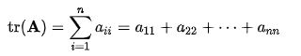  https://en.wikipedia.org/wiki/Trace_(lin 1
norm to distance | d(x, y) = ||x – y||, where ‘|| . ||’ denotes magnitude and ‘ – ‘ denotes difference
Euclidean Distance | d(p, q)² = (q₁ – p₁)² + (q₂ – p₂)²  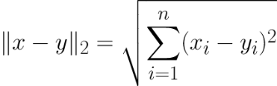  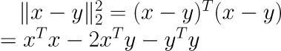
Holder’s Inequality | 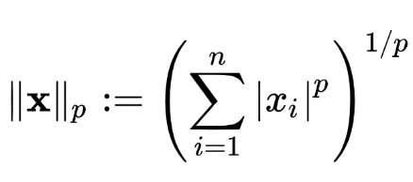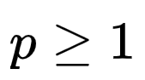
vector space axioms
  associativity | u + (v + w) = (u + v) + w
  commutativity | u + v = v + u
  identity element | there exists an element 0 ∈ V, called the zero vector such that v + 0 = v for all v ∈ V
  inverse elements | for every v ∈ V there exists an element -v ∈ V, called the additive inverse of v, such that v + (-v) = 0
  scalar-multiplication / field-multiplication compatibility | a(bv) = (ab)v
  identity element of scalar multiplication | I v = v, where I denotes the multiplicative identity in F
  distributivity | a(u + v) = au + av
spatial vectors | vectors in an n-dimensional vector space
vectorization | turns a matrix into a vector so that an n x m matrix will produce a n*m length vector
submatrix | a grouped subset of a matrix
block matrix | a subset of non-overlapping submatrices
determinant | the product of the eigenvectors of a matrix  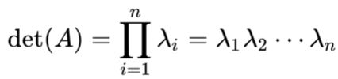

neural networks | 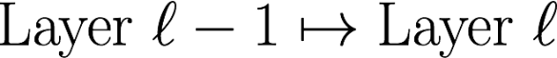  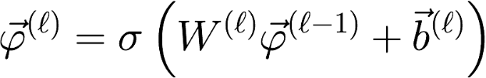
losses | 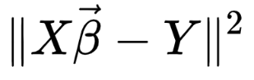
multivariate normal pdf | 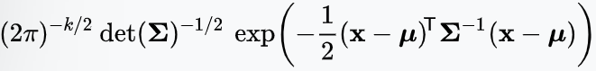
dimensionality reduction | simplifies complex, high-dimensional data by transforming it into a  lower-dimensional space
span of set | 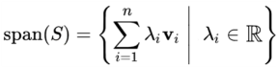  all the vectors obtained by linearly combining a set of vectors  S = {v₁, v₂, …, v_{n}}, such that
column span | colsp(A) = span({v₁, v₂, …, a_{n}})
column rank | rank(A) = dim(colsp(A))
null space | set of all vectors x of a matrix A for which Ax = 0
nullity | the dimension of the null space
rank-nullity relationship | for matrix A with n columns:  rank(A) + nullity(A) = n
orthonormality | a set of vectors {u₁, u₂, …, un} is orthonormal iff:  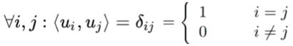
Kronecker delta | 𝛿_{ij} is a mathematical function that acts as a discrete "switch," returning 1  if its two indices i and j are the same, and 0 if they are different
Gram-Schmidt theorem | if {v₁, v₂, …, v_{n}} is a linearly independent list of vectors in an inner-product  space V, then there exists an orthonormal list {e₁, e₂, …, e_{n}} of vectors V  such that span(e₁, e₂, …, e_{n}) = span(v₁, v₂, …, v₃)
matrix inverse | an n-by-n square matrix A is invertible, if there exists an n-by-n square  matrix B such that AB = BA = I_{n} where In denotes the n-by-n identity matrix
matrix inverse equivalent statements | Let A be a square matrix  - there is an n-by-n matrix B such that AB = I_{n} = BA  - matrix A has a left inverse and a right inverse, in which case both  left and right inverses exist and B = C = A⁻¹  - A has full rand; that is, rank A = n  - A is invertible, that is, A has an inverse, is nonsingular, and is  nondegenerate
Probability and Statistics

discrete distribution | describes the probabilities of outcomes for discrete random variables  where each outcome has a specific probability between 0 and 1 and all  probabilities sum to 1  https://en.wikipedia.org/wiki/Probability_distribution
continuous distribution | describes probability for variables that can take any value within a range  https://en.wikipedia.org/wiki/Probability_distribution
discrete random variable | a random variable that has a countable range and assumes each value  in this range with a positive probability  https://gwthomas.github.io/docs/math4ml.pdf
continuous random variable | a random variable that has an uncountable range and assumes each  value in this range with probability zero  https://gwthomas.github.io/docs/math4ml.pdf
probability mass function | gives the probability that a discrete random variable is exactly equal to a  specific value  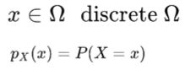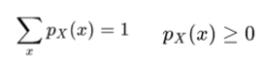  https://en.wikipedia.org/wiki/Probability_mass_function#:~:text=In%%20and%20statistics%2C%20a  ,mass%20is%20called%20the%20mode.
probability density function | describes the likelihood of a continuous random variable falling within  specific range, represented as a curve where the total area under it equals  1, and the area over an interval gives the probability  https://en.wikipedia.org/wiki/Probability_density_function#:~:text=In%20probability%20theory%2C  %20a%20probability,possible%20values%20to%20begin%20with.
joint distribution | a distribution over some combination of several random variables  https://gwthomas.github.io/docs/math4ml.pdf
independence | the likelihood of one random variable X_{i} is not a condition of X_{j}  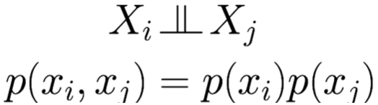
Bayes Rule | connects conditionals in one direction to conditionals in another direction  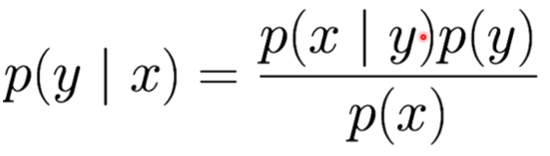
Bayes Theorem | 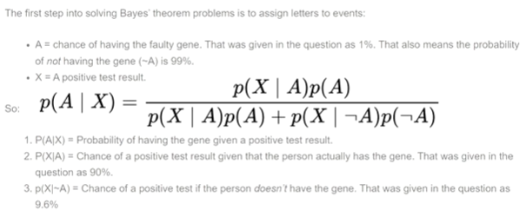
conditional likelihood | the probability that Y, given X = x  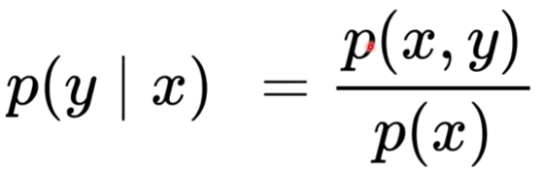
conditional independence | shows that X_{i} is independent of X_{j} given X_{k}  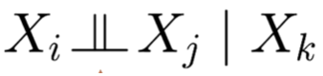
parameters | list of specific values needed to calculate a parametric distribution
parametric distributions | calculated probability given a list of parametric values  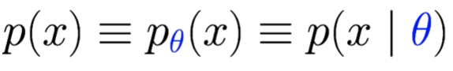
parametric families | all the possible distributions that can be calculated by adjusting parametric  values. some examples of parametric families:
  normal  (Gaussian) | 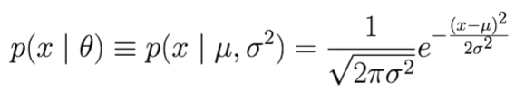
  truncated normal | 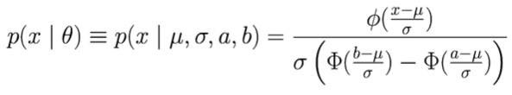
  multivariate normal | 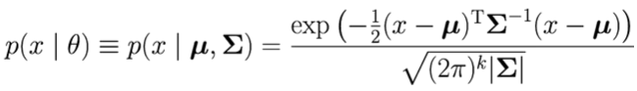
  logistic | 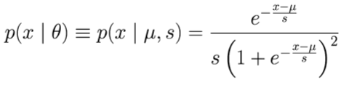
  beta | 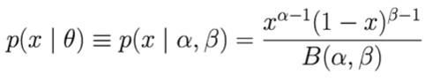
  binomial  (parametric pmf) | 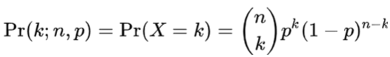
conditional distribution | show the probability of outcomes for one variable, given that another variable  is fixed at a specific value or falls within a certain category, essentially  focusing on a sub-population  https://www.khanacademy.org/math/ap-statistics/analyzing-categorical-ap/distributions-two-way-  tables/v/marginal-distribution-and-conditional-distribution#:~:text=On%20the%20other%20hand%  2C%20the,of%20car%20origin%20and%20color.
marginalization | the probability of the variables contained in a subset of a collection of  random variables is determined by integrating out additional variables  https://en.wikipedia.org/wiki/Marginal_distribution
statistical expectations | E[X] is the long-run average outcome of a random variable, calculated as  weighted average of its possible values where each value is weighted by its  probability
expected value | an expected value E_{X} from a random distribution p taken as a function f(X)  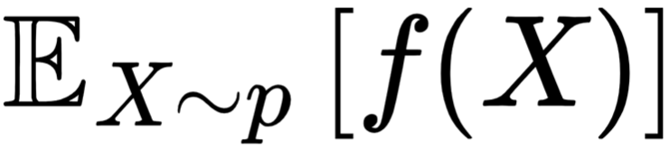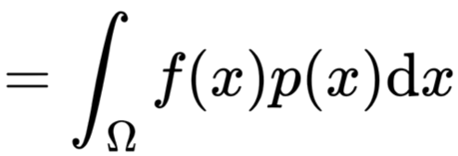
KL Divergence | a Kullback–Leibler divergence is a statistical distance: a measure of how  much an approximating probability distribution Q differs from the true value  KL properties:  - measure of how different two probability distributions are  - D(p||q) ≥ 0; D(p||q) = 0 iff p = q  - not a metric; not commutative, does not satisfy triangle equality  - the average number of bits that are wasted by encoding events from  a distribution p with a code based on a not-quite-right distribution of q  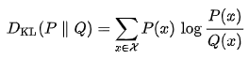  https://en.wikipedia.org/wiki/Kullback%E2%80%93Leibler_divergence
estimating expectations | given samples {x₁, x₂, .., x_{n}} of p, an empirical average of f(x) is calculated to  approximate the true value of f(x)  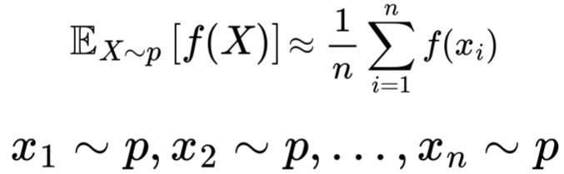

Live Session
Introduction |  | 12 Jan 2026
Instructor | Rei Sanchez-Arias
Email | reisanar@unc.edu
Website | https://www.reisanar.com/
Office Hours | Mondays 12:00 pm to 1:00 pm
Live Session | Monday 6:00 pm to 7:30 pm
Linear Algebra and Probability
Look up Terms | - Hessian matrix  - the Hessian matrix of a scalar function of several variables describes the curvature of that function  - by taking the determinant of the Hessian matrix at a critical point, we can test whether that point is a local min, max, or saddle point  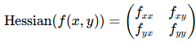  https://www.mit.edu/~ashrstnv/hessian-ma 1  - Jacobian matrix  - a matrix of all the first-order partial derivatives of a vector-valued function, acting as a multivariable function’s derivative, showing how changes in input variables affect output variables locally  - Essential for gradient descent in training neural networks, calculating sensitivity, and backpropagation  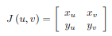  https://math.etsu.edu/multicalc/prealpha 1  - covariant matrix  - a square matrix giving the covariance between each pair of elements of a given random vector  - in the matrix diagonal there are variances, i.e., the covariance of each element with itself  - generalizes the notion of variance to multiple dimensions  https://ise.ncsu.edu/wp-content/uploads/sites/9/2022/01/Covariance-matrix-Wikipedia-1.pdf  - gradient  - (∇f) a vector that points in the direction of the function’s steepest increase and whose magnitude represents the rate of that increase  - calculated by collecting partial derivatives into a vector  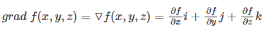  https://byjus.com/maths/gradient/#:~:tex 1
Look up on SciKitLearn | - QuadraticDiscriminantAnalysis  - Quadratic Discriminant Analysis.  - A classifier with a quadratic decision boundary, generated by fitting class conditional densities to the data and using Bayes’s rule.  - The model fits a Gaussian density to each class.  - BernoulliNB  - Naive Bayes classifier for multivariate Bebrnoulli models.  - Like MultinomialNB, this classifier is suitable for discrete data. The difference is that while MultinomialNB works with occurrence counts, BernoulliNB is designed for binbary/boolean features.  - MultinomialNB  - Naive Bayes classifier for multinomial models.  - The multinomial Naive Bayes classifier is suitable for classification with discrete features (e.g., word counts for text classification). The multinomial distribution normally requires integer feature counts. However, in practice, fractional counts such as tf-idf may also work.
Class Work Exercises
Class Work Notebooks
CW Notebook Solutions
Solution | DATA780\Week2\<fname_lname>_DATA780_week2_ProbStatML.docx"

