Neural Networks 2
Overview |  |  | [date]
[section title] |  |  |  | [optional]
[section overview]
[item]
[item]

Live Session Notes |  | 30 Oct 2025
- prepare for midterm
  - cross validation
  - back propagation
- practice LaTeX
- mid-way report due 03/25
- NeurIPS style (overleaf templates provided in Canvas)
- watch Jeffery Hinton interview with John Stewart
Neural Networks: Types and Applications  (watch these videos) | 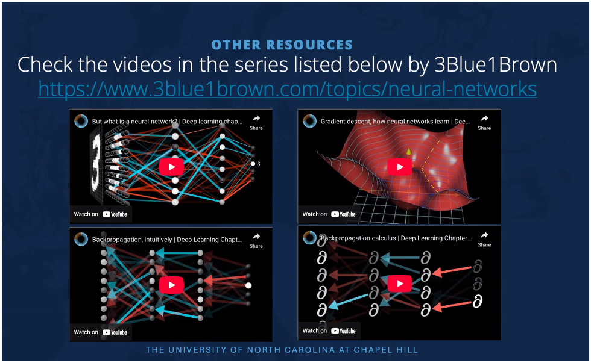
Steps to Build a NN | 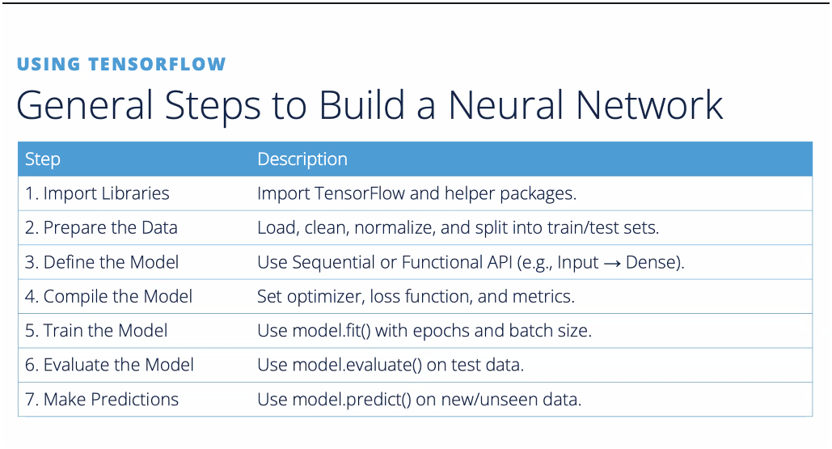
Neurons and Back Propegation | 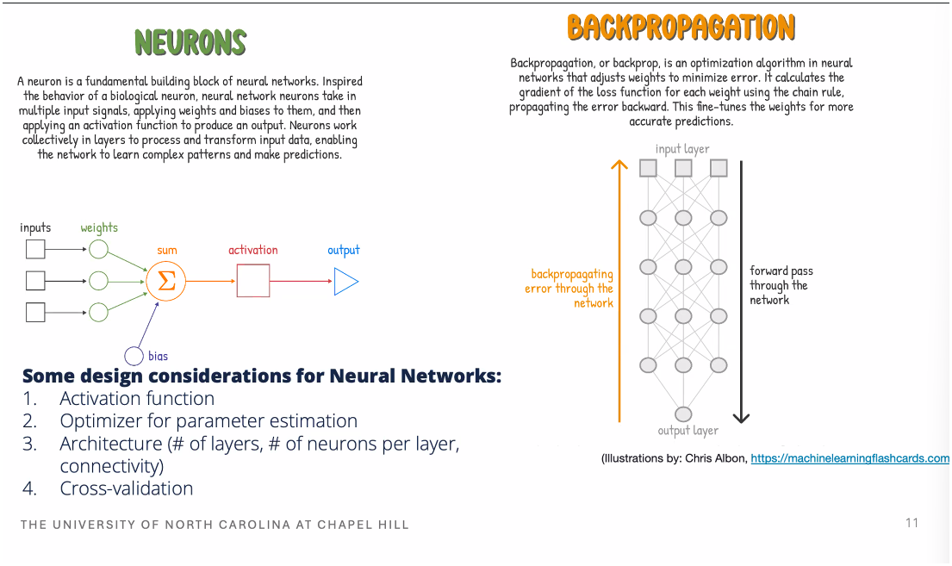
Activation Functions | - allow network to lean complex, non-linear  - 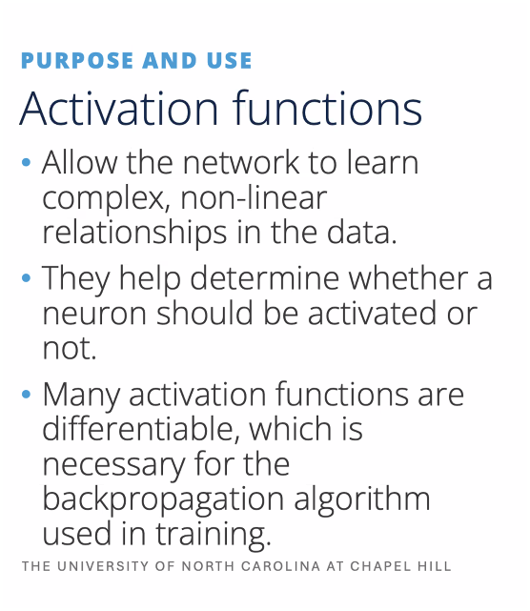  - 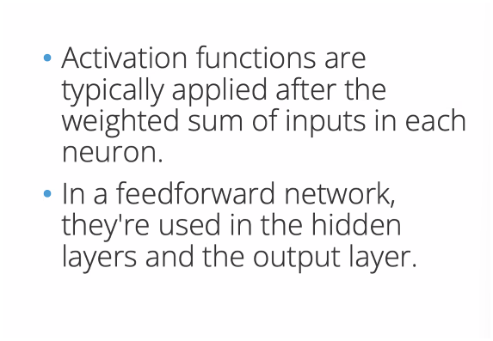

Adam Optimizer | - Adam: A Method for Stochastic Optimization  - https://arxiv.org/pdf/1412.6980  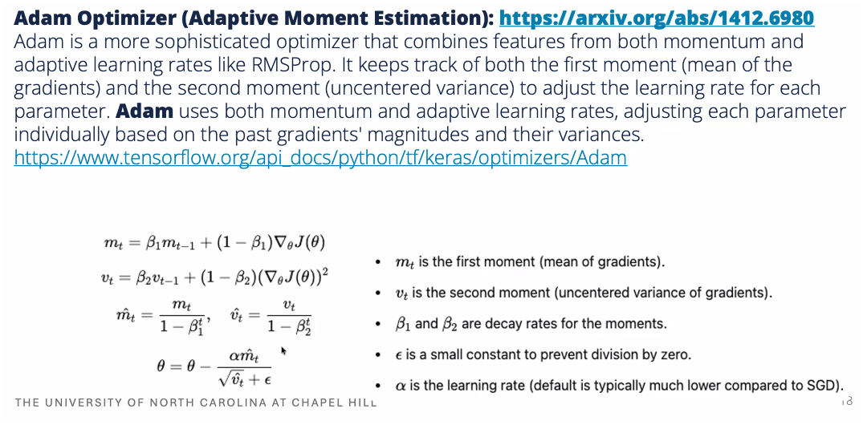
Backpropagation Explainer Acknowlegements | 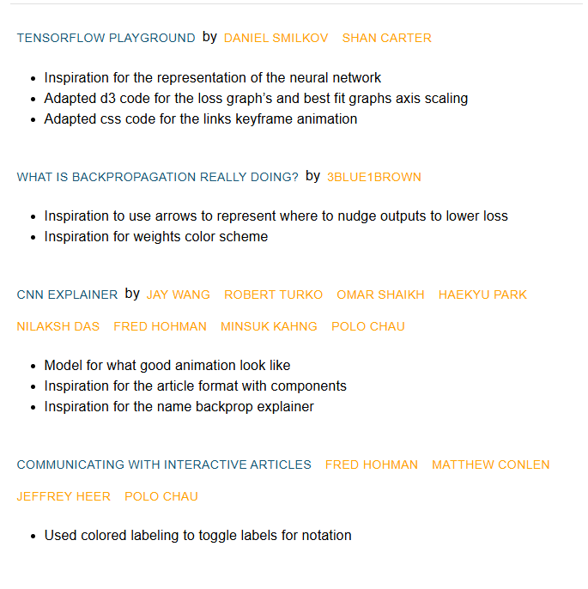  https://xnought.github.io/backprop-explainer/
TensorBoard | https://www.tensorflow.org/tensorboard

Convolutional Neural Networks  (CNNs) | - optimal for hierarchical feature extraction.  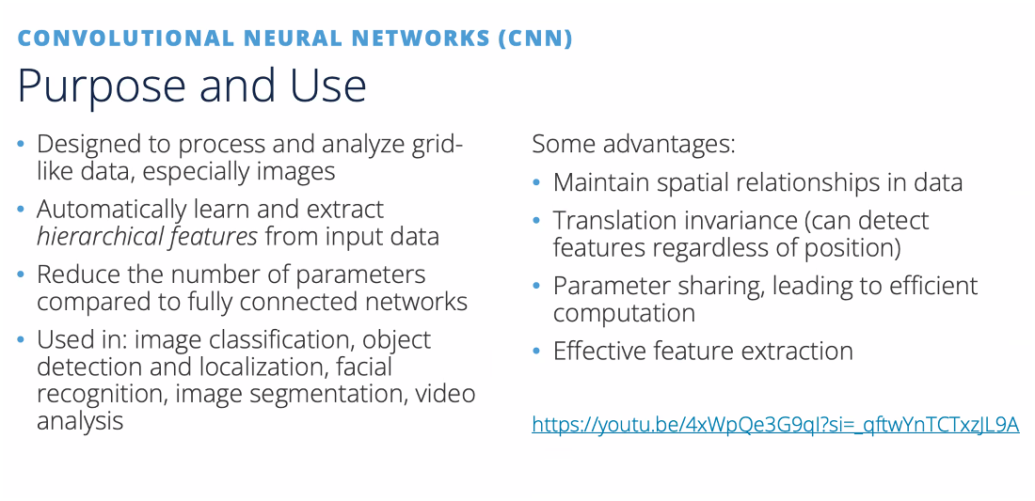  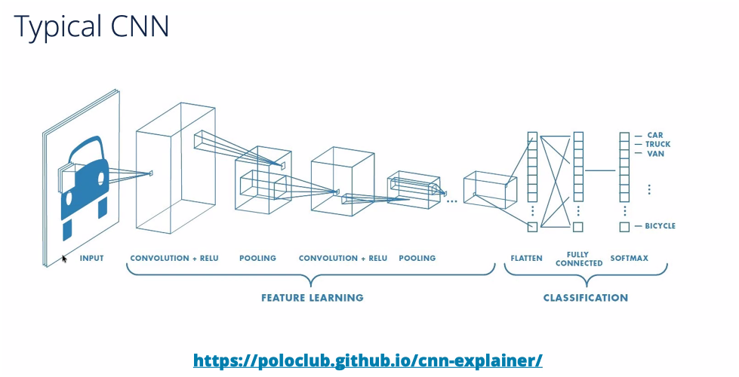  https://poloclub.github.io/cnn-explainer/  https://youtu.be/HnWIHWFbuUQ
Recurrent Neural Networks  (RNNs) | - b  