Review of Relational Databases
Overview
- Describe the relational database model
- Explain basic SQL functions
- Recognize the OMOP database

Async
The Relational Model
Data Models | - a collection of concepts used to describe:  - structure of a database  - relationships between data elements  - the history of databases is closely tied to the development of different data models  - conceptual data model  - high-level  - describes how users understand relationships between data  - main focus of this course  - physical data model  - more technical  - describes how data is physically stored on computer hardware  - not a major focus of this course

Hierarchical Model – 1960s | - organizes data in a top-down tree structure  - primarily supports one-to-many relationships  - a department  - can have many employees  - an employee  - belongs to only one department  - can have many projects  - can have many computers  - a project  - belongs to only one employee  - a computer  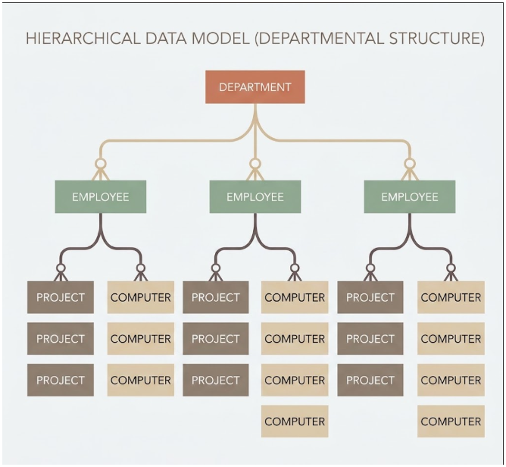  - belongs to only one person  Gemini 3.7 Flash  - key rule  - every child can only have one parent  - query limitation  - must begin at the top of the hierarchy
Network Model – 1960s | - the network model expanded the hierarchical model  - its major improvement was support for many-to-many relationships  - advantages  - more flexible than the hierarchical model  - problems  - difficult to maintain  - structural changes can be complicated  - not every real-world relationship fits naturally into a parent-child structure  - a more flexible model is still needed
Relational Model – 1970s | - the relational model was developed primarily through the work of E. F. Codd  - it became the foundation of modern relational databases  - a major improvement was separating physical data storage from conceptual presentation of data  - this makes databases easier to:  - query  - update  - manage
Properties of Relational Databases | - data Is stored in tables of rows and columns  - primary keys (or unique key)  - a unique identifier for a row in a table  - relations have no inherent order  - columns have no inherent order  - attributes must be atomic (can only contain one value)  - NULL values  - literally “nothing” – not “zero”  - NULL $≠$ NULL
Relational Model: Constraints
Constraints | - a rule used when designing and working with a relational database  - help control:  - what data can be stored  - which values are valid  - how records are uniquely identified  - how different tables may reference one another
Three Types of Constraints | - implicit  - built into the relational database system  - the user does not normally choose or manage these  - explicit  - rules deliberately defined by the database designer  - business rules  - usually more complex rules associated with the application using the database  - instead of allowing invalid data to reach the database, the application layer (ex: a web form) can enforce these rules first
Domain Constraints | - defines what kind of data can appear in an attribute or column  - commonly enforced using data types that are normally defined when the table is created  - values stored in that column must follow the defined domain
Key Constraints | - primary key uniquely identifies one row in a relation  - each value must be unique
Key Design Must Account for Future Data | - a key may work with the database's current data but fail when new records are added late  - therefore, database designers should consider  - existing records  - expected future records  - whether the chosen key will remain unique  - a poor key design can prevent legitimate future data from being stored
Composite Keys | - uses multiple attributes together to uniquely identify a row
Database Schema | - a map of the database  - every relation has a schema, and the schemas of all relations together describe the overall database structure  - looking at the complete schema helps designers make decisions based on the entire database, rather than designing each table independently
Entity Integrity | - an entity integrity constraint is an implicit database constraint  - example: a primary key can never be null
Referential Integrity | - referential integrity controls relationships between different relations  - example: if a record in Table B refers to a record in Table A, the referenced record must actually exist in Table A
Foreign Keys | - a foreign key  - is an attribute that references the primary key of another relation  - does not have to be the primary key of its own table  - only needs to reference the appropriate primary key in another table  - foreign keys are essential because they allow relational databases to:  - connect tables  - query information across tables  - represent relationships between entities
SQL Basics
FROM, SELECT, and WHERE | - SQL queries are built from three fundamental clauses  - required clauses:  - FROM  - which table(s) provide the data  - SELECT  - which columns appear in the output  - optional clause:  - WHERE  - which rows are returned  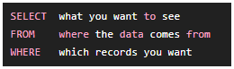

FROM: Choose the Table | - tells the database which table contains the data  - table aliases  - a table can be given a shorter temporary name called an alias    - now $'p'$ represents ‘table_patient‘ for the rest of the query
SELECT: Choose the Columns | - determines which columns appear in the query output  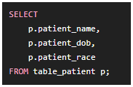  - the table may contain many more columns, but only these three will appear  - qualifying column names  - with its table name  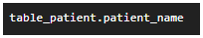  - with the table's alias  

SQL Functions in SELECT | - transform or calculate values before they appear in the output  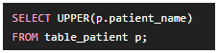  - UPPER() converts to uppercase  - so ‘Joe Waller’ becomes ‘JOE WALLER’
Renaming Output Columns | - a calculated or transformed column can be given an alias using AS  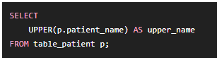  - does not rename the column in the original database  - only changes the name shown in the query output
Combining Column Values | - SQL functions can also combine values from multiple columns  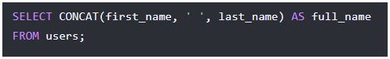
Core Functions | String Functions  - UPPER()  - converts text to uppercase  - LOWER()  - converts text to lowercase  - concatenation  - combines two or more string values into a single value  Aggregate Functions  - COUNT()  - counts the number of returned records or values  - AVG()  - calculates the average of numeric values  Mathematical Functions  - FLOOR()  - rounds a number down  - CEILING()  - rounds a number up  - Standard mathematical functions  - perform common arithmetic calculations  Date Functions  - date-difference functions  - calculate the amount of time between dates  - age/date calculations  - calculate values such as a person's age from stored dates  - Notes  - functions can be used in both SELECT and WHERE clauses  - exact function syntax can vary between relational database management systems  - this course uses PostgreSQL (Postgres) syntax
----

