Foundations of LLMs & Cloud Computing Basics
Overview |  | 14 Aug 2026
- establish foundation in LLM architecture
  - describe the key differences between major LLM providers
    - OpenAI
    - Anthropic
    - Google

- set up and configure cloud development environments for AI development
  - make your first API calls through the UNC AI Gateway
    - Azure
    - OpenAI

- reinforce understanding of transformers
  - explain the self-attention mechanism and its role in transformer architecture

Required Readings
- Vaswani, A., et al. (2017). "Attention Is All You Need."
  - the foundational transformer paper
  - focus on Sections 1-3 and the attention mechanism diagrams
  - https://arxiv.org/abs/1706.03762

- Brown, T. B., et al. (2020). "Language Models are Few-Shot Learners."
  - the GPT-3 paper that introduced modern prompting
  - read the introduction and emergent abilities section
  - https://arxiv.org/abs/2005.14165

- OpenAI (2023). "GPT-4 Technical Report."
  - understand current capabilities and limitations
  - https://arxiv.org/abs/2303.08774

Required Videos
- Understanding Transformer Architecture (4 min)
- Understanding Attention Mechanisms (4 min)
- Introduction to Cloud Platforms (3 min)
- Overview of Current Model Landscape (5 min)

Supplementary Videos
- Andrej Karpathy - "Let's build GPT: from scratch" (2 hours)
  - Highly recommended for deep understanding
  - https://www.youtube.com/watch?v=kCc8FmEb1nY

- MIT 6.S191 - "Transformers and Attention" (58 minutes) *404

Cloud Environment Setup
Environment Setup | - get your UNC AI Gateway API key  - sent via Canvas Inbox  - confirm access to the course models  - gpt-4.1-mini  - gpt-5.6-sol  - text-embedding-3-small  - configure API keys and environment variables
First API Calls | - complete the provided Jupyter notebook  - implement token counting and cost estimation  - deploy basic LLM with security checks
Documentation | - document your setup process  - note any challenges encountered
Live Session Preparation
Planned Discussion Items | - transformer architecture  - challenges from the lab  - bring questions about the readings
Key Concepts | - self-attention  - how models attend to different parts of the input simultaneously  - tokenization  - how text is converted to numerical representations  - context window  - maximum input size models can process  - temperature  - controls randomness in generation

Async
Understanding Transformer Architecture
Encoder-Decoder Structure | - Encoder  - a stack of identical layers  - reads input sequence and generates a rich contextual representation  - a set of context vectors  - Decoder  - also a stack of layers  - takes the encoders output  - generates output sequence one token at a time  - looks at what is already generated to inform the next word  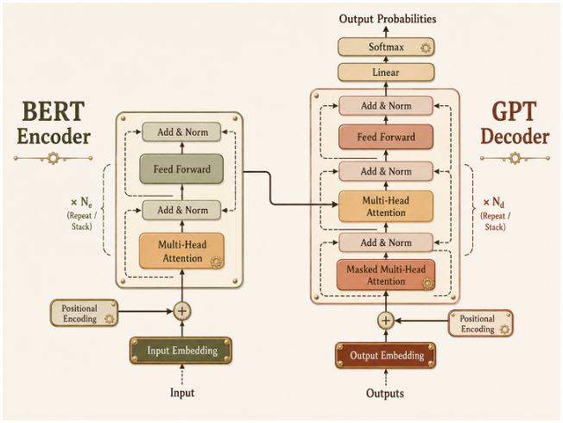  ChatGPT 5.6 Sol
Self-Attention Mechanism | - allows the model to look at all other words in the input sequence  - provides added context for the current word  - weighs the importance of all other words relative to a specific word  - allows the model to capture complex, long-range dependencies and context  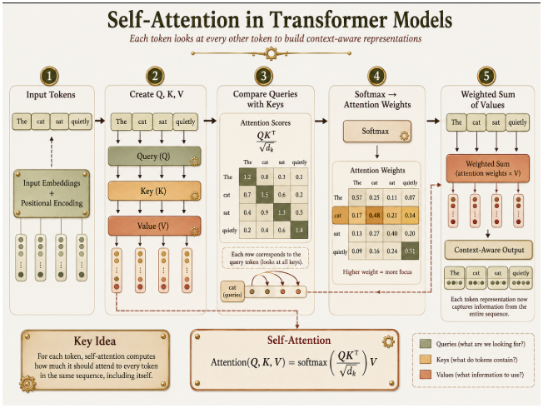  ChatGPT 5.6 Sol
Understanding Attention Mechanisms
Query, Key, Value Vectors | - Query (Q)  - the current word’s question  - “what am I looking for?”  - Key (K)  - the “label” of all words in the sequence  - “what information do I hold?”  - Value (V)  - the actual content / meaning of the words
Score Calculation | - the mechanism calculates the score by matching the Q of each word with the K of another  - similar to search engine matching your query (Q) string to a video title (K) to return a video (V)
Scaled Dot-Product Attention | - score  - compute the dot product of the Query with all Keys  - scale  - divide scores by the square root of the key’s dimension ($d_{k}$) to stabilize gradients  - softmax  - normalizes all weights to sum to 1  - output  - multiply the weights by the Value vectors and sum  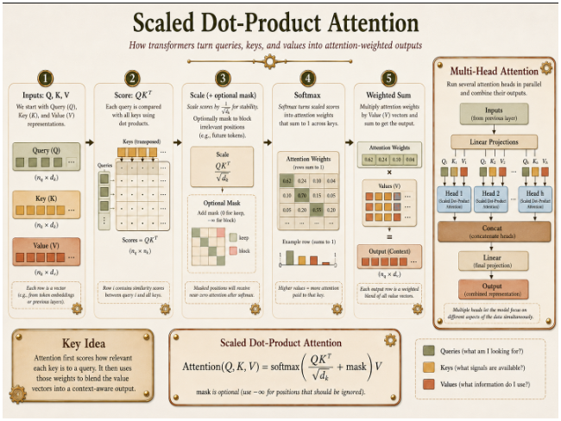  ChatGPT 5.6 Sol
Introduction to Cloud Platforms
IaaS | Infrastructure  - delivers on-demand infrastructure  - compute  - storage  - networking  - user manages  - OS  - middleware  - applications
PaaS | Platform  - provides development platform  - the cloud provider manages  - underlying hardware  - software resources
SaaS | Software  - delivers a complete, cloud-based application  - provider manages everything
Major Cloud Providers | - Amazon Web Services (AWS)  - the market leader  - extensive and mature catalog of services  - Microsoft Azure  - strong integration with Microsoft’s Enterprise ecosystem  - powerful hybrid cloud story  - Google Cloud Platform (GCP)  - leader in AI, machine learning, and data analytics  - leverages Google’s extensive infrastructure
Model Landscape (video data is stale)
Model Capabilities | GPT-4.0 | Claude Sonnet 3.5 | Gemini 1.5 Pro
 | - fast all-rounder  - native multimodal  - text  - audio  - vision  - ideal for real-time conversational AI | - reasoning specialist  - leads in  - top-tier reasoning  - instruction following  - coding benchmarks  - excellent for complex tasks | - “Context King”  - good multimodal skills  - its defining feature is its massive context window for large-scale analysis
Context Windows | 128K | 200K | 1M

Live Session
Welcome to DATA790
Dr. Grant Glass
