Linear and Logistic Regression
Course Facilitators
  - Course Instructor: Jonathan Schlosser, Adjunct Professor
- jschloss@unc.edu
- Office Hours: Mondays 5PM – 6PM
- PhD in Media and Communication from Chapel Hill
- Lead Data Scientist – Generative AI, AlignAI
- Research Interests
  - LLMs, MLOps, and Generative AI
  - Applied AI Development
  - Generative Documentation Systems
- Recent Projects
  - https://www.jonathanschlosser.com/projects/formbot
  - https://www.jonathanschlosser.com/projects/automated-pipeline-monitoring

  - Course Designer: Shashank Srivastava, Asst. Professor
- ssrivastava@cs.unc.edu
- PhD in Machine Learning from Carnagie Mellon University
- Leads the “Learning from Language Lab” at UNC Chapel Hill
- Research Interests
  - Language, intelligence, and Interactivity
  - Explanation & Alignment
  - Social & Cognitive Applications
- Recent Publications
  - Is Chain-of-Thought Really Not Explainability? Chain-of-Thought Can Be Faithful without Hint Verbalization
    - https://arxiv.org/abs/2512.23032
  - DiffVax: Optimization-Free Image Immunization Against Diffusion-Based Editing
    - https://diffvax.github.io/

Course Overview
- What is Deep Learning?
  - a subset of machine learning that has to do with building machine learning models that are large, complex, and differentiable
Data Science

Machine Learning

Deep Learning

you are here

- Applications of Deep Learning
  - Healthcare: from early disease detection to robotic surgeries
  - Transport and automation: powering autonomy in self-driving cars
  - Entertainment: personalizing streaming content
  - Science: predicting protein structures, creating new molecules
  - Technology and information: ChatGPT, Bard, and other language technologies

- Impact on Daily Life
  - Facial recognition in your phones
  - Speech technology in Siri and Alexa
  - Automated customer service and chatbots
  - Real-time translation apps
  - Home automation and the Internet of Things (IoT)
  - Fraud detection with credit cards

- Breakthroughs and Innovations
  - AlphaGo defeats human champions (2016)
  - Insilico Medicine identifies a new molecule for accelerated treatment of fibrosis in 46 days (2019)
  - Discover of exoplanets: Kepler-90i and Kepler-80g (2017)
  - Early detection of diabetic retinopathy (2021)

What to Expect |     images: ChatGPT 5.4  not  - heavy emphasis on linear algebra and calculus  - drudgery and hard work  - principles and methods underlying modern tools, but not the tools or libraries themselves  - “unless we grossly mess it up, this course is going to be hard”
Unit 1 Overview | - distinguish between traditional machine learning pipelines and deep learning models  - design linear models for predictive modeling  - implement gradient descent to train linear regression  - understand the classification approach presented in logistic regression

Async Materials
Linear Regression
Week 1 Outline | - form and model parameters  - loss function  - training with gradient descent  - mini-batch stochastic gradient descent  - hyper-parameters
Form and Model Parameters
Regression | - predicting a real-value (scalar) output based on a set of input features  $$f:x∈R^{d}→y∈R$$  - e.g. estimate the energy consumption of a home from  - $size$: floorspace ($sq ft$)  - $temp$: avg temperature ($F$)  - $prev$: consumption in previous month ($Kw$)
Linear Regression | - when the function $f$ is linear in the inputs $x$  $$y:consumption$$  $$x: [size, temp, prev]$$  $$w: [w_{1}, w_{2}, w_{3}]$$  - that is: $consumption=w_{1}size+w_{2}temp+w_{3}previous+b$  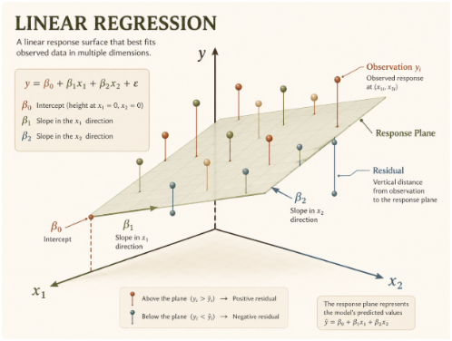  $$y=w^{T}x+b$$  - training set:  $X_{train}, Y_{train}≔\{{\left(x^{k}, y^{k}\right)}_{n}\}$  $$n × 1$$  ChatGPT 5.4  (bias)  $$scalar$$  $$\hat{Y}=Xw+b$$  $$d × 1$$  $$n × d$$
Linear Regression as a Neural Net | - linear regression can be thought of as a single-layer neural net (also called a perceptron)  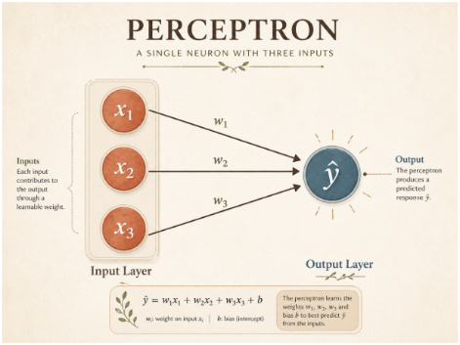  $$\hat{y}=w^{T}x$$  ChatGPT 5.4
Loss Function
Loss Function for Linear Regression | - describes “how well” your model is performing  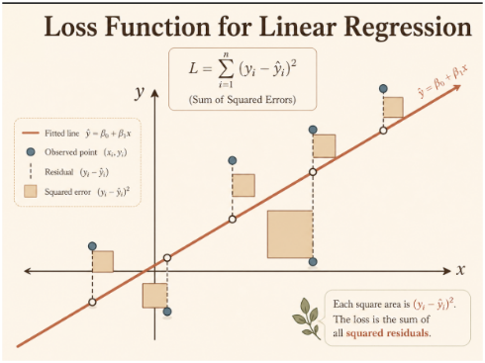  - loss function:  $$L\left(w\right)≔\frac{1}{2}\sum_{k}{{\left(y^{k}-{\hat{y}}^{k}\right)}^{2}}$$  $=L\left(w\right)≔\frac{1}{2}\sum_{k}{{\left(y^{k}-w^{T}x^{k}\right)}^{2}}$  ChatGPT 5.4  $$=sum(squared errors)$$

