The Potential Outcomes Framework
Overview |  |  | [date]
- learn the notation of potential outcomes and define individual-level effects using potential outcomes
- formulate average causal effects using potential outcomes notation, including average treatment effects (ATEs), average treatment effects on the treated, and conditional ATEs
- understand common challenges in causal attribution using the potential outcomes framework

Readings
- https://mixtape.scunning.com/04-potential_outcomes#statistical-inference
- https://mixtape.scunning.com/04-potential_outcomes#physical-randomization
- https://mixtape.scunning.com/04-potential_outcomes#potential-outcomes
- https://mixtape.scunning.com/04-potential_outcomes#average-treatment-effect
Async
Setting the Stage: From Urn Models to Box Models
https://www.degruyterbrill.com/document/doi/10.1515/jci-2023-0073/html
Summary | - Q: how can we explain Neyman’s 1923 ideas about causal inference in a way that students can actually understand?  - A: use simple physical models, especially:  - urns  - boxes  - tickets  - random draws  - two possible outcomes per subject  - the article argues that Neyman’s ideas are still underused in introductory statistics education, even though they are central to modern causal inference
Neyman’s 1923 Framework | - in an experiment, each unit has potential outcomes  - example:  - a person in a medical trial has  - one outcome if treated  - one outcome if not treated  - but we can only observe one of those outcomes  - that is the core causal-inference problem  - the missing outcome is called the counterfactual outcome  - the authors explain that Neyman’s setup treats the actual experimental units as the population of interest  - the randomness comes from  - random treatment assignment  - not from assuming the subjects were randomly sampled from some larger imaginary population
Potential Outcome | - a possible result for one unit under one treatment condition  - for unit i:  - $y_{i}(1)$ = outcome if treated  - $y_{i}(0)$ = outcome if untreated / control  - only one can be observed for each unit  - the appendix uses exactly this setup:  - $y_{i}(1)$ and $y_{i}(0)$ are fixed quantities, while treatment assignment indicators are random
Average Treatment Affect (ATE) | - $\hat{y}\left(1\right)$= average outcome if everyone were treated =  - $\hat{y}\left(0\right)$= average outcome if everyone were untreated  - $ATE=\hat{y}\left(1\right)-\hat{y}(0)$  - $\hat{ATE}=mean observed outcome in treatment group-mean observed outcome in control group$
Randomization-Based Inference | - the uncertainty comes from which units were randomly assigned to which treatment  - it does not require imagining that the experiment’s subjects are a random sample from a huge external population  - this is different from the common textbook approach, where two-sample tests are often justified by assuming two independent samples from two infinite or hypothetical populations
Conservative Standard Error | - a standard error is conservative when it is too large, or tends to overstate uncertainty  - that is usually safer than being too small  - the article emphasizes that the usual standard error in randomized experiments is often conservative because of two mistakes that partly cancel each other
Neyman’s First Major Result | - difference in group means is an unbiased estimator of the average treatment effect  - so, for a randomly assigned treatment  $$E[\hat{ATE}] = ATE$$  - so, the observed treatment-control difference is correct on average over repeated random assignments  - this works because the treatment group and control group are random samples from the finite set of experimental units
The Surprising Standard-Error Result | - the usual variance estimator for a difference in means is based on:  $$\frac{s_{1}^{2}}{n_{1}} +\frac{s_{0}^{2}}{n_{0}}$$  - where:  $$s_{1}² = sample variance in the treatment group$$  $$s_{0}² = sample variance in the control group$$  $$n_{1} = treatment-group size$$  $$n_{0} = control-group size$$  - traditional textbooks often justify this formula by pretending there are:  - two independent samples  - from two infinite populations  - but, in Neyman’s randomized experiment setup:  - the population is finite  - the treatment and control groups are not independent  - if one subject is in treatment, that same subject cannot also be in control  - so, the usual textbook justification is technically wrong for randomized experiments
The “Minor Miracle” | - Freedman, Pisani, and Purves explain the result using a box-of-tickets model  - each ticket represents one subject  - each ticket has two numbers  $$A = outcome under treatment A$$  $$B = outcome under treatment B$$  - but, once a subject is assigned to one treatment, only one number is visible  - the other is hidden  - this model makes potential outcomes easier to see visually  - the usual standard error makes two mistakes:  Mistake What it does  treats sampling as if it were with replacement makes the SE too big  treats the two sample means as independent makes the SE smaller  - the surprising result is that these two mistakes partly cancel  - this is why the ordinary two-sample standard-error formula can still be usable for randomized experiments  - Freedman, Pisani, and Purves describe this as a “minor miracle”
When the Usual Variance Estimator Works | - Case 1: Constant additive treatment effect  - this means every unit is affected by the same amount  - example:  - ‘everyone improves by exactly 5 points under treatment’  - then the usual variance estimator is unbiased  - so, it estimates the variance correctly on average  - Case 2: Heterogeneous treatment effects  - this means treatment effects vary across units  - example:  - some people improve a lot  - some improve a little  - some may get worse  - then, the usual variance estimator is generally conservative  - it tends to overestimate variance by an amount related to the finite-population variance of individual treatment effects:  $$conservative bias ≈ \frac{σ_{Δ}^{2}}{N}$$  - where:  $$σ̃²_Δ measures how much treatment effects vary across units$$  $$N is the number of subjects in the finite population$$  - if N is much larger than the treatment and control sample sizes, this bias becomes negligible
Important Warning About Pooled Variance | - the article also notes a technical caution:  - Neyman did not study the pooled variance estimator  - the pooled estimator can behave differently  - if treatment and control group sizes are unequal and treatment effects are heterogeneous, the pooled estimator may be:  - conservative  - anticonservative  - Anticonservative means it can underestimate uncertainty which is dangerous because it can make results look more precise than they really are
The Article’s Broader Argument | - most introductory statistics textbooks still explain two-sample tests using independent samples from hypothetical populations  - the authors think this misses an important opportunity  - in randomized experiments, we often do not need to imagine hypothetical superpopulations.  - we can instead say:  - the experimental units are the population  - random assignment creates the uncertainty  - causal inference is hard because each unit has missing potential outcomes  - the authors do not claim randomization-based inference is always better than superpopulation inference  - their claim is narrower:  - Students should learn both frameworks.  - randomization-based causal inference is currently underemphasized
Conceptual Diagram | Finite population of N units  each unit has two potential outcomes  $y_{i}(1)$ and $y_{i}(0)$  Random assignment  Treatment group: observe $y_{i}(1)$  Control group: observe $y_{i}(0)$  But for each unit:  one potential outcome is observed  one potential outcome is missing  Estimate:  ATE_hat = treatment mean − control mean  Core result:  ATE_hat is unbiased for ATE  Standard-error result:  usual SE formula often works  because two errors partly cancel
Most Important Takeaway | - Neyman’s 1923 contribution is not just historical, it gives a clean way to understand randomized experiments:  - causal uncertainty comes from random assignment  - each unit has multiple potential outcomes  - only one outcome is observed  - the difference in means is unbiased for the average treatment effect  - the usual standard error can be justified in a finite-population framework  - but its behavior depends on treatment-effect heterogeneity  - the authors’ educational point is that these ideas do not have to be hidden behind advanced notation  - they can be taught with boxes, tickets, diagrams, and careful explanation

Introduction to the Potential Outcomes Framework
Notation and Definitions | Treatment assignment:  - Binary treatment: $D_{i} ∈ \{0,1\}$  - Framework can be extended to continuous treatments (or doses)  Potential outcome:  - $Y_{i}(1)$: outcome if unit i receives treatment  - $Y_{i}(0)$: outcome if unit i does not receive treatment  Observed outcome:  $$Y_{i} = D_{i} · Y_{i}(1) + (1 - D_{i}) · Y_{i}(0)$$
Neyman’s Urn Model | 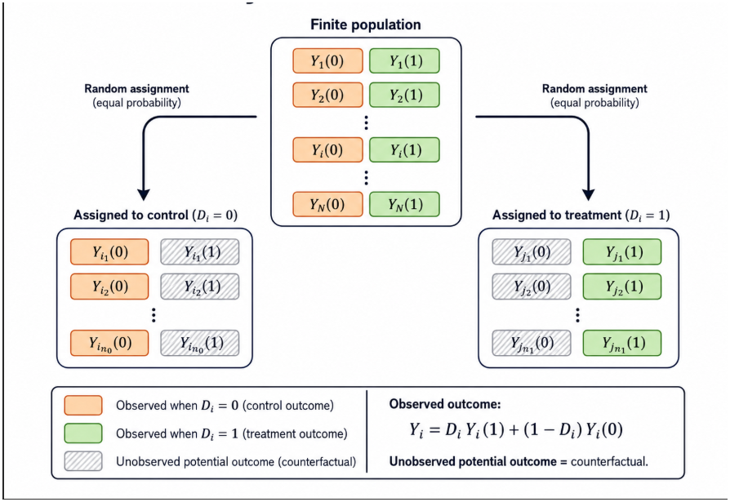

Example: Get Out the Vote Campaign | Voter Treatment (received GOTV call?) Y_i(1) (turnout with call) Y_i(0) (turnout without call) Observed turnout (Y_i)  Alice 1 1 (votes) 0 (doesn’t vote) 1  Bob 0 0 (doesn’t vote) 0 (doesn’t vote) 0  Carol 1 1 (votes) 1 (votes anyway) 1
Individual Treatment Effects (ITEs) | individual treatment effect (ITE):  $$τ_{i} = Y_{i}(1) - Y_{i}(0)$$  alternative definitions are possible:  $$\frac{Y_{i\left(1\right)}}{Y_{i}(0)} (less common)$$  F_{Y_i(1)}^{-1}(p) - F_{Y_i(0)}^{-1}(p) (quantile p effect)  the causal effect captures what would happen to the same individual under two alternative scenarios:  treated vs. untreated  counterfactual by definition!

