Neural Networks
Overview (what we will cover) |  |  | 16 Feb 2026
- modern neural networks
  - are not new
  - not all that different from previously discussed machine learning models
  - rely on function compositions to learn useful features
  - have a hierarchical architecture
  - employ non-linearities
- the building blocks of neural networks
  - units
  - layers
  - implemented using matrix operations
- pros and cons of neural networks
Reading |  | Be prepared for substantial hybrid assignment for next week
https://www.deeplearningbook.org/contents/mlp.html, Ch. 6: Deep Feedforward Networks

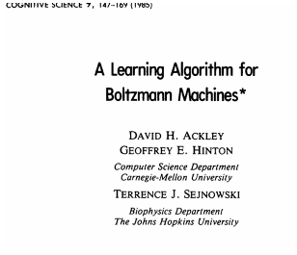

Artificial Neural Networks
Logistic Regression  (review)  https://tenor.com/search/im-rich-bitch-g    https://tenor.com/search/im-rich-bitch-g 2  https://tenor.com/search/im-rich-bitch-g 3 | $$\operatorname{Pr}\left(Y=1 ∣ X=x\right)={\left(1+\exp\left(-x^{T}β\right)\right)}^{-1}$$  - logistic regression    - it’s statistics!  - it has been around 60 years  - probably will not get you  $$Pr⁡[Y=1 | X=x]={(1 + exp⁡(-f{\left(x\right)}^{T} β))}^{-1}$$  - logistic regression with neural network learned features    - not statistics…  - IS deep learning  - has ONLY been around 50 years  - GET PAID.  Images by  ChatGPT 5.2
Neural Networks Big Picture
Machine Learning Supervised Loss | - supervised loss: a set of parameters that are typically operating linearly over input features  $$argmin_{θ}\sum_{i=1}^{N}{l_{θ}\left(x_{i}, y_{i}\right)}$$
NN Supervised Loss | - still using a linear or similar sigmoid predictor over learnable features  $$argmin_{θ,w}\sum_{i=1}^{N}{l_{θ}\left(f_{w\left(x_{i}\right)}, y_{i}\right)}$$  - there are additional parameters known as weights ($ω$) that we optimize over in addition to the linear features  - the weights determine the learnable features  - the number of output features will not necessarily coincide with the number of input features  $$f_{ω}\left(x\right): R^{d}→R^{k}$$

NN Regression Loss | $$argmin_{θ,w} \sum_{i=1}^{N}{θ^{T}{\left(f_{ω}\left(x_{i}\right)-y_{i}\right)}^{2}}$$  - key ingredients  - nonlinear  - hierarchical  - universal
Non-Linear Mappings
Linear Mapping | $$ŷ_{θ}\left(x_{1}, x_{2}\right)= θ_{1}x_{1}+ θ_{2}x_{2}+ θ_{0}$$  Linear Mapping  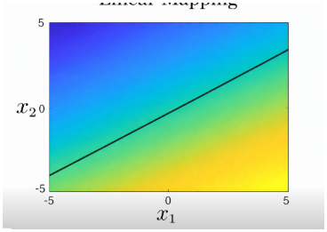  - many standard learning methods, such as ordinary least squares regression and logistic regression, are formulated as a linear map in the input space  - this is adequate your goal is to map a boundary line between classes  ChatGPT 5.2
Non-Linear Mapping | $$ŷ_{θ}\left(x_{1}, x_{2}\right)= \sum_{j=1}^{k}{θ_{j}f_{j}\left(x_{1}, x_{2}\right)}$$  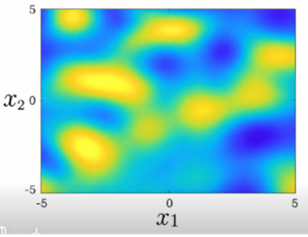  - these methods can be extended to a linear map in a nonlinear space  Non-Linear Mapping  - one perspective of what neural networks are doing is that they are learning a set of $k$ features that can be linearly combined calculate an output  ChatGPT 5.2
Hierarchal Features
“Stacking” Features | - one aspect that add to a neural network’s usefulness is that we can build features on top of features iteratively forming a hierarchical feature map  - we can combine simple features to derive more complicated feature sets  - this adds rich semantic meaning into calculated output features
One Layer | - a single layer transforms input features to output features  the dimensions of the input vector does not have to match the dimensions of the output vector  $$R^{s}⟼R^{s^{'}}$$  $${x \atop \begin{aligned}input \\ features\end{aligned}}⇒{x^{'} \atop \begin{aligned}output \\ features\end{aligned}}$$
Two Layers | - in a two-layer NN, the output from the previous layer becomes the input for the next layer  $${x \atop \begin{aligned}input \\ features\end{aligned}}⇒{x^{'} \atop \begin{aligned}output \\ features\end{aligned}}⇒{x^{''} \atop \begin{aligned}output \\ features\end{aligned}}$$  Two-Layer Neural Network  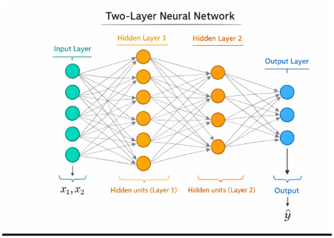  ChatGPT 5.2
Features of Features | - this builds a function of nested functions  $$f_{w}(x) = f_{w_{m}}^{m} (…f_{w_{2}}^{2}( f_{w_{1}}^{1}(x) )…)$$  - alternate notation  $$f_{w}\left(x\right)=( f_{w_{m}}^{m} ∘ ... ∘ f_{w_{2}}^{2} ∘ f_{w_{1}}^{1} )(x)$$
Building Blocks
Function Composition | - simply stacking linear functions can become problematic  - e.g. combining nested linear equations that result in a linear equation is not helpful:  $$f=wx+b=w^{3}\left(w^{2}\left(w^{1}x+b^{1}\right)+b^{2}\right)+b^{3}$$  - the “fix” is to add an addition function which we call a non-linearity $r$ that takes the output of the linear function to apply an element-wise non-linearity as shown in the previous section:  (can take other non-linear forms)  $\left( f_{w_{m}}^{m} ∘ … ∘ f_{w_{2}}^{2} ∘ f_{w_{1}}^{1} \right)\left(x\right)$  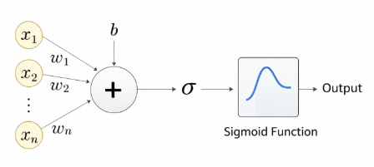  $$outputs ∈R$$  ChatGPT 5.2  $$b + \sum_{i=1}^{n}{x_{i} w_{i}}$$  linear combination (dot product)  $$∈R^{s\left(l\right)}$$  $$∈R^{s\left(l\right)×s(l-1)}$$  $∈R^{s\left(l\right)}$ $∈R^{s\left(l-1\right)}$
Matrix Notation | $$Layer l-1→Layerl$$  $${\vec{φ}}^{(l)}=σ( W^{l} {\vec{φ}}^{(l-1)} +\vec{b^{(l)}})$$  expanded form:  $$\left[\begin{matrix}φ_{1}^{l} \\ φ_{2}^{l} \\ \begin{matrix}. \\ .\end{matrix}\end{matrix}\right]=σ\left(\left[{\begin{matrix}{-w}_{1}^{l}- \\ {-w}_{2}^{l}-\end{matrix} \atop \begin{aligned}. \\ .\end{aligned}}\right] \left[\begin{matrix}\begin{matrix}{\vec{φ}}_{1}^{\left(l-1\right)} \\ {\vec{φ}}_{2}^{\left(l-1\right)} \\ .\end{matrix} \\ .\end{matrix}\right]+\left[\begin{matrix}\begin{matrix}b_{1}^{l} \\ b_{2}^{l} \\ .\end{matrix} \\ .\end{matrix}\right]\right) =\left[\begin{aligned}σ\left(W^{l}(\vec{φ^{l-1}}+b_{1}^{l}\right) \\ . \\ . \\ . \end{aligned}\right]$$  network with one hidden layer  $$σ(W^{\left(1\right)}x+ \vec{b^{\left(1\right)}})$$  regression loss for network with two hidden layers  and a linear output layer  $${\left(f\left(x\right)- y\right)}^{2}=$$  $${\left( W^{(3)}σ\left( W^{(2)}σ\left( W^{(1)}x + \vec{b^{(1)}}\right)+ \vec{b^{(2)}}\right)+ \vec{b^{(3)}}- y^{2} \right)}^{2}$$
Non-linearities | - when we compute gradients, we multiply by the derivatives of the activation functions  - for saturated units—those receiving very large positive or very large negative inputs—the slope of the activation function is close to zero  - because the derivative is near zero, the gradient becomes very small  - as a result, weight updates during gradient descent are minimal, and learning slows down significantly  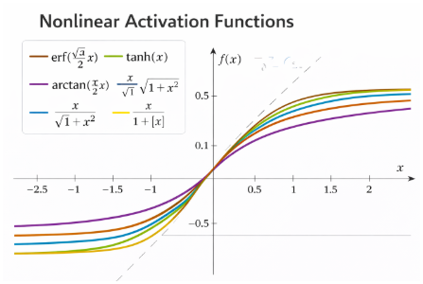  “vanishing gradients”  - to resolve vanishing gradients, non-linearities such as the ReLU or rectified linear unit have been used  - although the ReLU is a simple function, it is non-linear (piece-wise linear)  - other non-linear functions such as Leaky ReLU (ReLU with non-zero resolution of negative values) and other piece-wise functions  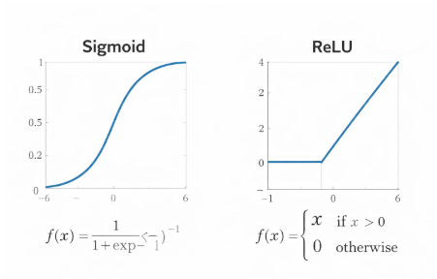  ChatGPT 5.2  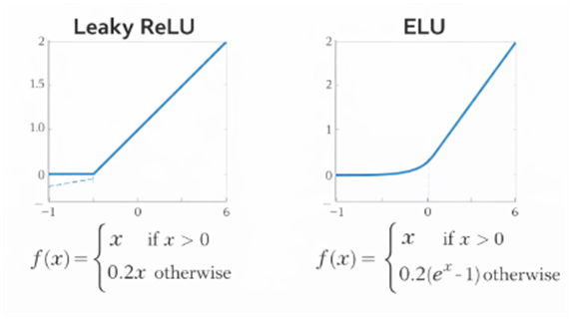  ChatGPT 5.2

Live Session Notes | 16 Feb 2026
- Be prepared for substantial hybrid assignment for next week
BINARY CROSS ENTROPY (BCE)
Mathematical explanation
To get from the Binary Cross-Entropy formula to the Softplus version in the code, we substitute the sigmoid function
$$σ(z)=\frac{1}{1+e^{-z}}$$into the loss equation and simplify.
- HW02 is due 18 Feb
thank you Gerhard!
  - review BCE for this assignment
  - attn: data mining and machine learning. pg 623

$$LOSS = neg\left(log likelihood\right)E0,1,L\left(θ\right)-\prod_{i}{{}_{}}p\left(y_{i} | x_{i},θ\right)$$
$$logL\left(θ\right)=E_{i}logP\left(y_{i} | x_{i},θ\right)$$
$$min-loss ⟷min⁡(neg(log-likelihood)=neg(max⁡(log-likelihod)$$
for a single sample with true label y E ???
and predicted probabliltiy p
if y=1: we want max(P(y=1|x))=p
if y=0: we want max(P(y=0|x)-1-p
'one could also use'
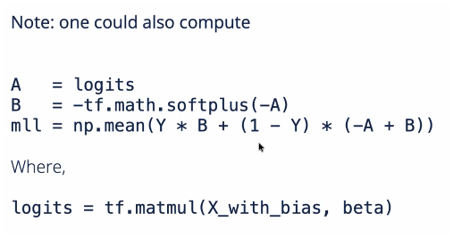

- https://playground.tensorflow.org/#activation=tanh&batchSize=10&dataset=
circle&regDataset=reg-lane&learningRate=0.03&regularizationRate=0&noise=
0&networkShape=4,2&seed=0.02680&showTestData=false&discretize=
false&percTrainData=50&x=true&y=true&xTimesY=false&xSquared=
false&ySquared=false&cosX=false&sinX=false&cosY=false&sinY=
false&collectStats=false&problem=classification&initZero=false&hideText=false

- The Adam (Adaptive Moment Estimation) optimizer is a popular, efficient gradient-based optimization algorithm used to train deep learning models by combining the advantages of Momentum and RMSprop.

General Steps to Build a Neural Network: TensorFlow
Step Description
- Import Libraries | Import TensorFlow and helper packages.
- Prepare the Data | Load, clean, normalize, and split into train/test sets.
- Define the Model | Use Sequential or Functional API (e.g., Input → Dense).
- Compile the Model | Set optimizer, loss function, and metrics.
- Train the Model | Use model.fit() with epochs and batch size.
- Evaluate the Model | Use model.evaluate() on test data.
- Make Predictions | Use model.predict() on new/unseen data.

- (comprehensive!) project proposal feedback has been sent out
  - suggested references have been provided
    - when perusing suggested references (Google Scholar), check at least one paper cited by that publication
    - focus on the methodology and reporting techniques
- be sure to mark the ‘completed by’ on CW assignments
  - coming up
  - week 7
    - neural networks 2
  - week 8
    - cross-validation
    - midway report
      - four page .pdf
      - NeruIPS-style files w/ overleaf template
    - MIDTERM!!!
part 1  - questionnaire  - multiple choice  - free response  - study guide provided in week 7  - closed notes  - “optional questions” (extra credit?) | part 2  - applied problems  - long notebook  - short sections  - NO AGENTS!

