Convolution
Overview |  |  |  | Class Meeting : 20 Jan 2026
- convolution
  - analytical
  - discrete
  - numerical
- formulate in terms of convolution kernels
- compute convolutions in one and higher dimension numerically
- Gaussian convolution
- box convolution
- efficiency and benefit of separable kernels
Convolution |  |  |  |  | [optional]
- convolution is a mathematical technique used on two functions $f$ and $g$ that produces a third function $f*g$
- $f*g$ is the integral of the product of the two functions after one is reflected about the y-axis and shifted
- uses an average of local-adjacent values based on kernel size
https://en.wikipedia.org/wiki/Convolution
Convolution in 1D
Applications of Convolution |  | - signal processing  - filtering (noise reduction  - system modeling  - reverberation (simulating sound reflections  - image processing  - sharpening  - edge detection  - feature extraction  - artificial intelligence  - convolutional neural networks  - physics and engineering  https://www.fieldbox.ai/seeing-through-computer-vision-convolution-101/
General Mathematical form | 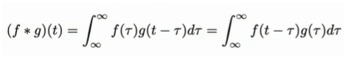
Properties | - f * g = g * f  - f * (g * f) = (f*g) * h  - f * (g + h) = (f * g) + (f * h)  https://mathworld.wolfram.com/Convolution.html
Discrete Convolution | 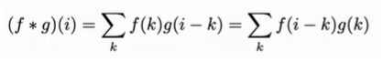
Layering | - a weighted sum of the convolution kernel  - can extract local features
Convolution Kernel | - the filter of a matrix for feature extraction  - each convolution process has its own kernel  - image blurring example: for each pixel in an image, the inner product of the pixel within the local window centered on that pixel and the kernel is calculated  - some kernel types  - asymmetric  - hat  - box  - exponential decay
Padding | - for when the convolution range is not defined at edges  - f is padded with reasonable data there are multiple tactics available  - zeros  - mirror-copy  - repeat closest value  - trim the range (usually only with very large sets)
Convolution in 2D
Overview | - two-dimensional convolution is mathematically the same as in 1D  - produced 2D integral  - often kernels are separable
Kernel Separability | - a function g(x, y), that can be rewritten as a product such that:  g( x, y ) = g^{x}(x)*g^{y}(y)  - the result is two 1D kernels  - by separating the kernel, each dimension can be convoluted individually  - continuous separable  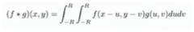  - discrete separable  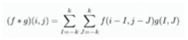
Sources | - https://mathworld.wolfram.com/Convolution.html  - https://evidentscientific.com/en/microscope-resource/tutorials/digital-imaging/processing/convolutionkernels

https://evidentscientific.com/en/microscope-resource/tutorials/digital-imaging/processing/convolutionkernels
Live Session Notes |  | 30 Oct 2025
*
*
*
*

