Governance, Bias, & Ethics
Key Points
- foundational concepts of ethics in data science and artificial intelligence
- final project is 45% of final grade
- two discussion assignments every week
Overview of Ethics in ML |  | [optional]
Decisions are increasingly made by machines. There is a pressing need to recognize and evaluate how structural racism, sexism, classism, and ableism may be embedded in and amplified by intelligent systems.
Course Specifics
Weekly Discussions | - two discussion assignments each week  - one post on classroom discussion board  - one will require additional research  - rubric is pass/fail  - 200-500 words  - essay reflects thought engagement with reading assignment  - all prompt issues are addressed  - engage with one other student’s post
Week 1
Discussion Prompt | Explore a current “code of ethics” or "professional conduct" in a setting that inspires you. This can be a professional association, a corporate acknowledgment, or a governing framework (e.g., The Association of Computing Machinery's Code of Ethics found here - https://www.acm.org/code-of-ethicsLinks to an external site.).  As you review consider what ethical frameworks are embedded into this document. Is anything missing? Why or why not? In your reply, post a link to the code of conduct you reviewed.
Response | UNC\Semesters\Spring_2026\DATA740\Week1\DATA740_week1_discussion.docx

Live Session
Introduction |  | 30 Oct 2025
Instructor | Rei Sanchez-Arias
Email | reisanar@unc.edu
Website | https://www.reisanar.com/
Office Hours | Wednesdays 12:00 pm to 1:00 pm (by appointment)
Class Meets | Wednesday 7:45 – 9:15pm
What to expect |  | DATA740
Discussion | - due by 7:30 pm before class on Wednesday
Keep in Mind | - review syllabus  - actively participate  - ask questions!  - review content prior to meeting
Class Structure | - first half of course  - understanding core theories, frameworks, and tools  - consider how variables, metadata, and categories are tied to ethical decisions  - consider concepts like privacy  - consider difference between standardization, corporate social responsibility, regulations, and liability for violating trust and safety  - second half of course  - take ideas and apply them to real world settings to see how data science is being used in various sectors and explore the ethical implications of those practices  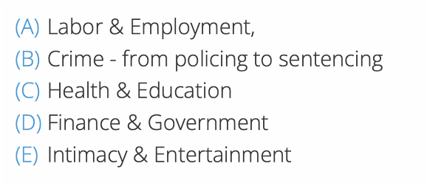  - each week you will be responsible for reading one academic article, listening to or watching educational podcasts/video, and reading two current events articles  - the academic article has been provided  - the podcast/video will be supplied by peers
Fina Project | - preform a case study in a specific student-chosen field  - deliverables  - paper that explains  - the role and sector represented  - articulation of the problem  - development of an ethical matrix  - considerations of data access, selection, curation, and privacy  - delineation of governance structure necessary  - a five min prerecorded video  - 200-word summary

In Class Exercise | DATA740
Assignment | use an AI generator to generate an image that represents you
Logic | This prompt was to ORACL with as little information as possible. I did not have ORACL generate the image because, for one, the agent has access to photos of me, plus I thought that it would be more interesting to see how the agent would use words to describe me.
Prompt | “I have been tasked with providing a prompt for an AI image generator to create an image that represents me. that is all the instructions. provide a suggestion for an effective prompt.”
Response from ORACL fed as prompt to ChatGPT 5.2 | “Photorealistic cinematic portrait of Joe Waller, mid 40s, friendly confident expression, neatly styled brown hair and eyes, wearing a dark hoodie under a fitted jacket. Background: modern home office with soft bokeh and subtle hints of code/security (abstract terminal glow, network diagram shapes) without readable text. Head-and-shoulders, 3/4 angle, 85mm lens look, midrange depth of field, standing in a futuristic robot driven world”
Image | 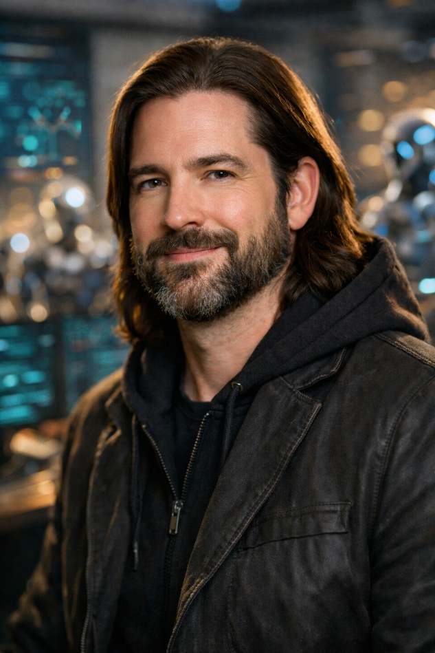
Analysis | This does look a lot like me, though not what I am looking for. For the second prompt, I went a different route and just wrote one myself.
Prompt 2 | “Create an image of me, Joe Waller, a Caucasian male in his mid-40s with brown eyes, beard, and long brown hair. this image should be cartoonish in the style of Rick and Morty, with me standing in as Rick, but with my physical description otherwise. the scene should be a lab environment with robots and robot parts neatly organized in the room and lots of books”
Image | 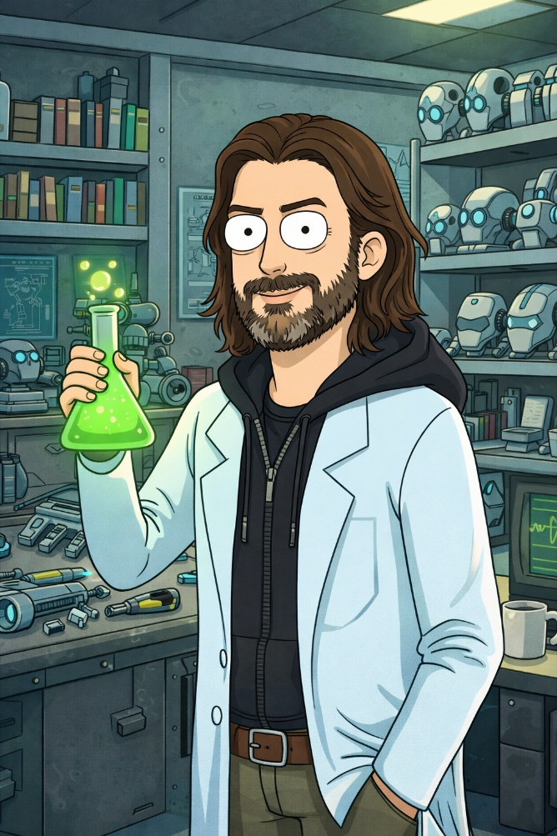
Analysis | Love it. This is now my Facebook profile picture.
In Class Exercise | DATA740
Introductions | - Name: Joe Waller  - Occupation: Student  - How long in program: 2nd semester  - Classes: 780, 750, 740  - share prompts and images

