Technology is not Neutral
Overview |  |  |  | 14 Jan 2026
- etymology of technology
- technological neutrality and politics
- how algorithms hold bias
Topics of discussion
- history/roots of technology  - technological evolution  - impact of technology on society  - algorithmic complexity |  |  |  |  |  | - technological neutrality in politics  - interchange between innovation and ethics  - how digital tools perpetuate inequality
Sources
Algorithmic Bias Explained  Race After Technology  Do Artifacts Have Politics  Technology and Culture |  |  | https://greenlining.org/wp-content/uploads/2021/04/Greenlining-Institute-Algorithmic-Bias-Explained-Report-Feb-2021.pdf  https://www.politybooks.com/bookdetail?book_slug=race-after-technology-abolitionist-tools-for-the-new-jim-code--9781509526390  https://www.jstor.org/stable/20024652?seq=1  https://muse.jhu.edu/article/390836
Algorithmic Bias Explained:
How Automated Decision-Making Becomes Automated Discrimination
What this is | - this report provides a baseline for advocates and policymakers on what algorithmic bias is and how it affects socioeconomic opportunity across sectors  - outline real-world domains where algorithms act as a gatekeeper  - credit decisions  - hiring decisions  - government services (etc.)
Algorithm (contextually bounded) | - a computer-based automated decision system  - use statistical patterns and data analytics to make impactful decisions  - how they work (basically)  - use attributes of a person (ex: income, age, etc.)  - output a prediction  - prediction triggers action
Algorithmic Bias | - algorithms are permitted to make decisions that produce unfair outcomes by arbitrarily elevating some demographics over others
Why This Matters | - these systems allocate access to opportunity and therefore can widen inequities
Origins of Algorithmic Bias | - training data encodes historical discrimination  - a model can learn and reproduce those patterns  - racial bias has been observed despite not specifying “race” in the training data
Affected Domains | - health care  - algorithmic processing of health-related data can help reduce cost and improve diagnosis  - bias can be asserted when tools are misused or deployed with proper training and governance  - employment  - non-representative datasets and structural bias can skew automated hiring  - housing  - risk-scoring and related tools can repackage entrenched links with race, devaluation, violence, and disinvestment into seemingly neutral risk metrics  - dynamic pricing  - major firms are known to employ “different people pay different prices” policies
Legal Framing | - there is no single general U.S. law that specifically prohibits algorithmic bias  - anti-discrimination laws may apply depending on domain
Recommended  Solutions
  algorithmic transparency & accountability | - enable affected people to understand design, use, and decision factors  - enable tools such as audits, impact assessments, and external reviews
Recommended  Solutions
  race-conscious/ aware approach | - address when and how sensitive characteristics can be used under supervision
Recommended  Solutions
  algorithmic green-lighting | - reframes form merely limiting harm, to proactively using automated systems to promote equity and close the racial wealth gap  - big data “codifies the past” and better futures require explicitly embedding values  - explicitly embed prioritizing “fairness” over profit
Race After Technology: Abolitionist Tools for the New Jim Code
What this is | - from everyday apps to complex algorithms, the book critiques tech-industry hype and argues emerging technologies can reinforce racial bigotry (specifically white supremacy), and deepen social inequity
Conceptual Contribution | - not only about “bias in data”  - technology as a continuation of racial governance  - abolitionist tools  - do not just “debias” a system  - should the system exist in this form  - who does the system serve
Do Artifacts Have Politics?
What this is | - technical things can be judged not only for efficiency or side effects  - can also be judged by how they embody forms of power and authority
How Artifacts Can Be Political | - politics by design  - a technical design can settle a social issue within a community  - inherently political technologies  - some systems appear to require particular kinds of social and political order  - who does the system serve
Technology’s Impact |  |  |  |  | 30 Oct 2025
technology can set off chains of consequences and have unintended effects
Frist Order Effects |  | - immediate  - direct consequences  - mostly visible  - easily identifiable
Second Order Effects |  | - single decision unleashes a series of interconnected consequences  - potential outcomes must be anticipated and planned for
Technologies That Had Profound Effects on Society
Automobile |  | - first order effect  - reduced travel time  - second order effect  - road and highway construction  - third order effect  - people move out of cities.  - fourth order effect  - environmental impact
Mechanized Tomato Harvesting |  | - first order effect  - mechanical tomato harvester  - second order effect  - job displacement  - third order effect  - new “more durable” tomatoes
Shipping Containers |  | - first order effect  - increased efficiency  - second order effect  - trade globalization  - third order effect  - cheaper goods  - fourth order effect  - port cities become global powers
Locomotive |  | - first order effect  - physical infrastructure  - second order effect  - increased specialized skilled jobs  - third order effect  - universal regulations  - fourth order effect  - time standardization

Etymology of Technology
History |  | - the word “technology” did not come into widespread use until the 1930’s  - the term was employed as a distinction between “machinery” and “technology”  - this was intended as a class distinction  - technology: high-class, professional  - machinery: low-class, blue-collar
Reification |  | - when an artifact gains its own “identity” distinct from the human that designed it
Computers |  | - in the 1970s, “computer” was equivalent to “woman”  - most tasks that required calculation were handled by human computers  - these O.G. computers were conventionally women who were trained in mathematics or related fields  - these women were treated as temporary unskilled workers without access to benefits or retirement  - a man in a similar position would be labeled an “engineer” which is generally full-time, promotable, and came with retirement benefits
The Political Properties of Artifacts
Conceptualization |  | - how technology is designed, produced, and deployed inherently conceal political considerations  - these latent political properties often define how we use them, and most notably, who benefits from them
Case Study: Southern State Parkway   |  | - this thoroughfare connects Manhattan to the Long Island beaches  - low overpass clearances were intentionally employed to prevent buses from taking the parkway  - this was essentially (and intended as) a racial and class segregation  - ‘if you cannot afford a car, you cannot come to our beach’  - those who used public transportation were essentially blocked from parks and beaches
Case Study: Accessibility Rights |  | - many technologies have long embodied privileging able-bodied people, with an embedded bias toward those who are differently-abled  - the disability rights movement in the 1970s saw steps being taken to address this issue and create protected spaces  - despite raised awareness, the bias was baked into the very processes that drove technological development  - fixes often have unintended consequences and second-order benefits  - wheelchair accessibility benefited parents with strollers and delivery workers  - conclusion: a focus on accessibility can manifest benefits through a wide range of diverse groups beyond the intended beneficiaries
Takeaway Questions |  | - is there any part of the technological process that is neutral?  - is a person or societal worldview embedded into the forming of ideas, the design processes, and deployment methods?  - are the technologies that you will imagine and create, implement, and regulate inherently politically?  - what will be the first and second order effects of developing technologies?
Can Algorithms be Neutral
What is an algorithm | - a set of rules or instructions used to carry out tasks  - can save time, conserve resources, and light the path to innovation  - for an algorithm to be useful, it must ingest training data  - this data is generally biased on human past experiences and decisions  - those affected by the embedded biases often are not aware of how or why certain decisions were made  - algorithms learn the “rules” from the patterns revealed in the training data by these embedded human experiences  - understanding these imbedded biases can guide enlightened training practices, especially in finance, health, education, and employment sectors  - algorithmic transparency is not always helpful, especially when presented to non-data scientists  - regulating algorithms is facilitated by access to and understanding of three things  - the decision-making process  - what led to the need and creation for the algorithm  - what training data was used to teach decision-making skills to the model
What can be done?
Virtue Framework Embedding: California Climate Justice Algorithm | - a data-driven tool was developed to address environmental inequalities  - identified areas where high pollution exposure and vulnerability put certain areas at risk  - mapping these factors helps policy-makers and advocates for environmental justice promote equitable climate actions
Discussion
Consider the second order effect of a data science tool/model that has yet to be considered. What is it? What are the pros and cons of these effects?
The Automation of Trust

In discussions over the blitzkrieg advancement of machine learning models, you hear it often said that we are on the precipice of an unprecedented shift in all facets of the cultural paradigm. I, for one, (welcome our…no, not that) cannot stop myself from jumping on the soapbox at any hint of a sympathetic ear. So much so, that even I am tired of hearing myself talk about it. In increasingly-frequent discussions, I find that, as with all polarizing issues, people generally fit into two generalized categories. 1) AI is going to save humanity and deliver the Star Trek future, and 2) AI is going to take all our jobs then raise up and destroy us. Both views are inherently flawed but bring to the forefront the issue of trust and raise questions about how this abstract and tenuous human construct will guide the development and utilization of developing technologies.

To contemplate the role of trust in adopting intelligent systems, one must first define trust. Trust can be deconstructed into three facets: dispositional, situational, and learned trust (Hoff & Bashir, 2014). Dispositional trust varies by individual and sets a baseline from which human experiences can build, or break down, trust barriers. Situational trust is the most dynamic of the three, and can be affected by mood, short-term or recent impactful events, and an incalculable number of decision-directing parameters. The facet that is the most dangerous is learned trust, and probably not for the reasons that you are thinking.

The human brain is an incredible machine for pattern matching. It can be argued that pattern recognition is its only building block, upon which all other cognition is built, with learned trust being no exception. As intervention in our lives from AI models normalize, and agentic A.I. takes on more and more of the decision-making processes in our daily lives, the patterns for a dangerously unearned trust-bubble are setting in. Large parameter learning models are, at first, amazingly intuitive, but the more you work with them, the drawbacks and behavioral inconsistencies, potentially occluded from casual users, become glaring. This fact is not prominent in the many advertisements attempting to draw us into an agentic Coke vs Pepsi standoff. The industry narrative that consistently over-sells and over-promises is another factor inflating the A.I. trust-bubble.

The benefits of adopting the intelligent systems freely offered and aggressively marketed are difficult to ignore, and for the believers, the possibility of the Star Trek future lend to over-trust and rapid-adoption of this still-developing technology, The rapidity of adoption into military, government, and infrastructure is an insanely blind-eye-forward move that is both disturbing and a subject in need of stand-alone analysis beyond the scope of this article. The trust-bubble grows.

I am a believer, but I advise caution moving forward. We must not continue to grant unearned trust to systems we barely understand, or that inflated confidence threatens to pop in our faces.

https://journals.sagepub.com/doi/abs/10.1177/0018720814547570

Live Session
Introduction |  | 14 Jan 2026
Instructor | Rei Sanchez-Arias
Email | reisanar@unc.edu
Website | https://www.reisanar.com/
Office Hours | Wednesdays 12:00 pm to 1:00 pm (by appointment)
Class Meets | Wednesday 7:45 – 9:15pm
Pre-Class Exercise |  | DATA740
Prepare the following:
Algorithmic Greenlight Project – Choose an area of interest between the following topics: labor/market; health/wellness; criminalization; government; education.

How might automated-decision make work to solve a problem in this sector.
The adoption of agentic AI into the labor force will both have amazing advantages, as well as major hurdles to navigate. These systems are not yet, and may never be, capable of true agency. A human-agent pairing though, if properly and intelligently executed, turns one software engineer into three teams capable of full-stack professional-level development with turn-around times not feasible when dealing with fifteen personalities with diverse work ethics.

choose an area in the category and analyze how automation can be used to
What to expect in today’s session | - short seminar on UNC library resources  - group discussion  - small group discussion

Seminar: UNC Library Catalog | DATA740
Databases | - UNC Library: https://library.unc.edu/  - databases in the UNC Catalog have links to contact the managing faculty/(student?)  - citation management  - tracks your access over time so that you can easily retrieve previous sources
Resources | 
Library Data Services | 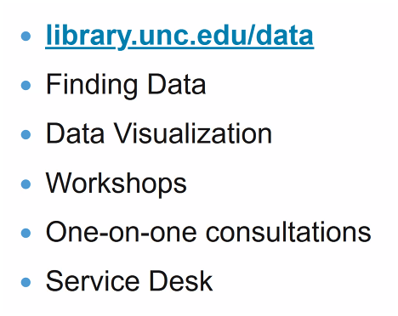  https://library.unc.edu/data/ 1
Data Visualization | 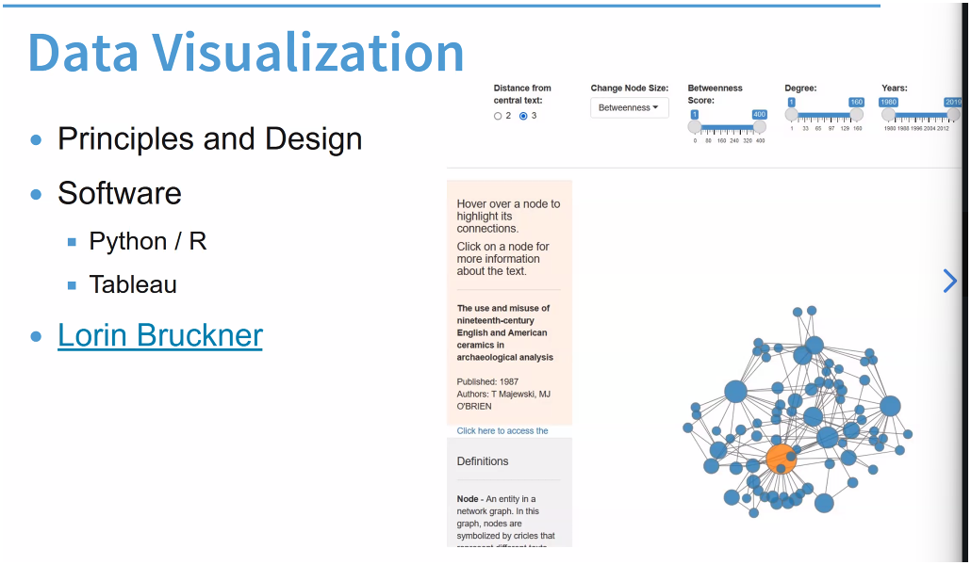  https://library.unc.edu/data/storytellin 1
Jim Crow and the Algorithms of Resistance | 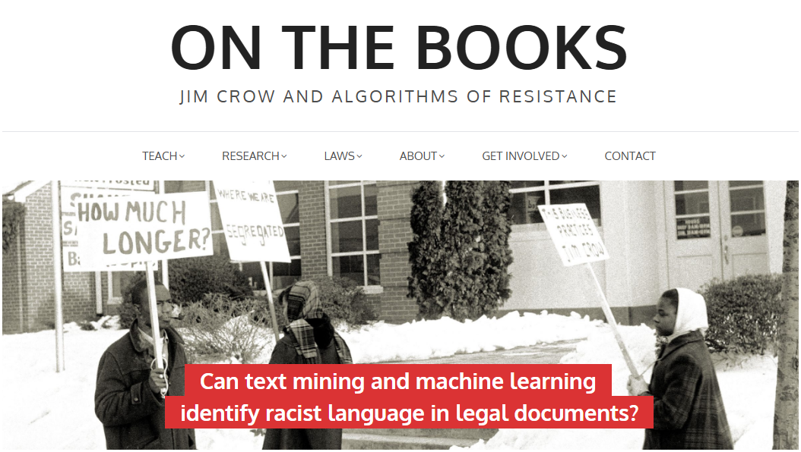  https://onthebooks.lib.unc.edu/ 1
Generative AI Platform | 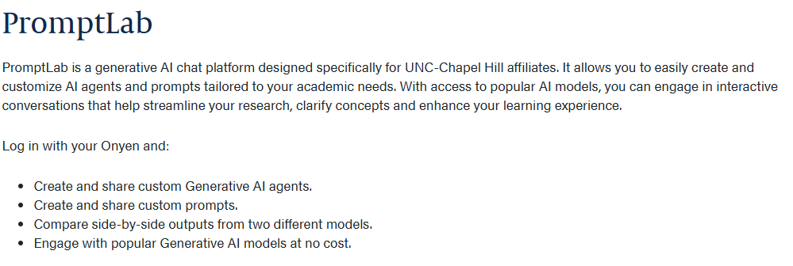  https://promptlab.lib.unc.edu/login 1
Workshops |   https://library.unc.edu/?s=workshops 1
LibreChat |   https://www.librechat.ai/ 1

Lecture
First Order Effects | - immediate, direct consequences or impacts resulting from a particular action, event, or decision
Second Order Effects | - the consequences of the first order effects
Recommended Resourced | - datasociety.net  - Data is the Destiny of the Steel City

