Matrix Solutions
Overview
- Calculate matrix condition number to get error bounds for solutions for Ax=b
- Manipulate matrices and determine when a matrix is not invertible
- Compute coordinates using a basis, in particular an orthogonal basis
- What PLU factorization is, how to compute it numerically and use it to solve linear systems.
- What banded and sparse matrices are and how the structure is used for solving large matrices.
- Matrix norms and condition numbers and how they are used to understand accuracy and numerical sensitivity.
- Flattening higher dimensional tensors to describe linear actions as matrices.
Solving Ax = b
Gaussian Elimination | - GE is used to solve Ax = b  - transform matrix into Row Echelon Form (REF) using Elementary Row Operations (ERO)
Sparse Matrix | - most elements are zero  - only have to store the non-zero elements and their locations  - efficient for storage and computation
Banded Matrix | - a sparse matrix  - non-zero entries are confined to a diagonal band comprising the main diagonal and zero or more diagonals on either side
Elementary Row Operations (ERO) | - swap rows (R_{i} ↔ R_{j})  - interchange two rows  - scale row (R_{i} → cR_{i})  - multiply a row by a non-zero constant (c)  - use to make a pivot 1  - add multiple rows (R_{i} → R_{i} + c)  - replace a row with itself plus a multiple (c) of another row  - use to create zeros below a pivot
Row Echelon Form  (REF) | - get the first pivot  - find the leftmost non-zero column  - if the top element (pivot) is zero, swap rows to make it non-zero  - make pivot 1  - optional for REF, required for RREF  - multiply the pivot row by the reciprocal of the pivot  - eliminate below pivot  - use row addition to make all entries below the pivot zero  - repeat  - move to the next row/column (submatrix) and repeat steps  1 – 3 until the  matrix is in REF  - produces matrix with ‘staircase pattern’ and zeros below pivots
Reduced Echelon Form  (RREF) | - follow REF steps  - also, use row operations to make all entries above the pivots zero  - result it an identity matrix on the ‘A side’
Back Substitution | - once in REF/RREF, start from the last non-zero equation and solve for the variable  - substitute that value into the equation above it  - continue until all variables are found
Interpreting Solution | - unique solution  - no inconsistent rows (like 0 = 5)  - no rows of all zeros (except very last row)  - infinite solution  - a row of all zeros (0 = 0) indicates a free variable (ex: x + y = 5)  - no solution  - an inconsistent row (ex: 0 = r where r ≠ 0)
Example | - Solve the system of linear equations using matrices  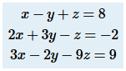  - write the augmented matrix  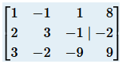  - perform row operations to obtain REF  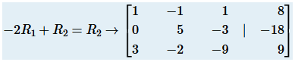  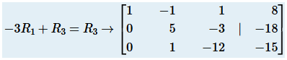  - interchange two rows  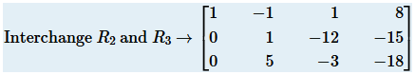  - perform row operations  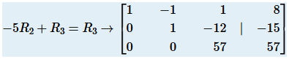  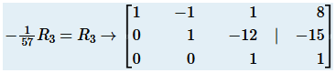  - the last matrix represents the equivalent system  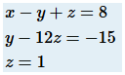  - solution is obtained using back-substitution
LU  Factorization | - any non-singular matrix A can be factored into a lower triangular matrix (L) and an upper triangular matrix (U)
Upper  Triangular  Matrix | 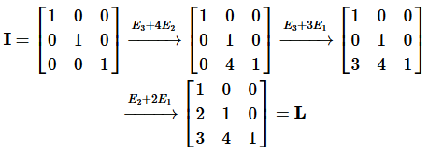
Lower  Triangular  Matrix | 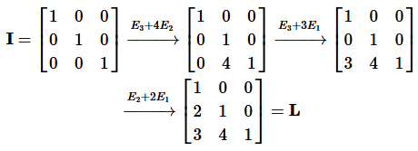
Validate  Solution  Using  Python | 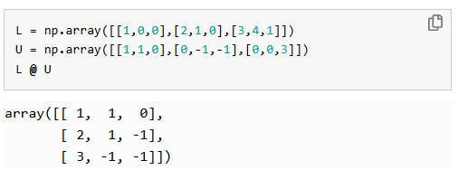
LU  Transformation  Using Python | 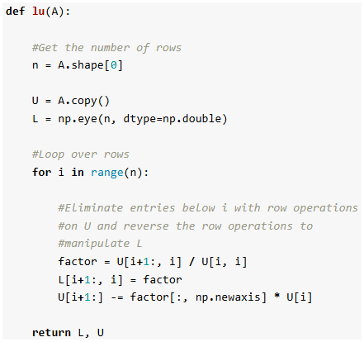
Sources | https://www.cs.cornell.edu/~tomf/notes/cs421-cheat-sheet.pdf  https://www.scribd.com/document/858540190/Gaussian-Elimination-and-Gauss.  https://courses.lumenlearning.com/waymakercollegealgebra/chapter/solve-a-system-with-gaussian-elimination/  https://johnfoster.pge.utexas.edu/numerical-methods-book/LinearAlgebra_LU.html
Spline
uses systems of linear equations to find piecewise polynomial functions (splines) that smoothly connect data points
Key Concepts |  |  | - piecewise polynomials  - A spline is made of multiple polynomial pieces joined at specific points called knots or breakpoints  - linear splines  - connecting points with straight lines, represented by $y=a+bx$ for each segment, solvable with basic linear equations  - higher-order splines  - use higher degree polynomials for smoother transitions  - knots/breakpoints  - points where the polynomial pieces connect, often data points themselves  - continuity conditions  - to ensure smoothness, derivatives must match at the knots, creating the system of linear equations
Solve Using Linear Algebra |  |  | - define polynomials  - N data points produce N – 1 segments  - each segment has its own polynomial  - interpolation constraints  - set up equations ensuring $P_{k}\left(x_{k}\right)=y_{k}$and $P_{k}(x_{k+1})=y_{k+1}$  - the spline passes through the data points  - smoothness constraints  - add equations for derivative continuity at interior knots  - introduces more unknowns and equations  - boundary conditions  - add conditions for the ends  - natural cubic splines have zero second derivatives at the ends  - solve the system  - the result is a large system of linear equations  - often represented as Ax = b  - solve for unknown coefficients
Sources |  |  | https://en.wikipedia.org/wiki/Spline  https://people.computing.clemson.edu/
Condition Number
the condition number (CN) of a matrix measures how sensitive the solution of a linear system or the inverse of the matrix is to changes in the input data
Low Condition Number |  | - indicates a well-conditioned matrix  - means that small input errors lead to small output errors
High Condition Number |  | - indicates an ill-conditioned matrix that is nearly singular  - small input errors can cause massive errors in the solution  - potentially leads to inaccurate results
Matrix Norm |  | - a measure of how large a matrix’s elements are  - the magnitude of the matrix  - is a real number between 1 and ∞  - denoted: || A ||
Key Points |  | - for any matrix A, cond(A) ≥ 1  - for the identity matrix I, cond(I) = 1  - for any matrix A and a non-zero scalar γ, cond(γA) = cond(A)  - for any diagonal matrix D, cond(D) = (max( |d_{i}| ) / min( |d_{i}| ))  - The condition number is a measure of how close a matrix is to being singular: a matrix with large condition number is nearly singular, whereas a matrix with a condition number close to 1 is far from being singular  - The determinant of a matrix is NOT a good indicator to check whether a matrix is near singularity
General Method |  | - calculate the product of the matrix norm of A and the matrix norm of A⁻¹  - cond(A) = ||A|| ||A⁻¹|| using the same matrix norm
2-Norm Method (Singular Values) |  | - compute Singular Value Decomposition  - perform the
Sources |  | https://courses.grainger.illinois.edu/cs357/fa2023/notes/ref-10-condition.html

Live Session Notes |  | 13 Jan 2026
- Matrix Solutions

*
*
*
*

