Week 4: Fourier Transform
Overview |  |  | Class meeting: 03 Feb 2026
- complex numbers
  - standard form
  - polar form
  - view as rotation and scale matrices
- Discrete Fourier Transform (DFT)
- Fourier Series
- use numerical libraries to compute DFT/frequency information encoding
- view DFT as product of an orthogonal matrix
- use DFT to analyze a signal where the frequency varies in time
Async
Fourier Transform
Complex Numbers (CNs) | - complex numbers (C) enable capturing roots of certain polynomials  - $0=x^{2}+1$  - $0=x^{2}+2x+2={\left(x+1\right)}^{2}+1$  - Add an imaginary number $i$ with $i^2=-1$  - $0=x^{2}+1=>x=±i$  - $0=x^{2}+2x+2 =>{\left(x+1\right)}^{2}+1=0=>x=-1± i$
CNs as Matrix | - $1<→ \left[\begin{matrix}1 & 0 \\ 0 & 1\end{matrix}\right]$  - $i<→ \left[\begin{matrix}0 & -1 \\ 1 & 0\end{matrix}\right], i^{2}= -1$ , counterclockwise ${90}^{0}$ rotation
CNs Standard Format | - $z=a+bi, where a is the real part and ib is the imaginary part$  - $a + ib = a\left[\begin{matrix}1 & 0 \\ 0 & 1\end{matrix}\right]+b\left[\begin{matrix}0 & -1 \\ 1 & 0\end{matrix}\right]= \left[\begin{matrix}a & -b \\ b & a\end{matrix}\right]$
CNs Polar Format | - $r = |z| = \sqrt{a^{2}+b^{2}}$  - $a+ib=r\cos{θ}+i\sin{θ}$  - $a+ib=r\left[\begin{matrix}\cos{θ} & -\sin{θ} \\ \sin{θ} & \cos{θ}\end{matrix}\right]$  $$z=a+ib$$  r  $$θ$$
CN Multiplication | - $1 and i$ commute so general multiplications work as expected  - $(a+ib)(c+id)=ac+ibc+iad+i^2 bd$  $$=ac-bd+i(bc+ad)$$  - $\left(a+ib\right)\left(c+id\right)→\left[\begin{matrix}a & -b \\ b & a\end{matrix}\right]\left[\begin{matrix}c & -d \\ d & c\end{matrix}\right]= \left[\begin{matrix}ac-bd & -ad-bc \\ ad+bc & ac-bd\end{matrix}\right]$  - exponential form  direction  magnitude  $${r e}^{iθ}$$  polar  form  - $e^{iθ}=cosθ+i sinθ$  - $e^{iα + iβ}=e^{iα}e^{iβ}$  - $z=a+ib=r e^{iθ}$
Complex Conjugate | - a complex conjugate (CC) is formed by reversing the sign of the imaginary part of a complex number  - $\overline{x+iy}=x-iy$ mirroring along the x-axis (complex conjugate)  - $\overline{z}z=(x+iy)(x-iy)=x^{2}+y^{2}={\left|z\right|}^{2}$ CN*CC = $R$ ${\left(magnitude\right)}^{2}$  CC: https://www.khanacademy.org/math/
Real and Imaginary Parts | - $re\left(z\right)=\frac{z+ ̅z }{2}$ $im\left(z\right)=\frac{z+\overline{z} }{2i}=-i\frac{z+ ̅z }{2}$
Hermitian Matrix | - A Hermitian matrix is a square complex matrix A equal to its own conjugate transpose and equates to the conjugate transpose of the matrix / vector  - $A*=A^{H}=\overline{{(A}^{T})}$ Hermitian: https://en.wikipedia.org/wiki/Hermitian_matrix
Inner Product | - $u⋅v=u^{H}v=\sum_{i}{\overline{{ u}_{i}} v_{i} }$  - $u⋅v=\overline{v⋅u}$
CN and Imaginary Numbers in Julia | julia> $z1=2+3im$  $$‘im’ declares the imaginary$$  $$part of the CN$$  $$2+3im$$  julia> z2 = 1 - 1im  1 - 1im  julia> norm(z1)  $$get modulus$$  3.605551275463989  julia> norm(z2)  1.4142135623730951  $$CN multiplication$$  julia> z1*z2  5 + 1im  julia> z1/z2  -0.5 + 2.5im  you get it…  julia> exp(1 + $im$)  1.4686939399158851 + 2.2873552871788423im  julia> exp(1)*cos(1)  1.4686939399158851  conversion → complex  julia> sqrt(complex(-1))  0.0 + 1.0im  julia> z = 3 + 2im  3 + 2im  julia> sqrt(z)  1.8173540210239707 + 0.5502505227003375im  julia> conj(z)  3 - 2im  julia> real(z) julia> imag(z)  3 2  julia> angle(z)  0.5880026035475675
Fourier Transform | - A Fourier transform (FT) is a mathemetical technique that transforms a function of time $x(t)$, to a fuciton of frequency $X(ω)$  - Three forms  - Fourier transform  - Fourier series  $$“Fourier Transform”$$  $$colloquially and in$$  $$this class$$  - discrete Fourier transform (DFT)  - Fourier transform ↔ inverse transform  - FTs are invertible using inverse of FT matrix $F^{-1}$  - For analytical functions on $R$  - $F\left(ω\right)= \int_{-∞}^{∞}{f\left(t\right)e^{-iωt}}dt$  - $f\left(t\right)= \frac{1}{2π}\int_{-∞}^{∞}{F\left(ω\right)e^{-iωt}}dω$  - Euler’s formula: $e^{iωt}=\cos\left(ωt\right)+ i\sin\left(ωt\right)$  - where 𝑒 is the base of the natural logarithm, 𝑖 is the imaginary unit ($i^{2}=-1$), and 𝑥 is the angle in radians  - bridges complex analysis and trigonometry by relating the exponential function to sine and cosine  Fourier Transform: https://lpsa.swarthmore.edu/Fourier/Xforms/FXformIntro.html  Euler’s Formula: https://www.youtube.com/watch?v=CRj-sbi2i2I

Fourier Series | - for anlytical functions that are periodic  - a series expansion of a periodic function into a sum of trigonometric functions  - $c_{n}=\frac{1}{L}\int_{0}^{L}{f\left(x\right)}e^{\frac{i 2πn x}{L},}dx$  - $f\left(x\right)= \sum_{-∞}^{∞}{c_{n}e^{\frac{i 2πn x}{L}}}$  - we will not be using this in this class  FS: https://en.wikipedia.org/wiki/Fourier_series
Discrete Fourier Transform | - a fundamental mathematical technique in digital signal processing that converts a finite sequence of evenly spaced data samples, typically representing a signal in the time or spatial domain, into its corresponding frequency domain representation. It computes the amplitude and phase of different frequencies present in the signal, enabling analysis and manipulation of, for instance, audio or image data.  $$c_{k}= \frac{1}{N}\sum_{n=0}^{N-1}{x_{n}exp(-i\frac{2πi k n}{N}})$$  $$z_{n}=\sum_{k=0}^{N-1}{c_{k}exp\left(-i\frac{2πi k n}{N}\right)}$$  DFT: https://en.wikipedia.org/wiki/Discrete_Fourier_transform

sin Transform | - a less complicated approach is to take back to a simpler transform, the $sin$ transform is related to the DFT  $$v_{k}^{i}=sin\left.\left(πk\frac{i}{n}\right.\right), k=1,…,n-1, i=1,…, n-1$$  $n-1$ vectors, each with $n-1$ values  - all of those vectors are orthogonal to eachother  $$v_{i}⋅v_{j}=0, if k≠j$$  $$v_{i}⋅v_{j}=\sum_{i=1}^{n-1}{sin\left.\left(πk\frac{i}{n}\right.\right)}sin\left.\left(πk\frac{j}{n}\right.\right)=0$$  - $n-1$ orthogonal values with $n-1$ entries, span all of $R^{n-1}$, so they form am orthogonal basis  - still, they are not quite orthonormal (orthogonal unit vectors)  since, $\left|{|v}_{k}\right|{\left.​\right|}^{2}=v_{k}⋅ v_{k}={\sum_{i=1}^{n-1}{\sin^{2}\left(πk\frac{i}{n}\right)}}^{2}=\frac{n}{2}$  - create a basis matrix  Decompose a Signal  $$reminder: V^{T}= V^{-1}, if V$$  $$is an orthogonal matrix$$  - $V = \left[v_{1}, v_{2},⋯,v_{n-1}\right]$  $V^{T}V=\frac{n}{2}I → { V}^{-1}=\frac{2}{n}V^{T}$  - ex: for a $basis V$, there is a $coordinate c$ such that there is a $vector x$ that $spans V$, such that$: x=Vc$  - any vector with $n-1$ entries can be spanned by the $V vectors$  $$reminder: a basis is a set of vectors$$  $$that acts a foundational, minimal$$  $$building block for a vector space$$  $$x=Vc⇒V^{T}x=V^{T}Vc=\frac{n}{2}c⇒c=\frac{2}{n}V^{T}x$$  $$c_{k}=\frac{2}{n}v_{k}⋅x,k=1,…,n-1$$  - putting this together: start with a $vector x$  $x=Vc=c_{1}v_{1}+⋯+c_{n-1}v_{n-1}⇒{ x}_{i}=\sum_{k=1}^{n-1}{c_{k} sin(πk\frac{i}{n})}$  - where the $c values$ come from the vector  vector  corresponds to: $|v_{k}{\left.​\right|}_{i}$  $$c=\frac{2}{n}V^{T}x⇒c_{k}=\frac{2}{n}v_{k}⋅x⇒c_{k}=\frac{2}{n}\sum_{i=1}^{n-1}{x_{i}}sin(πk\frac{i}{n})$$  - compare to the DFT equation  vector decomposition  $c_{k}=\frac{1}{N}\sum_{n=0}^{N-1}{x_{n} exp⁡(-i\frac{2πkn}{N})}$ $z_{n}=\sum_{k=0}^{N-1}{c_{k} exp⁡(i\frac{2πkn}{N})}$  - any vector can be decomposed like this:  1  0.4  0.3  0.1  0  .  .  .  0  - $x=v_{1}+0.4v_{2}+0.3v_{3}+0.1v_{4}=Vx = V$  - the $sin$ transform of $x$ is the coordinate with respect to the basis  Orthonormal: https://www.kristakingmath.com/blog/orthonormal-basis-for-a-vector-set
Visualization | - 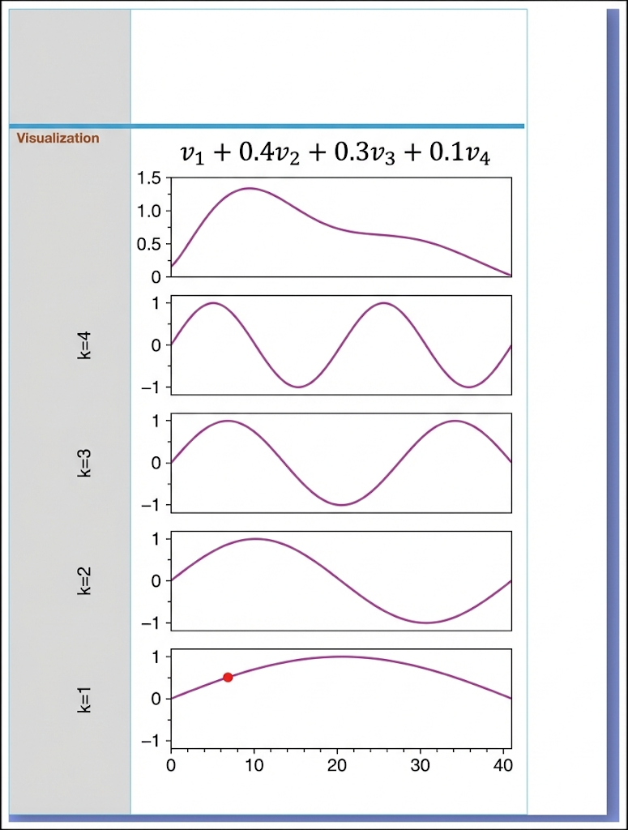  $$v_{1}+0.4v_{2}+0.3v_{3}+0.1v_{4}$$  decomposed wave  composite waveform  $$k=4$$  $$k=2$$  $$k=3$$  $$k=4$$
DFT – Numerical View
Computing | - small variation in what numerical methods compute  - fundamentally there is a standard matrix V  $$V_{n,k}=\exp\left(i\frac{2πikn}{N}\right) V^{-1}=\frac{1}{N}V^{H}$$  - there is flexibility where you put that N factor numerically  orthogonal (truly)  FFTW  easier to motivate  $$c=\frac{1}{N}V^{H}x x = V c$$  $$c=V^{H}x x=\frac{1}{N}Vc$$  $$c=\frac{1}{\sqrt{N}}V^{H}x x=\frac{1}{\sqrt{N}}Vc$$
Fast Fourier Transform (FFT) in Julia (ex 1) | julia> using FFTW  julia> x = Vector(range(start=0, step=0.1, length=10))  10-element Vector{Float64}:  0.0  0.1  $$x_{n}=\frac{n}{N}$$  $$y_{n}=sin (2π\frac{n}{N})$$  0.2  0.3  0.4  0.5  0.6  0.7  0.8  0.9  julia> y = sin.(2pi*x)  10-element Vector{ComplexF64}:  1.2246467991473532e-16 + 0.0im  -5.50555994384384e-16 + 5.0im  1.2246467991473532e-16 - 2.1117696842213397e-16im  1.2246467991473532e-16 - 4.440892098500626e-16im  1.2246467991473532e-16 - 1.305145441260248e-16im  9.957992501029599e-17 + 0.0im  1.2246467991473532e-16 + 1.305145441260248e-16im  1.9440492184190732e-16 + 4.440892098500626e-16im  1.2246467991473532e-16 + 2.1117696842213397e-16im  -5.50555994384384e-16 + 5.0im
Fast Fourier Transform (FFT) in Julia (ex 2) | julia> using FFTW  julia> x = Vector(range(0, 1, 11))  11-element Vector{Float64}:  0.0  0.1  0.2  0.3  0.4  0.5  0.6  0.7  0.8  0.9  1.0  julia> y = sin.(2pi*x)  julia> fft(y)  11-element Vector{ComplexF64}:  -1.1102230246251565e-16 + 0.0im  4.447252663038674 + 4.928889952937341im  -0.4364947971936885 + 0.6791991628794149im  -0.35239245098458942 + 0.3057831273272211im  -0.3323496580110257 + 0.1517266249897483im  -0.3256303599998888 + 0.04681857752931811im  -0.3323496580110257 - 0.1517266249897483im  -0.35239245098458942 - 0.3057831273272211im  -0.4364947971936885 - 0.6791991628794149im  4.447252663038674 - 4.928889952937341im  -1.1102230246251565e-16 + 0.0im
Toeplitz Matrix | a structured diagonal-constant matrix where each descending diagonal from left to right contains the same elements defined $T_{\left(ij\right)}=t_{\left(i-j\right)}$. these matrices are used in signal processing, image processing, and time series analysis for their efficiency in solving typically requiring only $O(n)$ distinct elements and $O\left(n^{2}\right)$to solve $Ax=y$.

