Neural Networks 2
Overview |  |  | 23 Feb 2026
Terms | - logits  - the quantile function associated with the standard logistic distribution  - quantile function  - a probability distribution's quantile function is the inverse of its cumulative distribution function  - softmax  - converts a tuple of $K$ real numbers into a probability distribution over $K$ possible outcomes  - attention  - a method that determines the importance of each component in a sequence relative to the other components in that sequence  - spatio-temporal data  - data that shows both spatial and temporal patterning  - convolutional neural networks  - a type of feedforward neural network that learns features via filter (or kernel) optimization  - multi-axes tensors  - a multi-linear tensor is an algebraic object that describes a multilinear relationship between sets of algebraic objects associated with a vector space  - flat vectors  - a vector bundle that is endowed with a linear connection with vanishing curvature (i.e. a flat connection)  - recurrent neural networks  - RNNs are designed for processing sequential data, such as text, speech, and time series where the order of elements is important  https://en.wikipedia.org/

Readings
- Convolutional Networks (pp. 326 through Section 9.3)
- https://www.deeplearningbook.org/contents/convnets.html

- Sequence Modeling: Recurrent and Recursive Nets (Section 2.5 pp. 120-127)
- https://www.deeplearningbook.org/contents/rnn.html

Convolutional Networks
Convolutional Networks  (CNNs) | - defined as a type of neural network with a grid structure, like images or time series  - inspired by biological systems  - foundational for image and pattern recognition tasks
Convolutional Operation | - a mathematical way to combine input data with a small set of learned weights (a kernel or filter) to extract features  - the kernel slides across the input grid and produces feature maps
Key Properties of Convolution | - sparse interactions  - depends on a small local region of the input  - limits the number of parameters dramatically compared to fully connected layers  - parameter sharing  - the same kernel weights are reused across different input positions reducing the number of parameters  - enables learning patterns that repeat across the data  - equivalence to translation  - handles patterns that shift in space  - if the input shifts, the output shifts in the same way  - helps detect patterns anywhere in the input

Pooling | - an operation applied after convolution to reduce the spatial size of feature maps  - makes the network less sensitive to small shifts in the input and reduces computation  - the most common form is max pooling  - picks the largest value from a small region
Sequence Modeling: Recurrent and Recursive Nets
Sequence Modeling | - a sequence is a list of vectors $x^{\left(1\right)}, x^{\left(2\right)}, x^{\left(3\right)}, …, x^{\left(τ\right)}$, where each element comes one after the other in time or order  - sequence modeling is about processing data where order matters (like text, audio, time series)
Recurrent Neural Networks  (RNNs) | - process elements one at a time  - at each step the network updates:  - a hidden state $h^{\left(t\right)}$, which is its memory.  - the hidden state combines the current input $x^{\left(t\right)}$and the previous state $h^{t-1}$  - shared processing lets the network handle sequences of variable length
Why RNNs | - traditional neural networks (like CNNs or fully connected nets) process fixed-length inputs  - many tasks require understanding order and history  h(t) = f(h(t−1), x(t))  o(t) = g(h(t))  Where:  - h(t): current memory / hidden state  - $x(t)$: current input  - $o(t)$: output at time $t$  - $f,g$: learned functions  output  new state
Unfolding the RNN | - to understand training and computation, we “unfold” the RNN through time  - view the network at each step as a separate layer connected to the next  - makes training easier to reason about
Parameter Sharing in RNNs | - same weights are used at every time step  - reduces the number of parameters  - allows the network to generalize sequences of different length
Types of RNN Processing | - outputs at each time step  - predicting the word in a sequence  - predicts something every step as it processes input  - reads entire sequence then outputs once  - classifying a sentence after ingesting it fully
Teacher Forcing | - in training, RNNs sometimes use the true output from the training data as input for the next step  - this helps learning but it is different from how the network runs in practice
RNNs as Probabilistic Models | - RNNs can be viewed as models that define a probability distribution over sequences  - model how likely a next element $y^{\left(t\right)}$is given previous inputs
Conditional RNNs | - RNNs can use another sequence as context to predict a target sequence  - can generate an output sequence of the same length as the input sequence  - ex: in image captioning, an image is input, and the RNN generates words about that image

Async Materials
How to Speak the Neural Network Lingo
Strategies of Defining Neural Networks | - satisfy constraints with differential activations  - make differential versions of common or useful operations (i.e. lookups) so networks can make use of them in a learnable fashion
Constraints | - examples  - all features must be between a particular range  - all features must be non-negative  - constrained features must be differentiable  - if constraint function is not differentiable, the chain rule cannot be applied to compute gradients
Activation Base | - a non-linear mathematical operation is applied to the output of each node  - the fundamental driver for learning complex patterns  - core components  - introduction of non-linearity into the system  - a firing decision determines if a neuronal output is relevant  - gradient flow ensures that gradients remain large during backpropagation, allowing the model to train effectively
Common Activation Functions | - SoftMax  - a mathematical function used in artificial intelligence to transform logits  - each value is between 0 and 1  - the sum of all values equals exactly 1  - one-hot vectors  - represents categorical data as binary vectors where only one element is hot, and the rest are cold  - negative log likelihood  - a loss function used to train classification models by minimizing the negative logarithm of the predicted probability
Additional Activation Functions | - rectified linear unit (ReLU)  - returns $input$ if positive, $0$ if not  - sigmoid/logistic  - input values to a range between 0 and 1  - frequently used in the output layer for binary classification  - hyperbolic tangent (tanh)  - maps inputs to a range between -1 and 1  - Leaky ReLU  a variant of ReLU that allows a small negative value, helping to prevent "dying neurons"
SoftMax for Attention | - computes a probability distribution from raw, unnormalized attention scores ensuring they sum to 1  - the resultant normalization allows the model to focus on relevant tokens (high values) and ignore other (low values)  keys  value vectors  $$\sum_{j=1}^{m}{\frac{\exp{sim(\vec{ϕ\left(x\right)}}, {\vec{κ}}^{\left(j\right)})}{\sum_{c=1}^{m}{exp}{sim(\vec{ϕ\left(x\right)}}, {\vec{κ}}^{\left(j\right)})}{\vec{v}}^{\left(j\right)}}$$
Convolutional Neural Networks
Properties | 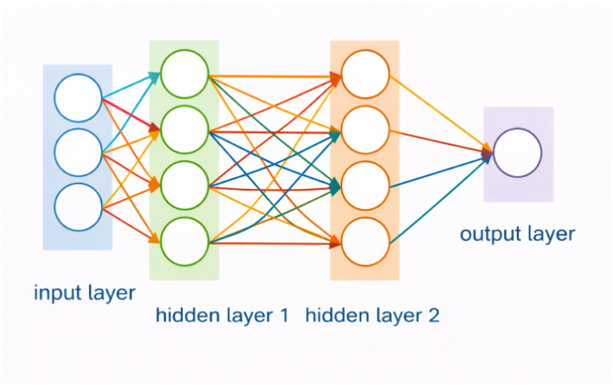  - low-level features are local  - features are translational invariant  - high-level features are composed of low-level features  ChatGPT 5.2  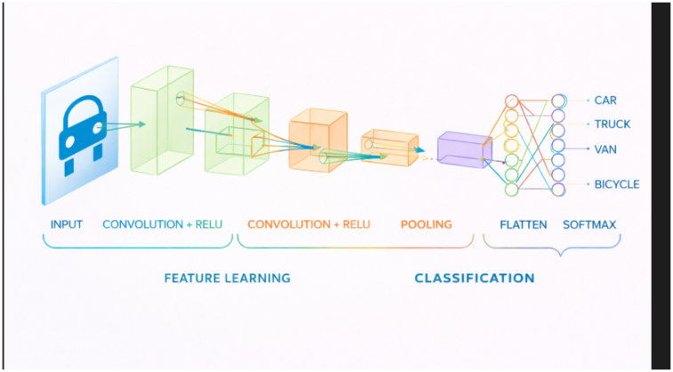  - modeled after biological analog  typical CNN

