Validation
Overview
- test set methods
- leave-one-out cross-validation
- k-fold cross-validation
- variants and imported caveats to validation techniques
Reading
The Elements of Statistical Learning
Trevor Hastie, Robert Tibshirani, Jerome Friedman
Chapter 7-7.2, 7.10
https://hastie.su.domains/ElemStatLearn/
Summary | - when building predictive models, two issues must be addressed  - model assessment  - how well the model preforms on new data  - model selection  - choose the best model complexity  - the key objective goes beyond simply fitting the training data to minimizing prediction error on future observations
Key Takeaways | - training error is not a reliable indicator of predictive performance  - prediction error = (bias)² + variance + noise  - increasing model complexity decreases bias but increases variance  - model assessment requires test error estimation  - cross-validation is the most common method for doing this

Validation
Error on Future Data
Fitting the Data | - we want the model to fit the data  - without over-fitting or under-fitting  - without becoming over-reliant on training data  - even if training error is low future errors can be high
Model Complexity and Choices
Ideal Model Complexity | overfitting  underfitting  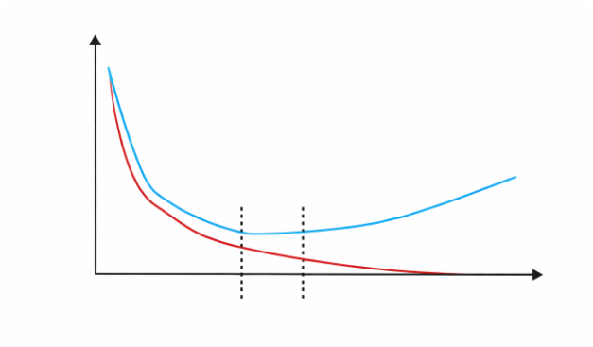  predictive  error  error on out-of-sample data  model complexity  error on in-sample data  ideal range for model complexity
Model Complexity and Choices
Linear Regression | - often the trend in the data is not obvious  - you have to select the model that is best for your data

Quadratic Regression
Piecewise Non-Parametric Regression
Test-Set Validation
Test-Set Method | - randomly choose 30% of the data to be a test set  - the remainder is the training set  - perform regression on the training set  - estimate your future performance with the test set  - this can be achieved with any of the three models  - the optimal model is not always the model with the lowest error  - the optimal model is the model that performs best on the test set after being trained on the training set
Results | - good news  - simply choose the model with the best test-set score  - bad news  - wastes data  - to get the estimate we loose 30% of the data  - if data is sparse, test set can match or not match randomly

Leave-One-Out Cross-Validation
LOOCV Method | - for $k=1$ top $R$  - let $\left(x_{k}, y_{k}\right)$ be the $k^{th}$ record  - temporarily remove $\left(x_{k}, y_{k}\right)$ from the dataset  - train the remaining $R-1$ datapoints  - note your error $\left(x_{k}, y_{k}\right)$  - when you have done this to all points, report the mean error  - to do this you average the mean error from each run  - this can be done with each of the three discussed methods
Results | - this method is expensive  - does not waste data  - this would be unmanageable with large datasets
K-Fold Cross-Validation
K-Fold Method | - randomly break the dataset into $k$ partitions  - for the partition  - for the red partition  - train on all the points not in the red partition  - find the test-set sum of errors on the red points  - repeat this for the green and blue partitions  - repeat this process with all of the candidate models

Contrasting Validation Methods
Review of Cross-Validation Methods  sometimes there are algorithmic tricks for making these cheap |  | Downside | Upside
 | Test-Set | variance  unreliable estimate of future performance | cheap
 | Leave-One-Out | expensive | does not waste data
 | 10-Fold | wastes $10\%$ of the data  $10x$ more expensive than test-set | only wastes $10\%$  only $10x$ times more expensive instead of $R$ times
 | 3-Fold | more wasteful than 10-fold  more expensive than test-set | slightly better than test-set
 | R-Fold | identical to leave-one-out
Cross-Validation Applications
Cross-Validation for Regression Hyper-Parameters | - choosing the number of hidden units in a neural net  - feature selection  - choosing a polynomial degree  - choosing which regressor to use  - parametric vs non-parametric
Cross-Validation for Classification | - instead of computing the sum squared errors on a test set  - total number of misclassifications in a test set
CV-Based Algorithm Choice | - compute 10-fold-cv error for different model class  - train the data with the algorithm that gave the best CV score
Choosing Hyperparameters | - perform test with every combination of hyperparameters  - for this hyperparameter set you will run 18 tests  - hyperparameter 1 in {H11, H22}  2 x 3 x 3 = 18  - hyperparameter 2 in {H21, H22, H23}  - hyperparameter 3 in {H31, H32, H33}
Validation to Choose Bandwidth | - make a set of candidate bandwidths around the “rule of thumb” bandwidths (ex: average 5th-nearest neighbor distance  $$H= {\left\{2^{j}h_{rot}\right\}}_{\left\{j = -M\right\}}^{\left\{M\right\}}$$  - split the data into “train” and “validation” sets  $$D_{val}∩ D_{trn}= ∅$$  - choose the bandwidth $h ∈H$with the best likelihood  $\frac{1}{\left|D_{val}\right|}\sum_{x ∈ D_{val}}{log( {\hat{p}}_{h\left(x\right)})}$ =  $$\left(\frac{1}{\left|D_{val}\right|}\right)\sum_{x ∈ D_{val}}{log} (\frac{1}{\left|D_{val}\right|}\sum_{x ∈ D_{val}}{k_{h}(x^{'}, x)}$$
Cross-Validation Alternatives
Other Cross-Validation Issues | - can do “leave all pairs out” or “leave all n-tuples out”  - k-folds where each fold is independently chosen subsets
Alternatives to CV-Based Model Selection | - Model selection methods  - Cross-validation  - AIC (Akaike information criterion)  - BIC (Bayesian information criterion)  - VC dimension (Vapnik–Chervonenkis dimension)

