Dimensionality Reduction
Overview |  |  | 23 Mar 2026
- feature vectors
- data manifold
- how Principal Component Analysis finds a linear subspace
- applications in images and data visualization
Reading
Pattern Recognition and Machine Learning
12.1: Principal Component Analysis (PCA)
Principal Component Analysis
Core Idea | - PCA is a method for finding a lower-dimensional representation of data that preserves as much of the important structure as possible  - PCA looks for a small number of new axes, called principal components, such that:  - the projected data varies as much as possible along those axes  - the axes are mutually orthogonal  - the lower-dimensional representation loses as little information as possible under a squared-error notion of reconstruction
Why PCA is Useful | - real data often lives in a high-dimensional space  - the true degrees of freedom may be much smaller  - PCA helps by:  - reducing dimensionality  - compressing data  - removing redundancy caused by correlated variables  - making visualization easier  - preparing data for later modeling steps
Setup | - suppose each data point is a vector  $$x_{n} ∈ R^{D}$$  - PCA first centers the data by subtracting the sample mean, so the transformed data has mean $0$  - then, studies the sample covariance matrix, whose eigenvectors determine the principal directions  - in Bishop’s development, the principal components are obtained from the eigenvalue problem for the covariance matrix
View 1: Maximum-Variance Formulation
Idea | - the first principal component is the direction onto which the projected data has the largest possible variance  - Then:  - the second principal component is the direction of largest remaining variance  - it must be orthogonal to the first  - the third is orthogonal to the first two  - and so on
Key Result | - the optimal directions are the eigenvectors of the covariance matrix  - the eigenvector with the largest eigenvalue gives the first principal component  - the next largest eigenvalue gives the second component  - larger eigenvalue = more variance explained by that component
View 2: Minimum-Error Formulation
Idea | - PCA can also be derived as a reconstruction problem  - project the data into a lower-dimensional subspace  - then reconstruct it back into the original space  - choose the subspace that minimizes the average squared reconstruction error
Important Conclusion | - the solution to this minimum-error problem is the same subspace found by the maximum-variance approach  - so PCA has two equivalent interpretations:  - keep directions of largest variance  - minimize information loss under squared reconstruction error
Reconstruction picture | - if you keep only $M<D$ principal components:  - each point is projected onto an $M-dimensional$ linear subspace  - the reconstruction is the closest point to the original data point within that subspace  - the discarded components correspond to lost information
Choosing Fewer Dimensions | - if you keep only the first few principal components, you get a compressed representation  - this works well when:  - the first few eigenvalues are much larger than the rest  - most variance is concentrated in a small number of directions  - in that case, the data can be approximated well using a low-dimensional linear manifold
High-Dimensional Data Case
Large Dimensionality Case | - directly solving the covariance eigenvalue problem can be expensive  - a useful trick is to work with a matrix involving inner products between data points instead  - this is especially helpful when the number of data points is smaller than the ambient dimension  - the nonzero eigenvalues are shared across these equivalent formulations  - this matters because PCA is often applied in settings like:  - images  - text features  - other very high-dimensional observations

What PCA is Actually Finding
PCA Finds a Linear Subspace | - assumes the important structure can be captured by straight-line combinations of basis directions  - does not model nonlinear curved manifolds  - later methods in the chapter extend this idea probabilistically and nonlinearly
Limits of PCA | - it is linear  - it is driven by variance, not necessarily by task relevance  - large variance directions are not always the most meaningful for prediction  - it is sensitive to variable scaling unless preprocessing is done carefully  - standard PCA is not a full probabilistic model in this initial formulation
Summary
PCA  Section 12.1 | - can be understood as:  - a way to find a low-dimensional representation of high-dimensional data  - a method based on eigenvectors of the covariance matrix  - a maximum-variance method  - equivalently, a minimum squared reconstruction error method  - a linear dimensionality reduction technique that prepares the ground for probabilistic PCA and related latent-variable models
Dimensionality Reduction
Another Type of Unsupervised Learning Task
Supervised vs Unsupervised Learning | Supervised Learning  - data: $(x, y)$  - $x$ is data  - $y$ is label  - goal:  - learn a function to map $x → y$  - examples:  - classification  - regression  - object detection  - semantic segmentation  - image captioning |  | Unsupervised Learning  - data: $x$  - just data  - no labels  - goal:  - learn underlying hidden structure of the data  - examples:  - clustering  - dimensionality reduction  - feature learning  - density estimation
Dimensionality Reduction | - unsupervised learning method  - discovering the degrees of freedom of the underlying instances  - what are the core dimensions of the dataset

Linear Encoder and Decoder
Encode | - for 3-D data, encoding converts the 3-D data to 2-D  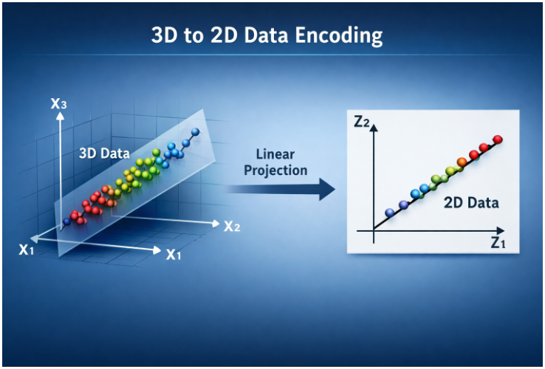  ChatGPT 5.4  - data preparation (normalization)  - compute the covariance matrix  - apply SVD  - project the 3-D vertices onto the plane formed by the first two eigenvectors
Decode | - for 3-D data, decoding converts the 2-D data back to 3-D  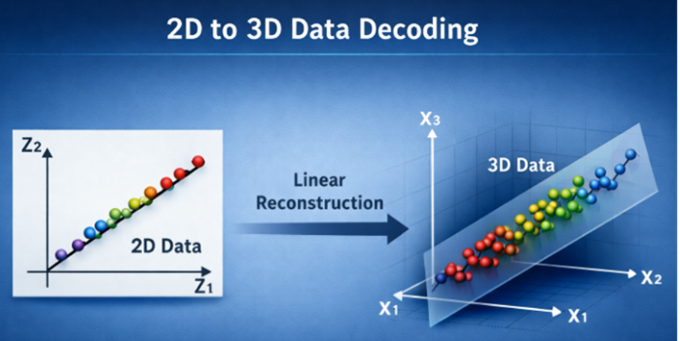  ChatGPT 5.4  - map the 2D points back to the 3D space using the transpose of the principal components matrix  - add the mean (gravity center) of the original data back to the reconstructed points to place the object in its original position  - if the 2D representation was heavily compressed, surface refinement or 3D convolutional neural networks
Linear Encoder and Decoder
 | encode | decode
K-Means | - $x∈R^{d}→\left\{1, …, k\right\}$ | - $\left\{1, …, k\right\}→CCenter\left(x\right)∈R^{d}$
Dim-Reduction | - $x∈R^{d}→R^{k}, k<d$ | - $z∈R^{k}→\hat{x}∈R^{d}$
Two Views on Dimensionality Reduction
Simple Dimensionality Reduction | - using a 2-D scatter plot as an example, one “view” would be to project the set directly to the x-axis  2.0  1.5  1.0  0.5  0  -0.5  -1.5  -2.0  -2.0 -1.5 -1.0 - 0.5 0 0.5 1.0 1.5 2.0
PCA | - this method has us determining a linear frame of reference corresponding to the direction of greatest variance  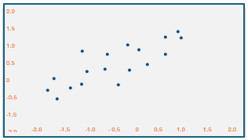  the projection here is more “spread out” giving a broader representation of the data
Maximum Variance View
PCA: Max Variance | - PCA is a linear dimensionality reduction technique  - find the directions of maximum variance in the data  $${〈〈x_{i}〉〉}_{i=1}^{N}$$  - assume that the data is centered, i.e.  $$\sum_{i}{x_{i}=0}$$
To Center Your  Data at $μ=0$  to center data at zero:  - find $μ$ (mean of data set)  - subtract $μ$ from each datapoint  (linear transformation) | - centered data transformation  $x_{i}^{'}= x_{i}- μ$, where $μ = \left(\frac{1}{N}\right)\sum_{i=1}^{N}{x_{i}}$  - thus,  $$x_{i}^{'}= x_{i}- \left(\frac{1}{N}\right)\sum_{i=1}^{N}{x_{i}}$$
PCA: Max Variance, cont. | - find a set of orthogonal vectors $v_1, ..., v_k$  - the first principal component $\left(PC\right)v_{1}$ is the direction of largest variance  - the second $PC v_{2}$ is the direction of largest variance orthogonal to $v_{1}$  - the $i^{th} PC v_{i}$ is the direction of largest variance orthogonal to $v_{1},..., v_{i-1}$  - $V_{D×k}$ gives projection  $z_{i}=V^{T}x_{i}$ for datapoint $x_{i}$  Z = XV for entire dataset
Expressed in Matrix Notation | $V=\left[\begin{matrix}| \\ v_{1} \\ |\end{matrix}\begin{matrix}| \\ v_{2} \\ |\end{matrix}\begin{matrix} … & \begin{matrix}| \\ v_{k} \\ |\end{matrix}\end{matrix}\right]$ where, $x_{i}∈R^{D}$  $z_{i}=v^{T}x=\left[\begin{matrix}- \\ - \\ -\end{matrix}\begin{matrix}v_{1} \\ … \\ v_{k}\end{matrix}\begin{matrix}- \\ - \\ -\end{matrix}\right]\left[\begin{matrix}| \\ x_{i} \\ |\end{matrix}\right]=\left[\begin{matrix}v_{1}^{T}x_{i} \\ … \\ v_{k}^{T}x_{i}\end{matrix}\right]$ where, $z_{i}∈R^{k}$
PCA: Max Variance, cont. | - we wish to find $v_1$ so that $\sum_{i=1}^{N}{z_{i}^{2}}$ is maximized  $$\sum_{i=1}^{N}{ z_{i}^{2}}=z^{T}z= v_{1}^{T}X^{T}X v_{1}$$  important constraint  - the maximum value attained by  $v_{1}^{T}X^{T}X v_{1}$ for $\left|\left|v_{1}\right|\right|= 1$  - is the largest eigenvalue of  $$X^{T}X$$
Reconstruction View
Best Reconstruction | - we have i.i.d. data ${〈〈x_{i}〉〉}_{i=1}^{N}$ data matrix $X$  - find a $k$-dimensional linear projection that best represents the data  - suppose $V_{k}∈ R^{D×k}$ is such that columns of $V_{k}$ are orthonormal  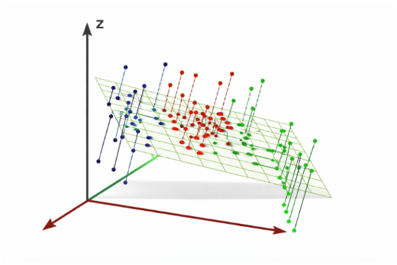  - project data $X$ onto subspace defined by $V_{k}$  reconstructed datapoint  $$Z=X V_{k}$$  - minimize reconstruction error  initial datapoint  $$z_{i}$$  $$\sum_{i=1}^{N}{|| x_{i}-V_{k} V_{k}^{T} x_{i} |{\left.​\right|}^{2}}$$
Singular Value Decomposition
Full vs Thin SVD | $X = U Σ V^{T}$ (assume $N > D$)  - thin SVD  $$U is N × D,$$  $$Σ is D × D,$$  $V is D × D,$  $$U^{T} U=V^{T} V=I_{D}$$  - $Σ$ is diagonal with $σ_{1}≥ σ_{2}≥ … ≥ σ_{D}≥ 0$  - The first $k$ principal components are the first $k$ columns of $V$  $U$ and $V$ are orthonormal matrices  - Full SVD:  $$U is N × N,$$  $$Σ is N × D,$$  $V is D × D$
Full vs Thin SVD Visualization | 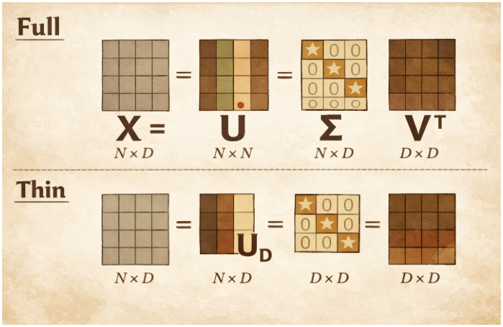  $$Σ_{D}$$

Selecting $K$
How Many Principal Components to Select | - look for the “elbow” in the curve of reconstructed error vs number of principal components  recombination error  select a $k$ somewhere in this range  # of principal components

