Clustering
Overview
- unsupervised machine learning
- identify salient patterns in the data
- k-means
- lossy compression scheme
- convergence and initialization
- hierarchical clustering
Reading
Pattern Recognition and Machine Learning
9.1 K-Means Clustering
https://oa.ee.tsinghua.edu.cn/ouzhijian/pgm/pgm-pdf/PRML%20book.pdf

Elements of Statistical Learning
14.3 Cluster Analysis
https://jqichina.wordpress.com/wp-content/uploads/2012/02/the-elements-of-statistical-learning.pdf
$K$ is assumed to be a known value
PRML: K-Means Clustering
9.1 K-Means Clustering
What  K-Means Means.. | - a non-probabilistic clustering method  - divides $N$ datapoint into $D-dimensional$ Euclidean space into $K$ clusters  - each cluster is represented by a prototype vector $μ_{k}$ (cluster center)  - objective is to assign each point to a cluster so that points are as close as possible to their assigned center
Key Representation | - for each datapoint $x_{n}$ there exist binary indicator variables $r_{nk}$  $$1-of-K coding$$  - $r_{nk}=1$: if $x_{n}$ is assigned to cluster $k$  - $r_{nk}=0$: else  - using these indicators, K-means minimizes the distortion objective  sum of squared distances from every point to its assigned cluster center  $$J=\sum_{n=1}^{N}{\sum_{k=1}^{K}{r_{nk}{\left|\left|x_{n}-μ_{k}\right|\right|}^{2}}}$$
How the Algorithm Works | K-means alternates between two steps  - assignment step  - keep the centers $μ_{k}$ fixed  - assign each point to the nearest center  - formally, set $r_{nk}=1$ for the cluster whose center gives the smallest square distance to $x_{n}$  - update step  - keep the assignments fixed  - recompute each center as the mean of the points assigned to that cluster  each prototype becomes the mean of its cluster members  $$μ_{k}=\frac{\sum_{n}{r_{nk}x_{n}}}{\sum_{n}{r_{nk}}}$$
Iteration and Convergence | - these two steps cycle until  - the assignments stabilize  - exit criteria are met  - each step reduces the objective $J$  - only guaranteed to reach a local minimum

Relation to Expectation  Maximization (EM) | - these two$K-means$ phases correspond to the $E-step$ and $M-step$  - $E-step$ $↔$ reassigning points  - $M-step$ $↔$ recompute centers  - $K-means$ is a special non-probabilistic limit of $EM$ for Gaussian mixtures
Practical Behavior | - “The Old Faithful” example shows  - the algorithm depends on the initial choice of centers  - poor initialization can require more iterations  - a common practical initialization is to choose $K$random data points as the initial centers  - the cost function $J$ decreases after successive $E$ and $M$ steps until convergence
Computational Issues | - a direct implementation can be slow because each assignment step compares every data point with every prototype vector  - the text mentions speedups based on  - tree-based data structures for nearby points  - triangle-inequality tricks to avoid unnecessary distance computations
Online Stochastic Version | - updates the nearest prototype after each incoming point  decreases over time  $$μ_{k}^{new}=μ_{k}^{old}+η_{n}\left(x_{n}-μ_{k}^{old}\right)$$  - where $η_{n}$is a learning rate  - makes $K-means$ suitable for sequential or streaming-style updates
Limits of Standard K-Means | - standard $K-means$ uses squared Euclidean distance  - creates two important limitations  - it is not appropriate for some variable types, such as categorical labels  - the mean can be sensitive to outliers, so the cluster centers may be non-robust
Generalization: K-medoids | - generalizes $K-means$ by replacing squared Euclidean distance with a more general dissimilarity measure $V\left(x,x^{'}\right)$, yielding a new objective:  $$J^{'}=\sum_{n=1}^{N}{\sum_{k=1}^{K}{r_{nk}}}V\left(x_{n},μ_{k}\right)$$  - this leads to $K-medoids$  - assignment still sends each point to the nearest prototype under the chosen dissimilarity  - the update step is harder  - the prototype is often restricted to be one of the actual data points in the cluster

Hard Assignments vs Soft Assignments | - hard assignment  - each point is assigned to exactly one cluster  - some points may lie roughly between centers  - so, hard assignment may be artificial  - soft assignments  - probabilistic model reflects uncertainty
9.1.1 Image Segmentation and Compression
Image Segmentation Example | - the textbook example applies $K-means$ to color images by treating each pixel as a data point in a $3-D$ RGB space  - one coordinate for  - red intensity  - green intensity  - blue intensity  - $K-means$  - groups similar colors together  - redraws each pixel using the color of its assigned cluster center  - result is an image represented using only $K$ colors
Important Caveat for Example | - a major weakness is that it ignores spatial proximity  - two pixels far apart but similar in color may be put in the same cluster  - nearby pixels are not treated as related just because they are adjacent in the image  - this approach is simple, but not strong enough for general image segmentation
Compression Viewpoint | - the same setup also gives a form of lossy compression  - instead of storing every original pixel vector  - store only the index $k$ of the nearest cluster center  - also, store the $K$ center vectors themselves  - this is called vector quantization  - cluster centers are called code-book vectors  - approximation is lossy because each original pixel is replaced by the nearest center, not preserved exactly
Bit-Cost Calculation | - if an image has $N$pixels and each RGB pixel uses $24$ bits total  rounded up as needed  - original image cost = $24N$bits  - compressed image cost = $24K+N{log{}}_{2}K$bits  - for the image in the example  - the original requires 1,036,800 bits  - K-means-compressed versions require  - 43,248 bits for $K=2$  - 86,472 bits for $K=3$  - 173,040 bits for $K=10$  - these are 4.2%, 8.3%, and 16.7% of the original size, respectively  - the trade-off is clear, smaller $K$ gives  - more compression  - smaller worse visual quality

Summary
Takeaway from Image Example | - shows that K-means  - clusters similar vectors  - can reduce data to a small codebook  - creates a direct trade-off between compression and fidelity  exploits local correlations in natural images  - the text notes that for better image compression  - cluster small blocks of neighboring pixels
Overall Takeaways for  K-means | - K-means as an iterative algorithm that alternates between  - assigning each point to its nearest center  - updating each center to the mean of its assigned points  - properties of $K-means$  - minimizes within-cluster squared distance  - converges to a local minimum  - uses hard assignments  - can be extended beyond Euclidean distance  - can be applied to tasks like image segmentation and lossy compression through vector quantization  - simplicity is its strength  - but is limited by assumptions

Async
Clustering Goals
Two Classes of Learning Problems | - supervised learning  - learning from pre-labeled data  - class labels (in classification)  - output values (regression)  - train data: $\left(X, Y\right)$for inputs $X$ and labels $Y$  - unsupervised learning  - learning from unlabeled, unannotated data  - train data: $X$ for unlabeled data  - learn from salient patterns from the input features themselves
Unsupervised Learning Methods | - clustering methods  - identify data groupings  - non-probabilistic method  - hierarchical clustering  - K-means algorithm  - probabilistic method  - mixture model  - density estimation  - determine data distribution  - dimensionality reduction  - determine low-dimensional representation

Clustering | - organizes data into clusters such that there is  - high intra-cluster similarity  - low inter-cluster similarity  - optimal for finding natural groupings among objects
Clustering as Lossy Compression
Data Shape | - data is stored as different data types with each having different sizes in memory  - even within the same data type group – such as float – there are variations such as different degrees of precision
The Problem | - suppose you transmit the coordinates of points drawn randomly from this dataset  - you can install decoding software at the receiver  - you're only allowed to send two bits per point  - this requires lossy compression  - loss is defined as the sum-squared error between decoded coordinates and original coordinates
Solutions: Minimizes Loss | - simplified model  send ‘00’  send the quadrant in the 2-D plane  decoding:  take the mean datapoint of the data clustered in that quadrant  rezone partitions  repeat  010  00  11  10
Optimizing Partitions and Centroids
K-Means | - ask user how many clusters  - randomly guess the $k$ cluster center locations  - each datapoint determines which center is closest  - each center “owns” a set of datapoints  - each center determines center of “owned” points  - center relocates to new position  - repeat until terminated
K-Means Questions | - what is it trying to optimize?  - are we sure it will terminate?  - are we sure it will find an optimal clustering?  - how should we start it?  - how could we automatically choose the number of centers?
K-Means Loss
Distortion | - encoder function  $$R^{m} → \left\{1, …, k\right\}$$  - decoder function  $$\left\{1, …, k\right\}→ R^{m}$$  - define  $$Distortion = \sum_{i=1}^{R}{{\left( x_{i}- DECODE\left( ENCODE\left(x_{i}\right)\right)\right)}^{2}}$$  - if we set,  $DECODE\left[j\right]=c_{j}$ then,  $$Distortion = \sum_{i=1}^{R}{{\left( x_{i}- c_{ENCODE\left(x_{i}\right)}\right)}^{2}}$$
Minimizing Loss With Respect to Partitions
The Minimal Distortion | $$Distortion = \sum_{i=1}^{R}{{\left( x_{i}- c_{ENCODE\left(x_{i}\right)}\right)}^{2}}$$  - what priorities must cluster assignments have when distortions minimized?  - $x_{i}$ must be encoded by its nearest center  $$c_{ENCODEI{(x}_{i})}=\begin{matrix}argmin \\ c_{j}∈\left\{c_{1},c_{2},…,c_{k}\right\}\end{matrix}{\left(x_{i}-c_{j}\right)}^{2}$$  at the minimal distortion
Minimizing Loss With Respect to Centroids
The Minimal Distortion (2) | - what properties must centers $c_{1},c_{2},…,c_{k}$ have when distortion is minimized?  - the partial derivative of distortion with respect to each center location must be zero  - this is a convex problem, so the minimum is where the derivative equals zero
Steps | - from above: the partial derivative of distortion with respect to each center location must be zero  OwnedBy(c_j):  the set of records owned by center $c_{j}$  $$Distortion = \sum_{i=1}^{R}{{\left(x_{i}- c_{ENCODE\left(x_{i}\right)}\right)}^{2}}$$  $$= \sum_{j=1}^{k}{\sum_{i ∈ OwnedBy\left(c_{j}\right)}{{\left(x_{i}- c_{j}\right)}^{2}}}$$  $\frac{∂Distortion}{∂c_{j}}$ $=\frac{∂}{∂c_{j}}\sum_{i ∈ OwnedBy\left(c_{j}\right)}{{\left(x_{i}- c_{j}\right)}^{2}}$  $$= -2 \sum_{i ∈ OwnedBy\left(c_{j}\right)}{\left(x_{i}- c_{j}\right)}$$  $$= 0 \left(for a minimum\right)$$
Alternating and Convergence
At the Minimum Distortion | - what properties must centers $c_{1}, c_{2}, …, c_{k}$ have when distortion is minimized?  - $x_{i}$ must be encoded by its nearest center  - each center must be at the centroid of “owned” points
Improving a Sub-Optimal Configuration | - what properties must be changed for centers $c_{1}, c_{2}, …, c_{k}$ when distortion is minimized?  - change the encoding so that $x_{i}$ is encoded by its nearest center  - set each center to the centroid of “owned” points  - neither operation is repeated in succession  - the approach must be alternation (K-means)
- there are only a finite number of ways of partitioning $R$ records into $k$ groups
- so, there are only a finite number of possible configurations in which all centers are the centroids of the points they own
- if the configuration changes on an iteration, it must have improved the distortion
- therefore, each time the configuration changes, it must move to a configuration it has never been to before
- if it tried to go on forever, it would eventually run out of configurations

K-Means Algorithm | - decide on a value for $K$  - initialize the $K$ cluster centers randomly if necessary  - decide the class memberships of the $N$ objects by assigning them to the nearest cluster centroids (aka the center of gravity or mean)  - reestimate the $K$ cluster centers, by assuming the memberships found above are correct  $${\hat{μ}}_{k}= \left(\frac{1}{C_{k}}\right)\sum_{i ∈ C_{k}}{x_{i}}$$  - if none of the $N$ objects changed membership in the last iteration, exit  - otherwise, repeat the process starting from the membership assignment step
Local Minima and Initialization
Optimal Solution | - the optimal solution is not necessarily reached  can you think of a configuration that converges to a state that does not have the minimum distortion?
Trying to Find Good Optima | - choose a logical starting point  - do many $K-means$ runs from different start locations

“neat trick”
- place first center on top of randomly chosen dataponit
- place second center on data point that is as far away as possible form the first placement
- place the $j^{th}$ center on the datapoint that is as far away as possible from the closest of centers $1$ through $j-1$

Choosing K
Choosing K According to Distortion | - purely choosing according to distortion typically does not sufficiently solve for $K-means$ and/or clustering  - larger $K$ values lead to less distortion but is not conducive to determinig clustering groups
Choosing the Number of Centers | - the most common approach is to try to find the solution that minimizes the Schwarz Criterion (also related to the BIC)  m = # dimensions  k = # centers  R = # records  $$Distortion + λ\left(\# parameters\right)\log{R}$$  $$= Distortion + λ m k\log{R}$$
Plot Objective Function Values of K = 1 to 6 | - we can plot the objective function values for $k = 1 to 6$  - the abrupt change at $k = 2$ is highly suggestive of two clusters in the data  - this technique for determining the number of clusters is known as “knee finding” or “elbow finding”  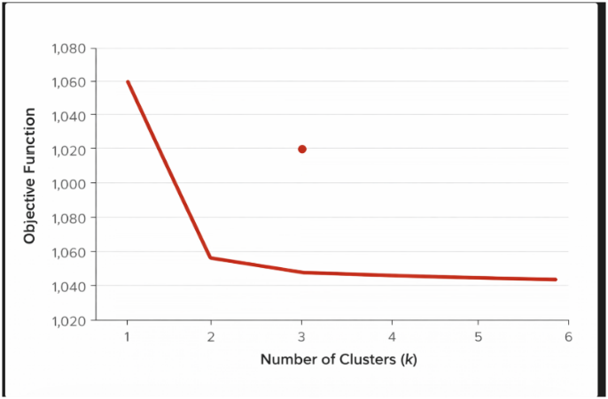  ChatGPT 5.3
Applications
Common Uses of K-Means | - often used as an exploratory data analysis tool  - in one dimension, a good way to quantize real-valued variables into $k$ non-uniform buckets  - used on acoustic data, in speech understanding, to convert waveforms into one of $k$ categories (known as vector quantization)  - also used for choosing color palettes on old-fashioned graphical display devices
Hierarchical Clustering
Two Types of Clustering | - hierarchical algorithms  - create a hierarchical decomposition of the set of objects using some criterion  - partitioning algorithms  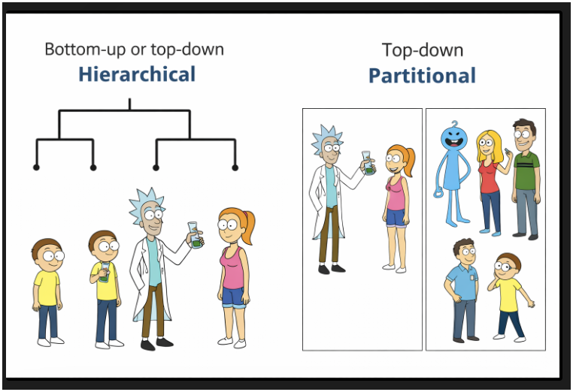  - construct various partitions and then evaluate them by some criterion  ChatGPT 5.4

Hierarchical Clustering  (How To) | - bottom-up (agglomerative)  - starting with each item in its own cluster, find the best pair to merge into a new cluster  - repeat until all clusters have “fused” together
Agglomerating Clusters
Distance Matrix |   - contains the distances between every pair of objects in a database              similarity assessment: greater value = greater distance (less similar)  0 3 2 7 8  0 4 6 8  0 8 8  0 3  0          D( , ) = 3  D( , ) = 3

Bottom Up (Agglomerative) | - start with each item in its own cluster  - find the best pair to merge into a new cluster  - repeat until all clusters fuse together  consider all possible combinations  choose the best one                …
Linking Options
Computing Distance Between Clusters | - single link  - cluster distance = distance of two closest members of each class  optimal for long, skinny clusters  the shortest measured distance corresponds to the most similarity and they would be merged
- complete link
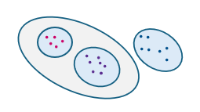
  - cluster distance = distance of the two farthest members
optimal for tight clusters

- average link
most used: most robust to noise
  - cluster distance =
average distance of all pairs

