**Rhytidectomy and Patient Education:**

**Are Patients Accessing Appropriate Information Online?**

**Amar Gupta, M.D.1**

**Dennis I. Bojrab II, M.D.1**

**Peter F. Svider, M.D.1**

**Adam J. Folbe, M.D. 1**

**Michael Carron, M.D. 1, 2**

**Giancarlo F. Zuliani, M.D. 1, 2**

1Department of Otolaryngology –Head and Neck Surgery, Wayne State University School of Medicine, Detroit, Michigan, USA

2Division of Facial Plastic and Reconstructive Surgery, Wayne State University School of Medicine, Detroit, Michigan, USA

**Running Title:** Rhytidectomy Patient Education

**Financial Disclosures, Conflicts of Interest**: None for all authors

**Word Count**: xxxx

**All Authors have approved the final manuscript and attest to the integrity of the original data and the analysis reported in the manuscript.**

**Corresponding Author:**

Amar Gupta, MD

Department of Otolaryngology – Head and Neck Surgery

Wayne State University School of Medicine

4201 St. Antoine, 5E-UHC

Detroit, MI 48201

Phone: (313) 577-0804

FAX: (313) 577-8555

E-mail: amgupt@med.wayne.edu

**ABSTRACT**

**Objectives/Hypothesis:** Healthcare providers should be aware of information freely available on the Internet to ensure proper patient care. The current analysis assesses the reliability, quality, and readability of Internet information describing rhytidectomy.

**Study Design:** Use of previously validated survey instruments to assess the reliability, quality and readability of online websites describing rhytidectomy.

**Methods:** An Internet search using Google with the search term “facelift” was conducted. The first 50 search results were reviewed and 36 were included in analysis. Websites were divided based on type of authorship into professional organization, academic, physician-based, and unidentified. The validated DISCERN instrument was used to determine reliability, quality, and overall rating of each site. The Flesch Reading Ease Score and Flesch-Kincaid Grade Level were used to measure readability.

**Results:** A 1-3 point scale was used to rate websites. Mean scores for reliability and quality ranged from 1.7 (+/-0.99) in the academic group to 2.0 (+/-0.12) in the unidentified group and from 1.5 (+/- 0.13) in the unidentified group to 1.7 (+/-0.38) in the physician-based group, respectively. The highest overall rating was 1.4 (+/- 0.22 and +/- 0.31 respectively) in the unidentified and physician-based groups and the lowest was 1 (+/- 0.58) in the academic group. The Flesch Reading Ease Scores ranged from 21.6 to 74.6. Flesh-Kincaid Grade levels ranged from 6.9 to 13.9.

**Conclusions:** Information available online on rhytidectomy may be significantly deficient in reliability, quality, and readability. Clinicians have a duty to provide patients with high quality information at an adequate level of comprehension.

**Key Words:** facelift, face lift, rhytidectomy, DISCERN index, readability, patient education materials, usability, reliability, quality of patient education materials, Flesch Readability Ease Score (FRES), Flesch-Kincaid Grade Level Readability Formula (FKGL)

**Introduction**

Recent estimates place the number of Internet users worldwide at approximately 34.3% of the total population, a number exceeding 60% when only considering Western countries.1–5 Internet usage continues to grow at a rapid rate and patients increasingly use this medium to seek medical information.6–8 In the United States, it is estimated that 72% of Internet users search online for health information5 and 80% of these start their search with a search engine such as Google. 9 A common cosmetic surgical term such as “plastic surgery” is entered into search engines roughly 200,000 times a month. 9 The unregulated nature and lack of standardization of this medical information has significant potential to mislead the lay public, as few mechanisms exist to ensure the quality and accuracy of resources utilized.10–12 Factors such as the search terms used, medical topic researched, and specific website viewed are all contributory.13,14

Literature is sparse regarding the reliability and quality of Internet information covering facial plastic surgery topics. No studies exist, for example, assessing these factors in relation to rhytidectomy, a common facial plastic surgery procedure. The elective nature of this procedure 15,16 places added emphasis on obtaining reliable and comprehensible information. In our institutional experience, patients interested in this procedure typically seek information on the Internet prior to the initial consultation or subsequent visits. To prevent misinformation and ensure proper patient care, health care providers should be aware of the status of the information freely available on the Internet. The current analysis applies several objective indicators to assess the reliability, quality, and readability of Internet information available on rhytidectomy.

**Methods**

An Internet search using Google was conducted to identify websites pertaining to rhytidectomy. The search term “facelift” was used rather than the medical term for this procedure, rhytidectomy, to ensure that our search results would mimic those of a typical patient. Analysis was restricted to the 50 websites on the first 5 pages of the search results, as a typical user is unlikely to look at websites beyond this.14,17 Upon clicking a search result, the page that loaded was reviewed. No additional links or websites within search results were pursued in order to standardize findings. Inclusion criteria comprised websites that were free to use and provided patient information on traditional rhytidectomy. Exclusion criteria included paid advertiser links at the top of search pages and links to video clips.

Websites fitting inclusion criteria were organized by type of authorship into the following categories: Professional Organization, Academic, Physician-based, and Unidentified. Sites were assessed for reliability and quality using the DISCERN instrument, a validated measurement instrument designed to help judge written information about treatment choices. DISCERN, the first standardized index of quality of consumer health information, shows inter-observer reliability and is effective whether used by a lay person or health care professional.18–22 DISCERN is freely and easily accessible in its entirety on the Internet (<http://www.discern.org.uk/discern_instrument.php>). This measurement tool consists of 15 core questions and an overall quality rating. Each question evaluates a specific criterion. The first eight questions collectively focus on the reliability of the publication and the seven subsequent questions rate the publication’s quality. The DISCERN instrument can be scored two ways. The assessor may use a numeric five point scale or a three point descriptive scale consisting of “no”, “partially”, or “yes” relating to how well each criteria is met. Numerous studies have used the three point scale effectively.17,23–25 In order to simplify the analysis and ensure objectivity, the three point descriptive scale was used in this study. A number of “1” was assigned to an answer of “no”; a number “2” was assigned to an answer of “partially”, and a number “3” was assigned to an answer of “yes”. The DISCERN values were tabulated and used to calculate mean scores for reliability and quality as well as an overall rating for each website. A mean score of “0” to “1” represented none to low, “1” to “2” represented low to moderate, and “2” to “3” represented moderate to high. Individual websites were independently reviewed by multiple authors (A.G., P.S., D.B.) and results were averaged and then used to calculate the overall means based on type of authorship.

In addition to quality and reliability, the readability of each web site was analyzed using two tools: Flesch Readability Ease Score (FRES) and Flesch-Kincaid Grade Level Readability Formula (FKGL). These indices have been widely used and validated in the literature.26–29 Readability refers to the ease with which text can be read and understood. Both the formulas used in this study use the same core measures to calculate readability – word length and sentence length. The values of these tests approximately correlate in an inverse fashion. A FRES score of 90-100 indicates easy comprehension by an 11-year old, a score of 60-70 indicates easy comprehension by a 13-15 year old and a score below 30 indicates that the material is best understood by university graduates. 26,28,30 The Flesh Kincaid Grade Level formula translates the 0-100 FRES score into a standard US grade level. 26,30 These two readability scores were calculated using Microsoft Word (Microsoft Corporation, Bellevue, WA).

**Statistical Analysis**

Comparison of continuous variables was performed using Mann-Whitney U-tests and Kruskal Wallis Tests as appropriate, with threshold for significance set at p < 0.05. SPSS version 20 (an IBM Company, Chicago, IL) was used for statistical calculations.

**RESULTS**

The first five pages of search results using the term “facelift” were reviewed, yielding a total of 50 websites. Fourteen websites were excluded from further analysis as they did not provide information on traditional rhytidectomy. The remaining 36 websites were classified based on authorship as follows: Professional Organization – 3 (8%); Academic – 3 (8%); Physician-based – 20 (56%); and Unidentified – 10 (28%). (Fig 1) The websites from professional organizations (8%) included those available from the American Society of Plastic Surgeons, the American Academy of Facial Plastic and Reconstructive Surgery, and the American Society for Aesthetic Plastic Surgery. The websites originating from academic institutions (8%) included two separate sites by the Mayo Clinic and one by the University of Kansas. The majority of sites were private-physician-based (56%) and the remainder had unclear authorship and were classified as unidentified (28%). Websites in the unidentified group included a message board, online encyclopedia entries, and news stories.

The mean DISCERN scores for reliability and quality, and the overall rating were calculated for each of the 36 reviewed websites. Nine sites (25.0%) had a mean reliability score of 2 or greater and only 5 (13.9%) had a mean quality score greater than or equal to 2. In terms of quality, 1 website (4.0%) achieved a score of 3, 11 (30.6%) a score of 2, and the remaining 24 (66.7%), a score of 1.

Organized by authorship categories, the mean score for reliability was significantly higher in the professional group compared to the physician-based group (p = 0.02) (Fig. 2). The mean scores for quality ranged from 1.5 (+/- 0.13) in the unidentified group to 1.7 (+/-0.38) in the physician-based group (Fig 2), although differences in quality did not reach statistical significance (Kruskal Wallis test, p > 0.05).

Mean scores for overall rating based on type of authorship were evaluated (Fig 3) and did not significantly differ among groups (Kruskal Wallis Test, p < 0.05).

The Flesch Reading Ease Score and Flesch-Kincaid Grade Level were tabulated for each of the 36 websites included in analysis. The Flesch Reading Ease Scores ranged from 21.6 to 74.6 and the Flesh-Kincaid Grade levels ranged from 6.9 to 13.9. Mean values based on type of authorship were analyzed. (Fig 4) The values for Reading Ease Scores ranged from 46.5 (+/- 26.83) in the professional organization group to 51.6 (+/- 11.56) in the physician-based group. The lowest Flesh-Kincaid Grade Level was 9.8 (+/- 5.65) in the academic group and the highest was 11 (+/- 6.37) in the professional organization group.

**Discussion**

The Internet is widely used by patients as a medium to access information on health-related topics and treatment options.5 The widespread availability of the Internet lies in contrast to the comparatively limited access patients have to their physicians directly. This is important to consider as patients internalize only 40-80% of the information presented during physician office visits.31 The information available online, however, is highly variable. Search engines rank results based on complex algorithms related to factors such as number of visitors and page popularity rather than quality.23 False advertising may further confound the information accessed.32,33 Patients are thus left to determine, themselves, which websites are relevant to the information they are seeking. This factor adds great potential for misinformation.

Readability of patient education materials has been examined for a variety of topics in Otolaryngology. These analyses have suggested that many freely available resources have difficulty levels that exceed the average adult’s level of comprehension. 26–28,34–36Our analysis is the first evaluation of Internet materials related to rhytidectomy, and goes further than previous analyses as we evaluate other indices - *reliability* and *quality* of information regarding facelifts. In the case of elective procedures, such as rhytidectomy, the need for effective patient education is further underscored. In our analysis, only a minority of websites had mean DISCERN scores of 2 or greater for reliability or quality, 25% and 13.9% respectively. This indicates that the readability or quality of most websites is likely inadequate. Furthermore, the majority of websites reviewed (66.7%) had an overall rating of 1, indicating poor quality. The professional and academic based websites did not consistently outscore websites in the other categories. The information on rhytidectomy available online is clearly inadequate to educate the lay audience about this procedure. Our own professional organizations and academic websites even fall short.

The majority of websites reviewed had physician-based authorship. Most of these were commercial websites set up to market private practices. In these websites, there was significant possibility of bias as discussion of rhytidectomy emphasized only one physician’s perspective and opinion. Minimal text was devoted to discussing procedure risks or alternate treatment options. None of the commercial physician-based websites cited sources; the only physician-based website that did clearly cite sources was non-commercial.

Websites with other types of authorship were also lacking in major areas. None of the professional organization-based websites had clearly cited sources and nor discussed effect of treatment on quality of life. Furthermore, only one website in this category discussed risks of treatment. The unidentified group comprised of a message board, encyclopedia entries and news stories. The message board discussed patients’ experiences with different surgeons and individual perspectives on the surgical experience. The news stories broadly discussed rhytidectomy without providing any specific facts while the encyclopedia entries were brief and did not clearly note the source of authorship. In the unidentified group as a whole, quality of life issues were seldom discussed. The effect of no treatment and the importance of shared decision making were also neglected in websites within this category. Similarly, academic websites neglected to cite sources and failed to mention the effects of no treatment, risks of treatment, or importance of shared decision making

Health literacy remains a widespread public health issue and is associated with various measures of patient outcomes including hospitalizations, complications, and even mortality.37–40 The average American adult reads at approximately an 8th-grade reading level.40,41 As such, the Department of Health and Human Services, and the National Institutes of Health recommend that all patient resources be written at a 4th to 6th grade reading level.27,28,34,41 Just 1 of the 36 reviewed websites was below a 6th grade reading level, but this same website scored below 2 for both reliability and quality, receiving an overall rating of 1. This indicates that even though the readability was adequate, the reliability, quality and overall rating were poor to moderate at best. Conversely, the only website with a mean score above 2 in reliability and quality had one of the highest readability grades at 12.9. The best website was one that a lay reader would be least likely to comprehend.

In order to improve the information presented on their websites, authors may choose to review information with a validated rating tool, such as DISCERN, prior to publication online. In general, areas where many websites lost points were failure to discuss risks of treatment, not discussing effect of no treatment, not mentioning the effect of treatment on quality of life, and not emphasizing importance of shared decision making. In addition to focusing on these areas, authors should work towards using multiple sources to reduce the possibility of bias. Resources and citations should be provided, which guide readers to additional material as necessary. Finally, authors should focus on simplifying the layout and substance of the material presented, possibly using tools such as FKGL and FRES to ensure an acceptable readability.

In addition to facilitating improved understanding of what a rhytidectomy encompasses, ensuring that patients are reading both comprehensive and accurate education materials has other benefits for the practicing facial plastic surgeon. A multitude of analyses regarding topics relevant to facial plastic surgeons and otolaryngologists have shown that perceived deficits in informed consent are brought up in a significant proportion of malpractice litigation. 42–47

Consequently, having a frank verbal discussion regarding the indications, benefits, risks, and alternatives is just as important as recording a discussion of these specific risks in a comprehensive written informed consent process. Providing patients with appropriate medical information or directing them towards appropriate resources may go a long way in facilitating this process, and should be strongly considered by the practicing facial plastic surgeon.

Although our study is novel in its examination of patient education materials regarding rhytidectomy and goes beyond an analysis of readability to examine other issues such as usability and quality, there are several limitations inherent to our study design. This was a current “snapshot” of the types of information patients may find upon searching the Internet, but further examination using a prospective study design would be of value. For example, having patients read current materials, which appear to be inadequate on the whole, then providing materials with higher quality and usability and evaluating whether patients comprehension has improved would certainly be helpful in validating our findings.

Another **potential** limitation the authors acknowledge relates to numerous reviewed websites being commercial in nature. These sites **were likely intended** to market services rather than educate patients. A tool such as DISCERN **may not be**an adequate measure of educational value in such cases. Patients **who may benefit**from commercial websites likely include those who have already decided to go ahead with a procedure and are trying to identify a surgeon. However, those seeking information on a procedure in the early stages of decision making may have a difficult time finding such data online.

**CONCLUSION**

The information available online on rhytidectomy is significantly deficient in reliability, quality, and readability. Websites are extremely variable and a high proportion of the information presented is poor. This has several potential implications including misinformation, patient misperceptions about surgery, and increased litigious pursuits. Clinicians have a duty and responsibility to provide patients with high quality information presented at an adequate level of comprehension.

**REFERENCES**

1. Miniwatts Marketing Group. Internet Usage Statistics. Available at: http://www.internetworldstats.com/stats.htm.

2. International Telecommunications Union. Percentage of Individuals using the Internet 2000 - 2012. Available at: http://www.itu.int/en/ITU-D/Statistics/Documents/statistics/2013/Individuals_Internet_2000-2012.xls.

3. US Census Bureau. Computer and Internet Use in the United States. Available at: http://www.census.gov/prod/2013pubs/p20-569.pdf.

4. Saithna A, Ajayi OO, Davis ET. The quality of Internet sites providing information relating to hip resurfacing. *Surg. J. R. Coll. Surg. Edinburgh Irel.* 2008;6:85–87.

5. Pew Internet and American Life Project. Available at: http://www.pewinternet.org/Reports/2013/Health-online/Part-One/Section-6.aspx.

6. Fashner J, Drye S. Internet availability and interest in patients at a family medicine residency clinic. *Fam Med*. 2011;43(2):117–120.

7. Ilic D, Bessell TL, Silagy CA, Green S. Specialized medical search-engines are no better than general search-engines in sourcing consumer information about androgen deficiency. *Hum. Reprod. Oxford Engl.* 2003;18:557–561.

8. Murero M, D’Ancona G, Karamanoukian H. Use of the Internet by Patients Before and After Cardiac Surgery: An Interdisciplinary Telephone Survey. *J. Med. Internet Res.* 2001;3:E27.

9. Evans D. Internet Visibility. *Ceatus Mark. Gr.* Available at: www.ceatus.com.

10. Butler L, Foster NE. Back pain online: a cross-sectional survey of the quality of web-based information on low back pain. *Spine (Phila. Pa. 1976).* 2003;28:395–401.

11. Surman R, Bath PA. An assessment of the quality of information on stroke and speech and language difficulty web sites. *J. Inf. Sci.* 2013;39:113–125.

12. Beredjiklian PK, Bozentka DJ, Steinberg DR, Bernstein J. Evaluating the source and content of orthopaedic information on the Internet: the case of carpal tunnel syndrome. *J. Bone Jt. Surg. Am. Vol.* 2000;82A:1540–1543.

13. Ademiluyi G, Rees CE, Sheard CE. Evaluating the reliability and validity of three tools to assess the quality of health information on the Internet. *Patient Educ. Couns.* 2003;50:151–155.

14. Ansani NT, Vogt M, Henderson BAF, et al. Quality of arthritis information on the Internet. *Am. J. Heal. Pharm. AJHP Off. J. Am. Soc. Heal. Pharm.* 2005;62:1184–1189.

15. Rodriguez-Bruno K, Papel ID. Rhytidectomy: principles and practice emphasizing safety. *Facial Plast. Surg. FPS*. 2011;27:98–111.

16. Larrabee W, Henderson J. Face lift: the anatomic basis for a safe, long-lasting procedure. *Facial Plast Surg*. 2000;16(3):239–53.

17. Neuman H, Cabral C, Charlson M, Temple L. Is internet information adequate to facilitate surgical decision-making in familial adenomatous polyposis? *Dis Colon Rectum*. 2007;50(12):2135–2141.

18. Griffiths KM, Christensen H. Website Quality Indicators for Consumers. *J. Med. Internet Res.* 2005;7:e55.

19. Charnock D, Shepperd S, Needham G, Gann R. DISCERN: an instrument for judging the quality of written consumer health information on treatment choices. *J. Epidemiol. Community Heal.* 1999;53:105–111.

20. Shepperd S, Charnock D, Cook A. A 5-star system for rating the quality of information based on DISCERN. *Health Info. Libr. J.* 2002;20:201–205.

21. Charnock D, Shepperd S. Learning to DISCERN online: applying an appraisal tool to health websites in a workshop setting. *Health Educ. Res.* 2004;19:440–446.

22. Rees CE, Ford JE, Sheard CE. Evaluating the reliability of DISCERN: a tool for assessing the quality of written patient information on treatment choices. *Patient Educ. Couns.* 2002;47:273–5.

23. Yeung T, D’Souza N. Quality analysis of patient information on surgical treatment of haemorrhoids on the internet. *Ann R Coll Surg Engl*. 2013;95:341–344.

24. Yeung TM, Mortensen NJ. Assessment of the quality of patient-orientated Internet information on surgery for diverticular disease. *Dis. Colon Rectum*. 2012;55:85–89.

25. Daraz L, MacDermid JC, Wilkins S, Gibson J, Shaw L. The quality of websites addressing fibromyalgia: an assessment of quality and readability using standardised tools. *BMJ Open*. 2011;1:e000152.

26. Sanghvi S, Cherla D V, Shukla PA, Eloy JA. Readability assessment of internet-based patient education materials related to facial fractures. *Laryngoscope*. 2012;122:1943–8.

27. Kasabwala K, Agarwal N, Hansberry DR, Baredes S, Eloy JA. Readability assessment of patient education materials from the American Academy of Otolaryngology--Head and Neck Surgery Foundation. *Otolaryngol. head neck Surg. Off. J. Am. Acad. Otolaryngol. Head Neck Surg.* 2012;147:466–71.

28. Misra P, Agarwal N, Kasabwala K, Hansberry DR, Setzen M, Eloy JA. Readability analysis of healthcare-oriented education resources from the American Academy of Facial Plastic and Reconstructive Surgery. *Laryngoscope*. 2013;123:90–96.

29. Woodmansey K. Readability of educational materials for endodontic patients. *J. Endod.* 2010;36:1703–1706.

30. Flesch R. A New Readability Yardstick. *J Appl Psychol*. 1948;32(3):221–33.

31. Kessels RPC. Patients’ memory for medical information. *J. R. Soc. Med.* 2003;96:520.

32. Smith P, Bansal-Travers M, O’Connor R, Brown A, BanthinC. Correcting over 50 years of tobacco industry misinformation. *Am J Prev Med*. 2011;40(6):690–8.

33. Carroll J. Legal examination of physician advertising on the internet. *Facial Plast Surg*. 2006;22(1):75–9.

34. Colaco M, Svider P, Agarwal N, Eloy J, Jackson I. Readability assessment of online urology patient education materials. *J. Urol.* 2013;189:1048–1052.

35. Hansberry DR, Agarwal N, Shah R, et al. Analysis of the readability of patient education materials from surgical subspecialties. *Laryngoscope*. 2013. Available at: http://www.ncbi.nlm.nih.gov/pubmed/23775508.

36. Misra P, Agarwal N, Kasabwala K, Hansberry DR, Setzen M, Eloy JA. Readability analysis of healthcare-oriented education resources from the American Academy of Facial Plastic and Reconstructive Surgery. *Laryngoscope*. 2013;123:90–96.

37. Sheridan SL, Halpern DJ, Viera AJ, Berkman ND, Donahue KE, Crotty K. Interventions for individuals with low health literacy: a systematic review. *J. Health Commun.* 2011;16 Suppl 3:30–54.

38. Berkman ND, Sheridan SL, Donahue KE, Halpern DJ, Crotty K. Low health literacy and health outcomes: an updated systematic review. *Ann. Intern. Med.* 2011;155:97–107.

39. Murray MD, Tu W, Wu J, Morrow D, Smith F, Brater DC. Factors associated with exacerbation of heart failure include treatment adherence and health literacy skills. *Clin. Pharmacol. Ther.* 2009;85:651–658.

40. Svider P, Agarwal N, Choudhry O. Readability assessment of online patient education materials from academic otolaryngology-head and neck surgery departments. *Am. J. Otolaryngol.* 2013;34:31–35.

41. National Institutes of Health. How to Write Easy-to-Read Health Materials. Available at: http://www.nlm.nih.gov/medlineplus/etr.html.

42. Svider P, Keeley B, Zumba O, Mauro A. From the operating room to the courtroom: a comprehensive characterization of litigation related to facial plastic surgery procedures. *Laryngoscope*. 2013;123(8):1849–53.

43. Svider P, Pashkova A, Folbe A, Eloy J. Obstructive Sleep Apnea: Strategies for Minimizing Liability and Enhancing Patient Safety. *Otolaryngol Head Neck Surg*. 2013.

44. Blake D, Svider P, Carniol E, Mauro A. Malpractice in otology. *Otolaryngol Head Neck Surg*. 2013;149(4):554–61.

45. Hong SS, Yheulon CG, Sniezek JC. Salivary gland surgery and medical malpractice. *Otolaryngol. neck Surg. Off. J. Am. Acad. Otolaryngol. Neck Surg.* 2013;148:589–94. Available at: http://www.ncbi.nlm.nih.gov/pubmed/23380759.

46. Svider P, Blake D, Sahni K, Folbe A. Meningitis and Legal Liability: An Otolaryngology Perspective. *Am. J. Otolaryngol. (In Press July 2013)*.

47. Svider P, Blake D, Husain Q, Mauro A, Turbin R. In the Eyes of the Law: Malpractice Litigation in Oculoplastic Surgery. *Ophthalmic Plast. Reconstr. Surg. (In Press May 2013)*.

**FIGURE LEGENDS**

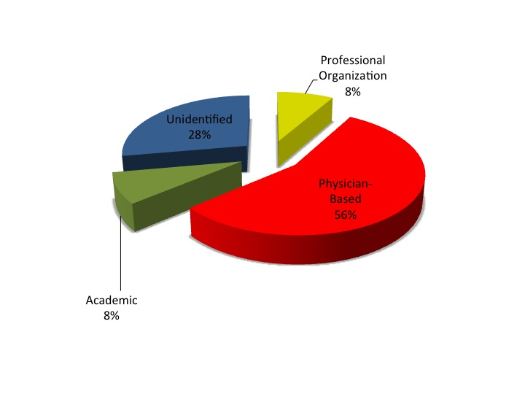

**Figure 1**. Authorship of websites included in this analysis.

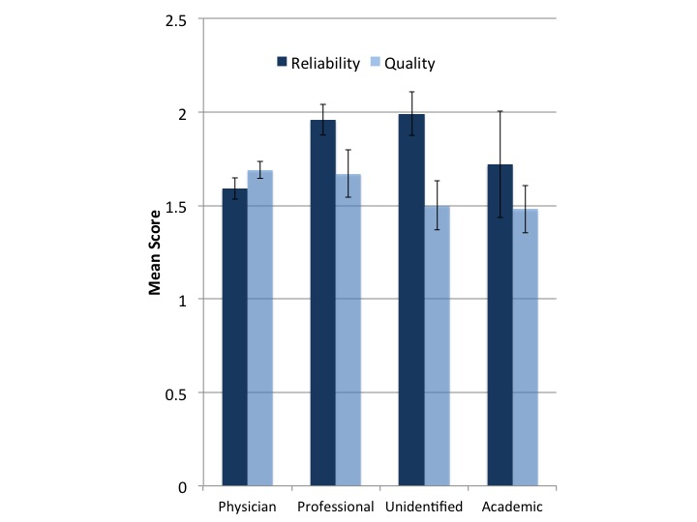

**Figure 2**. Mean Reliability and Quality Scores as determined using the DISCERN instrument. Error bars represent standard error of means.

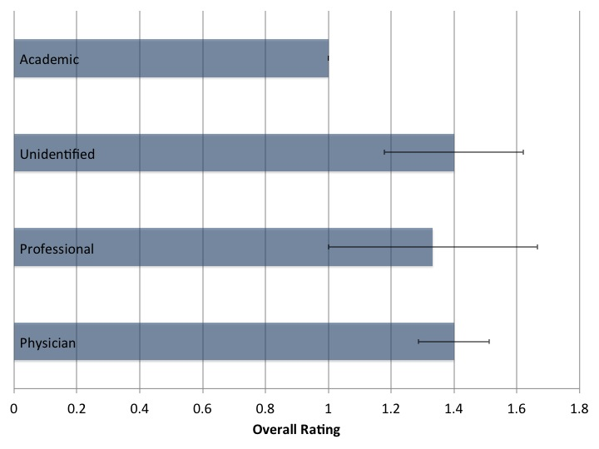**Figure 3**. Mean scores for overall rating. Error bars represent standard error of means.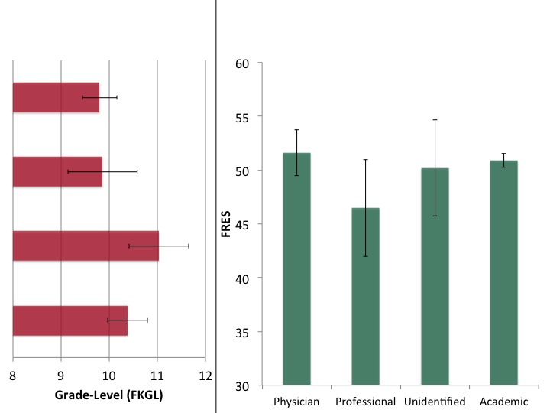

**Figure 4**. Readability scores of online patient education materials related to rhytidectomy. Grade-levels (left) derived from Flesch-Kincaid Grade Level Score (FKGL). FRES refers to Flesch Readability Ease Scale. Error bars represent standard error of means.