Table of Contents

title: “ArchLucid platform architecture handbook”
subtitle: “Version 2026.08.06d â€” generated from docs/architecture/architecture_handbook”

ArchLucid platform architecture handbook
Version: 2026.08.06b (see VERSION)
Canonical poster: docs/ARCHITECTURE_ON_ONE_PAGE.md
Diagram index: docs/architecture/architecture_diagrams/

Purpose
Provide a single, regenerable document that:
- Explains the ArchLucid product platform end-to-end (system context â†’ containers â†’ pipelines â†’ trust â†’ ops).
- Embeds the approved zoom-in diagrams next to the prose they illustrate.
- Points to ADRs and library docs for depth without duplicating every runbook.

Assumptions
- Azure-first hosting (Container Apps, SQL, private networking) unless a pilot diverges.
- Incomplete requirements and imperfect rollout are normal; backlogs stay observable (outboxes, health, metrics).

Constraints
- No public SMB; storage and queues use private endpoints and managed identity where possible.
- Single DDL source per database.
- Configuration bridge: ArchLucid* keys remain authoritative with legacy overrides until sunset.

What this handbook is not
It is not a customer architecture review package. ArchLucid produces those from evidence through the authority pipeline. This handbook is platform documentation maintained in-repo and exported to Word for offline review.

1. System context
ArchLucid turns architecture requests and evidence into versioned packages (golden manifests), decision traces, governance evidence, and exportable artifacts.

Actors
Actor | How they touch the system
Operators / architects | Browser â†’ Architect workspace (Next.js)
Sponsors / evaluators | Same UI; sponsor-oriented views and packages
CLI / CI automation | HTTPS â†’ API (API key or JWT), optionally via Front Door / APIM

Diagram â€” system overview
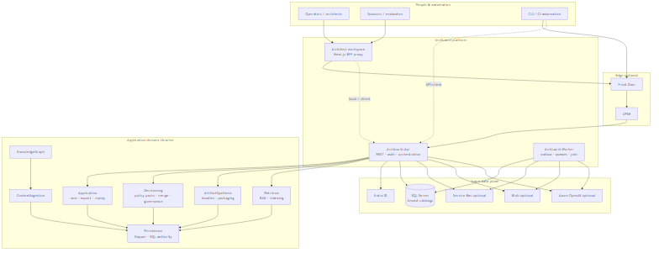
ArchLucid system overview

Diagram â€” review happy path
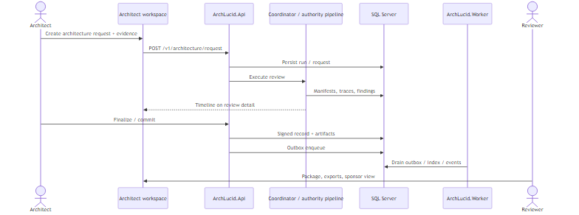
ArchLucid review happy path

Trust edges (summary)
- UI proxies to ArchLucid.Api with scope and correlation headers.
- API authenticates via Entra ID / JWT or API keys (environment-dependent).
- Authoritative persistence is SQL Server (database-per-tenant catalogs).
- Azure OpenAI, Service Bus, and Blob are optional for live models, integration fan-out, and large artifacts.

2. Containers and domain libraries

Deployable containers
Container | Responsibility
archlucid-ui | Operator / marketing shell; BFF proxy to API
ArchLucid.Api | Versioned REST, authZ, orchestration entry
ArchLucid.Worker | Outbox drain, queues, long-running jobs
ArchLucid.Cli | Scripted run lifecycle and graph export

Major libraries
Library | Responsibility
ArchLucid.Application | Runs, export, replay, analysis orchestration
ArchLucid.Decisioning | Policy packs, merge, governance, schema validation
ArchLucid.Persistence | Dapper SQL authority + workflow data access
ArchLucid.ContextIngestion | Evidence / context pipeline
ArchLucid.KnowledgeGraph | Graph snapshots from context
ArchLucid.ArtifactSynthesis | Artifact generators and packaging
ArchLucid.Retrieval | Embedding / indexing / Ask RAG path
ArchLucid.Host.Composition | DI graphs shared by Api and Worker
Deep dive: docs/library/ARCHITECTURE_CONTAINERS.md, docs/library/ARCHITECTURE_COMPONENTS.md.

3. Authority pipeline
Canonical path after POST /v1/architecture/request: persist the run, run or queue AuthorityPipelineStagesExecutor, then transactional finalize into a golden manifest, decision trace, and outboxes.

Diagram
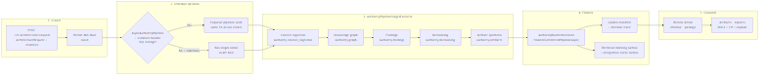
ArchLucid authority pipeline

Stages (OpenTelemetry)
Stage | Span name
Context ingestion | authority.context_ingestion
Knowledge graph | authority.graph
Findings | authority.findings
Decisioning | authority.decisioning
Artifact synthesis | authority.artifacts
Spans carry tag archlucid.stage.name for support correlation.

Detail
See docs/library/ARCHITECTURE_FLOWS.md (Flow A0), docs/library/CANONICAL_PIPELINE.md, docs/architecture/architecture_diagrams/archlucid-authority-pipeline.md.

4. Authority vs legacy coordinator
Two mental models can produce a golden manifest. Always inspect GET /v1/architecture/review/{runId} before calling execute / result / finalize.

Diagram
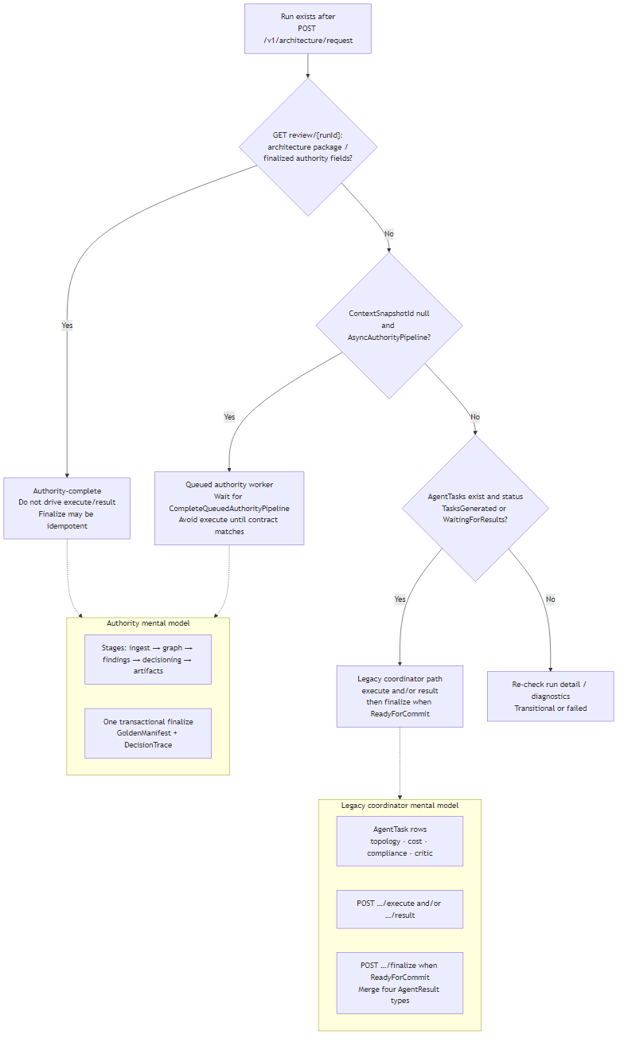
ArchLucid authority vs coordinator

Rule of thumb
Observation | Action
Finalized architecture package present | Authority-complete â€” do not drive execute/result
ContextSnapshotId null + async pipeline | Wait for worker
AgentTasks in TasksGenerated / WaitingForResults | Legacy coordinator path
Neither | Diagnostics / transitional / failed
Contract matrix: docs/library/AUTHORITY_VS_AGENTTASK_LOOP_CANONICAL_PATH_CONTRACT.md (TB-1007).

5. Async authority pipeline and outboxes
On SQL with AsyncAuthorityPipeline default-on and an evidence bundle present, pipeline work is enqueued in the same transaction as run create. The Worker completes stages via CompleteQueuedAuthorityPipelineAsync.

Diagram
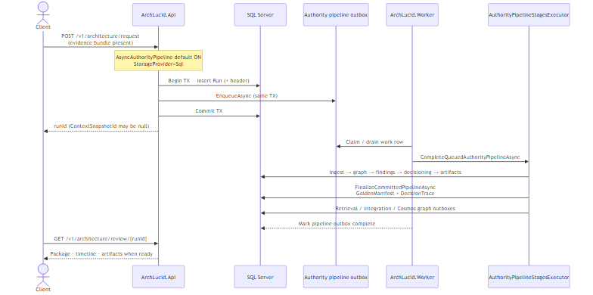
ArchLucid async outbox path

Related outboxes
Outbox | Purpose
Authority pipeline work | Durable stage execution after create
Retrieval indexing | Post-commit embedding / index (ADR 0004)
Cosmos graph snapshot | Async graph persistence when enabled (ADR 0038)
Integration events | Downstream / webhook fan-out
Local opt-out: AsyncAuthorityPipeline: false in appsettings.Advanced.json. InMemory never queues.

6. Governance and policy packs
Policy packs are the adaptive brain of governance: rules, alerts, and advisory defaults ship as JSON/YAML and merge hierarchically at tenant, workspace, or project scope. The evaluation engine in ArchLucid.Decisioning stays decoupled from framework-specific knowledge.

Diagram
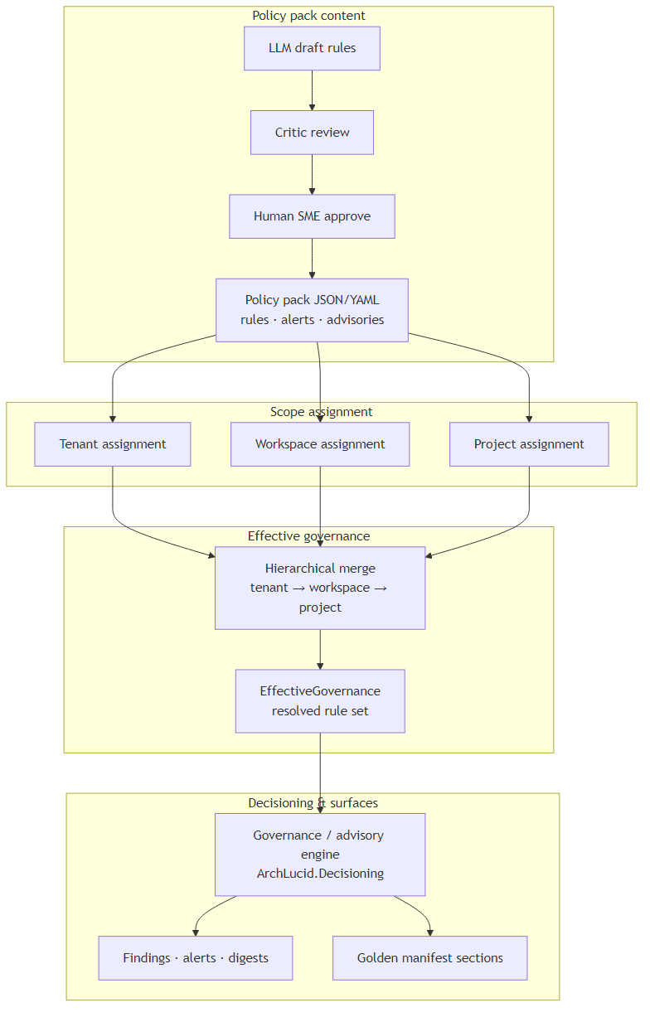
Governance and policy packs
Content velocity: LLM draft â†’ critic â†’ human SME. See docs/library/POLICY_PACK_CONTENT_BACKLOG.md.

7. Tenant isolation
Normative model (ADR 0037): production isolation is database-per-tenant catalogs, not SQL RLS. Workspace and project are organizational dimensions within a catalog, not paying-client security boundaries. SingleCatalog is fail-fast in production-like hosts.

Diagram
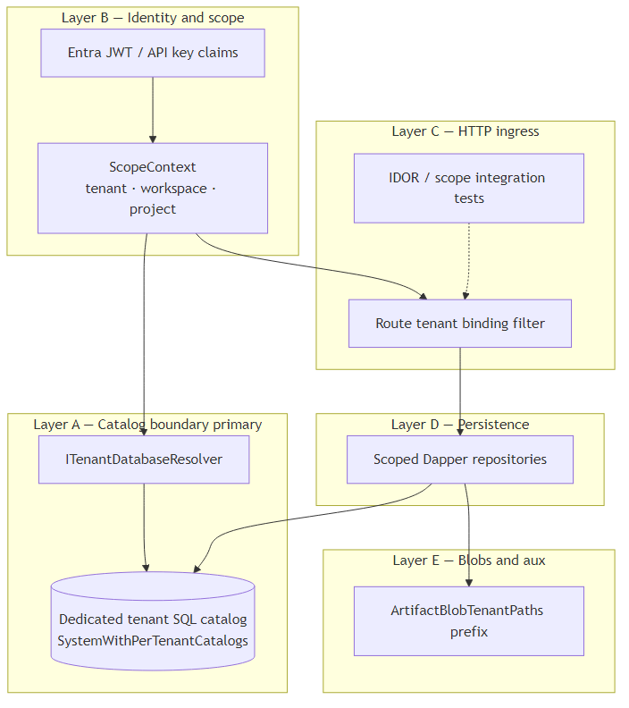
Tenant isolation
Trusted scope on production-like hosts comes from JWT/API-key claims or ambient job override â€” not from x-tenant-id headers alone. See docs/security/TENANT_ISOLATION_DEFENSE_IN_DEPTH.md.

8. Azure deployment topology
Terraform under infra/ is the IaC source of truth. Workloads typically run as Container Apps (Api + Worker) against Azure SQL with per-tenant catalogs, Key Vault / managed identity, optional Front Door/APIM, Service Bus, Blob, OpenAI, Redis, and Cosmos.

Diagram
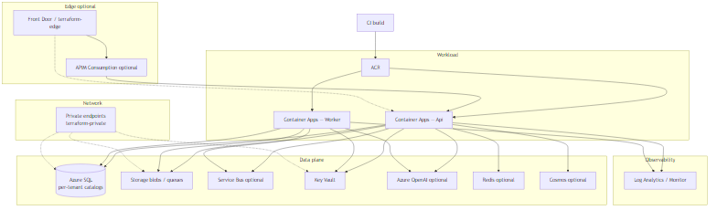
Azure topology
SQL schema is applied by the application host (DbUp), not inline Terraform scripts. Map of roots: docs/library/DEPLOYMENT_TERRAFORM.md.

9. Security model
Default deny on API controllers; Entra JWT or API keys; claims-based policies; production fail-closed on unsafe CORS, webhook HMAC gaps, billing misconfiguration, and SingleCatalog.

Diagram
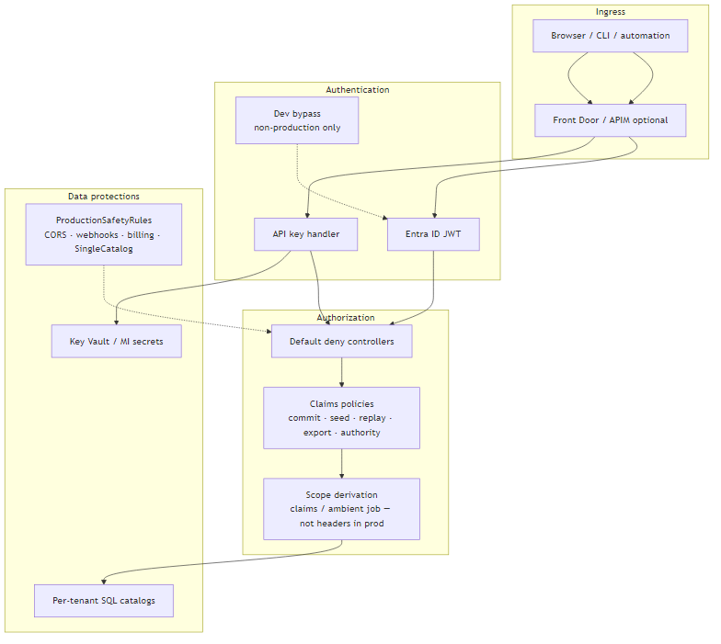
Security model
Secrets prefer Key Vault and managed identity. See also tenant isolation (chapter 7) and docs/ARCHITECTURE_ON_ONE_PAGE.md Â§7.

10. Data and persistence
Workflow Dapper repositories (Persistence.Data.*) and authority persistence (manifests, traces, UoW, outboxes) share SQL catalogs routed per tenant. One DDL source per database; forward-only migrations.

.NET project graph
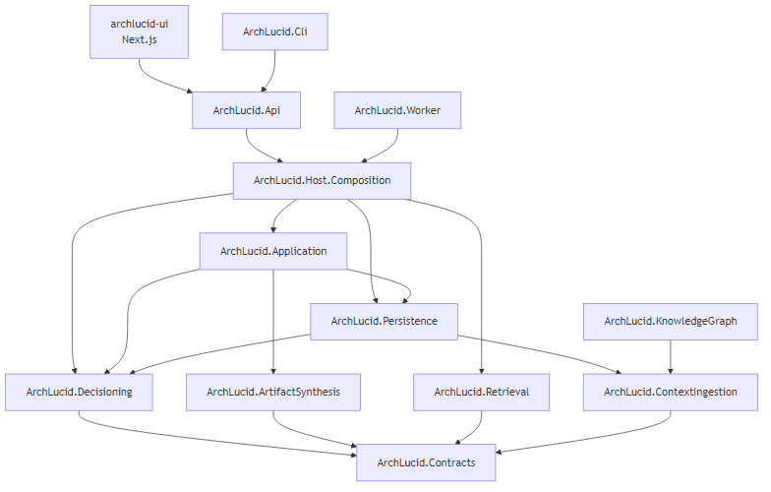
.NET project graph
See docs/library/DATA_MODEL.md, docs/library/ARCHITECTURE_COMPONENTS.md.

11. Operator UI shell
Next.js app under archlucid-ui/: marketing vs operator shell, server BFF proxy with scope and correlation headers, heavy clients deferred off hot paths.

Diagram
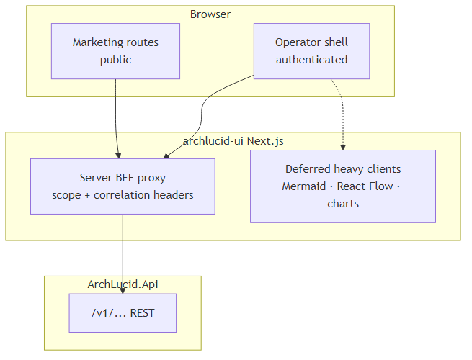
Operator UI shell
See archlucid-ui/docs/ARCHITECTURE.md, docs/library/operator-shell.md.

12. Exports, comparisons, synthesis, retrieval, and integrations

Export and replay
Export and replay

Comparison and drift
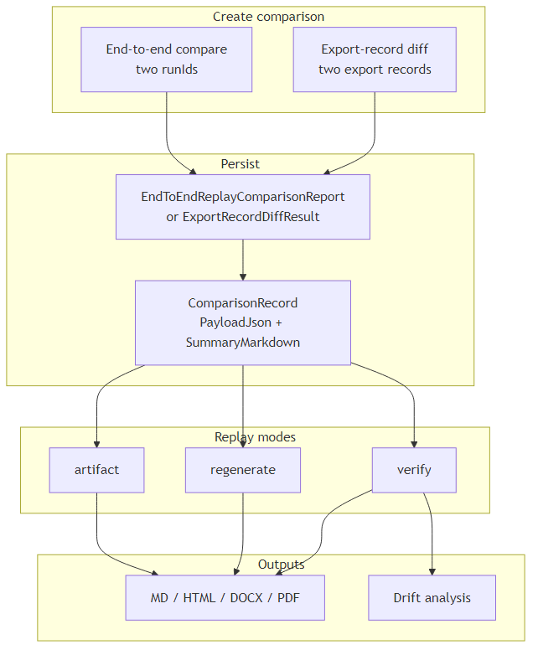
Comparison and drift

Artifact synthesis
Artifact synthesis

Retrieval / RAG
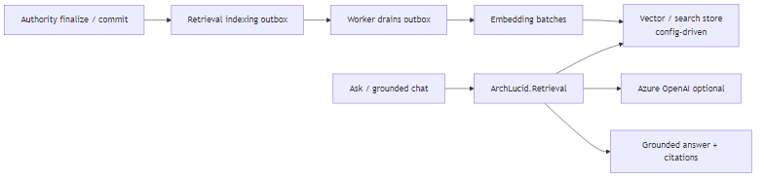
Retrieval RAG

Integrations / ITSM
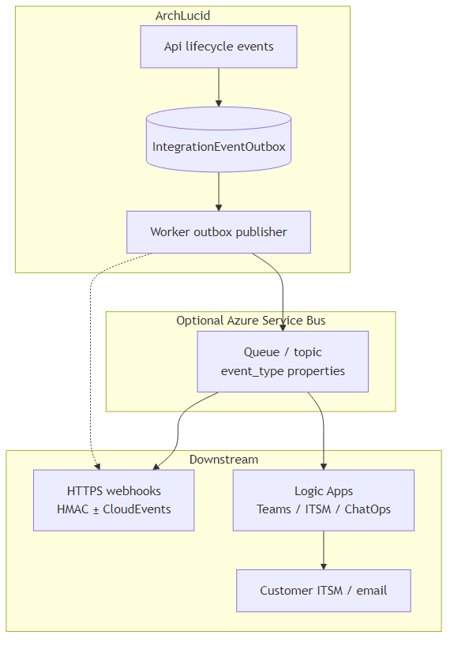
Integrations ITSM

First-run pilot path
First-run pilot
Deep dives: docs/library/ARCHITECTURE_FLOWS.md, COMPARISON_REPLAY.md, INTEGRATION_EVENTS_AND_WEBHOOKS.md, CANONICAL_FIRST_RUN_PATH.md.

13. Authority pipeline stage zoom-ins
Each authority stage emits an OpenTelemetry span with tag archlucid.stage.name. Queued and inline paths share the same stage executor.

Context ingestion
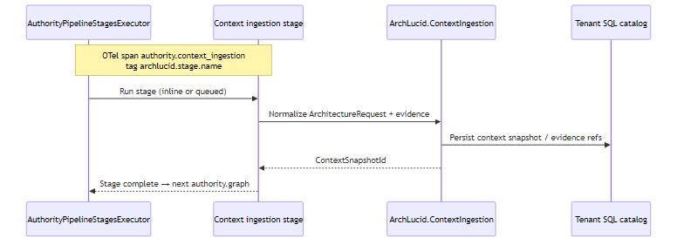
Context ingestion stage

Knowledge graph
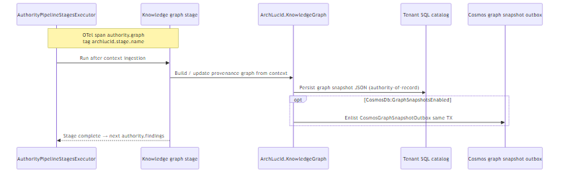
Knowledge graph stage

Findings
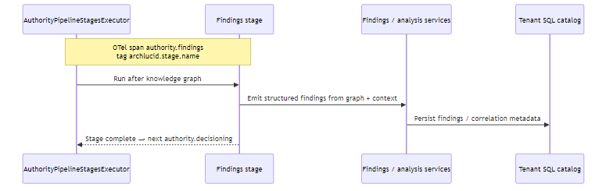
Findings stage

Decisioning
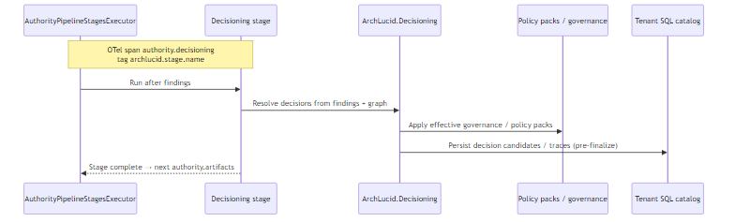
Decisioning stage

Artifacts and finalize
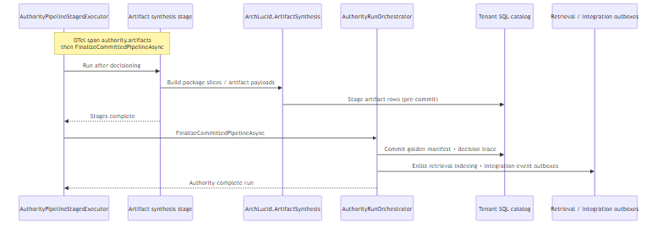
Artifacts and finalize

Detail
See docs/library/CANONICAL_PIPELINE.md, docs/library/BACKGROUND_JOB_CORRELATION.md, and diagram companions under docs/architecture/architecture_diagrams/.

14. Failure resilience and failover continuity

Failure resilience
Authority create enlists pipeline outbox work in the same SQL transaction as the run header (ADR 0038). Worker completion retries follow orchestrator and hosted-service lease semantics; Cosmos graph snapshots are eventually consistent projections of SQL authority.
Failure resilience

Failover continuity
Primary posture is Azure Container Apps + per-tenant Azure SQL catalogs, managed identity, Key Vault, health/outbox probes, and per-catalog backup. Failover is redeploy + SQL continuity controls documented in operations runbooksâ€”not an active-active multi-region product claim unless a pilot SoW states otherwise.
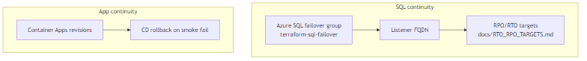
Failover continuity

Detail
- docs/library/ORCHESTRATOR_RETRIES.md
- docs/architecture/adrs/0038-run-durability-multi-store-outbox-production-secrets.md
- docs/operations/TENANT_SQL_TOPOLOGY_RUNBOOK.md

15. Threat models (Ask / RAG and webhooks)
Focused threat sketches for two high-traffic attack surfaces. Full security model remains chapter 9 and ADR 0037.

Ask / RAG
Threats: cross-tenant retrieval probes, prompt injection, unbounded spend. Controls: identity-derived scope, tenant-filtered retrieval corpus, grounded citations, quotas.
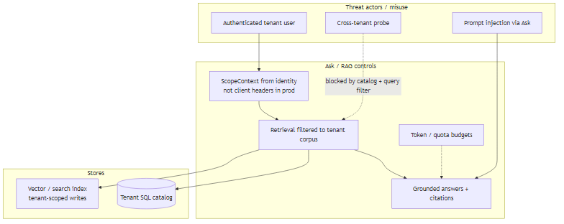
Ask / RAG threat model

Inbound webhooks
Threats: unsigned, replayed, or oversized posts. Controls follow INV-015 spine: rate â†’ bounded size â†’ verify â†’ parse â†’ fast ack, with fail-closed secrets and tenant correlation into the correct catalog.
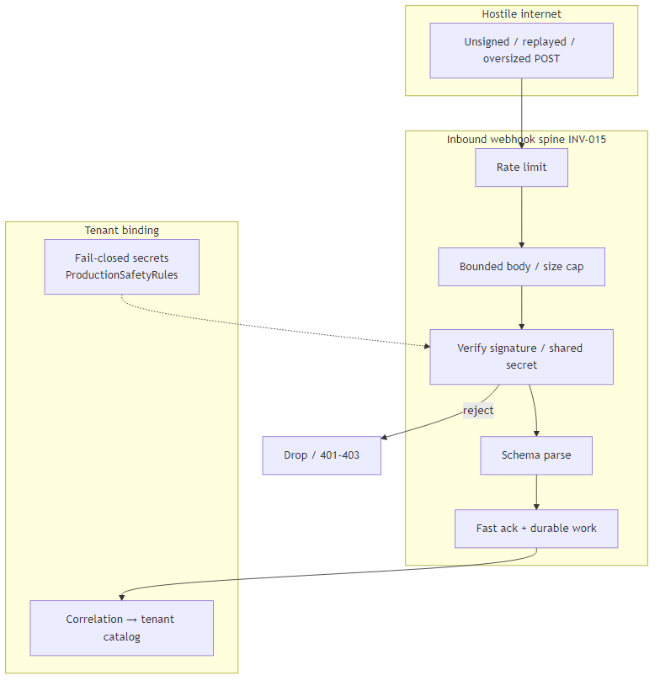
Webhook threat model

Detail
- docs/security/TENANT_ISOLATION_DEFENSE_IN_DEPTH.md
- docs/library/INTEGRATION_EVENTS_AND_WEBHOOKS.md
- docs/library/ARCHITECTURE_INVARIANTS.md (INV-015)

16. Data model (pragmatic ER)
Core authority tables hang off dbo.Runs. Comparison left/right run ids may omit FKs so historical rows stay referenceable. Full narrative: docs/library/DATA_MODEL.md.
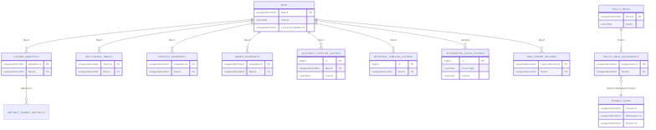
Data model ER
DDL source of truth: ArchLucid.Persistence/Scripts/ArchLucid.sql (one script per database).

17. Configuration precedence and fail-closed rules
Layered IConfiguration: appsettings â†’ Advanced/SaaS overlays â†’ environment wins â†’ in-memory bridges. Only ArchLucid* / ARCHLUCID_* are authoritative; legacy ArchiForge* keys warn and are ignored.
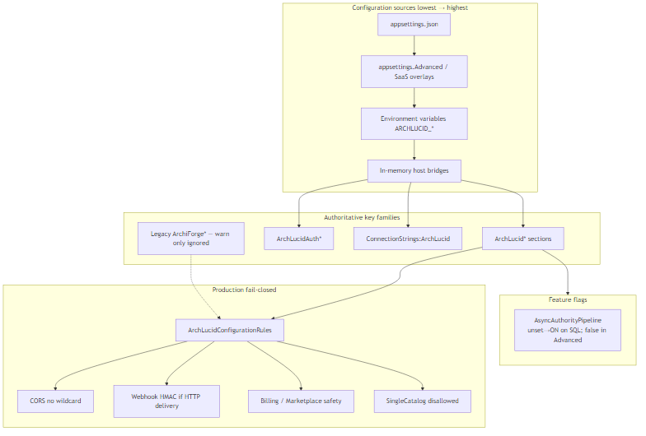
Config precedence
See docs/library/CONFIGURATION_REFERENCE.md, CONFIGURATION_ARCHITECTURE_PRECEDENCE_VALIDATION_DRIFT_CLAIM_MAP.md, CONFIG_BRIDGE_SUNSET.md.

18. Authentication by route tier
Anonymous health/version, unscoped marketing/webhook routes, and scoped operator /v1/* with JWT or API keys. Production-like hosts reject header-only scope and development bypass.
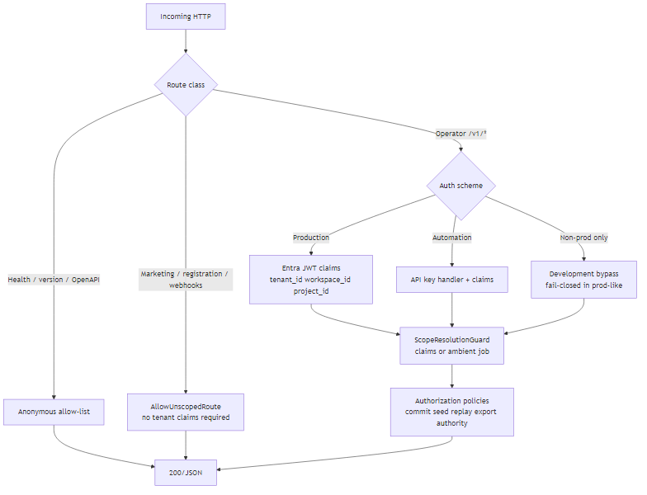
AuthN route matrix
See tenant isolation chapter and docs/security/TENANT_ISOLATION_DEFENSE_IN_DEPTH.md.

19. Pilot day-0 / day-1 wireflow
Operator click-path (not C4): signup â†’ intake â†’ first review â†’ finalize â†’ export â†’ invite reviewer â†’ ongoing compare/Ask.
Pilot day0 day1
See docs/CORE_PILOT.md, docs/library/CANONICAL_FIRST_RUN_PATH.md.

20. FinOps and capacity drivers
Dominant spend: Azure OpenAI (completions + embeddings), Azure SQL (especially per-tenant catalogs), Container Apps replicas. Optional bus/blob/edge add marginal cost.
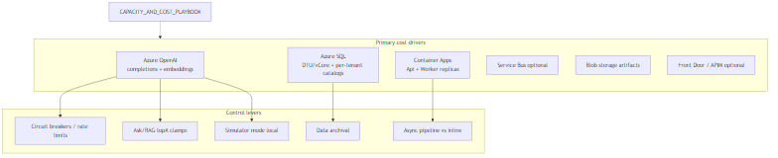
FinOps cost
Playbook: docs/library/CAPACITY_AND_COST_PLAYBOOK.md.

21. Observability map
Authority stages emit OpenTelemetry spans (authority.*, tag archlucid.stage.name). Outbox depth and pipeline timeouts surface as meters; support correlates logs via correlation id + runId.
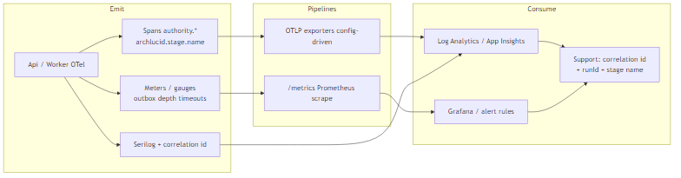
Observability map
Alerts: infra/prometheus/archlucid-alerts.yml. Background correlation: docs/library/BACKGROUND_JOB_CORRELATION.md.

22. DR / failover drill storyboard
SQL geo failover group listener is the app connection target. Drill: confirm listener â†’ force failover â†’ Api/Worker follow listener â†’ smoke /health/ready + synthetic review â†’ record actual RTO vs targets.
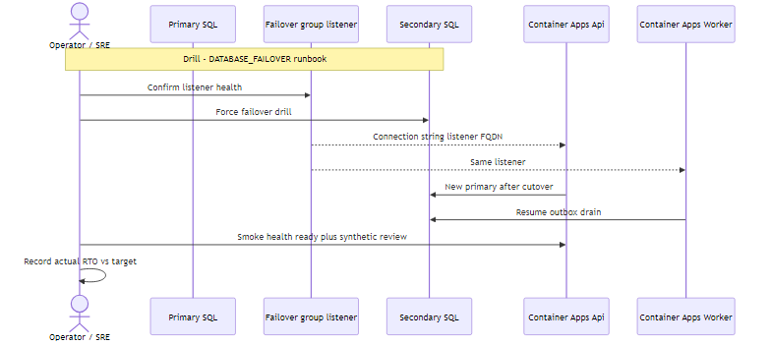
DR failover drill
See docs/runbooks/DATABASE_FAILOVER.md and docs/RTO_RPO_TARGETS.md (when present in tree).

23. Policy-pack authoring SDLC
Content velocity: LLM draft â†’ critic â†’ SME â†’ publish â†’ scope assign â†’ hierarchical effective merge â†’ advisory hits on reviews.
Policy pack SDLC
Samples under docs/samples/policy-packs/. Backlog: docs/library/POLICY_PACK_CONTENT_BACKLOG.md.

24. API surface heat map
Public/demo routes stay lightly authenticated; operator architecture APIs use fixed/expensive rate limits; comparisons, Ask, and reports are heavier; governance/admin are authority-gated.
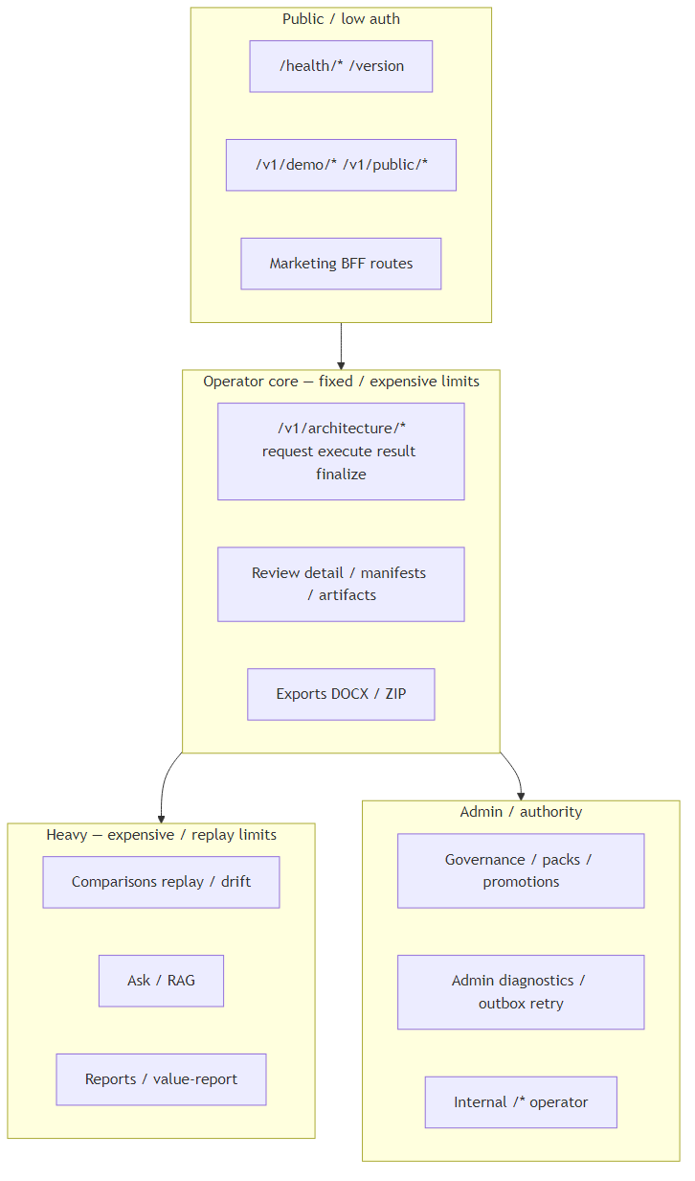
API surface heatmap
Contracts: docs/library/API_CONTRACTS.md. Atlas: docs/library/OPERATOR_ATLAS.md.

25. Evidence intake to context snapshot
Evidence (brief, documents, images, cloud ZIP) is validated in the intake wizard or API, assigned an evidence-bundle id, then consumed by authority context ingestion into a ContextSnapshot linked from dbo.Runs.
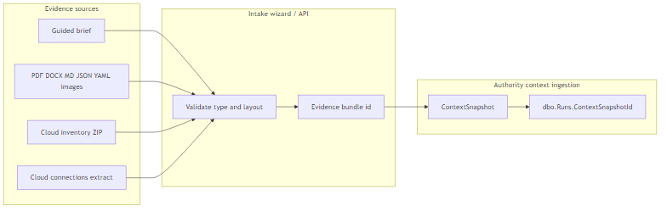
Evidence intake
See docs/library/customer-facing/EVIDENCE_INTAKE_OPERATOR_GUIDE.md.

26. Golden manifest anatomy
The committed architecture package (API: golden manifest) carries topology, cost, compliance, and critic-oriented sections plus version/scope metadata. UI panels and consulting exports read from this shape; a decision trace is the companion audit trail.
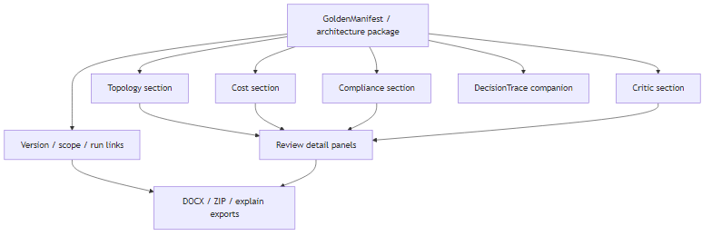
Golden manifest anatomy

27. Decision-trace replay walkthrough
Support and audit path: finding â†’ decision-trace entry â†’ policy rule id â†’ evidence/snapshot hint â†’ â€œwhy this firedâ€ for sponsors.
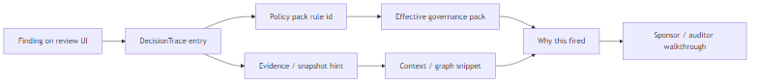
Decision trace replay

28. Billing, trial, and Marketplace
V1 ships wiring and sales-led pricing; live Stripe keys, published Marketplace offer, and signup DNS cutover remain owner flips (V1.1 candidate). Production safety rules fail closed on unsafe billing config.
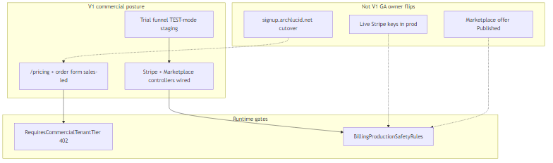
Billing trial Marketplace
See docs/library/V1_SCOPE.md commerce rows.

29. SCIM and users & roles
Inbound SCIM 2.0 (/scim/v2/*) uses per-tenant bearer tokens, maps groups to roles, and feeds seat accounting. Resulting users surface in operator users-and-roles; tokens become JWT/session claims for authZ policies.
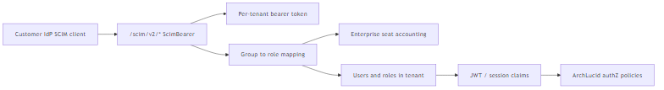
SCIM users roles
ADR 0032 Â· docs/integrations/SCIM_PROVISIONING.md.

30. Digest and alert subscriptions
Schedules drive advisory scans â†’ digest payloads â†’ tenant channel preferences (email / Teams / webhook) and optional Service Bus / Logic Apps fan-out via the integration outbox.
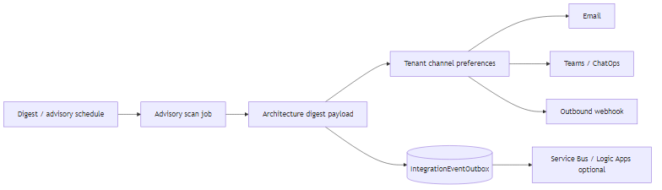
Digest alert subscriptions

31. Hot-path performance
Mermaid, React Flow, and charts stay behind dynamic imports (import-policy tests). List APIs should avoid fat JSON blobs; caching decorators and rate-limit classes protect expensive routes.
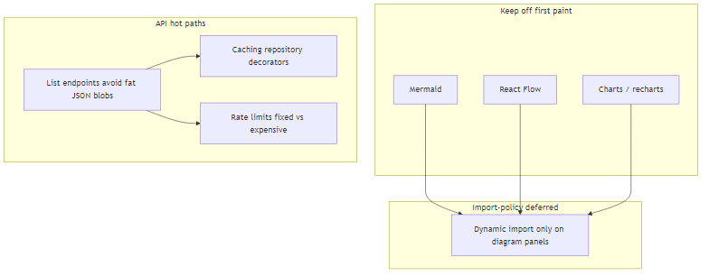
Hot path performance

32. Storage provider modes
InMemory never queues authority (dev/tests). Sql is the production path and must use SystemWithPerTenantCatalogs on hosted workloads; SingleCatalog is CI/local only and fail-closed in prod-like hosts. Cosmos graph remains an optional outbox side path.
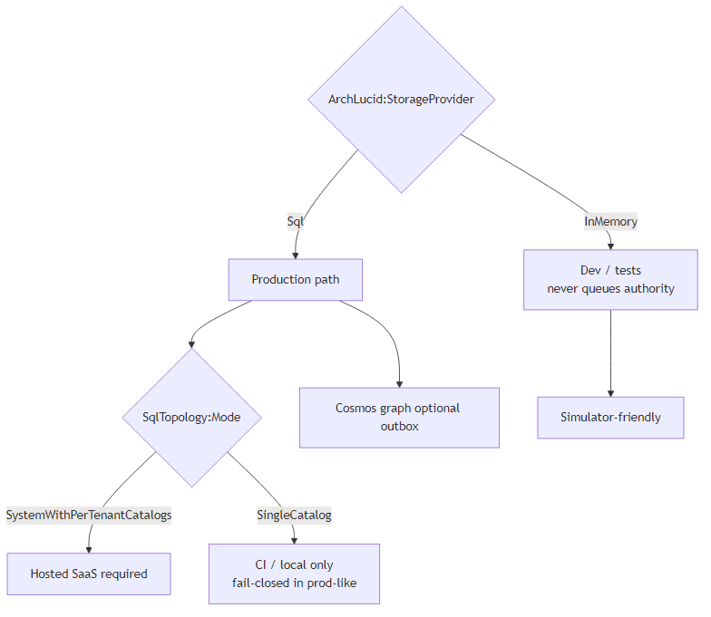
Storage provider modes

33. Compliance claim honesty board
Trust-center copy may describe owner pen-test posture, SOC self-assessment honesty, ADR 0037 isolation, and default-deny API. It must not imply a CPA SOC 2 report or a published third-party pen test until those exist (GTM G-REAL-05, G-ASSURANCE-02). Tech TB-135/TB-136 tracking is closed; owner execution remains open.
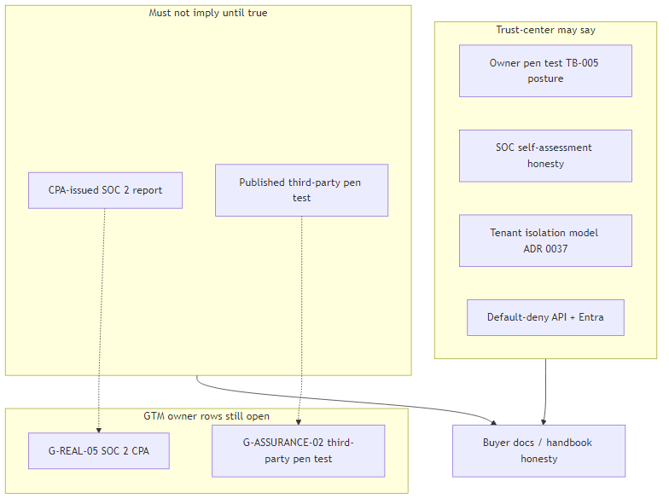
Compliance claim honesty

34. Agent-task / simulator matrix
Authority-complete runs must not be driven with execute/result. Legacy coordinator expects four AgentResult types (topology, cost, compliance, critic) before finalize. Executor may be simulator or real Azure OpenAI.
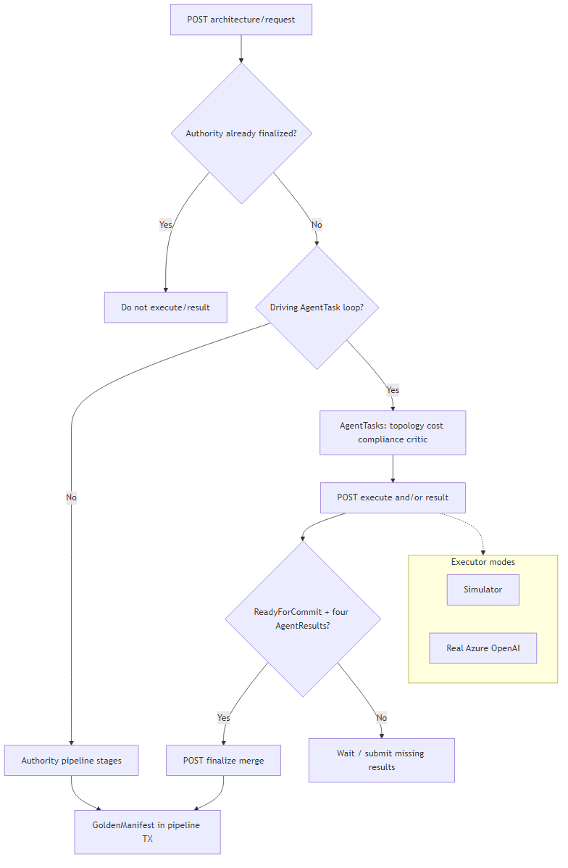
Agent task simulator matrix
See AUTHORITY_VS_AGENTTASK_LOOP_CANONICAL_PATH_CONTRACT.md (TB-1007).

Changelog (handbook)
Version | Date | Notes
2026.08.06d | 2026-08-06 | Expansion set 3: evidence intake, manifest anatomy, decision-trace replay, billing/trial, SCIM, digests, hot-path, storage modes, compliance honesty, agent-task/simulator.
2026.08.06c | 2026-08-06 | Expansion set 2: ER, config, authN, pilot, FinOps, observability, DR, policy SDLC, API heatmap, release workflow.
2026.08.06b | 2026-08-06 | Restored spine + stages/threats/buyer/drift.
living | prior | Original chapters 00â€“12 + 99.

References
Need | Doc
One-page poster | docs/ARCHITECTURE_ON_ONE_PAGE.md
C4 index | docs/architecture/README.md
Diagrams (Mermaid + SVG) | docs/architecture/architecture_diagrams/
Flows | docs/library/ARCHITECTURE_FLOWS.md
Containers | docs/library/ARCHITECTURE_CONTAINERS.md
Components | docs/library/ARCHITECTURE_COMPONENTS.md
ADRs | docs/architecture/adrs/
V1 scope | docs/library/V1_SCOPE.md
API contracts | docs/library/API_CONTRACTS.md
Tenant isolation | docs/security/TENANT_ISOLATION_DEFENSE_IN_DEPTH.md
Operator atlas | docs/library/OPERATOR_ATLAS.md

