Table of Contents

title: “ArchLucid buyer trust and topology pack”
subtitle: “Version 2026.08.06h â€” generated from docs/architecture/architecture_handbook”

Buyer front matter â€” ArchLucid platform architecture (excerpt)
Pack: Buyer
Version: see ../VERSION
Audience: Evaluators, security reviewers, and procurement technical readers.

What this pack is
A short, diagram-backed excerpt of how the ArchLucid platform is built and operated (Azure-first, authority pipeline, tenant isolation).

What this pack is not
It is not a customer architecture review package produced by ArchLucid for a tenantâ€™s systems. Those come from evidence through the product authority pipeline and product exports.

Honesty
- Production tenant isolation is database-per-tenant (ADR 0037). SQL Row-Level Security is not the production control.
- Async authority pipeline + transactional outbox is the SQL default (ADR 0038).
- CPA SOC 2 attestation and third-party pen-test publication are owner/GTM tracks â€” do not infer them from this pack.

1. System context (buyer)
ArchLucid is an Azure-first architecture authority platform: operators use the architect workspace; automation calls the versioned API; SQL holds authoritative run state; Worker drains outboxes; Azure OpenAI / Service Bus / Blob are optional depending on profile.
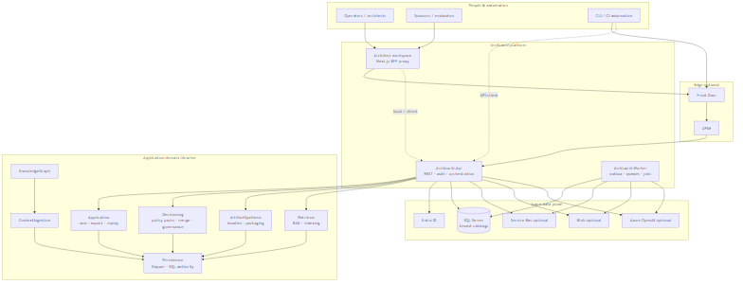
System overview
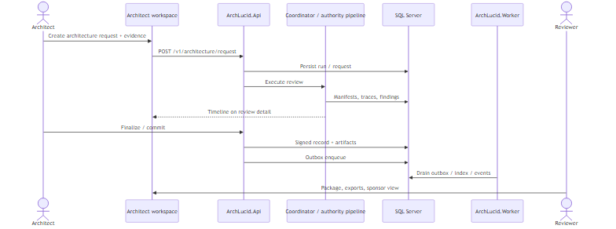
Review happy path

2. Authority pipeline (buyer)
A review request persists a run, then runs (or queues) five stagesâ€”context ingestion, knowledge graph, findings, decisioning, artifact synthesisâ€”before transactional finalize into a golden manifest and decision trace.
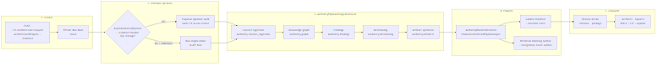
Authority pipeline

3. Tenant isolation (buyer)
Primary control: one product SQL catalog per tenant (SystemWithPerTenantCatalogs), resolved at connection time.
Not used in production: SQL Row-Level Security (removed; ADR 0037).
Defense-in-depth adds identity scope, HTTP route binding, scoped repositories, and tenant-prefixed blobs.
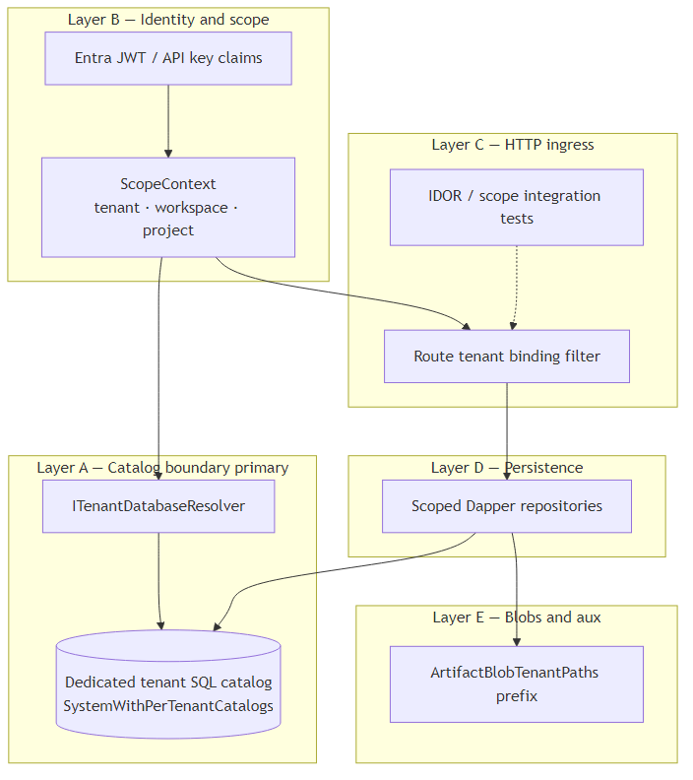
Tenant isolation

4. Security model (buyer)
Ingress via browser/CLI (optional Front Door/APIM), Entra JWT or API keys, default-deny controllers with claims policies, production-like Key Vault / managed identity, and startup safety rules (including blocking single-catalog SQL in production-like hosts).
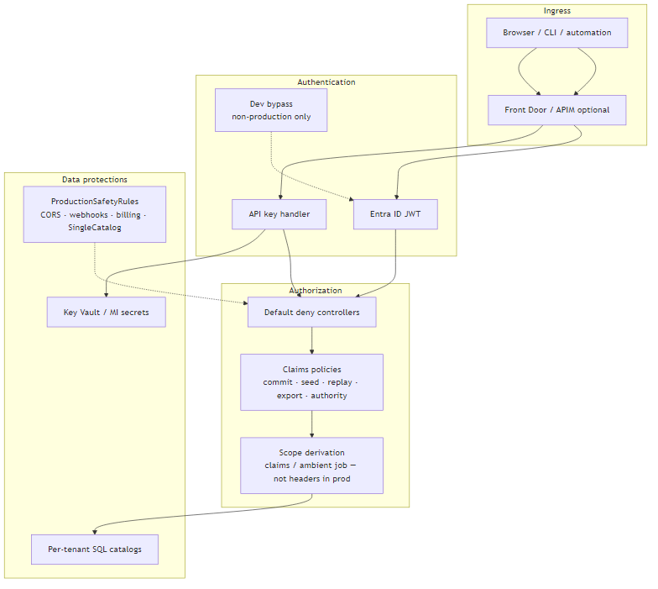
Security model

5. Azure topology (buyer)
Representative hosted shape: Container Apps for Api and Worker, Azure SQL (per-tenant catalogs), optional Service Bus / Blob / Azure OpenAI, Entra ID, private endpoints and managed identity where pilots require them. Exact SKUs follow Terraform and the pilot SoW.
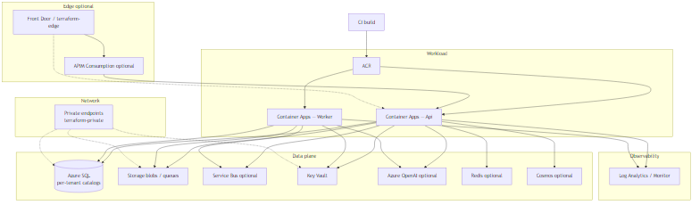
Azure topology

Buyer references
Need | Doc
Full platform handbook | docs/architecture/architecture_handbook/README.md
Diagram index | docs/architecture/architecture_diagrams/README.md
ADR 0037 tenant isolation | docs/architecture/adrs/0037-tenant-isolation-without-rls-defense-in-depth.md
ADR 0038 outbox / durability | docs/architecture/adrs/0038-run-durability-multi-store-outbox-production-secrets.md
Trust / isolation buyer page | docs/go-to-market/TENANT_ISOLATION.md
One-page poster | docs/ARCHITECTURE_ON_ONE_PAGE.md
Handbook vs product capabilities | docs/architecture/PLATFORM_HANDBOOK_VS_PRODUCT_CAPABILITIES.md

