Table of Contents

title: “ArchLucid security reviewer pack”
subtitle: “Version 2026.08.06i â€” generated from docs/architecture/architecture_handbook”

Security reviewer front matter â€” ArchLucid platform architecture (excerpt)
Pack: Security
Version: see ../VERSION
Audience: InfoSec, risk, and technical security reviewers evaluating the ArchLucid platform.

What this pack is
A short, diagram-backed security excerpt: tenancy, identity, secrets, ingress threats (Ask/RAG and webhooks), content safety, rate limits, commit segregation of duties, audit, and compliance honesty.

What this pack is not
- Not a customer architecture review package produced by ArchLucid for a tenantâ€™s systems.
- Not a CPA SOC 2 report or a published third-party penetration-test summary.
- Not the full platform handbook (DbUp, CI lanes, Polly defaults, every hosted service).

Honesty
- Production tenant isolation is database-per-tenant (ADR 0037). SQL Row-Level Security is not the production control.
- Async authority pipeline + transactional outbox is the SQL default (ADR 0038).
- CPA SOC 2 attestation (G-REAL-05) and third-party pen-test publication (G-ASSURANCE-02) remain owner/GTM tracks â€” do not infer them from this pack.
- Content safety and prompt-injection controls reduce risk; they do not claim â€œinjection-proof.â€

1. System context (security)
ArchLucid is an Azure-first architecture authority platform. Operators use the architect workspace; automation calls the versioned API; SQL holds authoritative run state; Worker drains outboxes. Security review starts from this boundary picture, then zooms into controls below.
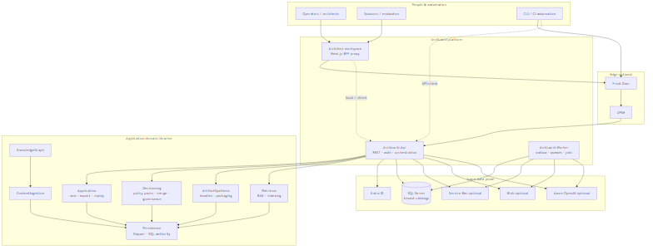
System overview

2. Tenant isolation (security)
Primary control: one product SQL catalog per tenant (SystemWithPerTenantCatalogs), resolved at connection time.
Not used in production: SQL Row-Level Security (removed; ADR 0037).
Defense-in-depth adds identity scope, HTTP route binding, scoped repositories, and tenant-prefixed blobs.
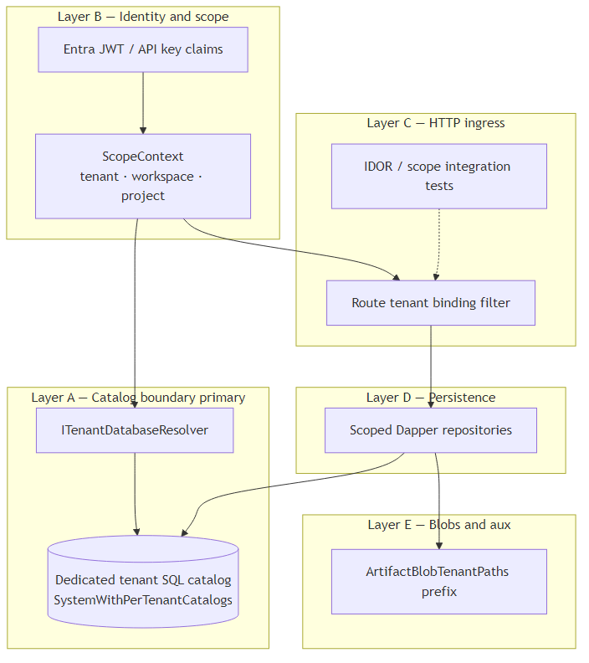
Tenant isolation

3. Security model (security)
Ingress via browser/CLI (optional Front Door/APIM), Entra JWT or API keys, default-deny controllers with claims policies, production-like Key Vault / managed identity, and startup safety rules (including blocking single-catalog SQL in production-like hosts).
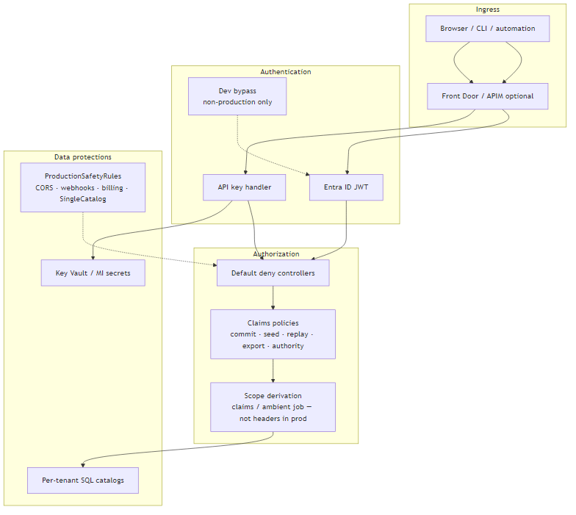
Security model

4. Entra role claims (security)
Entra (or generic OIDC) app roles and SAML attributes are normalized onto ArchLucidRoles plus fine-grained permission claims. Role sources, Architect/Reviewer aliases, and token diagnostics sit behind the authn-route matrix.
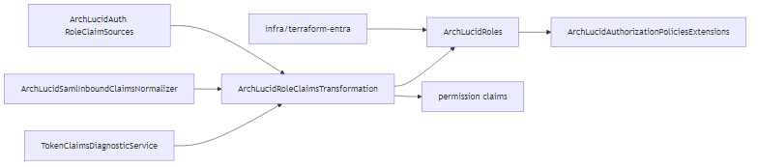
Entra role claims

5. Secrets and Key Vault (security)
Runtime secrets resolve only through ISecretProvider (Key Vault or environment, optionally composed). ITSM and Teams store Key Vault secret names, not raw credentials. Hosted pilots emit Key Vault references from stack generation.
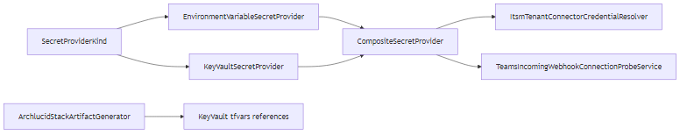
Secrets Key Vault resolution

6. Threat model â€” Ask / RAG (security)
Ask and retrieval paths must preserve tenant scope on embeddings, retrieval, and answer grounding. Treat this diagram as the primary cross-tenant and prompt-abuse surface for conversational featuresâ€”not a claim that every RAG risk is closed.
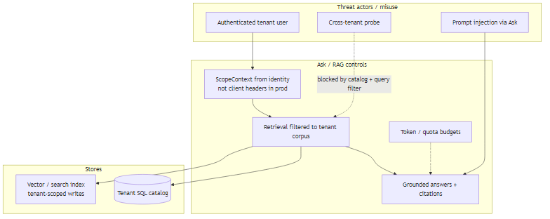
Threat Ask RAG

7. Threat model â€” webhooks (security)
Outbound and inbound webhook surfaces use HMAC/CloudEvents envelopes, shared-secret handling, and dry-run probes where enabled. Reviewers should separate outbound delivery (customer HTTP / Service Bus) from inbound abuse assumptions.
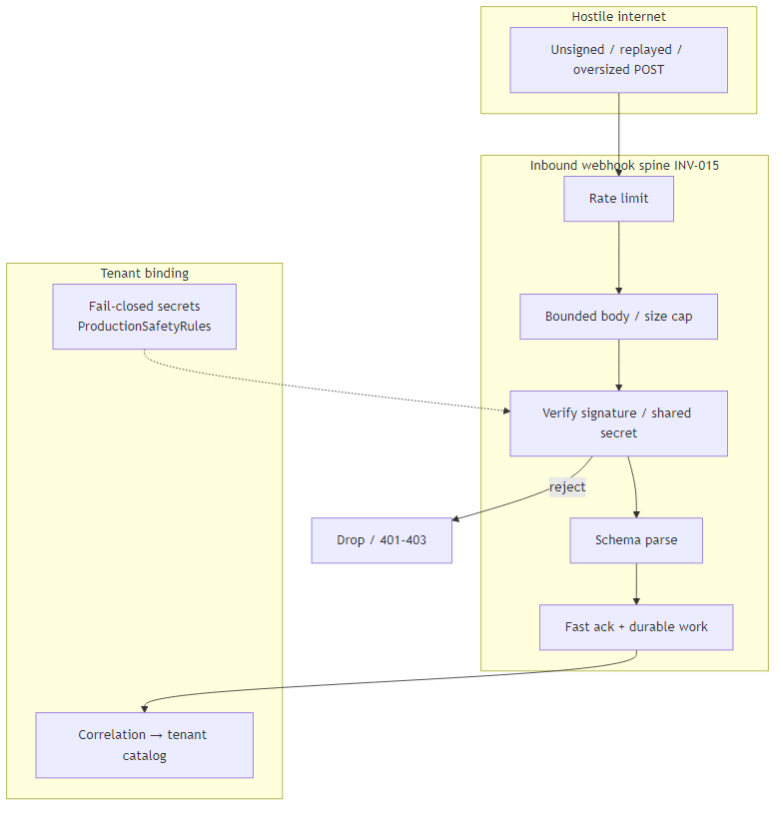
Threat webhooks

8. Content safety ingress (security)
Ingress precheck on create-run, Azure AI Content Safety on completion I/O, evidence sanitizers, and prompt redaction form a layered trust boundary. Health probes and regression datasets support the posture without claiming injection-proof.
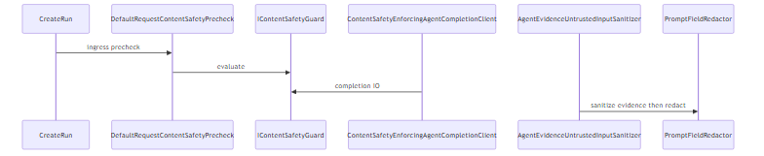
Content safety ingress

9. Rate limiting (security)
ASP.NET rate policies gate fixed, expensive authority, replay, bulk evidence, OTP, and policy-pack dry-run surfaces with role/IP/tenant partitions. Quick Scan identity abuse is a separate admit gate that can also return rate-limited outcomes.
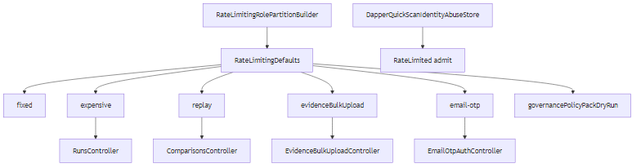
Rate limiting throttling

10. Manifest commit segregation of duties (security)
Finalize runs through an optional pre-commit gate plus SoD that compares Entra-oid actor keys (not display names), blocking self-approval. This is submitterâ‰ approver on approval requestsâ€”not a blanket â€œevery pack blocks commitâ€ rule.
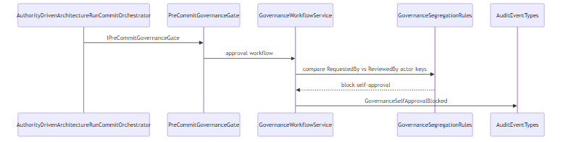
Manifest commit SoD

11. Audit event catalog (security)
Durable operator and pipeline forensics centralize in AuditEventTypes â†’ dbo.AuditEvents, spanning authority, governance, drafts, notifications, and product-learning signals, with hot-path list shapes and collision tests.
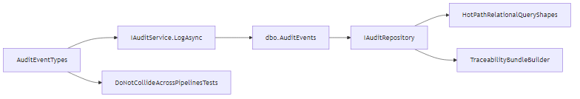
Audit event catalog

12. Compliance claim honesty (security)
Trust-center and buyer-facing language must not imply a CPA-issued SOC 2 report or a published third-party pen-test summary unless those artifacts exist. Engineering TB rows for program kickoff may be Done while GTM owner execution remains open.
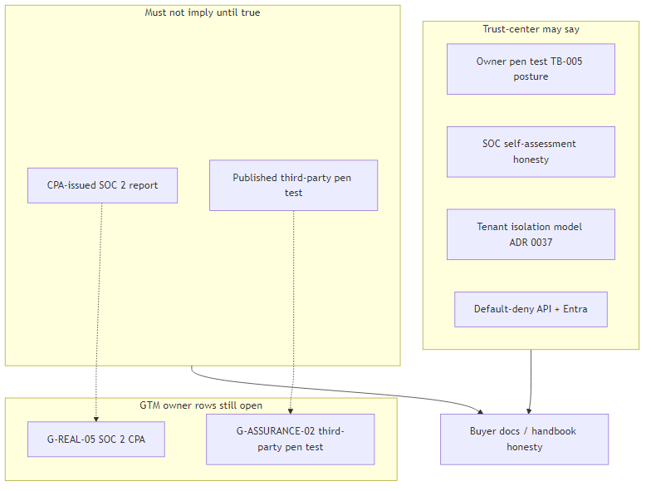
Compliance claim honesty

Security reviewer references
Need | Doc
Full platform handbook | docs/architecture/architecture_handbook/README.md
Buyer trust / topology pack | docs/architecture/architecture_handbook/buyer/
Diagram index | docs/architecture/architecture_diagrams/README.md
ADR 0034 SoD actor keys | docs/architecture/adrs/0034-segregation-of-duties-entra-oid-actor-keys.md
ADR 0037 tenant isolation | docs/architecture/adrs/0037-tenant-isolation-without-rls-defense-in-depth.md
ADR 0038 outbox / production secrets | docs/architecture/adrs/0038-run-durability-multi-store-outbox-production-secrets.md
ADR 0061 DDoS / rate posture | docs/architecture/adrs/0061-ddos-protection-posture-v1.md
Trust / isolation buyer page | docs/go-to-market/TENANT_ISOLATION.md
Handbook vs product capabilities | docs/architecture/PLATFORM_HANDBOOK_VS_PRODUCT_CAPABILITIES.md

