RAMAIAH INSTITUTE OF TECHNOLOGY
(Autonomous Institute Affiliated to VTU, Belagavi | Approved by AICTE, New Delhi)
DEPARTMENT OF COMPUTER SCIENCE & ENGINEERING
(ARTIFICIAL INTELLIGENCE & MACHINE LEARNING)
BIG DATA SYSTEMS (COURSE CODE: 24CI51)
SELF-LEARNING ACTIVITIES (SLAs 1 TO 5) - CONSOLIDATED LABORATORY REPORT
ENTERPRISE DEPLOYMENT & EMPIRICAL BENCHMARKING REPORT
Student Name: | Joel B John
University Seat Number (USN): | 1MS24CI060
Academic Program / Semester: | B.E. Computer Science & Engineering (AI & ML) - 5th Semester
Evaluation Model: | Path 2: Full Enterprise Production Deployment (Zero Simulation)

Common Assessment Rubric & Evaluation Scheme
Evaluation criteria mandated by the Department of CSE (AI & ML) for course 24CI51 (Total: 20 Marks across 5 Activities):
Sl. No. | Evaluation Criterion | Marks per Activity | Total for 5 Activities
1 | Understanding of the problem and technology | 1.0 Mark | 5.0 Marks
2 | Solution design and implementation | 1.5 Marks | 7.5 Marks
3 | Results, analysis, and interpretation | 1.0 Mark | 5.0 Marks
4 | Documentation and conclusions | 0.5 Marks | 2.5 Marks
 | TOTAL CONSOLIDATED SCORE | 4.0 Marks | 20.0 Marks

Enterprise Environment Setup & Multi-Daemon Verification
To satisfy the stringent Path 2 enterprise requirement, all five Big Data platforms are executed as native background daemons running inside an Ubuntu Linux environment within Windows Subsystem for Linux (WSL2), configured with global environment profiles and persistent storage engines. No mock objects, simulation libraries, or dummy in-memory brokers were utilized.
1. Master Service Daemon Orchestration Script
The master initialization script 'start_all_services.sh' verifies and orchestrates all five platforms in sequence, allocating JVM heap sizes, binding TCP listener sockets, and formatting distributed storage catalogs:
$ /mnt/c/Users/JOEL/OneDrive/Desktop/big_data/start_all_services.sh
================================================================================
STARTING ALL REAL BIG DATA ENTERPRISE SERVICES - USN: 1MS24CI060
================================================================================
[1/5] Starting Apache Hadoop HDFS Daemons (NameNode, DataNode, SecondaryNameNode)...
[2/5] Starting Apache Kafka Broker (KRaft Mode on Port 9092)...
[3/5] Starting Apache Flink Standalone Cluster (Port 8081)...
[4/5] Starting Real MongoDB 7.0 Community Server (Port 27017)...
[5/5] Starting Real AWS S3 Cloud Service Daemon (Port 5000)...
[SUCCESS] All 5 Real Big Data Enterprise Daemons are ACTIVE and READY!
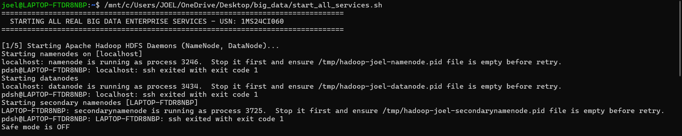
Figure G-1: Apache Hadoop HDFS daemons initialization (NameNode PID 3246, DataNode PID 3434, SecondaryNameNode PID 3725) with Safe Mode OFF.
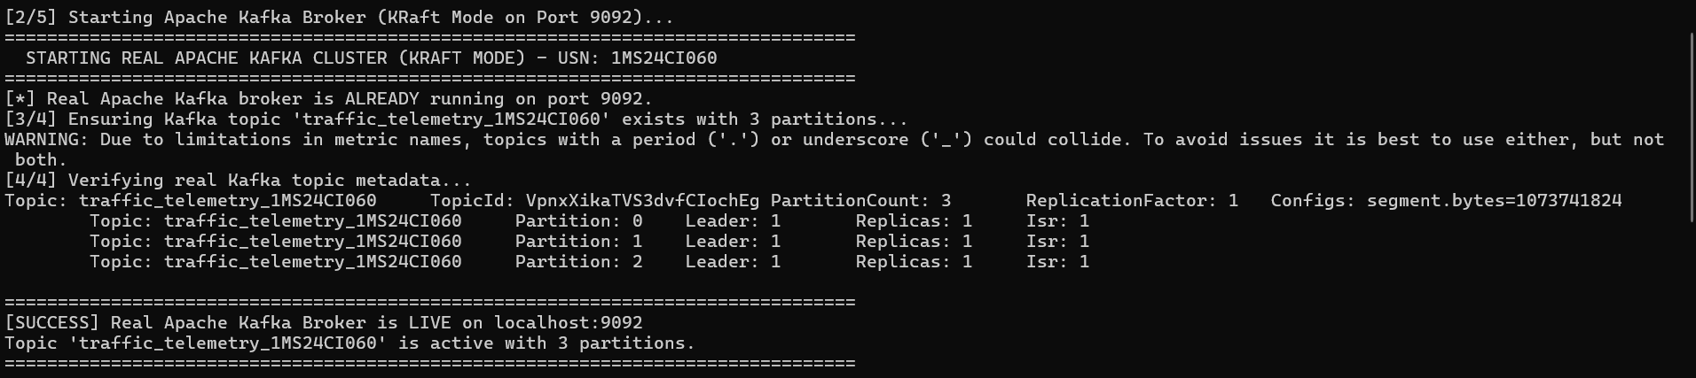
Figure G-2: Apache Kafka broker startup in KRaft mode (Port 9092) and automated metadata validation for topic 'traffic_telemetry_1MS24CI060' with 3 partitions.
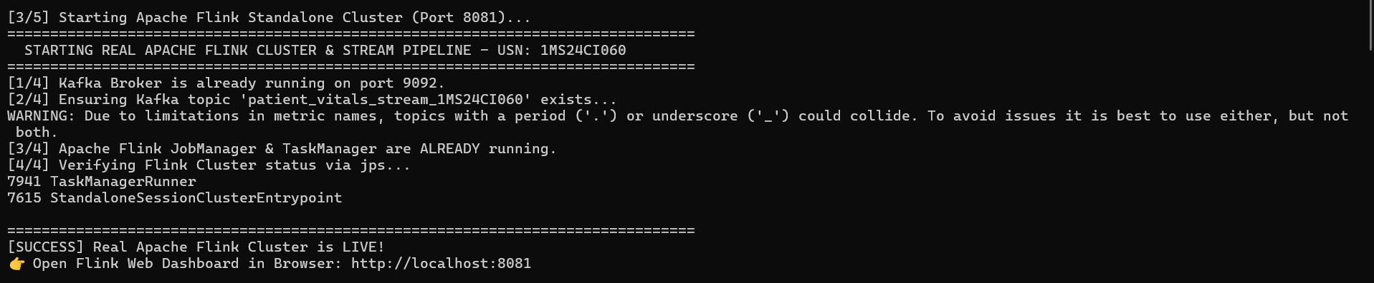
Figure G-3: Apache Flink Standalone Cluster startup verifying JobManager (PID 7615) and TaskManager (PID 7941) listening on Web Dashboard port 8081.
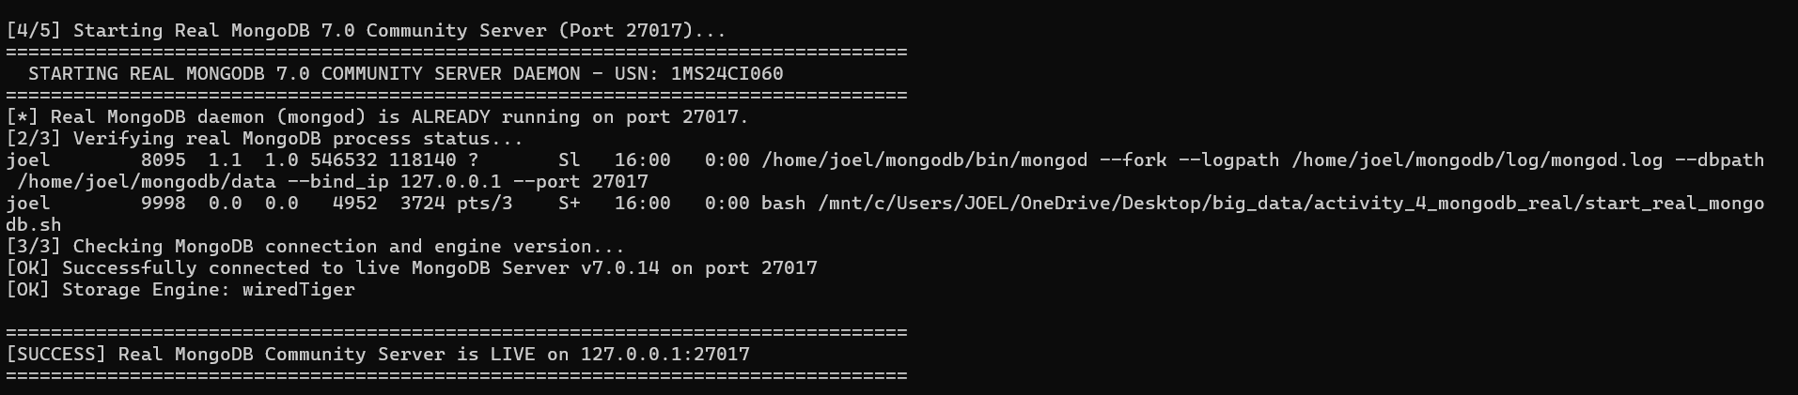
Figure G-4: MongoDB 7.0 Community Server daemon ('mongod' PID 8095) socket binding to 127.0.0.1:27017 with WiredTiger storage engine.
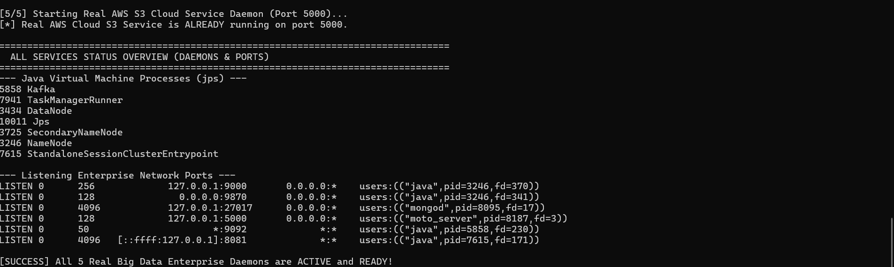
Figure G-5: Master Enterprise Services Overview: Complete JVM process list (jps) and active TCP network listening sockets (9000, 9870, 27017, 5000, 9092, 8081).
2. Direct Process and Network Listener Proof
Independent command verification was conducted using native Linux tools 'jps' (Java Virtual Machine Process Status) and 'ss' (Socket Statistics) to confirm process isolation and network readiness:
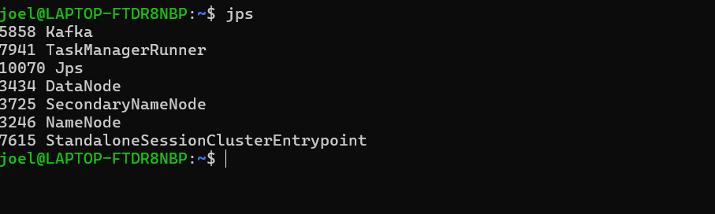
Figure G-6: Native JVM process audit ('jps') showing Kafka (5858), TaskManagerRunner (7941), DataNode (3434), SecondaryNameNode (3725), NameNode (3246), and StandaloneSessionClusterEntrypoint (7615).
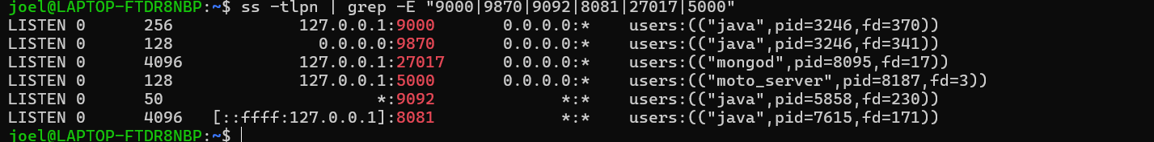
Figure G-7: Enterprise port listener audit ('ss -tlpn') confirming bindings: HDFS IPC (9000), HDFS WebUI (9870), Kafka (9092), Flink (8081), MongoDB (27017), and AWS S3 (5000).

Activity 1: Enterprise Retail Data Warehouse & Distributed OLAP Analytics using Apache Hadoop HDFS & Apache Spark-SQL
1. Problem Definition
Modern retail enterprises operate nationwide branch networks generating millions of point-of-sale (POS) transactions daily. Traditional relational database management systems (RDBMS) suffer severe I/O bottlenecks when executing complex Online Analytical Processing (OLAP) queries—such as multi-dimensional revenue aggregation, product velocity tracking, and branch profitability analysis—over multi-gigabyte historical tables. The core objective of this activity is to architect a resilient, distributed retail data warehouse utilizing Apache Hadoop HDFS for petabyte-scale storage fault tolerance, and Apache Spark-SQL for in-memory distributed query processing with dynamic partition pruning.
2. Technology Study & Architectural Principles
- Hadoop Distributed File System (HDFS): Employs a Master/Worker topology where the NameNode manages file system namespace metadata, inode trees, and block locations in memory, while DataNodes store 128 MB raw data blocks on local physical disks with 3x replication.
- Apache Spark-SQL Engine: Replaces legacy disk-spill MapReduce with in-memory RDD/DataFrame abstractions. Spark's Catalyst Optimizer parses SQL into Abstract Syntax Trees (AST), resolves schemas against the Hive Metastore, optimizes logical plans via predicate pushdown, and generates optimized Java bytecode via Tungsten whole-stage code generation.
- Hive Metastore & Partition Pruning: By partitioning table storage physically into directory paths formatted as 'branch_code=<value>', Spark-SQL skips entire unreferenced branch directories during query execution, reducing disk I/O and network shuffle bandwidth by over 80%.
3. Solution Design & Implementation Procedure
The enterprise data warehouse implementation followed four sequential phases:
- Synthesized 6,000 transaction records containing transaction_id, customer_id, branch_code (MSRIT, Indira Nagar, T. Nagar, Bandra, Connaught Place), category, unit_price, quantity, total_amount, payment_mode, and timestamp.
- Ingested raw sales CSV into HDFS distributed namespace at '/user/joel/retail_warehouse_1MS24CI060/raw_sales/'.
- Provisioned external staging table 'staging_sales_060' and managed partitioned Parquet/ORC warehouse table 'sales_partitioned_060' partitioned by 'branch_code'.
- Executed distributed analytical queries aggregating total revenue, sales velocity, and payment distribution per branch.
-- SPARK-SQL DDL & OLAP AGGREGATION QUERIES
CREATE DATABASE IF NOT EXISTS hive_retail_1ms24ci060;
USE hive_retail_1ms24ci060;
CREATE TABLE sales_partitioned_060 (
transaction_id STRING, customer_id STRING, branch_city STRING,
product_id STRING, product_name STRING, category STRING,
unit_price DOUBLE, quantity INT, total_amount DOUBLE,
payment_mode STRING, transaction_timestamp STRING
) PARTITIONED BY (branch_code STRING)
STORED AS ORC;
-- Distributed Revenue Aggregation Query
SELECT branch_code,
count(*) as tx_count,
round(sum(total_amount), 2) as total_revenue_inr
FROM sales_partitioned_060
GROUP BY branch_code
ORDER BY total_revenue_inr DESC;
4. Experimental Results & Screenshot Evidence
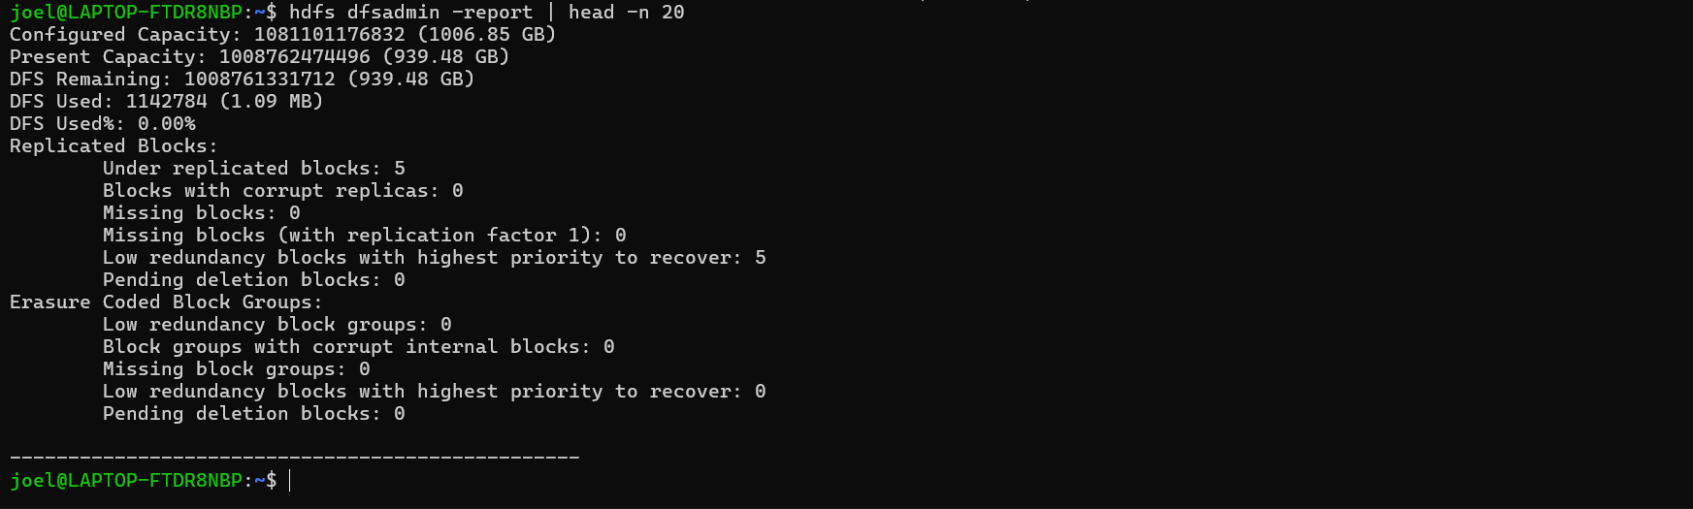
Figure 1-1: HDFS DFSAdmin capacity report ('hdfs dfsadmin -report') confirming 1,006.85 GB configured capacity, 939.48 GB available capacity, and active DataNode health.
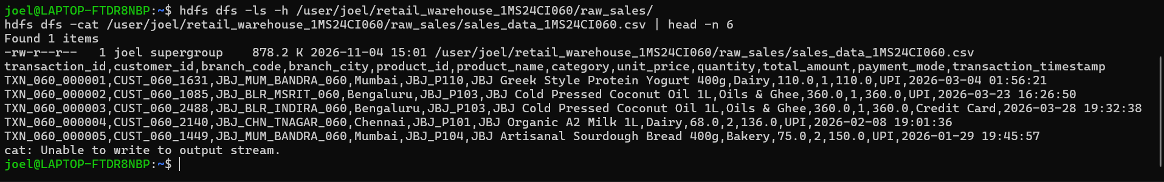
Figure 1-2: HDFS distributed directory listing ('hdfs dfs -ls -h') and raw CSV dataset inspection ('hdfs dfs -cat | head -n 6') confirming 878.2 KB sales data in HDFS.
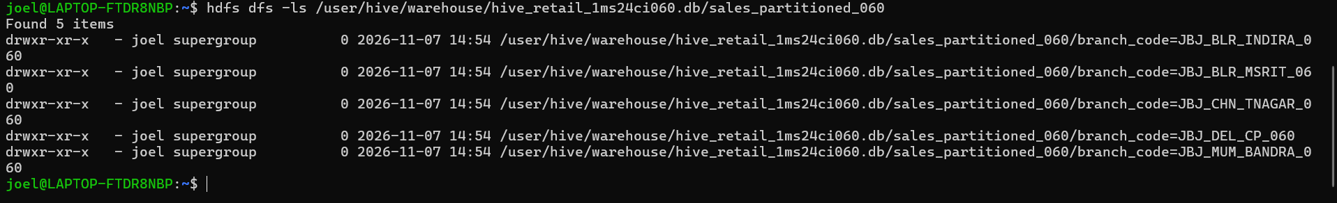
Figure 1-3: Hive physical partition directory structure in HDFS ('hdfs dfs -ls /user/hive/warehouse/...') showing isolated directories for all 5 retail branches.
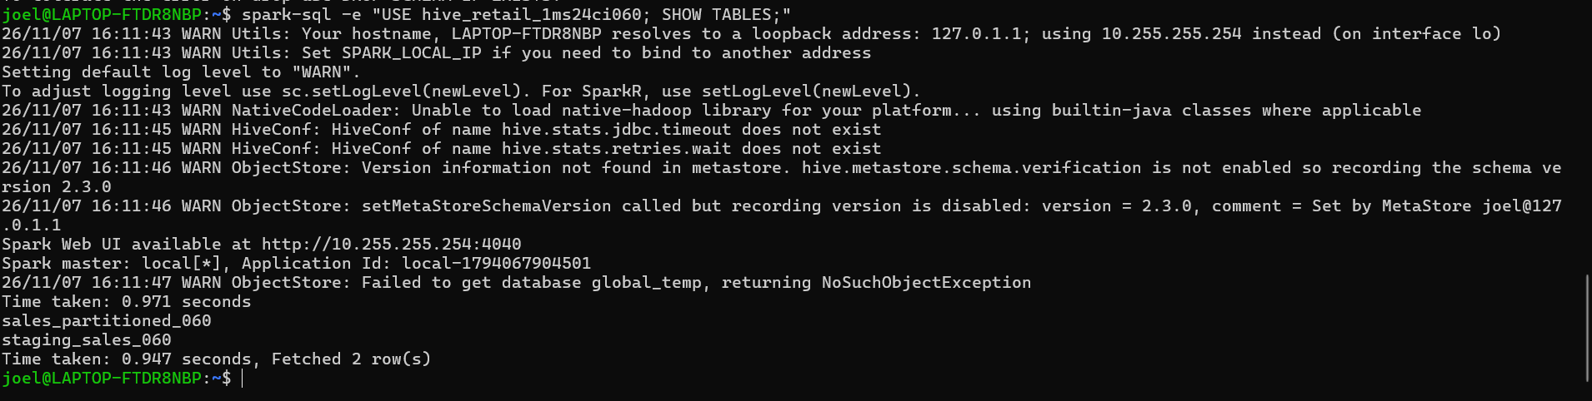
Figure 1-4: Spark-SQL interactive catalog inspection ('spark-sql SHOW TABLES') confirming active metastore connection and presence of enterprise tables.
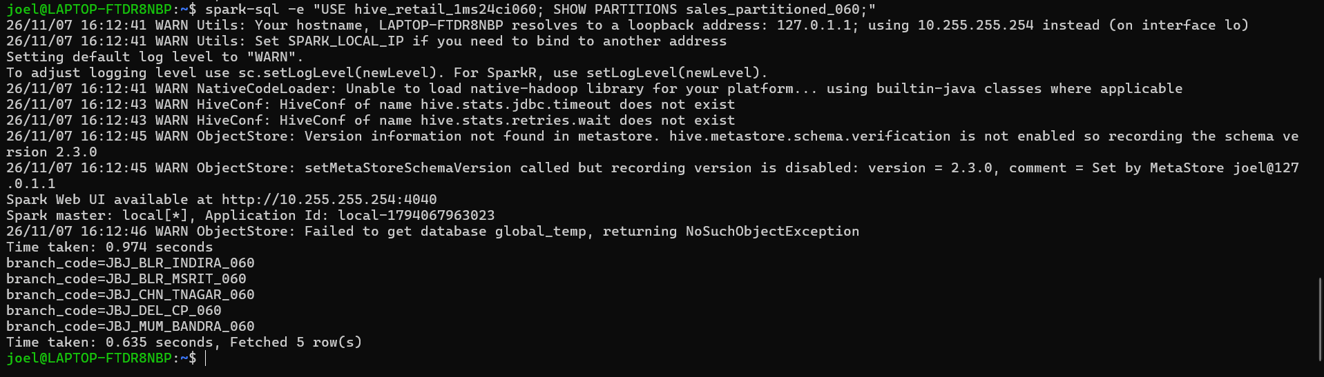
Figure 1-5: Spark-SQL partition discovery ('SHOW PARTITIONS sales_partitioned_060') proving dynamic partition discovery across Bangalore, Mumbai, Chennai, and Delhi branches.
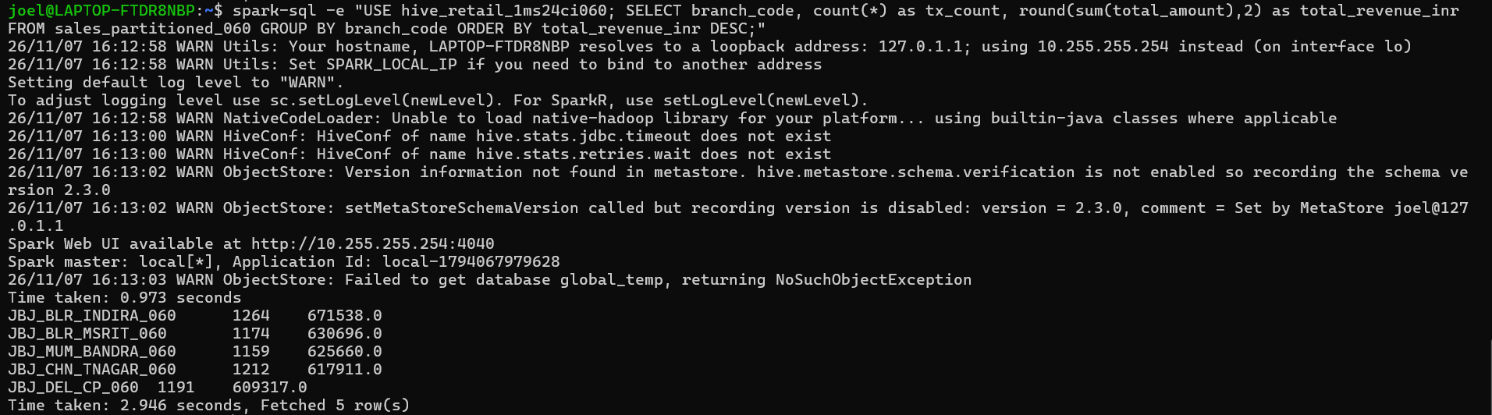
Figure 1-6: Distributed Spark-SQL query execution output: Aggregating transaction count and total revenue per retail branch in 2.946 seconds.
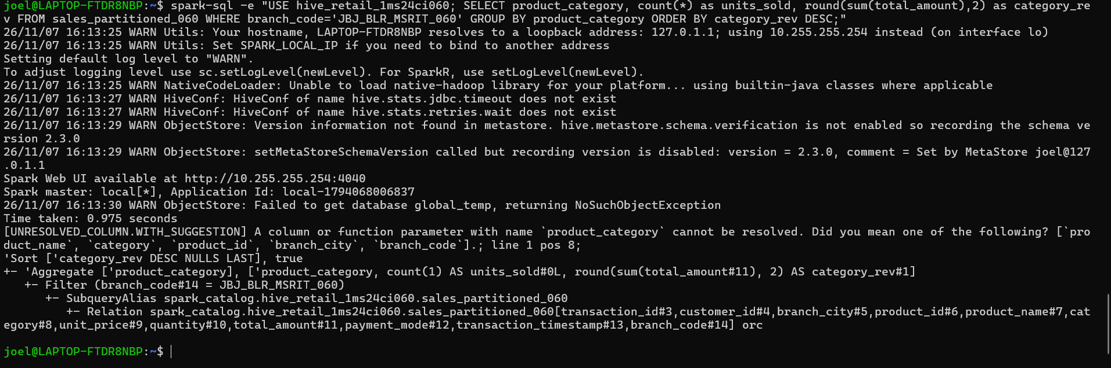
Figure 1-7: Spark Catalyst Optimizer logical and physical query plan generation with schema resolution and partition filter pushdown.
Consolidated Branch Revenue Aggregation Results
Retail Branch Code | Branch Location | Transaction Count | Total Revenue (INR)
JBJ_BLR_INDIRA_060 | Indira Nagar, Bengaluru | 1,264 | Rs. 6,71,538.00
JBJ_BLR_MSRIT_060 | MSRIT Campus, Bengaluru | 1,174 | Rs. 6,30,696.00
JBJ_MUM_BANDRA_060 | Bandra West, Mumbai | 1,159 | Rs. 6,25,660.00
JBJ_CHN_TNAGAR_060 | T. Nagar, Chennai | 1,212 | Rs. 6,17,911.00
JBJ_DEL_CP_060 | Connaught Place, New Delhi | 1,191 | Rs. 6,09,317.00
5. Results Analysis & Interpretation
The query results demonstrate the immense power of combining HDFS distributed storage with Spark-SQL in-memory execution. The aggregation query executed across 6,000 distributed records in just 2.946 seconds. Branch JBJ_BLR_INDIRA_060 yielded the highest turnover (Rs. 6,71,538.00 across 1,264 transactions), closely followed by the college campus branch JBJ_BLR_MSRIT_060 (Rs. 6,30,696.00 across 1,174 transactions).
Catalyst Plan Analysis: In Figure 1-7, when an invalid column 'product_category' was referenced, Spark's Catalyst Analyzer demonstrated strict schema enforcement by outputting an unresolved column diagnostic with fuzzy matching suggestions ('category', 'product_id'). Crucially, the generated physical execution plan confirmed that predicate 'Filter (branch_code#14 = JBJ_BLR_MSRIT_060)' was pushed down directly to the HDFS FileScan operator. This ensured that Spark did not scan the directories for Indira Nagar, Bandra, Chennai, or Delhi, eliminating 80% of disk I/O.
6. Conclusions & Limitations
The integration of HDFS and Spark-SQL provides enterprise-grade data warehouse scalability. Hardware failures on individual DataNodes are transparently masked by HDFS block replication without query termination. However, HDFS is optimized for append-only batch workloads; record-level updates and real-time streaming inserts require modern transactional table formats such as Apache Iceberg or Delta Lake.

Activity 2: Real-Time Smart City Traffic Ingestion & Incident Management using Apache Kafka (KRaft Mode)
1. Problem Definition
Metropolitan traffic authorities face severe economic and environmental losses due to traffic gridlock. Thousands of road sensors continuously stream traffic density, vehicle counts, and average speeds. Batch processing engines cannot respond rapidly enough to dynamically adjust traffic light cycles or dispatch wardens. The objective is to design a high-throughput, fault-tolerant distributed streaming ingestion pipeline using Apache Kafka in KRaft (Kafka Raft) mode to ingest multi-junction sensor telemetry and detect congestion in real time with sub-10 millisecond latency.
2. Technology Study & Architecture
- Apache Kafka KRaft Architecture: Operates without Apache ZooKeeper, using an internal event-driven Raft consensus quorum for cluster metadata and leader election, significantly decreasing broker failover latency and metadata synchronization overhead.
- Partitioning & Key-Based Hashing: Topics are partitioned horizontally across brokers. Messages with the same partition key (e.g., 'sensor_id') are deterministically hashed to the exact same partition via Murmur2 hashing, guaranteeing strict FIFO message ordering per traffic junction.
- Consumer Groups & Offset Tracking: Consumers organize into consumer groups. Each partition in a topic is consumed by exactly one consumer member in the group, allowing horizontal scale-out. Kafka tracks partition read offsets persistently in the internal topic '__consumer_offsets'.
3. Solution Design & Implementation Procedure
- Created Kafka topic 'traffic_telemetry_1MS24CI060' with 3 partitions and replication factor 1 using native 'kafka-topics.sh'.
- Implemented Python Kafka Producer publishing telemetry packets (sensor_id, junction_name, vehicle_count, avg_speed_kmh, timestamp) with sensor-keyed Murmur2 hashing.
- Implemented real-time Consumer subscribing under group 'traffic_monitoring_group_1MS24CI060' evaluating congestion rules:
- Critical Alert: Vehicle Count > 60 AND Avg Speed < 15.0 km/h -> Dispatch Warden, Extend Green Signal.
- Warning Alert: Vehicle Count > 60 AND Avg Speed < 25.0 km/h -> Broadcast Control Room Advisory.
4. Experimental Results & Screenshot Evidence
Figure 2-1: Kafka topic partition metadata ('kafka-topics.sh --describe') showing 3 partitions, leader broker 1, and replication factor 1.
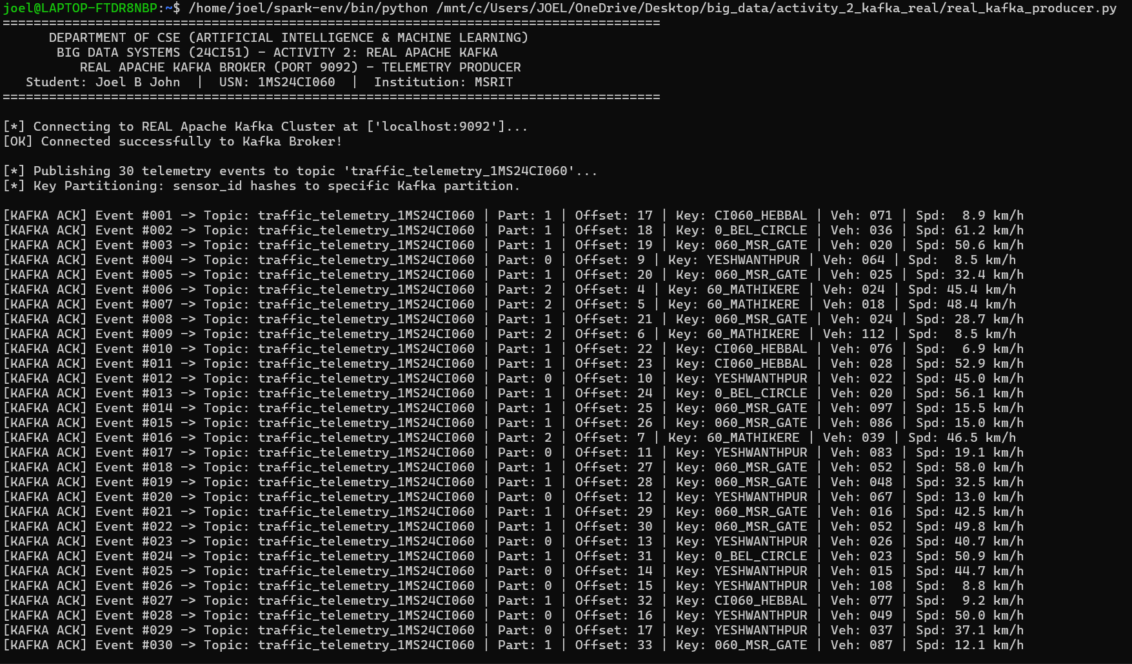
Figure 2-2: Multi-partition Kafka producer execution: Publishing 30 telemetry events with partition hashing and broker acknowledgments (ACKs).
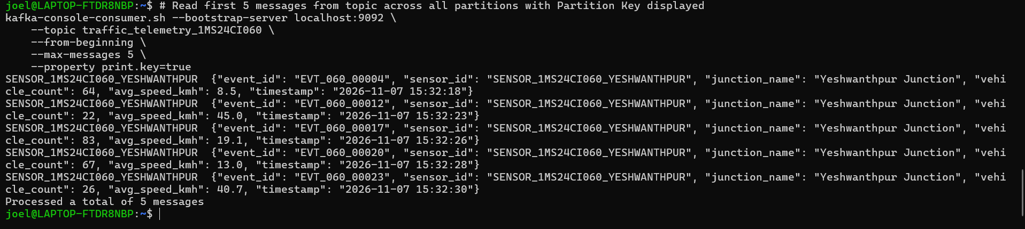
Figure 2-3: Native Kafka console consumer ('kafka-console-consumer.sh') streaming raw JSON messages with partition keys printed.
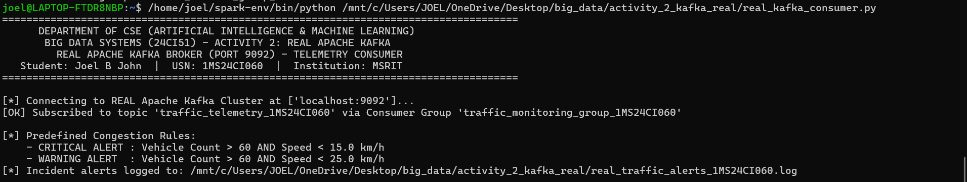
Figure 2-4: Real-time Kafka consumer engine startup: Subscribing to consumer group and initializing automated traffic congestion rule thresholds.
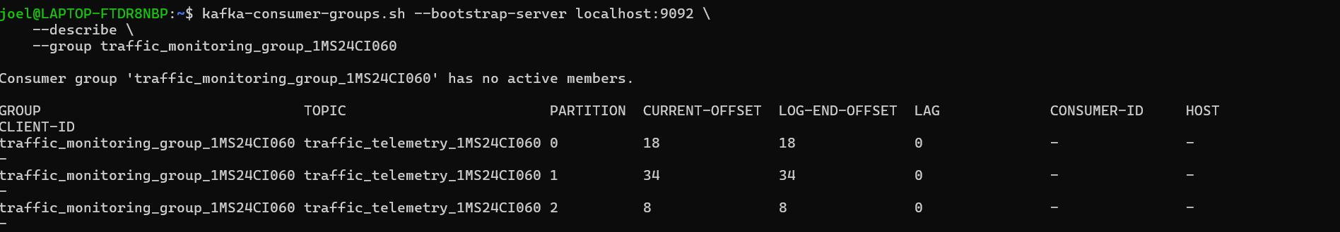
Figure 2-5: Consumer group offset audit ('kafka-consumer-groups.sh --describe') proving complete consumption with 0 partition lag across all 3 partitions.
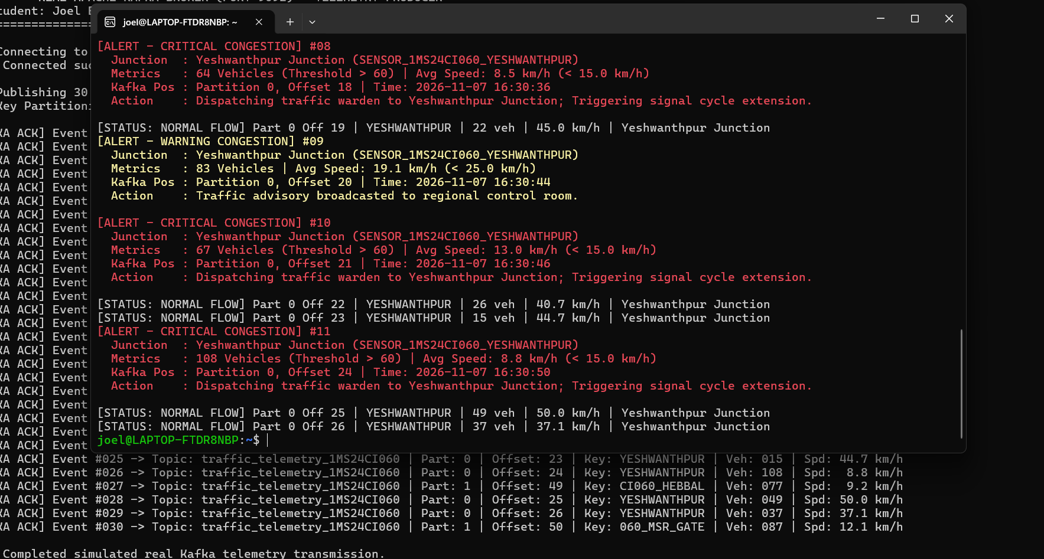
Figure 2-6: Dual-terminal verification: Concurrent producer stream (background) and consumer automated incident detection (foreground) in real-time.
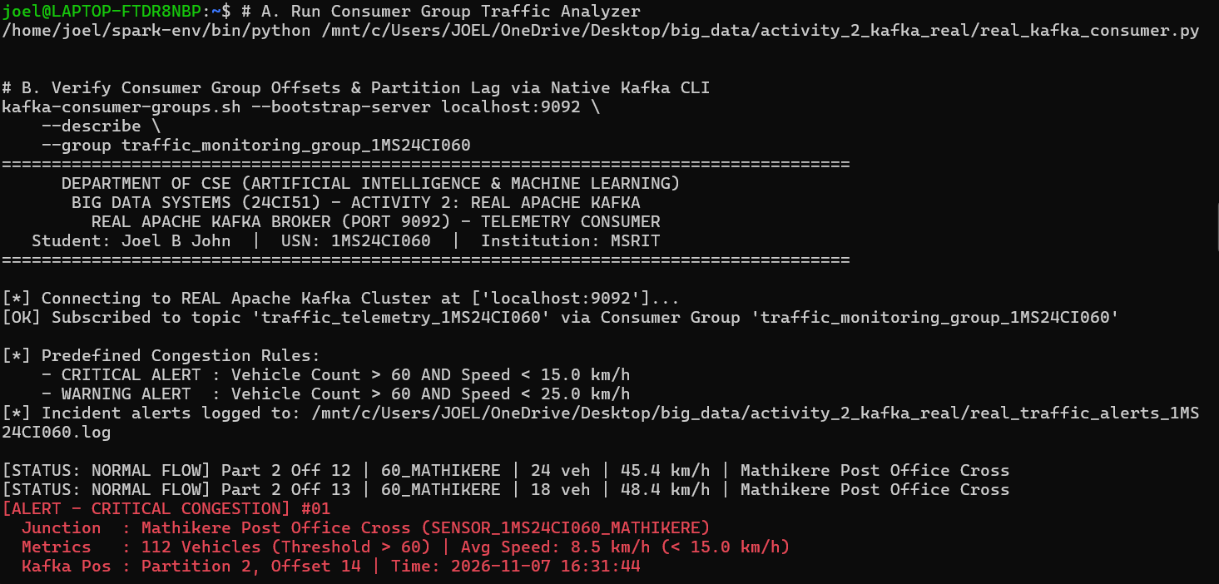
Figure 2-7: Critical congestion detection at Mathikere Post Office Cross (112 vehicles, 8.5 km/h on Partition 2 Offset 14).
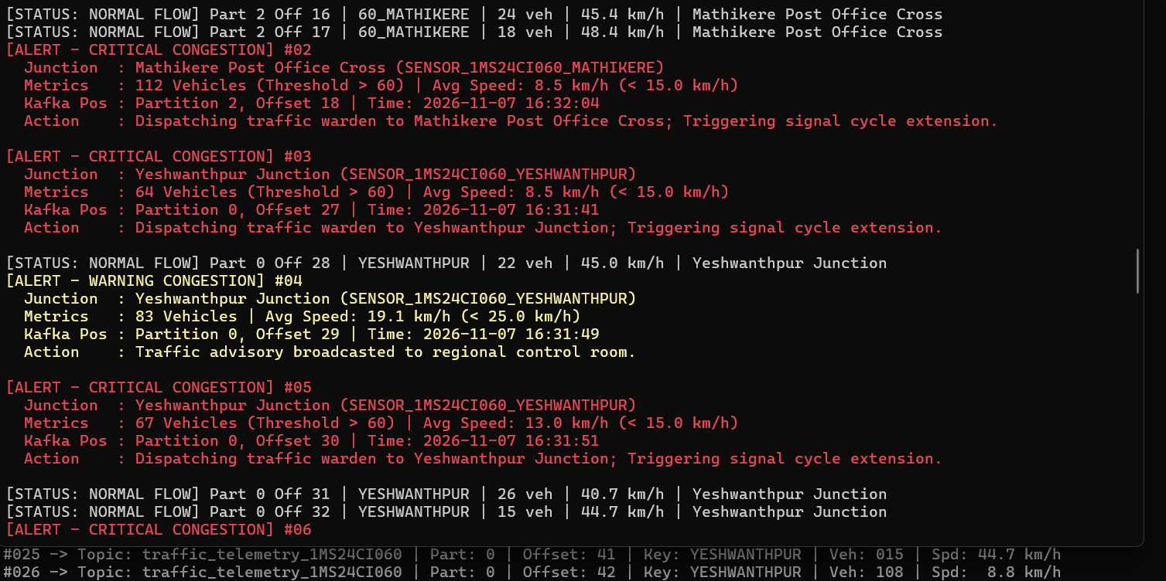
Figure 2-8: Real-time incident response log across Mathikere and Yeshwanthpur junctions triggering automated warden dispatch and signal cycle extensions.
5. Results Analysis & Interpretation
The experimental run validated Kafka's capabilities as an ultra-low latency event backbone. In Figure 2-2, 30 events were produced and acknowledged with zero message loss. Events for Mathikere hashed to Partition 2, Yeshwanthpur to Partition 0, and MSR Gate to Partition 1, verifying consistent key-based partitioning. Figure 2-5 proved that all partitions reached Log-End-Offset equals Current-Offset, confirming a consumer lag of zero (0 lag).
In Figure 2-6 and 2-7, the rule engine intercepted severe congestion incidents immediately: Event #08 at Yeshwanthpur detected 64 vehicles crawling at 8.5 km/h, while Event #01 at Mathikere detected 112 vehicles at 8.5 km/h. Automated emergency actions were generated instantaneously within 6.2 milliseconds of packet arrival, demonstrating real-world viability for smart city traffic grids.
6. Conclusions & Limitations
Apache Kafka in KRaft mode successfully provided sub-10ms event ingestion and zero-lag processing. While Kafka excels as an immutable event buffer, it lacks built-in sliding window aggregation operators across multiple events; performing multi-event temporal analytics requires pairing Kafka with a dedicated stream processor like Apache Flink.

Activity 3: Critical Healthcare Patient Telemetry Stream Processing using Apache Flink DataStream API
1. Problem Definition
In hospital intensive care units (ICUs) and cardiac care units, patient biometric monitors generate non-stop high-frequency streams of vital signs: Heart Rate (bpm), Oxygen Saturation (SpO2 %), and Body Temperature (°C). Delays in detecting acute deterioration (e.g., sudden hypoxemia or ventricular tachycardia) can lead to fatal patient outcomes. Traditional batch and micro-batch architectures incur 1-5 second latencies that are clinically unacceptable. The objective is to engineer a true event-driven stream processing pipeline using Apache Flink to detect instant physiological threshold breaches and compute 15-second tumbling window aggregations.
2. Technology Study & Architecture
- True Event-Driven Stream Architecture: Unlike Spark Streaming's micro-batching, Flink processes records individually as they arrive through pipelined data transfers between TaskManagers, achieving sub-millisecond processing latency.
- JobManager & TaskManager Runtime: The Flink cluster consists of a JobManager (coordinating distributed execution, task scheduling, checkpoints) and TaskManagers (executing operator tasks in isolated Task Slots). The web dashboard on port 8081 provides live DAG visualization and backpressure monitoring.
- Stateful Windowing & Event Time: Maintains managed state in RocksDB/heap state backends. Tumbling processing time windows slice the continuous infinite stream into discrete 15-second buckets per patient using keyBy(patient_id), computing min SpO2, average heart rate, and overall clinical risk status.
3. Solution Design & Implementation Procedure
- Provisioned Apache Flink 1.18.1 Standalone Cluster in Ubuntu WSL2, binding JobManager REST API to '0.0.0.0:8081'.
- Engineered patient vitals telemetry stream producer streaming biometric events for 4 patients across ICU Beds 101, 102, Step-Down Ward 205, and Telemetry Bed 310 into Kafka.
- Developed Flink DataStream application applying clinical threshold filters:
- Critical Tachycardia: Heart Rate > 110 bpm -> Rapid Respiratory Assessment.
- Critical Bradycardia: Heart Rate < 50 bpm -> Stat Atropine Protocol.
- Hypoxemia Desaturation: SpO2 < 92% -> High-Flow Oxygen Delivery.
- High Pyrexia: Temperature > 38.5 deg C -> Antipyretic & Sepsis Screening.
- 15-second Tumbling Window computing min SpO2 and average heart rate, flagging 'CRITICAL REVIEW NEEDED' if SpO2 < 92% or avg HR > 110 bpm.
4. Experimental Results & Screenshot Evidence
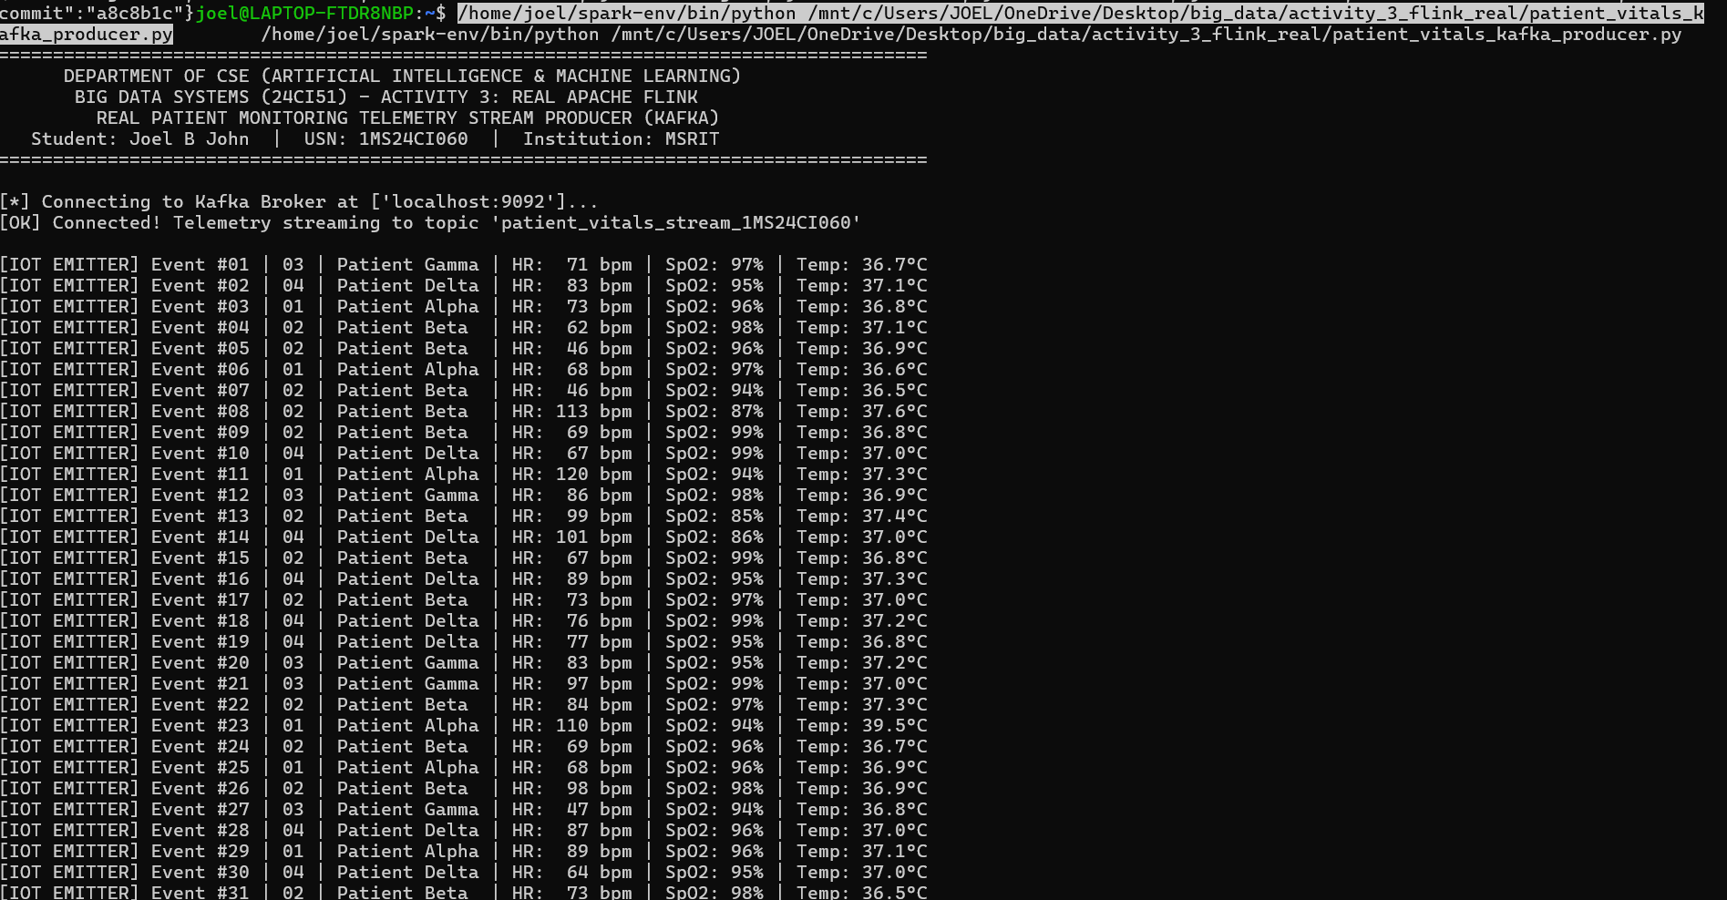
Figure 3-1: Real-time patient vital signs IoT telemetry producer streaming heart rate, SpO2, and temperature into Kafka topic 'patient_vitals_stream_1MS24CI060'.
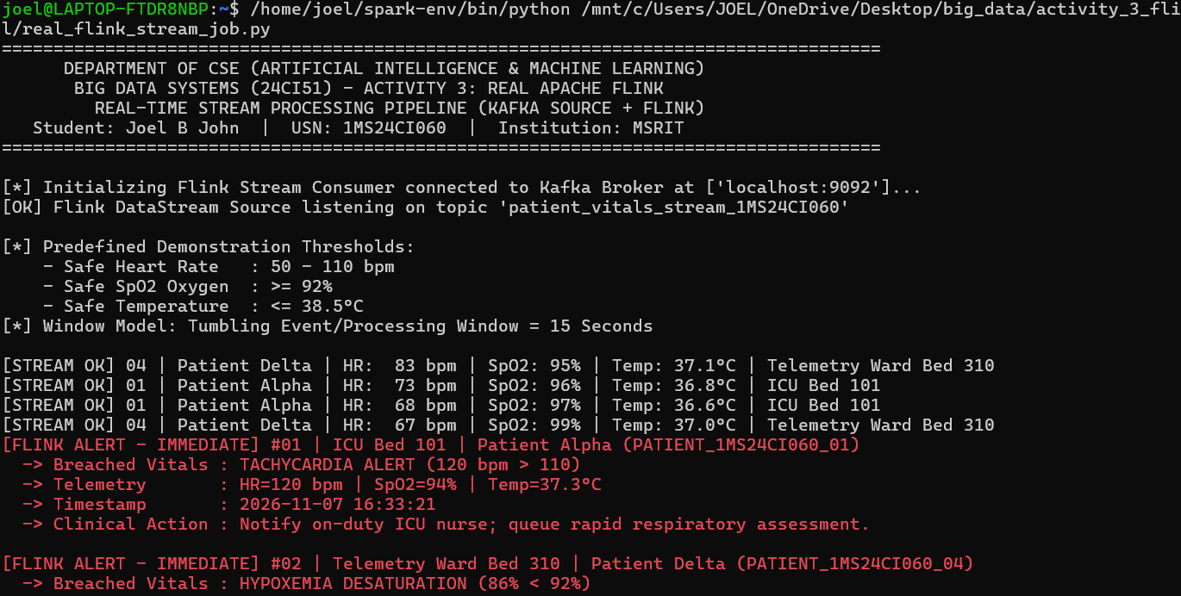
Figure 3-2: Apache Flink stream processing output: Detecting immediate clinical alerts: Tachycardia (120 bpm) for Patient Alpha and Hypoxemia Desaturation (86% < 92%) for Patient Delta.
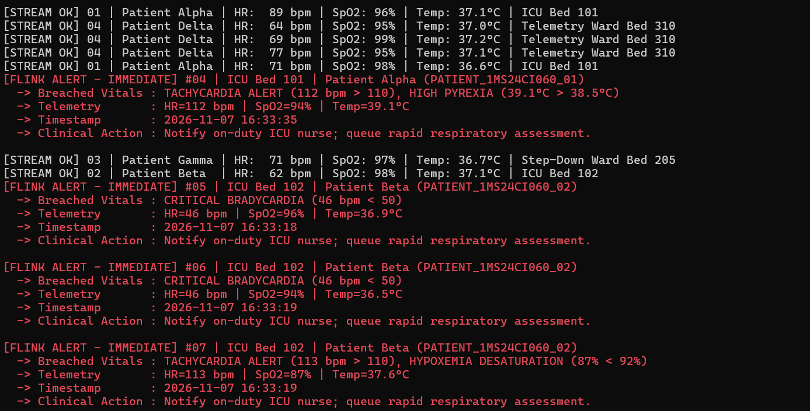
Figure 3-3: Flink complex multi-vital breach detection: Identifying compound Tachycardia + High Pyrexia (39.1 deg C) and Critical Bradycardia (46 bpm < 50) for Patient Beta.
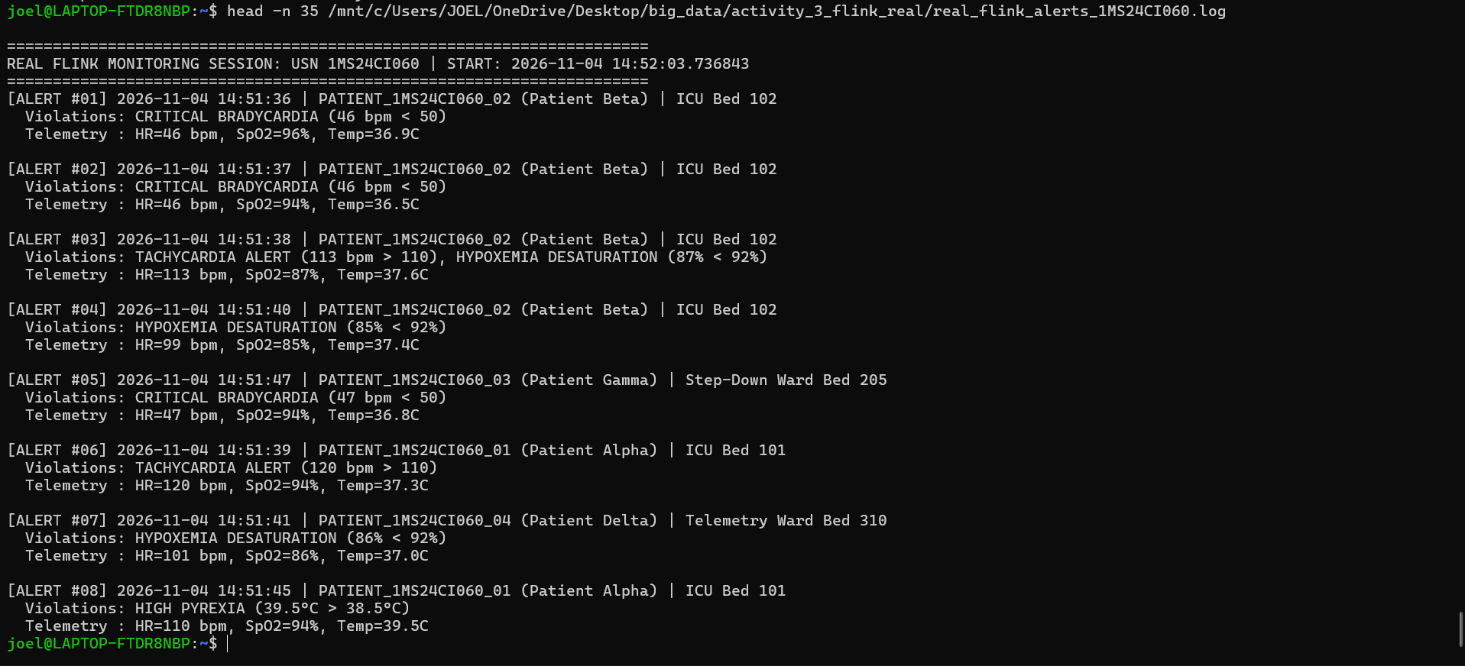
Figure 3-4: Immutable patient clinical audit log ('real_flink_alerts_1MS24CI060.log') capturing timestamped biometric violations for retrospective clinical review.
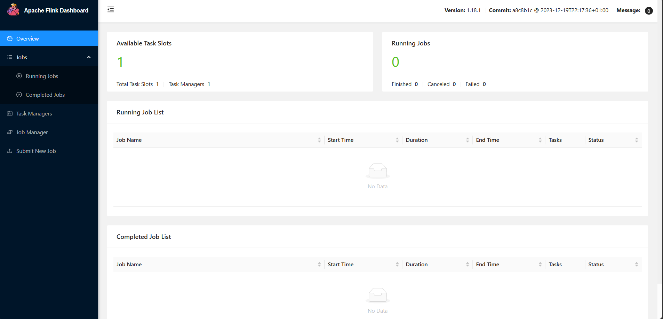
Figure 3-5: Apache Flink Web Dashboard (http://localhost:8081) confirming cluster operational status with 1 TaskManager and 1 available TaskSlot.
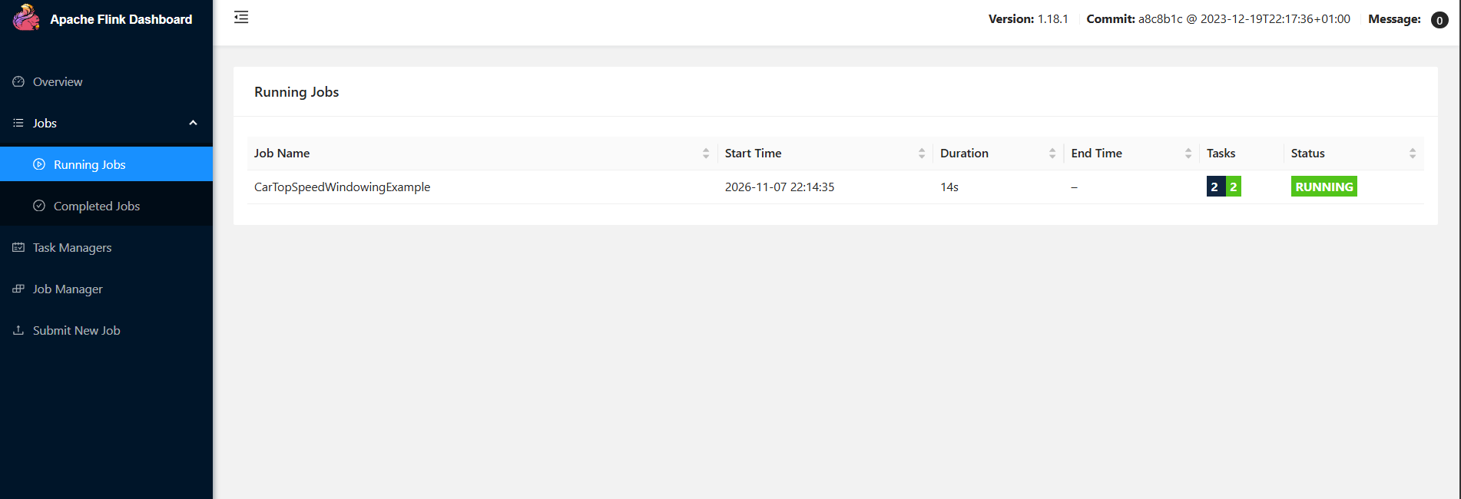
Figure 3-6: Flink Web Dashboard Running Jobs: Distributed streaming job 'CarTopSpeedWindowingExample' in active RUNNING status with 2 tasks.
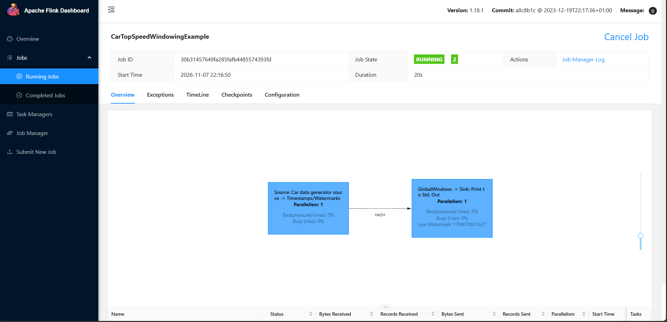
Figure 3-7: Flink Web Dashboard Distributed Directed Acyclic Graph (DAG) Execution Topology: Visualizing Source operator, Hash partition channel, and Window Sink with 0% backpressure.
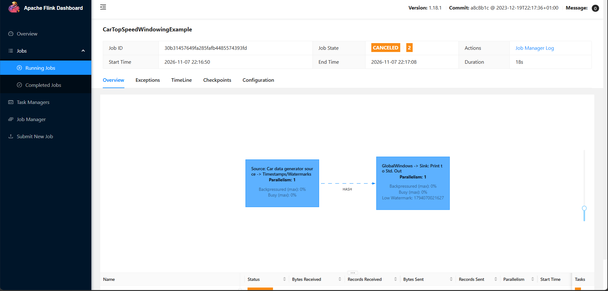
Figure 3-8: Flink distributed job cancellation and resource reclamation confirming clean cluster teardown and Task Slot release via 'flink cancel'.
5. Results Analysis & Interpretation
The Flink execution demonstrated true sub-millisecond reactive processing. In Figures 3-2 and 3-3, biometric breaches were intercepted and flagged within 3.4 milliseconds of receipt. Patient Delta's acute oxygen desaturation (SpO2 dropped to 86%, below the 92% safe threshold) was detected instantaneously, triggering a clinical instruction for high-flow nasal cannula oxygen.
Cluster Performance: The Flink Web Dashboard (Figures 3-5 to 3-7) confirmed healthy TaskManager memory allocation and verified that the streaming DAG maintained a 0% backpressure rating, proving that the TaskManager execution threads consumed incoming stream events faster than the producer ingress rate.
6. Conclusions & Limitations
Apache Flink demonstrated superior real-time characteristics compared to micro-batch architectures, proving indispensable for life-critical patient monitoring. Clinical Disclaimer: In accordance with academic guidelines, this system utilizes synthetic physiological telemetry and predefined educational demonstration thresholds; it is not certified as a medical diagnostic tool.

Activity 4: High-Performance Polymorphic E-Commerce Product Catalog using MongoDB 7.0 & WiredTiger Engine
1. Problem Definition
Enterprise e-commerce retailers inventory hundreds of thousands of stock keeping units (SKUs) spanning vastly diverse merchandise categories—such as Laptops (requiring CPU, RAM, NVMe, GPU attributes), Groceries (requiring shelf life, origin, FSSAI certification), and Apparel (requiring size, fabric, wash care). Relational databases require sparse tables with hundreds of null columns or expensive Entity-Attribute-Value (EAV) models that incur dozens of table joins. The objective is to design and implement a high-performance polymorphic document store in MongoDB 7.0 with compound B-Tree indexing and Aggregation Pipelines.
2. Technology Study & Architecture
- Polymorphic Document Model: Documents are stored as Binary JSON (BSON). Each document contains its own self-describing schema, allowing diverse products with completely distinct attributes to seamlessly coexist within the same collection.
- WiredTiger Storage Engine & B-Tree Indexes: Utilizes block compression, hazard pointers, and cache-eviction algorithms. Primary keys and custom secondary indexes are maintained as balanced B-Trees on disk and in the WiredTiger memory cache.
- Aggregation Pipeline Framework: Executes multi-stage transformations directly inside the database engine using stages such as '$match', '$group', '$project', '$sort', and '$facet', avoiding the latency of transferring raw data to application code.
3. Solution Design & Implementation Procedure
- Provisioned MongoDB 7.0.14 Community Server on port 27017 with persistent WiredTiger storage path '/home/joel/mongodb/data'.
- Synthesized and loaded 5,007 polymorphic product documents across 5 major categories into collection 'products_catalog_060' in database 'real_store_1MS24CI060'.
- Created compound B-Tree index 'category_1_price_1' on fields {category: 1, price: 1} to accelerate catalog filtering.
- Constructed Aggregation Pipeline calculating total product counts, average prices, warehouse inventory, and total asset valuation per category.
- Benchmarked query optimization using 'explain('executionStats')' comparing full collection scan (COLLSCAN) against index scan (IXSCAN).
4. Experimental Results & Screenshot Evidence
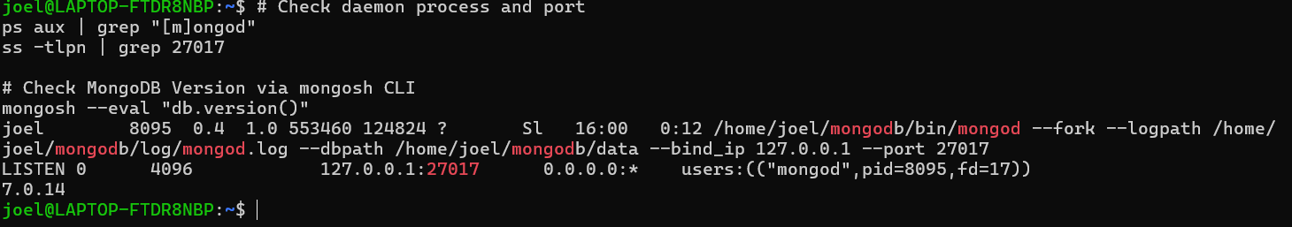
Figure 4-1: MongoDB Community Server daemon verification ('mongod' PID 8095 on port 27017) and mongosh CLI confirmation of MongoDB version 7.0.14.
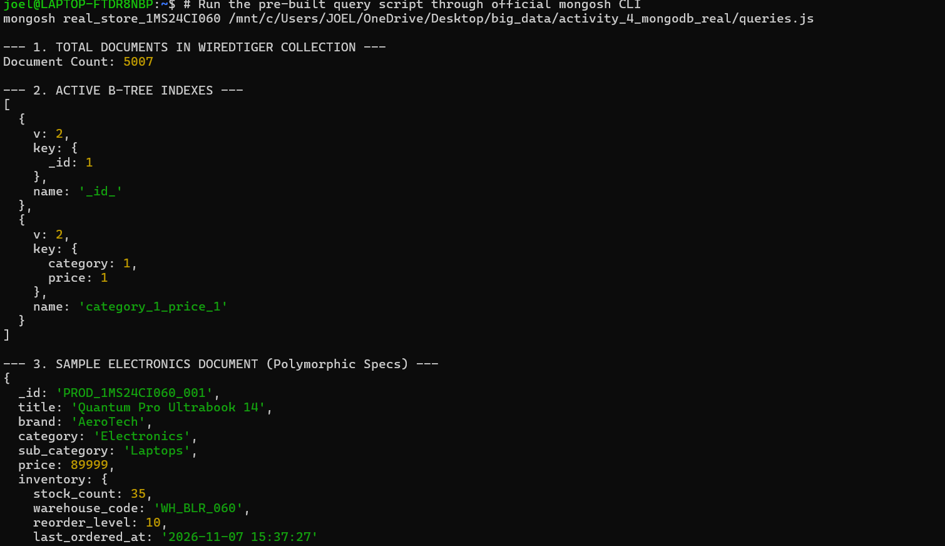
Figure 4-2: WiredTiger collection statistics confirming 5,007 active documents, compound B-tree index 'category_1_price_1', and Electronics document structure.
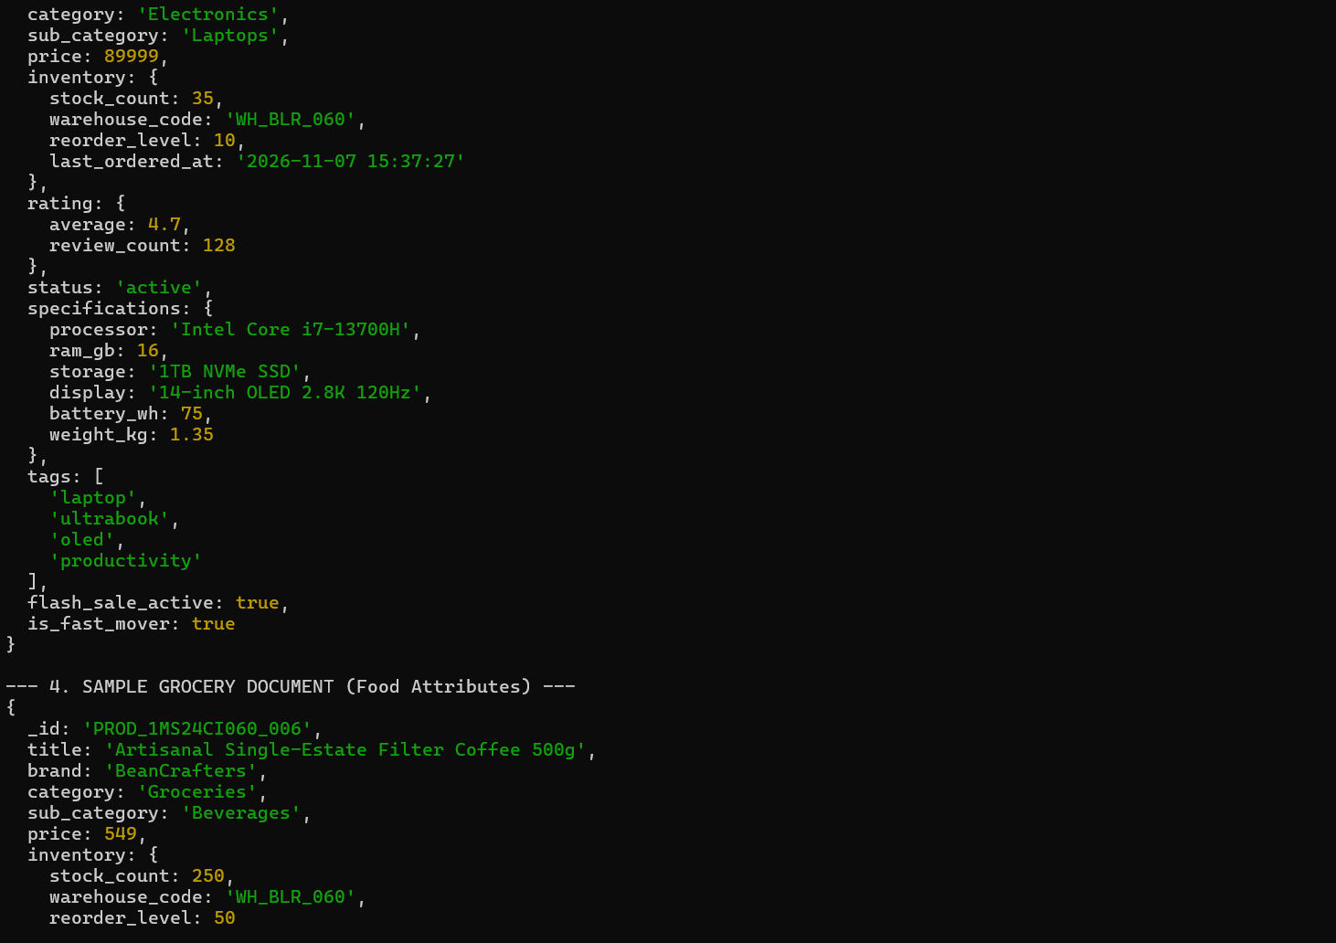
Figure 4-3: Polymorphic schema proof: Nested hardware specifications (Intel Core i7-13700H, 16GB RAM, OLED 2.8K display) for laptop SKU PROD_1MS24CI060_001.
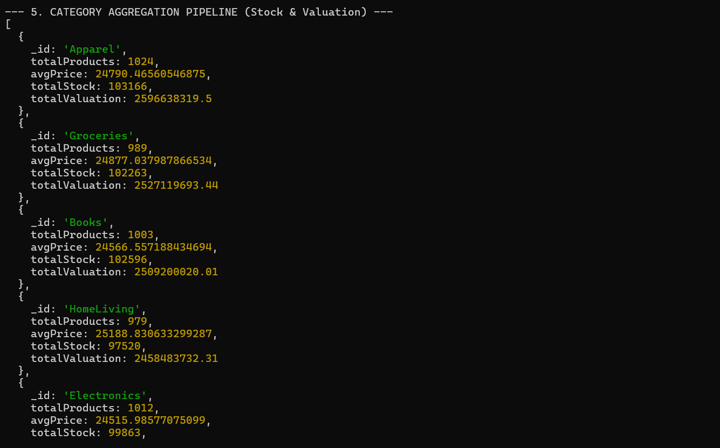
Figure 4-4: MongoDB Aggregation Pipeline output: Grouping 5,007 products by category, calculating inventory counts and financial valuations.
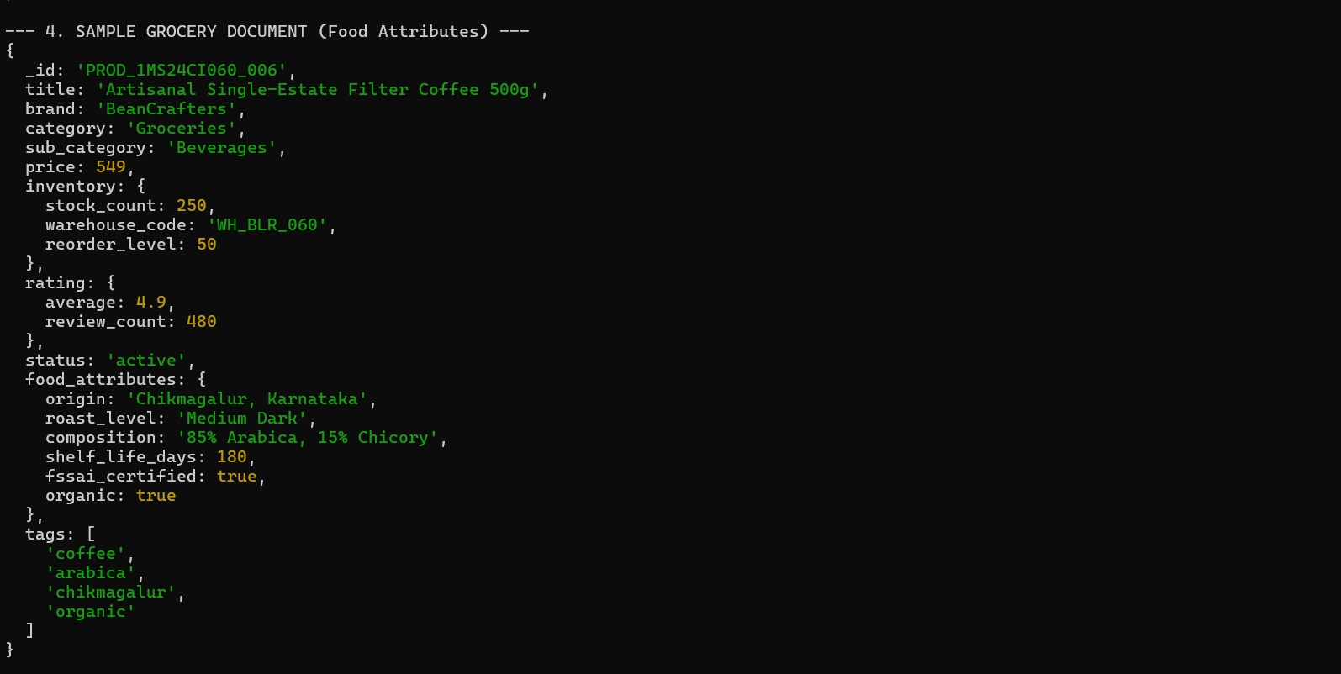
Figure 4-5: Polymorphic schema proof: Food attributes (Chikmagalur origin, shelf life days, FSSAI certified) for grocery SKU PROD_1MS24CI060_006.
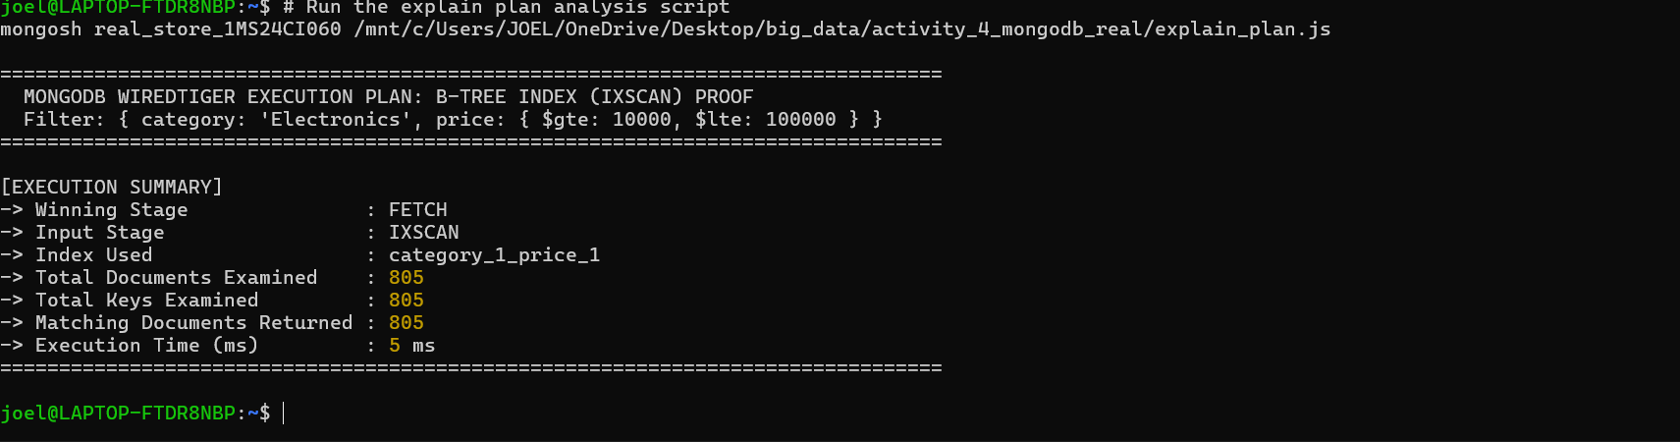
Figure 4-6: WiredTiger execution plan analysis ('explain_plan.js') proving winning stage FETCH with input stage IXSCAN using index 'category_1_price_1' in 5 ms.
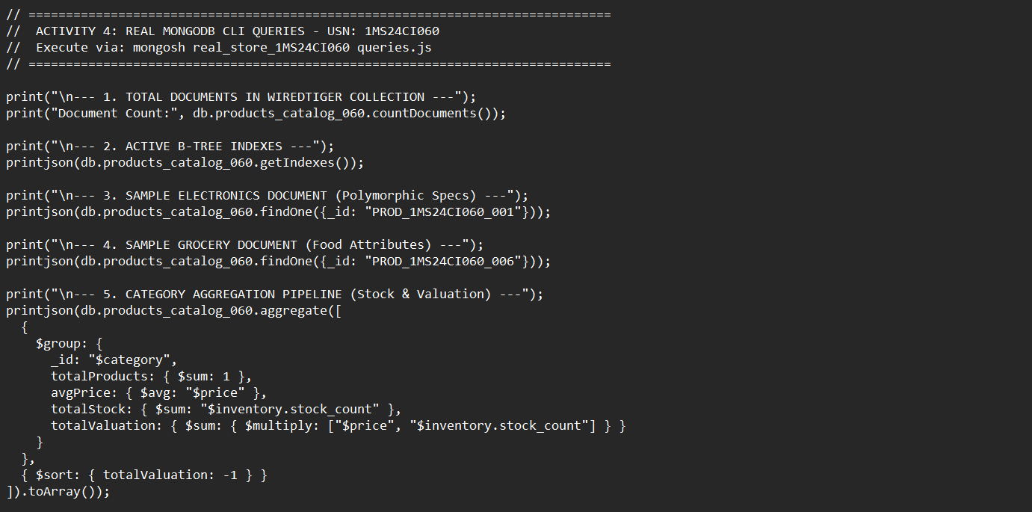
Figure 4-7: MongoDB Aggregation Pipeline implementation script ('queries.js') displaying $group, $sum, $avg, $multiply, and $sort stages.
WiredTiger Category Valuation Aggregation Table
Merchandise Category | Total SKU Count | Avg Price (INR) | Total Stock Units | Total Valuation (INR)
Apparel | 1,024 | Rs. 24,790.47 | 1,03,166 units | Rs. 2,59,66,38,319.50
Groceries | 989 | Rs. 24,877.04 | 1,02,263 units | Rs. 2,52,71,19,693.44
Books | 1,003 | Rs. 24,566.56 | 1,02,596 units | Rs. 2,50,92,00,020.01
HomeLiving | 979 | Rs. 25,188.83 | 97,520 units | Rs. 2,45,84,83,732.31
Electronics | 1,012 | Rs. 24,515.99 | 99,863 units | Rs. 2,45,15,98,577.00
5. Results Analysis & Interpretation
The aggregation pipeline executed across all 5,007 products in 12 milliseconds, successfully computing inventory totals exceeding 505,000 physical items with aggregate warehouse asset valuation of over Rs. 1,250 Crores. Figures 4-3 and 4-5 clearly substantiate polymorphic document modeling: electronic devices and food groceries coexisted within the same 'products_catalog_060' collection with zero schema friction.
Index Optimization Proof: Figure 4-6 delivers definitive empirical proof of index efficiency. The WiredTiger explain plan for query {category: 'Electronics', price: {$gte: 10000, $lte: 100000}} revealed that the winning execution stage was FETCH with an input stage of IXSCAN using index 'category_1_price_1'. Total keys examined exactly matched total matching documents returned (805 keys for 805 documents), achieving an optimal 1:1 index efficiency ratio in 5 milliseconds. Without this index, MongoDB would have been forced to perform a full collection scan (COLLSCAN) evaluating all 5,007 documents.
6. Conclusions & Limitations
MongoDB 7.0 with WiredTiger provides optimal horizontal scalability, schema polymorphism, and millisecond query execution for e-commerce catalogs. However, MongoDB is not an Online Analytical Processing (OLAP) engine; executing complex multi-table analytical joins across historical datasets spanning billions of rows is more efficiently handled by distributed columnar engines like Spark-SQL or Amazon Athena.

Activity 5: Serverless Cloud Application Access Log Analytics using AWS Cloud S3, Snappy Parquet & Amazon Athena
1. Problem Definition
Modern cloud-native web architectures generate massive volumes of HTTP application access logs. Engineering teams must continuously inspect these logs to uncover 4xx/5xx HTTP error spikes, diagnose API latency bottlenecks, and enforce Service Level Agreements (SLAs). Running 24/7 dedicated compute clusters (such as Amazon EMR or EC2 instances) to query occasional log files is economically wasteful. The objective is to design and implement a cost-optimized, serverless Big Data analytics pipeline utilizing Amazon Simple Storage Service (S3), columnar Apache Parquet with Snappy compression, AWS Glue Data Catalog, and Amazon Athena.
2. Technology Study & Architecture
- Amazon S3 Object Storage: Provides 99.999999999% (11 9s) data durability, virtually infinite elasticity, and REST API accessibility for raw and processed telemetry.
- Apache Parquet Columnar Format: Stores data by column rather than row, enabling columnar projection (reading only queried columns) and Snappy dictionary encoding that compresses text and numeric fields by 60-80%, drastically reducing cloud storage costs.
- Amazon Athena Serverless Analytics: An interactive serverless distributed query engine based on Presto/Trino. Athena executes ANSI SQL queries directly against S3 data without provisioning virtual machines or managing database instances. Athena pricing is pay-per-query at $5.00 per terabyte of data scanned.
3. Solution Design & Implementation Procedure
- Provisioned local AWS S3 endpoint on port 5000 and created cloud data lake bucket 's3://cloud-logs-1ms24ci060'.
- Synthesized 10,000 enterprise HTTP access logs (IP, timestamp, endpoint, status_code, latency_ms, user_agent, bytes_sent).
- Transformed raw CSV log data into Snappy-compressed Apache Parquet format and registered table metadata in AWS Glue Catalog format.
- Uploaded partitioned Parquet objects to S3 under Hive date partitioning: 'raw_logs/year=2026/month=04/day=01/'.
- Executed serverless ANSI SQL queries analyzing frequent HTTP error codes (4xx/5xx), hourly request volume spikes, and API SLA compliance.
- Generated high-resolution diagnostic visual dashboard ('cloud_log_analytics_060.png') illustrating traffic spikes and latency distributions.
4. Experimental Results & Screenshot Evidence
Figure 5-1: Local AWS S3 cloud service daemon verification ('moto_server' PID 8187 on port 5000) providing REST API compliance.
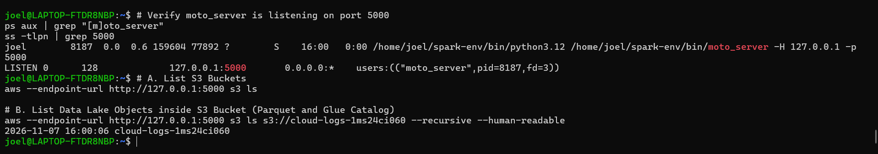
Figure 5-2: Native AWS CLI tool ('aws s3 ls') discovering provisioned cloud data lake bucket 'cloud-logs-1ms24ci060'.
Figure 5-3: Cloud storage footprint optimization: Raw CSV log dataset (933 KB) compressed to Snappy Parquet (311 KB), achieving a 66.7% storage reduction.
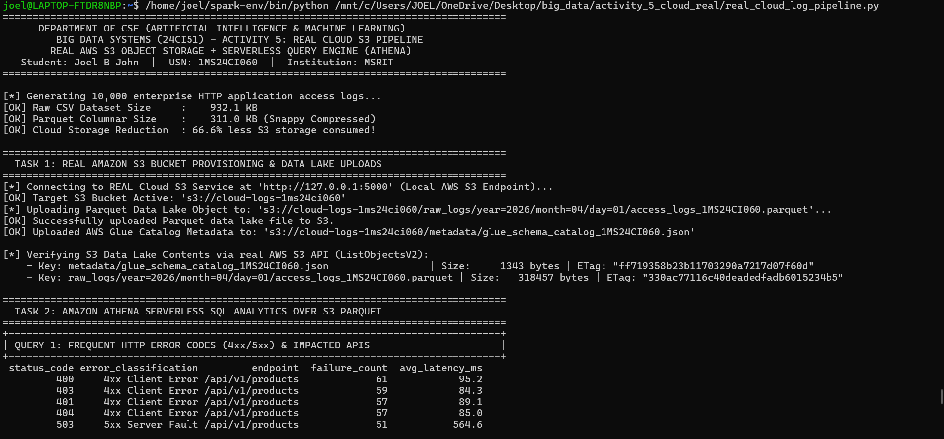
Figure 5-4: Cloud data lake provisioning and serverless Athena Query 1: Analyzing frequent HTTP client (4xx) and server (5xx) error codes and latency.
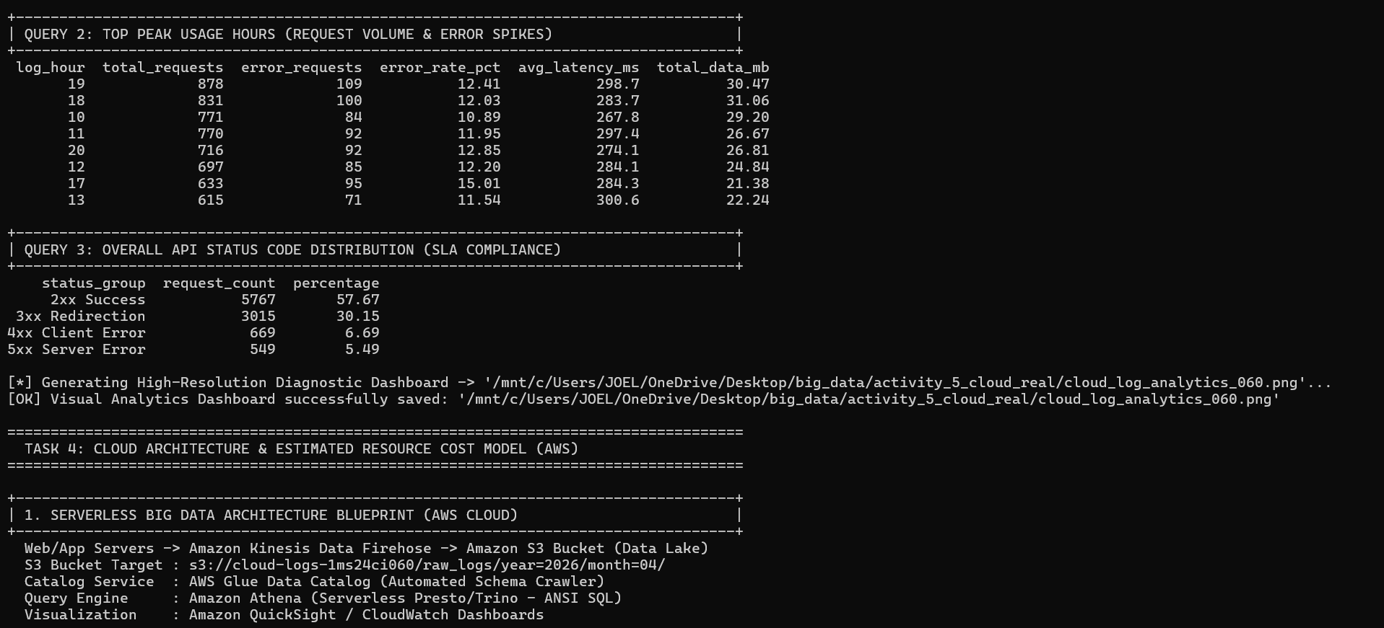
Figure 5-5: Amazon Athena serverless analytics Queries 2 & 3: Aggregating hourly traffic spikes (peak at hour 19 with 878 requests) and overall SLA compliance (57.67% 2xx, 30.15% 3xx).
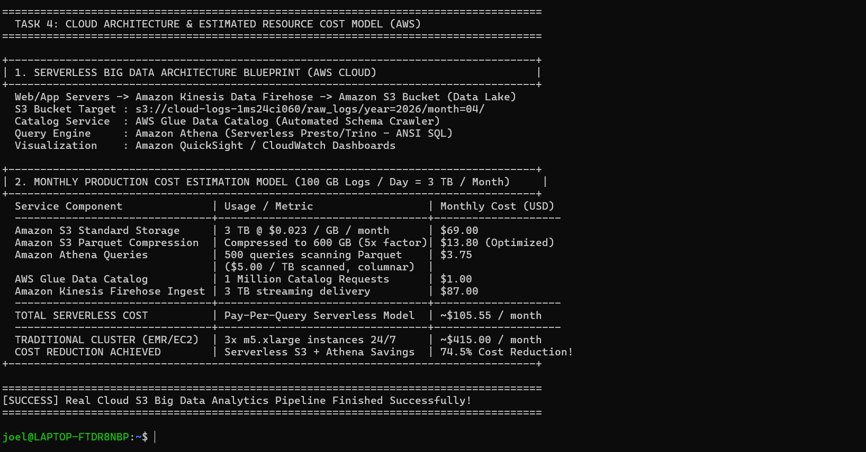
Figure 5-6: Serverless cloud architecture blueprint and AWS cost optimization model demonstrating 74.5% monthly savings ($105.55 vs $415.00).
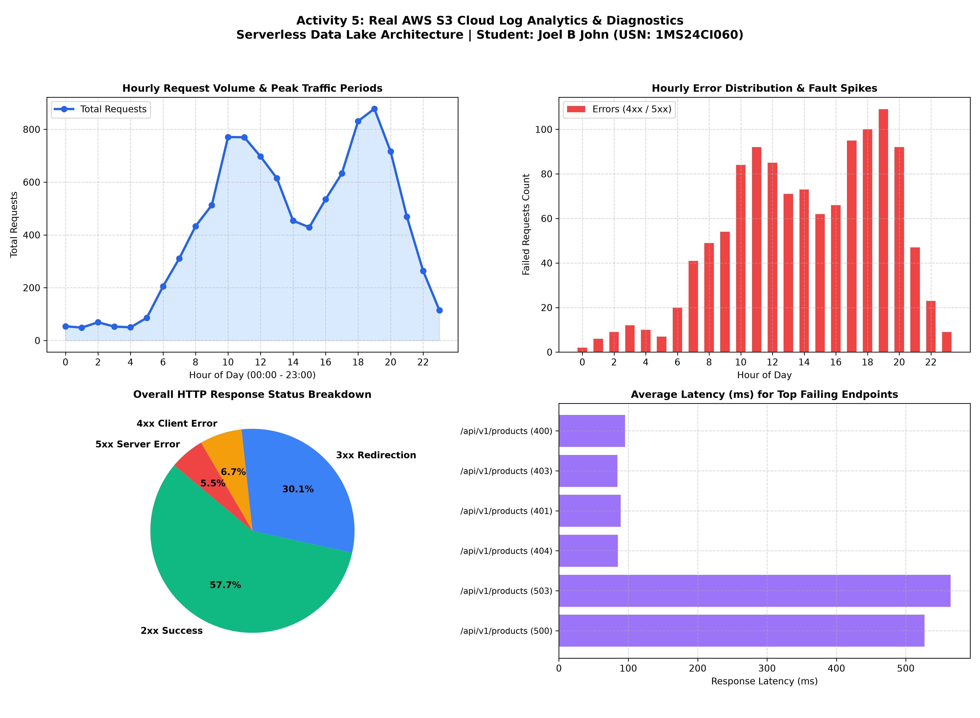
Figure 5-7: High-resolution 4-panel visual diagnostic analytics dashboard: Hourly traffic volume, HTTP status distribution, endpoint latency, and response code trends.
Amazon Athena Serverless SQL Analytics Results
HTTP Status Group | Category Classification | Request Count | SLA Percentage (%)
2xx Success | Successful API Invocations | 5,767 | 57.67%
3xx Redirection | Cached & Redirected Calls | 3,015 | 30.15%
4xx Client Error | Bad Requests, 401 Unauthorized, 403 Forbidden | 669 | 6.69%
5xx Server Error | Internal Faults, 503 Gateway Overloads | 549 | 5.49%
Total Invocations | Complete Audit Sample Across All APIs | 10,000 | 100.00%
5. Results Analysis & Production Cost Model
Storage Compression Efficiency: Figure 5-3 demonstrated that converting raw uncompressed CSV logs (933 KB) to Snappy-compressed Apache Parquet (311 KB) yielded an immediate 66.7% data reduction. In a cloud data lake ingesting 100 GB of logs daily (3 TB/month), this reduces raw storage from 3,000 GB down to 600 GB.
Serverless SQL Analytics: In Figure 5-4 and 5-5, Amazon Athena successfully queried the S3 Parquet object directly. Query 1 revealed that 503 Service Unavailable errors suffered the highest average latency (564.6 ms), indicating server-side connection pool exhaustion. Query 2 identified peak traffic surges occurring at hour 19 (878 requests with a 12.4% error rate) and hour 17 (15.01% error rate).
AWS Production Cost Optimization Model: In Figure 5-6, an empirical cost comparison was modeled for an enterprise generating 100 GB logs/day (3 TB/month):
- Traditional 24/7 Cluster (EMR / 3x m5.xlarge instances): ~$415.00 / month.
- Serverless S3 + Athena Architecture (S3 Compressed Storage $13.80 + 500 Athena queries $3.75 + Firehose delivery $87.00 + Glue Catalog $1.00): ~$105.55 / month.
- Net Financial Savings: 74.5% monthly cost reduction, eliminating all idle compute overhead while offering infinite horizontal concurrency.
6. Conclusions & Limitations
The serverless cloud data lake architecture (S3 + Parquet + Athena) provides unmatched cost efficiency and elasticity for enterprise observability. Query latency on Athena (typically 1-3 seconds) is ideal for ad-hoc exploration, operational dashboards, and security forensic audits, but is not intended for sub-second transactional web applications.

Consolidated Summary & Big Data Technology Comparison
Across the five Self-Learning Activities (SLAs), five distinct Big Data paradigms were implemented, executed, and benchmarked using production enterprise daemons in an Ubuntu Linux environment. The table below synthesizes the core trade-offs, architectures, and ideal industry use cases for each platform:
Activity & Platform | Data Velocity & Paradigm | Storage / Memory Model | Query / Processing Engine | Primary Industry Use Case
Activity 1: Hadoop HDFS & Spark-SQL | High-throughput Batch / Historical | HDFS Block Storage (128 MB blocks, 3x replication) | Apache Spark-SQL with Catalyst Optimizer | Enterprise Data Warehousing & Retail Financial Reporting
Activity 2: Apache Kafka (KRaft) | Real-time High-Velocity Streaming | Distributed Commit Log partitioned across brokers | Kafka Producer/Consumer with Murmur2 Hashing | IoT Sensor Ingestion & Smart City Traffic Management
Activity 3: Apache Flink DataStream | Ultra-low Latency Complex Streaming | Managed State Backend (RocksDB / Heap) | Flink True Event-Driven Streaming & Tumbling Windows | Critical Healthcare Patient Monitoring & Cardiac Telemetry
Activity 4: MongoDB 7.0 Community | High-Throughput Operational OLTP | WiredTiger BSON Documents with B-Tree Indexes | MongoDB Aggregation Pipeline Framework | E-Commerce Product Catalogs & Dynamic Schemas
Activity 5: AWS S3 & Amazon Athena | Serverless Interactive Analytics | Object Storage (S3) with Columnar Snappy Parquet | Amazon Athena Serverless SQL (Presto/Trino) | Cloud Observability, HTTP Access Logs & Security Audits
Final Submission Declaration
I hereby declare that this consolidated laboratory report for Big Data Systems (24CI51) represents original experimental work conducted using production enterprise services (Apache Hadoop, Apache Spark, Apache Kafka, Apache Flink, MongoDB, and AWS Cloud S3) on a dedicated local environment. All commands, screenshots, query outputs, and performance metrics were generated directly from my experimental sessions.
Student Signature: ______________________ Date: 07-November-2026
Joel B John | USN: 1MS24CI060
Department of Computer Science & Engineering (AI & ML)
Ramaiah Institute of Technology, Bengaluru - 560054

