Evaluating and Comparing Bicycle Tubing Materials:
a simplified FEM methodology

Joe Ganio-Mego (ORCHID ID = 0000-0001-6462-9842)¹

ABSTRACT
Material comparison will be carried out on popular down tube geometries with a fixed length of 300mm.
The considered bicycle type will be the road race ultralight one.
The limiting factor will be the fatigue limit strength. The pipe flexibility will be calculated. The flexibility of the steel tubing will be considered as a reference.
The results will be used to predict the lowest weight potential of a complete road bicycle frame made with the relevant tubes and materials. A hypothetical 3D-printed PLA pipe will also be evaluated.

Keywords: Bicycle, 3D printing, carbonfiber, Bicycle frame, PLA, Aluminum Alloys, chromoly steel, Freecad, Calculix.

¹ Contact Author : E-mail: gganio.geo@yahoo.com Telephone: +39 3495472346
This work including all the figures are licensed under CC BY 4.0.
Version 1. Unrevised and uncorrected.

1. Introduction

1a. Introduction / The Context

State-of-the-art road race bicycle frameset materials have evolved during the last 30 years.
Until the mid-’90s, steel was the most popular material. On the very high end, during those years, it received some competition from carbon fiber frames. They were the TVT-style carbon frames.
To keep this publication concise, we will be forced to ignore the TVT-style carbon fiber frames, despite their dominance in the professional races of those years and the fact that some of the authors own and ride some of those TVT bicycle specimens. Yes, TVT frames flex more than steel ones.
The characteristics of the steel used were constantly improving. Especially stainless chromoly alloys became the prime choice for bicycle applications.
By the mid-’90s, a reference road bicycle steel frame would weigh about 1.3 kg.
The riders considered those high-end frames kind of flexible. Therefore it was suggested to stay relatively light in grabbing the handlebar while focusing on having a steady round pedalling style, as the champions of those years were doing. Back in those years, many of those frames got cracked after a couple of years of riding. Some of the authors experienced riding those frames, including having to change frame every few years because of the appearance of a fatigue crack.
After the mid-’90s, aluminium alloy frames became popular. Frames that mixed carbon fiber portions and aluminium sections became available. Also, the first laminated carbon fiber frames became available.
Some people even experienced with magnesium alloys.
Back in those years, also titanium alloys became available. Because of conciseness requirements, this study will not consider the titanium frames.
Most of the alloys were either of the 6000 or 7000 aluminium alloy families.
Best-in-class 7000 aluminium alloy road bicycle frames could weigh below 1.0 kg.
Riders noticed that aluminium frames were stiffer than steel.
Of course, the super-light, below 1 kg, frames tended to pick up fatigue cracks after several seasons of riding.
By 2010, carbon fiber became the only material for high-end road race bikes.
Carbon fiber frames are optimized either for lightness or for aerodynamics.
Carbon fiber frames optimized for lightness can weigh even 600 g without paint.
Carbon fiber frames optimized for aerodynamics might weigh about 1 kg or more.
A regular paint job would weigh between 100 and 200g at least.
One of the authors experimented with doing the lightest paint job for a carbon fiber frame and couldn't go below 70g with clearly not acceptable results.
Even the ultra-light, carbon fiber frames feel solid and compliant when riding. It seems that there is room to go lighter.
After the year 2010, 3D printing became readily accessible to everybody. This study will evaluate if it is feasible to mimic the mechanical performances, in weight and stiffness, of a steel frame with PLA material. PLA is the most common 3D filament material.

1b. Introduction / UCI weight limit
Since the year 2000, UCI has introduced a 6.8 kg weight limit for road race bicycles. That limit has reduced the interest in developing lighter bicycles. [1]

1c. Introduction / ISO bicycles testing
Throughout the years, several testing methodologies to validate the safety of bicycles have been grouped and consolidated into a set of standards sanctioned by ISO. Especially the ISO 4210-6:2023 Part 6, 4.3 [2], which focuses on pedalling forces, has been used in this study as a reference to identify the simplified methodology to compare bicycle tubes.
It is noted that UCI, since 2019, has required race bicycles to comply with ISO 4210 standard [3]. We are in front of a belt and suspenders situation, which is good for structural safety but bad for the lightweight ambitions of bicycle technology.

1d. Introduction / CAD and FEM software used for this study
All 3D models, 2D drawings and FEM analyses have been done with FreeCAD[4]. It was a purpose and necessity of this study to simplify the structural analysis of a bicycle to allow running it on a very limited hardware. For this reason, the FEM analysis has been run with first-order tetra elements. Since the study is a comparative one, this further simplification was possible.
The FreeCAD mesher used in this study has been GMSH [5].
The FreeCAD FEM solver used in this study has been Caculix [6].

2. Methodology

Anybody familiar with road bicycles knows that the most significant deformations come from full-force sprint pedalling.
Under those conditions, the frame is loaded by the gravity of the rider plus the side loading generated by putting maximum force on the pedals and handlebar [7].
This loading condition is well summarized by ISO 4210 [2], as shown in the picture below.

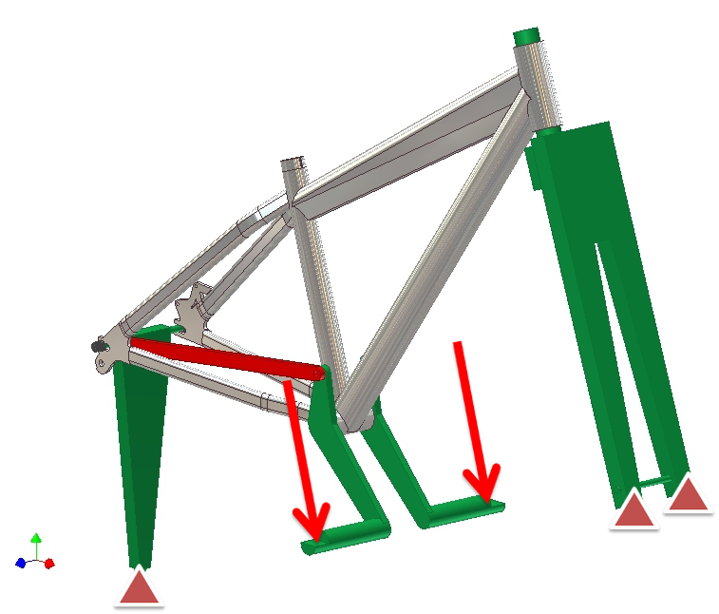

Figure 1: ISO 4210 Pedalling loads. This figure has been retreived from Marcin Zolnierczuk, GrabCAD [8] (Need to be contacted for usage permission).

The gravity and side momentum loads distribute on several pipes constituting a bicycle frame.
Suppose the down tube is the largest and heaviest pipe in a bicycle frame. If we isolate and focus only on the down tube, it might be possible to estimate the behaviour of the complete bicycle.

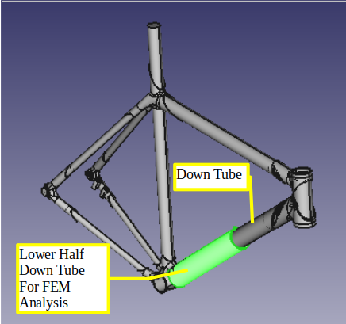

Figure 2: Down tube and lower half down tube to be used in this methodology. This figure has been retreived from Zach Medich, GrabCAD [9] (Need to be contacted for usage permission).

Indeed, the assumption of this methodology is to analyze by FEM only the lower half portion of the down tube and from it to estimate the entire frame's stiffness, strength and weight.
The ISO pedalling stress test is done with a 1000 N load alternating on one of each pedal.
All engineering considerations would agree with the loads chosen by ISO 4210.
In a bicycle frame, the pipes that go to the bottom bracket, which is the pedal crack hub, are 4, but two of them are the chain stays couple.
Therefore if we focus only on the down tube, it can be considered to use only one-third of the load.
This methodology will consider a standardized half-length down tube of 300mm. This tube will be constrained at zero displacements on one side.
The other side will be free and loaded in a uniform way.
The load will be a 300 N force in-line with the pipe, which will represent the gravity load and a 300 N perpendicular force which will represent the pedalling side momentum.

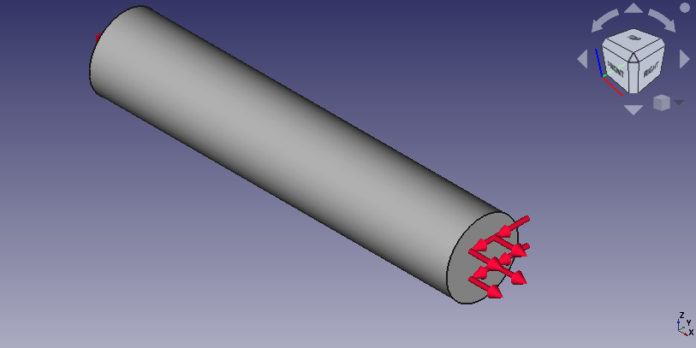

Figure 3: Loads. 300N in x direction and 300N in the -y direction. This figure is licensed under CC BY 4.0.

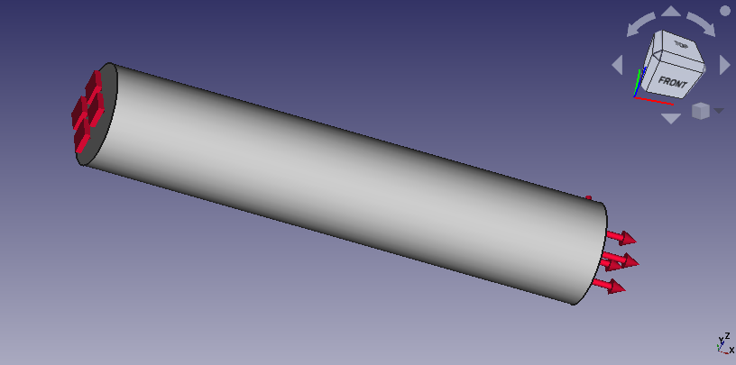

Figure 4: Constraints. 0 movement on xyz directions. This figure is licensed under CC BY 4.0.

Several lower half-down tubes will be compared. The geometries and materials of these tubes will be sourced from popular and typical supplier catalogues.
Results will be compared for stiffness, strength safety factor and estimated total bicycle weight.

3. Analysis

The 300mm geometry setup is an extreme simplification of a bicycle frame “down-tube”.
The down tube is one of the most critical tubes of a bicycle frame. Thus comparing through its subset allows us to extrapolate the results into estimating the total frame weight.

3a. Analysis / Geometries and Materials

In the bicycle industry, there are several suppliers of tubes and composite materials that are then transformed into finished bicycle frames.
The shapes that are proposed by the suppliers [10] are already optimized in function of the material of the tube itself. That means that steel down tubes are normally offered with outer diameters of 32mm. Aluminium alloy tubes are offered with OD typically of 50mm. Carbon composite pipes go at 60mm of OD, which is practically the largest OD feasible on a road bicycle because of the pedal crank stance.
A reference catalogue for this study has been the one of Fairing Industrial Inc. A well-known supplier of tubes and other elements especially used by artisan bicycle makers [11].
Since this study focuses on comparing state-of-the-art bicycle tubing, all the selected pipes are of the double-butted kind. Because only half pipe is analyzed, then only the portion intended to be connected to the bottom bracket is retained for the study.

Here we will list the pipes with geometry and material that has been analyzed in this study.

3b. Analysis / Chromoly Steel Pipe
FreeCAD File = Steel_4130crmo_Pipe_01.FCStd (Available at OSF and Github)
Pipe Material = Chromoly Steel AISI 4130
Pipe OD [mm] =31.8
Pipe Thickness at base [mm] =1.2 , Pipe Thickness at tip [mm] =0.9
Pipe weight [g] = 231.0 , Extrapolated full frame weight [g]=1495.0
(Note: weight extrapolation has been done by multiplying the pipe weight by 6.47)
Typical full frame weight (size M) for that kind of tubing (not painted)[g]=1350.0

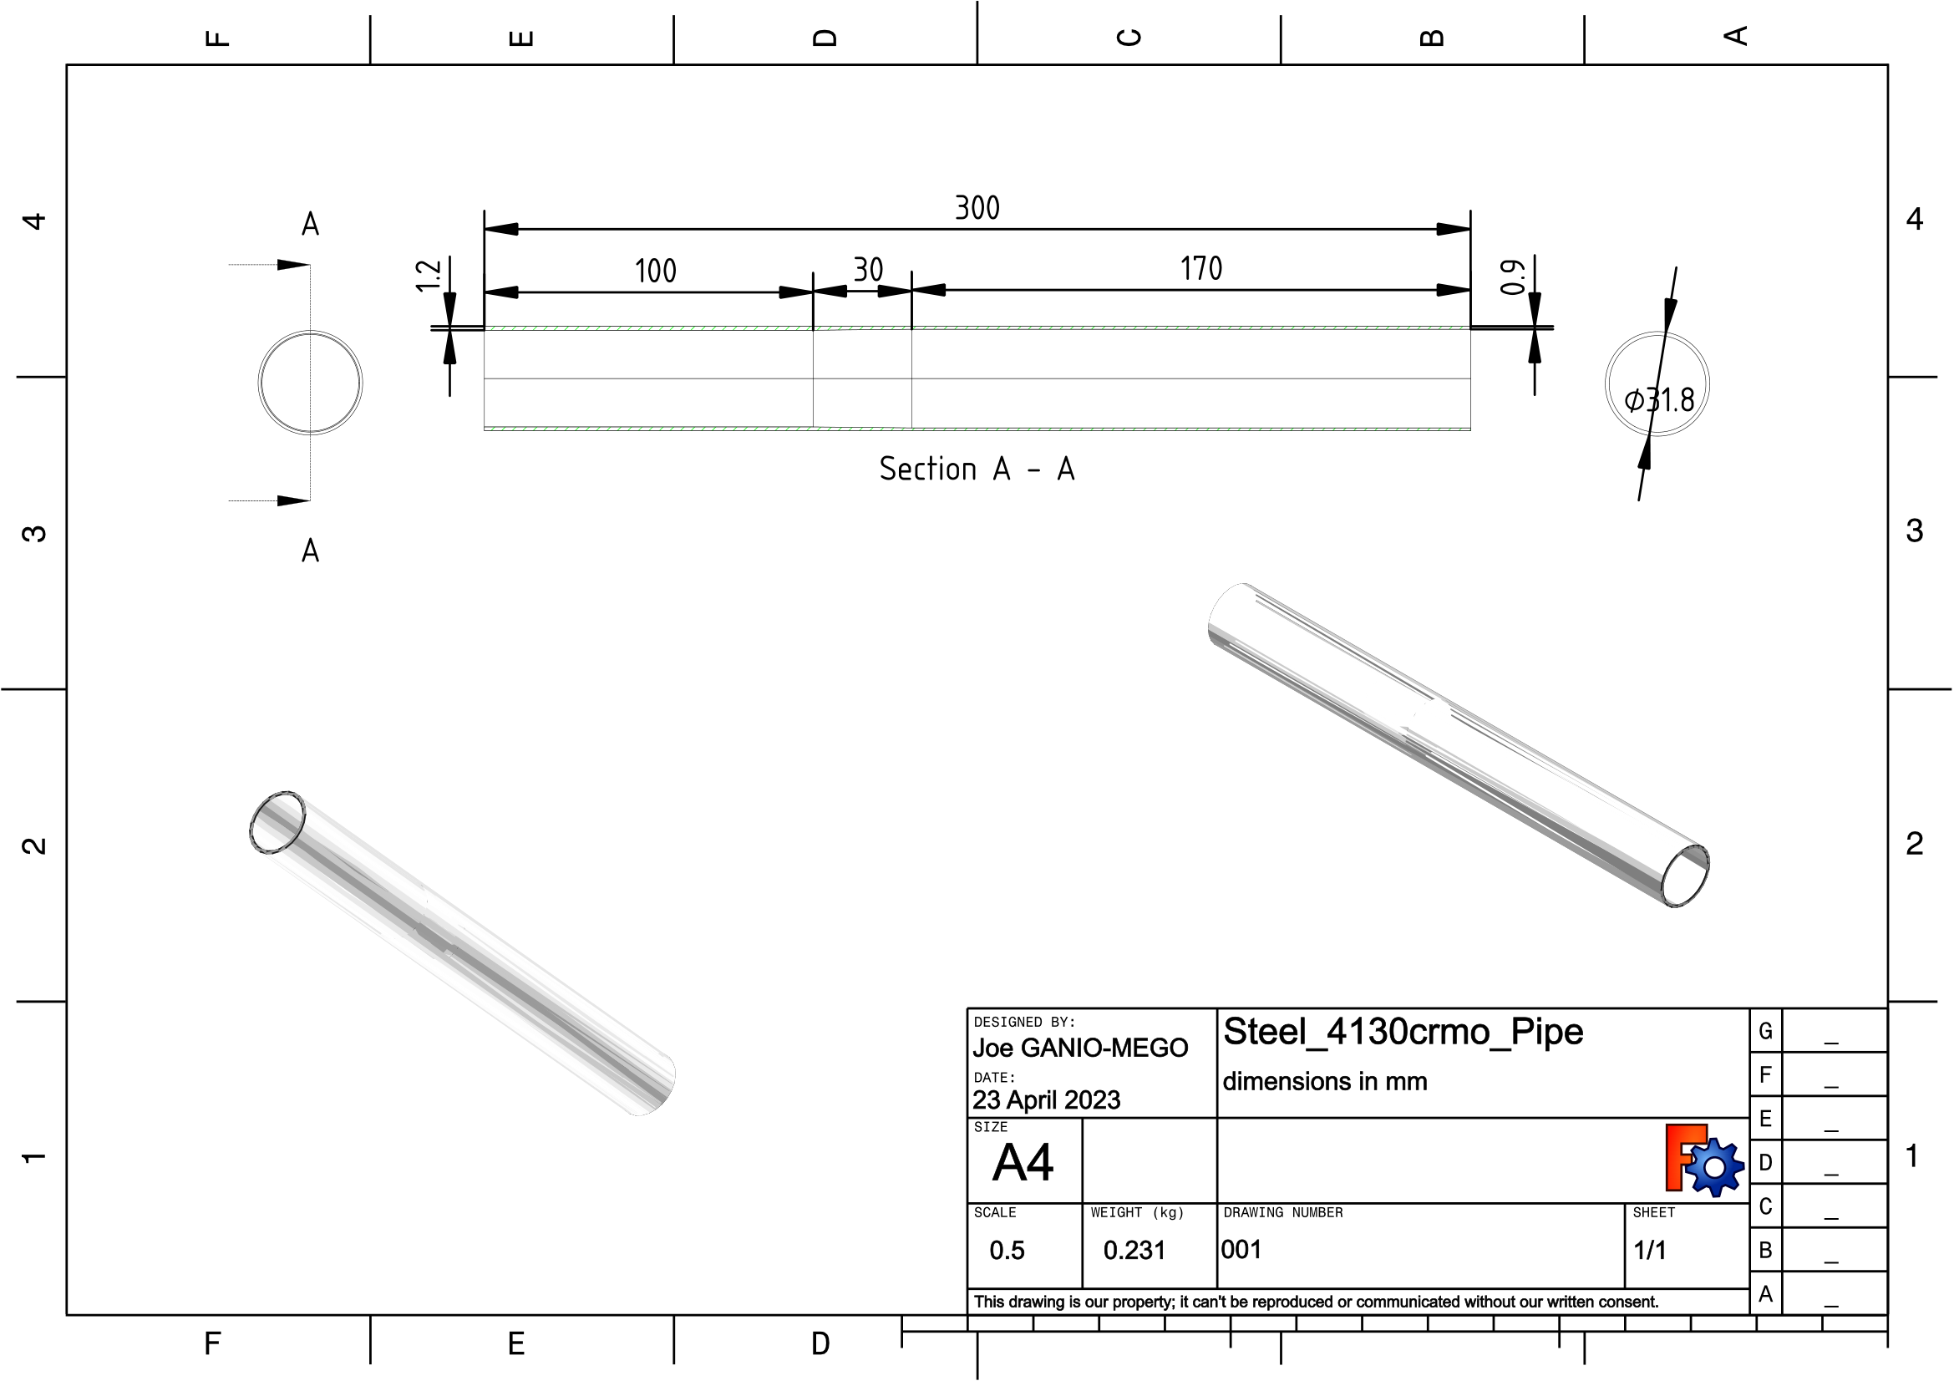

Figure 5: Chromoly Steel AISI 4130 pipe drawing. This figure is licensed under CC BY 4.0.

3c. Analysis / Aluminum 6061T0 Pipe
FreeCAD File = Alu_6061T0_Pipe_01.FCStd (Available at OSF and Github)
Pipe Material = Aluminum Alloy 6061T0
Pipe OD [mm] =50.8
Pipe Thickness at base [mm] =1.5 , Pipe Thickness at tip [mm] =1.1
Pipe weight [g] = 164.0 , Extrapolated full frame weight [g]=1059.0
(Note: weight extrapolation has been done by multiplying the pipe weight by 6.47)
Typical full frame weight (size M) for that kind of tubing (not painted)[g]=1100.0

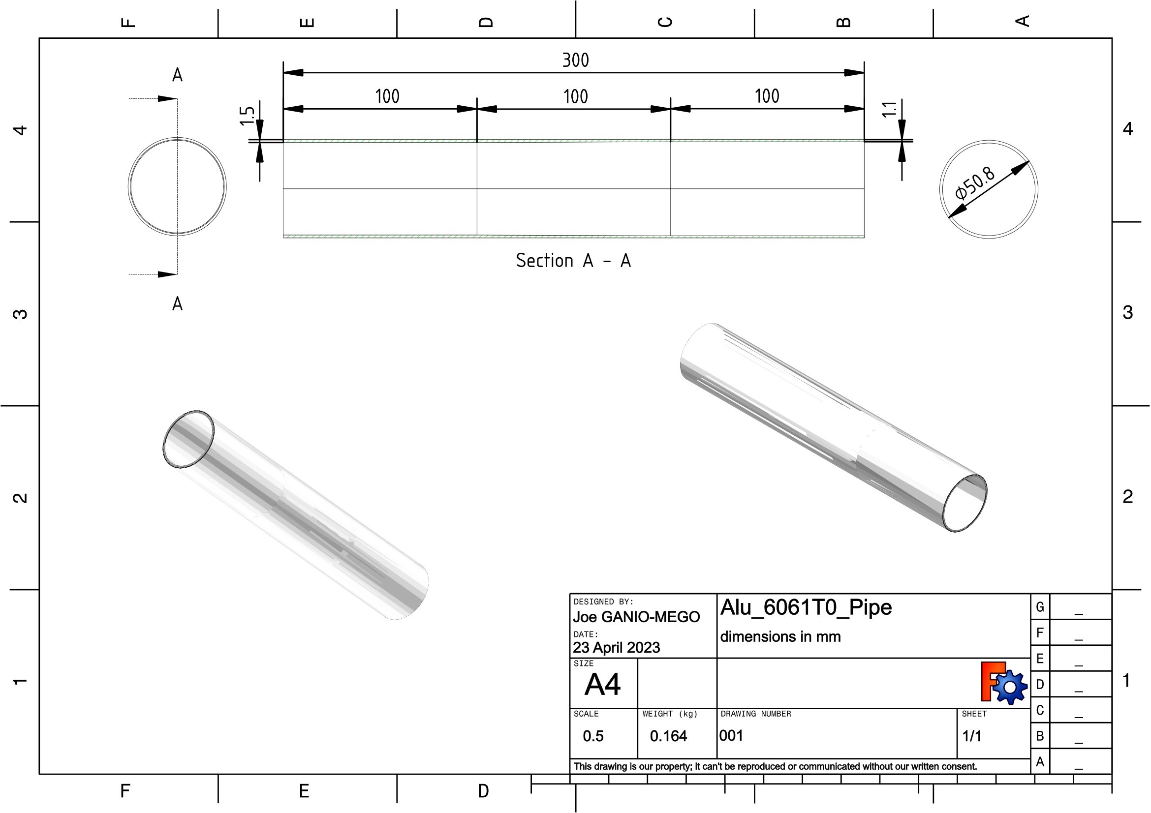

Figure 6: Aluminum Alloy 6061T0 pipe drawing. This figure is licensed under CC BY 4.0.

3d. Analysis / Aluminum 7005T6 Pipe
FreeCAD File = Alu_6061T0_Pipe_01.FCStd (Available at OSF and Github)
Pipe Material = Aluminum Alloy 7005T6
Pipe OD [mm] =50.8
Pipe Thickness at base [mm] =1.2 , Pipe Thickness at tip [mm] =0.9
Pipe weight [g] = 137.0 , Extrapolated full frame weight [g]=885.3
(Note: weight extrapolation has been done by multiplying the pipe weight by 6.47)
Typical full frame weight (size M) for that kind of tubing (not painted)[g]= 990.0

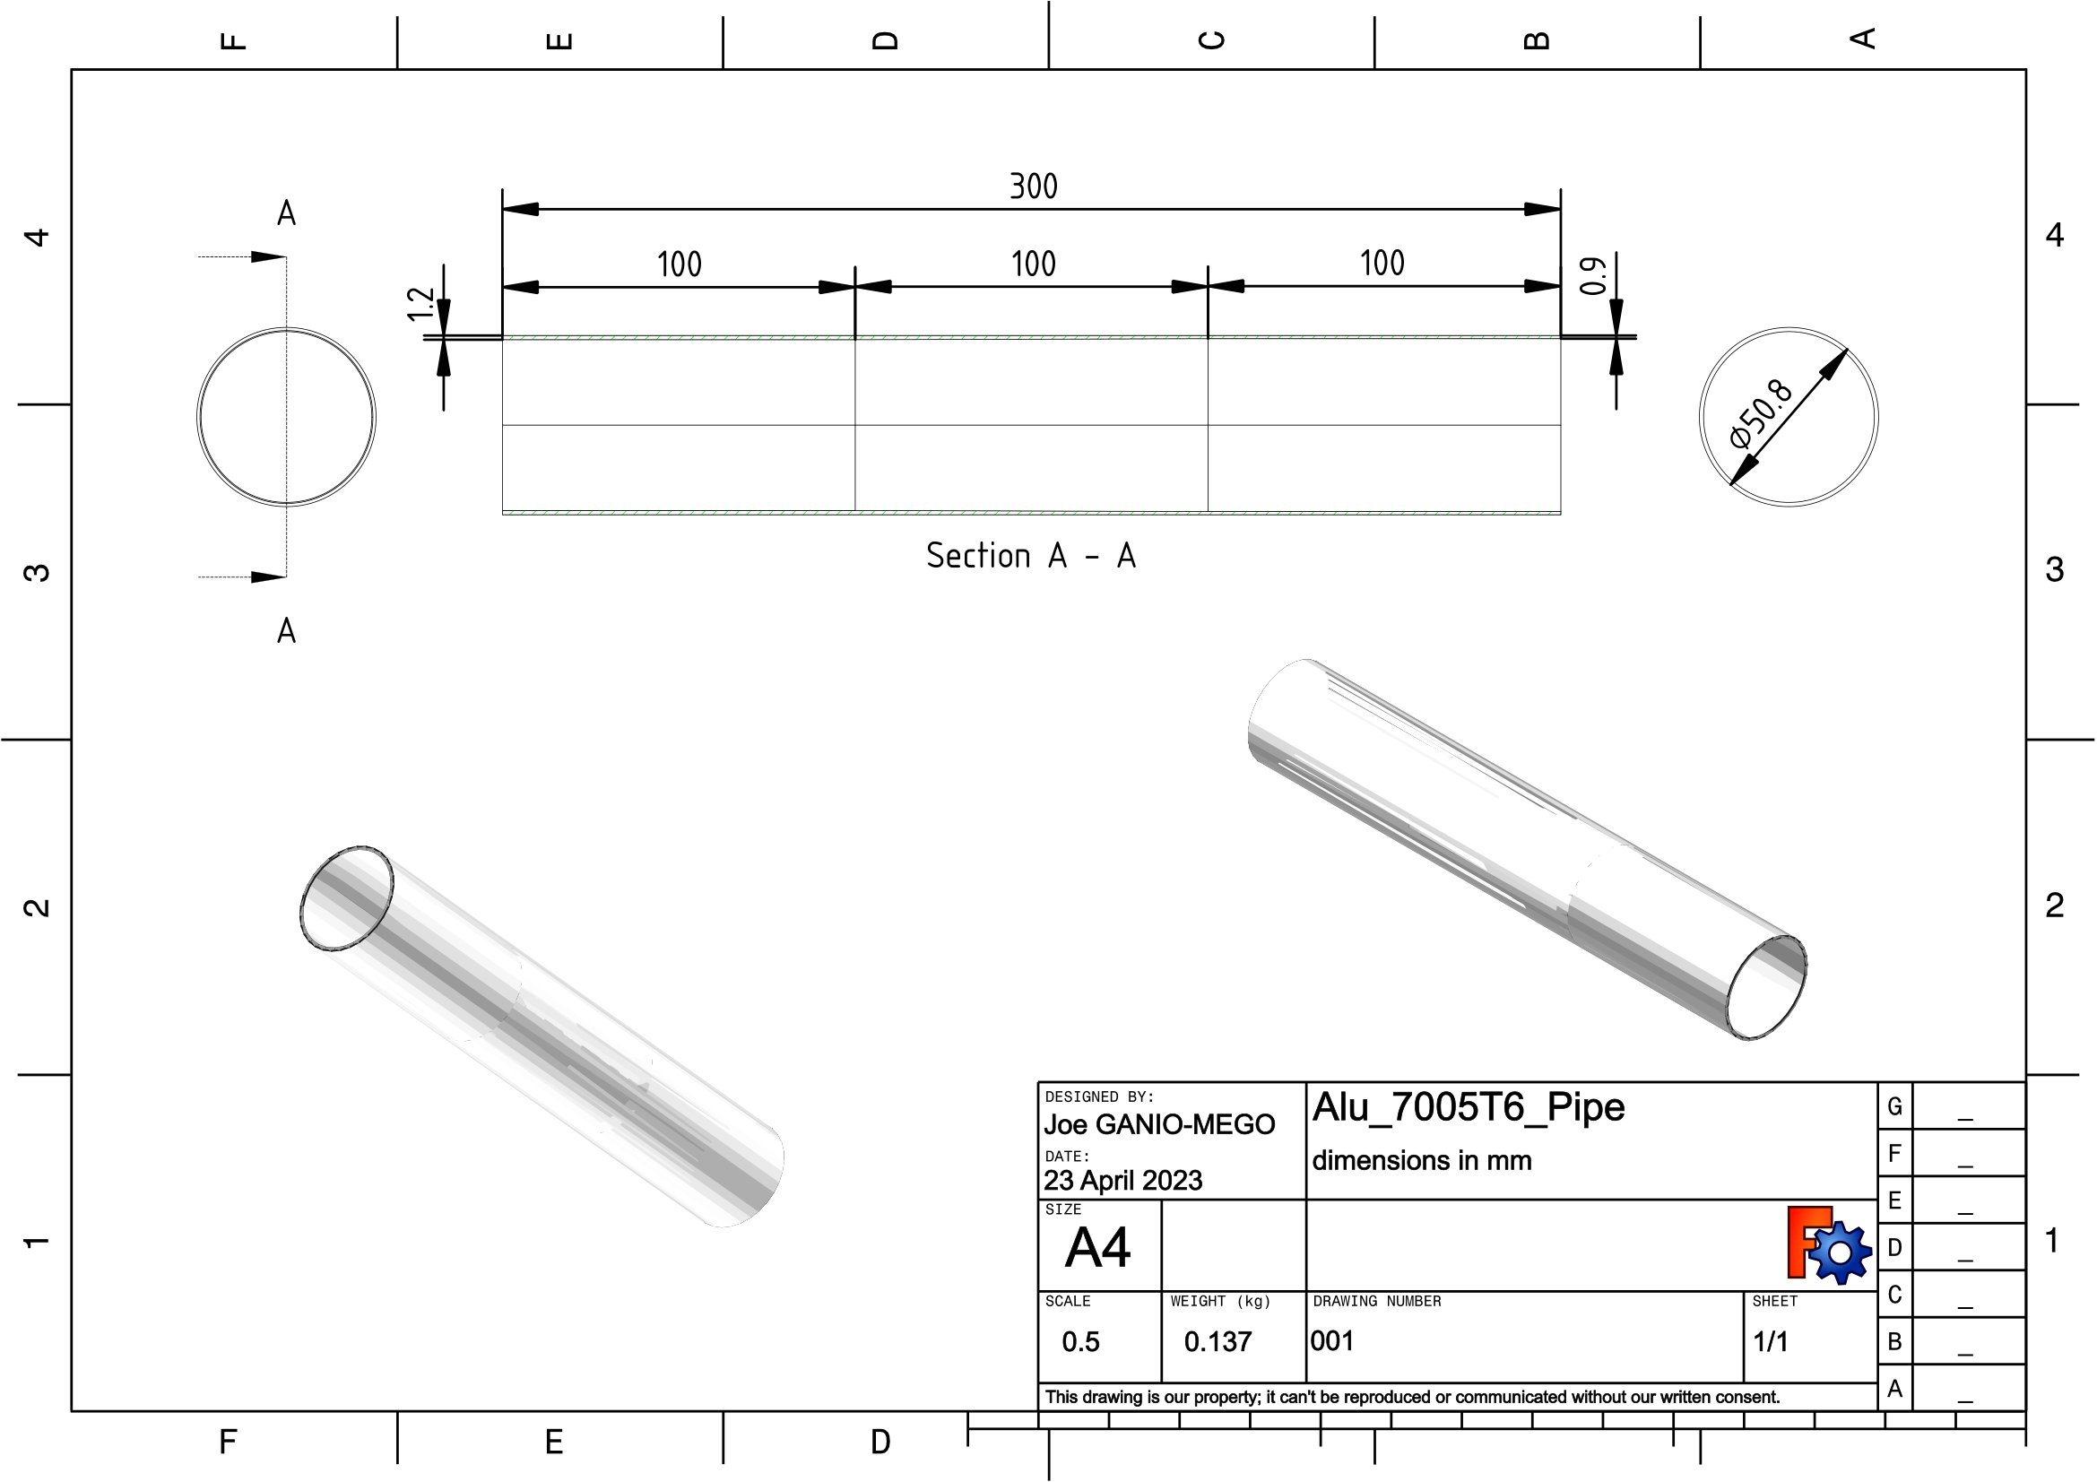

Figure 7: Aluminum Alloy 7005T0 pipe drawing. This figure is licensed under CC BY 4.0.

3e. Analysis / Carbonfiber T300 Pipe
FreeCAD File = CF_2d_T300_Pipe_01.FCStd (Available at OSF and Github)
Pipe Material = Carbonfiber T300 3K 2d woven fabric epoxy resin laminate
Pipe OD [mm] =60.0
Pipe Thickness at base [mm] =1.8 , Pipe Thickness at tip [mm] =1.4
Pipe weight [g] = 104.0 , Extrapolated full frame weight [g]=672.1
(Note: weight extrapolation has been done by multiplying the pipe weight by 6.47)
Typical full frame weight (size M) for that kind of tubing (not painted)[g]= 620.0

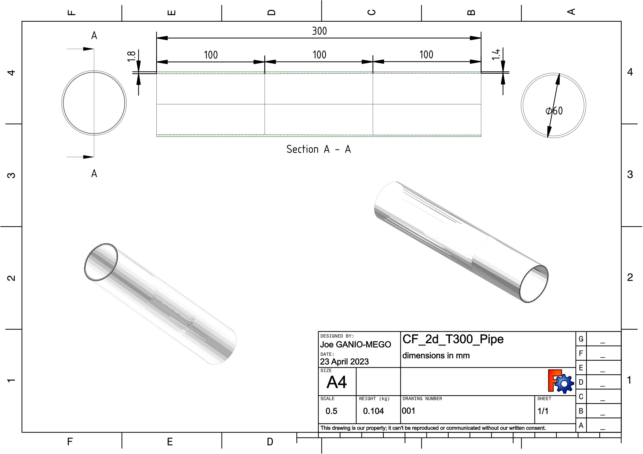

Figure 8: Carbonfiber T300 2d fabric resin laminate pipe drawing. This figure is licensed under CC BY 4.0.

3f. Analysis / Carbonfiber T700 Pipe
FreeCAD File = CF_2d_T700_Pipe_01.FCStd (Available at OSF and Github)
Pipe Material = Carbonfiber T700 3K 2d woven fabric epoxy resin laminate
Pipe OD [mm] =60.0
Pipe Thickness at base [mm] =1.7 , Pipe Thickness at tip [mm] =1.3
Pipe weight [g] = 102.0 , Extrapolated full frame weight [g]=658.0
(Note: weight extrapolation has been done by multiplying the pipe weight by 6.47)
Typical full frame weight (size M) for that kind of tubing (not painted)[g]= 600.0

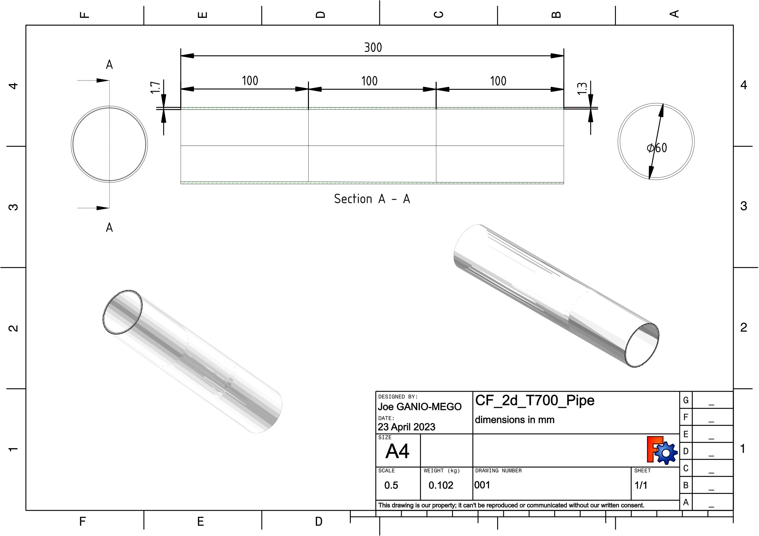

Figure 9: Carbonfiber T700 2d fabric resin laminate pipe drawing. This figure is licensed under CC BY 4.0.

3g. Analysis / Carbonfiber T800 Pipe
FreeCAD File = CF_2d_T800_Pipe_01.FCStd (Available at OSF and Github)
Pipe Material = Carbonfiber T800 3K 2d woven fabric epoxy resin laminate
Pipe OD [mm] =60.0
Pipe Thickness at base [mm] =1.5 , Pipe Thickness at tip [mm] =1.1
Pipe weight [g] = 94.0 , Extrapolated full frame weight [g]=609.4
(Note: weight extrapolation has been done by multiplying the pipe weight by 6.47)
Typical full frame weight (size M) for that kind of tubing (not painted)[g]= 590.0

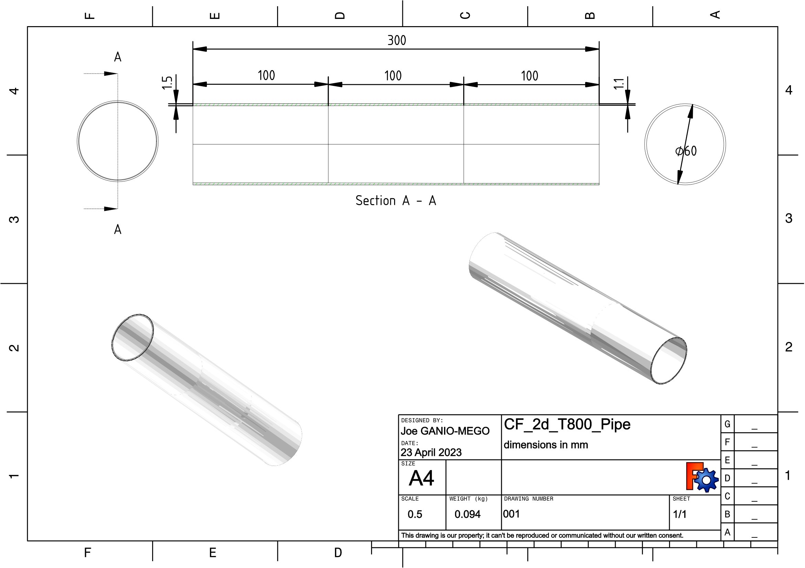

Figure 10: Carbonfiber T800 2d fabric resin laminate pipe drawing. This figure is licensed under CC BY 4.0.

3h. Analysis / FDM 3D Printed PLA Pipe
FreeCAD File = PLA_Shaped_Pipe_01.FCStd (Available at OSF and Github)
Pipe Material = PLA
Pipe OD [mm] =60.0
Pipe Thickness at base [mm] =15.0 , Pipe Thickness at tip [mm] =3.0
Pipe weight [g] =480.0 , Extrapolated full frame weight [g]=3105.0
(Note: weight extrapolation has been done by multiplying the pipe weight by 6.47)
Typical full frame weight (size M) for that kind of tubing (not painted)[g]= NA

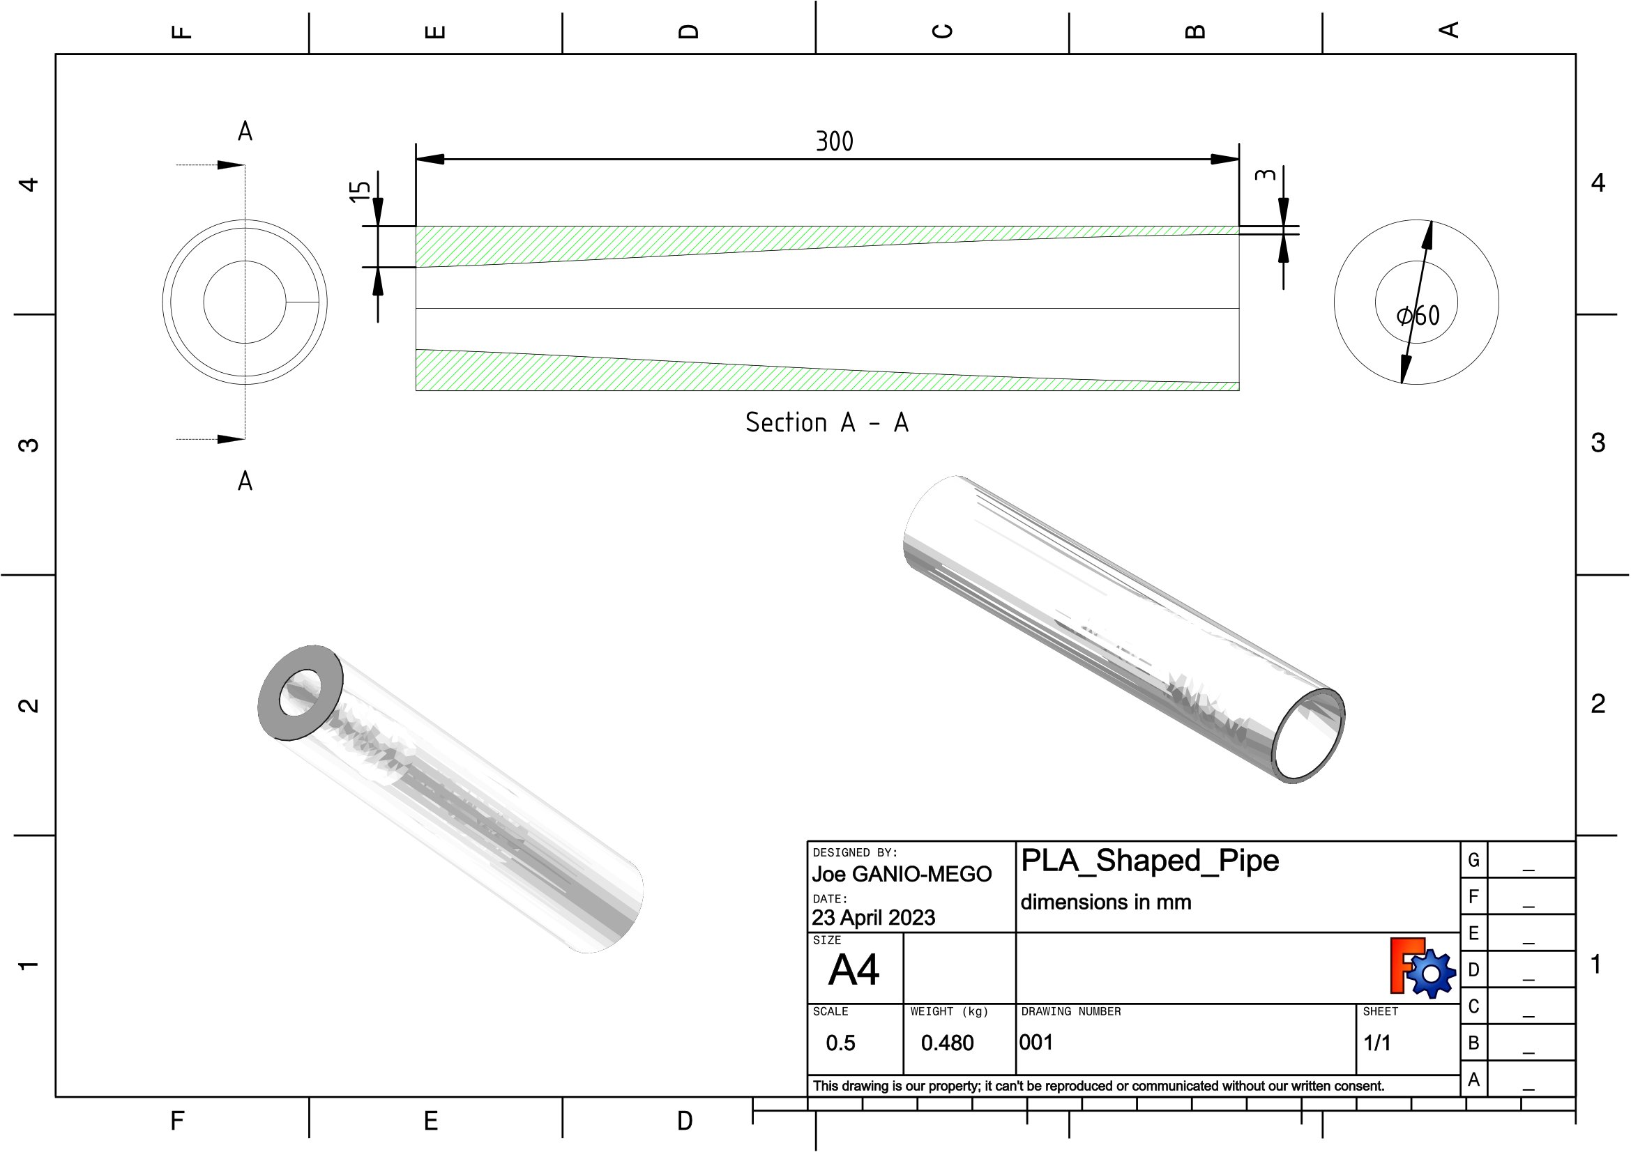

Figure 11: FDM 3D Printed PLA Pipe pipe drawing. This figure is licensed under CC BY 4.0.

3i. Analysis / Material Property Table

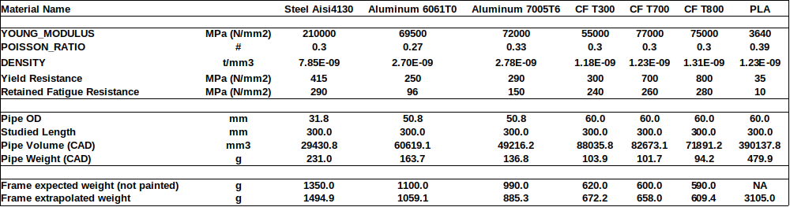

Table1: Material Properties Data.

These material properties have been generated from data coming from several sources [4][6][12][13][14][15][16][17][18][19][20][21][22][23][24][25][26][27][28][29][30][31][32][33][34][35][36]. The retained property has been identified by applying engineering judgment to the several relevant values found.
Especially the fatigue resistance properties have been difficult to be identified.
It has been attempted to focus on a 5 million cycles fatigue resistance. But that value is difficult to be measured, and therefore it is rarely available. Especially for non-metal materials, the fatigue resistance varies not only in the function of the cycles but also in the function of the amplitude cycle history.
With composites, the brand and kind of fabric supplier, the nature of the resin used and much more have an impact on the resulting properties. Furthermore, all properties related to composite materials are difficult to be identified because of the many specific parameters involved. The properties retained in this study for the composite materials are the best engineering guess also based on the finished product bicycle frames that are currently available in the market.

3l. Analysis / Output Parameters Definition

For each pipe these are the output parameters that will be used in the comparison.
Max Displacement [mm] (1)
Max Displacement is a direct Freecad/Calculix output. It is the calculated maximum displacement found by the solver among all nodes of the model.
Max Von Mises Stress [MPa] (2)
Max Von Mises Stress is a direct Freecad/Calculix output. It is the calculated maximum Von Mises Stress found by the solver among all nodes of the model.
Stiffness [1/mm] (3)
Stiffness will be defined as the inverse of Max Displacement:
Stiffness = 1/Max Displacement (4)

HCF Minimal Safety Factor [#] (5)
It is the high cycle fatigue safety factor, defined as:
HCF Minimal Safety Factor = (Material Fatigue Strength[MPa])/(Max Von Mises Stress [MPa]) (6)
Hereafter HCF Minimal Safety Factor might be shortened as SF.
Obviously SF should be at least above 1.0. Having SF values too high would mean an heavier than needed frame. Values around 2.0 are probably the ideal compromise between safety and fame weight.

4. Results
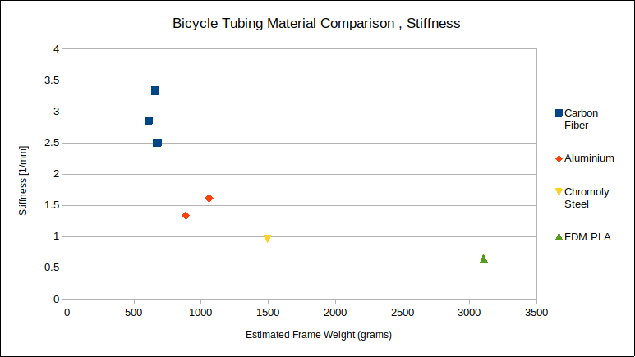
Figure 12: Calculated pipe stiffness function of estimated frame weight. This figure is licensed under CC BY 4.0.
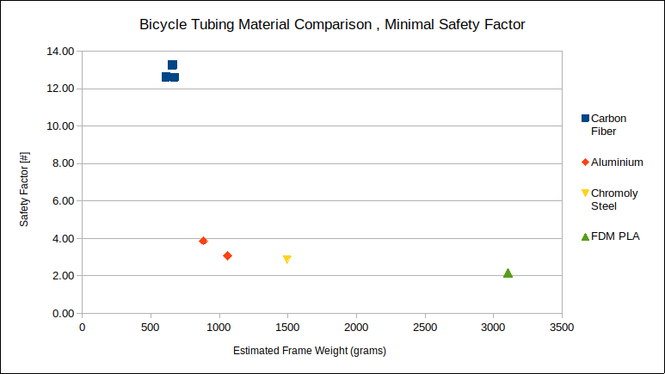
Figure 13: HCF Safety Factor function of estimated frame weight. This figure is licensed under CC BY 4.0.

It has to be considered that 1st order elements have been used for the analysis. Therefore the stiffness results can be trusted as is, but the safety factor ones are over-predicting. All SF should be lowered by probably 30%. Since this study is comparative and the minimal SF is above 2.0, there is no issue in this case.

5. Conclusions

The proposed methodology successfully provides comparative values for bicycle frame stiffness and weight performances.
The results match material selection charts [37][38], but this methodology allows us to account also for the pipe geometry.
Its simplicity can be used as a practical way to evaluate several possible down-pipe designs and materials.
The well-appreciated sound flexibility of chromoly steel frames has been confirmed.
Carbon fiber frames appear to have the possibility to reduce their weight further. There might be two factors that play a role in this case. The first one is that the material properties of laminated composites are difficult to be identified and to be repeated consistently especially the fatigue resistance. Therefore, the industry has chosen to play it safe and stay on the heavy side.
The second is that carbon fiber frames became popular after 2000 when the UCI weight limit was already active. Therefore the interest to shade off weight had dwindled.
At least from what has been seen in this study, a frame made by PLA would be outside of the acceptable range in terms of stiffness and weight. However, a deeper analysis is required to understand if this is really the case.

Appendix

A1. Model Repository

OSF (Open Science Foundation) = https://osf.io/pz6sa/
Github = https://github.com/joeganiomego/BicycleTubingMaterialComparison

References

[1] The UCI Tecnical Regulation. ARTICLE 1.3.019 . UCI – Union Cycliste Internationale, Aigle,
CH, www.uci.org.

[2] ISO 4210-6:2023(en) Cycles — Safety requirements for bicycles — Part 6: Frame and fork test methods - 4.3 Frame — Fatigue test with pedalling forces .Standard, International Organization for Standardization, Geneva, CH,www.iso.org.

[3] The UCI Tecnical Regulation. ARTICLE 1.3.002 . UCI – Union Cycliste Internationale, Aigle,
CH, www.uci.org.

[4] Juergen Riegel, Werner Mayer, Yorik van Havre (2001-2017). FreeCAD (Version: 0.20.2.29177 +426 (Git) Snap 517), Software Available from http://www.freecadweb.org, OS: Ubuntu Core 20 (ubuntu:GNOME/ubuntu), Word size of FreeCAD: 64-bit,Python 3.8.10, Qt 5.15.5, Coin 4.0.0, Vtk 7.1.1, OCC 7.6.3.

[5] C. Geuzaine and J.-F. Remacle. Gmsh: a three-dimensional finite element mesh generator with built-in pre- and post-processing facilities. International Journal for Numerical Methods in Engineering 79(11), pp. 1309-1331, 2009. GMSH embedded in FreeCAD FEM Workbench, FEM mesh from shape by GMSH. Software Available from https://gmsh.info .

[6] Dhondt, G. The Finite Element Method for Three-Dimensional Thermomechanical Applications, Wiley, 2004. Calculix embedded in FreeCAD FEM Workbench, Solver Calculix Standard. Software Available from http://www.calculix.de.

[7] Soden, P.D. & Adeyefa, Bodunrin. (1979). Forces applied to a bicycle during normal cycling. Journal of biomechanics. 12. 527-41. 10.1016/0021-9290(79)90041-1.

[8] Marcin Zolnierczuk (July 16th, 2016). FEA of Bike frame - fatigue test ISO 4210-6, www.simdespartner.com . FEA fatigue test of bike frame according to ISO 4210-6, submodeling of welds for fatigue life calculation. bicycle_frame_fatigue_test_ISO_4210-6.jpg
Retrieved March 14, 2023, from https://grabcad.com/library/fea-of-bike-frame-fatigue-test-iso-4210-6-www-simdespartner-com-1

[9] Zach Medich (September 25th, 2020). 3D Printed Titanium Lug Road Bike.Retrieved March 14, 2023, from https://grabcad.com/library/3d-printed-titanium-lug-road-bike-1

[10] Dedaindustrie s.r.l., Via L. Da Vinci, 19 26010 Campagnola (CR) - Italy. Online catalogs. Retrieved March 14, 2023, from http://www.dedacciai.com/

[11] Fairing Industrial Inc. , 12340 East End Ave., Chino, CA. 91790, USA, www.bicycleframedepot.us , www.fairing.com. Online catalogs. Retrieved March 14, 2023, from www.bicycleframedepot.us

[12] Eskandarzade, Mehdi & Noruzi, R. (2015). A Study of Fatigue Properties of Steel AISI4130 (30KhMF) After Upset Welding. Metal Science and Heat Treatment. 57. 52-56. 10.1007/s11041-015-9834-1.

[13] MatWeb, Your Source for Materials Information ,https://www.matweb.com/

[14] Broer, Agnes. (2018). Fatigue life prediction of carbon fibre-reinforced epoxy laminates using a single S-N curve.

[15] Pandzic, A[di]; Hodzic, D[amir], Hajro I[smar] & Tasic P[etar] (2020). Strength,Properties of PLA Material Obtained by Different Models of FDM 3D Printer, Proceedings of the 31st DAAAM International Symposium, pp.xxxx-xxxx, B. Katalinic (Ed.), Published by DAAAM International, ISBN 978-3-902734-xx-x, ISSN 1726-967 9, Vienna, Austria DOI: 10.2507/31st.daaam.proceedings.xxx

[16] Hodzic, D[amir] & Pandzic, A[di] (2021). Influence of Infill Design on Compressive and Flexural Mechanical Properties of FDM Printed PLA Material, Proceedings of the 32nd DAAAM International Symposium, pp.0191-0199, B. Katalinic (Ed.), Published by DAAAM International, ISBN 978-3-902734-33-4, ISSN 1726-9679, Vienna, Austria DOI: 10.2507/32nd.daaam.proceedings.029

[17] Katalinic, B[ranko]; Park, H[ong] S[eok] & Smith, M[ark] (2019). Title of Paper, Proceedings of the 30th DAAAM International Symposium, pp.xxxx-xxxx, B. Katalinic (Ed.), Published by DAAAM International, ISBN 978-3-902734-xx-x, ISSN 1726-9679, Vienna, Austria DOI: 10.2507/30th.daaam.proceedings.xxx

[18] Wu J, Pan Y, Ruan Z, Zhao Z, Ai J, Ban J and Jing X (2022), Carbon ﬁber-reinforced epoxy with 100% ﬁber recycling by transesteriﬁcation reactions. Front. Mater. 9:1045372. doi: 10.3389/fmats.2022.1045372

[19] Schmitz, Anne. (2021). Fatigue Properties of 3D Printed Carbon Fiber. 10.1115/IMECE2021-67626.

[20] Ezeh, O.H. and Susmel, L. orcid.org/0000-0001-7753-9176 (2018) On the fatigue strength of 3D-printed polylactide (PLA). In: Prcedia Structural Integrity. IGF Workshop “Fracture and Structural Integrity”, 04-06 Jun 2018, Cassino, Italy. Elsevier , pp. 29-36.

[21] Arief Yudhanto, Yutaka Iwahori, Naoyuki Watanabe, Hikaru Hoshi, Open hole fatigue characteristics and damage growth of stitched plain weave carbon/epoxy laminates, International Journal of Fatigue, Volume 43, 2012, Pages 12-22, ISSN 0142-1123

[22] Song Zhou, Xiaodi Wu, Fatigue life prediction of composite laminates by fatigue master curves, Journal of Materials Research and Technology, Volume 8, Issue 6, 2019, Pages 6094-6105, ISSN 2238-7854,

[23] Hoffmann, Yannick. (2017). CAN 3D PRINTED SURFBOARDS KEEP UP WITH TRADITIONAL SHAPED SURFBOARDS?. 10.13140/RG.2.2.27720.62721.

[24] Nabeel Maqsood, Marius Rimašauskas, Characterization of carbon fiber reinforced PLA composites manufactured by fused deposition modeling, Composites Part C: Open Access, Volume 4, 2021, 100112, ISSN 2666-6820

[25] Development of a Lightweight, Composite Carbon Fiber Street Racing Bicycle Frame , https://www.altair.com.es/customer-story/Duratec/development-of-lightweight-carbon-fiber-street-racing-bicycle-frame

[26] Rontescu, Corneliu & Cicic, Dumitru & Amza, Catalin Gheorghe & Chivu, O.R. & Dobrota, Dan. (2015). Choosing the optimum material for making a bicycle frame. Metalurgija -Sisak then Zagreb-. 54. 679-682.

[27] Shah, Jinesh & Shah, Shivangi & Mehta, Ghanshyam & Gandhi, Jainam & Gor, Mehul. (2020). Vertical stiffness of bicycle frame and its influence on rider comfort. SN Applied Sciences. 2. 1629. 10.1007/s42452-020-03410-w.

[28] Lin C-C, Huang S-J, Liu C-C. Structural analysis and optimization of bicycle frame designs. Advances in Mechanical Engineering. 2017;9(12).

[29] Derek Covill, Alex Blayden, Daniel Coren, Steven Begg, Parametric Finite Element Analysis of Steel Bicycle Frames: The Influence of Tube Selection on Frame Stiffness, Procedia Engineering, Volume 112, 2015, Pages 34-39, ISSN 1877-7058,

[30] Derek Covill, Philippe Allard, Jean-Marc Drouet, Nicholas Emerson, An Assessment of Bicycle Frame Behaviour under Various Load Conditions Using Numerical Simulations, Procedia Engineering, Volume 147, 2016, Pages 665-670, ISSN 1877-7058

[31] Hamzah Ibnu Yasin, Mahros Darsin, Gaguk Jatisukamto; Finite element analysis on e-bike frame model with composite material variations. AIP Conference Proceedings 21 February 2023; 2482 (1): 120001.

[32] Gupta, Rajeev & Rao, G. (2017). Analysis of Mountain Bike Frame By F.E.M. 10.9790/1684-1302018994.

[33] Margetin, M.; Chmelko, V.; Sulko, M.; Ďurka, R.; Koščo, T. Fatigue Lifetime Analysis of a Bicycle Frame Made by Additive Manufacturing Technology from AlSi10Mg. Metals 2022, 12, 1277

[34] Kitselis, A.G.; Nikolakea, C.S.; Manolakos, D.E. The Design Process of an Optimized Road Racing Bicycle Frame. Machines 2022, 10, 149.

[35] Sarath, Nimisha Sara Daniel and Jinuchandran. “Stress Analysis of Bicycle Frame using Different Materials by FEA.” (2021).

[36] Sourav, Sharma, A., Pandey, M. (2021). Material Selection and Analysis of Bicycle Frame. In: Singh, J., Kumar, S., Choudhury, U. (eds) Innovations in Cyber Physical Systems. Lecture Notes in Electrical Engineering, vol 788. Springer, Singapore.

[37] Engineers Academy. “Selecting Ideal Materials for Bicycle Frames Using Material Selection Charts”. (2018) . Material Selection - Level 4 Engineering. Youtube video : https://youtu.be/eRaxjdijGPg

[38] Material Selection Charts, http://www-materials.eng.cam.ac.uk/mpsite/interactive_charts/default.html

Joe Ganio-Mego (ORCHID ID = 0000-0001-6462-9842)
Telephone: +39 3495472346
E-mail: gganio.geo@yahoo.com

Note: October 2023.
This is a working paper.
I am actively looking for co-authors and co-contributors to continue this work.

This work including all the figures are licensed under CC BY 4.0.

