Evaluating 3D printed PLA as Bicycle Tubing Material:
a feasibility study

Joe Ganio-Mego (ORCHID ID = 0000-0001-6462-9842)¹

ABSTRACT

There is this question: does it make sense to build a road race bicycle frame by FDM 3D printing? And, in case that simple 3D printing of PLA filament would no be enough, would it help to skin over the 3D printed frame several layers of carbon fiber? These two techniques, might be found practical, in the custom made bicycle frame-building community. We apply here a super simplified methodology to compare bicycle tubing and we find that there is the possibility for a frame made with carbon fiber skinned over a PLA core to be competitive.

Keywords: Bicycle, 3D printing, carbon fiber, Bicycle frame, PLA, Aluminum Alloys, chromoly steel, Freecad, Calculix, carbon fiber skinning, framebuilders.

¹ Contact Author : E-mail: gganio.geo@yahoo.com Telephone: +39 3495472346
This work including all the figures are licensed under CC BY 4.0.
Version 1. Unrevised and uncorrected.

1. Introduction

1a. Introduction / The Context

There are different opinions about if and how 3D printing can be used to build high-performance bicycle frames. For sure 3D printing enables freedom of shape, thus being compatible with achieving highly aerodynamic shapes. But how it would perform for the stiffness-weight ratio needs to be made clear.
Especially in the community of bespoke and handmade frame-building, 3D printing might be the ideal tool to achieve one-off customization while benefiting from carbon fibre lamination's performance.
Since 3D printing enables practically any shape, including the internals of the pipe, that might trade off the fact that the 3D printing materials have, in general, much lower Young modula than carbon fiber. Looking at the material selection charts (also known as Ashby plots) [1][2], the most typical FDM material, PLA, has no chance compared to carbon fiber or aluminium. But the Ashby plots are shape agnostic. 3D printing has complete shape freedom. It could catch up with the modulus and strength penalization with finely engineered shapes.
Additionally, whenever 3D printing alone could not provide satisfactory performances, it could be coupled with carbon fiber to reach the desired structural performance.
That coupling would allow for carbon fiber lamination without the costly moulds since the 3D printing would be the mould itself.
Since the year 2000, UCI has introduced a 6.8 kg weight limit for road race bicycles. That limit has reduced the interest in developing lighter bicycles [3]. This lingering weight limit, even though it can be ignored by most of the general public and manufacturers, impacts the technical choices and commercial preferences of the bicycle industry.

1b. Introduction / CAD and FEM software used for this study
All 3D models, 2D drawings and FEM analyses have been done with FreeCAD[4]. It was a purpose and necessity of this study to simplify the structural analysis of a bicycle to allow running it on a very limited hardware. For this reason, the FEM analysis has been run with first-order tetra elements. Since the study is a comparative one, this further simplification was possible.
The FreeCAD mesher used in this study has been GMSH [5].
The FreeCAD FEM solver used in this study has been Caculix [6].

2. FEM Methodology

The comparative methodology that will be applied is the one identified by Ganio-Mego (2023)[7].
Basically, only the lower half of the downpipe is analyzed by FEM.
That, in a way, succeeds in mimicking a simplified way the ISO 4210 [8][9] pedalling test loading conditions.
The following picture summarizes the layout of this simplified methodology.

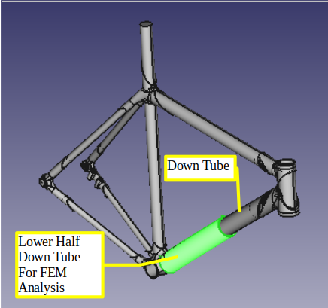

Figure 1: Down tube and lower half down tube to be used in this methodology. This figure has been retreived from Zach Medich, GrabCAD [10] (Need to be contacted for usage permission).

The load will be a 300 N force in-line with the pipe, which will represent the gravity load and a 300 N perpendicular force which will represent the pedalling side momentum.

3. Analysis

3a. Analysis / A Note on Materials

The considered materials will be only general standard PLA, T700 Carbon Fiber laminate and Chromoly Steel.

While researching FDM filament material properties, it became clear that filaments with chopped carbon fiber as a reinforcing agent needed more performance consistency. It means that the performance spread from one manufacturer to the other and from one filament style to another could have been more controllable, especially for the fatigue resistance performance. Since this article intends to focus on one-off bespoke frames made by handmade builders, it is not possible to lock that community into a single filament and filament brand that can be trusted. When sourced from generic suppliers, the evaluated materials are intended to be a generalist with consistent performance.
Additionally, PLA filaments reinforced by chopped carbon fiber appear to have worse fatigue strength than standard PLA [11][12][13][14][15][16][17].

The FDM filaments reinforced by continuous carbon fiber have interesting performances and probably will impose themselves in the future. But they require a special kind of printer, because of the reasons explained above they couldn't be considered.

Only T700-type carbon fiber will be considered. It is a happy medium between the T300 and T800 kinds, previously evaluated by [7]. T700 carbon fiber also has the same density as PLA, simplifying material comparison for combined CF and PLA pipes.

The benchmark pipe will be a chromoly steel one. The targeted threshold of goodness will be the Chromoly pipe's performance, flexibility, weight and fatigue safety factors.
Therefore the third material that will be considered will be Chromoly Steel.

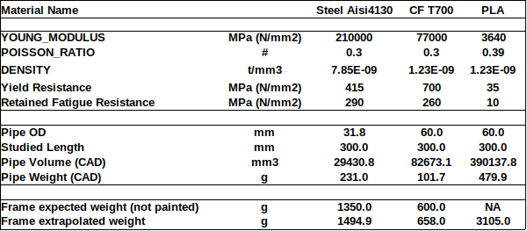

Table1: Material Properties Data.
(Note: weight extrapolation has been done by multiplying the pipe weight by 6.47)
The fatigue limit of PLA is considered constant regardless of the infill percentage.

These material properties have been generated from data coming from several sources [7]. The retained property has been identified by applying engineering judgment to the several relevant values found.
Especially the fatigue resistance properties have been difficult to be identified.
It has been attempted to focus on a 5 million cycles fatigue resistance. But that value is difficult to be measured, and therefore it is rarely available. Especially for non-metal materials, the fatigue resistance varies not only in the function of the cycles but also in the function of the amplitude cycle history.
The properties retained in this study for the composite materials are the best engineering guess based on the finished product bicycle frames currently available in the market. With composites, the brand and kind of fabric supplier, the nature of the resin used and much more have an impact on the resulting properties. Furthermore, all properties related to composite materials are difficult to be identified because of the many specific parameters involved.

3b. Analysis / Study Method

3b.1. First Phase
The first phase will compare several lower-half downtubes portions made only with PLA. The purpose of this comparison will be to find out if the internals of the pipe can play a positive role in the performance of the entire pipe itself.
The external pipes will be kept the same: a cylinder with OD 60m.
That is because the competing material is carbon fiber, which, similar to 3D printing, has practically no limitations on external shapes. The only restriction would be the width of the bottom bracket. We assume that the maximum pipe possible OD is 60mm.
However, nowadays, carbon fiber has to be laminated as a hollow shell. Inserting a carbon fiber pipe in some internal ribs or struts is impractical. At the same time, those come practically naturally for 3D printing either as purpose-designed features or as typical 3D printing infill patterns.

3b.2. Second Phase
Having identified the best PLA pipe shapes, those shapes will be used in the second phase as internal structures of pipes covered by laminated carbon fiber.
Covering a shape with carbon fiber layers (also called plies) is also called skinning.
The shape operates as a mould when the carbon fiber is pressed around it by vacuum bagging or other techniques.
The thickness of cured carbon fiber plies varies from the cloth or ply version used. They usually range from 0.1 mm to 0.6mm. Up to 3 or 5 layers can be laminated together in one pass. All of the above is subject to many variations of the many choices and possibilities that composite lamination offers.
In this study, it will be assumed that each carbon fiber layer (ply) will be 0.2mm thick. Only a maximum of three carbon fiber layers will be considered to be laminated on top of the PLA structure.
Results will be compared for stiffness, strength safety factor and estimated total bicycle weight.
The benchmarks will be the chromoly steel pipe, as a flexibility target not to exceed, and the T700 carbon fiber pipe as an idealized target.

3c. Analysis / Geometries and Materials
Here we will list the pipes with geometry and material that has been analyzed in this study.
3c.1. Chromoly Steel Pipe
FreeCAD File = Steel_4130crmo_Pipe_01.FCStd (Available at OSF and Github)
Pipe Material = Chromoly Steel AISI 4130
Pipe OD [mm] =31.8
Pipe Thickness at base [mm] =1.2 , Pipe Thickness at tip [mm] =0.9
Pipe weight [g] = 231.0 , Extrapolated full frame weight [g]=1495.0
(Note: weight extrapolation has been done by multiplying the pipe weight by 6.47)
Typical full frame weight (size M) for that kind of tubing (not painted)[g]=1350.0

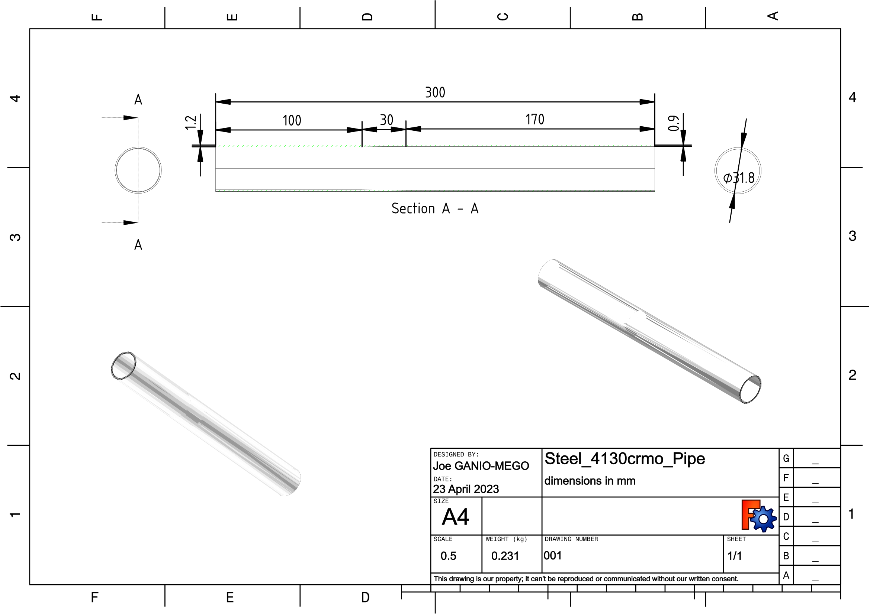

Figure 2: Chromoly Steel AISI 4130 pipe drawing. This figure is licensed under CC BY 4.0.
3c.2. Carbon Fiber T700 Pipe
FreeCAD File = CF_2d_T700_Pipe_01.FCStd (Available at OSF and Github)
Pipe Material = Carbon fiber T700 3K 2d woven fabric epoxy resin laminate
Pipe OD [mm] =60.0
Pipe Thickness at base [mm] =1.7 , Pipe Thickness at tip [mm] =1.3
Pipe weight [g] = 102.0 , Extrapolated full frame weight [g]=658.0
(Note: weight extrapolation has been done by multiplying the pipe weight by 6.47)
Typical full frame weight (size M) for that kind of tubing (not painted)[g]= 600.0

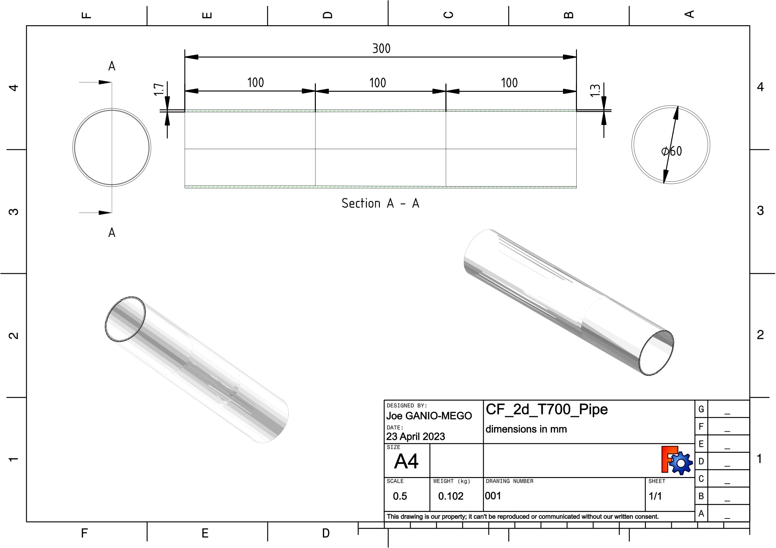

Figure 3: Carbon fiber T700 2d fabric resin laminate pipe drawing. This figure is licensed under CC BY 4.0.

3c.3. FDM 3D Printed PLA Pipe / Shaped Style
FreeCAD File = PLA_Shaped_Pipe_01.FCStd (Available at OSF and Github)
Pipe Material = PLA
Pipe OD [mm] =60.0
Pipe Thickness at base [mm] =15.0 , Pipe Thickness at tip [mm] =3.0
Pipe weight [g] =480.0 , Extrapolated full frame weight [g]=3105.0
(Note: weight extrapolation has been done by multiplying the pipe weight by 6.47)

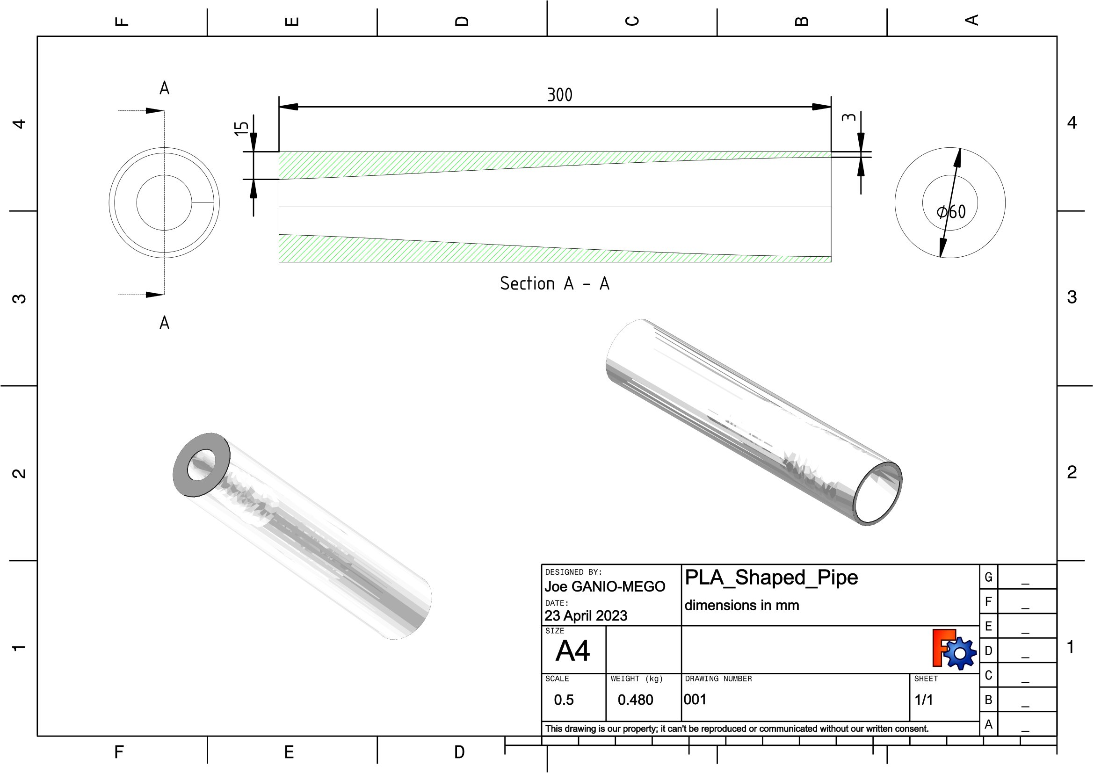

Figure 4: FDM 3D Printed PLA Pipe pipe drawing, shaped PLA pipe. This figure is licensed under CC BY 4.0.

3c.3. FDM 3D Printed PLA Pipe / Full Pipe Style

FreeCAD File = PLA_FullPipe_Pipe_01.FCStd (Available at OSF and Github)
Pipe Material = PLA
Pipe OD [mm] =60.0
Pipe Thickness at base [mm] = (Solid full pipe)
Pipe weight [g] =1043.0 , Extrapolated full frame weight [g]=6750.9
(Note: weight extrapolation has been done by multiplying the pipe weight by 6.47)

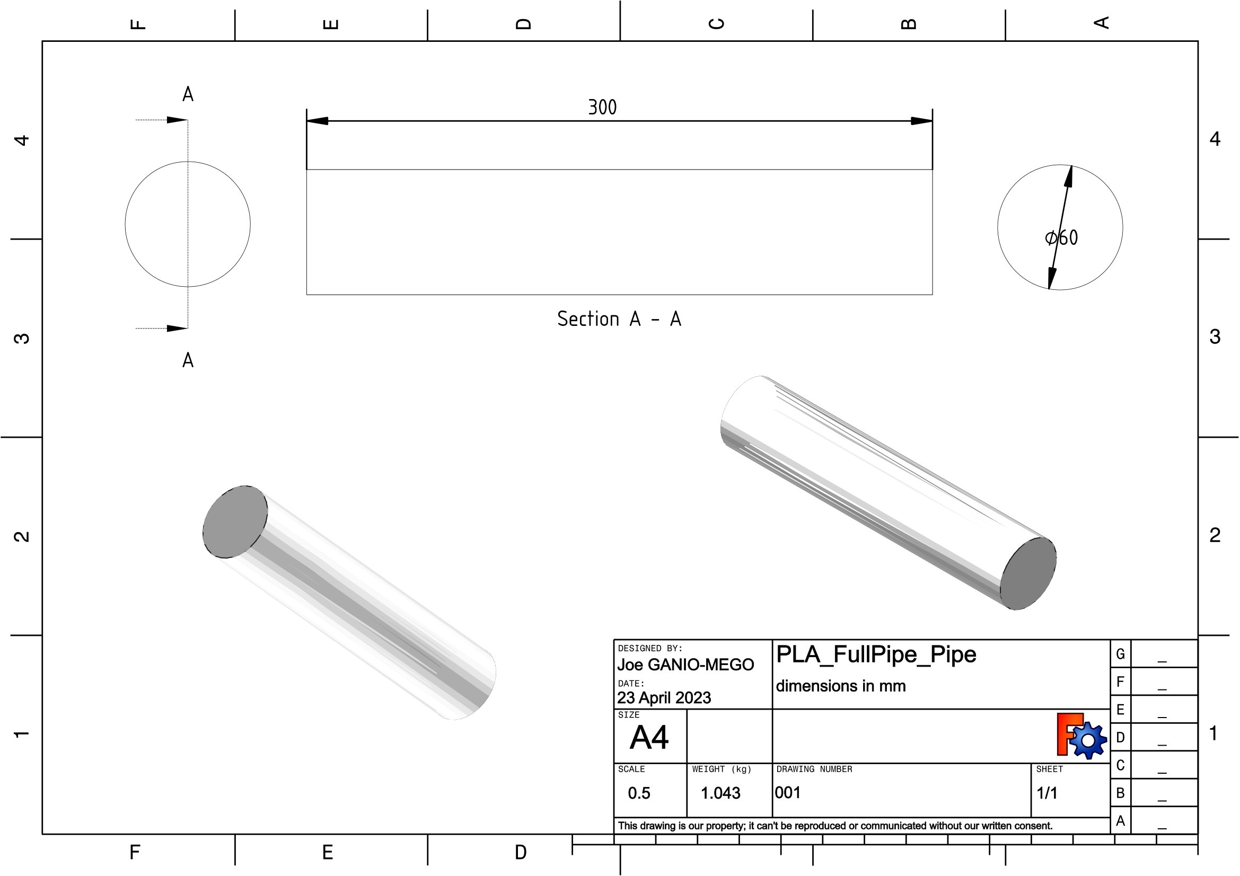

Figure 5: FDM 3D Printed PLA Pipe pipe drawing, full solid pipe. This figure is licensed under CC BY 4.0.

3c.4. FDM 3D Printed PLA Pipe / Stringer Style
FreeCAD File = PLA_RoundStringer_Pipe_01.FCStd (Available at OSF and Github)
Pipe Material = PLA
Pipe OD [mm] =60.0
Pipe Thickness at base [mm] = (Variable with stringer)
Pipe weight [g] =324.0 , Extrapolated full frame weight [g]=2094.6
(Note: weight extrapolation has been done by multiplying the pipe weight by 6.47)

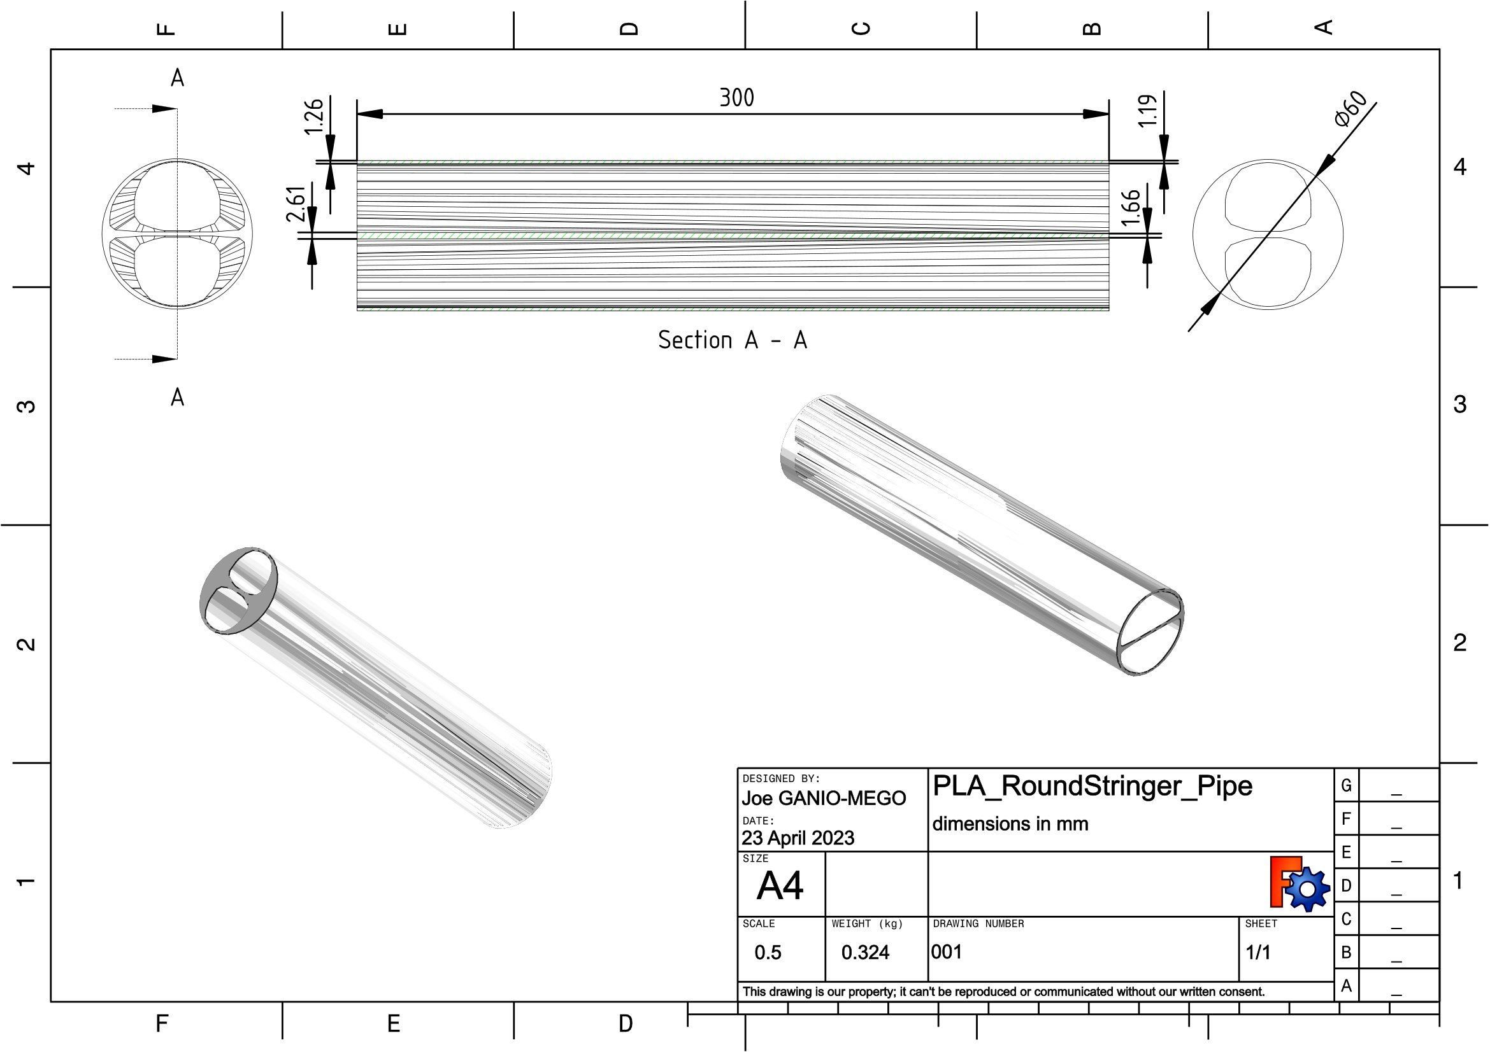

Figure 6: FDM 3D Printed PLA Pipe pipe drawing, round stringer pipe. This figure is licensed under CC BY 4.0.

3c.5. FDM 3D Printed PLA Pipe / No Stringer Style
FreeCAD File = PLA_NoRoundStringer_Pipe_01.FCStd (Available at OSF and Github)
Pipe Material = PLA
Pipe OD [mm] =60.0
Pipe Thickness at base [mm] = (Variable without stringer)
Pipe weight [g] =268.5 , Extrapolated full frame weight [g]=1737.3
(Note: weight extrapolation has been done by multiplying the pipe weight by 6.47)

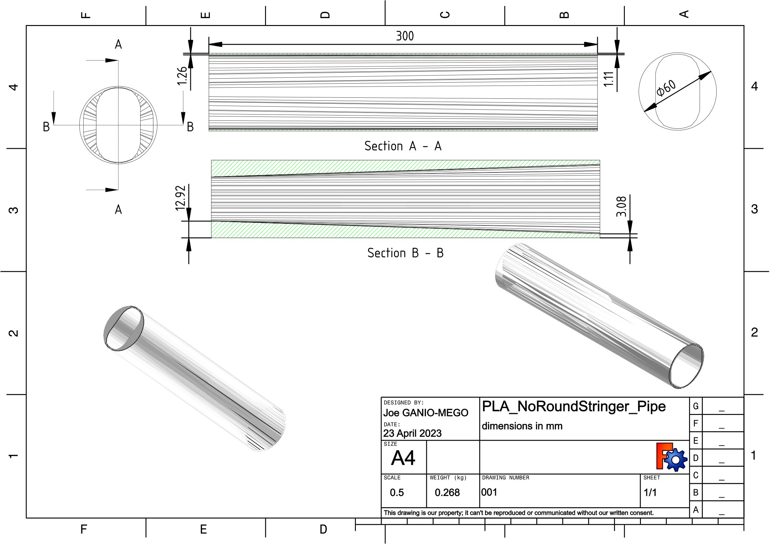

Figure 7: FDM 3D Printed PLA Pipe pipe drawing, no round stringer pipe. This figure is licensed under CC BY 4.0.

3c.6. Hollow Carbon Fiber 3 Layers Pipe
FreeCAD File = CF_NOPLA_HollowCF_3layers_Pipe_01.FCStd (Available at OSF and Github)
Pipe Material = Carbon fiber T700 3K 2d woven fabric epoxy resin laminate
Pipe OD [mm] =60.0
Pipe Thickness at base [mm] =0.6 , Pipe Thickness at tip [mm] =0.4
Pipe weight [g] =32.2 , Extrapolated full frame weight [g]=208.4
(Note: weight extrapolation has been done by multiplying the pipe weight by 6.47)
(Note: It is assumed that each carbon fiber ply is 0.2mm thick)

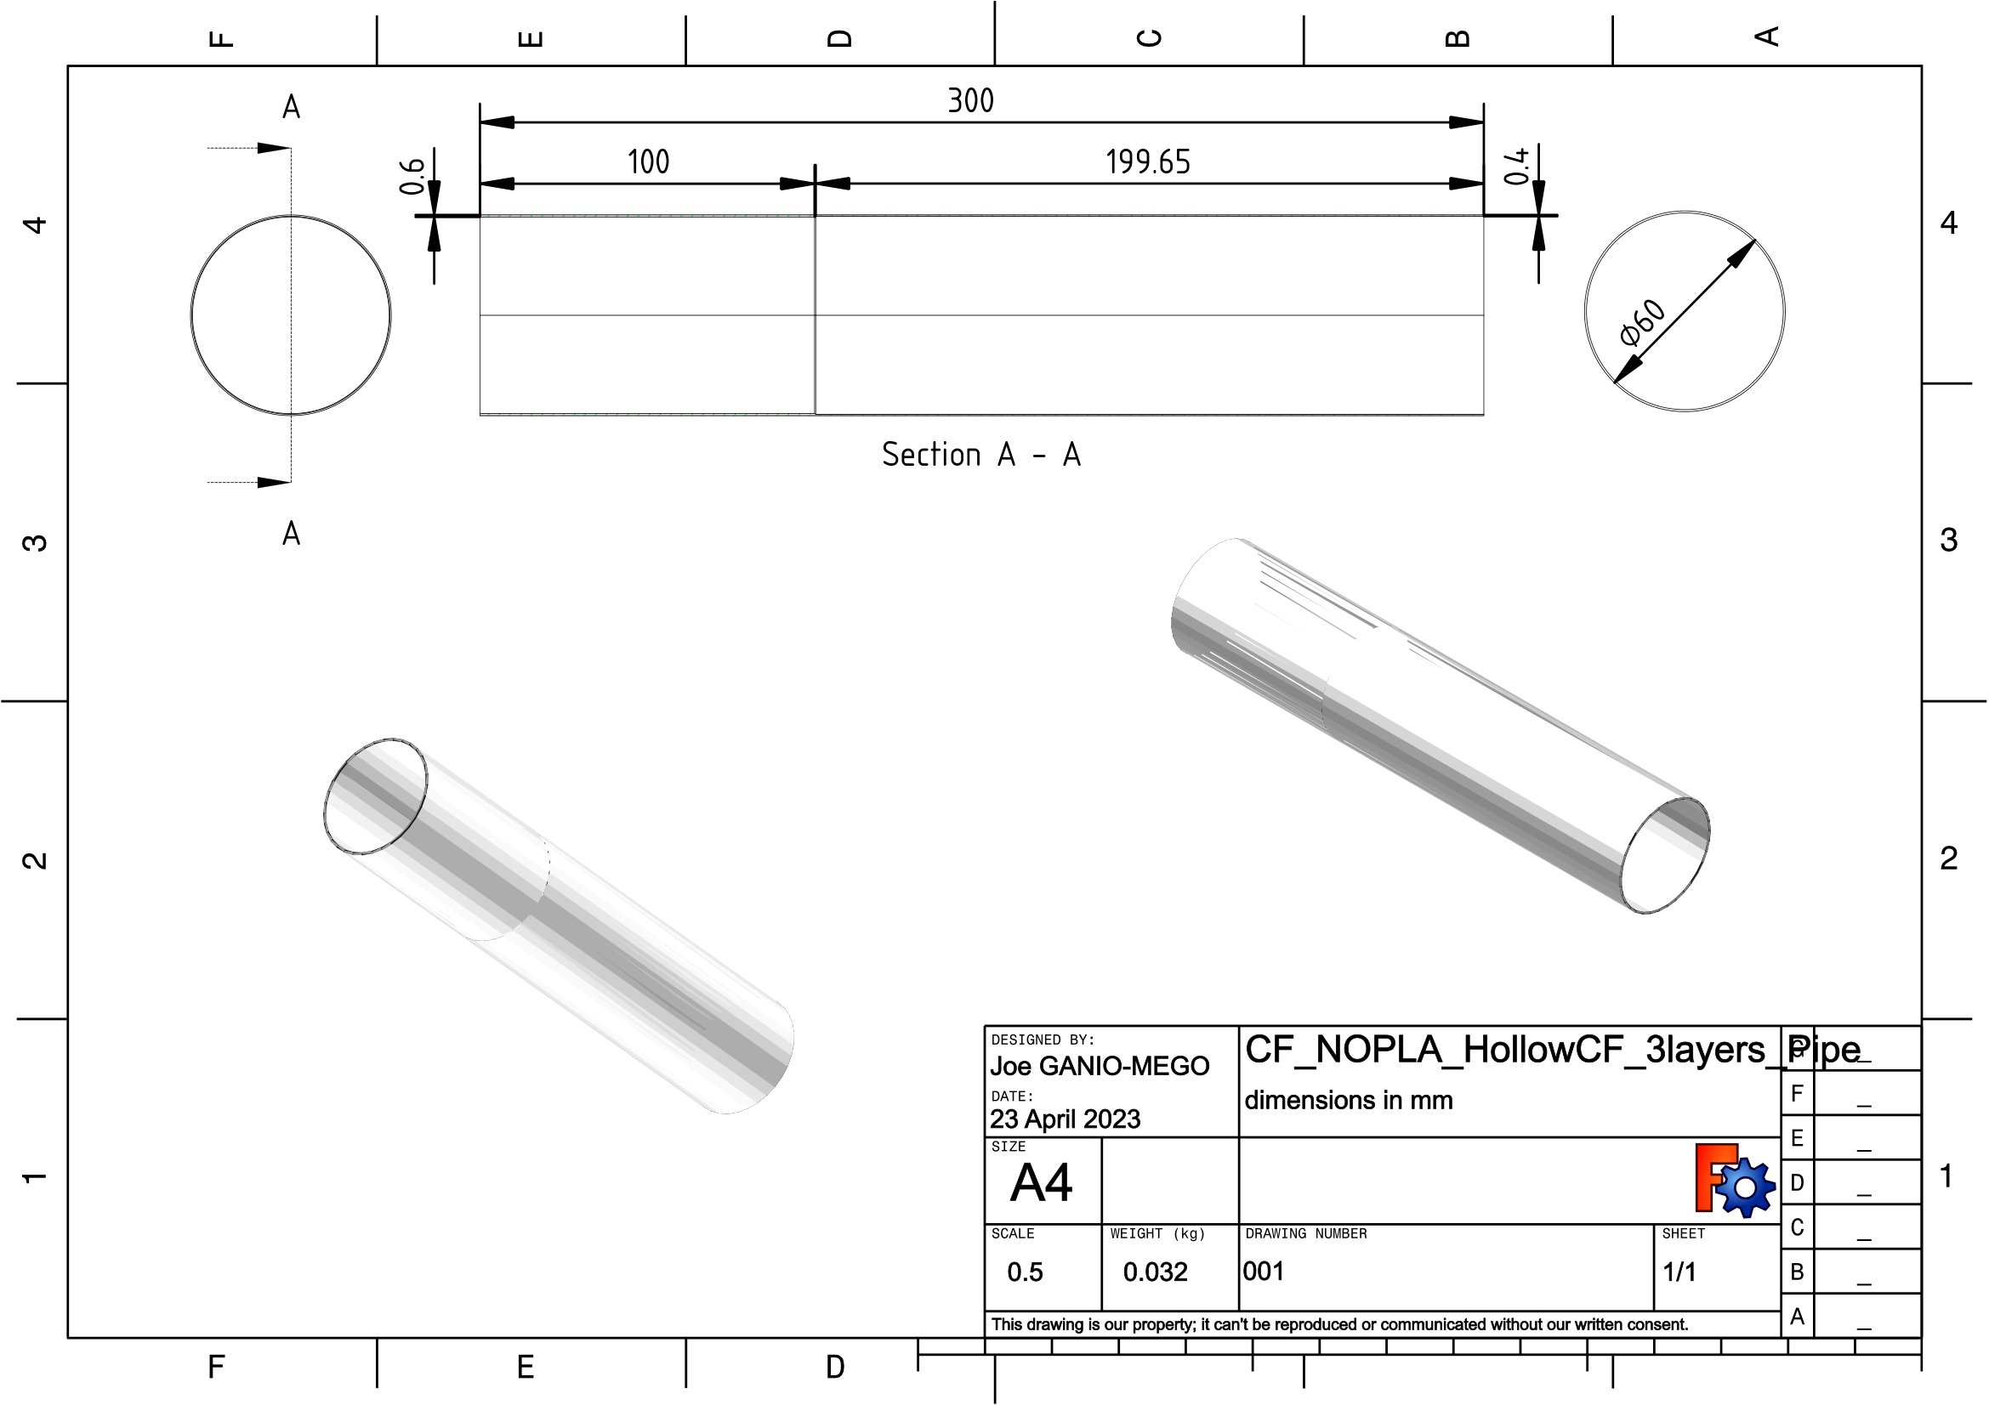

Figure 8: Hollow Carbon Fiber 3 Layers Pipe. This figure is licensed under CC BY 4.0.

3c.7. Carbon Fiber 3 Layers skinned above PLA Pipe
FreeCAD File = CF_PLA_HollowCF_3layers_Pipe_01.FCStd (Available at OSF and Github)
Pipe Material (outside skin)= Carbon fiber T700 3K 2d woven fabric epoxy resin laminate
Pipe Material (internal core) = PLA
Pipe OD [mm] =60.0
Carbon fiber skin Thickness at base [mm] =0.6 , Carbon fiber skin Thickness at tip [mm] =0.4
Pipe weight [g] =109.2 , Extrapolated full frame weight [g]=706.9
(Note: weight extrapolation has been done by multiplying the pipe weight by 6.47)
(Note: It is assumed that each carbon fiber ply is 0.2mm thick)

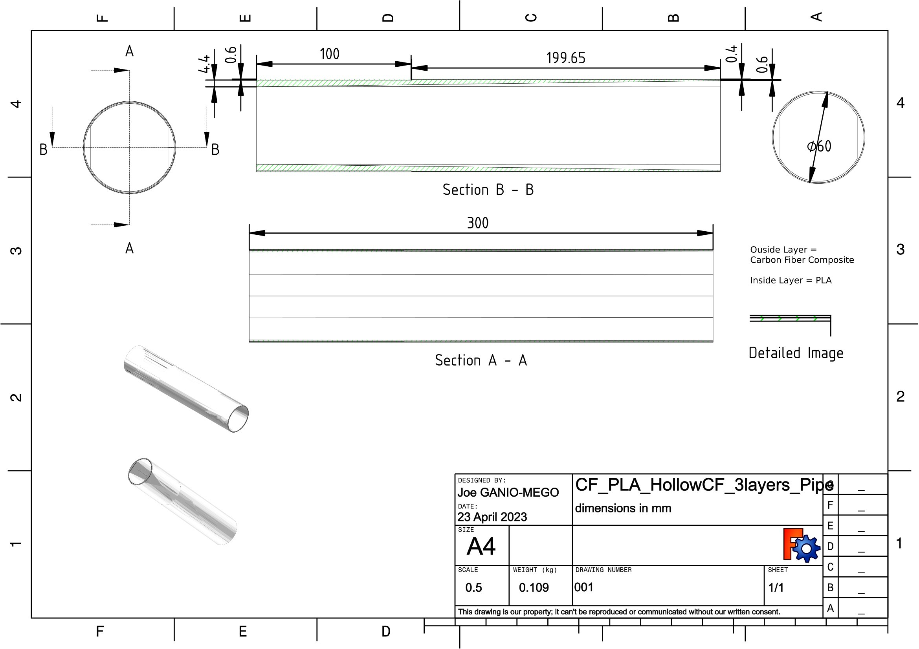

Figure 9: Carbon Fiber 3 Layers skinned above PLA Pipe. This figure is licensed under CC BY 4.0.

3c.8. Carbon Fiber 2 Layers skinned above PLA Pipe
FreeCAD File = CF_PLA_HollowCF_3layers_Pipe_01.FCStd (Available at OSF and Github)
Pipe Material = PLA
Pipe OD [mm] =60.0
Pipe Thickness at base [mm] =0.6 , Pipe Thickness at tip [mm] =0.4
Pipe weight [g] =142.0 , Extrapolated full frame weight [g]= 922.0
(Note: weight extrapolation has been done by multiplying the pipe weight by 6.47)
(Note: It is assumed that each carbon fiber ply is 0.2mm thick)

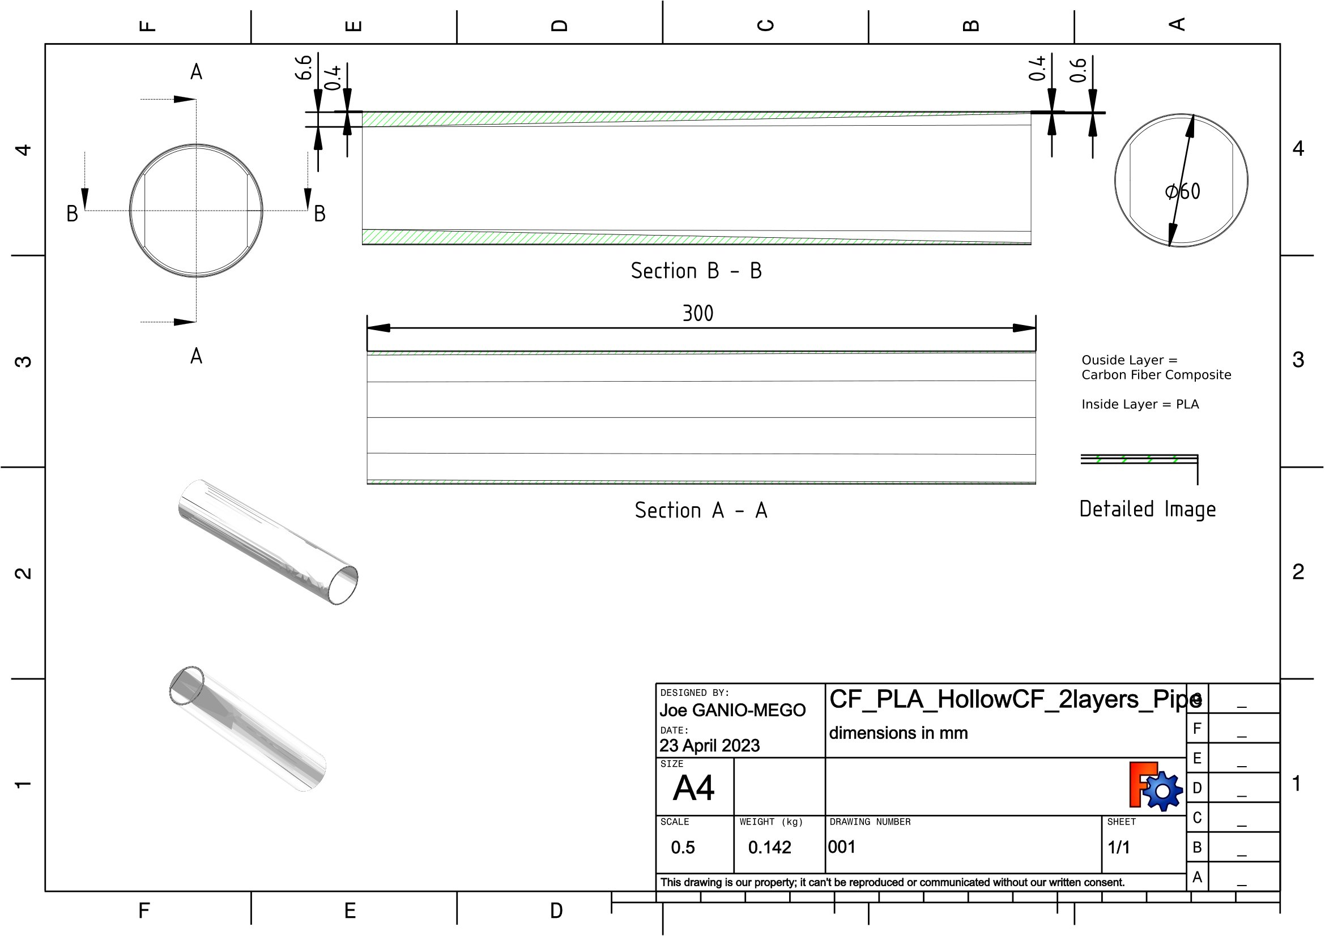

Figure 10: FDM 3D Printed PLA Pipe pipe drawing, Hollow Carbon Fiber 2 Layers Pipe. This figure is licensed under CC BY 4.0.

3c.9. Carbon Fiber 2 Layers skinned above PLA no stringer style Pipe
FreeCAD File = CF_PLA_HollowCF_3layers_Pipe_01.FCStd (Available at OSF and Github)
Pipe Material = PLA
Pipe OD [mm] =60.0
Pipe Thickness at base [mm] =0.6 , Pipe Thickness at tip [mm] =0.4
Pipe weight [g] =268.5 , Extrapolated full frame weight [g]=1737.3
(Note: weight extrapolation has been done by multiplying the pipe weight by 6.47)
(Note: It is assumed that each carbon fiber ply is 0.2mm thick)

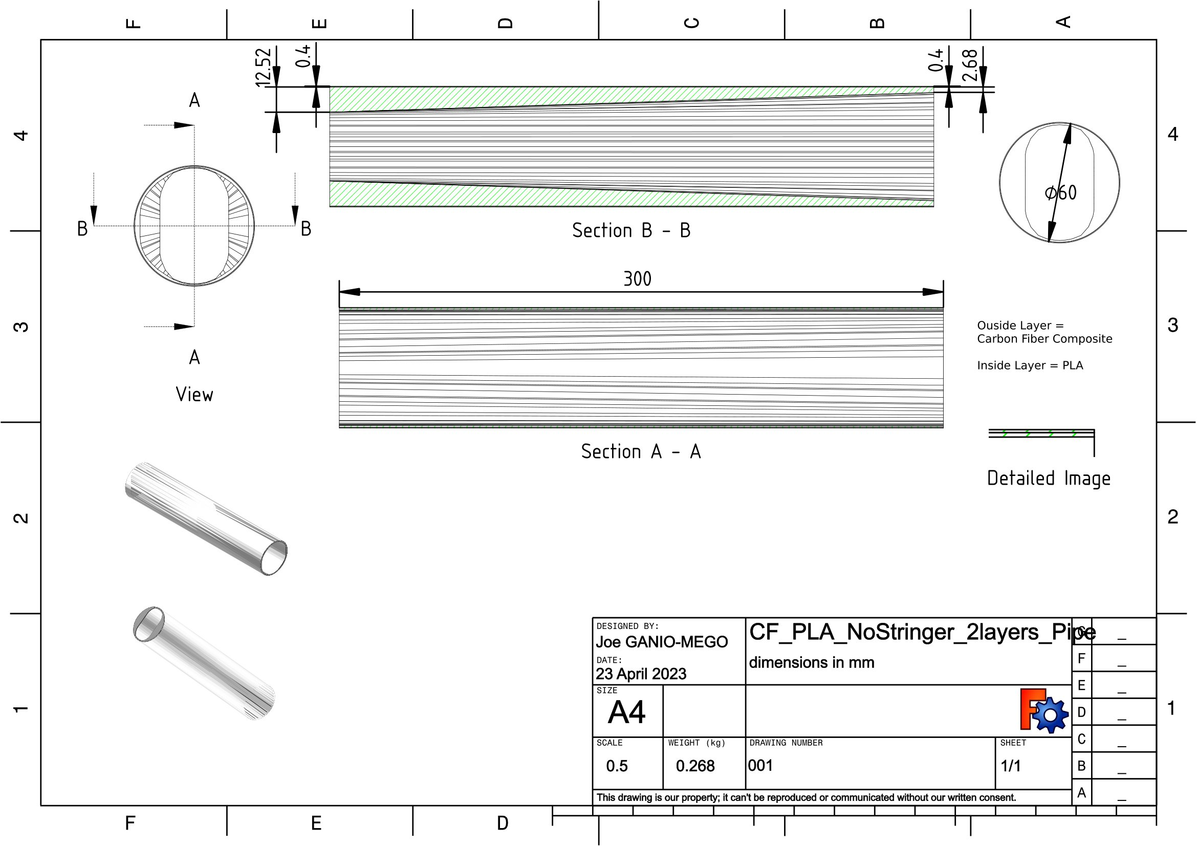

Figure 11: Carbon Fiber 2 Layers skinned above PLA no stringer style Pipe. This figure is licensed under CC BY 4.0.

3d. Analysis / Output Parameters Definition

For each pipe these are the output parameters that will be used in the comparison.
Max Displacement [mm] (1)
Max Displacement is a direct Freecad/Calculix output. It is the calculated maximum displacement found by the solver among all nodes of the model.
Max Von Mises Stress [MPa] (2)
Max Von Mises Stress is a direct Freecad/Calculix output. It is the calculated maximum Von Mises Stress found by the solver among all nodes of the model.
Stiffness [1/mm] (3)
Stiffness will be defined as the inverse of Max Displacement:
Stiffness = 1/Max Displacement (4)

HCF Minimal Safety Factor [#] (5)
It is the high cycle fatigue safety factor, defined as:
HCF Minimal Safety Factor = (Material Fatigue Strength[MPa])/(Max Von Mises Stress [MPa]) (6)
Hereafter HCF Minimal Safety Factor might be shortened as SF.
Obviously SF should be at least above 1.0. Having SF values too high would mean an heavier than needed frame. Values around 2.0 are probably the ideal compromise between safety and fame weight.

4. Results

4a. Results / First Phase / PLA only pipes of different shapes
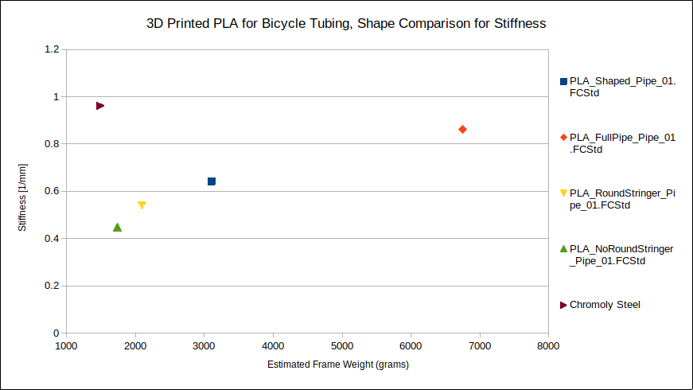
Figure 12: Calculated pipe stiffness function of estimated frame weight. This figure is licensed under CC BY 4.0.
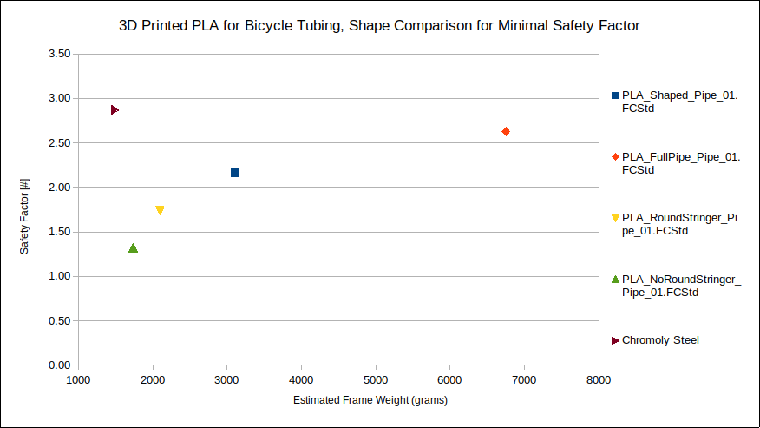
Figure 13: HCF Safety Factor function of estimated frame weight. This figure is licensed under CC BY 4.0.

It has to be considered that 1st order elements have been used for the analysis. Therefore the stiffness results can be trusted as is, but the safety factor ones are over-predicting. All SF should be lowered by probably 30%. Since this study is comparative and the minimal SF is above 1.3, there is no issue in this case.

4b. Results / First Phase / PLA only pipes of different shapes / Discussion
Smart internal shapes do help the overall pipe structural performance, but they are not enough to bring a PLA-made pipe close to at least the performance of the chromoly steel one.
We see that PLA-only pipes are not competitive with making a bicycle frame.
It is now interesting to see how they perform when skinned with carbon fiber.

4c. Results / Second Phase / Carbon fiber skinned over PLA pipes
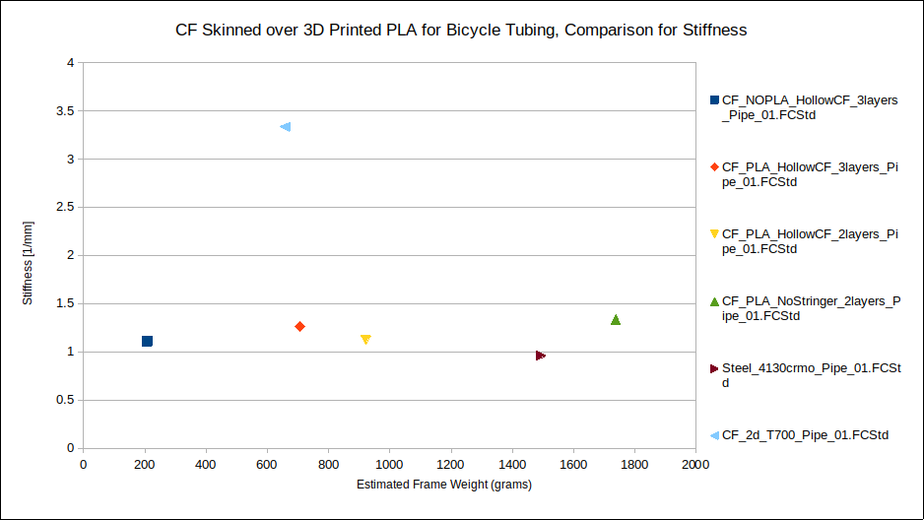
Figure 14: Calculated pipe stiffness function of estimated frame weight. This figure is licensed under CC BY 4.0.
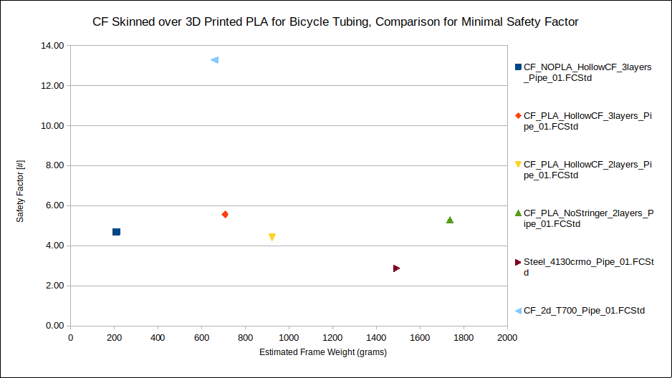
Figure 15: HCF Safety Factor function of estimated frame weight. This figure is licensed under CC BY 4.0.

As before, it has to be considered that 1st order elements have been used for the analysis. Therefore the stiffness results can be trusted as is, but the safety factor ones are over-predicting. All SF should be lowered by probably 30%. Since this study is comparative and the minimal SF is above 2.0, there is no issue in this case.

4d. Results / Second Phase / Carbon fiber skinned over PLA pipes / Discussion

Skinned carbon fiber over PLA pipes can perform better than chromoly steel pipes in terms of stiffness, weight and HCF safety factor.
It can be noticed that all in all, the structural performances of carbon fiber overwhelm the PLA ones to the point that to achieve better performances, there should be the least possible amount of PLA and the maximum necessary amount of carbon fiber. Basically, the PLA core should be designed as light as possible as long it withstands its function of inner lamination mould.

5. Conclusions

All elements show that building a bicycle frame with PLA is not convenient. When competing with laminated carbon fiber, PLA has the advantage of allowing for purpose-designed pipe internals.
However, the addition of these internals was not enough to bring a PLA frame at the required level of stiffness, safety factor and weight.
However, by skinning several layers of carbon fibre on top of a PLA core, the resulting frame is competitive and can be designed for lightness, aerodynamics or flexibility.
The best weight performance is achieved by using just a minimal amount of PLA to make a core robust enough to be used as a mould.
The structural comparisons in this study have been made on a lower half portion of the down tube. However, anybody willing to proceed with building a frame with carbon fiber skinned on top of PLA should not avoid considering a full-frame FEA analysis. That is because the total freedom of shape that PLA printing provides can only be exploited entirely by a smart design that can only be identified by accurate FEM modelling.
When PLA will be reinforced by carbon fiber in a reliable way, that will further improve the expected competitiveness of these frames.

Appendix

A1. Model Repository

OSF (Open Science Foundation) = https://osf.io/2wbdp/
Github = https://github.com/joeganiomego/PLAforBicycleTubing

References

[1] Engineers Academy. “Selecting Ideal Materials for Bicycle Frames Using Material Selection Charts”. (2018) . Material Selection - Level 4 Engineering. Youtube video : https://youtu.be/eRaxjdijGPg

[2] Material Selection Charts, http://www-materials.eng.cam.ac.uk/mpsite/interactive_charts/default.html

[3] The UCI Tecnical Regulation. ARTICLE 1.3.019 . UCI – Union Cycliste Internationale, Aigle,
CH, www.uci.org.

[4] Juergen Riegel, Werner Mayer, Yorik van Havre (2001-2017). FreeCAD (Version: 0.20.2.29177 +426 (Git) Snap 517), Software Available from http://www.freecadweb.org, OS: Ubuntu Core 20 (ubuntu:GNOME/ubuntu), Word size of FreeCAD: 64-bit,Python 3.8.10, Qt 5.15.5, Coin 4.0.0, Vtk 7.1.1, OCC 7.6.3.

[5] C. Geuzaine and J.-F. Remacle. Gmsh: a three-dimensional finite element mesh generator with built-in pre- and post-processing facilities. International Journal for Numerical Methods in Engineering 79(11), pp. 1309-1331, 2009. GMSH embedded in FreeCAD FEM Workbench, FEM mesh from shape by GMSH. Software Available from https://gmsh.info .

[6] Dhondt, G. The Finite Element Method for Three-Dimensional Thermomechanical Applications, Wiley, 2004. Calculix embedded in FreeCAD FEM Workbench, Solver Calculix Standard. Software Available from http://www.calculix.de.

[7] Joe Ganio-Mego. (2023). Evaluating and Comparing Bicycle Tubing Materials: a simplified FEM methodology. (ORCHID ID = 0000-0001-6462-9842).

[8] ISO 4210-6:2023(en) Cycles — Safety requirements for bicycles — Part 6: Frame and fork test methods - 4.3 Frame — Fatigue test with pedalling forces .Standard, International Organization for Standardization, Geneva, CH,www.iso.org.

[9] The UCI Tecnical Regulation. ARTICLE 1.3.002 . UCI – Union Cycliste Internationale, Aigle,
CH, www.uci.org.

[10] Zach Medich (September 25th, 2020). 3D Printed Titanium Lug Road Bike.Retrieved March 14, 2023, from https://grabcad.com/library/3d-printed-titanium-lug-road-bike-1

[11] MatWeb, Your Source for Materials Information ,https://www.matweb.com/

[12] Broer, Agnes. (2018). Fatigue life prediction of carbon fibre-reinforced epoxy laminates using a single S-N curve.

[13] Pandzic, A[di]; Hodzic, D[amir], Hajro I[smar] & Tasic P[etar] (2020). Strength,Properties of PLA Material Obtained by Different Models of FDM 3D Printer, Proceedings of the 31st DAAAM International Symposium, pp.xxxx-xxxx, B. Katalinic (Ed.), Published by DAAAM International, ISBN 978-3-902734-xx-x, ISSN 1726-967 9, Vienna, Austria DOI: 10.2507/31st.daaam.proceedings.xxx

[14] Hodzic, D[amir] & Pandzic, A[di] (2021). Influence of Infill Design on Compressive and Flexural Mechanical Properties of FDM Printed PLA Material, Proceedings of the 32nd DAAAM International Symposium, pp.0191-0199, B. Katalinic (Ed.), Published by DAAAM International, ISBN 978-3-902734-33-4, ISSN 1726-9679, Vienna, Austria DOI: 10.2507/32nd.daaam.proceedings.029

[15] Katalinic, B[ranko]; Park, H[ong] S[eok] & Smith, M[ark] (2019). Title of Paper, Proceedings of the 30th DAAAM International Symposium, pp.xxxx-xxxx, B. Katalinic (Ed.), Published by DAAAM International, ISBN 978-3-902734-xx-x, ISSN 1726-9679, Vienna, Austria DOI: 10.2507/30th.daaam.proceedings.xxx

[16] Wu J, Pan Y, Ruan Z, Zhao Z, Ai J, Ban J and Jing X (2022), Carbon ﬁber-reinforced epoxy with 100% ﬁber recycling by transesteriﬁcation reactions. Front. Mater. 9:1045372. doi: 10.3389/fmats.2022.1045372

[17] Schmitz, Anne. (2021). Fatigue Properties of 3D Printed Carbon Fiber. 10.1115/IMECE2021-67626.

Joe Ganio-Mego (ORCHID ID = 0000-0001-6462-9842)
Telephone: +39 3495472346
E-mail: gganio.geo@yahoo.com

Note: October 2023.
This is a working paper.
I am actively looking for co-authors and co-contributors to continue this work.

This work including all the figures are licensed under CC BY 4.0.

