

# Joy For Kids Shopping Cart and Donation System

# Software Quality Assurance Plan

Project Documentation Submitted

To the Faculty of School of

Computer Science and Information Technology

Of

Asia Pacific College

In Partial Fulfillment of the Requirements for the subject

Applied Projects 2

By

Rennon Errol Dadulla

Katharyn Alexandre Mayo

Lois Anne Logronio

Table of Contents

**Software Project Management Plan3**

Vision and Scope3

Visibility and Risk Analysis3

Management Approach3

Technical Approach3

Use Case3

**Requirements Document4**

Logical Database Description5

Requirements Document5

Requirements Traceability Matrix5

**Design Document1**

Type chapter title (level 2)2

Type chapter title (level 3)3

**Online Help4**

Type chapter title (level 2)6

**Implementation Map1**

Type chapter title (level 2)2

Type chapter title (level 3)3

**Test Plan4**

Type chapter title (level 2)6

**Deployment Plan1**

Type chapter title (level 2)2

Type chapter title (level 3)3

**Acceptance Plan4**

Type chapter title (level 2)5

Type chapter title (level 3)6

**Installation and Acceptance4**

Type chapter title (level 2)5

Type chapter title (level 3)6

# Software Quality Assurance Plan

**Vision and Scope**

The vision of the project is to provide shopping cart and donation system for those people who are interested on helping Filipino children by donating money or buying items from the foundation through the website.

The following are the required Major and Minor functions of the system:

**Major Functions:**

* Donation function
  + In this module, customers and clients can donate monetary value via debit and credit card which will be redirected to the JFK (Joy for Kids) Paypal account. Small part of the donation will go to the foundation for maintenance while the rest will go the Filipino children who are under the foundation.
* Shopping Cart function
  + In this module, users can help the children under the foundation by buying items sold in the website of the foundation. Proceeds will be used for the children of the foundation.

**Minor Functions:**

* Subscriber function
  + This module lets the user to be updated on the programs made by the foundation and upcoming events of the foundation through emailing the subscribers.
* Volunteer function
  + This module lets the user to be part of the programs to be conducted by the foundation. Volunteers will be contacted if they can come to the upcoming programs.
* Gallery function
  + This module lets the user to know the programs done by the foundation. Description and images are displayed on the Gallery page of the system.

**Visibility and Risk Analysis**

These are the following factors that can affect the visibility of the project and the system that developers are developing:

* Limited time for the project
  + The group is only given 10 weeks for the development of the system. Time management is needed to complete the project and cooperation of project team members so that there will be no miscommunication during the time of development.
* Slow internet connection
  + Clients who have slow internet connection on their device (laptops, PCs, smartphones) OS may have had a hard time on viewing the site and doing online transactions.
* Module functions
  + Each module has a chance that it may not be done because of developers’ lack of knowledge on doing a certain module.

**Management Approach**

The development methodology to be used for the project is the Agile Method, in which series of testing will transpire as the development of the system progresses.

(**AGILE METHOD DIAGRAM HERE**)

The project team will have weekly team meetings and must accomplish the following:

* Weekly Project Status Report (twice a week)
* Weekly Individual Accomplishment Reports
* Documentation (SQA)

**Technical Approach**

* Database Server: MySQL
* Design Tools: Paint, Pencil Tool, Adobe Photoshop, Pizap
* Documentation Tools: Microsoft Word, MySQL Workbench, Yed Graph Editor
* Programming Languages: PHP, HTML, CSS, Javascript
* Programming Tools: Yii Framework, Notepad++
* Webserver: APACHE

**Use Case**

**For Users**

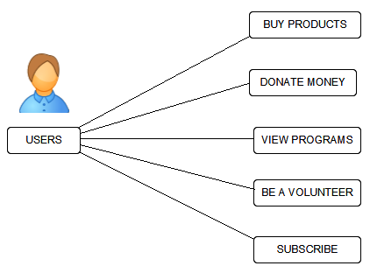

**For Admin**

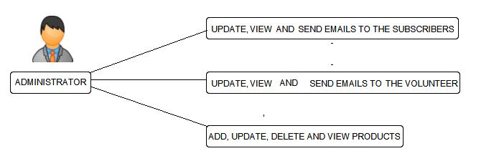

# Requirements Document

***Logical Database Description***

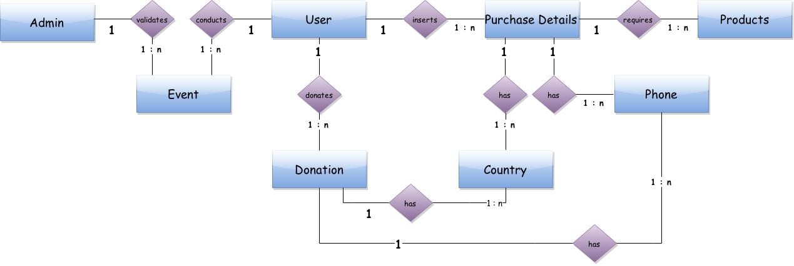

***Requirements Document***

***Requirements Traceability Matrix***

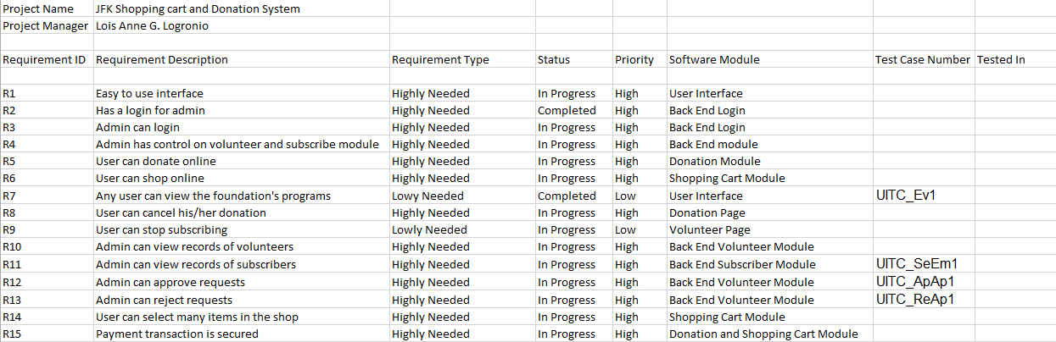

# Design Document

# Online Help

# Implementation Map

# Test Plan

# Deployment Plan

# Acceptance Plan

# Implementation and Acceptance