|  |
| --- |
| **ASIA PACIFIC COLLEGE**  School of Computer Science and Information  Technology |
| Journeys & More Global Tours and Consultancy Co. |
| Travel Arrangement & Appointment System |
| Documentation |
| **Arianne Bianca F. Papna**  **Erika C. Hidalgo**  **Roxanne Therese A. Luangco**  **IT 111** |
|  |

**Mr. Allan Cotecson**

Professor

Table of Contents

Software Project Management Plan 3

Vision 3

Scope 3

Feasibility and Risk Analysis 4

Management Approach 5

Roles and Responsibilities 6

Technical Approach 6

Requirements Document 8

The Logical Database Description 8

The Requirements Document 10

The Requirements Traceability Matrix 12

Design Document 12

The Physical Database Description 13

The Software Design Document 13

Online Help 15

Data Areas 15

Optional Scenarios 17

Data Dictionary 18

Test Plan 22

Background 22

Introduction 22

Assumptions 24

Test Items 25

Features to be tested 26

Features not to be tested 27

Approach 28

Item Pass / Fail Criteria 29

Suspension / Resumption Criteria 31

Test Deliverables 31

Testing Tasks 32

Environmental Needs 32

Responsibilities 33

Staffing and Training 33

Schedule 34

Resources 35

Risks and Contingencies 35

Approvals 36

Test Cases 38

Acceptance Plan 63

Installation & Acceptance Plan 64

The Acceptance Configuration Plan 64

Project Team/ Authors 65

## 

## Software Project Management Plan

### Vision

JMGTCC Travel Arrangement & Appointment System:   
The project aims to be a source of convenience, as a venue in providing reliable travel and tourism information and to help the company in achieving its goal in providing clients warm hospitality at the tip of their fingertips.

* To promote tourism by providing a module that features tour deals and packages for clients and travelers
* To provide a module for setting client Visa Appointment

### Scope

The following are the Project Deliverable:

* **Appointment Scheduler (Visa Consultation)**

 In the customer module of the system, clients can have access to the system in case they want to schedule a Visa Assistance Appointment with the General Manager. They will input their name, email address, phone number, appointment time and day and optional remarks or message.

* **Travel Deals Request**

The Client inputs necessary details about the travel packages he wants to avail. He can choose from the list of travel options or request for a new travel package-combination or arrangement offered by the agency.

* **Customer Service / Technical Support**

This is an online chat support feature that enables the clients of JMGTCC to communicate with the company IT Support Team through the application. The client can send a direct / instant message about technical concerns to the IT Support Team.

(**The Admin Module**) The Admin should be able to:

* View Visa Consultation Appointments
* Confirm Visa Consultation Appointment of client
* View Travel and Tour Arrangements
* Manage System modules

(**The Client Module**) The Client should be able to:

* Register for an account
* Be updated or notified though email
* File and submit a Visa Consultation Appointment request
* File and submit a Travel and Tour Arrangement
* Raise concerns via Live chat for technical support

### Feasibility and Risk Analysis

Listed below are the risks that could affect the website and functionality of the travel arrangement and appointment system of JMGTCC:

* + - **Incorrect / Inconsistent Data**

This risk is due to human error and is considered as a low threat to the system.  Although the risk is low, it can still affect the data from the client which will be stored to the database of the system.

**Possible Solution:**   
This type of risk can be avoided if the text fields, where the client must input the required data can be limited.  If possible, there must be available options to choose from, so that the user can avoid entering incorrect data.

* + - **Inaccessible Pages / Functions**

This type of risk is a high threat and must be prevented at all cost.   
  
The probable causes for this risk are:

* Server or Database Malfunction
* Algorithm or Programming Error
* Low or No Network Connectivity

**Possible Solution:**   
This can be prevented if the functionality of the system will be thoroughly checked and tested. The developers must make sure that the system pass through quality check.

* + - **Lack of Personnel to Support Customer Service**

This risk depends on the management of JMGTCC. It can be triggered by the sudden increase on the number of clients who needed more information about their company and the services that they offer.  It can be prevented if there are enough staff members and sufficient details about the company and their services in the website. 

**Possible Solution:**

The management of JMGTCC must ensure their clients that they can provide enough and knowledgeable staff in providing customer service.  This can be done by employing skilled individuals who can assist clients within a short amount of time or if there is a great increase on the number of clients, they too must increase the number of their employees.

### Management Approach

The development of the system will follow ***The Agile Model***; Through this, changes are welcomed in every step of the way as long as the discovered change is necessary for the success of the project. By using Agile method, the development of the system lets the users be involved and collaborate with the developers, and thus ideas and criticism from the customers are always observed and are evaluated through early stages of development.

The following diagram shows a simple depiction of the development process of the system.

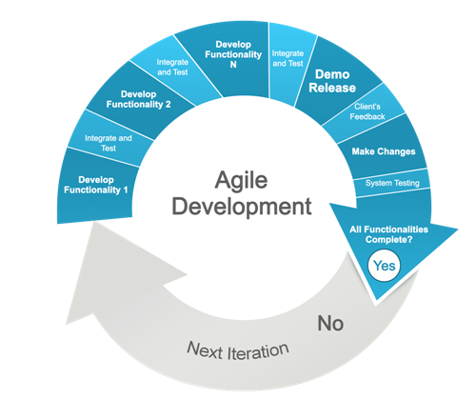

*There will be a meeting every week for project updates and concerns.*   
Throughout the development process, the team should complete the following:

* + Individual Weekly Accomplishment Report
  + Weekly Project Status Report
  + Final Project Documentation

Roles and Responsibilities

The project can be successfully completed if the workload will be divided and handled correctly.   
  
The following people are responsible in making this project possible:

|  |  |  |
| --- | --- | --- |
| **Student Name** | **Role** | **Responsibilities** |
| **Arianne Bianca Papna** | Project Manager / Developer | * Assigns roles and responsibilities * Monitors and reports the project status and progress * Manages the entire project team * Authoring of Project Documentation |
| **Erika Hidalgo** | Developer | * Updates the project manager about the system * Analyzes Software requirements and specifications * Manages Software UI |
| **Roxanne Therese Luangco** | QA / Developer | * Analyzes the Requirements from the client * Prepares test plan * Conducts review meetings with the team * Authoring of Project Documentation |

### Technical Approach

|  |  |  |
| --- | --- | --- |
| Software Environment | | |
| **Programming Languages** | **Specific Software** | **Web Server Application** | | **Operating System** | **Other Software/Applications** |
| PHP  HTML 5  CSS3  MySQL  Java | Yii Framework  phpMyAdmin | Apache  mySQL  Tomcat | | Windows 7 & above | Adobe Photoshop CS5  XAMPP  Notepad++ / Sublime  Browser  Android SDK |
| Hardware Environment | | | | | |
| Programming Languages | | | | | |
| PC / Laptop  Android(ver. 4.2.2 and above) Mobile |  |  | |  |  |

#### Use Case

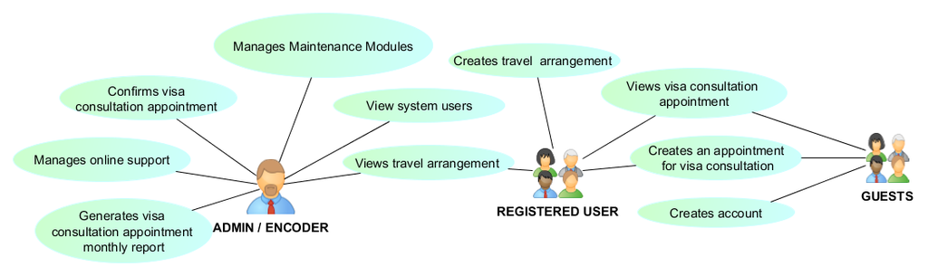

## Requirements Document

### The Logical Database Description

#### Logical Entity-Relationship Diagram

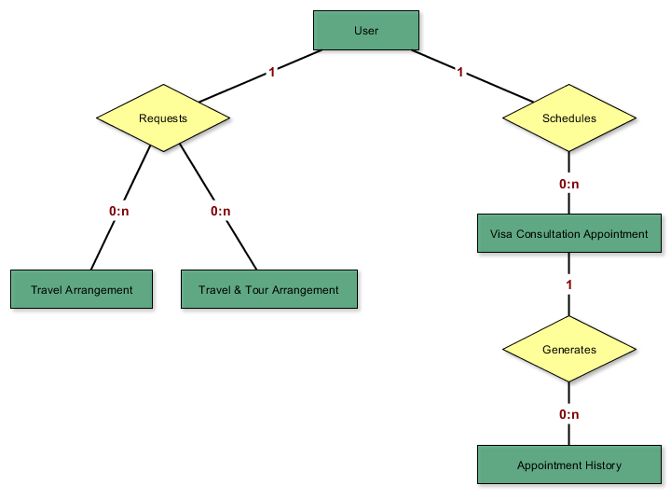

Users Entity   
**Description**   
A **User** is a person who uses the system; the one who creates a Travel Arrangement Request and a Visa Assistance Appointment. The information stored in this entity include Username, Password, Complete name, Gender, City, etc.

**Relationships**   
        A User can create zero to many Travel Arrangement requests.   
        A User can schedule zero to many Visa Assistance Appointments.

|  |
| --- |
| **Actor Interactions** |
| Role | Actors |
| Create | Guest |
| Read | Administrator |
| Update | - |
| Delete | - |

Travel Arrangement Entity   
**Description**   
**Travel Arrangements** are available Travel / Tour Packages offered by the company.  The package or arrangement can be customized according to the client's request.  The information stored in this entity includes the Departure Date, Date of Return, Place of Origin, Destination, etc.

**Relationships**   
        A User can create zero to many Travel / Tour Arrangement Requests.

|  |
| --- |
| **Actor Interactions** |
| **Role** | **Actors** |
| **Create** | Registered User |
| **Read** | Administrator |
| **Update** | - |
| **Delete** | - |

Appointment Entity   
**Description**   
The **Visa Consultation Appointments** are the list of appointments scheduled in a particular date and time. The information stored in this entity include the Appointment date and time, Visa type, etc.

**Relationships**   
        A User can schedule zero to many Visa Assistance Appointment.

|  |
| --- |
| **Actor Interactions** |
| **Role** | **Actors** |
| **Create** | Registered User, Guest |
| **Read** | Administrator, Registered User |
| **Update** | Administrator |
| **Delete** | - |

### The Requirements Document

#### Security Requirements

**Login Page**   
There are two different types of user for this system. Each of these users will have different roles and responsibilities so that not anyone can easily access classified information. To implement this, a login page will be provided to the users. This system would assume that only the user or whoever the user allows will have access to this application.   
  
        The system should be able to do the following:

* + - * Validate login credentials
      * Implement user access restrictions
      * Auto sign off after 15 minutes of idle time

**Safe Transactions**   
The clients of JMGTCC can be assured that the travel and other accommodation transactions that they input to the system will be considered confidential.   
        The system should be able to do the following:

* + - * Contain form conditions that would validate user input
      * Secure client travel details

User Requirements   
  
 **System Admin**   
        They are the users who will manage the whole system.  
        Through this system, they should be able to do the following:

* + - * View Visa Consultation Appointments
      * Confirm Visa Consultation Appointment of client
      * View Travel and Tour Arrangements
      * Manage System modules

**Clients of JMGTCC**   
       These are users who need assistance with their travels, accommodations or visa requirements.

       As the clients, they should be able to do the following:

* + - * Register for an account
      * Be updated or notified though email
      * File and submit a request for a Visa Consultation Appointment
      * File and submit a request for a Travel and Tour Arrangement
      * Raise concerns via Live chat for technical support
      * View booking history

### The Requirements Traceability Matrix

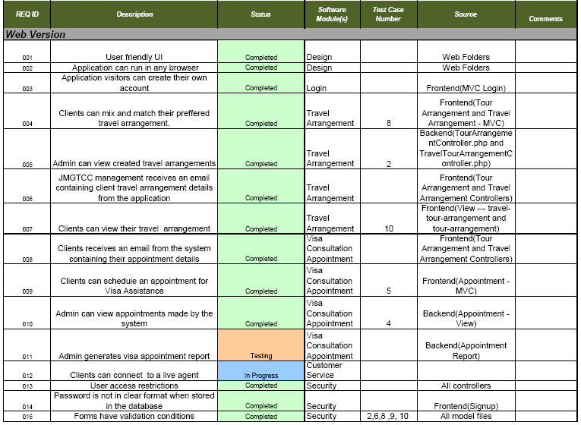

## Design Document

### The Physical Database Description

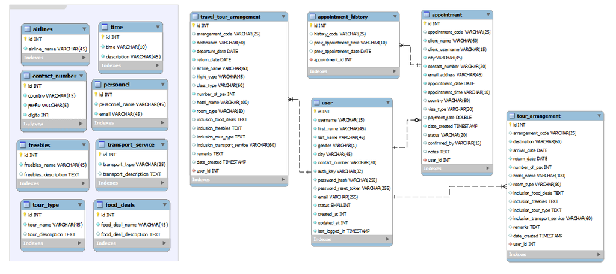

The Software Design Document

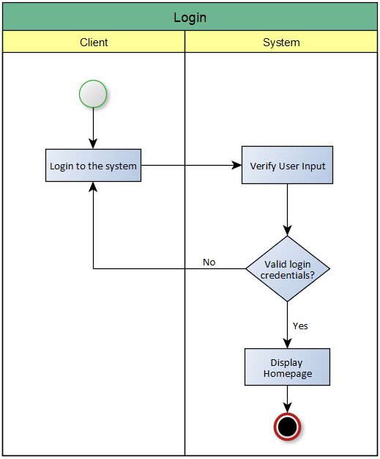 

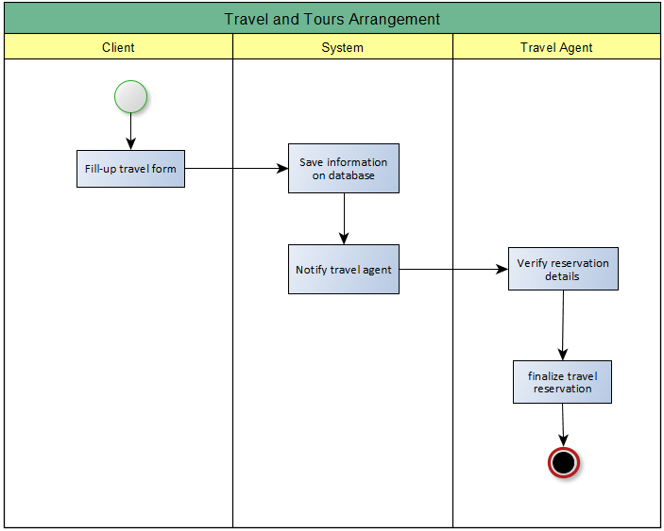

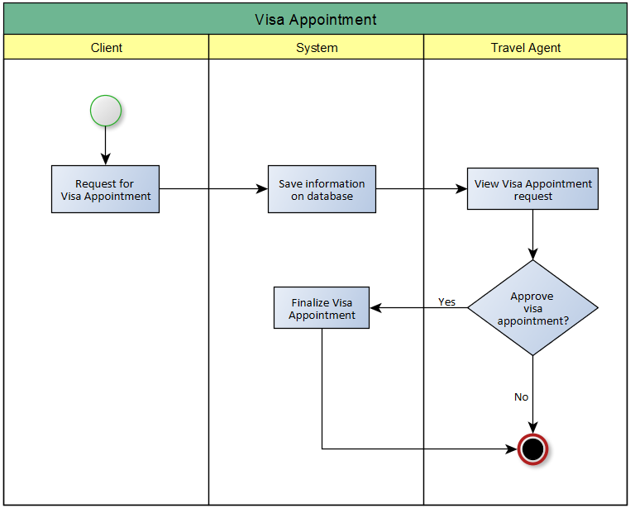

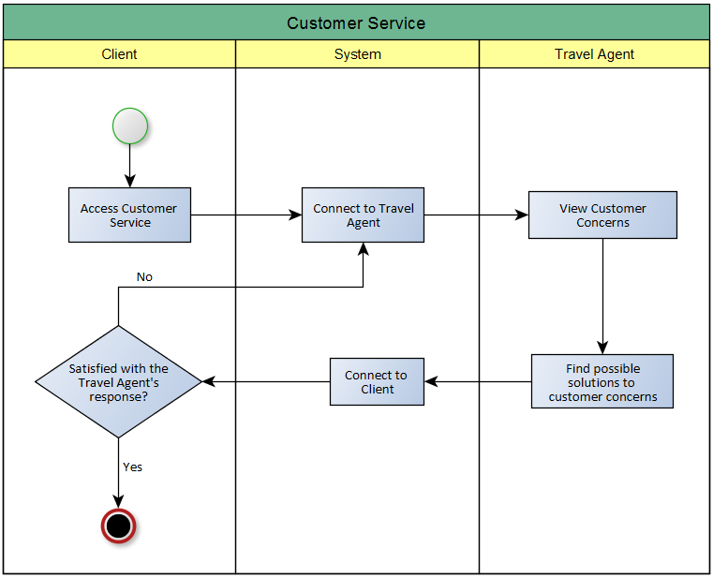

## Online Help

### Data Areas

**Frontend**

|  |  |
| --- | --- |
| **Forms** | **Accessible functions** |
| **User Sign-Up** | * + Create new user account |
| **User Log-In** | * + Log in registered user |
| **Visa Assistance Appointment** | * + Create new appointment   + View appointment (Only for registered Users) |
| **Travel / Tour Arrangement** | * + Create new travel / tour arrangement |

**Backend**

|  |  |
| --- | --- |
| **Forms (System Maintenance)** | **Accessible functions** |
| **Partner Airlines** | * + Create new airline record   + Update existing airline record   + Delete existing airline record   + View existing airline record |
| **Contact Numbers** | * + Create new contact number record   + Update existing contact number record   + Delete existing contact number record   + View existing contact number record |
| **Food Deals** | * + Create new food deal record   + Update existing food deal record   + Delete existing food deal record   + View existing food deal record |
| **Freebies** | * + Create new freebie record   + Update existing freebie record   + Delete existing freebie record   + View existing freebie record |
| **Personnel** | * + Create new personnel record   + Update existing personnel record   + Delete existing personnel record   + View existing personnel record |
| **User Roles** | * + Create new user role   + Update existing user role   + Delete existing user role   + View existing user role |
| **Appointment Time** | * + Create new appointment time record   + Update existing appointment time record   + Delete existing appointment time record   + View existing appointment time record |
| **Tour Types** | * + Create new tour type record   + Update existing tour type record   + Delete existing tour type record   + View existing tour type record |
| **Transport Services** | * + Create new transport seriviec record   + Update existing transport seriviec record   + Delete existing transport seriviec record   + View existing transport seriviec record |
| **User** | * + Create new user record   + Update existing user record   + Delete existing user record   + View existing user record |

### Optional Scenarios

|  |  |
| --- | --- |
| **Frontend: Users / Clients** | **Backend: Users / Admin** |
| * + "How can I view my previous appointments?"   + "How can I update my existing appointment?" | * + "How can I view newly created appointments?"   + "How can I verify newly created appointment?" |

**Frontend: Users / Clients**   
  
View Appointments

* + Travel / Tour Arrangements can be viewed by registered users (clients)
  + The Travel / Tour Arrangements listed in the Gridview are the arrangements created by the logged in user
  + Every time Travel / Tour Arrangement is created, it will be saved and can be seen in the Arrangement History (Gridview)

Update Appointment

* + Anyone (Registered user, Guest) can set a Visa Consultation Appointment
  + Registered users can view all the appointments created in the Appointment History
  + The appointments listed in the Gridview are the appointments created by the logged in user
  + Unregistered users can see their Appointment History
  + Users cannot update their previous appointments
  + When a new appointment is created, the previous appointment will be automatically cancelled unless the status is 'Confirmed'

**Backend: Users / Admin**   
  
View Appointments

* + Newly created appointments are displayed in a Gridview in the index (main page) of the backend
  + Unconfirmed appointments are also displayed in a Gridview in the index (main page) of the backend
  + All appointments saved in the database are listed in the Appointment page

Verify Appointments

* + Verify appointments in the Appointment page through the Appointment Code presented by the Client

### Data Dictionary

|  |  |  |  |  |  |  |  |  |
| --- | --- | --- | --- | --- | --- | --- | --- | --- |
| TABLE NAME | ATTRIBUTE NAME | CONTENTS | TYPE | FORMAT | NOT NULL | AI | PK | FK |
| user | Id  username  last_name  first_name  gender  city  contact_number  auth_key  password_hash  password_reset_token  email  status  created_at  updated_at  last_logged_in | User ID  Client’s Username  Client’s Lastname  Client’s Firstname  Client’s Gender  Client’s City address  Client’s Contact number  Client’s Authentication key  Client’s Encrypted password  Client’s Password reset token  Client’s Email address  Client’s Account status  Account’s Created date  Account’s Updated date  Client’s Last logged in date | INT  VARCHAR(15)  VARCHAR(45)  VARCHAR(45)  VARCHAR(1)  VARCHAR(45)  VARCHAR(20)  VARCHAR(35)  VARCHAR(255)  VARCHAR(255)  VARCHAR(255)  SMALLINT  INT  INT  TIMESTAMP | 9999999  XXXXX XXXXX  XXXXX XXXXX  XXXXX XXXXX  XXXXX XXXXX  XXXXX XXXXX  XXXXX XXXXX  XXXXX XXXXX  XXXXX XXXXX  XXXXX XXXXX  XXXXX XXXXX  9999999  9999999  9999999  YYYY-MM-DD 99:99:99 | **🗸**  **🗸**  **🗸**  **🗸**  **🗸**  **🗸**  **🗸**  **🗸**  **🗸**  **🗸**  **🗸**  **🗸**  **🗸**  **🗸**  **🗸**  **🗸** | **🗸** | **🗸** |  |
| appointment | Id  appointment_code  client_name  client_username  city  contact_number  email_address  appointment_date  appointment_time  country  visa_type  payment_rate  date_created  status  confirmed_by  notes  user_id | Appointment ID  Appointment Code  Client’s Name  Client’s Username  Client’s City address  Client’s Contact number  Client’s Email address  Client’s Appointment date  Client’s Appointment time  Country Visa  Visa Type  Payment rate  Appointment Created date  Appointment Status  Employee’s Username  Notes  User ID | INT  VARCHAR(25)  VARCHAR(60)  VARCHAR(15)  VARCHAR(45)  VARCHAR(20)  VARCHAR(45)  DATE  TIME  VARCHAR(60)  VARCHAR(30)  DOUBLE  TIMESTAMP  VARCHAR(20)  VARCHAR(15)  TEXT  INT | 9999999  XXXXXX-XXXXX  XXXXX XXXXX  XXXXX XXXXX  XXXXX XXXXX  XXXXX XXXXX  XXXXX XXXXX  YYYY-MM-DD  99:99:99  XXXXX XXXXX  XXXXX XXXXX  99.99  YYYY-DD-MM 99:99:99  XXXXX XXXXX  XXXXX XXXXX  XXXXX XXXXX  9999999 | **🗸**  **🗸**  **🗸**  **🗸**  **🗸**  **🗸**  **🗸**  **🗸**  **🗸**  **🗸**  **🗸**  **🗸** | **🗸** | **🗸** | **🗸** |
| Appointment_history | Id  history_code  prev_appointment_time  prev_appointment_date  appointment_id | History ID  History Code  Previous Appointment time  Previous Appointment date  Appointment ID | INT  VARCHAR(25)  TIME  DATE  INT | 9999999  XXXXXX-XXXXX  99:99:99  YYYY-MM-DD  9999999 | **🗸**  **🗸**  **🗸**  **🗸**  **🗸**  **🗸** | **🗸** | **🗸** | **🗸** |
| travel_tour_arrangement | id  arrangement_code  place_of_origin  destination  departure_date  return_date  airline_name  flight_type  class_type  number_of_pax  hotel_name  room_type  inclusion_food_deals  inclusion_freebies  inclusion_tour_type  inclusion_transport_service  remarks  date_created  status  date_confirmed  confirmed_by  date_updated  updated_by  user_id | ID  Arrangement code  Place of origin  Destination  Departure date  Return date  Airline name  Flight type  Airline class type  Number of passengers  Hotel name  Room type  Food Inclusions  Freebies  Tour type  Transport service  Remarks  Date created  Arrangement status  Date confirmed  Employee’s Username  Date updated  Updated by  User ID | INT  VARCHAR(25)  VARCHAR(25)  VARCHAR(25)  DATE  DATE  VARCHAR(60)  VARCHAR(45)  VARCHAR(60)  INT  VARCHAR(100)  VARCHAR(80)  TEXT  TEXT  TEXT  VARCHAR(60)  TEXT  TIMESTAMP  VARCHAR(20)  DATE  VARCHAR(15)  DATE  VARCHAR(20)  INT | 99999999  XXXXXX-XXXXXX  XXXXX XXXXX  XXXXX XXXXX  YYYY-MM-DD  YYYY-MM-DD  XXXXX XXXXX  XXXXX XXXXX  XXXXX XXXXX  9999999  XXXXX XXXXX  XXXXX XXXXX  XXXXX XXXXX  XXXXX XXXXX  XXXXX XXXXX  XXXXX XXXXX  XXXXX XXXXX  YYYY-MM-DD 99:99:99  XXXXX XXXXX  YYYY-MM-DD  XXXXX XXXXX  YYYY-MM-DD  XXXXX XXXXX  9999999 | **🗸**  **🗸**  **🗸**  **🗸**  **🗸**  **🗸**  **🗸** | **🗸** | **🗸** | **🗸** |
| tour_arrangement | id  arrangement_code  place_of_origin  destination  arrival_date  return_date  number_of_pax  hotel_name  room_type  inclusion_food_deals  inclusion_freebies  inclusion_tour_type  inclusion_transport_service  remarks  date_created  status  date_confirmed  confirmed_by  date_updated  updated_by  user_id | ID  Arrangement code  Place of origin  Destination  Date of arrival  Return date  Number of passengers  Hotel name  Room type  Food Inclusions  Freebies  Tour type  Transport service  Remarks  Date created  Arrangement status  Date confirmed  Employee’s Username  Date updated  Updated by  User ID | INT  VARCHAR(25)  VARCHAR(25)  VARCHAR(25)  DATE  DATE  INT  VARCHAR(100)  VARCHAR(80)  TEXT  TEXT  TEXT  VARCHAR(60)  TEXT  TIMESTAMP  VARCHAR(20)  DATE  VARCHAR(15)  DATE  VARCHAR(20)  INT | 99999999  XXXXXX-XXXXXX  XXXXX XXXXX  XXXXX XXXXX  YYYY-MM-DD  YYYY-MM-DD  9999999  XXXXX XXXXX  XXXXX XXXXX  XXXXX XXXXX  XXXXX XXXXX  XXXXX XXXXX  XXXXX XXXXX  XXXXX XXXXX  YYYY-MM-DD 99:99:99  XXXXX XXXXX  YYYY-MM-DD  XXXXX XXXXX  YYYY-MM-DD  XXXXX XXXXX  9999999 | **🗸**  **🗸**  **🗸**  **🗸**  **🗸**  **🗸** | **🗸** | **🗸** | **🗸** |
| airlines | id  airline_name | Airline ID  Airline Name | INT  VARCHAR(45) | 9999999  XXXXX XXXXX | **🗸**  **🗸** | **🗸** | **🗸** |  |
| contact_number | id  country  prefix  digits | Contract Number ID  Country  Country Prefix  Predefined Digits | INT  VARCHAR(45)  VARCHAR(5)  INT | 9999999  XXXXX XXXXX  XXXXX XXXXX  9999999 | **🗸**  **🗸**  **🗸**  **🗸** | **🗸** | **🗸** |  |
| freebies | id  freebies_name  freebies_description | Freebie ID  Freebie Name  Freebie Description | INT  VARCHAR(45)  TEXT | 9999999  XXXXX XXXXX  XXXXX XXXXX | **🗸**  **🗸** | **🗸** | **🗸** |  |
| food_deals | id  food_deal_name  food_deal_description | Food Deal ID  Food Deal name  Food Deal description | INT  VARCHAR(45)  TEXT | 9999999  XXXXX XXXXX  XXXXX XXXXX | **🗸**  **🗸** | **🗸** | **🗸** |  |
| hotels | id  hotel_name  country  star_rating | Hotel ID  Hotel name  Hotel Country address  Hotel Rating | INT  VARCHAR(60)  VARCHAR(45)  INT | 9999999  XXXXX XXXXX  XXXXX XXXXX  9999999 | **🗸**  **🗸**  **🗸** | **🗸** | **🗸** |  |
| personnel | id  personnel_name  email | Personnel ID  Personnel Name  Personnel Email address | INT  VARCHAR(45)  VARCHAR(45) | 9999999  XXXXX XXXXX  XXXXX XXXXX | **🗸**  **🗸**  **🗸** | **🗸** | **🗸** |  |
| time | id  time  description | Time ID  Time  Time Description | INT  TIME  VARCHAR(45) | 9999999  99:99:99  XXXXX XXXXX | **🗸**  **🗸**  **🗸** | **🗸** | **🗸** |  |
| tour_type | id  tour_name  description | Tour Type ID  Tour Name  Tour Description | INT  VARCHAR(45)  TEXT | 9999999  XXXXX XXXXX  XXXXX XXXXX | **🗸**  **🗸** | **🗸** | **🗸** |  |
| transport_service | id  transport_type  description | Transport Service ID  Transport Type  Transport Description | INT  VARCHAR(25)  TEXT | 9999999  XXXXX XXXXX  XXXXX XXXXX | **🗸**  **🗸** | **🗸** | **🗸** |  |

## Test Plan

## Background

Journeys & More Global Tours and Consultancy Co. (JMGTCC) Travel Arrangement and Appointment System Test Plan provides the overall plan on how the system testing should be done. This document will explain the detailed testing phases and other procedures to ensure that the system is fit for its purpose in giving efficiency and convenience to JMGTCC staff and clients.

## Introduction

**JMGTCC Booking and Reservation System Test Plan Objectives:**

* To ensure data integrity and system security
* To eliminate system errors
* To ensure that the system reach its target purpose

*JMGTCC Booking and Reservation System was initially developed in Wordpress and has been migrated and revised in Yii 2.0 Framework using PHP Programming Language. The system database design and data procedure has also been revised to incorporate new system modules and features.*

**Use Case Requirements:**

* Travel Arrangement Request / Inquiry Management
* Visa Consultation Appointment Management
* Online Support Management

**Testing Strategy**

The Testing Strategy will be divided into two (2) parts:

* **Static Testing**

This testing strategy or method is done during the development iterations. This is done by conducting tests and validations on the earlier stages of the development. The purpose of this is to find bugs and errors as early as possible to avoid complications on future stages of the software life cycle.

* **Dynamic Testing**

The main objective of this strategy or method is to find bugs and errors during the software execution. This is done hands-on while the code is being executed. The purpose of this is to make sure that the system is running, that it behaves based on the system requirements and specifications.

**Data and Database Integrity Testing**

|  |  |
| --- | --- |
| **Test Objective:** | To ensure Database access methods, procedures and processes function properly without data corruption |
| **Technique:** | * Execute database queries, methods and processes * Insert valid and invalid data * Inspect the database; check if all database events occurred properly, the data saved are populated accordingly, and if the data retrieved are correct |
| **Completion Criteria:** | All database access methods, procedures and processes function as designed and without any data corruption |
| **Special Considerations:** | * The testing may require the system to be running to invoke database processes from the system * The testing may also require to be manually conducted in localhost database server * There can only be limited number of records to be saved |

**Functional Testing**

|  |  |
| --- | --- |
| **Test Objective:** | To ensure proper system functionalities; this includes navigation, data entry, processing and retrieval |
| **Technique:** | * Execute processes based on use case data flow procedures using valid and invalid data   Execute each use case, data flow or function, using valid and invalid data to verify the following:   * The expected results occur when valid data is used * The appropriate error / warning messages are displayed when invalid data is used * Each business rule is properly applied |
| **Completion Criteria:** | * The expected results occur when valid data is used * Appropriate Error or warning messages are displayed when invalid data is used |
| **Special Considerations:** |  |

## Assumptions

**Change Requests**

Modules developed by each team developer will be uploaded to the application repository and will be initially checked by the team lead developer. Change logs will automatically be recorded through the repository logs. Once the testing begins, there should be no changes made to these modules or to the entire system, yet minimum or functional changes can be made if required.

**Personnel Dependencies**

* **Static Testing**

The project documentation and wiki site will be checked by the QA teams.

* **Dynamic Testing**

Each module is required to be tested, checked and validated by the QA teams.

For the user acceptance testing, the users (JMGTCC personnel) are required to test the system and its performance and features. Approval should also be made to each module for an organized change requests if possible.

**Software Dependencies**

* The source code must be tested and validated
* The database, server and hosting procedure must be secured
* The development framework must be updated and in the latest version

**Hardware Dependencies**

* The devices (desktop, laptop) used in development must be working properly
* The devices must have enough connectivity to the server for initial hosting

**Test Data & Database**

* The test data should be distributed to testing personnel during the testing procedure
* The database should also be available for viewing, encoding and deleting test records

## Test Items

The items to be tested are the following as implemented in Software Revision 2.0 of JMGTCC Travel Arrangement and Appointment System:

* **Visa Consultation Appointment (Visa Assistance)**

|  |  |  |
| --- | --- | --- |
| Data Requirements | : | User credentials, Appointment date and time |
| Function | : | The user can reserve a slot and schedules an appointment that will notify the travel agent for a new appointment schedule |

* **Travel Arrangement Request**

|  |  |  |
| --- | --- | --- |
| Data Requirements | : | Travel type, Place of Origin, Destination, Date and Time, Number of passengers, other travel packages and requests |
| Function | : | The user can choose from the list of travel packages offered by the agency or request for a new travel package-combination or arrangement |

* **Customer Service / Technical Support**

|  |  |  |
| --- | --- | --- |
| Data Requirements | : | User Credentials, User concern |
| Function | : | Online chat support feature that enables the direct / instant messaging |

## Features to be tested

The following are the features (functions or requirements) which will be tested. They represent the services available in the Travel Arrangement and Appointment System:

* **User Login**

Risk Identification: *High*

This feature serves as the first step in using the system. Username and password must be validated and system processes must be accessible according to user roles.

* **System Components / Modules**

Risk Identification: *High*

Every component must be tested, revised and free of bugs. Any module or component that functions incorrectly may affect the entire system processes and procedures.

* **Data Input Validation**

Risk Identification: *High*

Data input must be validated before saving to the System Database. This ensures Data integrity or data consistency over the entire system life cycle.

* **Email Sending**

Risk Identification: *High*

This is one of the core main functions of the system. It can be tested through creating a Visa Consultation Appointment and/or creating Travel and Tour Arrangement.

## Features not to be tested

The following are the features which will not be tested:

* **System Interface Design**

Risk Identification: *Low*

The User Interface (Design) will be based on the JMGTCC website template. The Booking and Reservation System will only follow the color theme and template used in the website.

* **Online Support**

Risk Identification: *Mid*

This is an extension from the framework. It is still under observation whether the team will pursue to add the feature and may not be available on the day of the dynamic testing schedule.

* **Generate Visa Consultation Appointment Report**

Risk Identification: *Mid*

This is still a work in progress feature and may not be available during the dynamic testing but will be added in the next release version.

* **Visa Consultation Appointment History**

Risk Identification: *Mid*

This is still a work in progress feature and may not be available during the dynamic testing but will be added in the next release version.

## Approach

An end-to-end integration testing will be done to check whether the system works from start-to-finish and to determine data dependencies with regards to the system modules. The diagram below shows the flow of testing from the main modules:

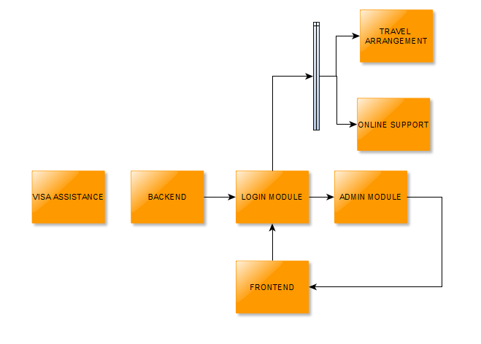

As what is shown above, the Visa Consultation Appointment module is a floating module that can be tested even without the other modules. For scheduling, the following testing should be done:

* Accessing the Visa Consultation Appointment
* Viewing available dates
* Booking a date

The testing process starts with the backend. The admin will logon to the system and manage the admin module wherein the rest of the process is dependent upon. Here is a list of the functions of the admin module:

* CRUD of Freebies
* CRUD of Food Deals
* CRUD of Airlines
* CRUD of Time
* CRUD of Tour Type
* CRUD of Transport Service
* Visa Consultation Appointment
* Travel Arrangement

From the admin, the frontend can now work simultaneously with the backend and registered users can now use the travel arrangement and online support feature.

## Item Pass / Fail Criteria

***Login Module***

Backend:

* System only accepts authorized users (Employees)
* Only the admin is able to create authorized users.

Frontend:

* Guests can create their account
* Logging in to the application

For both:

* Password encryption and strength
* 15 minutes session timeout
* No duplicate usernames
* Data input validation

***Visa Consultation Appointment***

Backend:

* Viewing the detailed record of the schedules
* Approving of schedules
* Display monthly earnings

|  |  |
| --- | --- |
| Frontend:   * Book a date | For both:   * View remaining unscheduled dates * Data input validation |

***Travel Arrangement***

Backend:

* Managing hotels
* Managing airlines
* Managing tour deals
* Verification of travel arrangements

Frontend:

* Create an arrangement

For both:

* View tour deals
* View arrangements
* Data input validation

***Online Support***

|  |  |
| --- | --- |
| Backend:   * Answer questions through chat | Frontend:   * See if support personnel is online * Inquire through chat |

## Suspension / Resumption Criteria

***Testing checkpoints***

1. Application is accessible in web and mobile.
2. Users can successfully login (Backend/Frontend).
3. Registered users can manage their travel arrangements. (Create, Update, View).
4. Users can schedule their visa appointment.
5. Manageability of the system. (Backend Perspective).
6. Backend users can monitor their client’s arrangements and schedules.
7. Live chat works for both the backend and frontend.

***Suspension Criteria***

* System testing should stop when:
* There are errors on the backend side of creating or inserting of data.
* Multiple critical errors are found from the starting point or the backend side
* Half of the requirements are not fulfilled.

***Resumption Criteria***

System testing should resume when:

* Found errors are fixed.
* There is enough functions or modules to test

## Test Deliverables

The following documents should be delivered:

* Test cases Documents
* Test Plan
* Test Scripts
* Test Data
* Test Results/reports
* Test summary report
* Defect Report
* Release notes

## Testing Tasks

|  |  |
| --- | --- |
| TASK | DESCRIPTION |
| Develop test cases | Detailed document of test cases.(Test case document) |
| Create dummy database for testing | Created database will be used for testing purposes only and will be destroyed afterwards.(Test Data) |
| Execute tests and evaluate defects | Execute test scripts and study found defects.(Test plan, test scripts) |
| Report defects | Document the found defects.(Defect Report) |
| Create test reports | Testing summary and reports. (Test Results and summary report) |

## Environmental Needs

***Hardware Requirements***

* PC/Laptop with internet connection
* Android Mobile Devices(For mobile testing)

***Software Requirements***

* Browsers that preferably supports HTML5 and CSS3 scripts.

Please refer to this link for browser support 🡪<http://fmbip.com/litmus>

* XAMPP (For local testing)
* PhpMyAdmin(For Local testing)

## Responsibilities

**Developer's Responsibilities**

|  |  |  |
| --- | --- | --- |
| Tasks | Person(s) Responsible | Responsibilities |
| Test cases Documents | Erika Hidalgo | Lead the team and assigned which test cases are assigned to each member |
| Test Plan | Arianne Bianca Papna | Divide the parts of the test plan among the team members, then later on integrate and check it. |
| Test Scripts | Erika Hidalgo | Create test scripts for the program. |
| Test Data | Arianne Bianca Papna | Create test data, which would be used for testing acceptable values. |
| Test Results/reports | Roxanne Therese Luangco | Consolidate all the test results and reports, then summarize it. |
| Test summary report |
| Defect Report | Arianne Bianca Papna | Write a report for any defect that will be found on the system. |

Aside from these responsibilities, each member must also:

* Assure that all tasks assigned to them are finished on time
* Properly test the system, before project presentation
* Provide all the documentation needed for the testing phase of the project

## Staffing and Training

The testers and quality assurance group are essential to make every project a success. Their responsibility to ensure that the system will pass through a series of test, is what makes a tester one of the most important contributors to the project. In order to achieve these, the testers must accomplish the following items:

* **Familiarization to Business Processes**

The tester must be fully aware of how a business works and the processes involved in it. Without knowing these, the testers will have a hard time in understanding the procedures and how the system works.

* **Hands-on experience**

Through this process, the testers can be more knowledgeable and skillful in terms of testing and quality assurance. This is one of the most important part of learning and training to every tester.

* **Testing Skills**

A tester must have at least one (1) certification or any proof that shows the acquired skills of the tester.

* **Determination to learn**

Since the technology keeps on changing, the tester must be responsible to keep up and learn more about the latest trend and the tools involved in it. Through these, the skill and knowledge of the tester can also be updated.

## Schedule

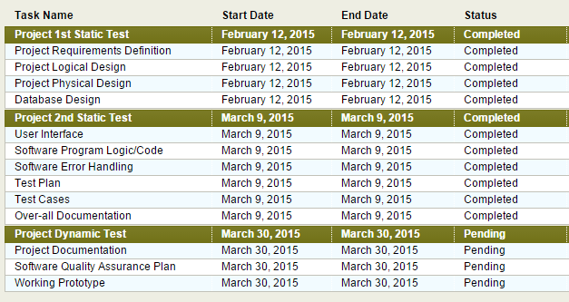

## Resources

Listed below are the resources that were used in developing the Booking and Reservation system of JMGTCC.

|  |  |
| --- | --- |
| Resources | Link |
| Official website of JMGTCC | http://journeysglobaltours.com/ |
| Project documentation of JMGTCC | http://projects2.apc.edu.ph/wiki/index.php/ |
| Project Repository | https://code.google.com/p/apc-softdev-it111-04 https://github.com/joegeneq/apc-softdev-it111-04 |
| Yii Framework Guide | http://www.yiiframework.com/doc-2.0/guide-intro-yii.html |

## Risks and Contingencies

|  |  |  |  |
| --- | --- | --- | --- |
| Risk Factor | Risk Statement | Impact | Contingency Plan |
| TECHNICAL RISK | | | |
| Incorrect or Inconsistent Data | This risk is due to human error. It can affect the data from the client which will be stored to the database of the system | Low | It can be avoided if the text fields, where the client must input the required data can be limited.   If possible, there must be available options to choose from, so that the user can avoid entering incorrect data. |
| Inaccessible Pages or Functions | This type of risk must be prevented at all cost. The probable causes for this risk are:   * Server or Database Malfunction * Algorithm or Programming Error * Low or No Network Connectivity | High | This can be prevented if the functionality of the system will be thoroughly checked and tested.  The developers must make sure that the system pass through quality check. |
| MANAGEMENT RISK | | | |
| Lack of Personnel to Support Customer Service | This risk can be triggered by the sudden increase on the number of clients who needed more information about their company and the services that they offer. | Medium | This can be done be avoided by employing skilled individuals who can assist clients within a short amount of time or if there is a great increase on the number of clients, or if there is a great increase on the number of clients, they too must increase the number of their employees. |
| Unskilled or Untrained Personnel | This risk can affect the management of JMGTCC and the system as well. | Medium | This could be prevented if proper training will be implemented and highly qualified staff is hired. |

## Approvals

The undersigned acknowledge that they have reviewed the JMGTCC document and agree with the approach it presents. Any changes to this Requirements Definition will be coordinated with and approved by the undersigned or their designated representatives.

|  |  |  |  |
| --- | --- | --- | --- |
| Signature: |  | Date: |  |
| Print Name: |  |  |  |
| Title: |  |  |  |
| Role: |  |  |  |

|  |  |  |  |
| --- | --- | --- | --- |
| Signature: |  | Date: |  |
| Print Name: |  |  |  |
| Title: |  |  |  |
| Role: |  |  |  |

|  |  |  |  |
| --- | --- | --- | --- |
| Signature: |  | Date: |  |
| Print Name: |  |  |  |
| Title: |  |  |  |
| Role: |  |  |  |

## Test Cases

**Journeys & More Global Tours and Consultancy Co.**

**(JMGTCC)**

Test Cases for Use Case: View System Users

**Introduction:**

This document provides an overview of the test case, ***View Users***

|  |  |  |  |  |  |
| --- | --- | --- | --- | --- | --- |
| Test Case Group Number: | | 1 | | | |
| Test Case Name: | | View System Users | | | |
| Test Case Reference: | | Use Case: View System Users(Backend) | | | |
| Test Case Priority: | | High | | | |
| Test Case Preconditions:   * Only the admin can view all the system users | | | | | |
| TC ID | **Condition Being Tested** | | **Expected Output** | **Observed Output** | **Verdict** |
| BE-LIVTC1 | Display manage user page | | Displays grid table of user accounts and create new user button after clicking user tab. | Does as expected | Pass |
| BE-LIVTC2 | Display individual user account information | | Display user account after clicking the view button in the left side of the grid table of the chosen data. | Does as expected | Pass |

**Remarks: No instructions as to how to visit the user page, preempt that tester will have to be instructed to locate Users link in nav bar**

**Journeys & More Global Tours and Consultancy Co.**

**(JMGTCC)**

Test Cases for Use Case: Views Travel Arrangement

**Introduction:**

This document provides an overview of the test case, ***Views Travel Arrangement.*** This test case applies to both the tour arrangement menu and the travel and tour.

|  |  |  |  |  |  |
| --- | --- | --- | --- | --- | --- |
| Test Case Group Number: | | 2 | | | |
| Test Case Name: | | View travel Arrangement | | | |
| Test Case Reference: | | Use Case: Views Travel Arrangement (Backend) | | | |
| Test Case Priority: | | High | | | |
| Test Case Preconditions:   * Only the admin can view all the tour and travel tour arrangements. | | | | | |
| TC ID | **Condition Being Tested** | | **Expected Output** | **Observed Output** | **Verdict** |
| BE-VTVTC1 | Display manage travel and travel tour arrangement page | | Displays grid table of arrangement page | Does as expected, it would’ve been better if instructions to create a tour arrangement was placed before | Pass |
| BE-VTVTC2 | Display individual arrangement record information | | Display arrangement record after clicking the view button in the left side of the grid table of the chosen data. | Does as expected | Pass |

**Remarks: Sequence to create a travel tour arrangement, should have been included before this test case**

**Journeys & More Global Tours and Consultancy Co.**

**(JMGTCC)**

Test Cases for Use Case: Manages Maintenance Modules

**Introduction:**

This document provides an overview of the test case, ***Manage food deals, airlines, freebies, time, tour type and transport service*** or simply the maintenance modules***.***

|  |  |  |  |  |  |
| --- | --- | --- | --- | --- | --- |
| Test Case Group Number: | | 3 | | | |
| Test Case Name: | | Manage Maintenance Modules | | | |
| Test Case Reference: | | Use Case: Manage Maintenance Modules(Backend) | | | |
| Test Case Priority: | | High | | | |
| Test Case Preconditions:   * Only the admin can create, update and delete records from the maintenance modules. | | | | | |
| TC ID | **Condition Being Tested** | | **Expected Output** | **Observed Output** | **Verdict** |
| 2.1 Manage Food Deals | | | | | |
| BE-FDCTC1 | Displays create new food deal form. | | Displays food deal form which includes:   * Food Deal Name * Food Deal Description | Does as expected | Pass |
| BE-FDCTC2 | Check uniqueness of deal name. | | Displays notification if the deal name is already taken. | Does as expected | Pass |
| BE-FDCTC3 | Check for empty fields | | System will not accept empty fields and will return a notification. | Does as expected | Pass |
| BE-FDVTC4 | Display manage food deals page | | Displays grid table of food deals and create new food deal button. | Does as expected | Pass |
| BE-FDVTC5 | Display each food deal information | | Display food deal information after clicking the view button in the left side of the grid table of the chosen data. | Does as expected | Pass |
| BE-FDUTC1 | Display food deal update form | | Displays update form with original values after clicking ‘update’ button. | Does as expected | Pass |
| BE-FDUTC2 | Check uniqueness of deal name. | | Displays notification if the deal name is already taken. | Does as expected | Pass |
| BE-FDUTC3 | Check for empty fields | | System will not accept empty fields and will return a notification. | Does as expected | Pass |
| BE-FDUTC4 | Delete food deal | | Deleted food deal will be removed from the database after clicking the ‘Delete’ button. | Does as expected | Pass |
| 2.2 Manage Airlines | | | | | |
| BE-ALCTC1 | Displays create new airline record form. | | Displays airline record form which includes:   * Airline Name | Does as expected | Pass |
| BE-ALCTC2 | Check uniqueness of airline name. | | Displays notification if the airline name is already taken. | Does as expected | Pass |
| BE-ALCTC3 | Check for empty fields | | System will not accept empty fields and will return a notification. | Does as expected | Pass |
| BE-ALVTC4 | Display manage airline page | | Displays grid table of airline records and create new airline button. | Does as expected | Pass |
| BE-ALVTC5 | Display each airline information | | Display airline information after clicking the view button in the left side of the grid table of the chosen data. | Does as expected | Pass |
| BE-ALUTC1 | Display airline record update form | | Displays update form with original values after clicking ‘update’ button. | Does as expected | Pass |
| BE-ALUTC2 | Check uniqueness of deal airline. | | Displays notification if the airline name is already taken. | Does as expected | Pass |
| BE-ALUTC3 | Check for empty fields | | System will not accept empty fields and will return a notification. | Does as expected | Pass |
| BE-ALUTC4 | Delete airline record | | Deleted hotel record will be removed from the database after clicking the ‘Delete’ button. | Does as expected | Pass |
| 2.3 Manage Freebies | | | | | |
| BE-FRCTC1 | Displays create freebies record | | Displays contact number record form which includes:   * Freebies Name * Freebies Description | Does as expected | Pass |
| BE-FRCTC2 | Check uniqueness of freebie record. | | Displays notification if the record is already taken. | Does as expected | Pass |
| BE-CNCTC3 | Check for empty fields | | System will not accept empty fields and will return a notification. | Does as expected | Pass |
| BE-CNVTC4 | Display manage freebie page | | Displays grid table of freebie records and create new record button. | Does as expected | Pass |
| BE-CNVTC5 | Display each freebie information | | Display freebie information after clicking the view button in the left side of the grid table of the chosen data. | Does as expected | Pass |
| BE-CNUTC1 | Display freebie record update form | | Displays update form with original values after clicking ‘update’ button. | Does as expected | Pass |
| BE-CNUTC2 | Check uniqueness of freebie record. | | Displays notification if the freebie record is already taken. | Does as expected | Pass |
| BE-CNUTC3 | Check for empty fields | | System will not accept empty fields and will return a notification. | Does as expected | Pass |
| BE-CNUTC4 | Delete freebie record | | Deleted freebie record will be removed from the database after clicking the ‘Delete’ button. | Does as expected | Pass |
| 2.4 Manage Time | | | | | |
| BE-TMCTC1 | Displays create time record form | | Displays time record form which includes:   * Time * Description | Does as expected | Pass |
| BE-TMCTC2 | Check uniqueness of time record. | | Displays notification if the record is already taken. | Does as expected | Pass |
| BE-TMCTC3 | Check for empty fields | | System will not accept empty fields and will return a notification. | Does as expected | Pass |
| BE-TMVTC4 | Display manage time page | | Displays grid table of time records and create new record r button. | Does as expected | Pass |
| BE-TMVTC5 | Display each time information | | Display time information after clicking the view button in the left side of the grid table of the chosen data. | Does as expected | Pass |
| BE-TMUTC1 | Display time record update form | | Displays update form with original values after clicking ‘update’ button. | Does as expected | Pass |
| BE-TMUTC2 | Check uniqueness of time record. | | Displays notification if the record is already taken. | Does as expected | Pass |
| BE-TMUTC3 | Check for empty fields | | System will not accept empty fields and will return a notification. | Does as expected | Pass |
| BE-TMUTC4 | Delete time record | | Deleted contact number record will be removed from the database after clicking the ‘Delete’ button. | Does as expected | Pass |
| 2.5 Manage Tour Type | | | | | |
| BE-TTCTC1 | Displays create tour type record form | | Displays tour type record form which includes:   * Tour Name * Tour Description | Does as expected | Pass |
| BE-TTCTC2 | Check uniqueness of tour type record. | | Displays notification if the record is already taken. | Does as expected | Pass |
| BE-TTCTC3 | Check for empty fields | | System will not accept empty fields and will return a notification. | Does as expected | Pass |
| BE-TTVTC4 | Display manage tour type page | | Displays grid table of tour type records and create new record button. | Does as expected | Pass |
| BE-TTVTC5 | Display each tour type information | | Display tour type information after clicking the view button in the left side of the grid table of the chosen data. | Does as expected | Pass |
| BE-TTUTC1 | Display tour type record update form | | Displays update form with original values after clicking ‘update’ button. | Does as expected | Pass |
| BE-TTUTC2 | Check uniqueness of tour type record. | | Displays notification if the record is already taken. | Does as expected | Pass |
| BE-TTUTC3 | Check for empty fields | | System will not accept empty fields and will return a notification. | Does as expected | Pass |
| BE-TTUTC4 | Delete tour type record | | Deleted tour type r record will be removed from the database after clicking the ‘Delete’ button. | Does as expected | Pass |
| 2.6 Manage Transport Service | | | | | |
| BE-TSCTC1 | Displays create transport service record form | | Displays transport service record form which includes:   * Transport Type * Transport Description | Does as expected | Pass |
| BE-TSCTC2 | Check uniqueness of transport service record. | | Displays notification if the record is already taken. | Does as expected | Pass |
| BE-TSCTC3 | Check for empty fields | | System will not accept empty fields and will return a notification. | Does as expected | Pass |
| BE-TSVTC4 | Display manage transport service page | | Displays grid table of transport service records and create new record button. | Does as expected | Pass |
| BE-TSVTC5 | Display each transport service information | | Display transport service information after clicking the view button in the left side of the grid table of the chosen data. | Does as expected | Pass |
| BE-TSUTC1 | Display transport service record update form | | Displays update form with original values after clicking ‘update’ button. | Does as expected | Pass |
| BE-TSUTC2 | Check uniqueness of transport service record. | | Displays notification if the record is already taken. | Does as expected | Pass |
| BE-TSUTC3 | Check for empty fields | | System will not accept empty fields and will return a notification. | Does as expected | Pass |
| BE-TSUTC4 | Delete transport service record | | Deleted tour type r record will be removed from the database after clicking the ‘Delete’ button. | Does as expected | Pass |

**Remarks**

**__________________________________________________________________________________________________________________________________________________________________________________________________________________________________________________________________________________________________________________________________________________________________**

**Journeys & More Global Tours and Consultancy Co.**

**(JMGTCC)**

Test Cases for Use Case: Confirms Visa Consultation Appointment

**Introduction:**

This document provides an overview of the test case, ***Confirms Visa Consultation Appointment,*** wherein the admin confirms the appointment schedule made when the client physically arrives in the office or payment has been made.

|  |  |  |  |  |  |
| --- | --- | --- | --- | --- | --- |
| Test Case Group Number: | | 4 | | | |
| Test Case Name: | | Confirm Visa Consultation Appointment | | | |
| Test Case Reference: | | Use Case: Confirms Visa Consultation Appointment (Backend) | | | |
| Test Case Priority: | | High | | | |
| Test Case Preconditions:   * Only the admin can confirm the schedule/appointment | | | | | |
| TC ID | **Condition Being Tested** | | **Expected Output** | **Observed Output** | **Verdict** |
| BE-VCCTC1 | Displays the confirm button | | Confirm button is displayed in the update page of the chosen record | Does as expected | **Pass** |
| BE-VCCTC2 | Changing Appointment Status | | Status of the record should be changed to “Confirmed” after clicking the confirm button. | Does as expected | **Pass** |

**Remarks**

**Button is not labeled as ‘confirm’, but as set payment – which is a bit misleading for tester, nevertheless, it has been clarified by developers**

**Note: This module is not yet complete and is still in development.**

**Journeys & More Global Tours and Consultancy Co.**

**(JMGTCC)**

Test Cases for Use Case: Generates Visa Consultation Monthly Report

**Introduction:**

This document provides an overview of the test case, ***Generates Visa Consultation Monthly Report,*** wherein the admin generates a report that contains the total profit of the visa assistance service of JMGTCC.

|  |  |  |  |  |  |
| --- | --- | --- | --- | --- | --- |
| Test Case Group Number: | | 5 | | | |
| Test Case Name: | | Visa Consultation Monthly Report | | | |
| Test Case Reference: | | Use Case: Generates Visa Consultation Monthly Report(Backend) | | | |
| Test Case Priority: | | High | | | |
| Test Case Preconditions:   * Internet Connection for emailing | | | | | |
| TC ID | **Condition Being Tested** | | **Expected Output** | **Observed Output** | **Verdict** |
| BE-VRCTC1 | Displays generate report button | | Button is displayed in the Visa Assistance Appointment index page, located at the top right corner of the page’s body |  |  |
| BE-VRCTC2 | Display two date picker for selecting month duration | | Admin is redirected to a new page to determine month duration of the report and displays a generate button at the end of the page |  |  |
| BE-VRCTC2 | Hide the result from the application’s admin | | The application should not show the actual details of the report to the admin after clicking the generate button. |  |  |
| BE-VRCTC2 | Notification after successful generation of reports | | A notification should be seen after clicking the generate button, confirming that an email was sent to JMGTCC’s owner. |  |  |

**Remarks**

**No test case for appointment emailing.**

**____________________________________________________________________________________________________________________________________________________________________________________________________________________________________________**

Journeys & More Global Tours and Consultancy Co.

(JMGTCC)

Test Cases for Use Case: Creates Travel Arrangement

Introduction:

This document provides an overview of the test case, *Creates Travel Arrangement,* for the travel arrangement & appointment system of JMGTCC.

|  |  |  |  |  |  |
| --- | --- | --- | --- | --- | --- |
| Test Case Number: | | 6 | | | |
| Test Case Name: | | Creates a Travel Arrangement | | | |
| Test Case Reference: | | Use Case: Manages Maintenance Modules | | | |
| Test Case Priority: | | High | | | |
| Test Case Preconditions:   * A user can create one to many Travel / Tour Arrangements * Only registered users can create a Travel / Tour Arrangement | | | | | |
| TC ID | Condition Being Tested | | Expected Output | Observed Output | Verdict |
| 1.1 Create Tour Arrangement | | | | | |
| FE-TACTC1 | Display Tour Arrangement form | | The Create Page with empty fields will be displayed, where the user could input the required information.  The form must contain the following fields:   * Place of Origin * Destination * Date of Arrival * Date of Return * Number of PAX * Hotel Name * Room Type * Accommodation / Food Inclusions * Tour Type * Transport Services * Notes | Does as expected | Pass |
| FE-TACTC2 | **Input validation**  Validate User input according to form fields; Show appropriate error or success message | | Required fields will be highlighted and error messages will appear if the fields are null or empty, optional fields will be disregarded. | Does as expected | Pass |
| FE-TACTC3 | **Submit Entries**  Upon submission, the data input must be saved to the database | | The data will be saved to the database and the user will be redirected to the View Page once successful. | Does as expected | Pass |
| FE-TACTC4 | **Email Notification**  Upon submission, the tour arrangement details should be sent to the travel agent’s email address | | The details of the tour arrangement request created by the client in the system will be sent to the travel agent’s email address. | Does as expected | Pass |
| 1.2 Create Travel and Tour Arrangement | | | | | |
| FE-TTACTC1 | Display Travel and Tour Arrangement form | | The Create Page with empty fields will be displayed, where the user could input the required information.  The form must contain the following fields:   * Place of Origin * Destination * Date of Departure * Date of Return * Airline Name * Flight Type * Class Type * Number of PAX * Hotel Name * Room Type * Accommodation / Food Inclusions * Tour Type * Transport Services * Notes | Does as expected | Pass |
| FE-TTACTC2 | **Input validation**  Validate User input according to form fields; Show appropriate error or success message | | Required fields will be highlighted and error messages will appear if the fields are null or empty, optional fields will be disregarded. | Does as expected | Pass |
| FE-TTACTC3 | **Submit Entries**  Upon submission, the data input must be saved to the database | | The data will be saved to the database and the user will be redirected to the View Page once successful. | Does as expected | Pass |
| FE-TTACTC4 | **Email Notification**  Upon submission, the tour arrangement details should be sent to the travel agent’s email address | | The details of the tour arrangement request created by the client in the system will be sent to the travel agent’s email address. | Does as expected | Pass |

**Remarks**

__________________________________________________________________________________________________________________________________________________________________________________________________________________________________________________________________________________________________________________________________________________________________

Journeys & More Global Tours and Consultancy Co.

(JMGTCC)

Test Cases for Use Case: Views Travel Arrangement

Introduction:

This document provides an overview of the test case, *Views a Travel Arrangement,* for the booking and reservation system of JMGTCC.

|  |  |  |  |  |  |
| --- | --- | --- | --- | --- | --- |
| Test Case Number: | | 7 | | | |
| Test Case Name: | | Views a Travel Arrangement | | | |
| Test Case Reference: | | Use Case: Creates a Travel Arrangement | | | |
| Test Case Priority: | | Medium | | | |
| Test Case Preconditions:   * The Travel / Tour Arrangement to be viewed should be existing * The page should only be accessible to the user who created the Travel Arrangement * The Travel Arrangement module is only accessible to registered users | | | | | |
| TC ID | Condition Being Tested | | Expected Output | Observed Output | Verdict |
| FE-TAVTC1 | Display Travel Arrangement information | | The View Page will be rendered with the Travel Arrangement information. | Does as expected | Pass |

**Remarks**

__________________________________________________________________________________________________________________________________________________________________________________________________________________________________________________________________________________________________________________________________________________________________

Journeys & More Global Tours and Consultancy Co.

(JMGTCC)

Input Validation for Use Case: Creates Travel Arrangement

Introduction:

This document provides the conditions for the input validation of the test case, *Crates / Updates a Travel Arrangement,* for the booking and reservation system of JMGTCC.

|  |  |  |  |  |
| --- | --- | --- | --- | --- |
| TC ID | Condition Being Tested | Expected Output | Observed Output | Verdict |
| 1.1 Create Tour Arrangement | | | | |
| FE-TACTC5 | Validate Date of Arrival | Form field must not accept entries not in date format. This should not be null. | Does as expected | Pass |
| FE-TACTC6 | Validate Date of Return | Form field must not accept entries not in date format. The Return Date must be a date ahead of Arrival Date. This should not be null.  (in progress) |  |  |
| 1.2 Create Travel and Tour Arrangement | | | | |
| FE-TTACTC5 | Validate Date of Departure | Form field must not accept entries not in date format. This should not be null. | Does as expected | Pass |
| FE-TTACTC6 | Validate Date of Return | Form field must not accept entries not in date format. The Return Date must be a date ahead of Departure Date. This should not be null.  (in progress) |  |  |
| FE-TTACTC7 | Validate Airline Name | Form Field must be in alphabet form.  This field is optional. | Does as expected |  |
| FE-TTACTC8 | Validate Flight Type | Form Field must be in alphabet form.  This field is optional. | Does as expected | Pass |
| FE-TTACTC9 | Validate Class Type | Form Field must be in alphabet form.  This field is optional. | Does as expected | Pass |
| 1.1 Create Tour Arrangement / 1.2 Create Travel and Tour Arrangement | | | | |
| FE-TACTC7  FE-TTACTC10 | Validate Place of Origin | Form Field must be in alphanumeric form. This can be optional. Default value = “Manila, Philippines” | Does as expected | Pass |
| FE-TACTC8  FE-TTACTC11 | Validate Destination | Form Field must be in alphanumeric form. This should not be null. | Does as expected | Pass |
| FE-TACTC9  FE-TTACTC12 | Validate Number of PAX | Form Field must only accept numeric values. This should not be null. | Does as expected | Pass |
| FE-TACTC10  FE-TTACTC13 | Validate Hotel Name | Form Field must be in alphanumeric.  This field is optional. | Does as expected | Pass |
| FE-TACTC11  FE-TTACTC14 | Validate Room Type | Form Field must be in alphabet form.  This field is optional. | Does as expected | Pass |
| FE-TACTC12  FE-TTACTC15 | Validate Accommodations / Food Inclusion | Form Field must be in a checkbox list. The values accepted must be in array. This field is required. | Does as expected | Pass |
| FE-TACTC13  FE-TTACTC16 | Validate Tour Type | Form Field must be in a checkbox list. The values accepted must be in array. This field is required. | Does as expected | Pass |
| FE-TACTC14  FE-TTACTC17 | Validate Transport Services | Form Field must be in a checkbox list. The values accepted must be in array. This field is required. | Does as expected | Pass |
| FE-TACTC15  FE-TTACTC18 | Validate Notes | Form Field can be in alphanumeric form. This field is optional. | Does as expected | Pass |

**Remarks**

**______________________________________________________________________________________________________________________**

**Journeys & More Global Tours and Consultancy Co.**

**(JMGTCC)**

Test Cases for Use Case: Creates Account

**Introduction:**

This document provides an overview of the test case, ***Creates Account*** for the booking and reservation system of JMGTCC.

|  |  |  |  |  |  |
| --- | --- | --- | --- | --- | --- |
| Test Case Number: | | 8 | | | |
| Test Case Name: | | Create user account | | | |
| Test Case Reference: | | Use Case: Creates Account (Front-end) | | | |
| Test Case Priority: | | High | | | |
| Test Case Preconditions:   * User must not have any existing account | | | | | |
| TC ID | **Condition Being Tested** | | **Expected Output** | **Observed Output** | **Verdict** |
| FE-UACTC1 | Display ***Create Account*** form | | Page displaying the form which contains the following:   * Fields where the user could input the following **required** information: * Username * First Name * Last Name * Gender * City * Contact Number * Email * Password * ‘*Create’* button | Does as expected | Pass |
| FE-UACTC2 | Verify username uniqueness | | There will be a notification “***This username has already been taken***” to inform the user that the username cannot be used anymore. | Does as expected | Pass |
| FE-UACTC2 | Verify email address | | There will be a notification “***Email is not a valid email address***” to inform the user that the email is invalid. It can only be valid if it contains the characters “@” and “.” | Does as expected | Pass |
| FE-UACTC3 | Verify password | | Passwords should contain at least six (6) characters or else the system will not accept it as a valid value. | Does as expected | Pass |
| FE-UACTC4 | Verify form completion | | All the following required values must be filled:   * Username * First Name * Last Name * Gender * City * Contact Number * Email * Password   If required fields are not completely filled but the user submitted it, then the user will be notified that it was a required field. | Does as expected | Pass |
| FE-UACTC5 | Save Data | | The data from user input is stored in the database. | Does as expected | Pass |

**Remarks**

**__________________________________________________________________________________________________________________________________________________________________________________________________________________________________________________________________________________________________________________________________________________________________**

**Journeys & More Global Tours and Consultancy Co.**

**(JMGTCC)**

Test Cases for Use Case: Creates an appointment for Visa

**Introduction:**

This document provides an overview of the test case, ***Creates an appointment for Visa*** for the booking and reservation system of JMGTCC.

|  |  |  |  |  |  |
| --- | --- | --- | --- | --- | --- |
| Test Case Number: | | 9 | | | |
| Test Case Name: | | Create an appointment for Visa | | | |
| Test Case Reference: | | Use Case: Creates an appointment for Visa | | | |
| Test Case Priority: | | High | | | |
| Test Case Preconditions:   * The appointment date must be at least one(1) day after current date | | | | | |
| TC ID | **Condition Being Tested** | | **Expected Output** | **Observed Output** | **Verdict** |
| FE-VACTC1 | Display ***Create Appointment*** page | | Page displaying the form which contains the following:   * Fields where the user could input the following required information: * Client Name * City * Contact Number * Email Address * Visa Type * Appointment Date * Appointment Time * Notes * ‘*Create’* button | Does as expected | Pass |
| FE-VACTC2 | Verify email address | | There will be a notification “***Email is not a valid email address***” to inform the user that the email is invalid. It can only be valid if it contains the characters “@” and “.” | Does as expected | Pass |
| FE-VACTC3 | Validate appointment date | | The appointment date must be at least one day after the current date to when the user is reserving the appointment. Other date before the allowed date must be disabled. | Does as expected | Pass |
| FE-VACTC4 | Verify form completion | | All the following required values must be filled:   * Client Name * City * Contact Number * Email Address * Appointment Date * Appointment Time   If required fields are not completely filled but the user submitted it, then the user will be notified that it was a required field. | Does as expected | Pass |
| FE-VACTC5 | Save Data | | The data from user input is stored in the database. | Does as expected | Pass |

**Remarks**

**__________________________________________________________________________________________________________________________________________________________________________________________________________________________________________________________________________________________________________________________________________________________________**

**Journeys & More Global Tours and Consultancy Co.**

**(JMGTCC)**

Test Cases for Use Case: Views visa appointment schedule

**Introduction:**

This document provides an overview of the test case, ***Views visa appointment schedule*** for the booking and reservation system of JMGTCC.

|  |  |  |  |  |  |
| --- | --- | --- | --- | --- | --- |
| Test Case Number: | | 10 | | | |
| Test Case Name: | | View visa appointment schedule | | | |
| Test Case Reference: | | Use Case: Views visa appointment schedule | | | |
| Test Case Priority: | | Medium | | | |
| Test Case Preconditions:   * Only clients who have an existing account in the system can view the visa appointment schedule. * User must have a pending visa appointment | | | | | |
| TC ID | **Condition Being Tested** | | **Expected Output** | **Observed Output** | **Verdict** |
| FE-VAVTC1 | Display ‘***Appointment Schedule***’ page | | The following information must be displayed to the user:   * Client Name * City * Contact Number * Email Address * Appointment Date * Appointment Time | Does as expected | Pass |

**Remarks**

**Testers encountered difficulty in identifying if test case refers to the search page(landing page) or the view page(individual record)**

## Acceptance Plan

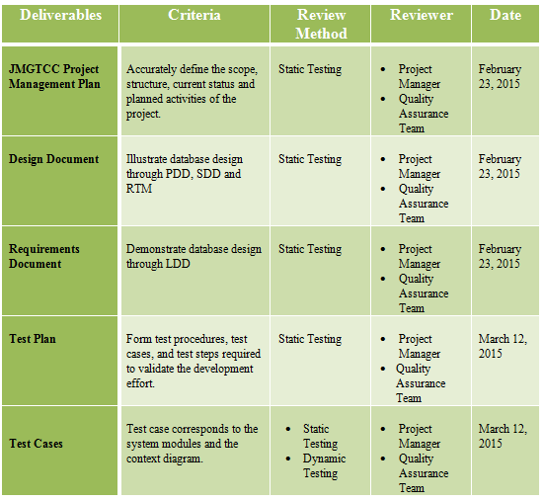

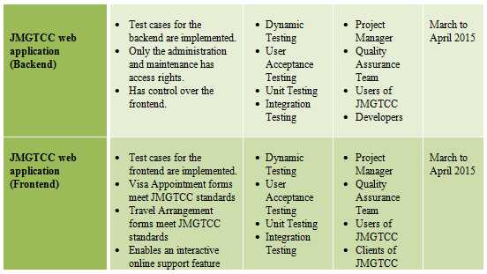

## Installation & Acceptance Plan

### The Acceptance Configuration Plan

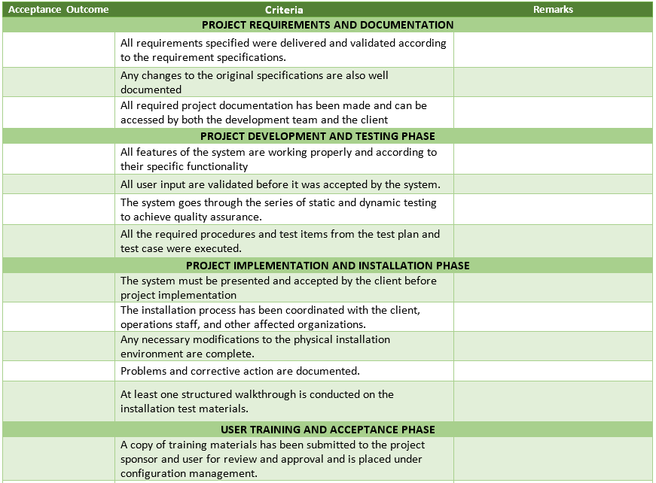

## Project Team/ Authors

|  |  |  |
| --- | --- | --- |
| **Mr. Allan Cotecson** | Professor | allanc@apc.edu.ph |

|  |  |  |
| --- | --- | --- |
| **Arianne Bianca Papna** | Project Manager / Developer | afpapna@student.apc.edu.ph |
| **Erika Hidalgo** | Developer | echidalgo@student.apc.edu.ph |
| **Roxanne Therese Luangco** | QA / Developer | raluangco@student.apc.edu |