|  |
| --- |
| **ASIA PACIFIC COLLEGE**  School of Computer Science and Information  Technology |
| Journeys & More Global Tours and Consultancy Co. |
| Travel Arrangement & Appointment System |
| SQAP |
| **Arianne Bianca F. Papna**  **Erika C. Hidalgo**  **Roxanne Therese A. Luangco**  **IT 111** |
|  |

**Mr. Allan Cotecson**

Professor

Table of Contents

Software Project Management Plan 2

Vision 2

Scope 2

Feasibility and Risk Analysis 3

Management Approach 4

Roles and Responsibilities 5

Technical Approach 5

Requirements Document 7

The Logical Database Description 7

The Requirements Document 9

The Requirements Traceability Matrix 10

Design Document 11

The Physical Database Description 11

The Software Design Document 11

Online Help 13

Data Areas 13

Optional Scenarios 15

Deployment Plan 15

Acceptance Plan 15

Installation & Acceptance 17

The Acceptance Configuration Plan 17

Project Team / Authors 17

## 

## Software Project Management Plan

### Vision

JMGTCC Travel Arrangement & Appointment System:   
The project aims to be a source of convenience, as a venue in providing reliable travel and tourism information and to help the company in achieving its goal in providing clients warm hospitality at the tip of their fingertips.

* To promote tourism by providing a module that features tour deals and packages for clients and travelers
* To provide a module for setting client Visa Appointment

### Scope

The following are the Project Deliverable:

* **Appointment Scheduler (Visa Consultation)**

 In the customer module of the system, clients can have access to the system in case they want to schedule a Visa Assistance Appointment with the General Manager. They will input their name, email address, phone number, appointment time and day and optional remarks or message.

* **Travel Deals Request**

The Client inputs necessary details about the travel packages he wants to avail. He can choose from the list of travel options or request for a new travel package-combination or arrangement offered by the agency.

* **Customer Service / Technical Support**

This is an online chat support feature that enables the clients of JMGTCC to communicate with the company IT Support Team through the application. The client can send a direct / instant message about technical concerns to the IT Support Team.

(**The Admin Module**) The Admin should be able to:

* View Visa Consultation Appointments
* Confirm Visa Consultation Appointment of client
* View Travel and Tour Arrangements
* Manage System modules

(**The Client Module**) The Client should be able to:

* Register for an account
* Be updated or notified though email
* File and submit a Visa Consultation Appointment request
* File and submit a Travel and Tour Arrangement
* Raise concerns via Live chat for technical support

### Feasibility and Risk Analysis

Listed below are the risks that could affect the website and functionality of the travel arrangement and appointment system of JMGTCC:

* + - **Incorrect / Inconsistent Data**

This risk is due to human error and is considered as a low threat to the system.  Although the risk is low, it can still affect the data from the client which will be stored to the database of the system.

**Possible Solution:**   
This type of risk can be avoided if the text fields, where the client must input the required data can be limited.  If possible, there must be available options to choose from, so that the user can avoid entering incorrect data.

* + - **Inaccessible Pages / Functions**

This type of risk is a high threat and must be prevented at all cost.   
  
The probable causes for this risk are:

* Server or Database Malfunction
* Algorithm or Programming Error
* Low or No Network Connectivity

**Possible Solution:**   
This can be prevented if the functionality of the system will be thoroughly checked and tested. The developers must make sure that the system pass through quality check.

* + - **Lack of Personnel to Support Customer Service**

This risk depends on the management of JMGTCC. It can be triggered by the sudden increase on the number of clients who needed more information about their company and the services that they offer.  It can be prevented if there are enough staff members and sufficient details about the company and their services in the website. 

**Possible Solution:**

The management of JMGTCC must ensure their clients that they can provide enough and knowledgeable staff in providing customer service.  This can be done by employing skilled individuals who can assist clients within a short amount of time or if there is a great increase on the number of clients, they too must increase the number of their employees.

### Management Approach

The development of the system will follow ***The Agile Model***; Through this, changes are welcomed in every step of the way as long as the discovered change is necessary for the success of the project. By using Agile method, the development of the system lets the users be involved and collaborate with the developers, and thus ideas and criticism from the customers are always observed and are evaluated through early stages of development.

The following diagram shows a simple depiction of the development process of the system.

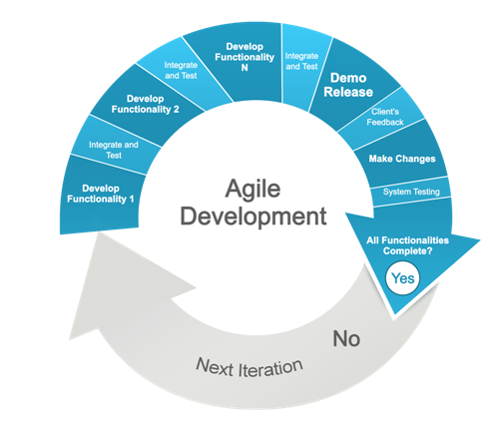

*There will be a meeting every week for project updates and concerns.*   
Throughout the development process, the team should complete the following:

* + Individual Weekly Accomplishment Report
  + Weekly Project Status Report
  + Final Project Documentation

Roles and Responsibilities

The project can be successfully completed if the workload will be divided and handled correctly.   
  
The following people are responsible in making this project possible:

|  |  |  |
| --- | --- | --- |
| **Student Name** | **Role** | **Responsibilities** |
| **Arianne Bianca Papna** | Project Manager / Developer | * Assigns roles and responsibilities * Monitors and reports the project status and progress * Manages the entire project team * Authoring of Project Documentation |
| **Erika Hidalgo** | Developer | * Updates the project manager about the system * Analyzes Software requirements and specifications * Manages Software UI |
| **Roxanne Therese Luangco** | QA / Developer | * Analyzes the Requirements from the client * Prepares test plan * Conducts review meetings with the team * Authoring of Project Documentation |

### Technical Approach

|  |  |  |
| --- | --- | --- |
| Software Environment | | |
| **Programming Languages** | **Specific Software** | **Web Server Application** | | **Operating System** | **Other Software/Applications** |
| PHP  HTML 5  CSS3  MySQL  Java | Yii Framework  phpMyAdmin | Apache  mySQL  Tomcat | | Windows 7 & above | Adobe Photoshop CS5  XAMPP  Notepad++ / Sublime  Browser  Android SDK |
| Hardware Environment | | | | | |
| Programming Languages | | | | | |
| PC / Laptop  Android(ver. 4.2.2 and above) Mobile |  |  | |  |  |

#### Use Case

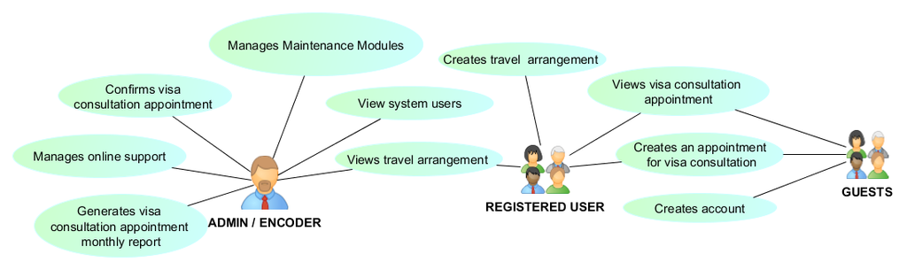

## Requirements Document

### The Logical Database Description

#### Logical Entity-Relationship Diagram

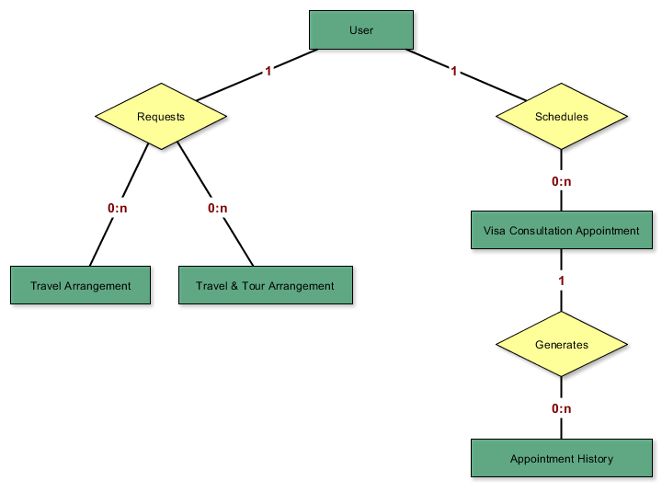

Users Entity   
**Description**   
A **User** is a person who uses the system; the one who creates a Travel Arrangement Request and a Visa Assistance Appointment. The information stored in this entity include Username, Password, Complete name, Gender, City, etc.

**Relationships**   
        A User can create zero to many Travel Arrangement requests.   
        A User can schedule zero to many Visa Assistance Appointments.

|  |
| --- |
| **Actor Interactions** |
| Role | Actors |
| Create | Guest |
| Read | Administrator |
| Update | - |
| Delete | - |

Travel Arrangement Entity   
**Description**   
**Travel Arrangements** are available Travel / Tour Packages offered by the company.  The package or arrangement can be customized according to the client's request.  The information stored in this entity includes the Departure Date, Date of Return, Place of Origin, Destination, etc.

**Relationships**   
        A User can create zero to many Travel / Tour Arrangement Requests.

|  |
| --- |
| **Actor Interactions** |
| **Role** | **Actors** |
| **Create** | Registered User |
| **Read** | Administrator |
| **Update** | - |
| **Delete** | - |

Appointment Entity   
**Description**   
The **Visa Consultation Appointments** are the list of appointments scheduled in a particular date and time. The information stored in this entity include the Appointment date and time, Visa type, etc.

**Relationships**   
        A User can schedule zero to many Visa Assistance Appointment.

|  |
| --- |
| **Actor Interactions** |
| **Role** | **Actors** |
| **Create** | Registered User, Guest |
| **Read** | Administrator, Registered User |
| **Update** | Administrator |
| **Delete** | - |

### The Requirements Document

#### Security Requirements

**Login Page**   
There are two different types of user for this system. Each of these users will have different roles and responsibilities so that not anyone can easily access classified information. To implement this, a login page will be provided to the users. This system would assume that only the user or whoever the user allows will have access to this application.   
  
        The system should be able to do the following:

* + - * Validate login credentials
      * Implement user access restrictions
      * Auto sign off after 15 minutes of idle time

**Safe Transactions**   
The clients of JMGTCC can be assured that the travel and other accommodation transactions that they input to the system will be considered confidential.   
        The system should be able to do the following:

* + - * Contain form conditions that would validate user input
      * Secure client travel details

User Requirements   
  
 **System Admin**   
        They are the users who will manage the whole system.  
        Through this system, they should be able to do the following:

* + - * View Visa Consultation Appointments
      * Confirm Visa Consultation Appointment of client
      * View Travel and Tour Arrangements
      * Manage System modules

**Clients of JMGTCC**   
       These are users who need assistance with their travels, accommodations or visa requirements.

       As the clients, they should be able to do the following:

* + - * Register for an account
      * Be updated or notified though email
      * File and submit a request for a Visa Consultation Appointment
      * File and submit a request for a Travel and Tour Arrangement
      * Raise concerns via Live chat for technical support
      * View booking history

### The Requirements Traceability Matrix

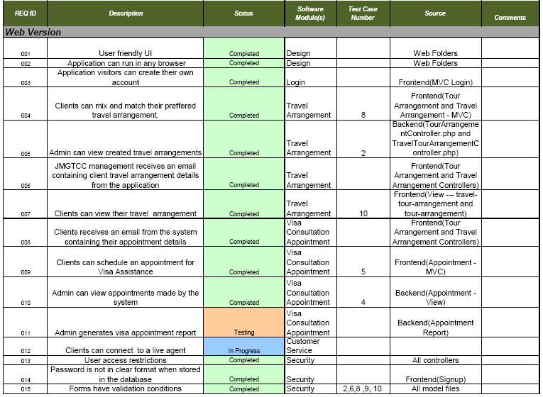

## Design Document

### The Physical Database Description

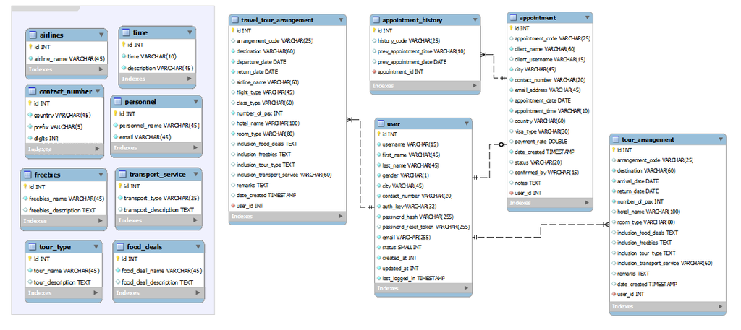

The Software Design Document

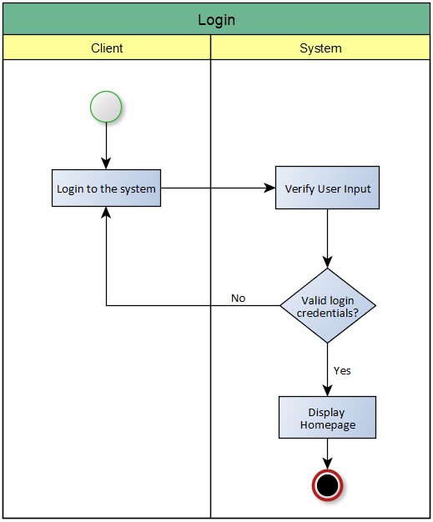 

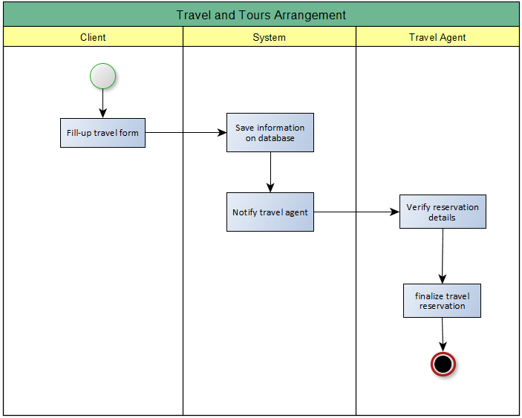

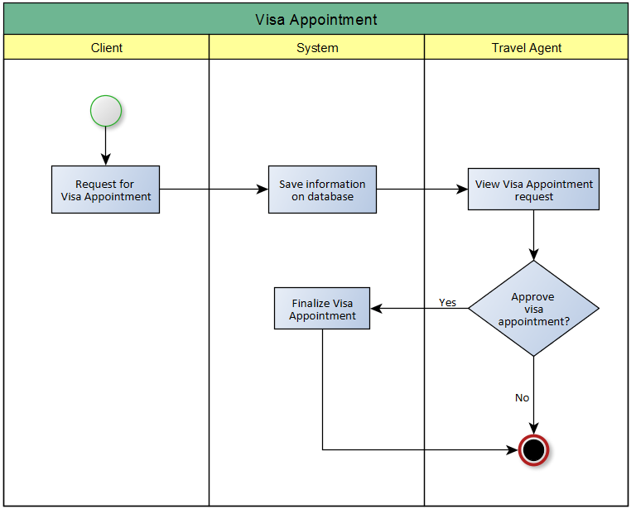

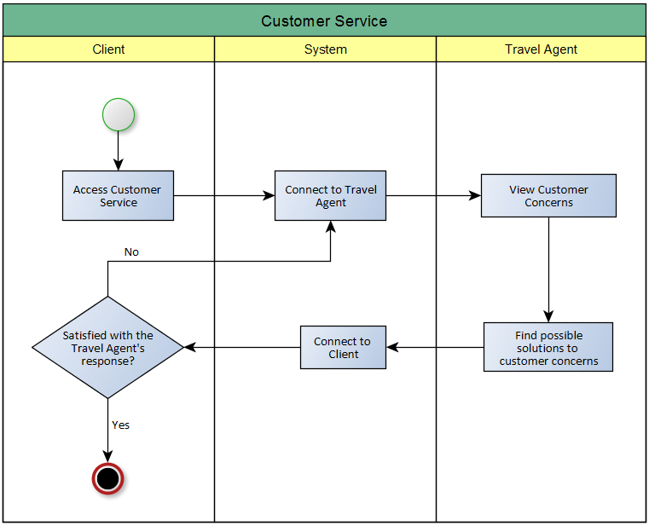

## Online Help

### Data Areas

**Frontend**

|  |  |
| --- | --- |
| **Forms** | **Accessible functions** |
| **User Sign-Up** | * + Create new user account |
| **User Log-In** | * + Log in registered user |
| **Visa Assistance Appointment** | * + Create new appointment   + View appointment (Only for registered Users) |
| **Travel / Tour Arrangement** | * + Create new travel / tour arrangement |

**Backend**

|  |  |
| --- | --- |
| **Forms (System Maintenance)** | **Accessible functions** |
| **Partner Airlines** | * + Create new airline record   + Update existing airline record   + Delete existing airline record   + View existing airline record |
| **Contact Numbers** | * + Create new contact number record   + Update existing contact number record   + Delete existing contact number record   + View existing contact number record |
| **Food Deals** | * + Create new food deal record   + Update existing food deal record   + Delete existing food deal record   + View existing food deal record |
| **Freebies** | * + Create new freebie record   + Update existing freebie record   + Delete existing freebie record   + View existing freebie record |
| **Personnel** | * + Create new personnel record   + Update existing personnel record   + Delete existing personnel record   + View existing personnel record |
| **User Roles** | * + Create new user role   + Update existing user role   + Delete existing user role   + View existing user role |
| **Appointment Time** | * + Create new appointment time record   + Update existing appointment time record   + Delete existing appointment time record   + View existing appointment time record |
| **Tour Types** | * + Create new tour type record   + Update existing tour type record   + Delete existing tour type record   + View existing tour type record |
| **Transport Services** | * + Create new transport seriviec record   + Update existing transport seriviec record   + Delete existing transport seriviec record   + View existing transport seriviec record |
| **User** | * + Create new user record   + Update existing user record   + Delete existing user record   + View existing user record |

### Optional Scenarios

|  |  |
| --- | --- |
| **Frontend: Users / Clients** | **Backend: Users / Admin** |
| * + "How can I view my previous appointments?"   + "How can I update my existing appointment?" | * + "How can I view newly created appointments?"   + "How can I verify newly created appointment?" |

## Deployment Plan

## Acceptance Plan

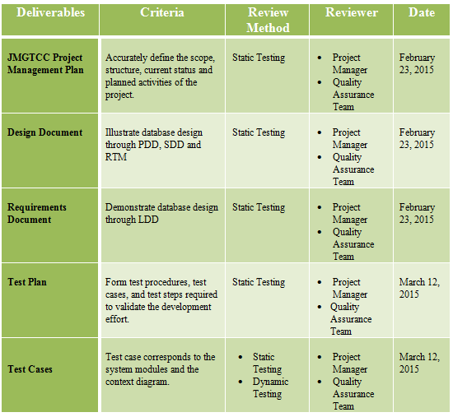

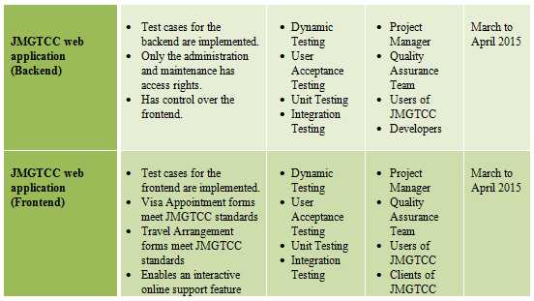

## Installation & Acceptance

### The Acceptance Configuration Plan

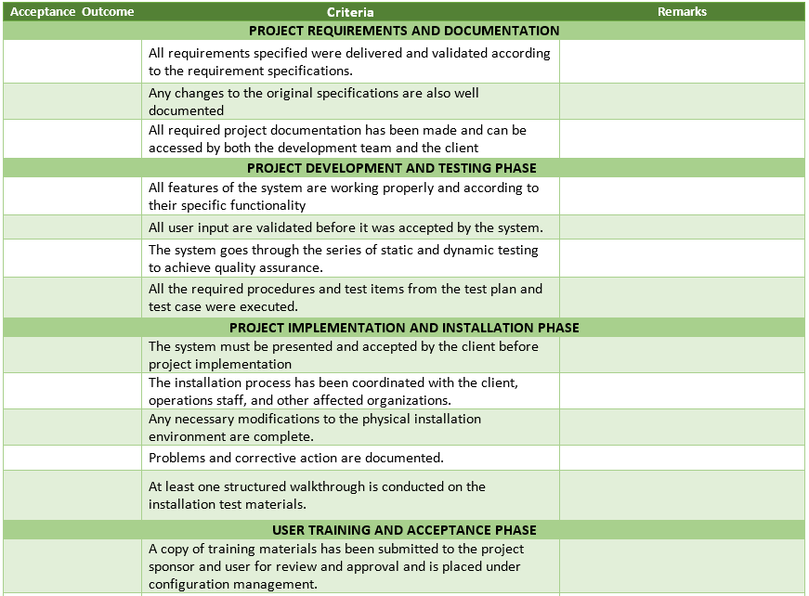

## Project Team / Authors

|  |  |  |
| --- | --- | --- |
| **Mr. Allan Cotecson** | **Professor** | **allanc@apc.edu.ph** |

|  |  |  |
| --- | --- | --- |
| **Arianne Bianca Papna** | Project Manager / Developer | afpapna@student.apc.edu.ph |
| **Erika Hidalgo** | Developer | echidalgo@student.apc.edu.ph |
| **Roxanne Therese Luangco** | QA / Developer | raluangco@student.apc.edu |