|  |
| --- |
| **ASIA PACIFIC COLLEGE**  School of Computer Science and Information  Technology |
| Journeys & More Global Tours and Consultancy Co. |
| Test Plan |
|  |
| **Arianne Bianca F. Papna**  **Erika C. Hidalgo**  **Roxanne Therese A. Luangco**  **IT 111** |
|  |

**Mr. Allan Cotecson**

Professor

## 

## Background

Journeys & More Global Tours and Consultancy Co .(JMGTCC) Booking and Reservation System aims to promote tourism by providing a module that features tour deals and packages for clients and travelers and to provide Visa Consultancy Appointment Services. Overall, the system consists of modules that cater Appointment Scheduling, Travel Deals Request, Technical Support and Language Translator.

Each module should be quality checked to ensure data integrity and security. The main modules, Visa Appointment Scheduler and Travel Arrangement Request, are necessary to be checked every development iteration to minimize or eliminate bugs and errors before implementation. The overall testing of the system ensures that the system is fit for its purpose in giving efficiency and convenience to JMGTCC staff and clients.

## Introduction

**JMGTCC Booking and Reservation System Test Plan Objectives:**

* To ensure data integrity and system security
* To eliminate system errors
* To ensure that the system reach its target purpose

JMGTCC Booking and Reservation System was initially developed in Wordpress and has been migrated and revised in Yii 2.0 Framework using PHP Programming Language. The system database design and data procedure has also been revised to incorporate new system modules and features.

The modules include of the CRUD (Create, Update, Delete, View) procedure for system maintenance, language translation processing that enable the system to change the language preferences for data processing and viewing, technical support operation that consist of online tech support in real-time, travel arrangement or travel deal request / inquiry procedure that notifies the travel agent of new prospect clients and travel transactions, and the Visa Consultation appointment scheduling process that lets the client to reserve a slot and create consultation appointment with the company (JMGTCC).

**Use Case Requirements:**

* Travel Arrangement Request / Inquiry Management
* Visa Appointment Scheduling Management
* Online Support Management
* Enable System Language Translation

**Testing Strategy**

The Testing Strategy will be divided into two (2) parts:

* **Static Testing**

This testing strategy or method is done during the development iterations. This is done by conducting tests and validations on the earlier stages of the development. The purpose of this is to find bugs and errors as early as possible to avoid complications on future stages of the software life cycle.

* **Dynamic Testing**

The main objective of this strategy or method is to find bugs and errors during the software execution. This is done hands-on while the code is being executed. The purpose of this is to make sure that the system is running, that it behaves based on the system requirements and specifications.

**Data and Database Integrity Testing**

|  |  |
| --- | --- |
| **Test Objective:** | To ensure Database access methods, procedures and processes function properly without data corruption |
| **Technique:** | * Execute database queries, methods and processes * Insert valid and invalid data * Inspect the database; check if all database events occurred properly, the data saved are populated accordingly, and if the data retrieved are correct |
| **Completion Criteria:** | All database access methods, procedures and processes function as designed and without any data corruption |
| **Special Considerations:** | * The testing may require the system to be running to invoke database processes from the system * The testing may also require to be manually conducted in localhost database server * There can only be limited number of records to be saved |

**Functional Testing**

|  |  |
| --- | --- |
| **Test Objective:** | To ensure proper system functionalities; this includes navigation, data entry, processing and retrieval |
| **Technique:** | * Execute processes based on use case data flow procedures using valid and invalid data   Execute each use case, use case flow, or function, using valid and invalid data, to verify the following:  The expected results occur when valid data is used.  The appropriate error / warning messages are displayed when invalid data is used.  Each business rule is properly applied. |
| **Completion Criteria:** | * The expected results occur when valid data is used * Appropriate Error or warning messages are displayed when invalid data is used |
| **Special Considerations:** |  |

## Assumptions

**Change Requests**

Modules developed by each team developer will be uploaded to the application repository and will be initially checked by the team lead developer. Change logs will automatically be recorded through the repository logs. Once the testing begins, there should be no changes made to these modules or to the entire system, yet minimum or functional changes can be made if required.

**Personnel Dependencies**

* **Static Testing**

The project documentation and wiki site will be checked by other teams.

* **Dynamic Testing**

Each module is required to be tested, checked and validated by other teams.

For the user acceptance testing, the users (JMGTCC personnel) are required to test the system and its performance and features. Approval should also be made to each module for an organized change requests if possible.

**Software Dependencies**

* The source code must be tested and validated
* The database, server and hosting procedure must be secured
* The development framework must be updated and in the latest version

**Hardware Dependencies**

* The devices (desktop, laptop) used in development must be working properly
* The devices must have enough connectivity to the server for initially hosting

**Test Data & Database**

* The test data should be distributed to testing personnel during the testing procedure
* The database should also be available for viewing, encoding and deleting test records

## Test Items

The items to be tested are the following as implemented in Software Revision 2.0 of JMGTCC Booking and Reservation System:

* **Appointment Scheduler (Visa Assistance)**

|  |  |  |
| --- | --- | --- |
| Data Requirements | : | User credentials, Appointment date and time |
| Function | : | The user can reserve a slot and schedules an appointment that will notify the travel agent for a new appointment schedule |

* **Travel Arrangement Request**

|  |  |  |
| --- | --- | --- |
| Data Requirements | : | Travel type, Place of Origin, Destination, Date and Time, Number of passengers,other travel packages and requests |
| Function | : | The user can choose from the list of travel packages offered by the agency or request for a new travel package-combination or arrangement |

* **Customer Service / Technical Support**

|  |  |  |
| --- | --- | --- |
| Data Requirements | : | User Credentials, User concern |
| Function | : | Online chat support feature that enables the direct / instant messaging |

* **Language Translator**

|  |  |  |
| --- | --- | --- |
| Data Requirements | : | Country, Language |
| Function | : | Language setting or language preference |

## Features to be tested

The following are the features (functions or requirements) which will be tested. They represent the services available in the Booking and Reservation System:

* **User Login**

Risk Identification: *High*

This feature serves as the first step in using the system. Username and password must be validated and system processes must be accessible according to user roles.

* **System Components / Modules**

Risk Identification: *High*

Every component must be tested, revised and free of bugs. Any module or component that functions incorrectly may affect the entire system processes and procedures.

* **Data Input Validation**

Risk Identification: *High*

Data input must be validated before saving to the System Database. This ensures Data integrity or data consistency over the entire system life cycle.

## Features not to be tested

The following are the features which will not be tested.

* **System Interface Design**

Risk Identification: *Low*

The User Interface (Design) will be based on the JMGTCC website template. The Booking and Reservation System will only following the color theme and template used in the website.

## Approach

An end to end integration testing will be done to check whether the system works from start to finish and to determine data dependencies with regards to the system modules. The diagram below shows the flow of testing from the main modules:

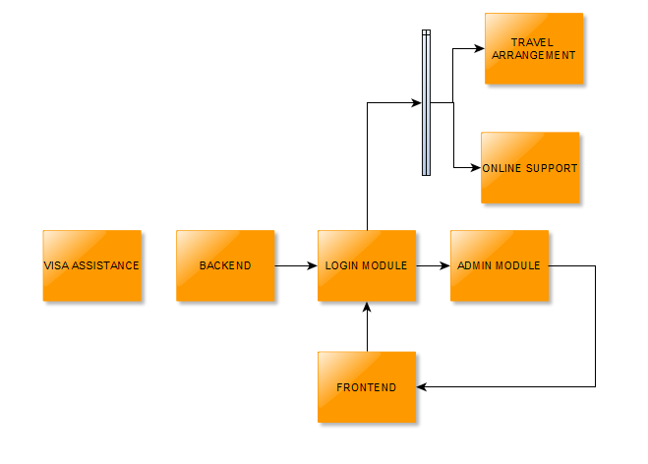

As what is shown above, the Visa Assistance module is a floating module that can be tested even without the other modules. For scheduling, the following testing should be done:

* Accessing the Visa Assistance Scheduler
* Viewing available dates
* Booking a date

The testing process starts with the backend. The admin will logon to the system and manage the admin module wherein the rest of the process is dependent upon. Here is a list of the functions of the admin module:

* CRUD of Hotels
* CRUD of Tour Deals
* CRUD of Airlines
* CRUD of Users
* Visa scheduling
* Travel Arrangement

From the admin, the frontend can now work simultaneously with the backend and registered users can now use the travel arrangement and online support feature.

## Item Pass / Fail Criteria

***Login Module***

Backend:

* System only accepts authorized users (Employees)
* Only the admin is able to create authorized users.

Frontend:

* Guests can create their account
* Logging in to the application

For both:

* Password encryption and strength
* 15 minutes session timeout
* No duplicate usernames
* Data input validation

***Visa Assistance***

Backend:

* Viewing the detailed record of the schedules
* Approving of schedules
* Display monthly earnings

|  |  |
| --- | --- |
| Frontend:   * Book a date | For both:   * View remaining unscheduled dates * Data input validation |

***Travel Arrangement***

Backend:

* Managing hotels
* Managing airlines
* Managing tour deals
* Verification of travel arrangements

Frontend:

* Create an arrangement

For both:

* View tour deals
* View arrangements
* Data input validation

***Online Support***

|  |  |
| --- | --- |
| Backend:   * Answer questions through chat | Frontend:   * See if support personnel is online * Inquire through chat |

## Suspension / Resumption Criteria

***Testing checkpoints***

1. Application is accessible in web and mobile.
2. Users can successfully login (Backend/Frontend).
3. Registered users can manage their travel arrangements. (Create, Update, View).
4. Users can schedule their visa appointment.
5. Manageability of the system. (Backend Perspective).
6. Backend users can monitor their client’s arrangements and schedules.
7. Live chat works for both the backend and frontend.

***Suspension Criteria***

* System testing should stop when:
* There are errors on the backend side of creating or inserting of data.
* Multiple critical errors are found from the starting point or the backend side
* Half of the requirements are not fulfilled.

***Resumption Criteria***

* System testing should resume when:
* Found errors are fixed.
* There is enough functions or modules to test

## Test Deliverables

The following documents should be delivered:

* Test cases Documents
* Test Plan
* Test Scripts
* Test Data
* Test Results/reports
* Test summary report
* Defect Report
* Release notes

## Testing Tasks

|  |  |
| --- | --- |
| TASK | DESCRIPTION |
| Develop test cases | Detailed document of test cases.(Test case document) |
| Create dummy database for testing | Created database will be used for testing purposes only and will be destroyed afterwards.(Test Data) |
| Execute tests and evaluate defects | Execute test scripts and study found defects.(Test plan, test scripts) |
| Report defects | Document the found defects.(Defect Report) |
| Create test reports | Testing summary and reports. (Test Results and summary report) |

## Environmental Needs

***Hardware Requirements***

* PC/Laptop with internet connection
* Android Mobile Devices(For mobile testing)

***Software Requirements***

* Browsers that preferably supports HTML5 and CSS3 scripts.

Please refer to this link for browser support 🡪<http://fmbip.com/litmus>

* XAMPP (For local testing)
* PhpMyAdmin(For Local testing)

## Responsibilities

**Developer's Responsibilities**

|  |  |  |
| --- | --- | --- |
| Tasks | Person(s) Responsible | Responsibilities |
| Test cases Documents | Erika Hidalgo | * The person who is assigned to each task is responsible for leading the team and dividing the work load to the team members. * The validation and integration of the task assigned to the team is also a part of that person's responsibility |
| Test Plan | Arianne Bianca Papna |
| Test Scripts | Erika Hidalgo |
| Test Data | Arianne Bianca Papna |
| Test Results/reports | Roxanne Therese Luangco |
| Test summary report | Roxanne Therese Luangco |
| Defect Report | Arianne Bianca Papna |

**User's Responsibilities**

The user is responsible for the following:

* Understand the process of their business
* Provide all necessary information on the requirements for the project
* Inform the developers about their concerns
* Ask and be aware of the solutions the developer offered to them
* Give prompt feedback to the developers

## Staffing and Training

The following training requirements have been identified to help the staff members in familiarizing themselves not only to the business, but also to the system. Through this they can fully utilize the functions and features of the system in assisting their clients.

* **Business Processes Familiarization**

The staff must be fully aware of how the business works. Without knowing it, the staff will have a hard time in understanding their procedures in helping their clients and also the system.

* **System Demo**

This will serve as the first exposure of the staff members to the system. This is the stage where the functions of the system and the steps on how to use it will be explained further.

* **Hands-on experience**

Through this training the staff members can familiarize themselves to the interface and functionality of the system. This is where they could also experience how the system works and how to use it.

* **Test/ Evaluation**

This is the part where the staff could be assessed on how well they are knowledgeable about the interface of the system and how it works.

## Schedule

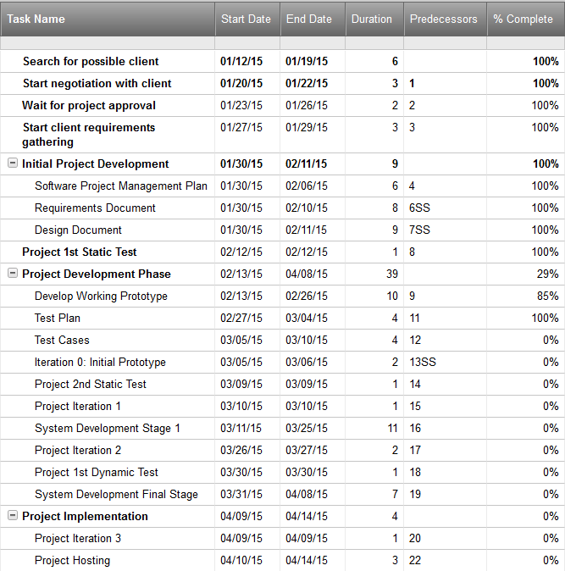

## Resources

Listed below are the resources that were used in developing the Booking and Reservation system of JMGTCC.

|  |  |
| --- | --- |
| Resources | Link |
| Official website of JMGTCC | http://journeysglobaltours.com/ |
| Project documentation of JMGTCC | http://projects2.apc.edu.ph/wiki/index.php/ |
| Project Repository | https://code.google.com/p/apc-softdev-it111-04 |
| Yii Framework Guide | http://www.yiiframework.com/doc-2.0/guide-intro-yii.html |

## Risks and Contingencies

|  |  |  |  |
| --- | --- | --- | --- |
| Risk Factor | Risk Statement | Impact | Contingency Plan |
| TECHNICAL RISK | | | |
| Incorrect or Inconsistent Data | This risk is due to human error. It can affect the data from the client which will be stored to the database of the system | Low | It can be avoided if the text fields, where the client must input the required data can be limited.   If possible, there must be available options to choose from, so that the user can avoid entering incorrect data. |
| Inaccessible Pages or Functions | This type of risk must be prevented at all cost. The probable causes for this risk are:   * Server or Database Malfunction * Algorithm or Programming Error * Low or No Network Connectivity | High | This can be prevented if the functionality of the system will be thoroughly checked and tested.  The developers must make sure that the system pass through quality check. |
| MANAGEMENT RISK | | | |
| Lack of Personnel to Support Customer Service | This risk can be triggered by the sudden increase on the number of clients who needed more information about their company and the services that they offer. | Medium | This can be done be avoided by employing skilled individuals who can assist clients within a short amount of time or if there is a great increase on the number of clients, or if there is a great increase on the number of clients, they too must increase the number of their employees. |
| Unskilled or Untrained Personnel | This risk can affect the management of JMGTCC and the system as well. | Medium | This could be prevented if proper training will be implemented and highly qualified staff is hired. |

## Approvals

The undersigned acknowledge that they have reviewed the JMGTCC document and agree with the approach it presents. Any changes to this Requirements Definition will be coordinated with and approved by the undersigned or their designated representatives.

|  |  |  |  |
| --- | --- | --- | --- |
| Signature: |  | Date: |  |
| Print Name: |  |  |  |
| Title: |  |  |  |
| Role: |  |  |  |

|  |  |  |  |
| --- | --- | --- | --- |
| Signature: |  | Date: |  |
| Print Name: |  |  |  |
| Title: |  |  |  |
| Role: |  |  |  |

|  |  |  |  |
| --- | --- | --- | --- |
| Signature: |  | Date: |  |
| Print Name: |  |  |  |
| Title: |  |  |  |
| Role: |  |  |  |