|  |
| --- |
| **ASIA PACIFIC COLLEGE**  School of Computer Science and Information  Technology  JMGTCC  Travel Arrangement & Appointment System |
| Documentation |
|  |
| **Arianne Bianca F. Papa**  **Erika C. Hidalgo**  **Roxanne Therese A. Lanugo**  **IT 111** |
| **A.Y. 2014 - 2015** |

**Mr. Jose Eugenio Quesada**

Professor

Table of Contents

[Brief Description 2](#_Toc416288328)

[Project Objective 2](#_Toc416288329)

[Project Purpose 3](#_Toc416288330)

[Problem Statement 3](#_Toc416288331)

[Rationale 4](#_Toc416288332)

[System Recommendation 4](#_Toc416288333)

[Target User Beneficiaries 4](#_Toc416288334)

[System Failure 5](#_Toc416288335)

[System Functions 5](#_Toc416288336)

[System Design and Diagrams 7](#_Toc416288337)

[Name of Team Members and Duties 12](#_Toc416288338)



# 

# Brief Description

**Company Overview**

JMGTCC is a Philippines based travel bureau engaged in international and local ticketing, hotel reservation, worldwide tour packages, domestic island tours, corporate travel plans, and customized travel arrangements. JMGTCC specializes in adventure and off-the-beaten path tourism and travel activities.

JMGTCC began its operations as a ticketing agent and travel consultancy outfit providing consultancy and documentation services to Filipinos and foreigners here and abroad. JMGTCC is currently the Metro Manila Visa Assistance Center, helping local and international travelers with legitimate and verifiable visa applications and all other related documentation processing and consultancy services. JMGTCC connects travel newbies and veterans with professional service providers of quality tours and accommodations that fit each traveler’s wish and budget.

**Project Overview**

JMGTCC Travel Arrangement & Appointment System is a web application that caters JMGTCC Client's travel inquiries and appointments. The application is accessible outside the internal network of JMGTCC for the company's clients and prospect clients.

# Project Objective

**Short-Term Objectives**

* To improve the features or modules of the existing JMGTCC Booking & Reservation System
* To add new features or modules to the existing system
* To incorporate adequate security checklist and validations to system

**Long-Term Objectives**

* To automate the company's manual Appointment processing for Visa Assistance
* To consolidate all the JMGTCC Clients' travel inquiries and travel arrangements to a single system

# Project Purpose

**Vision**

JMGTCC Travel Arrangement & Appointment System:

The project aims to be a source of convenience, as a venue in providing reliable travel and tourism information and to help the company in achieving its goal in providing clients warm hospitality at the tip of their fingertips.

The purpose of the project is to be able to help the company in providing automated operations of Appointment scheduling and Travel Inquiries to their clients. In line with this, the project aims to provide a single platform / system where the JMGTCC clients can submit their inquiries, travel requests and arrangement and schedule for an appointment all at the same time.

# 

# Problem Statement

JMGTCC caters Visa Assistance and Travel & Tour Arrangements. Setting and confirming an appointment with a travel agent helps the management to have an organized appointment scheduling by assisting clients based on their scheduled date and time.

However, these processes are done manually. For the appointment, clients would call the office to set an appointment on a specific time and date. And for the travel and tour arrangement, clients would send emails to the travel agents indicating what kind of travel packages they want and how they want the entire tour and itinerary would be.

To minimize the manual processing of the company and to make the company operations more efficient and effective, a system will be developed to automate the appointment scheduling for Visa Assistance and to provide an application where clients can arrange their tour packages based on given travel deals.

# Rationale

This project is developed to aid the manual processing of JMGTCC for Visa Assistance and Travel & Tour Arrangements. Not only that this project can help JMGTCC management in   
consolidating Client requests into a single application, but also give convenience to MGTCC clients to be redirected to an application where they can do two (2) operations in a single   
system. In addition, JMGTCC clients can also be updated on current tour packages and inclusions the company offers.

# System Recommendation

The system is hosted and available online and can through any browser but it still recommended for the users to access it using browsers that support HTML5 or CSS3 for full usage. As for the mobile version, browser compatibility is still not a problem though the development team prefer version 4.2.2 or higher.

# beneficiaries_zpssfuxzcex.pngTarget User Beneficiaries

# System Failure

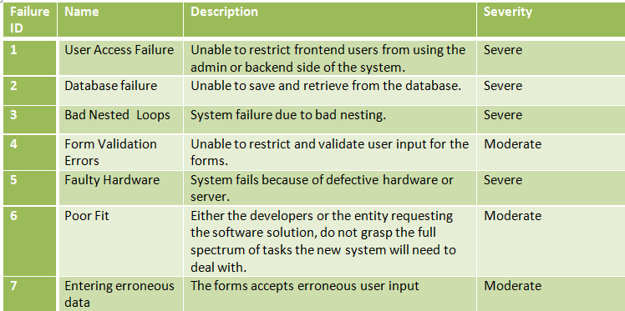If the system fails, a backup database, software and hardware should always be available to continue the operation of JMGTCC. The following are some failures that may occur on the system:

# System Functions

The following are the main system functions:

* **Appointment Scheduler (Visa Consultation)**

In the customer module of the system, clients can have access to the system in case they want to schedule a Visa Assistance Appointment with the General Manager. They will input their name, email address, phone number, appointment time and day and optional remarks or message.

* **Travel Deals Request**

The Client inputs necessary details about the travel packages he wants to avail. He can choose from the list of travel options or request for a new travel package-combination or arrangement offered by the agency.

* **Customer Service / Technical Support**

This is an online chat support feature that enables the clients of JMGTCC to communicate with the company IT Support Team through the application. The client can send a direct / instant message about technical concerns to the IT Support Team.

(**The Admin Module**) The Admin should be able to:

* + View Visa Consultation Appointments
  + Confirm Visa Consultation Appointment of client
  + View Travel and Tour Arrangements
  + Manage System modules

(**The Client Module**) The Client should be able to:

* + Register for an account
  + Be updated or notified though email
  + File and submit a Visa Consultation Appointment request
  + File and submit a Travel and Tour Arrangement
  + Raise concerns via Live chat for technical support

# 

# System Design and Diagrams

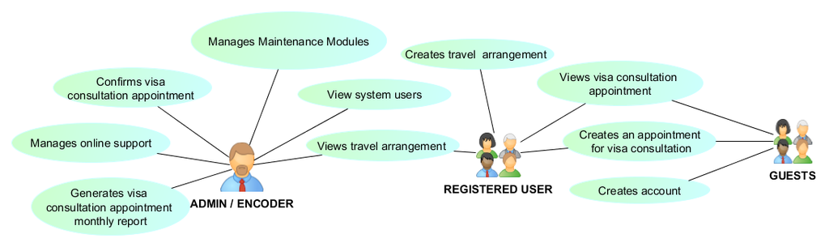**Use Case**

**Context Diagram**

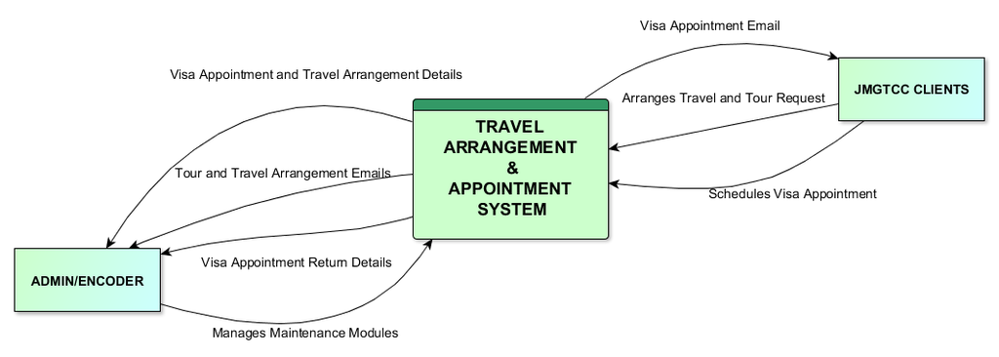

**Data Flow Diagram: Level 0**

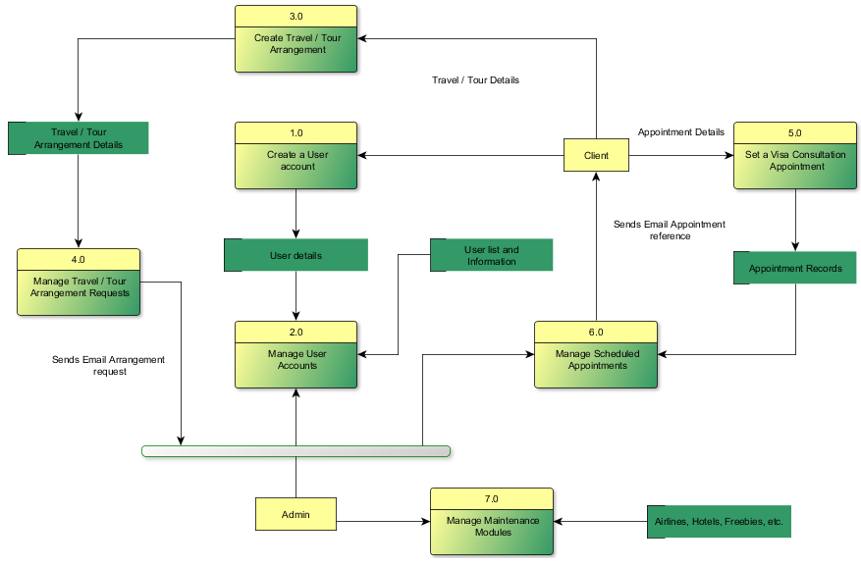

**Activity Diagrams**

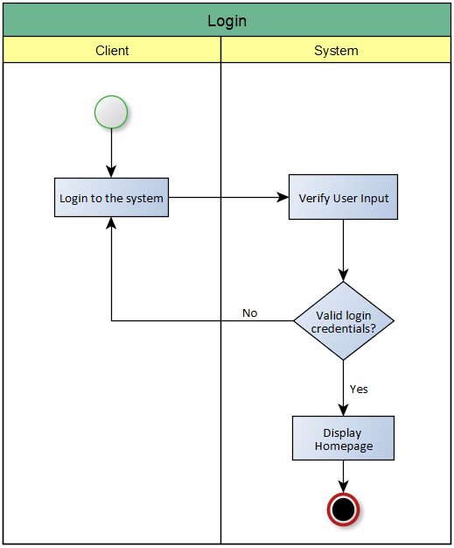

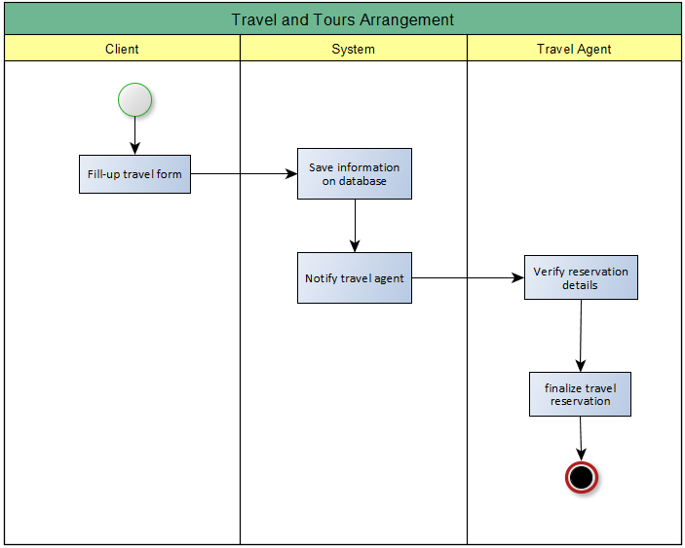

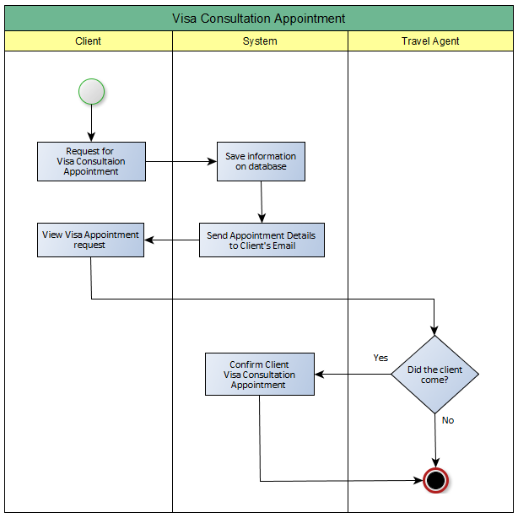

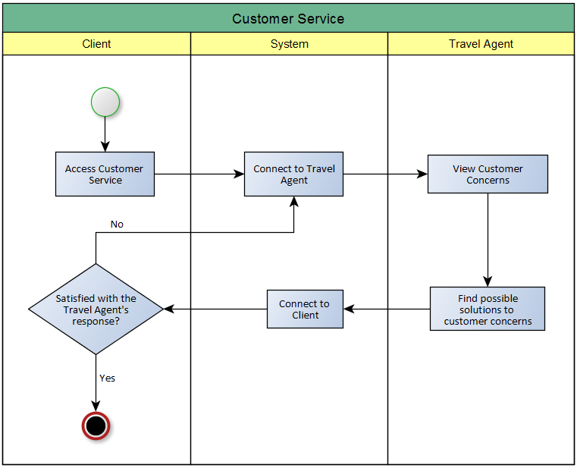

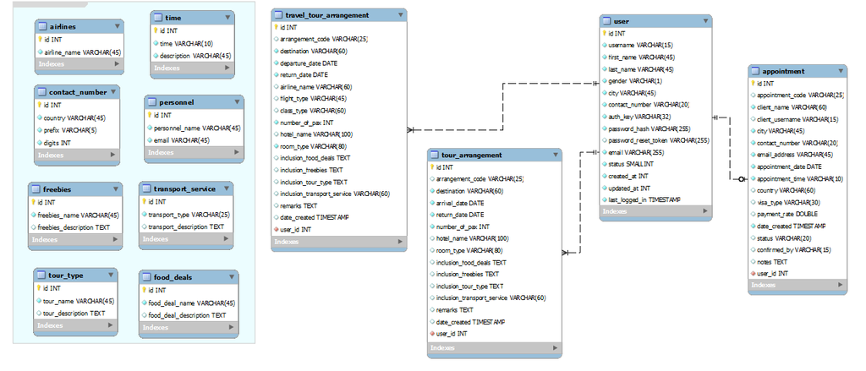**Entity Relationship Diagram**

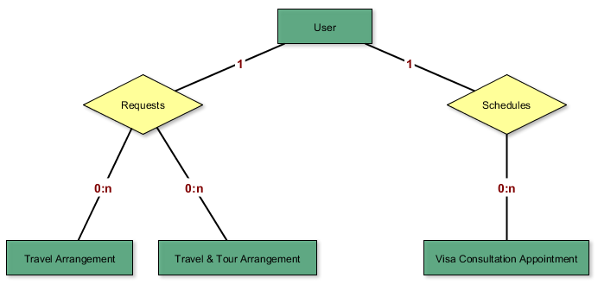**Logical Data Model**

# Name of Team Members and Duties

**Roles and Responsibilities**

The project can be successfully completed if the workload will be divided and handled correctly.   
  
The following people are responsible in making this project possible:

|  |  |  |
| --- | --- | --- |
| **Student Name** | **Role** | **Responsibilities** |
| **Arianne Bianca Papna** | Project Manager / Developer | * + Assigns roles and responsibilities   + Monitors and reports the project status and progress   + Manages the entire project team   + Authoring of Project Documentation |
| **Erika Hidalgo** | Developer | * + Updates the project manager about the system   + Analyzes Software requirements and specifications   + Manages Software UI |
| **Roxanne Therese Luangco** | QA / Developer | * + Analyzes the Requirements from the client   + Prepares test plan   + Conducts review meetings with the team   + Authoring of Project Documentation |