

**The Lightswitch Database System**

**Project Team:**

Jan Patrick P. Macasero

Armand S. Cuenca

Mark Andrew H. Mendoza

Kara Olarte  
Ivan Castrodes

**General Objectives**

- To create a reliable system to fit the organization's needs.

- To improve and integrate any existing system the organization has to the project.

### Specific Objectives

*Client Database*

* To create a database for the company.

*Client System Security*

* To create a unique security system for the company.

### Target Audience

* *Company Clients* - they can utilize the system to view project details that entails the project they offered to the company as well as view transactions they have with the company.
* *Company Members* - they are the founders of the company and are in charge of the approval of freelance applications, client meetings and company transactions and they will benefit the most from the database system for data processing and storage.
* *Freelance Employees* - they are employees who are temporarily employed by the company based on what type of project the company is pursuing. They can submit their bio-data via the system.

### Cite Related Architecture

* The system is browser based and will using Xammp integrated into the client’s server. <http://www.apachefriends.org/en/xampp.html>
* Joomla website framework will be used in the majority of the system functionalities. <http://www.joomla.org/>
* The database side of the system will be managed using Xammp and Joomla integrated database functions.

### Project Description

* The overall scope of this project is to introduce a system to the client's company mainly a database system to handle all the necessary data processing and storage that the company requires such as managing equipment, employee, clients, and projects, financial and transactional records while also making it as easy & user friendly it can be.

### Project Description

* The overall scope of this project is to introduce a system to the client's company mainly a database system to handle all the necessary data processing and storage that the company requires such as managing equipment, employee, clients, and projects, financial and transactional records while also making it as easy & user friendly it can be.

### Glossary

* *Company* - refers to "The Lightswitch" company name.
* *Client* - Person who request project/s needs.
* *Freelance Employee* - Outsourced personnel that assists the main employees in events/projects.
* *Contract* - Terms and conditions about the agreement between the client and the company.
* *Proposal* - Proposed process that the company presents to the client appropriate to the project.
* *Project* - Main focus and source of revenue for the company.
* *Inventory* - Equipment that is utilized by the company and its employees.

**Event Table**

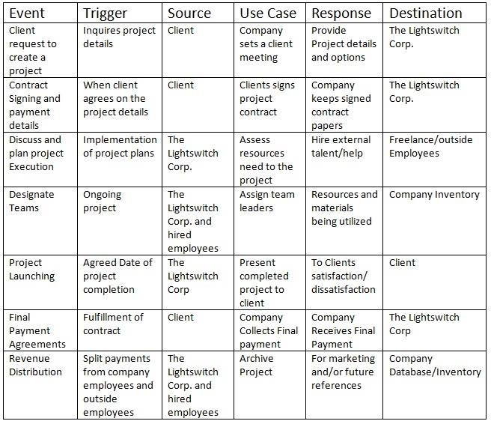

**Use Case Diagram**

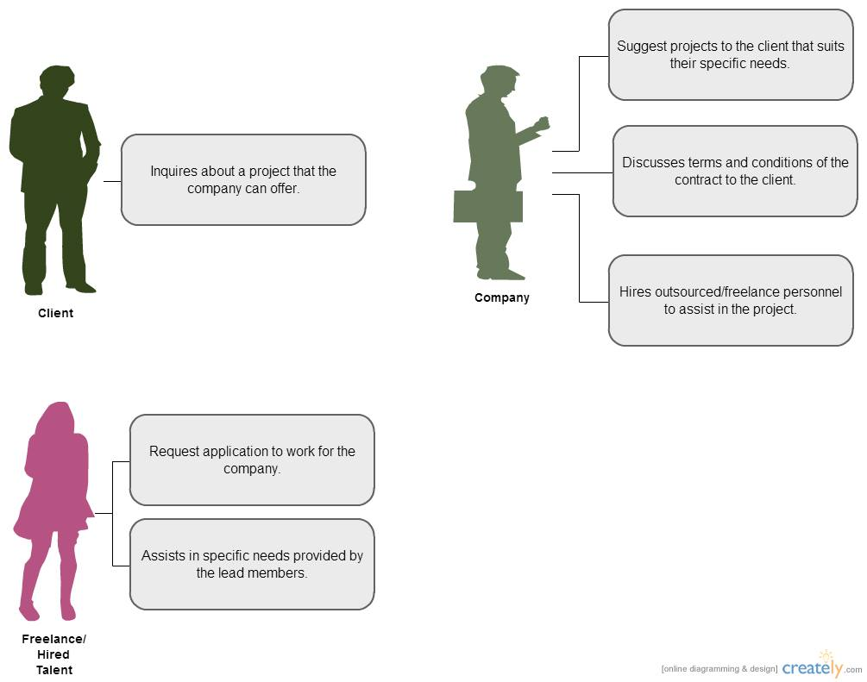

**Use Case Full Description**

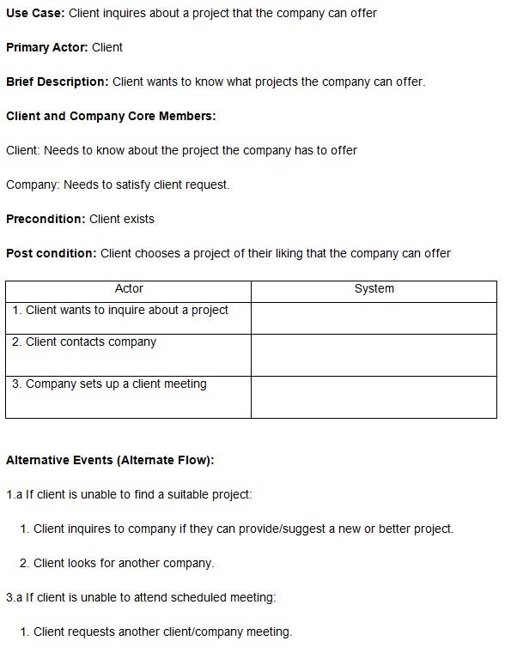

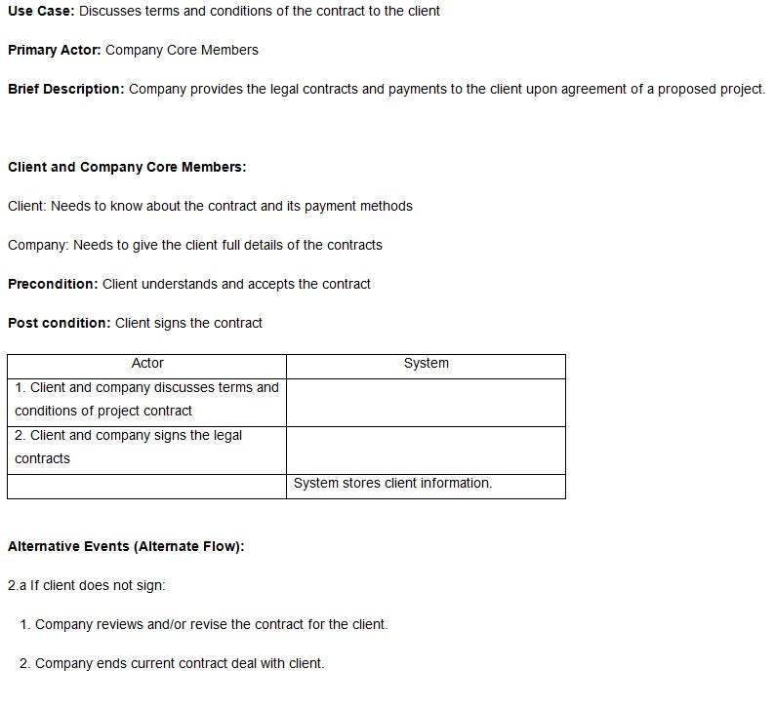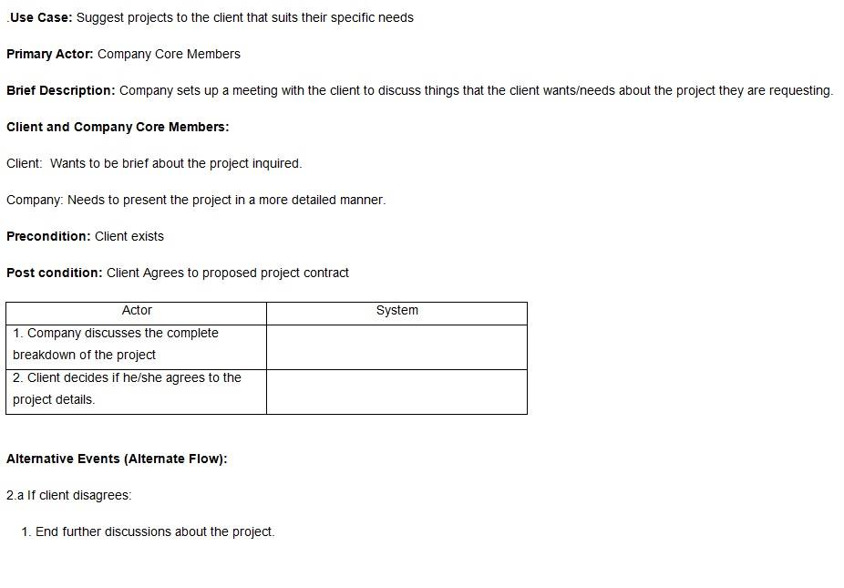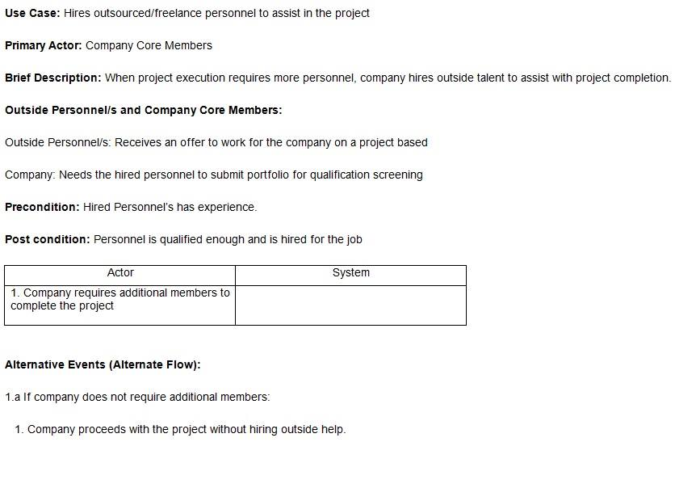

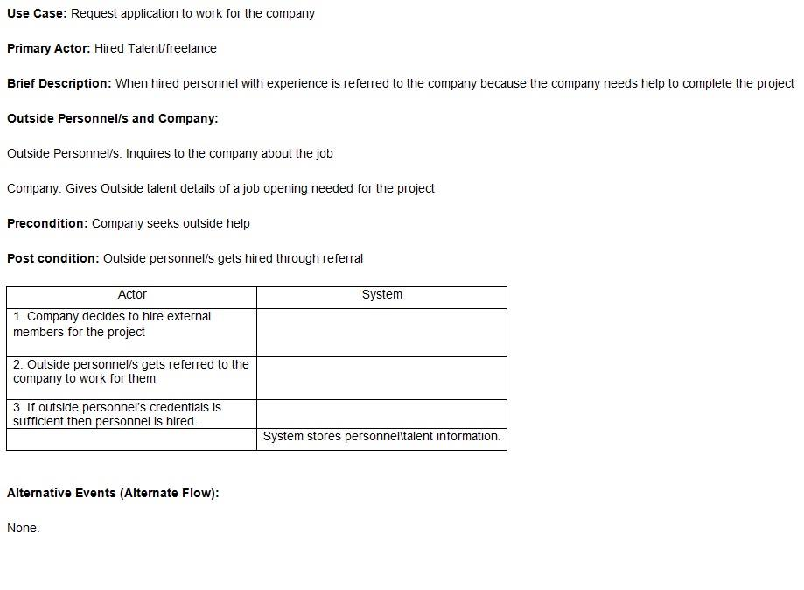

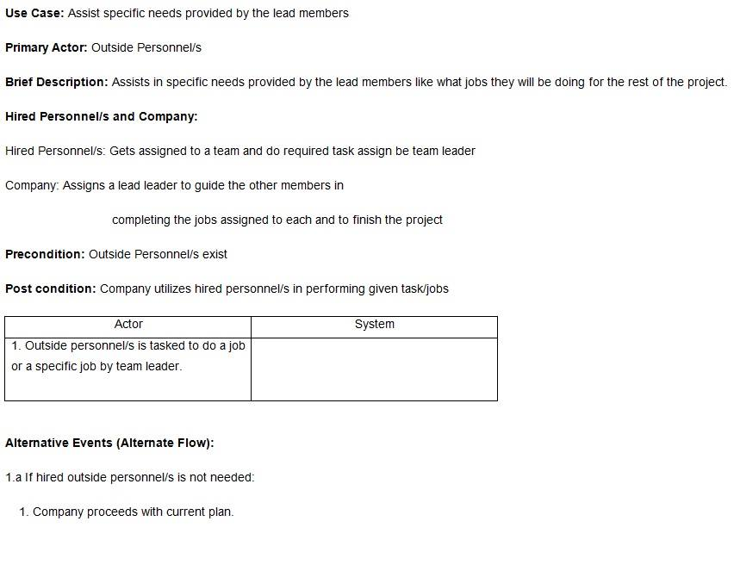

**Context Flow Diagram**

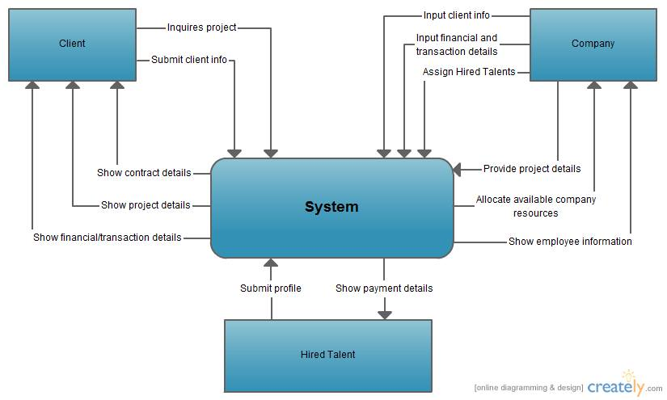

**Data Flow Diagram**

**Company Operations**   
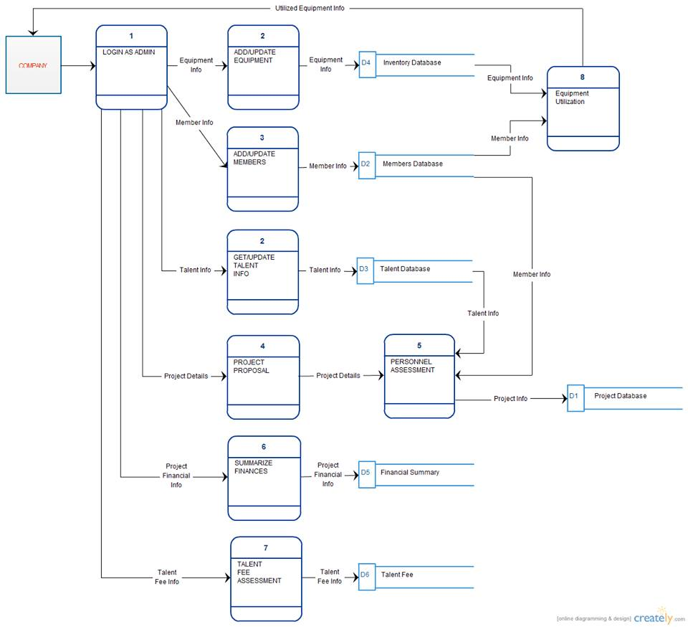

**Client Registration and Account Functions**   
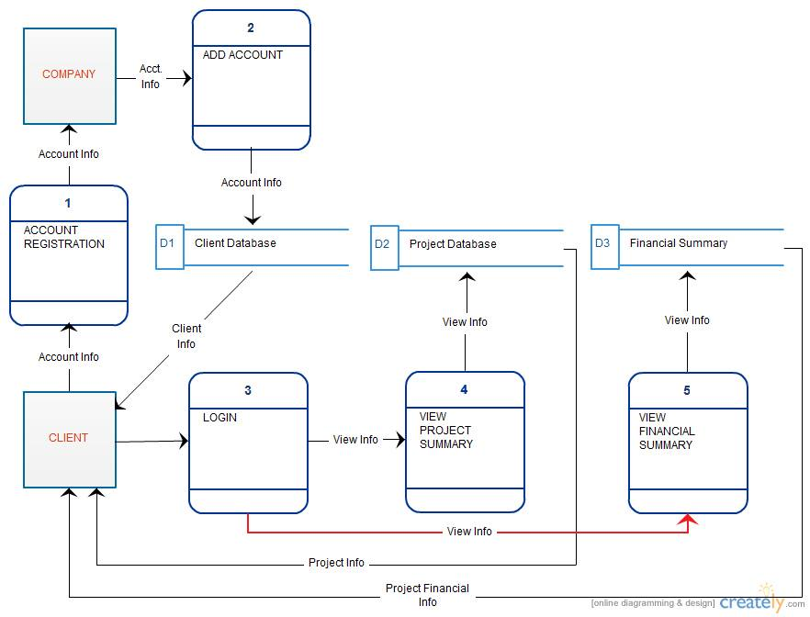

**Talent Registration and Account Functions**   
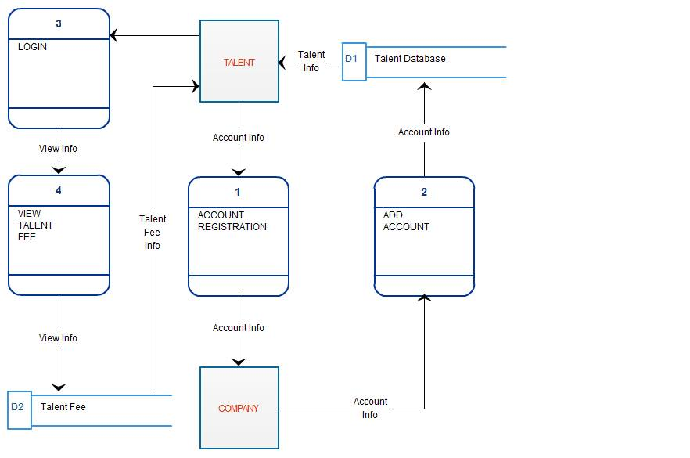

**Entity Relationship Diagram**

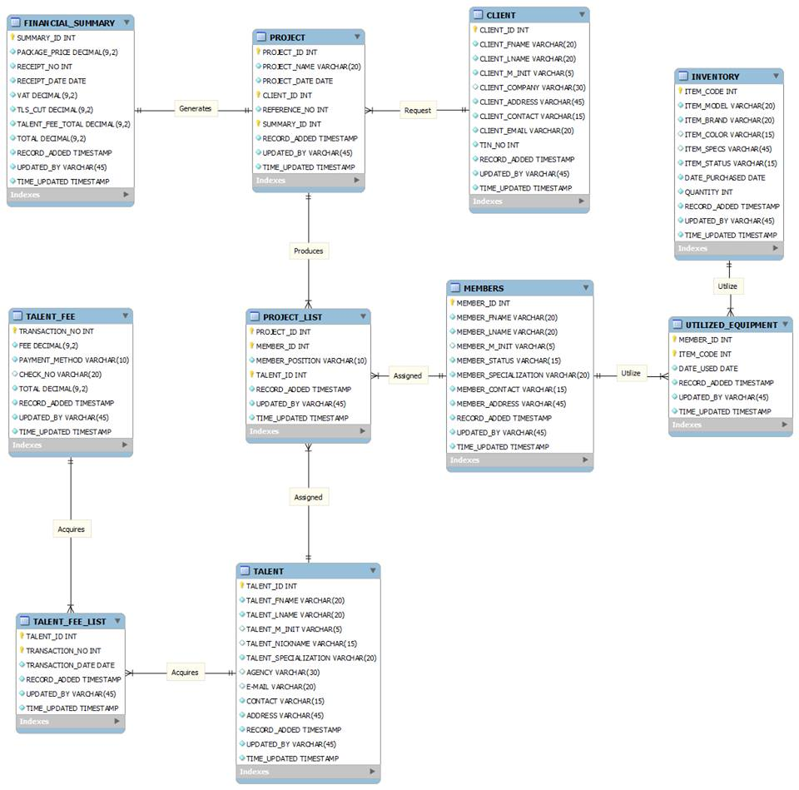

**Activity Diagram**

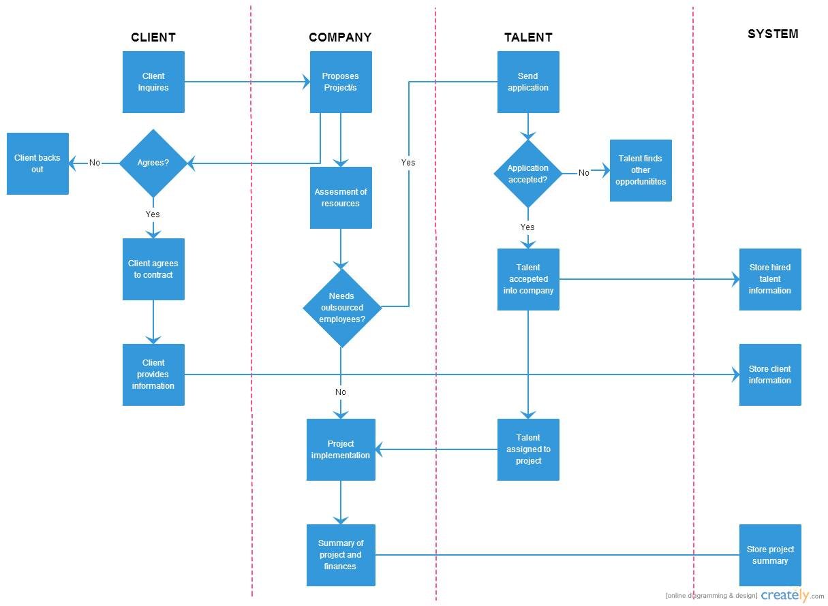

**Data Dictionary**

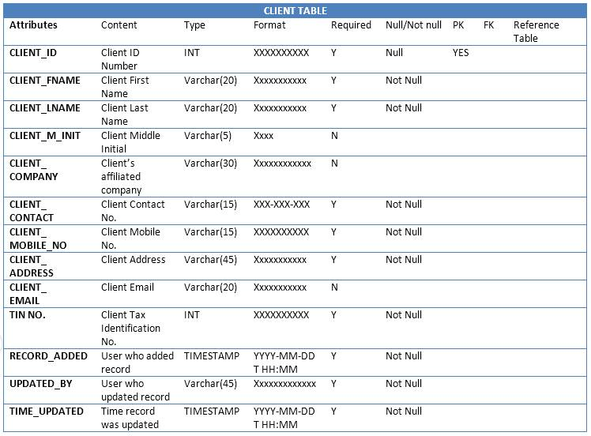

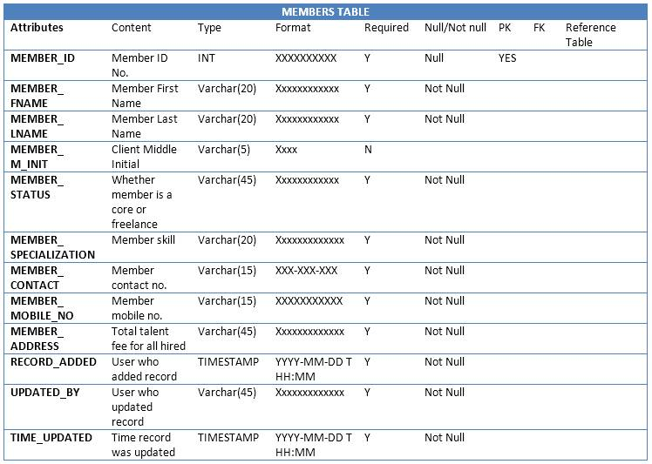

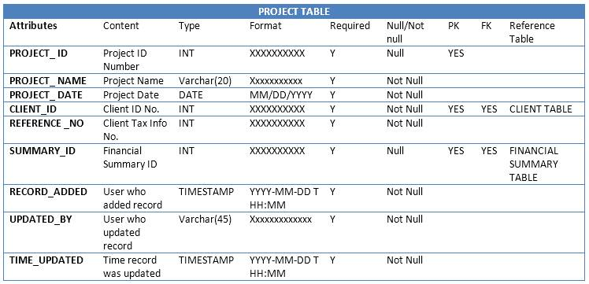

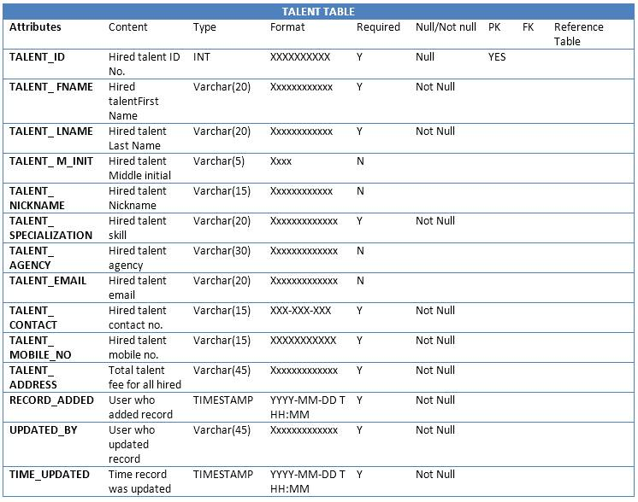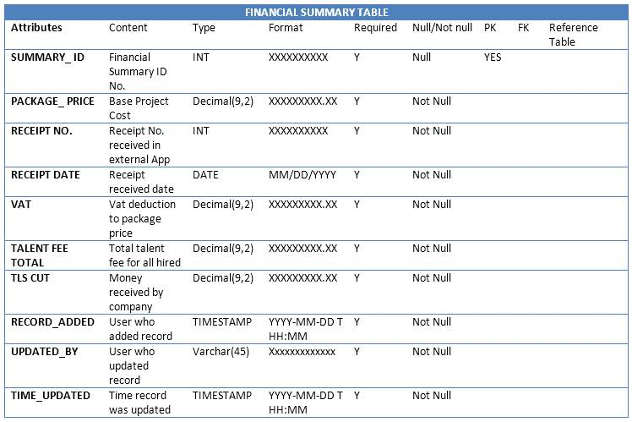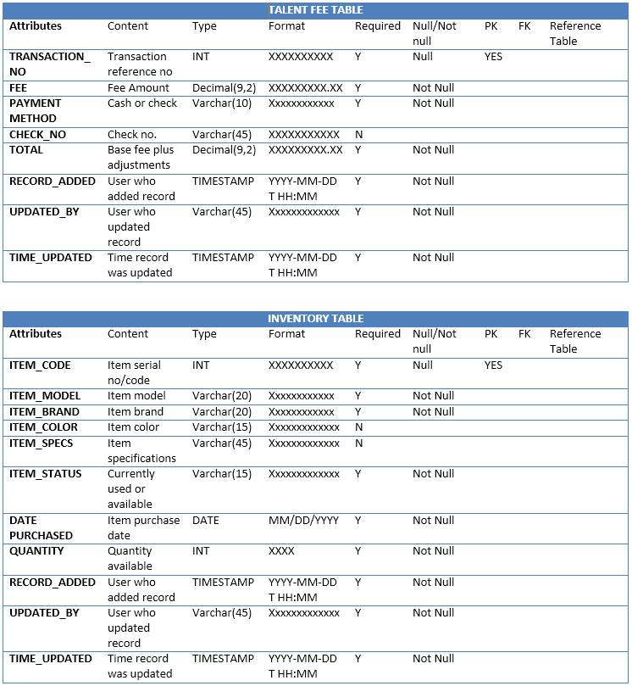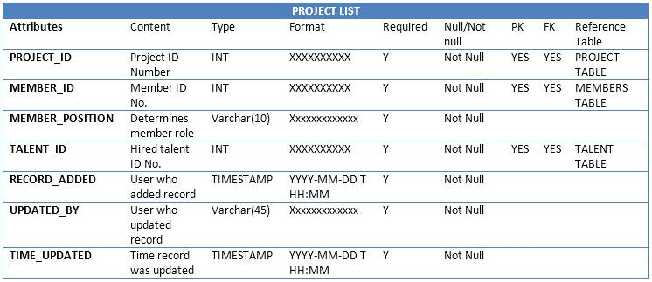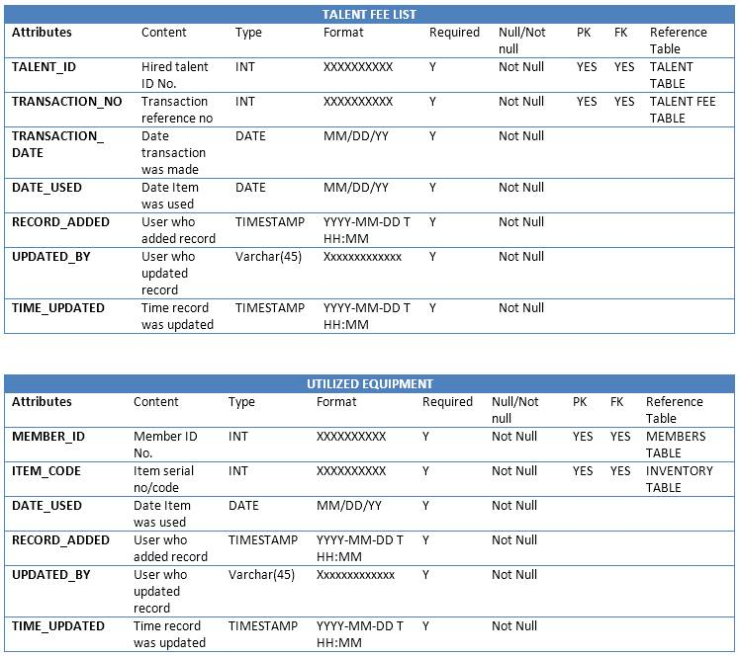

**Proposed System**

Proposed System Details

Using Joomla 2.5 as our framework basis and using php, html, and css as our main programming languages and after discussing with the client we have proposed to create a web based system that will be integrated in the clients existing website. The web based system would contain the following features:

**Login** - The Login feature is set up to determine what kind of user is going to use the system. The roles will be divided into two, the administrator or the super user which has access to all the features of the system, and the normal user which has limited access to some of the features. Additional roles and privileges can also be added by the administrator to normal or defined users if needed.

**Home Page** - Its purpose is to be the first page the administrator or normal user sees after logging in. It can also be viewed in the log in page even if a user hasn't log in yet.

**Client Page** - All Client data info/info's are can be found here but only administrators can view this.

Financial Page - Any financial related data is stored here in table format and can also only be viewed by administrators.

**Inventory Page** - Equipment’s, Materials, and other work related gadgets information is compiled in this page. Some features can be viewed by normal users and some for privileges users.

**Members Page** - This page is the database section for the hired talent or the freelancers that want to work for the company or have already work for the company.

**Project Page** - This page contains all necessary data on their company's project whether it be completed, on-going, or being proposed.

**Archives Page** - This page features the history of the company's completed projects and includes the necessary information that entails said projects. Editing features are restricted only to administrators.

**Other Features**

Other features also include a security system. Normal User's that register will be required to input a password that will passed the requirements of having at least

1 lower case, upper case, numeric and special character in the password. If such requirements are not met, the administrators may choose not to activate their accounts until requirements have been fulfilled.

**Search button** - allows them to quickly search and item with a hyperlink in the search window to direct them at the exact location of searched item.

**Upload Files** - an upload plug-in for them to be able to upload files on selected pages they want files upload. Date time stamp included upon upload.

**Calendar** - allows them to set events or memos for certain uses like setting a date and time stamp of borrowed equipment’s.

**Screenshots of Proposed System**

**Home Page**

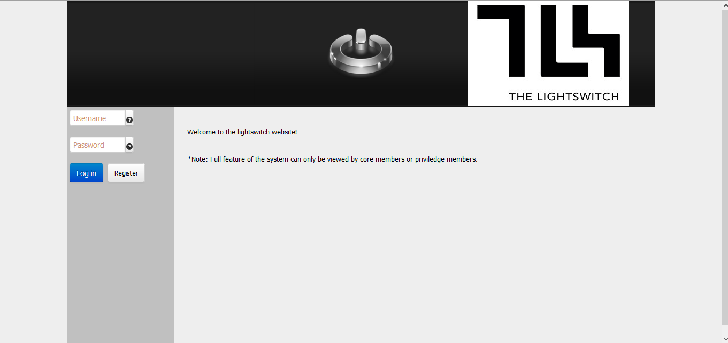

**Home Page (logged in)**

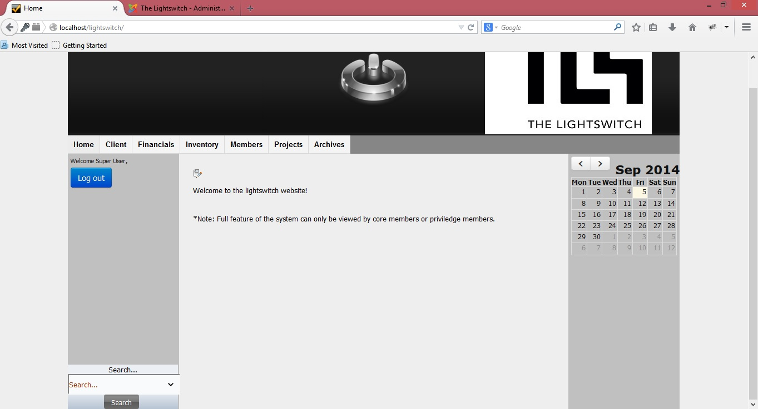

**Client Page**

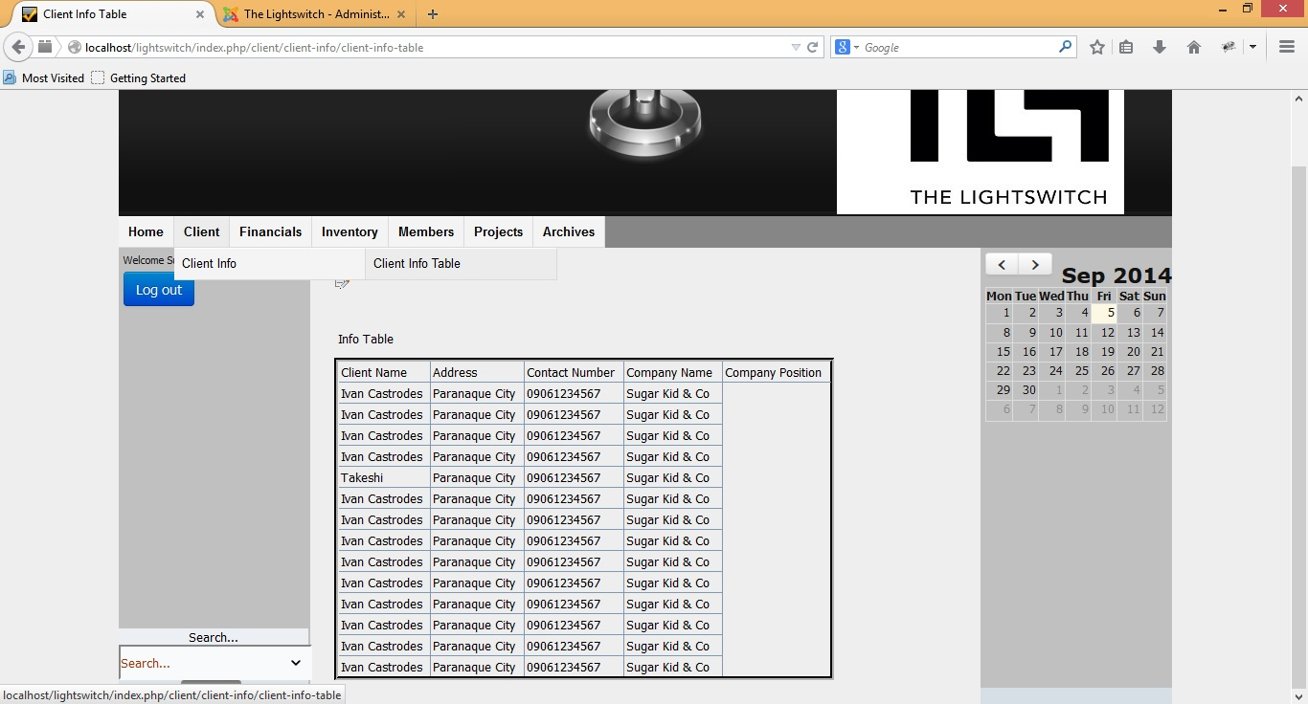

**Financial Page**

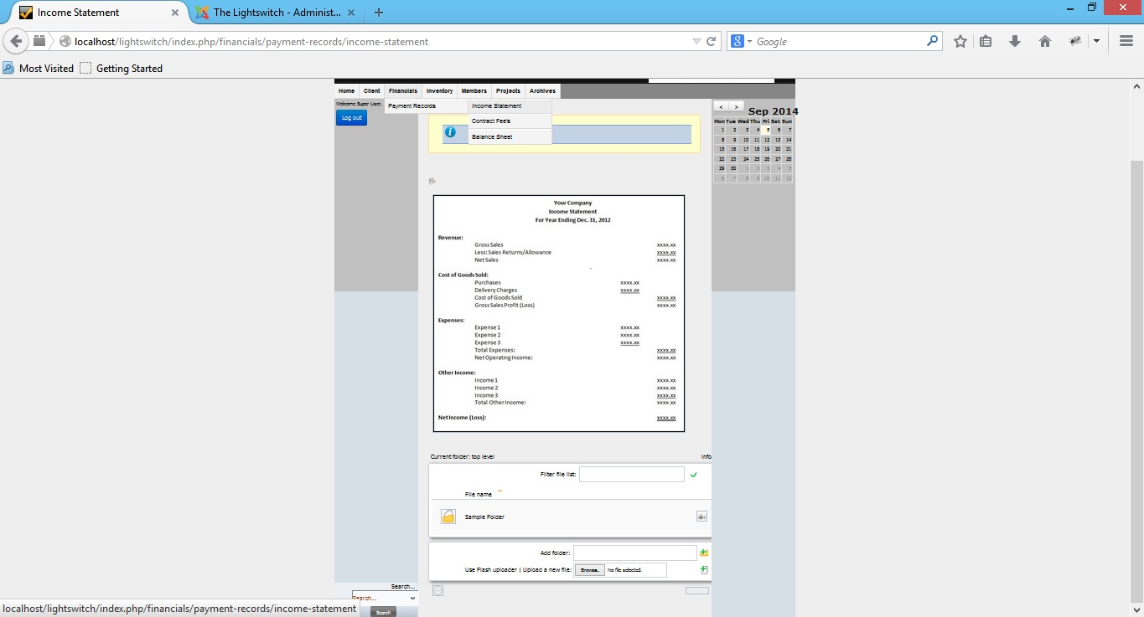

**Inventory Page**

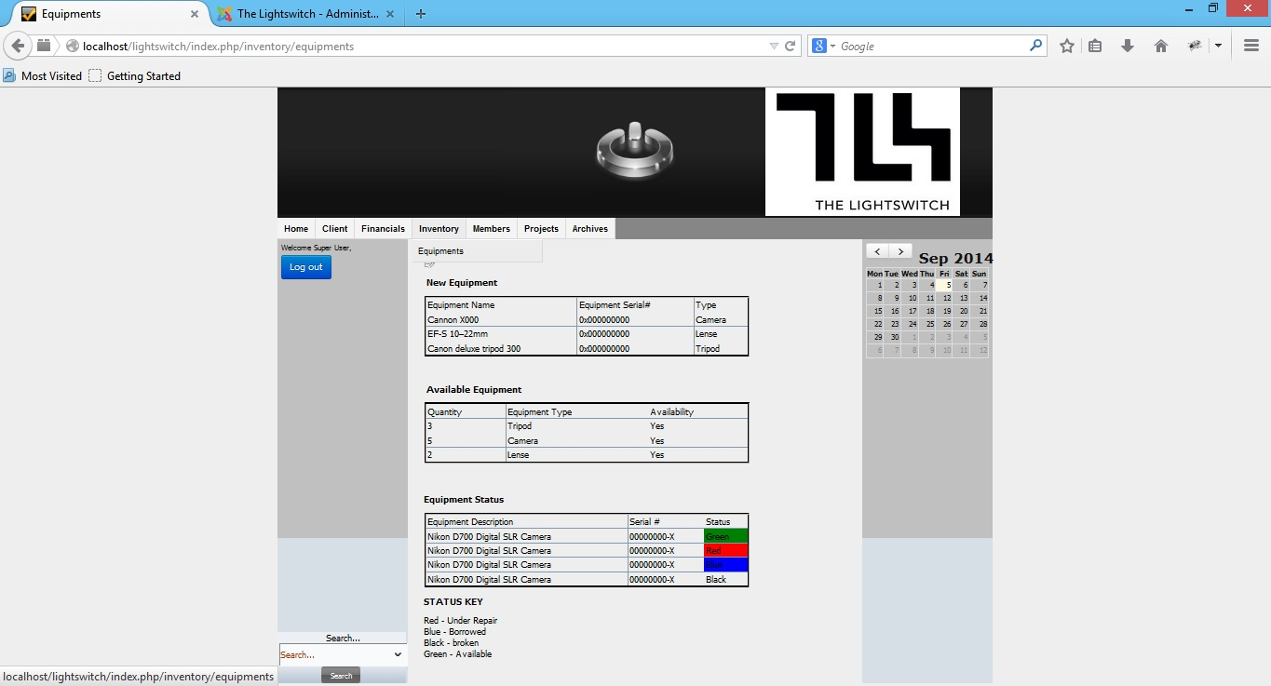

**Members Page**

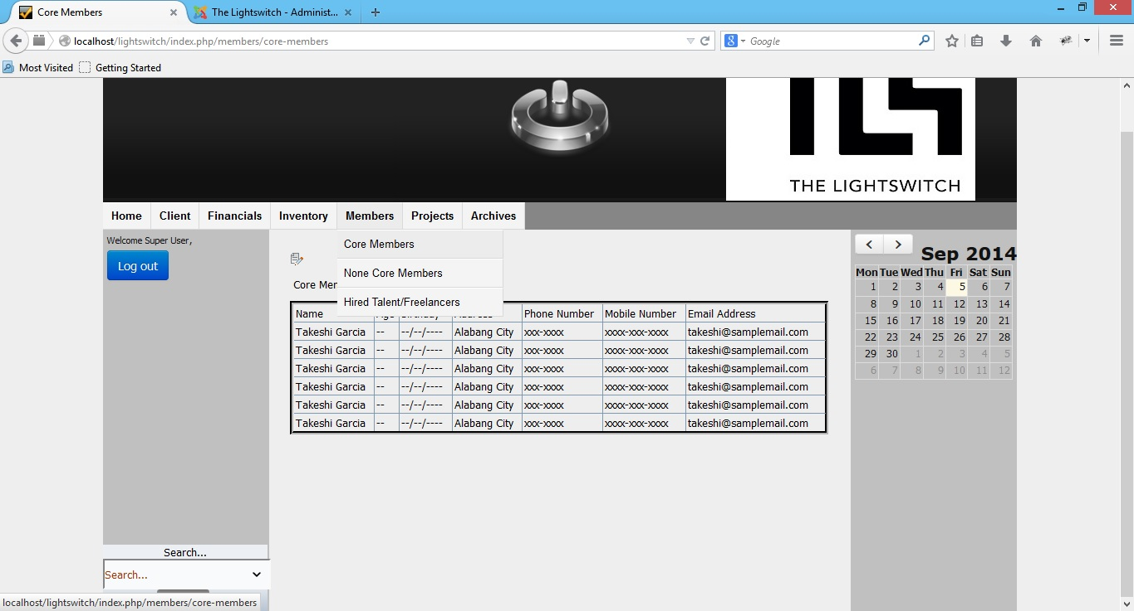

**Projects Page**

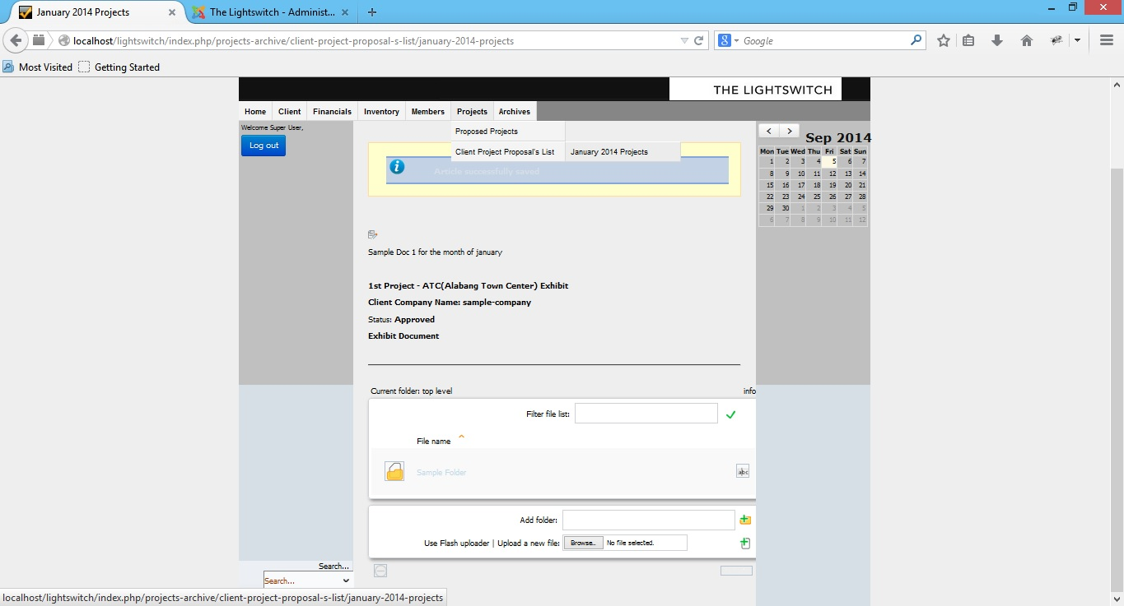

**Archives Page**

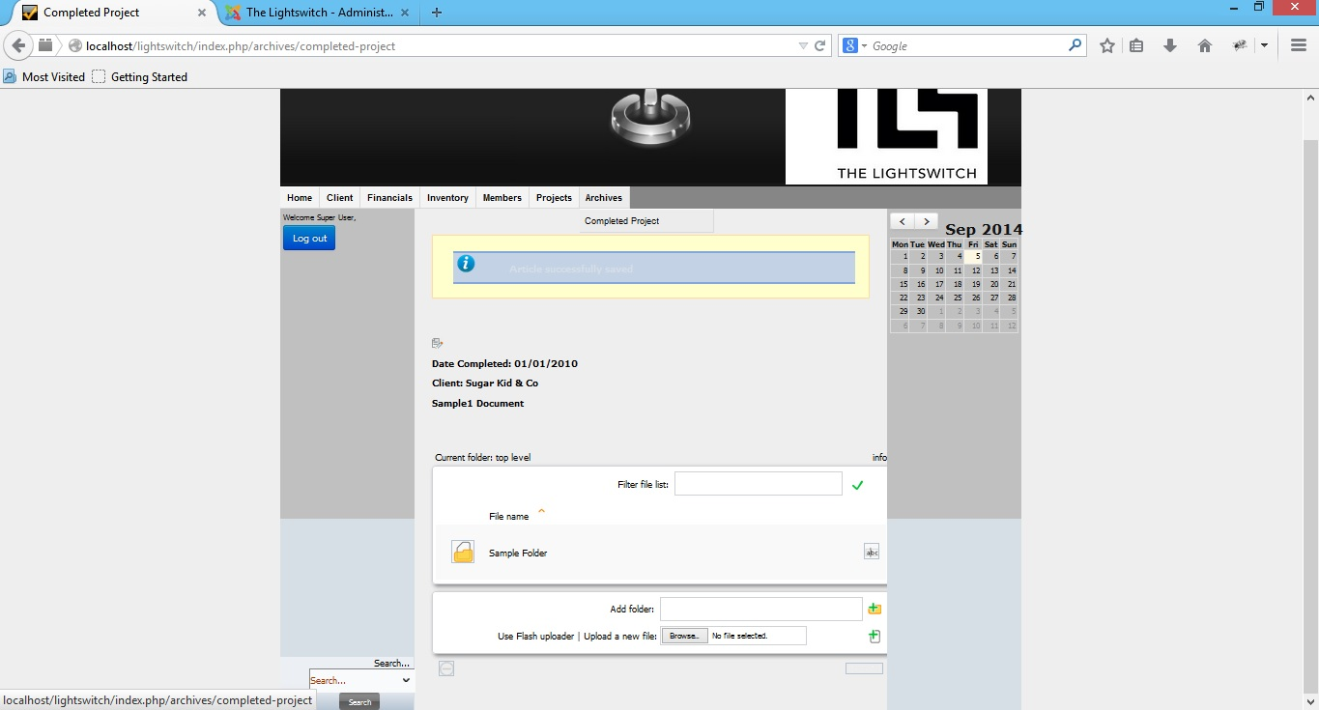

**Admin Home Page**

