**The Test Plan**

This Test Plan is designed for the purpose of testing the documentations of test procedures, test cases, and test steps requirements to validate the development of our system.

Background and Introduction

The Project is done by using the Agile Method of development, which has a given requirement/s for passing a certain level of confidence that the system will work at par with the industry’s requirements. We must able to satisfy this requirements through testing. There are certain test chosen specifically for this project which involves various stages (2 Static, 2 Dynamic test, 1 Overall Quality Assurance Testing, etc.) Each of this are factors that the project should be in line with the standards defined in this test plan to get a passing rate.

Static and Dynamic Tests schedules set by the professor have been given to as components of this project. During the said schedules of testing, the team’s prototype for the first iteration will be evaluated by an external Quality Assurance Team using the given guideline standards to rate the project.

After each test phase, evaluation by the external Quality Assurance Team will be closely noted and reviewed. For the static test results, documentation and files revision will be done as soon as the assessment of the external Quality Assurance team is receive. For the dynamic test results, all errors or bugs identified will be examined and fixes to be implemented by the team of the project. Further Quality Assurance tests will be based on the results of the previous static and dynamic test, in line with previous updates and corrections done by the team.

**Assumptions**

The basis of this assumption follow the core concepts that may serve as the guide of the project’s test phase: The system must have the following basic deliverables declared in the project scope:

a. All the Basic documentation deliverables (SQAP, Test Cases, Test Plans, etc.) to be evaluated by an external Quality Assurance Team (Static testing) b. A database of the entire system (Static testing) c. Create a tool for uploading files, documents, and images linked to the systems database (Dynamic testing) d. Provide a calendar for setting dates on borrowed equipment’s (Dynamic testing)

Roles and Responsibilities in the project

a. Each member of the team have designated roles and responsibilities defined. b. The design and development requirement phase has been successfully accomplished.

In testing the system, certain criteria’s are considered and are expected: System requirements are set, and conditions dependent on the system are provided

a. The test plan, test cases and other requirements for testing to proceed have been provided by the proponents

An external Quality Assurance Team has been selected to review the stated deliverables Certain standards has been set to properly evaluate the deliverables defined

Assuming that all the things stated above are satisfied, scheduled testing phases may proceed. On a side note, it is important that these testing phases are aligned with the schedules set for the project’s evaluation.

Test Items/Programs

The proponents have prepared the following to properly establish the items that must be tested during the phases of Quality Assurance Testing:

A. Documentation for Static Testing

i. Project Requirements Definition

ii. Project Logical Design

iii. Project Physical Design

iv. Database Design

v. User Interface

vi. Software Program Logic / Code

vii. Software Error Handling

viii. Test Plan, Test Cases

ix. Overall Quality of Documentation

x. Documentation Completeness

Features To Be Tested/Features Not To Be Tested

A.User Registration and Login

I. User Site Access

II. User Site Registration

III. User Site Login

IV. User roles

B. Pages

I. Home Page - Its purpose is to be the first page the administrator or normal user sees after logging in. It can also be viewed in the log in page even if a user hasn't log in yet.

II.Client Page - All Client data info/info's are can be found here but only administrators can view this.

III. Financial Page - Any financial related data is stored here in table format and can also only be viewed by administrators.

IV.Inventory Page - Equipments, Materials, and other work related gadgets information is compiled in this page. Some features can be viewed by normal users and some for privileges users.

V.Members Page - This page is the database section for the hired talens or the freelancers that want to work for the company or have already work for the company.

VI.Project Page - This page contains all necessary data on their company's project whether it be completed,on going, or being proposed.

VII.Archives Page - This page features the history of the company's completed projects and includes the necessary information that entails said projects. Editing features are restricted only to administrators.

C.User Priviledge

I. CRUD for Admin

II. CRUD for Core members

III. View and Create for None Core member

IV. View for Client/Freelancers

D.Calendar

I. Calendar View

II. Add Events

Approach

Agile Approach where in we have 2 test one for **Static test** and the other is for**Dynamic Test**

Pass/Fail Criteria

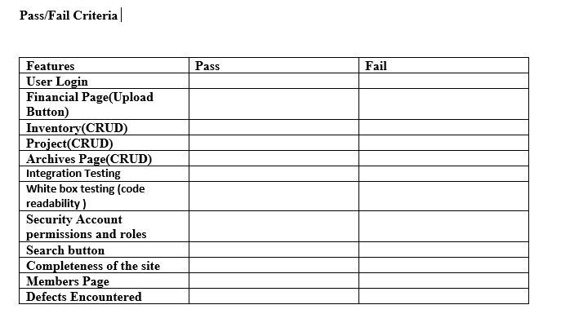

Suspension/Resumption Criteria

From the start of the project until completion, testing will be done to improve the system further and minimize errors. Should the testing in any other circumstances be suspended due to unforeseen events(e.i. corruption of data, natural disasters, etc), shall be resumed as soon as possible. Long test check points are done after each iterations.

Test Deliverables

Complete Documentation of the entire system

User Manual

Operational Manual

Test report

Test software

TESTING TASKS Functional tasks

Administrative Task

Environmental Needs

Hardware Environment:

CPU: Intel® Core™ i3/i5/ i7

System Type: 32-bit Operating system / 64-bit Operating system

Memory/Storage: 500GB

Software Environment:

Programming Languages:

- PHP 5.4.16

- MySQL

DATABASE SERVER:

- PHPMyAdmin

WEB SERVER APPLICATION:

- XAMPP 1.8.2

OPERATING SYSTEM:

- This system will run in any Windows Operating System such as Windows XP, Windows Vista, Windows 7 and Windows 8

TOOLS:

For development:

- TortoiseSVN

- Browser

- Notepad++ or Sublime Text 2

For testing:

- Browser

FRAMEWORK:

- Yii2 with advanced template

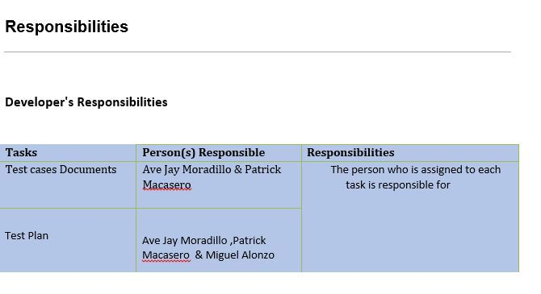

Staffing & Training

The training requirements for the members of the Lightswitch:   
a.First is to familiarize our system first so that they can full grasp the functions and features of the system.   
b.Second we will make them try our demo system or prototype so they can actually recommend their own personal taste regarding to the system.   
c.Lastly we will make user manual for them if they don’t know how to use the features of the system

Schedule

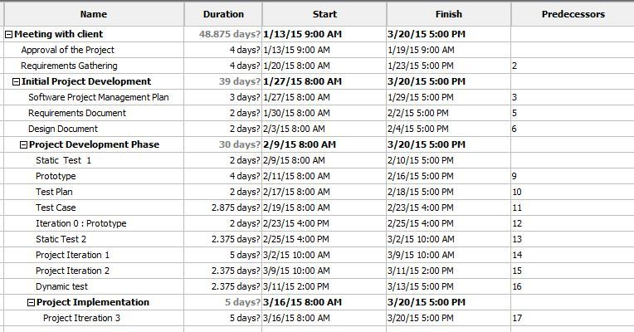

Resources

Project Repository <https://github.com/joegeneq/apc-softdev-it111-08>   
Yii 2 Framework Guide <http://www.yiiframework.com/doc-2.0/guide-intro-yii.html>

Risk and Contigencies

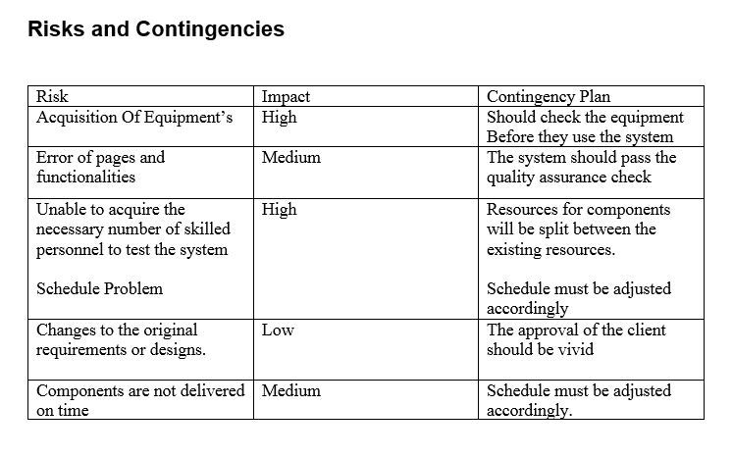

Approvals:

|  |  |  |
| --- | --- | --- |
| Project Adviser | Signature | Date |
|  |  |  |
|  |  |  |
| Project Panelist |  |  |
| Sir Justin Pineda |  |  |
|  |  |  |
| SQA Group |  |  |
| Lois Anne Logronio |  |  |
| Katharyn Alexandre Mayo |  |  |
| Renon Errol C. Dadulla |  |  |
|  |  |  |
| Subject Professor |  |  |
| Mr. Allan Cotecson |  |  |