***Gado & Jess Jalandoni*** *Scholarship Virtual Tracking System*

*Software Requirements Specification*

*February 19, 2014*

**Table of Contents**

|  |  |
| --- | --- |
| **Executive Overview** |  |
|  |  |
| **I. Introduction** |  |
| 1.1. Purpose |  |
| 1.2. Project Scope |  |
| 1.3. Intended Audiences |  |
| 1.4. References |  |
| 1.5. Specific Overview |  |
|  |  |
| **II. Overall Description** |  |
| 2.1. Product Perspective |  |
| 2.2. User Classes and Characteristics |  |
| 2.3. Operating Environment |  |
| 2.4. Design and Implementation Constraints |  |
| 2.5. User Documentation |  |
| 2.6. Assumptions and Dependencies |  |
|  |  |
| **III. Functional Requirements** |  |
| 3.1. Summary Use Case Dependencies |  |
| 3.2. External Roles |  |
|  |  |
| **IV. Non Functional Requirements** |  |
| 4.1. Performance Requirements |  |
| 4.2. Safety Requirements |  |
| 4.3. Security Requirements |  |
| 4.4. Software Quality Attributes |  |
|  |  |
| **V. External Interface Requirements** |  |
| 5.1. User Interfaces |  |
| 5.2. Hardware Interfaces |  |
| 5.3. Software Interfaces |  |
| 5.4. Communication Interfaces |  |
|  |  |
| **VI. Appendices** |  |
| 6.1. Appendix A |  |
| 6.2. Appendix B |  |

***Executive Overview***

The Scholarship Virtual Tracking System of Gado & Jess Jalandoni Scholarship Program by Assisi Foundation, Inc. is a web-based system wherein the admin, coordinators, scholars, and the graduates/alumni would be able to view and manage their profiles depending on the role that is designated for each of the end-user.

The **non-admin** objectives for the Scholarship Virtual Tracking System are to:

* For the **coordinator** role:
* Add grades of scholar(s)
* View the profile of the scholar(s) that are only enrolled in the school of the coordinator
* For the **scholar** and **graduate/alumni** role:
  + View his/her profile and grades
  + Update his/her profile

The **admin** objectives for the Scholarship Virtual Tracking System are to:

* Add scholar(s) , coordinator(s), school(s)
* View profile(s) of scholar(s) , coordinator(s), school(s)

The **Scholarship Virtual Tracking System** objectives are to:

* Organize the database of Gado & Jess Jalandoni Scholarships.
* Track the funding for each scholar on a school year (S.Y.) basis.
* Track the grades of the scholars.
* View the information updates of former and the current scholars.

***I. Introduction***

**1.1. Purpose**

This SRS aims to describe the system to be produced including its functional and non-functional requirements for the Scholarship Virtual Tracking System. This will serve as a reference during the entire development phase. This document is intended to be use by the members of the project development team which will implement and verify the specified functions of the system.

**1.2. Project Scope**

This SRS discusses the goals, objectives and functions of the Scholarship Virtual Tracking System. Several chapters of this document will further explain the functional and non-functional requirements of the Scholarship Virtual Tracking System.

The objectives of this system include:

* To organize the database of Gado & Jess Scholarship Program.
* To track the funding for each scholar on a school year (S.Y.) basis.
* To track the grades of the scholars.
* To view the information updates of former and current scholars.

The limitations of this system include:

* It does not support an online application system for the scholarship program.
* Only approved applicants for the scholarship program are entered in the system.
* Only the grade point average (GPA) is stored in the system.

**1.3. Intended Audiences**

The intended audiences for this specification of the Scholarship Virtual Tracking System include:

* **Assisi Development Foundation, Inc.**
  + Administration Department
* **Project Development Team**
  + Project Manager
  + Programmers must implement the requirements specified in this SRS.
  + Designers must layout the system according to the requirements specified in this SRS.
  + Software Quality Control (SQC) must ensure that these requirements are followed and met.
* **Users**
  + Scholars, and former scholars (alumni) who will be able to view and update their profile and view their grades.
  + Coordinators who will be able to view and update their profile and add grades to the scholars.
  + Admin who will be responsible in adding, updating and deleting (for erroneous inputs) within the system.

**1.4. References**

* http://projects2.apc.edu.ph/~jlquesada/APC/softdev/SRS_Elibrary%20v8.0.pdf
* http://projects2.apc.edu.ph/~jlquesada/APC/softdev/e-library.pdf

**1.5. Specification Overview**

This document is made up of six sections:

* **Introduction**, which describes the purpose, scope and intended users of the Scholarship Virtual Tracking System.
* **Overall Description**, fives details of the intended users, describes the existing system and then provides an overview of the Scholarship Virtual Tracking System.
* **Functional Requirements**, specifies the functional requirements in terms of a use case model consisting each external’s use cases and use case paths.
* **Non – functional Requirements**, describes the specific non-functional requirements of the system such as: Performance Requirements, Safety Requirements, Security Requirements, and Software Requirements.
* **External Interface Requirements**, describes the interfaces (User Interface, Hardware Interfaces, Software Interfaces, and Communication Interfaces) of the system. Includes user response such as: clicking the mouse, input using keyboard, etc.
* **Appendices**, contains the data dictionary and system mock-ups.

***II. Overall Description***

**2.1. Product Perspective**

The Scholarship Virtual Tracking System is a new system that aims to replace the manual storing and searching of files for the current and past scholars of the Gado & Jess Jalandoni Scholarship Program. Through this system, the coordinators are able to enter the grades of the scholar. Scholars would be able to view their profiles grades and update their profile, as well, as long as they have an internet connection. Simultaneously, the admin is able to add a scholar, add a coordinator, view, search, and update a scholar’s profile if necessary.

**2.2. User Classes and Characteristics**

|  |  |
| --- | --- |
| **Admin** | An admin is someone from the management who may add or update a file into a system. He/she is the one responsible for maintaining the files in the system. |
| **Coordinator** | A coordinator is someone from the school partner who serves as the contact person of the Gado & Jess Jalandoni Scholarship Program. He/she is the one responsible in entering the grades of the scholars in the system. |
| **Scholar/Graduate/Alumni** | A scholar is a student who is currently subscribed as a scholar with Gado & Jess Scholarship Program. If a scholar finished his/her study in college, he/she will later be identified as a graduate/alumni. |

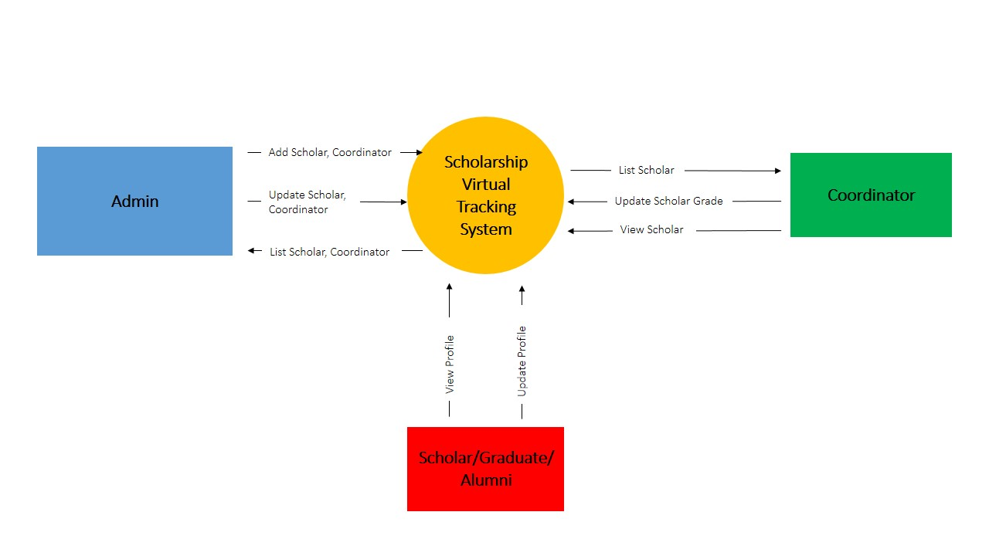

**Figure 1**

*Context Diagram of version 1.0 of the Scholarship Virtual Tracking System*

**2.3. Operating Environment**

|  |  |
| --- | --- |
| **OE-1:** | The Scholarship Virtual Tracking System shall operate in any web browser such as: Mozilla Firefox, Google Chrome and Internet Explorer, all in its latest version. |
| **OE-2:** | The Scholarship Virtual Tracking System shall operate on a server running Windows 7 32-bit and Apache Web Server. |
| **OE-3:** | The Scholarship Virtual Tracking System shall be available to any desktop/laptop with internet connection. |

**2.4. Design and Implementation Constraints**

|  |  |
| --- | --- |
| **CO-1:** | The system shall use MySQL Framework as its database management system. |
| **CO-2:** | All scripts shall be written in PHP. |

**2.5. User Documentation**

|  |  |
| --- | --- |
| **UD-1:** | A user manual will be made available to the users for them to fully understand the parts and functions of the system. |
| **UD-2:** | A user demo shall be conducted before the system implementation. |

**2.6. Assumptions & Dependencies**

|  |  |
| --- | --- |
| **AS-1:** | The Scholarship Virtual Tracking System is accessible by the admin, coordinators, and scholars/alumni with internet connection. |
| **AS-2:** | Admin, coordinators, and scholars/alumni have their own login credentials. |
| **DE-1:** | Application for the scholarship may be attained if a school has received a letter of intent from Gado & Jess Jalandoni Scholarship Program indicating that they are welcoming students applying for a scholarship grant. |

***III. Functional Requirements***

**3.1. Summary Use Case Diagrams**

The following use case diagrams summarize the functional requirements for the Scholarship Virtual Tracking System:

* Admin Summary Use Case Diagram
* Coordinator Summary Use Case Diagram
* Student/alumni Summary Use Case Diagram

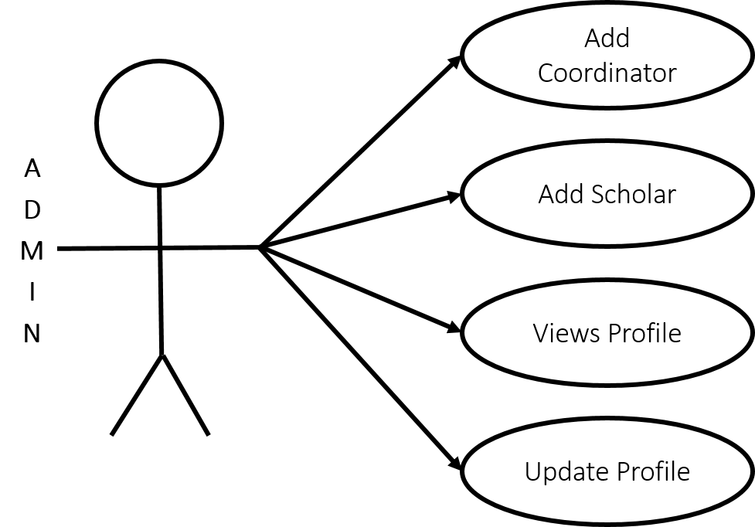

**Figure 2**

*Admin Summary Use Case Diagram*

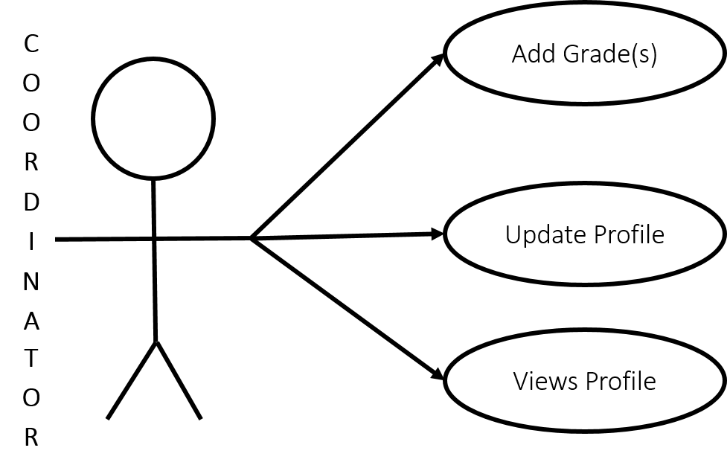

**Figure 3**

*Coordinator Summary Use Case Diagram*

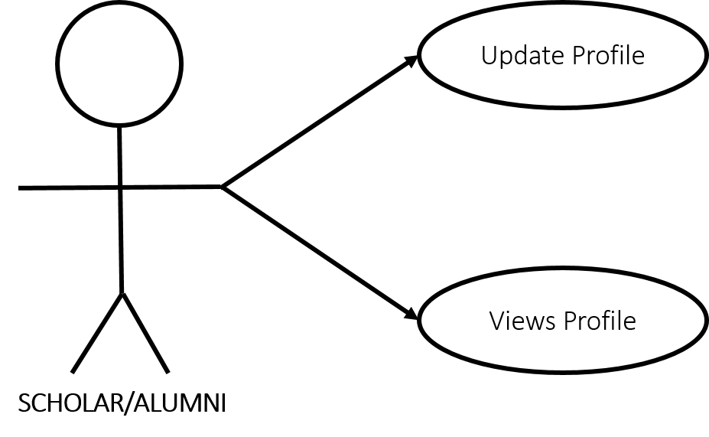

**Figure 4**

*Scholar/alumni Summary Use Case Diagram*

**3.2. External Roles**

***3.2.1. Admin***

Definition

An *admin* is a person assigned to maintain the Scholarship Virtual Tracking System.

Responsibilities

These are the following responsibilities of admin:

* Maintain the Scholarship Virtual Tracking System.
* Add new scholars and coordinators.
* Update profile(s) of coordinator(s) from the system.
* View scholars and coordinators.

Required Capabilities

An admin needs the following skill to effectively use the Scholarship Virtual Tracking System:

* Must know basic computer skills.

Use Case Diagram

*See figure 2 for the admin use case diagram.*

***3.2.2. Coordinator***

Definition

*Coordinator* is an access level/group pertaining to the contact persons in each partner school.

Responsibilities

These are the following responsibilities of coordinator:

* View scholars
* Add grades of scholars

Required Capabilities

Coordinator needs the following skill to effectively use the Scholarship Virtual Tracking System:

* Must know basic computer skills.

Use Case Diagram

*See figure 3 for the admin use case diagram.*

***3.2.3 Scholar/Alumni***

Definition

*Scholar/alumni* is an access level/group pertaining to students/graduate students who are subscribed with Gado & Jess Jalandoni Scholarship Program.

Responsibilities

These are the following responsibilities of scholar/alumni:

* View own profile.
* Update own profile.

Required Capabilities

Scholar/alumni needs the following skills to effectively use the Scholarship Virtual Tracking System:

* Must know basic computer skills.

Use Case Diagram

*See figure 4 for the scholar/alumni use case diagram.*

**3.3 Use Cases**

***3.3.1. User Creates New Scholar Profile***

|  |  |  |
| --- | --- | --- |
| **NUMBER:** | **UC01** | |
| **USE CASE NAME:** | **User Creates New Scholar Profile** | |
| **ACTOR(S):** | **Admin** | |
| **BASIC FLOW** | **Actor Action**  **Step 1:** User clicks the “Scholars” tab.  **Step 3:** User clicks the “Create Student” link.  **Step 5:** User fills out the necessary fields.  **Step 6:** User clicks the “Next” button.  **Step 8:** User fills out the necessary fields.  **Step 9:** User clicks the “Next” button.  **Step 11:** User fills out the necessary fields.  **Step 12:** User clicks the “Create” button. | **System Response**  **Step 2:** System displays the “List of Scholars” page.  **Step 4:** System displays the “Profile” form.  **Step 7:** System displays the “Application” form.  **Step 10:** System displays the “Allocation” form.  **Step 13:** System sends an e-mail with your corresponding username and randomly generated password.  **Step 14:** System displays the summary of the newly created scholar profile. |
| **ALTERNATIVE FLOW** | **1. at Step 6:**  If User, clicks “Create” button.  **2. at Step 9:**  If User, clicks “Create” button. | System displays a message (SM03).  System displays a message (SM03). |
| **PRECONDITION** | User must be registered in the Scholarship Virtual Tracking System.  User is logged in as Admin. | |
| **POSTCONDITION** | User was able to add New Scholar Profile into the system | |
| **SPECIAL REQUIREMENTS** | Fields required: Lastname, Firstname, Sex, Birth date, Place of birth, Address, Contact number, Email, School, Type of application, Course, Duration, Timeline, Sponsor | |

***3.3.2. User Creates New Coordinator Profile***

|  |  |  |
| --- | --- | --- |
| **NUMBER:** | **UC02** | |
| **USE CASE NAME:** | **User Creates New Coordinator Profile** | |
| **ACTOR(S):** | **Admin** | |
| **BASIC FLOW** | **Actor Action**  **Step 1:** User clicks the “Coordinator” tab.  **Step 3:** User clicks the “Create Coordinator” link.  **Step 5:** User fills out the necessary fields.  **Step 6:** User clicks the “Create” button. | **System Response**  **Step 2:** System displays the “List of Coordinator” page.  **Step 4:** System displays the “Profile” form.  **Step 7:** System sends an e-mail with your corresponding username and randomly generated password.  **Step 8:** System displays the summary of the newly created coordinator profile. |
| **ALTERNATIVE FLOW** | **1. at Step 6:**  If User, clicks “Create” button. | System displays a message (SM03). |
| **PRECONDITION** | User must be registered in the Scholarship Virtual Tracking System.  User is logged in as Admin. | |
| **POSTCONDITION** | User was able to add New Coordinator Profile into the system | |
| **SPECIAL REQUIREMENTS** | Fields required: Lastname, Firstname, Sex, Birth date, Place of birth, Address, Contact number, Email, School | |

***3.3.3 User Updates Profile***

|  |  |  |
| --- | --- | --- |
| **NUMBER:** | **UC03** | |
| **USE CASE NAME:** | **User Updates Profile** | |
| **ACTOR(S):** | **Admin, Coordinator, Scholar/Admin** | |
| **BASIC FLOW** | **Actor Action**  **Step 1:** User clicks the “Your Name” tab.  **Step 2:** User clicks the “Edit Profile” submenu.  **Step 4:** User changes the necessary fields.  **Step 5:** User clicks the “Save” button. | **System Response**  **Step 3:** System displays the form to be edited.  **Step 6:** System saved the changed fields into the system. |
| **ALTERNATIVE FLOW** | **1. at Step 4:**  If User does not want to change a value of a field, he/she may already click the “Save” button. | System saves the profile of the User without changes. |
| **PRECONDITION** | User must be registered in the Scholarship Virtual Tracking System.  User is logged in as Admin, Coordinator or Scholar/Alumni. | |
| **POSTCONDITION** | User was able to update the Admin, Coordinator or Scholar/Alumni Profile in the system | |
| **SPECIAL REQUIREMENTS** | Fields required: Lastname, Firstname, Sex, Address, Contact number, Email | |

***3.3.4 User Adds Grade to a Scholar***

|  |  |  |
| --- | --- | --- |
| **NUMBER:** | **UC04** | |
| **USE CASE NAME:** | **User Adds Grade to a Scholar** | |
| **ACTOR(S):** | **Coordinator** | |
| **BASIC FLOW** | **Actor Action**  **Step 1:** User clicks the “Grade” tab.  **Step 3:** User clicks the “Create Grade”.  **Step 5:** User fills up the necessary fields.  **Step 6:** User clicks the “Create” button. | **System Response**  **Step 2:** System displays the “List of Grade” page with corresponding Scholar information.  **Step 4:** System displays the “Grade” form.  **Step 7:** System displays the summary of the updated coordinator profile. |
| **ALTERNATIVE FLOW** |  |  |
| **PRECONDITION** | User must be registered in the Scholarship Virtual Tracking System.  User is logged in as Coordinator. | |
| **POSTCONDITION** | User was able to update the Coordinator Profile into the system | |
| **SPECIAL REQUIREMENTS** | Fields required: Lastname, Firstname, Sex, Birth date, Place of birth, Address, Contact number, Email, School | |

***3.3.5. User Views Profile***

|  |  |  |
| --- | --- | --- |
| **NUMBER:** | **UC05** | |
| **USE CASE NAME:** | **User Views Profile** | |
| **ACTOR(S):** | **Admin, Coordinator, Scholar/Admin** | |
| **BASIC FLOW** | **Actor Action**  **Step 1:** User clicks the “Your Name” tab.  **Step 2:** User clicks the “Edit Profile” submenu.  **Step 4:** User changes the necessary fields.  **Step 5:** User clicks the “Save” button. | **System Response**  **Step 3:** System displays the form to be edited.  **Step 6:** System saves the changed fields into the system. |
| **ALTERNATIVE FLOW** | **1. at Step 4:**  If User does not want to change a value of a field, he/she may already click the “Save” button. | System saves the profile of the User without changes. |
| **PRECONDITION** | User must be registered in the Scholarship Virtual Tracking System.  User is logged in as Admin, Coordinator or Scholar/Alumni. | |
| **POSTCONDITION** | User was able to update the Admin, Coordinator or Scholar/Alumni Profile in the system | |
| **SPECIAL REQUIREMENTS** | Fields required: Lastname, Firstname, Sex, Address, Contact number, Email | |

***3.3.6 System Messages***

|  |  |
| --- | --- |
| **No.** | **Message** |
| SM01 | “Name” successfully created. |
| SM02 | “Name” successfully updated. |
| SM03 | “Field Name” is required. |

***IV. Non Functional Requirements***

**4.1. Performance Requirements**

|  |  |
| --- | --- |
| PE-1: | System can be accessed by many users simultaneously. |
| PE-2: | Search results shall take no longer than 1 minute for it to fully appear onto the screen (may vary depending on the query). |
| PE-3: | System displays error messages to users. |
| PE-4: | System has search fields. |

**4.2. Safety Requirements**

|  |  |
| --- | --- |
| SA-1: | Since the system can be accessed by everyone certain issues will arise. Login credentials will be provided to the users of the system. |
| SA-2: | Since it is hosted by one service provider. The possibility of having the hosting server to go down might cause the system to be inaccessible. |

**4.3 Security Requirements**

|  |  |
| --- | --- |
| SE-1: | Only registered users of the Assisi Development Foundation, Inc., partner school, and scholar/alumni will be given access to the Scholarship Virtual Tracking System. |
| SE-2: | The system will only allow “admin” of the Scholarship Virtual Tracking System to add and edit/update profiles in the system. |
| SE-3: | “Coordinator” will only be able to view, update his/her profile and add grades to scholars in his/her assigned school. |
| SE-4: | “Scholar/alumni” will only be able to view his/her profile with/without his/her grades and update his/her profile. |

**4.4. Software Quality Attributes**

|  |  |
| --- | --- |
| SQ-1: | **Accessibility:** This is a web based system, it can be accessed by users with internet connection. |
| SQ-2: | **Accuracy:** All informations in the system are correct and updated. |
| SQ-3: | **Compatibility:** This system can be accessed using several web browsers (Mozilla Firefox, Google Chrome, and Internet Explorer). No particular browser is recommended. It depends on the user’s preference. |
| SQ-4: | **Safety:** This system does not directly or indirectly cause harm to life or property. |
| SQ-5: | **Usability:** This system is easy to use. The design is user-friendly. |

***V. External Interface Requirements***

**5.1. User Interfaces**

|  |  |
| --- | --- |
| UI-1: | Member may navigate using the mouse and keyboard. |
| UI-2: | System uses data tables for a more organized way of displaying records and informations. |
| UI-3: | System has search fields. |

**5.2. Hardware Interfaces**

|  |  |
| --- | --- |
| HI-1: | Network (to allow users to connect in the server) |
| HI-2: | Client Computers (used to access the website) |
| HI-3: | Server (to manage access in the network) |
| HI-4: | Production Support Systems (e.g. back-up, UPS) |

**5.3. Software Interfaces**

|  |  |
| --- | --- |
| SI-1: | Operating Systems (Windows 7 32-bit & 64-bit, Windows 8 32-bit & 64-bit |
| SI-2: | Web Browsers (Mozilla Firefox, Google Chrome, etc.) |
| SI-3: | Database Management System (MySQL Framework) |
| SI-4: | Yii! Framework |

**5.4. Communication Interfaces**

|  |  |
| --- | --- |
| CI-1: | Internet Connection |
| CI-2: | Web Browser |

***VI. Appendices***

**6.1. Appendix A**

**6.2. Appendix B**