1. To change Hostname(Terminal Name)

* python imvconfig.py --hostname CodebizIoT

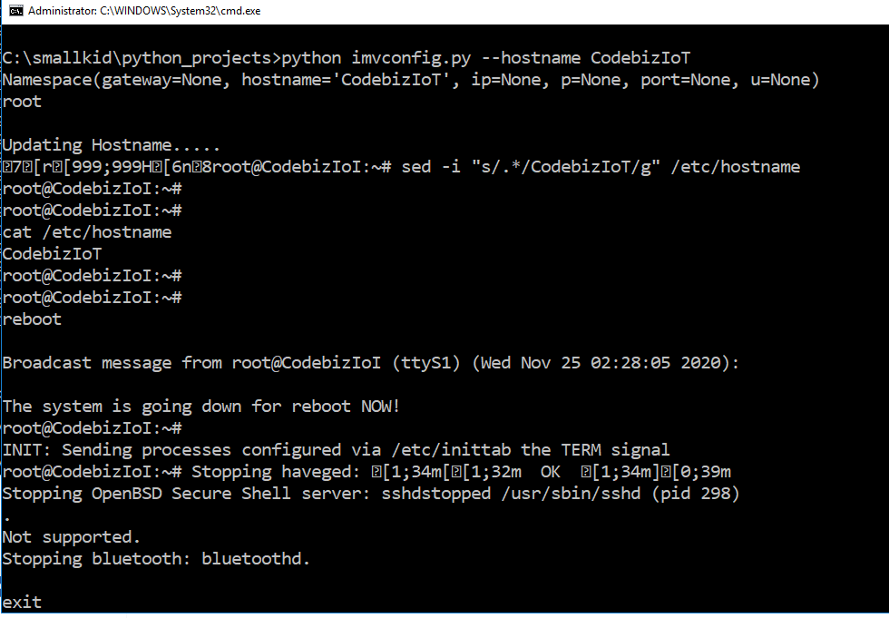

1. Changing IP Address
   * python imvconfig.py --ip 192.168.1.11
   * 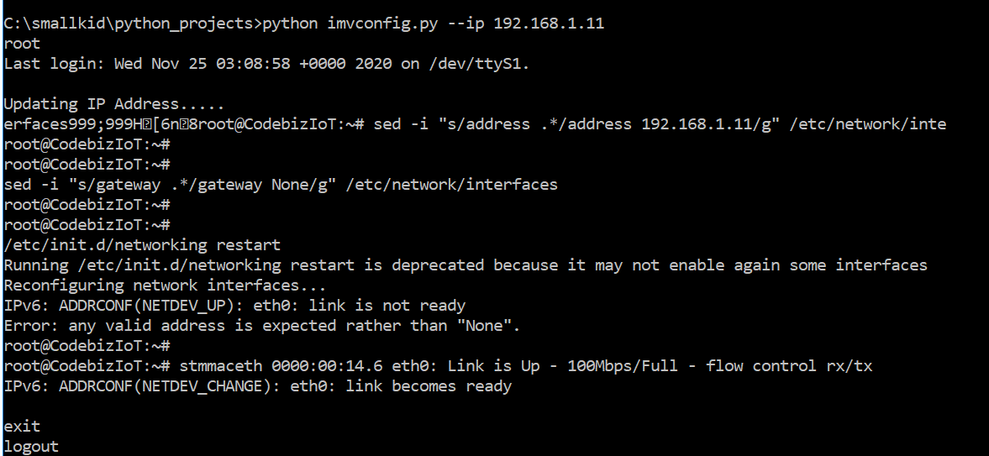
2. Adding User
   * python imvconfig.py -u imvftpuser -p 1234567890!

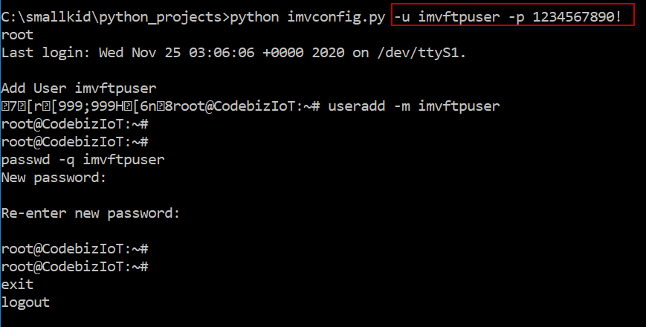

1. Connecting to FTP
   * ftp ip_address
   * enter user and password

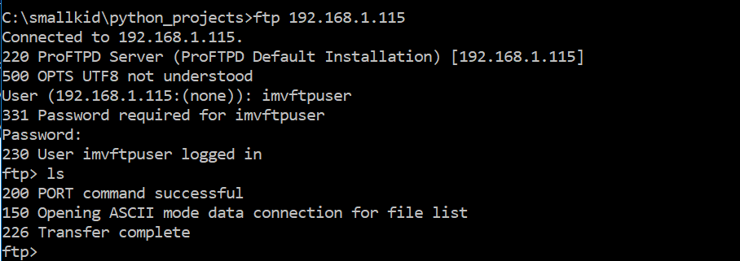

1. Get Hostname
   * python imvconfig.py --get hostname
   * 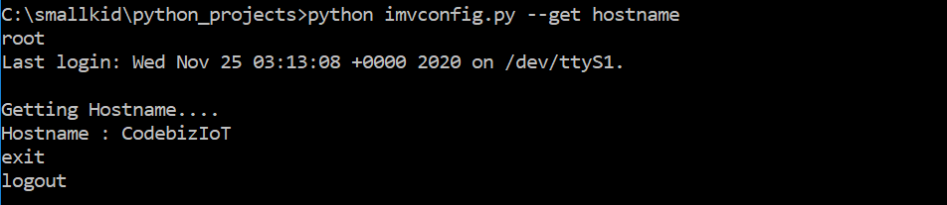
2. Get IP Address
   * python imvconfig.py --get ip
   * 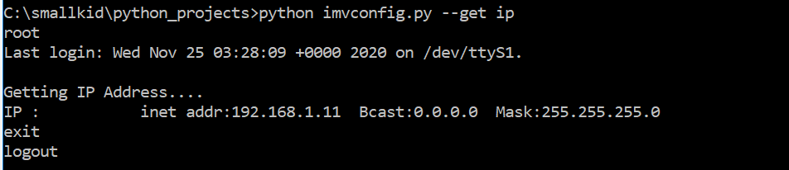
3. Using Config file eg. imvconfig.json

Update and specify the parameters of the file. Once updated it will automatically get the values using the python script

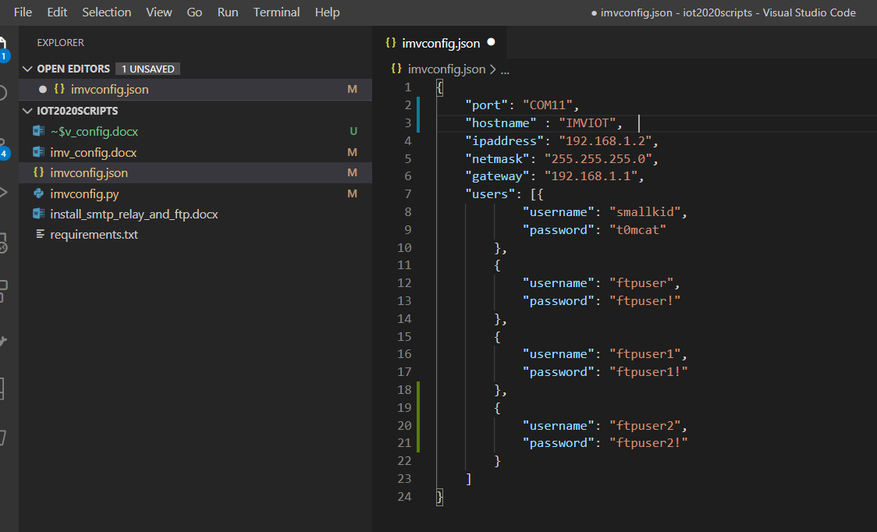

To run using the config file python imvconfig.py --configfile imvconfig.json

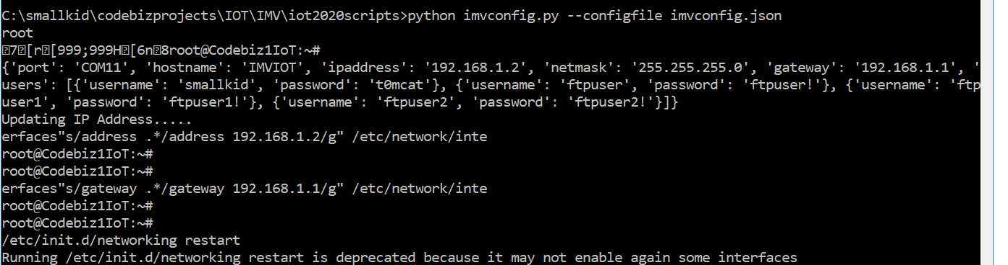

1. To update all at once just run the batch script “updateconfig.bat” to update the config to the device.

