**Isfield**

TF = isfield(S,field) returns 1 if field is the name of a field of the structure array S. Otherwise, it returns 0.

If field is an array that contains multiple names and S is a structure array, then TF is a logical array that has the same size.

If S is not a structure array, then isfield returns 0.

**How to create a structure?**

This example shows how to create a structure array. A structure is a data type that groups related data using data containers called fields. Each field can contain data of any type or size.

Store a patient record in a scalar structure with fields name, billing, and test.

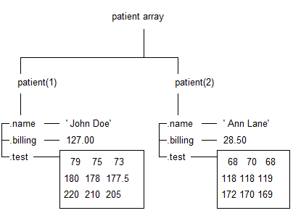

patient(1).name = 'John Doe';

patient(1).billing = 127.00;

patient(1).test = [79, 75, 73; 180, 178, 177.5; 220, 210, 205];

patient(2).name = 'Ann Lane';

patient(2).billing = 28.50;

patient(2).test = [68, 70, 68; 118, 118, 119; 172, 170, 169];

**pwd**

Identify current foldercollapse all in page, displays the MATLAB® current folder.

example

currentFolder = pwd returns the path to the current folder.

cd c:\myMATLABFiles

currentFolder = pwd

currentFolder =

'c:\myMATLABFiles'

**fullfile**

Build full file name from parts

f = fullfile('myfolder','mysubfolder','myfile.m')

f =

'myfolder\mysubfolder\myfile.m'

FileSpec = fullfile(pwd,'Report\Template\Template_Traction_Simulations(Chinese).docx');

**actxserver**

Create COM server

Create a Microsoft® Excel® object and display the ActivePrinter property. MATLAB® displays the value for your system.

e = actxserver('Excel.Application');

get(e,'ActivePrinter')

ans = \\printers\Copy-Fl2-South on Ne04:

When you are finished with the application, close Excel in MATLAB and delete the server object.

Quit(e)

delete(e)

**invoke**

invoke(actx_word.Documents,'Open',FileSpec);

**SaveAs**

Save project to new file

Word document command

**Insert point**

Find end of document and make it the insertion point:

end_of_doc = get(actx_word.activedocument.content,'end');

set(actx_word.application.selection,'Start',end_of_doc);

set(actx_word.application.selection,'End',end_of_doc);