Fast/Easy Development of an In-Database Agent via Select AI Agent in Oracle Autonomous AI Database

By Joe Hahn
March 30, 2026
v1

Modern enterprises accumulate data across a wide variety of sources: structured relational tables, unstructured documents, and the ever-expanding public web. Answering an important business question often means synthesizing across all three data sources, yet few tools can handle that breadth gracefully. Select AI Agent, which is functionality that exists within the Oracle Autonomous AI Database (ADB), addresses this challenge directly.

An AI Agent is an LLM-powered reasoning engine that decides how to answer a question by synthesizing outputs that are generated by a portfolio of specialized Tools, each of which are optimized for a different data source. And to illustrate the power of ADB’s Select AI Agent,
this blog post will develop an Agent on top of mock sales data, and then playtest how that Agent handles questions and requests generated by three distinct business personas, namely:

- A sales analyst that needs to combine transactional database records with product marketing text and real-world market context via a single query.
- A customer-success manager that wants to search and summarize a vast sea of social media posts for sentiment around a specific product, without writing a single line of SQL.
- A product team that wants natural-language access to structured sales data, and access to (unstructured) product descriptions, and live web searches—all via the same interface.

Where a standalone NL2SQL tool or a standalone RAG solution covers only one dimension of the data landscape, an Agent orchestrates multiple tools together, routing each question to the right resource automatically. If your business data lives partly in database tables, partly in unstructured files, and partly on the public internet, Select AI Agents are the right solution.

Cloud Architecture for an in-database Agent

Nearly all components of the Select AI Agent solution utilized here reside within Oracle Autonomous Database (ADB). This results in a very lean architecture that is readily deployed on Oracle Cloud Infrastructure (OCI), with Figure 1 showing the solution's key components.

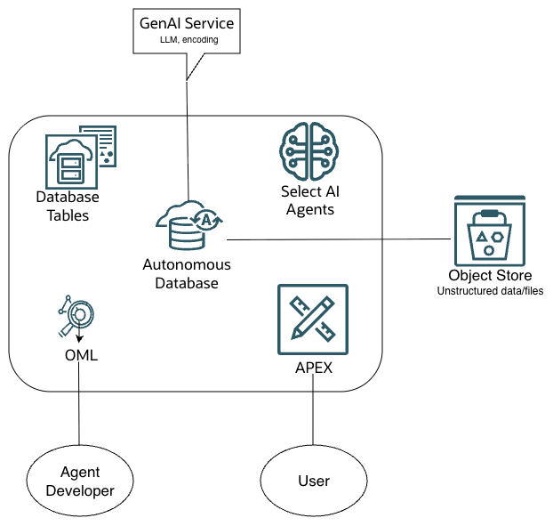
Figure 1. Cloud architecture of the Select AI Agent solution deployed on OCI. The lower left corner shows the Agent Developer using an OML Notebook, which is provided by Autonomous AI Database (ADB), to author and deploy the Agent, while the Business User interacts with that Agent via an Oracle APEX frontend. The Select AI Agent is hosted within ADB and orchestrate calls to various Tools that in turn call upon structured database tables and unstructured data stored as files in Object Store, with the OCI GenAI Service providing the LLM that perform NL2SQL as well as the encoder that is utilized by the RAG Tool.
This architecture’s key components are:

- Oracle Autonomous AI Database (ADB): The solution hub that hosts the database tables and the Select AI Agent configurations, as well as:
  - Oracle Machine Learning (OML) Notebooks: The Agent developer's workbench. In this example, all of the agent’s setup code is authored, tested, and executed inside of OML notebooks, making it easy to develop database code snippets interactively and inspecting results inline, which is invaluable when testing the Agent’s output.
  - Oracle APEX: The no-code/low-code frontend through which business users interact with the Agent via natural language. APEX is natively integrated with ADB, so connecting an APEX application to the in-database Agent requires little effort.
- OCI Object Store: Store this solution’s unstructured data as files within Object Store. The dataset utilized below include about 80 product descriptions and ten thousand mock social media posts, which will serve as the knowledge bases for the Agent's two RAG Tools that are detailed below.
- OCI GenAI Service: This on-demand OCI service provides two capabilities: (1) a Large Language Model (LLM) that enables Natural Language to SQL translation (NL2SQL, which converting a user's natural-language question into executable SQL), and an embedding model that converts chunks of text into vectors stored in ADB, which in turn allows the Agent’s RAG Tool to utilize vector similarity search.

Because this solution’s chief components are provided by ADB, there is no sprawling infrastructure to manage. This solution’s external components are the GenAI Service and the Object Store bucket that are easily connected to ADB.

The Data
A large portion of this example solution is built upon Oracle's classic Sales History (SH) schema, which is a rich and publicly available dataset that Oracle has shipped for its database for decades. That dataset contains eight tables and has the SALES table at its core, see Figure 2. This demo’s most important tables are:

- SALES: This table tracks nearly one million mock purchases by mock customers, and provides information about customer ID, product ID, purchase timestamp, and purchase price.
- CUSTOMERS: A demographics table containing customer IDs, names, addresses, geographic data, and many other attributes.
- PRODUCTS: A product catalog of product IDs, names, and other categoric descriptions.

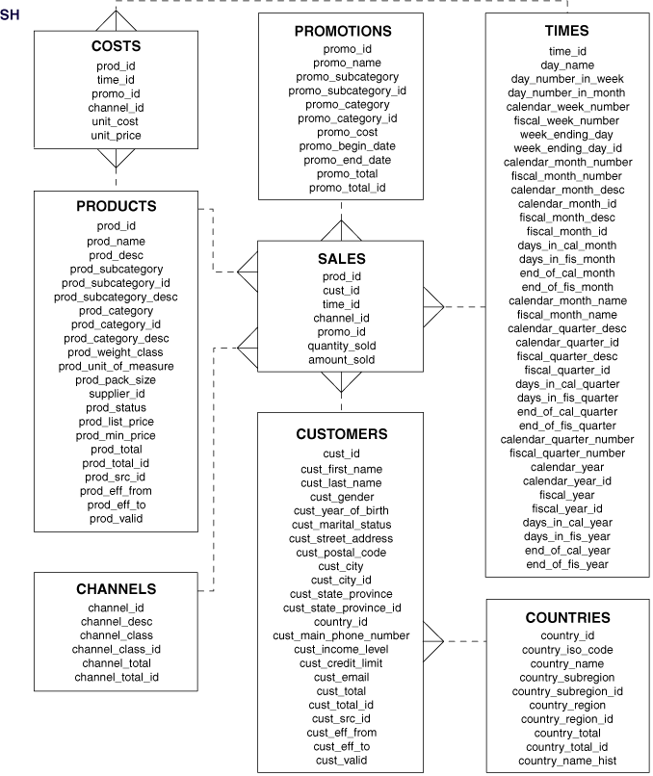
Figure 2. Relationships among the tables in the Oracle Sales History (SH) schema, and their join keys.

These structured tables are exposed to the agent's NL2SQL tool, which allows the Select AI Agent to address questions that can be recast as SQL queries against the tabular data.

In addition to the structured database tables, two sets of unstructured files are also stored in separate folders within an OCI Object Store bucket:

- Product Descriptions: One text file per record in the PRODUCTS table (Figure 2), with each containing detailed product description. Note that the PRODUCTS table itself does not include any descriptions of the 80 or so products, only their name, size, price, and comparable characteristics. So the GenAI LLM (Figure 1) was also tasked with generating a rich and verbose product description that is consistent with the item’s entry in the PRODUCTS table. Each mock product description is then exported as a file stored in the products folder in Object Store. That products folder and its ~80 mock product descriptions then become the knowledge base that the Agent’s RAG Tool can consult when a user asks about product characteristics and features.
- Social Media Posts: Ten thousand random selections from a join of the SALES, CUSTOMERS, and PRODUCTS tables were also fed into the GenAI service’s LLM, with instructions to craft a mock social media post describing how much (or little) the customer in question enjoyed the product, and whether the price was right. Those mock social media posts are then stored as ten thousand files in the socal_media folder in Object Store, which in turn becomes the knowledge base for another RAG Tool that can query those posts.
Together, these three data sources—structured database tables and unstructured product descriptions & social media posts—will provide the in-database Agent a multi-dimensional view of the business that no single query mechanism could address isolation.

The Agent, the Team, its Task, and its Tools
ADB’s Select AI Agent framework organizes its components as a hierarchy that is illustrated in Figure 3. Each bubble in Figure 3 represents a boilerplate PL/SQL code snippet that the Agent developer copies from documentation and then tailors to the use case.

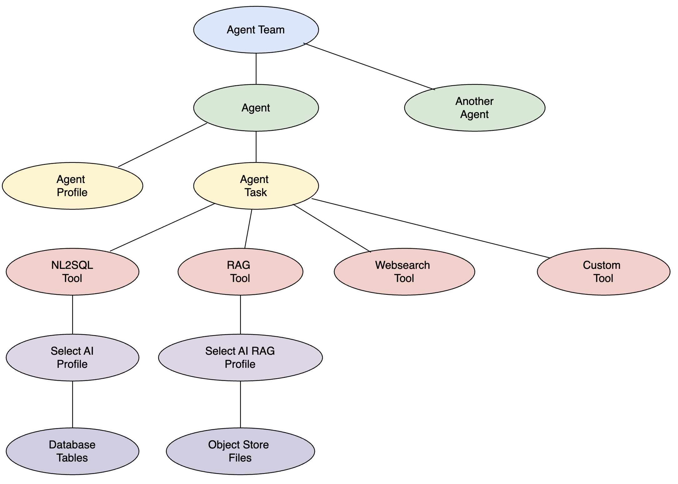
Figure 3. The Select AI Agent hierarchy. At the top is the Agent Team containing one or more Agents. Each Agent has a Profile (which configures the LLM used by the Agent) and a Task (which provides the instruction set that governs tool selection). The Task allows the Agent to connect to 4 possible tool types: an NL2SQL Tool (backed by a Select AI Profile pointing at Database Tables), one or more RAG Tools (each backed by a Select AI RAG Profile pointing at Object Store Files), a Websearch Tool (for live internet queries), plus additional Custom Tools if desired.
The Agent Team (which is useful for orchestrating multi-agent workflows) resides at the top of this hierarchy, and it references one or more Agents, keeping in mind that this example utilizes a single Agent. The Select AI Agent has two key sub-components:

- Agent Profile: This declares the Agent's identity, the LLM it will use for reasoning, and that LLM operating parameters.
- Agent Task: The natural-language instruction set that tells the Agent what it can do, what data sources are available, and—critically—when to use the various Agent Tools.

The Agent Task is the most critical portion of the Agent’s definition, as that tells the Agent when to use any of the various tools it has at its fingertips. The PL/SQL code that defines our Agent’s Task is:
BEGIN
DBMS_CLOUD_AI_AGENT.create_task(
task_name => 'SALES_TASK',
attributes => '{"Instruction": "Process this request:{query} per the following:' ||
'1. If the request can be satisfied by querying database tables,' ||
'then use the `SALES_SQL_TOOL` to satisfy the request' ||
'Use the `SALES_SQL_TOOL` when the request is about product sentiment scores.' ||
'2. If the request is about products and their descriptions,' ||
'then use the `SALES_PRODUCT_RAG_TOOL` to satisfy the request.' ||
'Use the `SALES_PRODUCT_RAG_TOOL` when comparing product descriptions.' ||
'3. If the request is about what customers said in their social media posts about various products they purchased,' ||
'then use the `SALES_SOCIAL_RAG_TOOL` to satisfy the user request.' ||
'4. If the request can be satisfied by performing a WEBSEARCH,' ||
'then use the `SALES_WEB_TOOL` to satisfy the user request.' ||
'Also state which particular online references were used to derive the answer.' ||
'5. Use the SALES_PRODUCT_RAG_TOOL or the SALES_SOCIAL_RAG_TOOL tool before using the WEBSEARCH tool.",
"tools": ["SALES_SQL_TOOL", "SALES_PRODUCT_RAG_TOOL", "SALES_SOCIAL_RAG_TOOL", "SALES_WEB_TOOL"]}'
);
END;
/

Likewise, additional PL/SQL code snippets (Figure 3) will create the Select AI profile that tells the NL2SQL Tool of the relevant database tables, and as well as the RAG profiles containing paths to their respective knowledge bases in Object Store.

The number of bubbles seen in Figure 3 might imply that the creation of a Select AI Agent is a code-heavy endeavor, but it is not the case because those PL/SQL code snippets are boilerplate copied from Oracle documentation. The only snippet requiring substantial thought is the Agent’s Task, which the above example shows is a natural language policy statement that does not require any algorithmic logic, and this Task is used by the Agent to route the user’s request to the right tool or tools. In short, the creation of an in-database Agent via Select AI Agent fast/easy and is very low code.

All of the codes that are used to create our Agent, namely the Agent, its Tools, the mock product descriptions, and the mock social media posts, are archived as Oracle Machine Learning (OML) notebooks stored at <internal-not-yet-public-git>. Readers interested in rebuilding this content within their ADB are advised to consult that archive’s README for details.

The Ask Oracle APEX Frontend
While the OML notebook interface is ideal for Agent developers during development and testing, business users need a more approachable interface. Oracle provides a ready-made Ask Oracle APEX application that serves as a polished, no-code frontend for Select AI Agents.

The Ask Oracle app presents a simple chat-style interface: the user submits a plain English request and the receives the agent's answer—whether that answer was derived from a SQL query, a RAG retrieval, or a web search. The user does not need to know which tool was invoked as the agent handles that routing transparently. And because APEX is natively integrated with ADB, there is no API layer to maintain between the frontend and the agent. The Ask Oracle APEX app can be downloaded from the Oracle APEX App Gallery at Ask-Oracle, and can be imported directly into any ADB-hosted APEX workspace and then configured to point at your Agent with minimal setup.

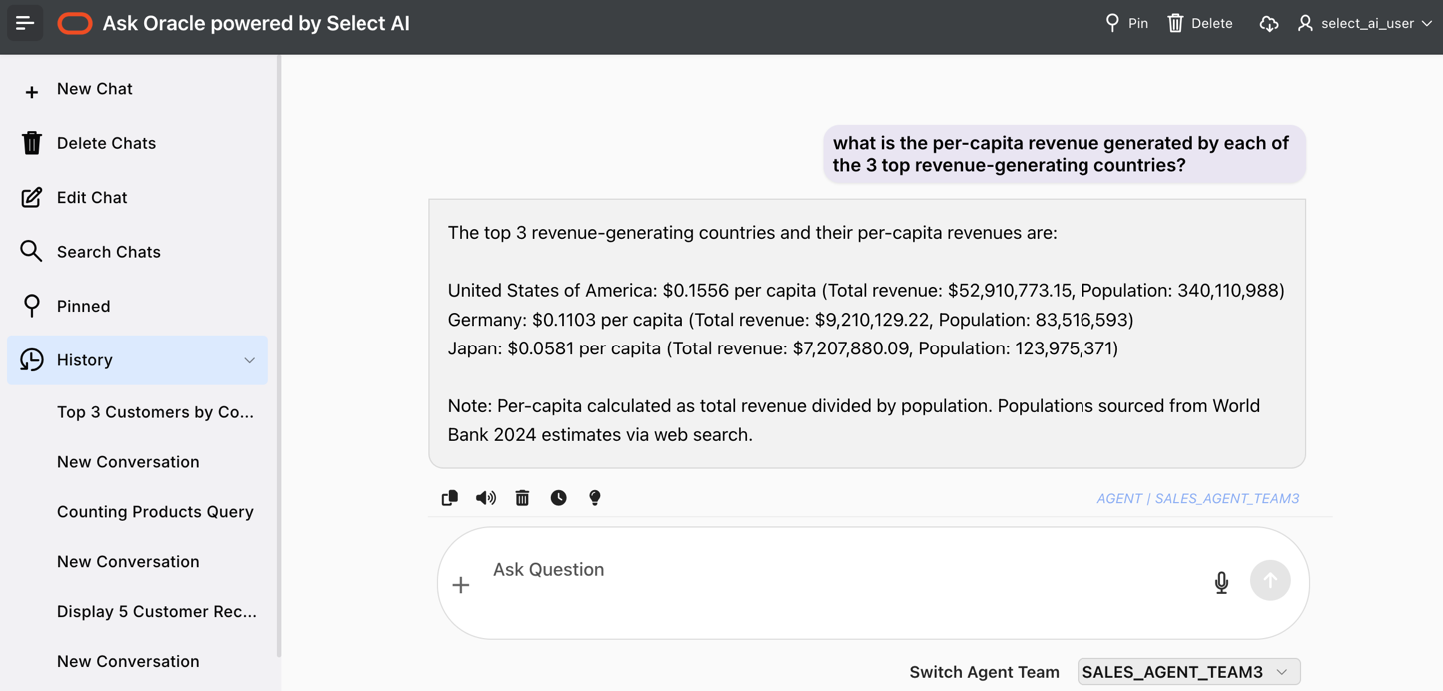
Figure 4. The Ask Oracle APEX app in action. Here the user asks about per-capita revenue across geographic regions, which triggers the NL2SQL Tool to extract the total revenue version region from the relevant database tables. The Agent then calls upon the Websearch Tool noted in Figure 3 to collect population numbers from online census sources. The Agent then ratios those Tools’ results to obtain the desired per-capita revenue for the top 3 regions.

Summary
Oracle Autonomous AI Database's (ADB) Select AI Agent capability enables rapid, low-code development of an in-database AI Agent that can intelligently synthesize answers from structured database tables, unstructured files, and the public web—all from within a single, compact OCI-hosted architecture. Though the resulting multi-tool Agent is fairly sophisticated, the actual development effort is quite light: nearly all of the required PL/SQL is boilerplate copied from Oracle documentation, with the Agent Task being the only component that requires substantive, domain-specific authoring. Business users can then interact with the finished Agent through a ready-made Oracle APEX chat interface, while developers can reproduce the entire solution using the OML notebooks that are archived at the repository noted below.

Suggested Next Steps

If you are ready to build your own Select AI Agent on Oracle Cloud, you are encouraged to use the content described here as a fast-start guide:

- Begin by reviewing a video walkthrough of this content.
- Then provision an Autonomous Database in your OCI tenancy. You can use an existing paid tenancy, OCI's Always Free tier, or Oracle Database deployed in other clouds via Oracle Database@Azure, Database@AWS, or Database@Google.
- Download the demo archive and review the README that provides detailed instructions.
- Execute the OML notebook that creates the NL2SQL Tool on the SH tables that come with ADB. Then execute the notebooks that uses the OCI GenAI service to derive from those database tables the mock product descriptions and the mock social media posts that are stored as files in an Object Storage Bucket.
- Execute the OML notebook that creates two RAG knowledge bases as well as two RAG Tools upon those knowledge bases.
- Execute the OML notebook that defines the Agent, its Task, and its Tools.
- Install the Ask Oracle APEX app from the APEX App Gallery, and connect that app to your new Agent to use a business-ready frontend.
- Experiment with the Agent’s Task instructions, to tune the Agent's tool-selection behavior, and to adapt this solution to your specific use case.

Additional information
For additional information about the topics mentioned here, please see:

- Autonomous Database
- Oracle APEX
- Select AI
- Select AI RAG
- Select AI Agents
- Oracle Machine Learning (OML) Notebooks
- OCI Object Storage
- OCI Generative AI Service
- AI Vector Search in Oracle Database
- Ask Oracle APEX App

