Bonnie Cooper & Associates
1611 Dakota • League City, Texas 77573-7231
(713) 338-9338 • bcooper@ghgcorp.com

Final Report

An Analysis of the Lunar Exospheric Dust and Sodium, as well as the Zodiacal Light, from the Clementine “Lunar Horizon Glow” Images

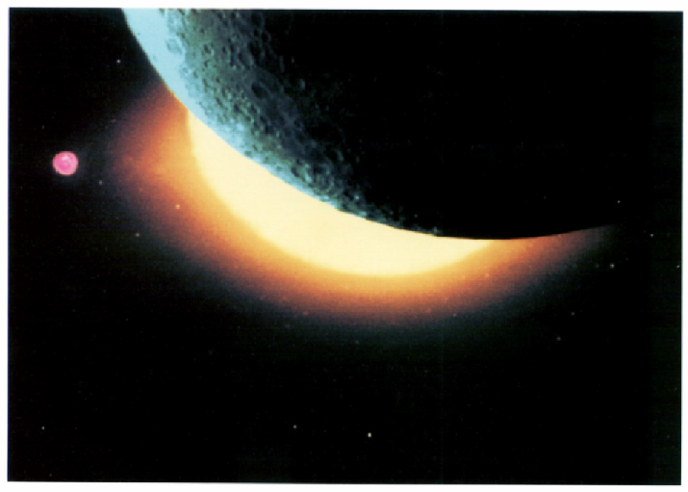

Submitted to:

Herbert A. Zook
NASA Johnson Space Center
Houston, Texas 77573

November 1, 1996

Final Report

Summary of Tasks Completed
A. An analysis of 100 Clementine star-tracker images with the following subtasks for each image:
1. Removal of thermal background
2. Streak removal
3. Flatfield correction using flatfield photographs
4. Absolute brightness calibration
B. Obtain stellar spectra distributions on stars of known stellar magnitude in order to do absolute image brightness calibration.
C. Assist in laboratory analysis of the scattering properties of the ND2 neutral density filter.
D. Deliver final report to the Principal Investigator. This report will describe in detail the procedures used to carry out the above tasks.
All of the tasks listed above have been completed.

Detailed Procedure Description

In order to determine the absolute brightness of the Lunar Horizon Glow and Zodiacal Light seen in the Clementine images, we must correct each image so that brightness variations caused by camera effects do not interfere with brightness variations due to the scene being observed. After the camera corrections have been done, we must also understand the significance of the digital numbers (brightness values) in the various parts of each image.
Prior to starting the tasks named in the S.O.W., it was necessary to download approximately 917 image files from the “Batcave”, and convert them to IRAF format. Of these, 638 Startracker images show the lunar horizon, and deserve further study. It will be necessary to choose about 100 of these for thorough examination.

Task #A1, Removal of Thermal Background:
In addition to the signal generated by the light itself, every pixel in a CCD camera has a different zero point (bias), sensitivity, and response to temperature (dark current). Normal procedure for an imaging CCD is to take a “dark frame”--an exposure of the same duration as the raw image but with no light allowed to strike the CCD. This provides information about what the internal pixel-to-pixel variations are on the CCD. Subtracting each pixel in the dark frame from the corresponding pixel in the raw frame removes the bias and thermal signals, leaving only the signal generated by light striking the CCD (Berry, 1994). We have not been able to locate darkframe exposures for the Clementine Startracker cameras. Moreover, these cameras were operated without active cooling, and so their temperatures vary somewhat depending on where the Clementine spacecraft was in its orbit. This causes the thermal electrons per CCD pixel, which usually number several thousand electrons, to vary even more than a temperature-stable CCD camera system.
A formula developed at Lawrence Livermore to subtract the thermal electrons from the flatfield exposures is:
D = (t + 54.8) * 0.0189 * [e^{(0.097*T)}] +150 - (8.1 * offset)
where
D = Darkcurrent correction
t = exposure time in milliseconds
54.8 is the readout time of the CCD
T = temperature of the CCD in degrees Centigrade
offset=offset mode I.D. number from the image header
For orbit 66, T= -1.646°C and t=199.9392 milliseconds. The darkcurrent for each frame in orbit 66 would therefore be 32.59 dn. This is a reasonable result for orbit 66, because the minima in the images were from 34 to 37 dn. Subtracting 32.59 dn from each would leave minimum values of 2.59 to 5.59 dn.
As a double-check on this darkcurrent removal scheme, we also developed a method of calculating the average darkcurrent based on the images themselves. We chose a 100-pixel block in a dark-moon area of each image and found its average. Then we used IMEXAMINE to determine the mean, standard deviation, minimum and maximum of the intensity of that block of pixels. The results for some of the images in orbit 65 are shown in Table 1, and a complete list for orbit 66 is given in Appendix I.

Table 1. Examples of 100-pixel darkcount calculations Image Image
MEAN MEDIAN STDDEV MIN MAX Min Max
lba0008v.066.imh 40.92 41 1.079 36 43 36 213
lba0009v.066.imh 40.88 41 0.9773 39 43 35 194
lba0010v.066.imh 40.7 41 0.8704 39 43 36 206
lba0011v.066.imh 40.74 41 0.7865 39 42 37 255
If we subtract the means given in Table 1 from all pixels in the image, there will be negative numbers in the darkest parts of the image. This is ok, because we have calculated the average darkcurrent, and it is to be expected that some of the pixels will have values above that and others below. Thus we should expect to have some negative pixels if we subtract the average darkcurrent from each of them.

Task #A2, Streak Removal:
Because the Clementine Startracker camera does not have a shutter, the camera remains exposed to light throughout its imaging cycle. The camera takes up to 0.7 seconds to gather an image, then an additional 0.97 microseconds to shift that image out of the CCD and into its memory registers. During the time that the shift is occurring, the CCD is still exposed, and any bright light in the field of view will be added to the march of pixels across the CCD. If there is a bright object in the image, then pixels that are at column positions above and below that bright spot not only record their own primary image location for time T, but each element is also exposed to the bright region for a lesser time, τ. This causes a “streak” in the resulting image, as seen for the Zodiacal Light in Figure 1.
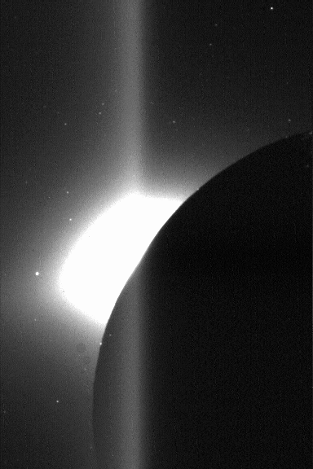
Figure 1. Uncorrected Clementine Startracker iamge showing streak. See text for discussion.
We developed two methods to reduce/eliminate the streaks. Method A involves a matrix transformation and Method B involves “dark Moon subtraction”, as defined below.
We want to obtain an image as would be seen with only the prime exposure, T (i.e., we want to get rid of the streak). If we let Mij equal the measured pixel response at each i, j (row, column) position, and Aij equal the "actual" pixel response that would occur due only to exposure, T, then we must solve n simultaneous equations, where n = 576 (the number of rows in the Star Tracker CCD), to obtain the Aij. The elements of the resulting matrix equation are given by
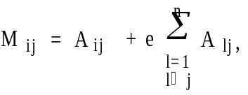
where Aij = aijT and e = τ/T. The aij values are responses per unit time of exposure. The inverse matrix elements are given by
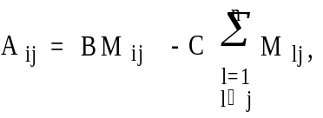

The above method of streak removal only works when image pixels are not "saturated". Saturation occurs when the integrated brightness of the image exceeds 256 digital units (each eight-bit digital unit corresponds to 75 electrons when the camera is operated in the most sensitive mode, which was usually the case for the LHG images). When such saturation occurs, Method B can be used. This involves obtaining an "average background" row for those rows in the darkest part of the image, and subtracting it, line by line, from the entire image. When the very dark Moon (unlit by Earth shine) covers several rows of the image, suitable background rows may be taken from that area, since these pixels have much less than one digital unit of true image brightness. This procedure was used to obtain Figure 2. The UV/Vis camera also has no shutter, but it operates in 'frame transfer' mode, which greatly lessens the 'non-primary' exposure times that tend to make streaks.
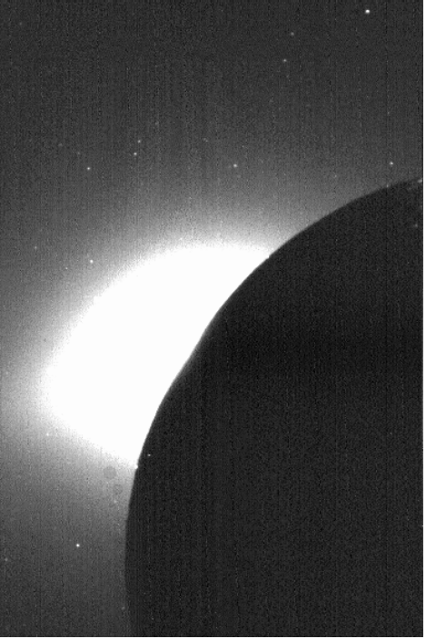
Figure 2. Image shown in Figure 1, after streak removal routine. See text for details.

Task #A3, Flatfield Correction:
In addition to the thermal noise correction mentioned in Task #1, a “flatfield” frame is also taken to calibrate the CCD. This is an exposure with the camera aimed at a uniformly illuminated source. Dividing each image pixel by the corresponding pixel in the flatfield frame removes the effects of sensitivity variations and vignetting in the optical system. Flatfield images were obtained from Josh Resnick of Research Support Instruments, Inc. These consisted of 54 flatfield images of StarTracker A, and 54 flatfield images of StarTracker B. The flatfield data set for StarTracker A contains images of all three gain settings (approximately 350 e⁻/count, 150
e⁻/count, and 75 e⁻/count. Six different integration times were used and three images were taken at each setting. However, all of the highest-gain images were saturated out, as were the higher integration times on the middle and lower gain settings. The integrating sphere lamps were set to 3.8x10⁻⁶ W/cm²/sr/μm at 650 nm, with the 2.0 ND Wratten filter placed on the startracker baffle.
For the 54 StarTracker B images, an offset of 160 counts was used, and consequently there are fewer saturated images. The integrating sphere lamps were set to 3.5x10⁻⁶ W/cm²/sr/μm at 650 nm, again with the 2.0 ND Wratten filter in place.
Before the flatfield corrections were done, we made darkcurrent corrections on each of the flatfield images. We subtracted the value d from each pixel in the image, where d was derived from the formula
d=(t+54) * m *exp(.097*T) + n - p
where t is the exposuire time in milliseconds, m = {.005, .010, .0189} depending on the gain setting of the camera, T is the CCD temeprature in degrees Celsius, n={36, 76, 150} depending on the gain setting, and p= 160 for the StarTracker B flatfields, 0 for the StarTracker A flatfields. (While doing darkcurrent corrections on the regular images, p=8.1*(offset mode ID#)). The following table shows the flatfield images that were used, the darkcurrent that was subtracted, and the resulting image name that was assigned to each product:

Name Less Darkcount New Name | Name Less Darkcount New Name
AFB31060 91.42 A31060dark | AFB31061 91.42 A31061dark
AFB31062 91.42 A31062dark | BFB32060 19.14 B32060dark
BFB32061 19.14 B32061dark | BFB32062 19.14 B32062dark
BFB62060 29.55 B62060dark | BFB62061 29.55 B62061dark
BFB62062 29.55 B62062dark

Next we normalized the images so that the highest value (in the center of the image) would be set ;equal to 1. This was necessary so that when we divide each image by the flatfield image, we will have values in the resulting image which are of the same order of magnitude as the values in the original images. The following table shows the darkcurrent images, the mode of the image, and the image name of the resultant image that was derived by dividing each image by its mode:
Darkcurrent Corrected Image | Mode | Darkcurrent Image / Mode =
A31060dark.imh | 109.9 | nrmlA31060.imh
A31061dark.imh | 109.8 | nrmlA31061.imh
A31062dark.imh | 109.8 | nrmlA31062.imh
BFB32060.imh | 155.1 | nrmlB32060.imh
BFB32061.imh | 155.1 | nrmlB32061.imh
BFB32062.imh | 155.3 | nrmlB32062.imh
BFB62060.imh | 206.1 | nrmlB62060.imh
BFB62061.imh | 199.1 | nrmlB62061.imh
BFB62062.imh | 208.0 | nrmlB62062.imh

After this, we created average images from each of the three image sets. The following table shows the sets of three images that were averaged together, and the resulting image names:
Three Images that were averaged together: |  |  | Resulting Image:
nrmlA31060.imh | nrmlA31061.imh | nrmlA31062.imh | normalAcomb.imh
nrmlB32060.imh | nrmlB32061.imh | nrmlB32062.imh | normalB3comb.imh
nrmlB62060.imh | nrmlB62061.imh | nrmlB62062.imh | normalB6comb.imh

These darkcurrent-corrected, normalized and averaged flatfield images are now used to do flatfield corrections on the StarTracker images in our dataset. The sensitivity of each pixel varies depending on the pixel position. Dividing each image by the appropriate flatfield image corrects the image for the changing sensitivity of the CCD.

Task #A4, Absolute Brightness Calibration:
In order to know precisely how much horizon glow and Zodiacal Light brightness is represented by each image, it is important to establish a reference by which we can compare any pixel’s intensity against a standard. Images of stars and planets of known magnitude and spectral energy distribution can be used for this task. There are identifiable stars in practically all of the Startracker images, and they have different intensities in images with different exposure times. Their visual magnitudes and spectral types (corrected for extinction) have been compared with one another and with the LHG and Zodiacal Light.
For the StarTracker (without optics) we have 6.67x10¹⁶ electrons/cm²-sec. We can reduce this to a solar-type star of magnitude ⁺2.80 (such as β Hydri):
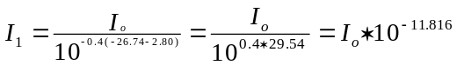
.

Now considering the StarTracker optics and throughput, f=1.74 cm and f/D = 1.25, ⇒ D=1.392 cm. The area of the object would be
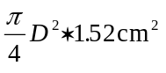.
Assume the optical throughput is 0.4 (i.e., 40% of the photons striking the optics make it through to the CCD). The effective area is then
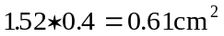.
The total image on the CCD is then
.
Now assume, for a 200 millisecond exposure, 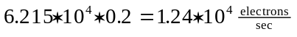
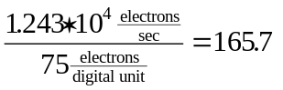 digital units.

Task B, Obtain Stellar Spectral Distributions of Stars of Known Brightness:

Spectral distributions from 3200 Å to 10,200 Å have been obtained for the following stars:
HD209750, α Aqr, spectral type G2 Ib, visual magnitude 2.90, star in double system
HD204867, β Aqr, spectral type G0 Ib, visual magnitude 2.91, star in double system
HD196524, β Del, spectral type F5 IV, visual magnitude 3.63, spectroscopic binary
HD188512, β Aql, spectral type G8 IV, visual magnitude 3.71, variable star

Spectral information from 3200 Å to 8175 Å was also obtained for:
HD2151, β Hyi, spectral type G2 IV, visual magnitude 2.80, stellar analogue

No continuous spectrum from 3200 Å to 10200 Å was found for any of the above stars. Instead, for the first four, two data sets were merged to create a model spectral continuum. For the fifth star, β Hyi, the only available data were from 3200 Å to 8175 Å.
The values from 3200 to 8174 were obtained from the online catalogue “/pub/adc/archives/catalogs/3/3126” at Goddard Space Flight Center. These data were contributed by V.I. Burnashev (1985). Because the paper which describes the spectral reductions is in Russian, it was not possible for us to get the information directly. Instead, we must rely upon the sketchy information given in the GSFC supplementary “readme” file, which says that “...The absolute calibration based on energy distribution of the primary standard Alpha Lyrae, according to Kharitonov, being the mean of the absolute calibrations of Kharitonov et al., Hayes and Latham, Tug et al.” According to the readme file, the numbers express the logarithm of energy in ergs/s/cm²/cm. Thus the first step is to use each number as an exponent of the base 10. The number derived can then be plotted and compared to a solar spectrum or to a Planck blackbody curve to verify that it is the same general shape (Figure 1).
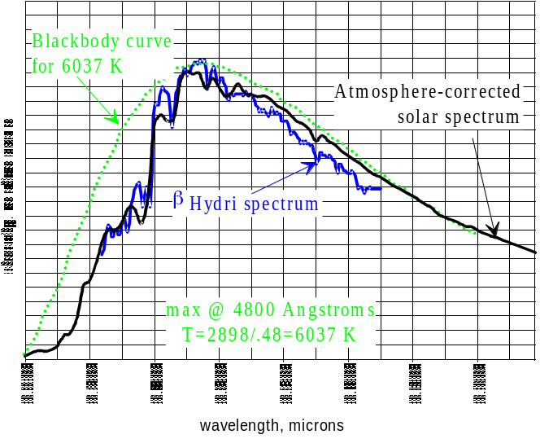
Figure 1. Star spectrum, solar spectrum and Planck blackbody curve for 6037K, to show general agreement of star spectrum shape with the other two curves. Star is β Hyi, HD 2151.
Although the values given were reported as being in absolute intensity units, it was found that the numbers corresponding to the intensity at the visible wavelength were not consistent with the relation
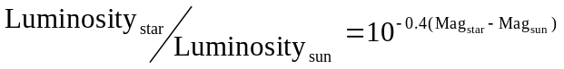
Consequently we determined a ratio factor at λ=5500. This number was used as a multiplier on Burnashev’s (1985) data, to obtain spectra that looked the same, but now satisfy the above relation. The ratioing factors determined were as follows:
β Aql, “corrected Willstrop” data: 5.746*10⁵
β Aql, Crimean data: 5.204*10⁵
β Hyi, Chilean data: 5.500*10⁵
β Hyi, “corrected Willstrop” data: 1.254*10⁶
β Del, Crimean data: 5.475*10⁵
β Del, Chilean data: 5.513*10⁵
β Del, Moscow data: 5.893*10⁵
β Aqr, Crimean data: 5.005*10⁵
β Aqr, Chilean data: 5.425*10⁵
β Aqr, Moscow data: 5.500*10⁵
β Aqr, “corrected Willstrop” data: 5.500*10⁵
α Aqr, Crimean data: 5.425*10⁵
α Aqr, Chilean data: 5.475*10⁵
α Aqr, Moscow data: 5.425*10⁵
α Aqr, “corrected Willstrop” data: 5.425*10⁵
We do not know whether these data have been corrected for atmospheric absorption; however, the close match of curve shapes between the corrected solar spectrum (Labs & Neckel (1970) and β Hyi, a solar analog (Figure 1), suggests that they have.
The second part of the spectra for all the stars (except β Hyi) were from data published by Danks and Dennefeld (1994). These data cover a spectral range from 5800 to 10200 Å. According to the authors, the sky spectrum has been subtracted from each stellar spectrum, and the cleaned spectra have been divided by the flat field, corrected for extinction, and divided by the spectral response curve in order to obtain flux. However, the published data still had absorption features which could not be accounted for by known stellar absorption features. Instead, they must be a result of atmospheric absorption. The absorption troughs at 6844-6932 Å, 7576-7696 Å, and 9288-9664 Å by fitting a line between the endpoints (see Appendix II). Figure 2 shows an example of the Danks and Dennefeld (1994) spectra, before and after removal of the atmospheric absorption features.
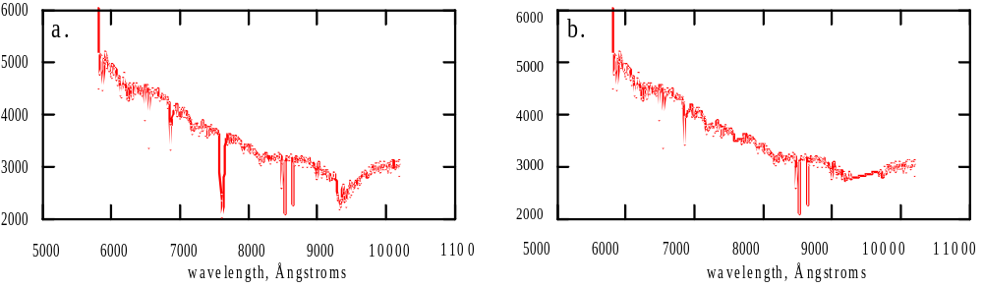
Figure 2. a) Example of a long-wavelength spectrum with atmospheric absorption features, and b) the same spectrum after the absorption features have been averaged out. This spectrum is for HD 209750, α Aqr.
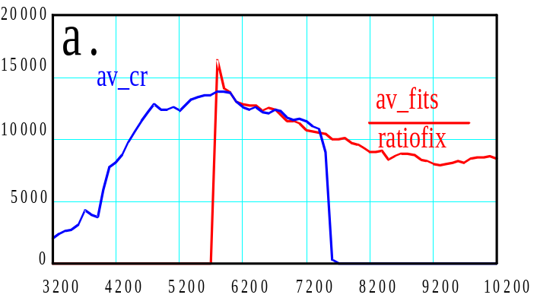
Figure 3a. The long-wavelength spectrum(red) has been divided by a ratio factor in order to correspond to the short-wavelength spectrum (blue). Names shown for the curves refer to Mathcad variable names.
After making the correction for the atmospheric absorption, the next step was to fit each star’s 3200-8175 Å spectrum with its corresponding 5800-10200 Å spectrum. The short-wavelength spectrum was averaged over every 4 data points (originally 25 Å resolution) and the long-wavelength spectrum was averaged over every 25 data points (originally 4 Å resolution). Figure 3a shows the fit of the two spectra as well as their appearance after averaging.
The two spectra were spliced together in Mathcad by using a short program which specifies that the value of the short-wavelength spectrum will be used whenever the wavelength is less than or equal to 6500, and the long-wavelength spectrum will be used otherwise. Figure 3b shows the spliced spectrum.
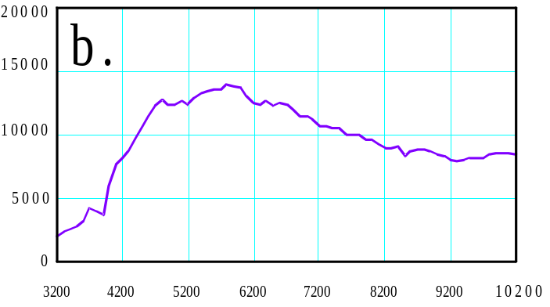
Figure 3. b) Spliced spectrum for the star HD 209750, α Aqr.

Variable Stars
Of the five candidate stars found, three were listed as variables; however, they type and period of variability were not found in the literature. Consequently, we did our own analysis of the available data to find out the variability of all five stars. We used the reported values of visual magnitudes from the SIMBAD database and did scatter plots of each value versus the year in which the observation was reported. The results of this variability analysis are shown in Figure 4. It is evident that the stars which were classed as variables were not highly variable; and indeed, in some cases, the “non-variable” stars showed as much or more variability in their reported visual magnitudes as the “variable” ones. Furthermore, the star β Hyi, HD 2151, was listed in the SIMBAD database as a variable star, but this was disputed in the literature (Dravins et al., 1993), and it truly is not a variable, as shown by Figure 4.
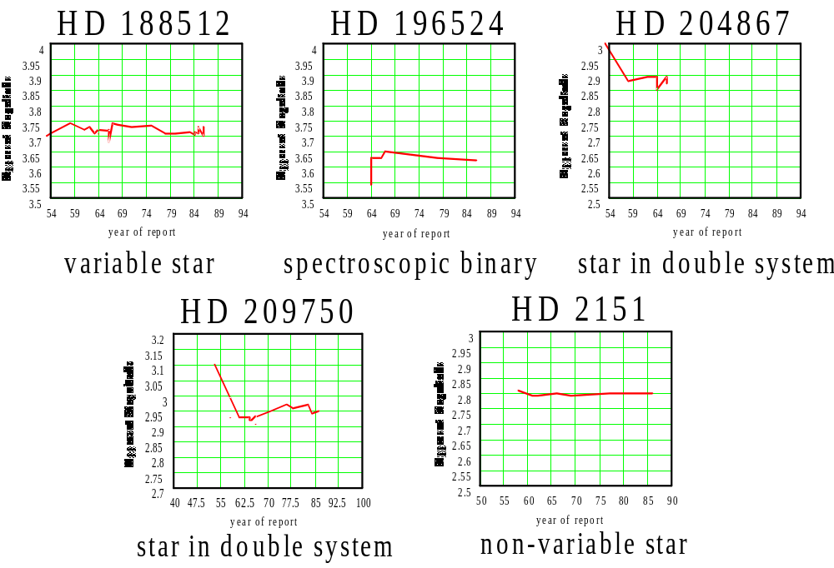
Figure 4. Variability in visual magnitude observations for selected stars. The non-variable star HD2151 was reported in the literature as a variable. None of the variations are greater than 0.2 magnitudes.
Task C, Assist in Laboratory Analysis of the Scattering Properties of an ND2 Neutral Density Filter:
An ND2 Neutral Density Filter was acquired from Josh Resnick at Research Support Instruments, Inc. Arrangements were then made with Manny Lott and Bill in Building 15 to use the optical laboratory there to perform light scattering experiments on this ND2 filter. We have assisted with this procedure.
Task D, Deliver Final Report to the Principal Investigator:
This report is the Final Report, describing in detail the procedures used to carry out the above tasks.

References
Burnashev, V.I. (1985) Abastumanskaya Astrofiz. Obs. Bull. 59, 83.
Danks, A.C., and Dennefeld, M (1994) An Atlas of Southern MK Standards from 5800 to 10,200 Å. Pub. Astron.Soc.Pac., 106, 382.
Dravins, D., Lindegren, L., Nordlund, A., and VandenBerg, D.A. (1993) The distant future of solar activity: A case study of b Hydri. I. Stellar Evolution, lithium abundance, and photospheric structure. A.J., 403, 385-395.
Labs, D., and Neckel, H. (1970). Transformation of the absolute solar radiation data into the international practical temperature scale of 1968. Solar Physics, 15, 79-87.

Appendix 1. Darkcurrent Calculations by "Hand", orbit 66
Image Image
MEAN MEDIAN STDDEV MIN MAX Min Max
lba0008v.066.imh 40.92 41 1.079 36 43 36 213
lba0009v.066.imh 40.88 41 0.9773 39 43 35 194
lba0010v.066.imh 40.7 41 0.8704 39 43 36 206
lba0011v.066.imh 40.74 41 0.7865 39 42 37 255
lba0012v.066.imh 40.72 41 0.922 38 43 37 255
lba0013v.066.imh 40.55 41 0.9783 38 42 36 255
lba0014v.066.imh 40.48 41 0.8466 38 42 36 255
lba0015v.066.imh 40.63 41 0.6765 39 42 35 255
lba0016v.066.imh 40.69 41 1.042 39 48 36 255
lba0017v.066.imh 40.32 40 1.004 39 47 35 255
lba0018v.066.imh 40.47 41 1.068 39 47 35 255
lba0019v.066.imh 40.28 40 1.207 38 47 35 255
lba0020v.066.imh 40.41 40 1.111 38 47 35 255
lba0021v.066.imh 40.2 40 1.092 38 47 35 255
lba0022v.066.imh 40.32 40 1.004 39 46 35 255
[lba0023v.066.imh 40.28 40 1.173 38 47 35 234
lba0024v.066.imh 40.22 40 1.115 38 47 35 255
lba0025v.066.imh 40.08 40 1.203 38 47 35 255
lba0026v.066.imh 40.17 40 1.164 38 47 35 255
lba0027v.066.imh 40.37 40 1.125 38 48 35 255
lba0028v.066.imh 40.08 40 1.178 38 47 35 255
lba0029v.066.imh 40.19 40 1.022 38 46 35 254
lba0030v.066.imh 40.01 40 1.193 38 47 35 255
lba0031v.066.imh 40.1 40 1.259 37 48 35 255
lba0032v.066.imh 40 40 1.295 36 47 35 255
lba0033v.066.imh 40.09 40 1.364 36 47 35 255
lba0034v.066.imh 39.86 40 0.9537 38 42 35 216
lba0035v.066.imh 39.94 40 1.023 38 45 35 207
lba0036v.066.imh 39.84 40 1.187 37 46 35 223
lba0037v.066.imh 40.06 40 0.8143 38 42 35 197
lba0038v.066.imh 39.98 40 0.8987 38 42 35 195
lba0039v.066.imh 40.12 40 0.8442 39 42 35 195
lba0040v.066.imh 40.15 40 1.019 38 43 35 197
lba0041v.066.imh 40.11 40 0.8275 38 42 35 203
lba0042v.066.imh 40.01 40 0.8703 38 42 35 204
lba0043v.066.imh 40.15 40 0.8919 38 42 35 252
lba0044v.066.imh 40.09 40 0.9959 37 42 35 222
lba0045v.066.imh 40.33 40 1.272 37 44 35 235
lba0046v.066.imh 40.01 40 1.01 36 42 34 240
lba0047v.066.imh 40.21 40 0.9022 37 42 35 238
lba0048v.066.imh 40.24 40 0.9547 37 43 35 244
lba0049v.066.imh 40.1 40 0.9156 38 42 35 255
lba0050v.066.imh 39.89 40 0.9733 37 42 35 255
lba0051v.066.imh 39.58 40 0.901 37 41 35 255
lba0052v.066.imh 39.73 40 0.9085 37 42 34 255
lba0053v.066.imh 39.85 40 1.019 37 43 35 255
lba0054v.066.imh 40.17 40 0.8172 38 42 34 255
lba0055v.066.imh 40.26 40 0.9059 38 42 35 255
lba0056v.066.imh 40.25 40 1.058 38 43 35 255
lba0057v.066.imh 39.95 40 1.114 37 42 35 255
lba0058v.066.imh 40 40 0.9949 37 42 35 255
lba0059v.066.imh 39.92 40 0.849 38 42 35 255
lba0060v.066.imh 39.6 40 1.155 35 42 35 255
lba0061v.066.imh 39.73 40 0.9305 38 42 35 255
lba0062v.066.imh 39.44 39 1.038 38 42 35 255
lba0063v.066.imh 39.56 40 1.095 35 42 34 255
lba0064v.066.imh 39.53 39 1.01 37 42 34 255
lba0065v.066.imh 39.75 40 0.9252 38 42 35 255
lba0066v.066.imh 39.8 40 0.964 38 43 35 255
lba0067v.066.imh 39.64 39 0.959 37 42 35 255
lba0068v.066.imh 39.56 39 0.9777 37 42 35 255
lba0069v.066.imh 39.71 40 1.057 37 43 35 255
lba0070v.066.imh 39.71 40 0.9775 38 43 35 255
lba0071v.066.imh 39.65 40 0.9783 38 42 35 255
lba0072v.066.imh 39.82 40 0.9469 38 42 35 255
lba0073v.066.imh 39.88 40 1.028 37 42 35 255
lba0074v.066.imh 39.93 40 0.9129 38 42 35 255
lba0075v.066.imh 39.98 40 0.8874 38 42 35 255
lba0076v.066.imh 39.87 40 1.107 37 43 35 255
lba0077v.066.imh 39.95 40 1.048 37 42 35 255
lba0078v.066.imh 40.2 40 0.8646 38 43 34 255
lba0079v.066.imh 40.28 40 0.9329 38 42 35 255
lba0080v.066.imh 40.22 40 0.8596 38 42 35 255
lba0081v.066.imh 40 40 0.8989 38 42 35 255
lba0082v.066.imh 40.04 40 0.942 38 43 33 255
lba0083v.066.imh 40.14 40 1.092 37 42 35 255
lba0084v.066.imh 40.11 40 1.014 38 43 35 255

