TABLE OF CONTENTS

Lunar and Asteroid Data Analysis Program Cover Sheet i
Co-Investigators ii
Proposal Summary Form iii
Budget Summary, First Year iv
Budget Summary, Second Year v
Full Budget Summary vi
Current and Pending Support vii
Table of Contents x
Abstract 1
Introduction and Background 1
The Dust LHG (Lunar Horizon Glow) 2
Surveyor LHG Observations 2
Apollo 17 Astronaut Naked-Eye Observations of LHG 2
Lunokhod II and Apollo 16 Surface UV Observations 3
Apollo 17 LEAM 4
Sodium and Potassium Exosphere 4
The F-Corona and Zodiacal Light (CZL) 5
Clementine Data and Early Observations 7
Clementine LHG 7
Clementine CZL 9
Project Description and Analysis Procedure 9
1. Removal of thermal background electrons 9
2. Streak removal 10
3. Flatfield corrections 11
4. Calibration of images to absolute brightness 12
5. Determine solar depression angle, and locate pixel position of occulted Sun 12
6. Model and remove the zodiacal light from the images 13
7. Analyze dust density as a function of altitude above the Moon 14
8. Analyze sodium density as a function of altitude above the Moon 14
9. Prepare one or more mosaics of the CZL images 14
10. Analyze dust density in interplanetary space 15
Statement of Work 16
References 17
Personnel 20
Facilities and Equipment 21
Proposed Costs 22
Resumes 25
Special Matters 31

An analysis of the lunar exospheric dust and sodium, AS WELL AS THE ZODIACAL LIGHT as revealed in the clementine ‘horizon glow’ images

Abstract
We propose to analyze the Lunar Horizon Glow images that were taken by the Clementine Star Tracker cameras, to learn more about the dust exosphere of the Moon. There is strong evidence for a dense cloud of dust above the lunar surface. The origin of this cloud is not established beyond question at present, although persuasive arguments have been put forward for electrostatic transport of dust over the lunar surface. The Star Tracker cameras on board the Clementine spacecraft have adequate sensitivity to photograph this sunlit dust cloud, while the spacecraft was on the dark side of the Moon. We also propose, as a secondary goal and using the Moon as a Sun-occulting shield, to analyze the Solar F-Corona and Zodiacal Light (CZL). The analysis procedure involves removal of thermal noise from the images, streak removal, flatfield correction, calibration of images to absolute brightness, locating the x-y position of the occulted sun in each image, and locating the symmetry plane of the CZL. We can then model and remove the zodiacal light from the images, which will allow us to isolate the brightening caused by dust alone, and analyze its density as a function of altitude above the Moon. An additional benefit of this procedure is that we will develop a model of the zodiacal light and gain information about the inner solar system dust cloud that causes it.

Introduction and Background
There is strong evidence, from five independent measures, of a surprisingly dense cloud of dust above the lunar surface. The origin of this cloud is not established beyond question at present, although Criswell [1972 and 1973] has put forward persuasive arguments for electrostatic transport of dust over the lunar surface. This dust exosphere can not be primarily attributed to ejecta from impacts by interplanetary meteoroids, for two reasons. First, the spatial density of dust in the cloud is far too high to be caused by meteoroid impact ejecta. Second, in-situ measurements of the local dust impact rate peaks sharply at local lunar sunrise and sunset, and it is unreasonable to expect such a time variation to be due to meteoroid impacts.
Zook and Potter [1993], in a proposal submitted to NASA Headquarters and to the Naval Research Lab's Clementine Project, showed that both the UV/Vis and Star Tracker cameras onboard the Clementine spacecraft should have adequate sensitivity to photograph this sunlit dust cloud, as a Lunar Horizon Glow (LHG), while the spacecraft was on the dark side of the Moon. It was also proposed, as a secondary goal and using the Moon as a Sun-occulting shield, to photograph the Solar F-corona and zodiacal light (CZL). Because of the great range of brightnesses expected for CZL measurements at different angular elongations from the Sun, a large range of exposure times were used. Zook and Potter (1993) further recognized that the neutral Sodium LHG (with an approximate 100 km scale height) might also be visible to the Star Tracker camera. The proposal was submitted too late to be considered under NASA NRA-93-OSSA-2, and therefore was not funded. Nevertheless, the Naval Research Lab and the Clementine Science Team carried out an extensive program of CCD photography of LHG and CZL during the mission. Over 600 LHG frames were taken.
A short summary of current knowledge of the dust LHG, the Sodium LHG, and the CZL is given below.

The Dust LHG (Lunar Horizon Glow).

Figure 1. Two Surveyor 7 photographs of the same area, superimposed and offset. One is before, and the other after, sunset. A glow is clearly seen following the topography of the horizon.
Surveyor LHG Observations: A narrow glow was observed to extend above and along the sunset lunar horizon by the Surveyor 1, 5, 6, and 7 spacecraft, for up to two hours after sunset [e.g., Shoemaker et al., 1968; Criswell, 1972; Rennilson and Criswell, 1974]. This LHG was clearly distinct from the solar corona, and varied in brightness (energy per cm2 per second per unit solid angle) by over two orders of magnitude from Surveyor 6 to Surveyor 7 [Rennilson and Criswell, 1974]. The Surveyor 7 LHG (Figure 1) was the brightest observed, at a maximum brightness of approximately 0.3 candles per square centimeter, or about 10-6 B¤, for the first half hour after sunset, where B¤ is the average brightness of the Sun. This is comparable to the average brightness of the full Moon, which is about 2*10-6B¤. Criswell [1972, 1973] argued that this LHG, with a scale height of 10 to 20 cm, was caused by a cloud of lunar dust grains continuously being ejected above the lunar surface. He further argued that this ejection was due to electrostatic repulsion between charged lunar dust grains and a like-charged local lunar surface, as the LHG brightness was about 105 times too high to be due to meteoroid impact ejecta. He speculated that the charging was primarily due to solar UV photons ejecting electrons from sunlit portions of the Moon near the sunset terminator, and depositing them in nearby dark areas of the Moon (perhaps along local field lines). It is interesting to note that potentials up to -100 volts have been deduced from measurements made with the Suprathermal Ion Detector (SIDE) on the lunar surface during terminator crossing [Freeman and Ibrahim, 1975].
Apollo 17 Astronaut Naked-Eye Observations of LHG: Each of the three Apollo 17 astronauts observed and sketched an LHG with the unaided eye as their Command Module approached orbital sunrise at an altitude of 110 km [McCoy and Criswell, 1974; Zook and McCoy, 1991]. Figure 2 shows one of the sketches, by Command Module Pilot Ron Evans. The LHG is a narrow, dim glow surrounding both sides of the zodiacal light bulge, and exterior to the lunar limb in this sketch.
Figure 3 shows a series of sketches by Apollo 17 commander Gene Cernan, which show the development of LHG with time. The sketches depict the glow at time intervals of about 6, 3, 2 and 1 minutes, and at about 5 seconds, before orbital sunrise with a spacecraft motion of about 3° per minute. In addition to LHG, one notes the "streaks" in most of the sketches. McCoy and Criswell [1974] suggested that these were due to a lunar dust cloud that extended above the 110-km orbital altitude of the Apollo 17 spacecraft. The streaks were presumed to be caused by shadowing by lunar mountains. However, Zook and McCoy [1991] found that the LHG that astronauts observed above the lunar limb and to the side of the central bulge had a scale height of only 10 to 20 km. It seems unlikely that both streaks and LHG can be caused by the same lunar exospheric dust cloud, and some of us now feel that the streaks are caused by a spacecraft contamination cloud that has stretched out along the spacecraft orbit. Zook and McCoy [1991] estimated that the LHG brightness sketched by the astronauts was about
2*10-12 B¤. This brightness estimate was considered uncertain to a factor of 2 or 3, although a larger error in the estimate could not be ruled out.

Figure 2. Sketches of lunar horizon glow made from orbit during the Apollo 17 mission, by astronaut Ron Evans.

Figure 3. Sketches of lunar horizon glow made from orbit during the Apollo 17 mission, by Commander Gene Cernan.
Lunokhod II and Apollo 16 Lunar Surface UV Observations: The Soviet Lunokhod II lunar rover [Severny et al., 1975] measured the vertical brightness of the LHG when the Sun was about 1o below the western horizon, and obtained a brightness of 4*10-12B¤. The lunar shadow extended about 260 meters above the Lunokhod spacecraft at the time of measurement. The Lunokhod observation appears to confirm the astronaut brightness estimates, as interpreted by Zook and McCoy. An LHG was also photographed during the lunar day by the Lunar Surface UV camera (sensitive to light between 1050 and 1600 angstroms) that was placed on the Moon during the Apollo 16 mission [Page and Carruthers, 1978]. They attributed the observed LHG to a lunar dust cloud above the surface. Because these photographs were taken during lunar daytime, some mechanism other than the Criswell mechanism [1972; 1973; see also Berg, 1978] would have to operate. Perhaps it was charge separation of the impinging solar wind electrons and protons by the local lunar magnetic fields. One might note, in this regard, that the strange and poorly understood swirls associated with the Reiner Gamma crater are also associated with unusually strong local lunar magnetic fields [e.g., Hood and Williams, 1989]. Could electrostatic transport of dust cause the "swirl" phenomenon?
Apollo 17 LEAM: The Apollo 17 Lunar Ejecta and Meteorite (LEAM) experiment recorded an especially high flux of dust particle impacts during sunrise and sunset terminator crossings [Berg et al., 1975]. Figure 4 shows the number of particle impacts during three-hour intervals, summed over 22 lunations, plotted versus time in hours past lunar sunrise. This remarkable time variation of the impact rate makes no sense under impacts by interplanetary meteoroids. The Criswell mechanism [1972, 1973], however, does make understandable an increased impact rate as being due to increased electrostatic ejection of dust near lunar terminator crossings.
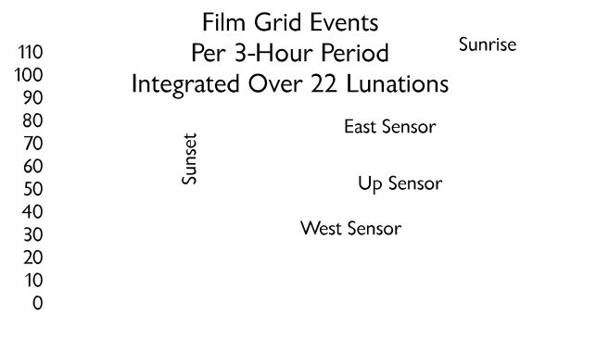
Figure 4.
Sodium and Potassium Exosphere.
Sodium and potassium in the atmosphere of the Moon have been detected by ground-based spectroscopic measurements of the emission lines of these elements, excited by resonant scattering of sunlight. The intensity of the emission above the bright limb at first and last quarter is about 4 kilorayleighs for sodium and 1 to 2 kilorayleighs for potassium. These intensities correspond to column densities of the order of 10⁸ to 10⁹ atoms/cm² for sodium and about 10⁸ atoms/cm² for potassium. The sodium and potassium atmospheres are in a state of dynamic equilibrium. The atoms are continually lost from the Moon by photoionization, solar radiation pressure, and thermal escape, and must be replaced by a steady source to balance these losses. Impact vaporization driven by infalling micrometeoroids, solar wind sputtering of surface rocks, and photon-stimulated desorption of sodium from surface rocks have all been proposed as possible sources for sodium and potassium. Sodium emissions sometimes almost disappear near full Moon. Potter and Morgan (1994) have suggested that this is evidence in favor of the sputtering hypothesis. This is because the Moon is partially shielded from solar wind protons when it is in the magnetotail.
The Clementine data offer a unique opportunity to study the sodium and potassium emissions at viewing angles unobtainable from a ground-based platform. For example, we can look along the Moon-Sun line above the lunar terminator when the Moon is outside the Earth’s magnetotail. This would test the hypothesis that solar wind sputtering is an important factor in generating these species.

Figure 5. False-color enhanced image from McDonald Observatory showing sodium glow in the lunar exosphere. Moon-Sun line is in the plane of the image, and terminator is perpendicular to the plane of the image.
The optical filters on Clementine are wide-band, and the detectors will see both the D₂ and D₁ lines of both sodium and potassium. If it were possible to view the lunar limb at first or third quarter, we expect that the total maximum sodium brightness would be about 6 kilorayleighs, and the total potassium brightness would be about 1.8 kilorayleighs, for a total of nearly 8 kilorayleighs. These intensities will only be seen for lines of sight that cross the subsolar point. The Clementine images are all views above the dark, or Earth-lit terminator, for which the emission intensity will be less by a factor of at least two, probably more. However it is precisely these data that are of interest, since the geometry cannot be duplicated from a ground-based observing platform. We estimate the S/N=1 sensitivity of both the Star Tracker camera to be about 1 kilorayleigh, so that the emissions should be just within the sensitivity capability of the instrumentation.
A significant question is how do we plan to discriminate between resonance emissions and light scattered by lunar dust? The scale height of resonance emissions will be of the order of several hundred kilometers, as opposed to tens of kilometers (or less) for the dust layer, so that we can use scale height as the discriminator.
The F-Corona and Zodiacal Light (CZL).
The zodiacal light is a faint glow of light barely visible to the unaided eye from the Earth's surface. It is brightest near the sun and decreases moving away from the sun along the plane of the ecliptic. It gradually brightens again in the anti-Sun direction and becomes the "gegenschein", whose brightness is estimated from Pioneer 10 and 11 measurements at 110 S-10 units* [Hanner et al., 1976] to about 150 S-10 units [Toller and Weinberg, 1985]. The zodiacal light grades into the F-corona near the Sun, which has a brightness of up to about 10-7B¤, (218 S10 units equals 10-13B¤) at small angular elongations from the Sun [e.g., Gillett et al., 1964]. By whatever name, all of these optical phenomena are the result of sunlight scattered off the dust cloud that constitutes the interplanetary meteoritic complex. This light, and the meteoroids that cause it, are mostly concentrated near the ecliptic plane. One can model the latitudinal and radial distribution, and the symmetry plane, of the dust that causes this light, by comparing variations in light brightness with observing direction (especially heliocentric latitude and longitude), and by assuming an angular light scattering dependence generated by the dust grains. It should then be possible to deduce the relative contributions of asteroidal and cometary dust; or, perhaps, other sources of dust may need to be postulated.
There are many writings on measurements of the CZL or on theoretical efforts to model the interplanetary dust cloud that causes this light (for excellent reviews, see, for example, Blackwell et al., 1967 for measurements; Leinert and Grün, 1990 for both dust and zodiacal light measurements and modeling; and Giese et al., 1986, on modeling). We wish here only to mention some of those publications that highlight the different types of measurements that have been made so far, and to point out some of the difficult problems that had to be dealt with. The contributions that the Clementine spacecraft observations will be able to make to a better understanding of the CZL brightness distribution with pointing direction will then become apparent.
The Pioneer 10 and 11 spacecraft measured the zodiacal light brightness versus distance of the spacecraft from the Sun, and versus solar elongation (angle from the Sun to the viewing direction) outside 1 AU [Hanner et al., 1976; Toller and Weinberg, 1985]. However, as Schuerman [1980] pointed out, these variables are not independent. He found that the variation of zodiacal light brightness, as the spacecraft moved radially outward from the sun, depended upon which solar elongation angle was used as a reference angle. The astrophysical cause of such variations was not then known, but we now think it is due, at least in part, to one or more heliocentric dust rings. Jackson and Zook [1989] predicted that there should be a ring of dust around the Sun that is shepherded by resonant perturbations of the Earth. Dermott et al. [1994], in a lovely analysis of the IRAS data, obtained clear infra-red observational evidence for the actual existence, and extent, of this ring. Reach et al. [1995] provided observational confirmation of the ring and additional details on it in their analyses of the infra-red COBE data. These analyses continue.
The radial variation of the brightness of zodiacal light, with heliocentric distances from 0.3 to 1 AU, was measured from Helios 1 and 2 by Leinert and his colleagues [Leinert et al., 1977, 1980, and many other papers]. They found, at constant elongation, that the brightness of the zodiacal light varied as r-2.3, corresponding to a dust spatial density varying as r-1.3, where r is distance from the Sun. They also established that the plane of symmetry of the zodiacal light was not the ecliptic plane but a plane inclined 3º to it, with an ascending node of 87º. The Helios spacecraft spun on an axis that was aligned with the ecliptic pole. There were three telescopes on board the spacecraft, each with a photomultiplier at its focus. One telescope continuously monitored the polar region (90o to the ecliptic), one was inclined 15o to the ecliptic plane, and one was inclined 30o to the ecliptic. The inclined telescopes continuously swept out circular arcs of the sky of 1 or 2 degree widths. Arc sectors of 5.6 to 22.5 degrees long were averaged to obtain a brightness value at a particular pointing direction. The closest that they could measure to the Sun along the telescope line-of-sight was 0.09 AU; from the Earth that would correspond to a solar elongation angle of about 5o. Clementine, by comparison, recorded data to within 0.1o elongation from the Sun.
Koutchmy and Lamy [1985] have published a short summary of CZL brightnesses and polarizations at small elongation angles from the Sun. Nearly all of these F-corona and inner zodiacal light measures were taken from the Earth during lunar eclipse of the Sun, and were done both in the visible and in the infra-red. The best visual wavelength studies were done, during solar eclipses, from a high flying airplane [see Blackwell et al., 1967] or from a balloon 110,000 feet above the Earth's surface [Gillett et al., 1964]. Even at the latter altitude, sunlight scattered from the terrestrial atmosphere was an order of magnitude brighter than was the CZL brightness at an elongation of 15o from the Sun. At a solar elongation of 3o, the two brightnesses were about the same. Thus, there were severe corrections for background sunlight scattered by the terrestrial atmosphere (which varied, depending on dust or ice clouds in the stratosphere). Inside about 1o elongation, the solar K-corona (light scattered by coronal electrons) needs to be separated from the F-corona. The early infrared observations seemed to show rings of dust at 4 to 9 solar radii from the Sun, but these were not seen in later measurements [e.g., Lamy et al., 1992; MacQueen and Greely, 1995], and are now thought to have been artifacts of the earlier observations.
Bohlin [1971] analyzed the image photometry of the inner CZL taken with the Surveyor 6 and 7 vidicon cameras on the Moon (e.g., Figure 1). The data were somewhat restricted because of constraints in the sensitivity and dynamic range of the Surveyor vidicon cameras. The Moon itself was used to occult the Sun. MacQueen et al. [1973] also used the Moon to occult the Sun, and carried out conventional photography of the inner CZL (approximately 1o to 12o elongation) with an astronaut-operated 70 mm Hasselblad camera. The photographs were taken with a high speed film (Kodak 2485) from the Command Module of Apollo 16 while it orbited the Moon. The authors were able to obtain two-dimensional brightness profiles of the inner CZL with these photographs. One caution concerning photographs taken from manned spacecraft, however, stems from work by McCoy [1976] who showed that, at least for CZL photographs taken from Apollo 15 and 17, there was a local component of brightness added to the CZL. McCoy thought that the local component was due to sunlight scattered off a lunar dust cloud with a scale height of about 100 km. Whether or not the Apollo 16 photography of MacQueen et al. [1973] was also contaminated by a "local component" is not yet entirely clear.

CLEMENTINE DATA AND EARLY OBSERVATIONS
Clementine LHG: A very dim LHG, at about 10-13B¤ brightness and with a scale height of 10 to 20 km, has been recorded with the Star Tracker camera on the Clementine spacecraft. It can barely be seen as a faint glow along the lunar limb (Figures 5 and 6). 10-13B¤ is about 20 times dimmer than was estimated from the astronaut sketches [Zook and McCoy, 1991]. The Clementine results are still somewhat uncertain, however, because corrections for camera characteristics, subtraction of the background zodiacal light, and subtraction of a possible Na vapor LHG (with a scale height of about 100 km) have not yet been taken into account.
This finding raises the question: why should the Clementine LHG be so much dimmer than the LHG observed by the Apollo astronauts? We offer three possibilities: (1) Zook and McCoy badly over-estimated the LHG brightness suggested by the astronaut sketches. (2) The astronauts were recording a "Mach band" effect [Gonzalez and Wintz, 1987; p. 19] where the human eye misinterprets sudden brightness changes. For example, when humans gaze at a surface of uniform brightness juxtaposed against a very dark region, they will appear to see an increased brightening of the uniformly lit region next to the boundary between the bright and dark regions. (3) The flux of solar far-UV photons that ejects energetic photo-electrons capable of highly charging the lunar surface is much lower at times of low solar activity compared to times of high activity. The Clementine observations were taken during a time of low solar activity (March and April 1994) compared to when the astronaut sketches were made (December 1972), and this may be the cause of the low Clementine LHG. The Lunokhod II observations tend to rule against reasons 1 and 2, but reason 3 remains viable at present.
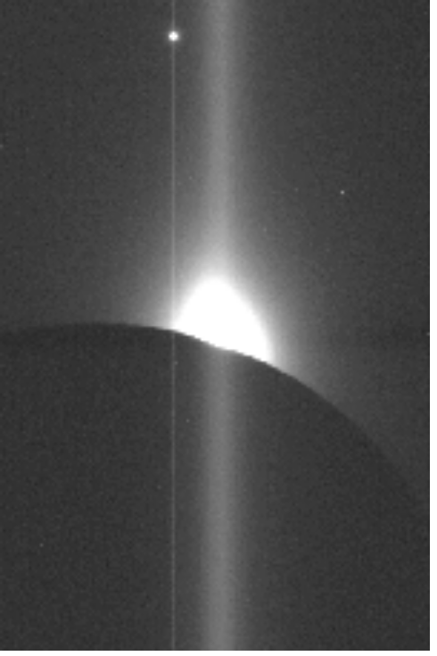
Figure 5. "Raw" imagery from Clementine Star Tracker camera, Orbit 273, Image #4 (exposure duration = 100 ms).
Notwithstanding the apparently low value of LHG recorded by Clementine, there remains little doubt that electrostatic transport of lunar dust occurs, and that it often dominates the meteoritic impact transport of lunar dust--at least at the small particle sizes recorded optically and by impacts on the Apollo 17 LEAM. Further, despite the excellent analyses of Criswell [1972, 1973] and Berg [1978], it must be said that the correct process of electrostatic transport has not yet been established beyond question. We believe that this process, whatever it is, represents an important astrophysical problem in its own right, and an understanding of it may well have application to certain problems in "dusty plasmas". It is therefore important to obtain the value and extent of the LHG measured by the Clementine spacecraft. Obtaining these values will require an exact separation of the dust LHG from all other sources of light, such as CZL and Sodium LHG.
Figures 5 and 6 show two versions of a single Clementine Star Tracker camera exposure. Figure 5 is the "raw" image, as it was transmitted to the ground, and Figure 6 is the same image after both the thermal electron background and the "streak" have been removed. The streak is due to the fact that the camera is operated without a shutter. Techniques of streak removal are discussed in the following section, "Project Description and Analysis Procedure".
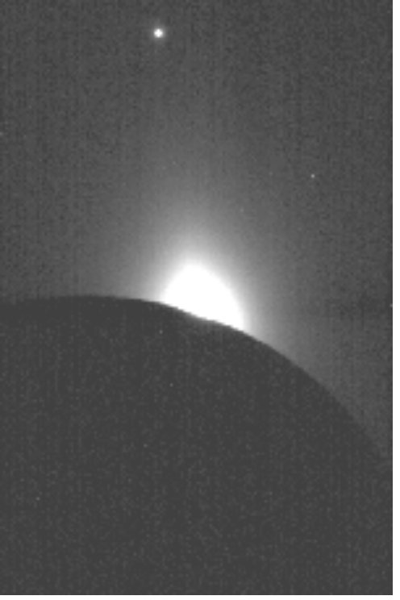
Figure 6. Image from Figure 5, after removing both the thermal electron background and the "streak".
Clementine CZL. Figures 5, 6 and 7 demonstrate the excellent potential of the Clementine images for studying the solar F-coronal and zodiacal light (CZL). Some of these images include solar depression angles of less than 1o (e.g., less than 1o elongation from the Sun) and many of the images show CZL beyond 20o elongation. Figure 7, with a look direction near the lunar south polar region, nicely displays the CZL brightness structure perpendicular to the ecliptic.

Figure 7. Clementine image from Star Tracker "B" camera, Orbit 193. Look direction is toward the south polar region. Bright object at upper-left-center is Venus. This image shows the CZL structure perpendicular and parallel to the ecliptic.
We believe that we can obtain the axis of maximum brightness of the CZL to about 0.1o, and that we can derive the inclination and ascending node of the cloud to about the same accuracy. We should also be able to derive an accurate model of the spatial density of the dust that gives rise to the observed CZL. The problems of obtaining a flat field image, and of deriving absolute photometry, are discussed in the next section.

Project Description and Analysis Procedure
The procedure that we will use to reduce the Clementine LHG and CZL images to photometrically correct images will follow generally along the path described by Berry [1994]. However, there are additional processing steps involved for the Clementine images. We lay out our entire analysis procedure below.
1) Removal of thermal background electrons. The Star Tracker and UV/Vis CCD cameras are operated without active cooling, and so their temperatures vary somewhat depending on where the Clementine spacecraft is in its orbit. This causes the thermal electrons per CCD pixel (usually several thousand) to vary with time. To a first approximation we can use a formula developed at Lawrence Livermore to subtract off the thermal electrons. When we also have a part of the Moon in the picture that is not illuminated by either the Sun or the Earth, we can further require that the formula be adjusted to give a "null" result on the dark Moon. (Starlight on the Moon should result in significantly less than one digital unit.)
2) Streak removal. Because the Star Tracker camera did not have a shutter, the CCD was continuously exposed. Consequently, additional CCD photon recording--beyond the primary exposure time--occurs during the time of CCD "read out". Each pixel records the local time-integrated image intensity at its location in the CCD during the primary exposure time, T, by the creation of a corresponding number of electron-hole pairs (only the electrons are stored). However, each "logical" pixel also records image intensities at all other pixel locations along a CCD column for the shorter time, τ, that it takes to read out each row of the CCD. If there is a bright region in the image, then pixels that are at column positions above and below that bright spot not only record their own primary image location for time T, but each element is also exposed to the bright region for a lesser time, τ. This causes a "streak" in the resulting image, as seen for Venus and the CZL in Figure 5. For the Star Tracker cameras, τ = 94.4 microseconds, and T ranges from 30 to 700 milliseconds for different exposures.
However, we want to obtain an image as would be seen with only the prime exposure, T (i.e., we want to get rid of the streak). If we let Mij equal the measured pixel response at each i, j (row, column) position, and Aij equal the "actual" pixel response that would occur due only to exposure, T, then we must solve n simultaneous equations, where n = 576 (the number of rows in the Star Tracker CCD), to obtain the Aij. The elements of the resulting matrix equation are given by

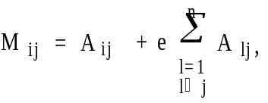
where Aij = aijT and e = τ/T. The aij values are responses per unit time of exposure. The inverse of this matrix is easily obtained analytically and the matrix elements are given by
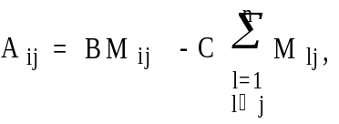

The above method of streak removal only works when image pixels are not "saturated". Saturation occurs when the integrated brightness of the image exceeds 256 digital units (each eight-bit digital unit corresponds to 75 electrons when the camera is operated in the most sensitive mode, which was usually the case for the LHG images). When such saturation occurs, another method of streak removal can be used. This involves obtaining an "average background" row for those rows in the darkest part of the image, and subtracting it, line by line, from the entire image. When the very dark Moon (unlit by Earth shine) covers several rows of the image, suitable background rows may be taken from that area, since these pixels have much less than one digital unit of true image brightness. This procedure was used to obtain Figure 6. The UV/Vis camera also has no shutter, but it operates in 'frame transfer' mode, which greatly lessens the 'non-primary' exposure times that tend to make streaks.
3. Flatfield corrections. Each image must be divided by a "flat field image", to derive photometrically accurate maps of the lunar horizon glow and corona/zodiacal light. A flatfield image is obtained by photographing a field of uniform brightness with the flight camera. At Zook's request, Research Support Instruments, Inc. (RSI), in support of the Naval Research Lab and under tight time constraints, attempted to obtain flat field Star Tracker images in the "integrating sphere" at NRL. However, the uniform field of the integrating sphere was too bright for even the shortest allowable exposure times for the Star Tracker camera. RSI got around that problem by putting a neutral density 2 filter (ND2) in front of the camera's light baffle. This solved the over-exposure problem but raised another: the light that goes obliquely through a neutral density filter is absorbed more than light that strikes the filter at normal incidence; also, more light is reflected from the filter surfaces at oblique incidence.
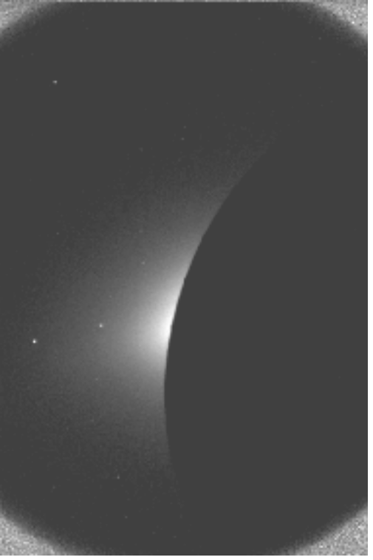
Figure 8. Image after applying the available flatfield correction. The image is over-brightened in the corners, showing the effects of the neutral density #2 filter.
That we cannot use the uncorrected integrating sphere flatfield images as true "flat fields" is seen by examination of Figure 8. It shows a thermal background and streak-corrected image from Orbit 66 after division by a flatfield image from RSI. The corners of this image are over-brightened, attesting to the fact that the flat field image is too dark in the corners, at large angles to normal incidence.
We plan to carry out laboratory measurements, at a variety of incidence angles, of light transmission through an ND2 filter supplied by RSI that is identical to the one used in the NRL integrating sphere calibrations. We will also measure the light that is forward-scattered from the incident direction by the filter. With these measurements we should be able to accurately adjust the flatfield images supplied by RSI for the flight camera. The division of the Clementine flight images by the "flatfield" is done only after thermal background and streak removal are completed on both the flight images and the flatfield images.
4. Calibration of images to absolute brightness. In order to know precisely how much horizon glow and CZL is represented in each image, it is important to establish a reference by which we can compare any pixel's intensity against a standard. There are three different standards that are available in the Clementine Star Tracker images: 1) stars and planets of known magnitude and spectral intensity distribution, 2) Star Tracker images of the Milky Way (assuming they were taken), and 3) the Earthlit Moon.
There are identifiable stars in practically all of the Star Tracker images; and they have different intensities in images with different exposure times. Their visual magnitude and spectral type (corrected for extinction) will be compared with one another and with the LHG and CZL. The color of type A stars corresponds with the blue light that is expected from the horizon glow, whereas the yellow to white light of type G stars will correspond to the color of the CZL. The Milky Way has a known but weak brightness and can be used to roughly calibrate diffuse source objects. Use of the Earthlit Moon as a calibration standard is, however, a nontrivial task. We must keep track of the solar spectrum as it is modified by scattering of sunlight from the Earth, and then from the Moon. Some combination of these three references may be used to establish the absolute brightness of the lunar horizon glow, and of the CZL.

5. Determine Solar Depression Angle, and Locate Pixel Position of Occulted Sun. In order to make meaningful comparisons of the amount of horizon glow seen in each image, we need to know how far the sun is below the lunar horizon in each case. This can be determined with the sub-spacecraft latitude and longitude, and the sub-solar latitude and longitude, as given in the image headers:
cosθ = cos(lat2)cos(long2)cos(lat2)cos(long2) + cos(lat1)sin(long1)cos(lat2)sin(long2) + sin(lat1)sin(lat2),
where θ is the angle between the sub-spacecraft point and the subsolar point, as shown in Figure 9. Lat1, long1, lat2 and long2 are the sub-spacecraft and sub-solar latitudes and longitudes. The angle between the subspacecraft point and the lunar horizon, φ, can be calculated because we know the two sides of the right triangle formed by the line to the horizon, and the line to the center of the Moon. The known sides are the target-center distance, given in the image header, and the radius of the Moon. Thus sinφ=[(lunar radius) / (target-center distance)]. The solar depression angle is equal to φ - γ.
For each frame, we need to specify the x, y position where the center of the sun would be if the Moon were not in the way, and also establish the x-y locus of points defining the ecliptic in each image. We can determine this by using the image-center right ascension and declination, as given in the image header, and the known positions of planets and bright stars in each image. The right ascension and declination of the Sun can be determined from sky map programs or ephemeris tables, and corrected to the Moon's location. The positions of bright stars in the same image can also be determined from digital sky maps. The first step is to create a new α and β coordinate system that is centered at the x, y center of the image. α is the angle from the center of the image as measured on the spherical image surface of the camera, and β is the azimuth angle from a given reference direction. The transformation between α and β coordinates, and right ascension and declination coordinates, is carried out in a manner similar to the transformation between ecliptic and equatorial coordinates (e.g., McNally, 1974).
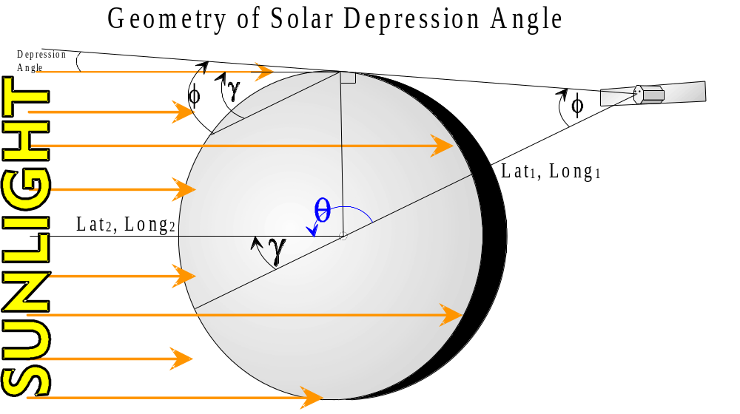
Figure 9. Viewing geometry for solar depression angle calculation.
In the Star Tracker camera, a fiber optics bundle has been polished to a concave spherical shape at one end of the bundle, and this forms the image surface. The other end of the fiber optics bundle has been polished flat and placed against the CCD. Thus, the spherically-shaped images is transmitted to the planar image surface of the CCD by the following transforms:
x = c sinαcosβ
y = c sinαsinβ
where x and y are pixel coordinates on the CCD and c is a constant that transforms angular dimensions to linear ones.

6. Model and remove the zodiacal light from the images. We wish, as an end product, to determine the individual absolute brightness variations of the lunar horizon glow (LHG) due to dust, that due to and sodium, and that due to the zodiacal light. We can then create images of each brightness source separately. With such separately determined brightness sources we can calculate: (1) the amount of dust that would be required to create the dust LHG; (2) the sodium LHG (if it exists); and (3) the zodiacal light.
As a preliminary to the above (somewhat complicated) task, there is a simpler procedure that can give some information about the absolute brightness of the horizon glow, as follows:
First, we will register two images from the same orbit so that the background stars are aligned (as projected back to the spherical image surface), but where the solar depression angle has changed. The two images, for example, could be obtained at different times as the Clementine spacecraft proceeds toward orbital sunrise. We then subtract the image with the lesser solar depression angle from that with the greater solar depression angle. The result is that the zodiacal light (which remains fixed relative to the background stars) is subtracted from the second image above the lunar limb (below the lunar limb we will, of course, get a nonsensical negative CZL and LHG result). But this will leave only LHG above the lunar limb in the second image, where all LHG in the first image is below the lunar limb in the second image. The result is not very pretty in our preliminary efforts (without proper flat field correction), but can still give us a quick and dirty view of LHG.
Finally, we will write a program to "flatten" the limb of the Moon, so that we can integrate several lines across the image to determine an average sky brightening due to horizon glow. We should be able to differentiate sodium horizon glow from dust horizon glow via the different scale heights of the two phenomena.

7. Analyze dust density as a function of altitude above the Moon.
After completing the above steps, we will be able to derive LHG brightness as a function of angular distance from the lunar horizon, and as a function of distance along the horizon from the down-sun location.
We will also derive scattering per unit volume in the exosphere above the Moon, from the above brightness measures. This may require comparing photos at different solar depression angles, but taken during one orbit. From this we can determine allowed ranges of dust and sodium density above the Moon, and derive some features of the scattering function.

8. Analyze sodium density as a function of altitude above the Moon. Same as above for dust.

9. Prepare One or More Mosaics of the CZL Images. After subtraction of LHG from the images, a clear picture of the zodiacal light should emerge. The mosaics will include more of the CZL region than can be seen in any individual image; they will not be limited to a dynamic range of 256, as images of different exposure times can be combined. We may also combine images from different orbits.
10. Analyze Dust Density in Interplanetary Space. The CZL background must be correctly subtracted from all images to obtain the true lunar horizon glow brightness in each image--a primary goal of this proposal, discussed in steps 7 and 8 above. In this sense, CZL represents an interfering background to be removed. The Clementine Star Tracker CZL images, however, constitute in their own right a set of exceptionally fine CZL measurements of the outer solar corona and the inner zodiacal light (after subtraction of LHG).
The CZL brightness at a given elongation angle, ε, from the Sun and at a given angle, ψ, relative to the ecliptic plane, represents the integrated brightness of sunlight scattered off all interplanetary dust grains along the line of sight, or in the (ε, ψ) direction. After we have carried out the procedures mentioned in the previous sections, we will have accurately determined the CZL brightness as a function of ε and ψ. The next problem is to solve (invert) the integral to obtain the spatial density of dust as a function of heliocentric latitude and radial distance from the Sun, as well as to determine the angular efficiency with which interplanetary dust scatters sunlight (the volume scattering efficiency).
As the mathematical procedures used to solve the CZL integral brightness equation have been discussed in previously published work [e.g., Lamy and Perrin, 1986], we will not go into detail here. One useful technique is to assume the answer in terms of a parameterized model of the zodiacal cloud, as well as of the scattering function, and to keep adjusting the parameters until a fit to the observed brightness is obtained. This is the technique used by Giese et al. [1986], as well as other investigators. We expect to make use of this technique, although other techniques of integral inversion will also be employed.
A preliminary examination of the Clementine CZL data indicates that there is less “flattening” of the zodiacal light isophotes at small elongation angles (1 or 2 degrees) than at large elongation angles. This could mean that we are starting to see the domination, at small elongation angles, of forward diffraction, over reflection, of light off the interplanetary dust. Diffraction depends on the scattering angle, δ, as δ⁻³, for particles as large as 30 to 60 microns radius [Grün et al., 1985]. We now think that particles in this size range are the dominant contributors to the cross-sectional area of the interplanetary cloud. Small-angle scattering predominates for dust that is closer to the Earth than to the Sun and, because the near-Earth dust is all at low heliocentric latitude, little change in dust density occurs for out-of-plane observations compared to in-pane observations at small elongation angles. Thus, a measurement of the elongation angles at which diffraction starts to be predominant is also a measure of the effective dust size for light scattering . The radial dependence of the spatial density of dust is also important, of course, to determine where diffraction dominates reflection.

STATEMENT OF WORK
1. The work for the first year will be to carry out steps 1 through 6 in the preceding section (Project Description and Analysis Procedure) for all images, and publish papers on the absolute brightness of dust LHG, sodium LHG, and CZL versus look direction. These steps were:
1. Remove thermal background.
2. Streak removal.
3. Flatfield correction.
4. Absolute brightness calibration.
5. Relate instrument image coordinates to equatorial coordinates.
6. Separate LHG and CZL from each other.
2. The second year’s work will concentrate on steps 7 through 10, resulting in papers on the spatial density of dust and sodium above the lunar surface and on the spatial density of interplanetary dust:
7. Analyze dust and sodium density above the Moon, and publish.
8. Assemble useful mosaics of CZL images.
9. Analyze interplanetary dust spatial distribution, and publish.
References

Berg, O.E., Wolf, H., and Rhee, J. (1975) Lunar soil movement registered by the Apollo 17 cosmic dust experiment. In: Lecture Notes in Physics, 48, "Interplanetary Dust and Zodiacal Light" (H. Elsässer and H. Fechtig, eds.) pp. 233-237. Springer-Verlag, NY.
Berg. O.E. (1978) A lunar terminator configuration. Earth & Planet. Sci. Lett., 39, 377-381.
Berry, R. (1994) Image processing in astronomy. Sky & Telescope, April, 1994, pp. 30-36.
Blackwell, D.E., Dewhirst, D.W., and Ingham, M.F. (1967) The zodiacal light. In: Advances in Astronomy and Astrophysics, 5 (Z. Kopal, ed.) pp 1-69. Academic Press, NY.
Bohlin, J.D. (1971) Photometry of the outer solar corona from lunar-based observatories. Solar Physics, 18, 450-457.
Criswell, D.R. (1972) Lunar dust motion. Proc. Lunar Planet Sci. Conf. 3rd, pp. 2671-2620.
Criswell, D.R. (1973) Horizon-glow and the motion of lunar dust. In: Photon and Particle Interactions with Surfaces in Space, 545-556. D. Reidel, Dordrecht-Holland.
Dermott, S.F., Jayaraman, S., Xa, Y.L., Gustafson, B.A.S., and Liou, J.C. (1994) A circumstellar ring of asteroidal dust in resonant lock with the Earth. Nature, 369, 719-723.
Freeman, J.W., and Ibrahim (1975) Lunar electric fields, surface potential and associated plasma sheaths. The Moon, 14, 103-114.
Giese, R.H., Kneissel, B., and Rittich, U. (1986) Three-dimensional models of the zodiacal dust cloud: a comparative study. Icarus, 68, 395-411.
Gillett, F.C., Stein, W.A., and Ney, E.P. (1964) Observations of the solar corona from the limb of the Sun to the zodiacal light, July 20, 1963, Ap. J., 140, 292-305.
Gonzalez, R.C., and Wintz, P. (1987) Digital Image Processing, 2nd ed. Addison-Wesley, Reading, Mass.
Grün, E., Zook, H.A., Fechtig, H., and Giese, R.H. (1985) Collisional balance of the meteoritic complex. Icarus, 62, 244-272.:
Hanner, M.S., Sparrow, J.G., Weinberg, J.L., and Beeson, D.E. (1976) Pioneer 10 observations of zodiacal light brightness near the ecliptic: changes with heliocentric distance. In: Lecture Notes in Physics, 48, "Interplanetary Dust and Zodiacal Light" (H. Elsässer and H. Fechtig, Eds.) pp. 29-35. Springer-Verlag, NY.
Hood, L.L., and Williams, C.R. (1989) The lunar swirls: distribution and possible origins. Proc. 19th Lunar and Planet. Sci. Conf., pp. 99-113, Lunar and Planetary Inst., Houston.
Jackson, A.A., and Zook, H.A. (1989) A solar system dust ring with the Earth as its shepherd. Nature, 337, 629-631.
Koutchmy, S., and Lamy, P.L. (1985) The F-corona and the circumsolar dust evidences and properties. In: Properties and Interactions of Interplanetary Dust ((R.H. Giese and P. Lamy, eds.), pp. 63-74, D. Reidel, Dordrecht, Holland.
Lamy, P.L., and Perrin, J.M (1986) Volume scattering function and space distribution of the interplanetary dust cloud. Astron. Astrophys., 163, 269 - 286.
Lamy, P., Kuhn, J.R., Lin, H., Koutchmy, S., and Smartt, R.N. (1992) No evidence of a circumsolar dust ring from infrared observations of the 1991 solar eclipse. Science, 257, 1377-1380.
Leinert, C., Pitz, E., Hanner, M., and Link, L. (1977) Observations of zodiacal light from Helios 1 and 2. J. Geophys., 42, 699-704.
Leinert, C., Hanner, M., Richter, I., and Pitz, E. (1980) The plane of symmetry of interplanetary dust in the inner solar system. Aston. Astophys. 82, 328-336.
Leinert, C., and Grün, E. (1990) Interplanetary dust. In. Physics of the Inner Heliosphere: I (R. Schwenn and E. Marsch, eds.) pp. 207-275. Springer-Verlag, NY.
MacQueen, R.M., Ross, C.L., and Mattingly (1973) Observations from space of the solar corona/inner zodiacal light. Planet. Space Sci., 21, 2173-2179.
MacQueen, R.M. and Greeley, B.W. (1995) Solar coronal dust scattering in the infrared. Astrophys. J., 440, 361-369.
McCoy, J.E., and Criswell, D.R. (1974) Evidence for a high-altitude distribution of lunar dust. Proc. 5th Lunar Science Conf., 2991-3005. Pergamon Press, NY.
McCoy, J.E. (1976) Photometric studies of slight scattering above the lunar terminator from Apollo solar corona photography. Proc. Lunar Sci. Conf. 7th, 1087-1112, Pergamon Press, NY.
McNally, D. (1974) Positional Astronomy. 375 pgs, John Wiley & Sons, NY.
Page, T., and Carruthers, G.R. (1978) S201 far ultraviolet atlas of the large Megellanic Cloud. NRL Report 8206, 125 pp. U.S. Govt. Printing Ofc.
Potter, A.E., and Morgan, T.H. (1988) Discovery of sodium and potassium in the atmosphere of the Moon. Science, 241.
Reach, W.T., Franz, B.A., Weiland, J.L., Hauser, M.G., Kelsall, T.N., Wright, E.L., Rawley, G., Stemwedel, S.W., and Spiegman, W.J. (1995) Observational confirmation of the ring around the Sun by the COBE diffuse infrared background experiment. Nature, 374, 521-523.
Rennilson, J.J., and Criswell, D.R. (1974) Surveyor observations of lunar horizon glow. The Moon, 10, 121-142.
Schuermann, D.W. (1980) Evidence that the properties of interplanetary dust beyond 1 A.U. are not homogeneous. In: Solid Particles in the Solar System ( I. Halliday and B.A. McIntosh, eds.) pp. 71-74. D. Reidel, Boston.
Severny, A.B., Terez, E.I., and Zvereva, A.M. (1975) The measurements of sky brightness on Lunokhod-2. The Moon, 14, 123-128.
Shoemaker, E.M., Morris, E.C., Batson, R.M., Holt, H.E., Larson, K.R., Montgomery, D.R., Rellison, J.J., and Whitaker, E.A. (1968) III. Televisions observations from Surveyor, Park K. Sunset observations, by J.J. Rennilson. JPL Tech. Report. 32-1265.
Toller, G.N., and Weinberg, J.L. (1985) The change in near-ecliptic zodiacal light brightness with heliocentric distance. In: Properties and Interactions of Interplanetary Dust (R.H. Giese and P. Lamy, eds.) pp. 21-25. D. Reidel, Dordrecht, Holland.
Zook, H.A., and McCoy, J.E. (1991) Large-scale lunar horizon glow and a high altitude lunar dust exosphere. GRL, 18, pp. 2117-2120.
Zook, H.A., and Potter, A.E. (1993) A proposal to study the lunar dust exosphere of the Moon with the UV/Vis camera on the Clementine spacecraft. Submitted April, 1993 to NASA Headquarters in response to NRA-93-OSSA-2.
Personnel
H. Zook (Principal Investigator) has overall responsibility for execution of the proposed work. He will concentrate on theoretical analysis of the brightness distributions of dust Lunar Horizon Glow and the CZL into the correspondig spatial densities of dust above the lunar surface and in interplanetary space inside one AU.
Zook was responsible for planning the scientific campaign of Lunar Horizon Glow photography that Clementine, with its operational constraints, carried out. He will spend 25% of his time on these analyses.

A.E. Potter (Co-Investigator), has primary responsibility for overseeing IRAF software analysis of images and for analysis of the sodium atmosphere brightness in terms of sodium atom spatial densities. He will publish papers on this topic and spend 10% of his time on these analyses.

B. Cooper (Co-Investigator) has primary responsibility for actually carrying out the IRAF image analysis on 800 to 1000 images, using steps outlined in the Analysis Procedure, with inputs from Potter and Zook. She will spend 100% of her time on these analyses. In the second year, she will supply FORTRAN program support to Zook and Potter, and will publish articles in the “popular” press (e.g., Sky and Telescope, etc.). This second task may be started in the first year.

J. C. Liou (Collaborating Scientist) will provide advice and support in the analysis of the zodiacal light, especially in determining the inclination and ascending node of the zodiacal cloud. He has had experience in analyzing the IRAS data.

M. Horanyi (Collaborating Scientist) will provide expertise on the electrostatic transport of dust, and will help interpret features seen in the dust LHG.
Facilities and Equipment

Public domain software is available that will be used for the image analysis portion of this project. This software, IRAF (Image Reduction and Analysis Facility), is a general purpose software system for the reduction and analysis of astronomical data. IRAF is written and supported by the National Optical Astronomy Observatories (NOAO) in Tucson, AZ, under cooperative agreement with the National Science Foundation.
We presently have limited access to a Sun Sparcstation 2 UNIX workstation. This system is now primarily used for analysis of Earth observations by another group; the time available for its use will not be adequate for the work proposed here.
A desktop computer will be purchased that will run LINUX (the PC version of UNIX). LINUX is also public domain. The IRAF support group at Kitt Peak has informed us that they plan to port the IRAF software to the LINUX environment this summer, so that the IRAF version will be available for us when we begin our research in October.
We will require some additional storage; specifically a 4 Gb hard drive for the PC that is running IRAF. Currently, we know of 605 Star Tracker LHG images, although there may be more when we receive the entire CD-ROM data set. The raw data files are 230 Kb each, for a total of 139 Mb of space. The IRAF conversions will require at least 604 Kb each, for a total of 365 Mb. It would be prudent to save these original conversions so that we can retrace our steps if necessary; consequently we will need at least another 365 Mb of space to store the darkcurrent corrected images, 365 Mb or more of space to store the un-streaked images, and 365 Mb or more of space to store the flatfield-corrected images. Thus we will need at least 1.2 Gb for the files we already know exist, that we will need to store. We will use the remainder of the disk space to store other files as they are created, so that we will have immediate access to the "raw" data and to previously processed images as we work..

Proposed Costs
FY '96:
Title: An Analysis of the Lunar Exospheric Dust and Sodium as Revealed in the Clementine 'Horizon Glow' Images
PRINCIPAL INVESTIGATOR: H.A. Zook
SUMMARY OF FIRST YEAR PROPOSED COSTS:
Salaries and Wages 45,000
Fringe Benefits 9,000
Equipment 7,000
Travel 2,000
Computer support expenses 2,000
Publication or page charges 1,000
TOTAL FUNDS REQUESTED FOR FY '96 66,000

SUMMARY OF STAFFING REQUEST (Salaries plus Fringe Benefits)
1. Senior Personnel:
Principal Investigator 0.25 year 0
Co-P.I. A.H. Potter, Ph.D. 0.1 year 0
Co-P.I. Bonnie Cooper, Ph.D. 1.0 year 54,000
2. Technical Support 0 0
3. Other 0 0
4.. TOTALS 1.35 54,000

Identification and estimated cost of major capital equipment items to be acquired:
A desktop (Pentium-PC) computer will be purchased which will have a 4 gigabyte hard drive, 32 megabytes of random-access memory, a 20" high-resolution monitor, a graphics accelerator card, a compact disc drive, a tape drive backup, an ethernet card, keyboard and mouse. It will run IRAF image processing software which is public domain software, under the LINUX operating system (UNIX for PC's) which is also in the public domain.
Purpose and estimated number and lengths of trips planned: Two trips to International Astronomical Union meetings to deliver papers, one by P.I. (H.A. Zook, and the other by Co-I (B.Cooper).

Estimated expenses as yearly requirements by major work phases:
Year 1. Tasks 1 through 6 as discussed in “Statement of Work” section, page 16.

Purpose and estimated number and lengths of trips planned: Two trips to International Astronomical Union meetings to deliver papers.
Proposed Costs
FY '97:
Title: An Analysis of the Lunar Exospheric Dust and Sodium as Revealed in the Clementine 'Horizon Glow' Images
PRINCIPAL INVESTIGATOR: H.A. Zook
SUMMARY OF FIRST YEAR PROPOSED COSTS:
Salaries and Wages 45,000
Fringe Benefits 9,000
Travel 2,000
Computer support expenses 2,000
Publication or page charges 1,000
TOTAL FUNDS REQUESTED FOR FY '97 59,000

SUMMARY OF STAFFING REQUEST (Salaries plus Fringe Benefits)
1. Senior Personnel:
Principal Investigator 0.25 year 0
Co-P.I. A.H. Potter, Ph.D. 0.1 year 0
Co-P.I. Bonnie Cooper, Ph.D. 1.0 year 54,000
2. Technical Support 0 0
3. Other 0 0
4.. TOTALS 1.35 54,000

Estimated expenses as yearly requirements by major work phases:
Year 2. Tasks 7 through 9 as discussed in “Statement of Work” section, page 16.

Purpose and estimated number and lengths of trips planned: Two trips to International Astronomical Union meetings to deliver papers.

Proposed Costs
FY '96 and '97
Title: An Analysis of the Lunar Exospheric Dust and Sodium as Revealed in the Clementine 'Horizon Glow' Images
PRINCIPAL INVESTIGATOR: H.A. Zook
FULL DURATION REQUESTED: 2 Years, Start Date: 10/1/95 End Date: 9/30/97
Salaries and Wages 90,000
Fringe Benefits 18,000
Equipment 7,000
Travel 4,000
Computer support expenses 4,000
Publication or page charges 2,000
TOTAL FUNDS REQUESTED FOR FY '96 and ‘97 125,000

SUMMARY OF STAFFING REQUEST:
1. Senior Personnel:
Principal Investigator 0.5 year 0
Co-P.I. A.H. Potter, Ph.D. 0.2 year 0
Co-P.I. Bonnie Cooper, Ph.D. 2.0 year 108,000
2. Technical Support 0 0
3. Other 0 0
4.. TOTALS 2.7 108,000

Purpose and estimated number and lengths of trips planned: Four trips to International Astronomical Union meetings to deliver papers.
Resumes
pages 25 - 30
Special Matters

The proposed work will be done at the NASA Johnson Space Center on computer facilities provided by NASA (but see request for purchase of a UNIX-capable PC).
Previous Work Experience: Zook analyzed the Apollo 17 astronaut sketches of lunar horizon glow (LHG) that were obtained using the unaided eye. He theoretically analyzed the altitude distribution of lunar dust that gave rise to the observed LHG and estimated its brightness (see Zook and McCoy, 1981, GRL, 18, 2117-2120). Potter discovered the Na and K atmospheres of Mercury and of the Moon and has published numerous papers on this subjects (e.g. Potter and Morgan, 1994, GRL, 21, 2263-2266). He is an expert in using IRAF software to analyze the Na and K spectral and imaging data he has obtained. Cooper is also very experienced in the use of the IRAF software, and has had extensive experience in image processing and interpretation.

* An S-10 unit is a brightness unit that is equivalent to one tenth-magnitude star, smeared out over one square degree.

