
^{GolfCaddy5 V2.01}



Manual Version 2.10
November 1998
EPOC 32 Palmtop Computers GolfCaddy5 User Guide©1998 M.G.Gardner
CONTENTS

1.INTRODUCTION
Description
2.SETTING UP
Installation
Upgrading
Game type
Handicap
Preferences
Other Views
3.MENU BARS
Course Card
View
Round Data
Options
Information
Side menu functions
4.GOLFCARD
Golf card Active zones
5.ANALYSE
Current card
Individual Hole
Card Group
Green putting
6.OTHER VIEWS
Quick view
Course notes
Holememo
Clubs
7.BLANK GOLFCARD
Creating a blank course card
Editing a blank course card
Importing blank course card
8.MARKED CARDS
Saving marked cards
Loading marked cards
Finding marked cards
9.TUTORIAL FOR PLAYING A GAME
Tutorial
Quick Tips
10.REGISTRATION INFORMATION
Registration Details
Methods of Registering
11.SPECIFICATIONS

12.INFORMATION
History
Problems
Disclaimer
13.CREDITS

1.INTRODUCTION

Description

GolfCaddy5 is an electronic scoring card, analyst and caddy, for EPOC 32 palmtop computers. It has primarily been designed for the Psion Series 5 but works equally well with the Geofox One.

It is designed to be taken on the golf course with you keeping track of you and three other players scores. It can automatically score various games for up to four players, which currently include:

- Stableford
- Matchplay
- Medal stroke play

There is automatic / manual handicap allowance provided for all types of games. Choices available are Full, 7/8,3/4,7/16,3/8,None

Up to 500 Blank Golf cards can be held each with its distance, Par and stroke index information with the added benefit of storing notes about each hole and information on the course, which is all instantly accessible during a game.

A database of previous marked cards (up to a maximum of 1000) can be stored and analysed during or after a game. Future enhancements will included an unlimited amount of cards.

Several different screen views of your current golf round make the game more enjoyable. They can show you a quick break down of holes ‘Double bogeyed’ to ‘Holed in one’ and provide you with a history on how you performed on various holes before you drive off and how well your green putting is going before you make that putt. A Club yardage table and Caddy is also provided to aid you with distance/club selection and on your main card everybody's Gross and Nett score for quick in game comparison.

All information can be entered, by tapping on the screen or entering it quickly via the keyboard. If you are like me then it doesn’t matter if you ever forget that pencil to mark your card, just don’t forget your Palmtop.

2.SETTING UP

Installation

You can install GolfCaddy5 on the C: or D: drive. Note you can not mix it between drives.

I recommend using ‘PsiZIP’ (Shareware available from RMR Software) to install the application. Just highlight all the files by tapping on them, then select ‘Extract’. Leave the Folder dialog box blank, select drive (C: or D:) and tick ‘Restore folders’.

If you have acquired the application from CDROM then you may be required to set all the file properties to 'Modify'. This can be done by highlighting each file and presing ctrl+p. Ensure the only box ticked is the Modify one.

The following below is for your information if extracting manually. Be careful to name all folders correctly.

What to do...
Unzip all files

Press ‘SYSTEM’ icon
Press ‘MENU’ under tools select ‘PREFERENCES’ and tick ‘SHOW SYSTEM FOLDER’
Press ‘OK’

go to System/Apps/ on the chosen drive (C or D)
Create folder called ‘GolfCaddy5’
Copy the following files into GolfCaddy5. The following is an example of installing it into the C Drive.

C:System/Apps/GolfCaddy5
- GolfCaddy5.aif
- GolfCaddy5.app
- GolfCaddy5.icn
- Create FOLDER ‘CardData’
- Create FOLDER ‘Pic’

C:System/Apps/GolfCaddy5/Pic
- Buttons.mbm
- Title.mbm

C:System/Apps/GolfCaddy5/CardData
- Options
- Cardlist
- Caddy
- Courselist
- Rounddata4
- Clubs
- Create FOLDER ‘Card28081’

C:System/Apps/GolfCaddy5/Carddata28081
- Data
- Holememo
- Mainmemo

Pressing the ‘Extra’s bar’ should now reveal the Icon for GolfCaddy5

If you want the program to work on the D Drive and have installed it on the C Drive the do the following:
Go to C:/systems/Apps and highlight the GolfCaddy5 Folder. Press ‘Ctrl+x’ (Cut). Go to Drive D:/System/Apps and press ‘ctrl+v’ (Paste). The Series 5 with the old ROM V1.00 required the moved folder to be renamed to something different, wait a few seconds, and then renamed back to the original name before the Extras bar would update. If this weren’t done then you would get an error message ‘NOT FOUND’

Upgrading

When upgrading please follow the instructions carefully, if in doubt email the Author

REGISTERED USERS UPGRADING FROM V2.00 to Version 2.01

In the Folder 'System/apps/GolfCaddy5'
REPLACE FILE GolfCaddy5.app

REGISTERED USERS UPGRADING FROM V1.21 to Version 2.00/Version 2.01

Please note that if you have any clubyard distances entered in the application ,they will be lost on upgrading. Please make a note of these distances if you want to re-use them before applying the upgrade procedure.

Please do the following in the selected folders:

In the Folder 'System/apps/GolfCaddy5'
REPLACE FILE GolfCaddy5.app
REPLACE FILE GolfCaddy5.aif

In the Folder 'System/apps/GolfCaddy5/Pic'
REPLACE FILE Buttons.mbm
DELETE FILE background2.mbm

In the Folder 'System/apps/GolfCaddy5/Carddata'
DELETE FILE Clubyards
ADD FILE Clubs
ADD FILE Caddy

You may have noticed a file called ROUNDDATA4, do NOT install this file if upgrading. The program will automatically upgrade your existing ROUNDDATA file.

Game Type

The different game types can be selected from the Main menu bar under ‘Options’. You can select the game type when starting a round, you can change the game type during a round or at the end of a round. Note that the game type is saved with the marked card in your database of previous rounds.

Handicap

The correct handicap allowance is chosen after you have selected your game type but can be overridden to what allowance you wish to play to. The correct strokes are then given to the various players depending on their handicap.

Preferences

Several preferences are available for the user, which include the following:
- Distance of measurement.
- Date format.
- Small Nett scores ‘on’ or ‘off’.
- Which tees used.
- Green putting recording ‘on’ or ‘off’.
- Stableford Blackout.
- Record Hole detail.

The entire above can be found in under ‘Options’ in the main menu.

Other Views

Apart from the main Golfcard view several other views including the analysis views are available and a described in more detail later:
- Quickview
- Current Card
- Card Group
- Individual hole
- Card hole detail
- Green putting
Club Yardage
- Hole memo
- Course Notes

3.MENU BARS

Course Cards

Select card Enables you to select a blank Golfcard from your list.
Create New Card Enables you to create a new blank Golfcard.
Remove Card Complete removal from your list of a Golfcard.
Edit Card You can edit any blank Golfcard.
Import Card You can import any Golfcard found on my web site.
Close Quit the program.

View

Quick View Shows a small scorecard for a convenient overview of the current game, listing Birdies and Par’s etc.
Holememo Shows your hole notes.
Graph A ‘in game’ graph comparing your round to the other players throughout
the game. Automatic zoom function.
Card Select Top, Middle or a Bottom view of the Score card.

Round Data

Save You can save your filled in card thus adding it to your database of games for analysis.
Clear Clears current card of any marked in data, leaving blank Golfcard.
Load Loads any saved card for viewing or editing.
Remove Completely removes a filled in card from your database Analyse.
Current card Shows your performance on current viewed card.
Card Group Shows both your overall gross scores for up to 160 rounds and how you performed on each hole during the last six rounds on the particular course current viewed on the scorecard.
Individual Hole On the current viewed card it will show how you performed on a particular hole for the last 50 games.
Green putting On the last 8 games it shows how you putted on the greens.
Card Hole Detail Shows the break down of the current card viewed.

Options

Set owner Enter your own name and Handicap.
Game Type Set the game type and Handicap allowance.
Nett Score for.. Select which player has the big Nett score shown for. Select which Tee’s used. Turn small Nett scores On or Off.
Preferences Select Units of Distance, Yards or Meters Select Date Format. D/M/Y or M/D/Y.Turn small Nett scores On or Off. Select Green putt recording On or Off. Select Stableford Blackout On or Off. Record individual hole detail during game On or Off
Compression Compress all GolfCaddy5 files. Use a few times a year.

Information

Course Notes Gives Club information on the current viewed score card.
Club Distance Set your club names and distance here. Club Chart accessible from here
Also set up your Values for the Caddy Function.
Help Help file, not yet installed.
Register Register here or obtain details on how to register.

Side Menu Functions

The side menu bar is always available during viewing of the main card, regardless of if you are scrolling up and down. It provides access to certain functions quickly. There are eleven hot spots on the side toolbar:

Top Show top of card.
Mid Show middle part of card.
Bot Show bottom of card.
Arrow up Scroll card upwards.
Arrow down Scroll card downwards.
Quick View Shows a small scorecard for a convenient overview of the current game.
Hole History Analysing view of hole history.
Clubs Into the club database and caddy functions.
Graph icon In game comparison graph.
Select card Load a unmarked golf card.
Nett Marker Can also be called ‘Nett Player X’. Goes into the Nett score view Dialog.

4.THE GOLFCARD

Golfcard Active Zones

The Golfcard is approximately the same size as a ‘Card’ Golfcard. Currently Version 2.01 has no facility to print the card out but this will be added in due course.

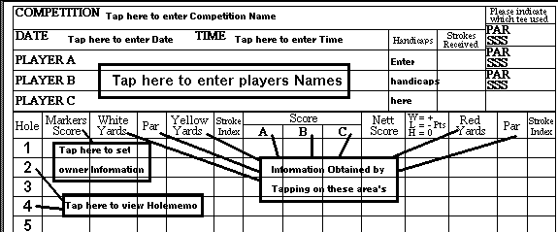

There are many ‘Active’ areas on the Golfcard, which allow interaction without having to call up the Menu bar to enter or display information. The zones, which can be tapped on, are to numerous to mention it is best to experiment by tapping on different parts of the card to see what happens. Other parts of the Golfcard automatically fill in. Due to the limited screen size of the Series 5 only 1/3 of the card is shown at any one time. The Geofox shows approximately a half of the card.

5.ANALYSE

Current card Analysis

This part of the display shows your performance for the current card displayed. For example it can show the Marker that on the last 18 holes his round broke down in to the following. 2 Birdies, 6 Par’s, 5 Bogeys, 3 Double Bogeys and 2 '3 Over Pars'. It also shows a bar graph plotting left to right for comparison between the marker and the other players.

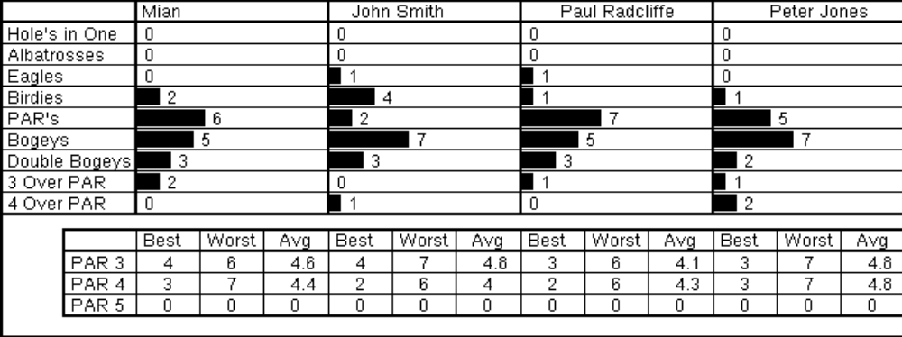

The bottom part of the display shows your best and worst strokes on Par 3,4,5’s. It also works out an average. This also works for the other players.

For example it can show the Marker that his best Par3 was 4 strokes, his worst 6 strokes and over the 18 holes for Par 3’s he averaged 4.6 per hole. The same is repeated for Par 4’s and all of the Par5’s.

Individual Hole Analysis

This Analysis screen takes the hole history way back to the round you played 50 games ago. It can therefore show you if you are improving or failing on a particular hole. This screen can be accessed from the main score card by tapping on the hole number and then selecting ‘History’, the correct hole should be selected for the hole you are going to play.

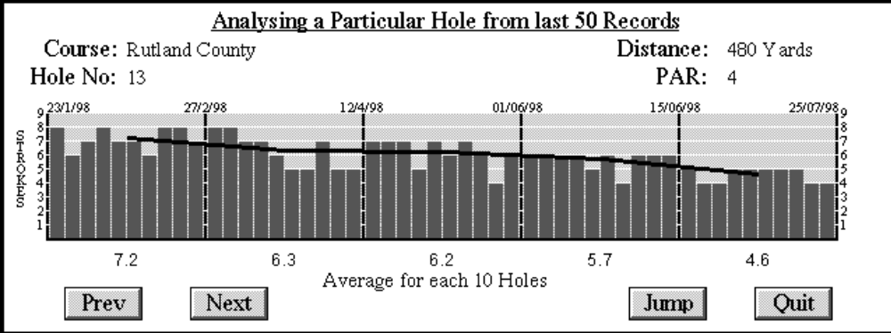

The bars represent the 50 previous holes played with the most recently saved game being the bar on the right, to the oldest bar on the left hand side. The 50 bars are broken down into games of 10. The average of this block of 10 is taken and plotted in the middle of the block. A line has then being added. This has been used to show if you are improving or not on a particular hole.

If the line moves up, left to right, then you are not improving.
If the line slopes down, left to right, then you are improving on that hole.

The dates of certain blocks have been extracted from the saved cards and place above the bars. Card dates are taken from records 1,10,20,30,40,50 (games ago). From this page you can view any hole on the course selected by using the ‘PREV’ and ‘NEXT’ or ‘JUMP’ touch icons at the bottom or the menu bar. If ‘STROKE DETAIL’ has been recorded during any game this also can be brought via the button or menu up to show what percentage of errors have occurred on the particular hole in question.

Card Group Analysis

The top part of this analysis screen shows your gross scores from your past rounds on the course currently selected on the scorecard. It can be set to compare your last 10, 20, 40, 80 or 160 rounds. It also displays an average gross score for all the rounds displayed.

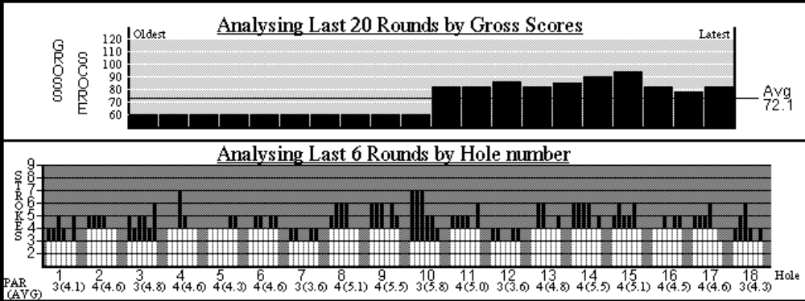

The bottom part of the display analyses your last six rounds from the course currently selected from the scorecard. Each hole is shown by a group of six bars. The bar on the right of the six is your most recent game saved in the database. The bar on the left of the six is the game you played on this course, six games ago. Under each of the six bars is the hole number and in brackets the average for the six rounds on that hole. On the left-hand side of each number in brackets is the Par for that hole. The height of the bar shows how many strokes you took and anything in black is over Par. Therefore the white part is Par or below for that particular hole.

Green putting

It is said that almost half of your shots are putts so it is a vital part of the game. Good putting is so important because a handful of missed putts can mean the difference between a handicap of 18 and 23. The object of every putt is to hole the ball, but always try to ensure that if it misses the next one is a putt from close range, which you will not miss.

To state the obvious ‘any more than two putts per green is a WASTE of strokes.

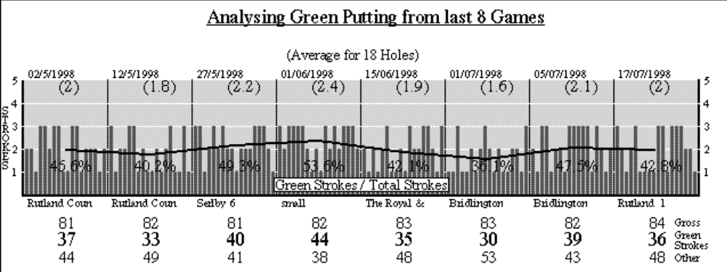

Green putting is analysed from the last 8 games played regardless of which course. Therefore it takes into account the last 144 greens putted on. It has been broken down into the various games of 18 holes. Various information has been placed around the individual 18 holes which include course name, Date played, Gross score, Green strokes for that game and other strokes. Each bar in the block of 18 represents the putts taken on that hole from hole 18 on the left of the block to hole 1 on the right of the block. An average for each block of eighteen has been plotted, and a line drawn between them all.

Line sloping down from left to right shows putting improving
Line sloping up left to right shows putting getting worse

The average is also displayed below the date. I have also included a percentage figure in the block of eighteen. This shows how many green strokes made up that particular game. I haven’t yet decided if this was a good idea , but maybe it will show you where in your game you are failing or succeeding! I believe a good percentage is around 50% ± 5% ? any more then maybe your green putting is letting you down or visa versa.

Card Hole Detail

Card hole detail shows a break down of your current cards stroke detail. During a game you can optional record several types of information mainly to show how many shots were wasted during a round by the following break down:
- 3 off the Tee
- Sand Trap
- Water hazard
- Out of bounds
- Lost ball
- Penalty stroke/s Incurred

It will also show your total number of green strokes in comparison to Total strokes taken.

6.OTHER VIEWS

Quick View

Quickview is a convenient way of viewing your entire round or comparing your round against your opponents without having to scroll the card. It is accessible by taping the relevant icon on the ‘Side Menu’. Quickview currently only shows your gross scores but it has an added advantage of listing each hole and displaying abbreviations to show what you made, such as:

!!! Less than a Albatross
ABT Albatross
EGL Eagle
BRD Birdie
PAR Par
BGY Bogey
DBG Double Bogey
*** More than a Double Bogey

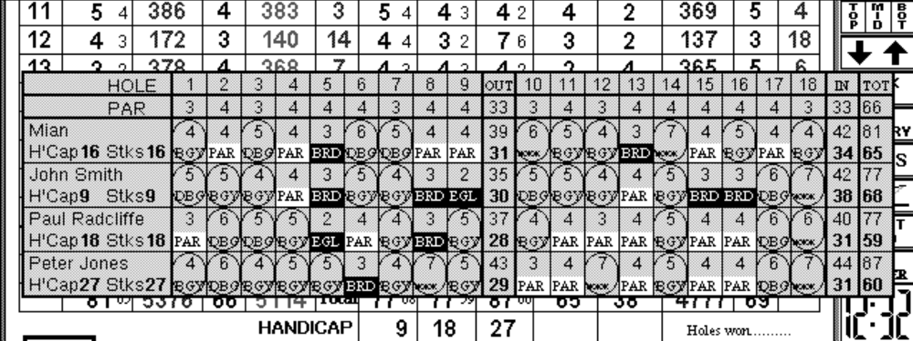

Course Notes

This is basic Course information which is stored with the blank scorecard. It gives you information on the course for quick reference. Also it is handy for others who download your Golfcards from my Web page.

Hole Memo

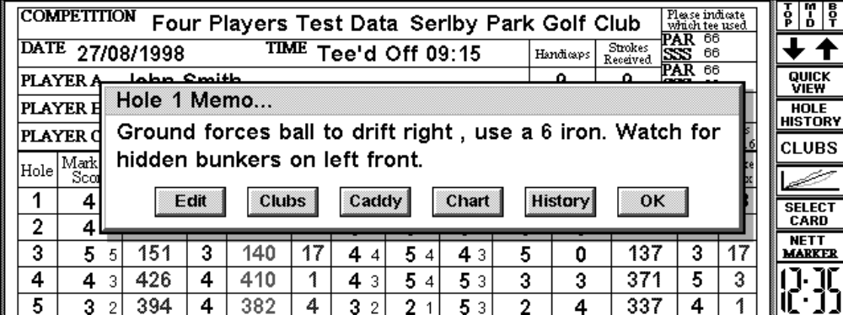

By tapping on the hole number this brings up the ‘Hole memo’. It is another convenient feature of GolfCaddy5. You can use it to remind you which club you favour, direction, what to look out for. It can be used to hold any information you wish. Also from this dialog box you can bring up your ‘Individual Hole Analysis’ and your club database and caddy function.

Clubs

By going into the Clubs screen several functions can be accessed from club detail to caddy settings.

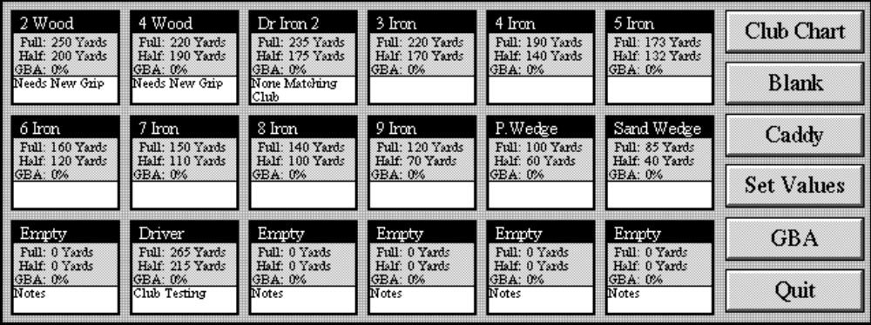

Club Database
This part of Golfcaddy5 allows to you record information about your clubs. You can store up to 18 clubs here. Each club can have information held about it
- Name of Club
- Full swing distance
- Half swing distance
- GBA
- Notes (Up to 30 characters)

Club Yardage table
A basic club yardage table is also accessible from this screen. This plots both your full swing distances in Shaded black and Half swing distances in Grey.

Set Values
Set values allow you to set up the figures your caddy function will use to calculate its choice of club. Things that effect club selection have been cut down into the following.

Wind Effect Strong, Medium and Light and Direction
Ground Effect Hard , Normal and Soft
Ball Effect Three types of balls
Height Effect Uphill, Downhill and Normal

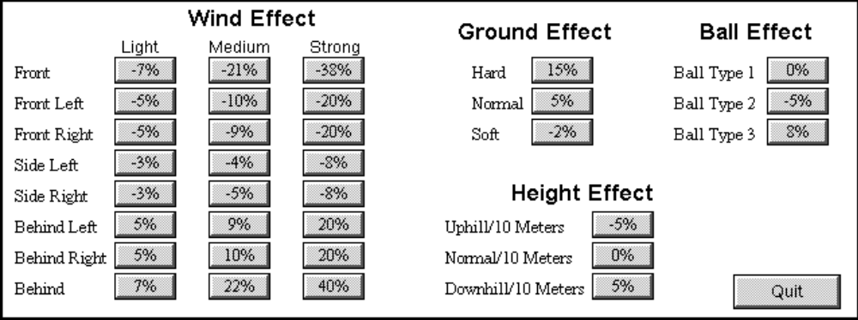

You can change the values of each of the boxes by tapping on them. You can then enter a new percentage on how much the overall distance is effected by. If you find that in strong wind that you hit a 150 yard shot some 190 yards. You will need to set the percentage to around 27%.

Caddy
Caddy is a golf aid to help you select the correct club when lots of different conditions exist. You will have to enter several pieces of information and the caddy will then suggest which clubs to use and what distance to hit for. You need to enter the following:

- Distance
- Height difference
- Wind Strength
- Ground conditions
- Ball type

Caddy will then use the pre-set values set up in ‘Set Values’ to calculate the distance to hit for. It performs it’s calculations in the following order wind, Ground, ball and height.

Example:124 yards to the pin, Height difference +20 Meters, Wind strength medium, Direction left behind, Ground Hard, and Ball type one.
Caddy will then use the percentages in the pre-set values by doing the following:
Wind adjusts distance by +9% Distance is changed to 112.84 Yards
Ground effects distance by +15% Distance is changed to 95.91 yards
Ball type 1 effects distance by 0% No change
Height effects by –5% per 10 Meters Distance changed to 105.5 yards.
It works out roughly if you hit normally for 106 yards the ball will travel 140 yards. With the current conditions,
Caddy will then tell you this and also pick out the two clubs with the distances closest to this value.

Obviously there are other effects on the ball and this is no perfect guide, how high the ball flies with the wind conditions has not yet been introduced, but I believe it does work as an aid to club selection in it’s current format. Improvements are to be implemented in due course.

GBA
This button has been added for future use. It will be used to access a Good, Bad average statistic for a particular club.

7.BLANK GOLFCARD

Creating Golf cards

GolfCaddy5 is only provided with only one, Pre-completed Golfcard for quick demonstration purposes. This obviously will be of little use for you. You will therefore have to create your own Golfcard or Import one from my Web site. You select ‘Create One’ from the Menu. Carefully enter all the data asked for and your Blank course Golfcard will be created. Any mistakes can be edited afterwards.

This part of Golfcaddy5 is admittedly not one of my better pieces of coding. This will be improved in the future. There is very little error checking in this part and entering the wrong piece of data will cause it to go back to the start.

Editing Golfcards

When editing created Golfcards, you must first select the card, move through the dialog boxes to the required place. Correct the error. Then press ‘Finish’. Your card will then have been amended.

Importing Golfcards

Golfcards can be Imported from my web site. When you import a card you must create a Folder in the CardData folder and make sure it is named differently then any other folder. The format is :

CardXXXXX

NOTE: XXXXX must be replaced by five digits (e.g. Card54321) please make a note of this file name.

You must then place 3 files retrieved from my Web site in to this folder. The 3 files are named:

Data
Holememo
Mainmemo

GolfCaddy5 must then be run up. In the menu Course cards, ’import card’ must be selected. The file name must now be entered (e.g. Card54321). Select import card. The card should now be imported along with all course and hole notes.

8.MARKED CARDS

Saving ,Loading and Finding marked cards

After marking information into your Golfcard, you may wish to save all the data to your database of complete Golfcards. This information is used by the analysis functions. Only when the marked cards have been saved is the data analysed.

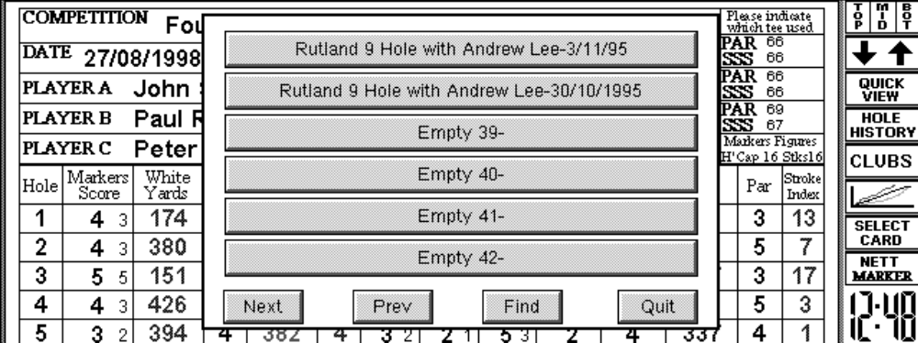

Currently to amend any saved marked cards, you will have to load it, amend it and then save it. You will then be required to delete the old record by using the ‘Remove’ function. Be aware that filled in cards are saved concurrently, therefore if a card is amended after you have played further games it will be saved after these games.

All cards completed and saved to your database are saved in file concurrently. Therefore if you intend to enter old cards from the past, please ensure you enter the oldest first, so that all analyse functions work correctly for yourself.

GolfCaddy5 can hold presently 1000 filled in cards. Finding a particular card can after a time be quite difficult. The ‘Find’ function can help in this case. It will allow up to 8 characters to be entered (Not case sensitive). The fields searched are the following:
- The name saved under
- Competition name on card
- Date on card
- Time played on card
- Players names on card

If a record is found it will appear at the top of the list. If this is not the correct record the search will continue from this point by selecting ‘Find again’.

9.TUTORIAL FOR PLAYING A GAME

Tutorial

Please follow this tutorial to give you some insight in to how to use GolfCaddy5

1.Start the application by selecting it from the ‘Extras bar’. Press any key to remove the title screen. You will now see the top third of the Golfcard. Notice the Toolbar on the right hand side.

2.Bring up the Menu .We will now select card from the course cards menu. This will bring up a selection of six cards. Up to 500 can be stored here. The program provides only one at this time until others are entered by yourself. We will select ‘Serlby Park’ by tapping on it

3.Tap on the side toolbar, Top card, middle card, bottom card, to quickly move through the displays of the card. Hot keys are also provided and are listed next to the choice on the menu bar. (E.g. ‘ctrl+m’ for middle view).Tap on the up and down arrows to move through the card more slowly. The arrow keys on the keyboard do the same as well. Tapping on club key will bring up the club database and access to the Caddy functions.

4.In the Options menu bar select ‘Set Owner’. You can also tap on the box, Markers score, from the main card. Type in your name and handicap then tap on Ok. This setting saved by GolfCaddy5 for future use.

5.We will now start to fill in the top of the scorecard. Tap on the box with the words ‘COMPETITION’ in it. Type in the competition name. Tap on the ‘Date’ box and enter the date. Note today's date will appear. Tap on the ‘Time’ box and enter the time. Note current time will appear. Tap on the Player A box. Type in the name of the player. (Same for Player B & C).

6.In Options on the menu select GAME TYPE (Ctrl+g) and select Stableford from the list. Tap ‘OK’ and accept the allowance of 7/8th’s.You can of course select any allowance but the correct allowance will always display first. The strokes received box will now update.

7.We are now going to start an imaginary game. You are on hole 1. Tap the number 1 under the word hole. This is where hole one’s memo is kept. From here you can edit this information, bring up the club database or display your history on the hole from your previously saved games. All other hole memos are displayable by tapping on the relevant hole number. Ok now you will play the hole. Once it has been finished the following actions can be taken.

Hole history is taken from your last 50 records. When you start GolfCaddy5 a display like the one shown will occur. This is due to the lack of records sampled. As you save games a more accurate picture will be built up

8.Now to enter strokes taken you can either tap on the column for markers score or press ‘S’ to enter strokes via the keyboard, which is a quicker method if two or more players are being marked for. By tapping on the markers column a small window with number’s 1 to 10 will appear. Tap on the relevant number for strokes taken. Do the same for each player. If this small window was brought up by accident, then tap on ‘X’. If more than 10 strokes were taken tap on the ‘>’ to manually enter a number. If you pressed ‘S’ then enter the strokes via the keyboard. When the scores have been entered you will notice that the Nett score column updates to show the Markers Nett score and the points column shows your Stableford points. If you wished to display the Nett score for Player A then tap on the ‘Nett’ icon on the side toolbar and select Player A from the dialog box. Both the Nett column and Stableford points column will update for player A. The same can be done for Player B. As you can see you can display Nett scores and Stableford scores for all three players. Another useful feature is the ability to display Nett scores for everyone at the same time. Back to the menu and under Options/Preferences you may have noticed a option to turn on ‘Small Nett scores’. By turning this on you will see small Nett scores appear on the right hand side of the Gross score

9.Pressing ‘Quick View’ or ‘Ctrl+v’ will only show a small scorecard for each player. This only works with Gross scores but highlights various scores to show where you scored ‘Pars, Bogeys and birdies etc. This works well for comparing your round to the other players. If small Nett scores have been selected then Nett scores for the outward nine, inward nine and total Nett are shown.

10.Another option you could turn on, just for the marker, is the ability to record ‘Green putting’. This is shown on the score card on the left-hand side of the markers gross score. Only marked cards saved to your database are used in the analysis side of green putting. This uses the last 144 greens putted on. This can be displayed at any time during the game along with all other analysing functions.

11.Yet another option you could turn on is the ability to record Stroke detail. This brings up a extra dialog box after Green putting which can be marked.

12.If you were to select Options/Game type again, you could change the game to a Matchplay game. This would exclude Player B & C as in Matchplay only the Markers and Player’s A score are compared. Strokes are also reworked out in accordance with Matchplay rules with the highest handicap player receiving a determined amount of strokes.

13.When the card is completed it will be filled in as above. When finished you can save your card, which is your database of past cards used for analysis, or clear the card. Note there is no undo option. To save your card bring up ‘Round Data’ from the menu and select ‘Save’ . You could use the Hotkeys ‘Ctrl+a’.

Quick Tips

Some quick tips for getting on with Golfcaddy5:
- If marking for more than one player, Instead of tapping the column to enter the score try pressing 'S'. This is a faster method of entering the score.
- Scroll up and down the card using the arrow keys on the keyboard.
- Turn off Green recording and small nett scores to speed up the 'update' of the card.
- If entering old marked golfcards ,enter them in date order,oldest first.
- For the first few rounds on the golfcourse mark another card just in case you don't get on with the program!!

10.REGISTRATION

GolfCaddy5 is classed as ‘Shareware’. This means that after an evaluation period you are encouraged to register your personal copy with the Author. Only one Limitation has been applied to encourage you to register. The only limitation is that a maximum of six marked cards can only be saved to the database. Other than that you can use the application fully allowing you to evaluate it.

Registration you will find is very cheap. As with all Psion shareware it is found to be at a fraction of the price of commercial similar applications. You not only get the product fully working with a very minor restriction but also direct support from the Author, and free upgrades. You will find you can also use the application free if you find you do not require the save facility.

After you register with the Author you are sent a registration code. Note that you will never be required to pay for the product twice. This code is only valid for your copy of GolfCaddy5. After entering this code you will be able to use the program to it’s full ability. Save more than six rounds. You will receive support via email from the Author. Most importantly you will have a say in how you would like the program developed and receive notification on all free upgrades.

There are several ways to register your copy and several ways to pay.
Method 1
By secure on-line link with Regnet. (http://www.reg.net/product.asp?ID=2108) They accept payment with Credit cards. This will cost you $15 Dollars. Of this Regnet Keeps $6 Dollars and sends the Author $9 Dollars. Your registration is sent to you via email from the author when Regnet confirms payment has been made.
Method 2
Send a Cheque for £5 pounds Sterling, making it payable to M.G.Gardner to the Authors address. As soon as your cheque is received, your registration is sent to you via email or posted, if a SAE is provided.
Method 3
Send a Cheque in any other currency for the equivalent of £9 pounds sterling, making it payable to the Mr.M.G.Gardner to the Authors address, in any other currency. The extra covers charges made by my bank. As soon as your cheque is received, your registration is sent to you via email or posted, if a SAE is provided.

Currently my address is: Mr.M.G.Gardner
13 Varsity Way
Locking
Weston-Super-Mare
N.Somerset
United Kingdom
BS24 7DH

Email: mian@dial.pipex.com
Web: http://dspace.dial.pipex.com/mian/

Due to the nature of my work I do tend to change address every few years. If the current date is past June 1999 then please check my web site for a new address or Email me to confirm my address.You could always download the latest version from my web site. I do redirect my mail but I find old copies of programs and files do tend to exist for many years.

If you plan on registering please ensure to provide me with the following:
- Payment
- Your Personal Program Serial number found in the Menu under Information/Register
- Email Address / Postal Address

11.SPECIFICATIONS

Application Name: GolfCaddy5
Date of first release: May 1998
Version Number: 2.01
Version Date: November 1998
Application Size: Approx 287K
Memory Required when running: Approx 436K
Format: Epoc32

History database: Currently holds 1000 marked cards. Will be expanded
1000 marked cards: Each using 300 bytes. Approx. 212k would be used for 1000 cards
Course cards: Holds 500 Blank Cards
500 marked cards: Each card using 2800 bytes. Approx. 1.5Mb would be used for 500. Who
plays 500 courses?

12.INFORMATION

History

The Application

V1.00 1st May 1998, Golfcard5 Released .

V1.01 10th May 1998, Reorganisation of the card data files:More economical use on the D drive!: 'Esc' pressed on various dialog boxes caused program to crash. Fixed !

V1.02 20th May 1998, Possible to install/swap onto either drive, but not mixed!!!:All menu Short cut keys added (e.g. CTRL+e to exit.....etc):Keyboard entry of strokes allowed ( press 's') :Other minor enhancements to trivial to note.

V1.10 31st July 1998,Renamed from Golfcard5 to Golfcaddy5 due to possible name conflict:Unit of distance preference:Quick view overhauled also shows 'Birdies,pars,Bogeys':Analyse a particular golfcard:Analyse a group of golfcards for the same course:Compact function for all golfcaddy5 files:Date Format preference:Automatic Date viewing for loading cards:Small nett scores for each column available:Registration price reduced.

V1.20 3rd August,All player options saved:Green putting recording added:Analyse a particular hole:Analyse green putting:Bug fix on 'Creating new card'.

V1.21 7th September,Fixed keyboard input of strokes bug:Version updated on golfcard graphics:Fixed Search bug - will now find correct record on loading card and search for name of file,competition name,date of card time of card and players names,also continues from last found record:Green putting avg correct to account for 9 hole games and zero putts:Fixed Memory Bug - Tests show that approx max memory required when running is 436K Approx:Removed Dialog box for hole preference when entering individual hole analysis:Bug fixed in editing course card ,yellow in/out yards back to front:Average gross for 'Card group analysis' always correct regardless of records sampled:'Card group' analysis now supports 9 hole viewing:Basic in Game comparison graph with automatic zooms:Marked cards for loading displayed from most recent to oldest.(reversed!): Application can be closed from externally,from open files list:Stableford Blackout available on Nett score column.

V2.00 1st November 1998:Stableford Blackout nett score reduced by one stroke to show correct Nett score when using 'blackout'.....whoops:Fourth Player Added :Nett and Smallnet scores give better indication of total than previous version which started negatively allowing for handicap.:New screen layout. Card now drawn from program using far less memory as when it was a mbm file.:Reduced most of needless 'updates' when information changes have not effected scores.:Quickview more intelligent and shows some nett scores:All dialogs set for affirmative on the right, negative on left.Dialogs set to allow enter key for yes/ok etc and ESC for Cancel,no etc. NO pressing the 'o' key or OK!:Limited menu bars fitted to , hole history page, Club page etc. This is for Geofox users.:I believe all extra windows can be closed using the 'ESC' key. This includes the 'Select card' ,'Load card' type windows.:Small bug found on 'Keyboard entering' of scores,Fixed.:Clubs list amended. Fully editable names and two distances for full swing and limited swing. :Caddy function introduced to help you decide what distance to go for linked with club selection.:Caddy function settings for different conditions editable.These allow you to decide on what sort of percentage of distance is affected for things like wind speed and strength , height of pin from current location and ground conditions.:Quick chart of club distances.:Holememo accessible from menu bar and Hotkey added. All new caddy functions added to dialog.:Smooth scroll function:Stroke detail information added,'3 of the tee','Out of bounds' etc:Hole history extra Button added to provide facility to view Stroke detail history:Dialog box added to view current round Stroke detail.:Auto naming for saving round:New restyled tool bar

V2.01 3rd November 1998 ,Fixed Bug on Matchplay, Too many strokes given to both players,but it still produced correct result.:Battery check program lock out.Incorrect advice given to halt program

The User Guide

V1.00 September 1998 , On-line and of line HTML Manual produced for V1.21

V1.01 September 1998 , Minor errors and omissions corrected.

V2.00 November 1998 , On-line & Off line HTML Version 1.21 removed. Word 8.0 and Psion Word format manual produced. Screen shots have been removed. Will be distributed within the zip file and available as a down load.This will also replace the Readme file found within the zip.

V2.01 5th November 1998 , Extra information added

V2.02 7th November 1998 , Manual reformatted on the psion so allowing easier print out.In future editions manually will be produced on the psion then converted to Word97.

V2.10 8th November 1998 , Pictures re-introduced into User manual.

Problems

Before reporting any calculation errors please ensure that the ‘game type’ is the one you want. Also check the handicap allowance has been selected to the desired one.
If bugs are found please email me with a full description of what happened with what was done before hand.

If you have trouble-installing GolfCaddy5 please ensure all folders created by yourselves have been named correctly and all files are in their correct location. Also all the files are either all on the C drive or all on the D drive. Do NOT mix!.If you have aquired the application from CDROM then you may be required to set all the file properties to 'Modify'. This can be done by highlighting each file and presing ctrl+p. Ensure the only box ticked is the Modify one.If you still have no luck then please email me for a quick response

A known problem currently being investigated is when your battery levels are dangerously low and Golfcaddy5 has been installed on the D drive. If Golfcaddy5 is unable to write to the drive due to very low batteries then a ‘General Failure’ error will be reported.This you may find happens on quite a few applications.

Disclaimer

As far as I can tell it's not going to harm your Psion or Geofox. It has never harmed mine! Just watch out for any rain/sand on the golf course! .It is not healthy for your Palmtop.
Please also keep regular backed up copies of all files from your Psion to PC. All your marked cards are stored in one file called ‘rounddata4’. Keep a backed up copy of this file somewhere safe. Never overwrite this file. I can not be held responsible for all your golf round information being destroyed.

Never replace the 'Rounddata4' file as this contains your marked cards

13.Credits

Author Mian Gardner
Coding Mian Gardner
Advertising Stefan Smith, 5Alive - http://5alive.psionking.com/
S5Event Demo Al Richey, RMR Software- http://www.rmrsoft.com/
User Guide Mian Gardner & Sue Gardner
Refreshments Sue Gardner
Exceptional good ideas Registered Users, you know who you are! ,Thank you.

