Gen5R - V2.03 -
ANCESTRAL TREE
FOR REVO

Documentation non contractuelle

http://perso.wanadoo.fr/michel.catton/

1. QUICK START USING GEN5
1.1 General
1.2 Files contained in G5RGB23.zip
1.3 Installation
1.4 Begin to use
2 DISPLAY PERSON
2.1 Keys
2.2 Buttons
2.3 File Menu
2.4 Menu Display
2.5 Menu Update
2.6 Menu View
2.7 Menu Tools
3 DISPLAY COUPLE
3.1 Keys
3.2 Menu File
3.3 Menu Display
3.4 Menu Update
3.5 Menu Tools
4 CREATE A PERSON
4.1 Entering person
4.2 Entering dates
4.3 Entering Notes
5 HOW TO REGISTER
5.1 To register by post mail
5.2 To register with credit card on the web
6 CHARACTERISTICS

1. Quick start using Gen5

1.1 General
Gen5-R is a full genealogy application. It takes advantage of experience gained from « Arbre Généalogique » for PSION S3 and Gen5 for PSION S5/5MX
It gives genealogy Psion’s mobility, in consultation as in creation/update. With Gen5-R, you can also :
- load a GEDCOM file copied (but not converted) with PSIWIN, from another genealogy program (PC, ...),
- convert your data base as GEDCOM file meant to be used with another genealogy program.
After registering, a family tree will store thousands of persons, 5 couples for a person and 24 children for a familly.

1.2 Files contained in G5ReGB23.zip
- Essential program file : G5ReGBUS.sis,
- Quick english documentation G5ReGB23.doc (Word for windows) and French documentation G5ReFR23.doc (Word for windows),
- Readme.txt

1.3 Installation
During installation you must select "UK English" if you want to have DD.MM.YYYY, and "US English" if you prefer MM.DD.YYYY.

1) There are 2 methods to install Gen5-R depending on where you have copied the .sis file and what setup you have :
- On a PC :
From PSIWIN, double click the G5ReGBUS.sis file, this will automatically install Gen5-R on your REVO.
Select "UK English" to have DD.MM.YYYY dates and "US English" to have MM.DD.YYYY.
If that doesn't work right click the My Psion icon and click the Install New Program option.
- On your REVO
Tap the G5ReGBUS.sis file to install Gen5.-R
Select "UK English" to have DD.MM.YYYY dates and "US English" to have MM.DD.YYYY.
2) Tap the Gen5 icon on the extra's bar.
3) To uninstall goto the Control Panel, tap the Add/Remove icon, select Gen5 and finally press the Remove button.

1.4 Begin to use
Tap the Gen5 icon on the extra's bar. Now, you can create your ancestral tree person by person or import a GEDCOM file.
To create the first person, use « Add other » under « Update » menu, « Add card » option.
Filling as a priority the name, surname and select gender fields. Other fields are optional.
Buttons to use :
Ctrl+D or Details button to go to the second data screen,
Esc or Cancel button for cancelling all the modification (first and second screen),
Ctrl+S or Saving button for saving all the modifications (first and second screen).
When the first person is created, Gen5 switches to display mode. You will then complete your family tree creating spouse, parent or children.

2 Display person

2.1 Keys
Left or Right : Goes to family card,
Tab : Selects family,
P : Goes to parents family card,
Enter : Goes to last card,
Esc : Goes to back card,
Up and down : Scrolls the notes.

2.2 Buttons
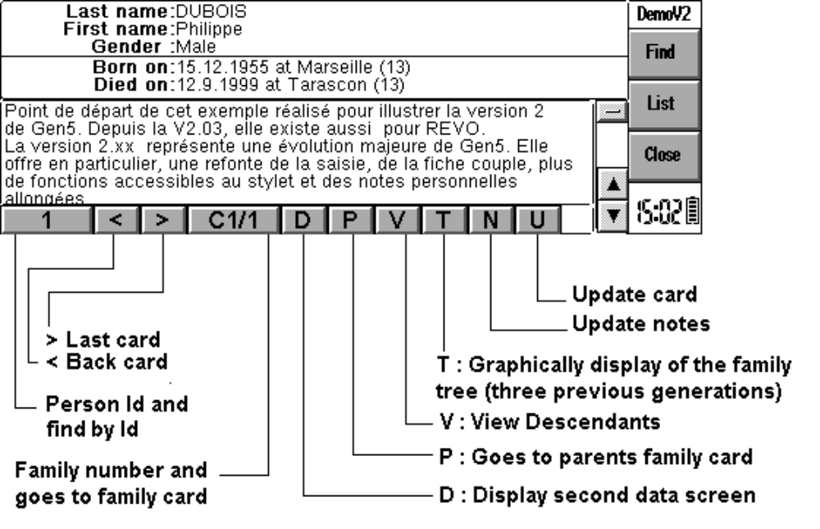
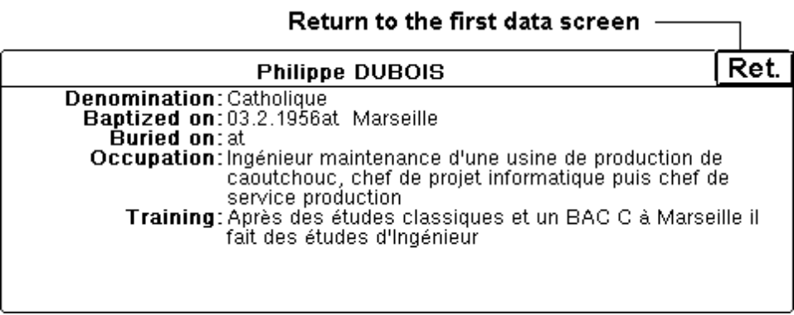

2.3 File Menu
New : (Ctrl-n) Saves the data base and creates a new one,
Open : (Ctrl-o) Saves the data base and open another one,
Option Save as : (Ctrl-a) Saves the data base under a new file name which becomes the current name,
Option Save : (Ctrl-s) Saves the current data base,
Option Revert to saved : (Ctrl-r) Cancels any changes and reverts to the previous version,
Option Import GEDCOM file : (Ctrl-i) loads a GEDCOM file copied but not converted with PsiWin, coming from another genealogy program (PC...). See GEDCOM key-words on characteristics.
Option Export GEDCOM file : (Ctrl-x) Converts a GEDCOM file meant to be used with another genealogy program,
Close : (Ctrl-e) quits Gen5 after saving the current data base.

2.4 Menu Display
Details : (Ctrl-d) displays details on the current card if the button D is displayed. Back with Ret. button or Esc or Enter keys,
List : (Ctrl-l) switches to list mode. This mode allows you to select a person using the stylus.
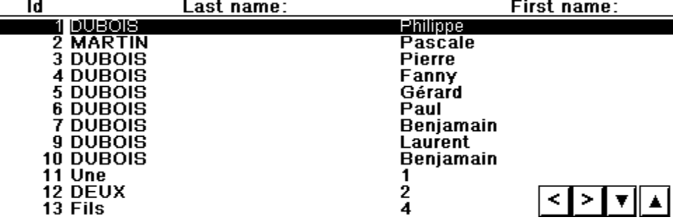
Keys to use in list mode :
- Ctrl+Down / Up and buttons : Next page / home,
- Down / Up : next / previous line,
- Right and Left : move,
- Ctrl+Right : end right,Ctrl+Left : beginning left
- Enter : Display the card.
Find (Shift-Ctrl-F) Display persons found by :
- person's last name and first name (also find button),
- Id (also Id button),
- Dates,
- Without link,
- Without parent
- Without couple.
When you find a person by his name or surname, you can use ? to replace a letter and * to replace several letters.
Father and Mother : (Ctrl-f or Ctrl-m) displays one of the parents,
Couple : (Ctrl-C) displays a spouse list if there are several.

2.5 Menu Update
Update card : (Shift-Ctrl-U or U button) modifies or completes the current card,
Update notes : (Shift-Ctrl-N or N button) creates or updates notes related to the current person,
Add card - Parent : (Shift-Ctrl-P) Creates a parent (father or mother). His rank gives his position in the created family,
Add card - Marriage : (Shift-Ctrl-M) Creates a new couple (Maximum 5). If there already is a couple (one parent and one or several children), you must use the menu option Union from the couple card,
Add card - Child : (Shift-Ctrl-C) Creates a child (Maximum 24 per couple). Children are created by chronological order in the selected couple with the down key on the parent card. If a couple exists, you may directly create a child with the Enter key beside the right number,
Add card - other : (Shift-Ctrl-A) Add a person without link, for example the first person of database,
Delete card : (Shift-Ctrl-D) deletes a card on condition that this card has no more than one family tie.

2.6 Menu View
Opening preferences : (Shift-Ctrl-O) forces Gen5 to open the current data base on the selected card,
Zoom In and Out : (Ctrl-w and Shift-Ctrl-W) modifies the zoom level. Works also with the stylus,
Family tree : (Ctrl-t or T button) Allows to graphically display the current person, his or her spouse and the three previous generations. You can select the person using the stylus.
Keys to use :Left and Right moves inside the tree, Esc or Enter : Back to display mode.
View Descendants : (Ctrl-v or V button). Displays the 60 first descendants belonging to the 4 next generations. You can select a descendant using the stylus or the Enter key.
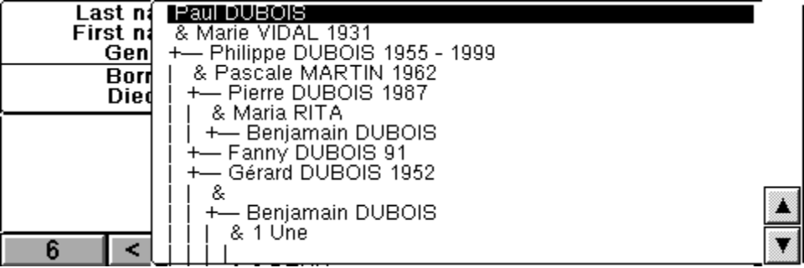
- Keys to use : Up / Down : To move inside the list,
- Ctrl+Up / Down : Top / end of the list,
- Enter : Display selected person's card,
- Esc : Back to the initial card, Zoom In and Out.

2.7 Menu Tools
Internal couple : (Shift-Ctrl-I) creates a family tie between two persons existing in the data base. The person's card from which the function is called, is one of the spouses.
Complete indexes : (Shift-Ctrl-X) completes persons indexes from the couple indexes. This function is useless after an import.
About Gen5 : (Shift-Ctrl-G) displays the number of persons in the current base, the version number and details on the author,
Help on Gen5 : (Shift-Ctrl-H),
Register : (Shift-Ctrl-R) to register Gen5 and remove any limits.

3 Display Couple
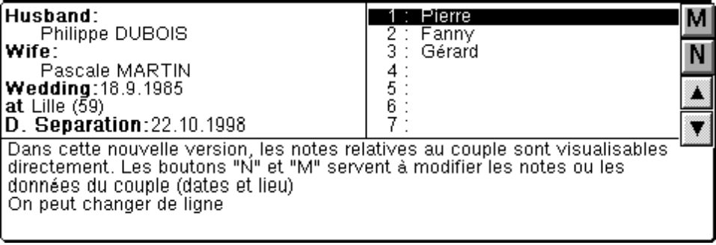

3.1 Keys
Right : Goes to wife’s card or creates it if it does not exist,
Left : Goes to husband’s card or creates it if it does not exist,
Up and Down : Selects a child,
Enter : Displays child's card or creates it if it does not exist,
You can select a person’s card (or creates it if it does not exist) using the stylus

3.2 Menu File
Close the file with (Ctrl-e) or without (Shift-Ctrl-Q) saving

3.3 Menu Display
Father : (Ctrl-f) Display views the father's individual card
Mother : (Ctrl-m) Display views the mother's individual card

3.4 Menu Update
Marriage : (Shift-Ctrl-M or M button) Marriage modifies dates or events about the wedding,
Notes : (Shift-Ctrl-N or N button) updates notes related to the couple,
Union : (Shift-Ctrl-U) adds one of the spouse still not created.

3.5 Menu Tools
Children order : (Shift-Ctrl-O) to reorder children in the couple's card,
- Up / Down : Selects a child,
- Enter : Attributes an order number to the selected child,
- Tab : Validates children order after attributing a number to each of them,
- Esc : Cancel.
Add link : (Shift-Ctrl-A) to add a person already existing in the data base to this family (as father, mother or child),
Cut link : (Shift-Ctrl-C) to delete the couple's card and break any link between these persons. However, these persons are not deleted from the data base,
Help on Gen5 : (Shift-Ctrl-H)

4 Create a person

4.1 Entering person
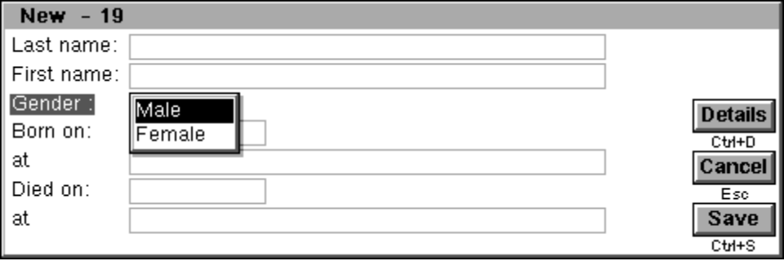
When you create a person (first person of the data base, parent, spouse or child) you must record as a priority the name, surname and select gender fields.

Ctrl+D to go to the second data screen,
Esc for cancelling all the modification (first and second screen),
Ctrl+S for saving all the modification (first and second screen).
This action is also available for the second screen.
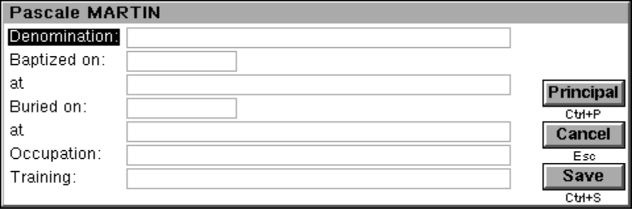

4.2 Entering dates
Dates must be between 1.1.1 and 31.12.2100. Their format is DD.MM.YYYY with UK English option or MM.DD.YYYY with US English option. Conveniently, it is possible to enter a 0 for a unknown day or month.
You must put a point (.) between day and month and between month and year.

4.3 Entering Notes
The field is limited to 1000 characters. Use the buttons to quit.

5 How to Register
Gen5 is not free, it is shareware. This is a system which allows you to try this product for an evaluation period of one month free of charge. If you want to continue using it after this time you must register your copy.
Registration will remove the nag screens and a family tree will stock thousands of persons against less than thirteen.
Registered users will also be sent upgraded versions of Gen5 free of charge, (except any postage charges for registered users without an e-mail address).
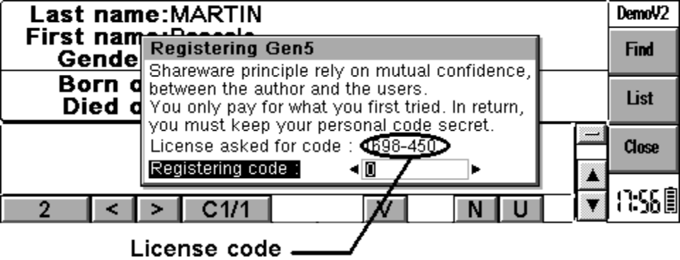

5.1 To register by post mail
To register, you will have to send me your name and address and 15£ or 25$ cash (no checks please), or 150FF(french cheque or money) and the license code (Shift+Ctrl+R) to :
Michel Catton
31, avenue Charles de Gaulle - P2
95160 MONTMORENCY
FRANCE
e_mail : michel.catton@wanadoo.fr
Please include your e-mail address, postal address and the license code (Shift+Ctrl+R) and which version of Gen5 you are using, and how you know about Gen5.
You will then receive the registration instructions and your personal code to enter in the register option.

5.2 To register with credit card on the web
You can also purchase Gen5 on-line with a credit card : 180FF ( Web registring costs to me 30FF) or 1110BEF - 46CAD - 44,5CHF - 54DEM - 27,95EUR - 19GBP - 30,95USD ...
http://perso.wanadoo.fr/michel.catton/
with your the license code (Ctrl+E)
You will then receive by e_mail the registration instructions and your personal code to enter in the register option.

6 Characteristics
English version by G. Aubard (Corrections are welcome :o).
Number person < 30 before registration
> 9000 after registration
Number couples / person < 6
Number children / couple < 25
Number characters / note < 1000 (person) and <250 (couple)
Date = or > 1.1.1 and < 1.12.2100
The GEDCOM key-words are :
1 NAME,
1 SEX,
1 BIRT, 1 CHR, 1 DEAT, 1 BURI, 2 DAT, 2 PLAC,
1 EDUC, 2 DAT, 2 PLAC, 2 TYPE,
1 OCCU, 2 DAT, 2 PLAC, 2 TYPE,
1 RELI,
1 NOTE, 2 CONC, 2 COUNT,
1 HUSB,
1 WIFE,
1 CHIL,
1 MARR, 2 DAT, 2 PLAC,
1 DIV, 2 DAT.

