Psion Series 3a NMEA GPS with digital mapping

β0.06 (preliminary) 2nd April 1996

The program allows the Psion Organiser 3a to read NMEA data from the Rockwell (and other) GPS receivers. The GPS information can be used to dsplay your location as a ‘dot on a map’. The program will not operate on the older Series 3 organisers.

Key options are :

Psion-D | Configure DGPS port
Psion-X | Exit program
Psion-O | Reset odometer
Psion-N | Calculate UK NGR
Psion-W | Move window positions
Psion-I | Display information screen
Psion-M | Select map, and overlay GPS position
Psion-P | Preview maps in database (overlays current position where appropriate)
Psion-T | Set track recording interval
Psion-S | Set speed alarm limit
Diamond key | Select GPS / Map display

The program will ‘beep’ when a position is initially displayed, and when the status of accuracy of the displayed position changes, i.e. when differential corrections are applied, or when navigation is lost.

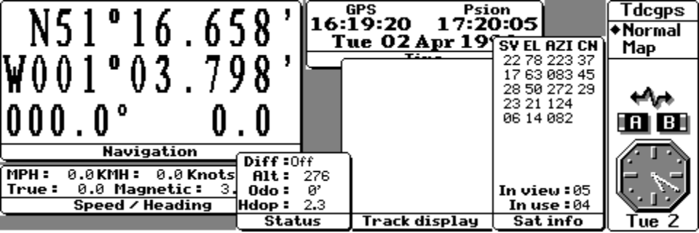

When the diamond key is pressed for the first time, or Psion-M selected, you will be given a choice of maps from those which are appropriate for your current position.

Maps are ‘registered’ with an internal database with the top left and bottom right geographical locations, together with a verbose description of the map being stored. From these values, the program calculates the scale of the map, and is able to overlay the current position onto that map.

Maps are simple to scan and enter into the Psion, the only constraint with the current version is that the maps must be 416 x 160 pixel bitmaps.

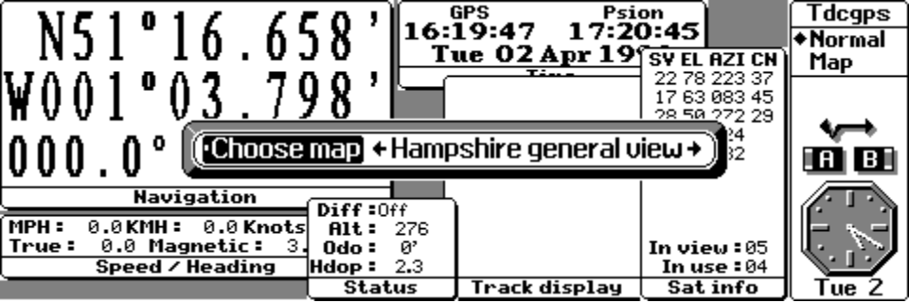

When the map is selected by pressing ‘Enter’, the map will be displayed together with a flashing ‘dot’ on the map for the current position. When your position moves, the dot will track that movement.

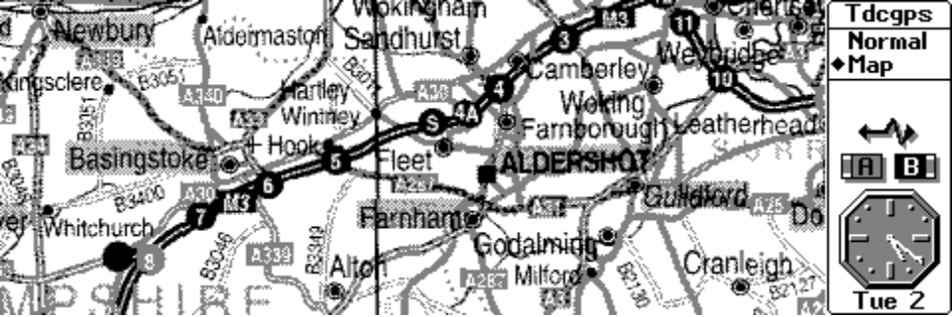

Serial cable configuration

The program requires a one-to-one connection from the Psion 3 link serial adaptor to the TDC Microtracker serial board (as supplied in the GPS starter pack). The one-to-one connection essentially re-instates the null modem device built into the standard serial cable supplied with the Psion 3 link.

The program is distributed as ‘freeware’ and is available on CompuServe in the PALMTOP forum, on various sites on the Internet and the TDC BBS on +44 (0)1256 57900. Maps are not currently supplied with the program, these are the responsibility of the user.

0000.doc 8 November, 2026

