ENGLISH

PsioMan
Version 1

Software for the administration
of Psion Series 3a files under
Windows as well as file transfer
to and from the Psion 3a.

User's Guide

© 1994, 1995 Lansing Systems · D-46539 Dinslaken

All mentioned trade names are registered trademarks
of their respective owners.
License Agreement
You will get the Licence Key according to the international and European copyright laws. You are allowed to pass on the program disk without the serial No. and / or the License Key.
Limited Warranty: Lansing Systems warrants that a) the software will perform substantially in accordance with the accompanying product description(s) for a period of 90 days from the date of receipt; and b) any Lansing Systems supplied hardware accompanying the software will be free from defects in materials and workmanship under normal use and service for a period of one year from the date of receipt.
Customer remedies: Lansing Systems' entire liability and your exclusive remedy shall be, at Lansing Systems' option, either a) return the price paid or b) repair or replacement of the software or hardware that does not meet Lansing Systems' Limited Warranty and which is returned to Lansing Systems with a copy of our receipt.
No other Warranties: To the maximum extent permitted by applicable law, Lansing Systems disclaims all other warranties, either express or implied, including but not limited to implied warranties of merchantability and fitness for a particular purpose, with respect to the software, the accompanying product documentation(s) and written materials, and any accompanying hardware. The limited warranty contained herein gives you specific legal rights.
No Liability for consequential damage: To the maximum extent permitted by applicable law, Lansing Systems and its suppliers shall not be liable for any other damages whatever (including, without limitation, damages for loss of business profits, business interruption, loss of business information, or other pecuniary loss) arising out of the use of or inability to use this product, even if Lansing Systems has been advised of the possibility of such damages. In any case, Lansing Systems' entire liability under any provision of this agreement shall be limited to the amount actually paid by you for the software.
Contents
1 Introduction
2 System Requirements
3 Installing the Program
3.1 Starting the Setup Program
3.2 Operation of the Setup Program
3.3 Creating the Program Icons
4 Usage of the 3Link Interface
4.1 Connection of the 3Link Interface
4.2 Serial Ports and Windows
4.3 Usage of the Psion Link Function
5 Program Usage
5.1 Directions for Usage
5.2 Starting the Program
5.3 First Steps
5.4 Functions of the Different File Windows
6 Updates
6.1 The License Key
7 Service and Help for Problems
7.1 Displaying Problems
7.2 IBM OS/2

Introduction
PsioMan has been created to link Psion Series 3a palmtop computers with the Windows PC. Particular effort was made to ensure that the Psion files operate like a typical Windows program with regard to appearance and functionality.
PsioMan uses the files which have been copied to the hard disk of your computer by the file backup function of Psion (see also chapter 5.3, 'First Steps' on page 12).
At this point it has to be stressed that PsioMan does not reproduce the same functions as the Psion Series 3a. Rather, PsioMan serves to view Psion files within the Windows environment and to copy data into the clipboard. Additionally, further functions like editing of databases etc. are available.
Lansing Systems gives you the possibility to install and use the latest version of PsioMan. This is controlled by the license key that has been created during the installation. Thus you can use a new version which has been loaded by modem without any problems (see also chapter 6, 'Updates' on page 17).

System Requirements
Please make sure that you meet these equipment criteria before installing PsioMan:
· IBM compatible PC
· Windows 3.1 or 3.11,
Windows for Workgroups 3.1 or 3.11 or
Windows 95
· Psion Series 3a
(Psion Series 3 without Diary viewer)
· Psion 3Link interface
· A Psion communication program
(If Psion Link does not operate on your PC)

Installing the Program
The installation of the program files takes place with the help of the setup program. All files are copied to the specified directory. During the installation only the vbrun300.dll file will be copied into the \windows or \windows\system directory.
You are able to use PsioMan only after the installation to the hard disk of your computer.

Starting the Setup Program
A precondition for the installation is that you have started a Windows version in working order (see chapter 2, 'System Requirements' on page 6).
1 Choose the menu command File, Run in the Windows Program Manager that you use.
2 Type the path for the setup program into the text entry field Command Line in the Run dialog. If you have, for example, inserted the PsioMan installation disk in drive A:, type a:\setup.exe.
3 Click on the OK button.
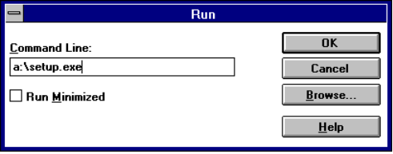
Now the installation program is started and will be initialized. This will take a moment.

Operation of the Setup Program
If the initialization of the setup program has been completed, you are asked for some more information which is needed for the installation:
1 Choose the language for the installation in the first dialog of the setup program.
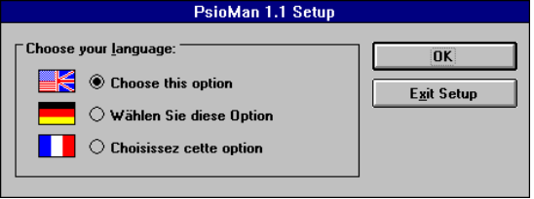
The setup program checks, if there is already a licensed version of PsioMan installed.
If no license information is found here, you will have to initiate the license of your copy of PsioMan now:
2 Enter your name, the name of your firm or the city and the serial number which is printed on the installation disk into the appropriate text entry fields. You can remove the disk from the floppy drive to read the serial number. However, insert the disk again into the floppy drive before you click OK. If you do not want to install a licensed version (but a test version), you do not have to enter anything into the text entry fields, but simply choose the Test Version button.
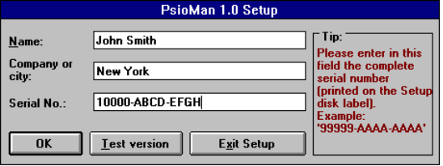
3 Then you must confirm the program path or change it as you like:
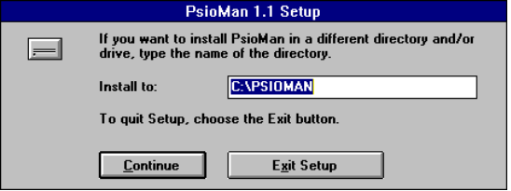
Now the necessary files are copied from disk to hard disk and then the program icons are created in the program manager.

Creating the Program Icons
If you have started the installation from the Microsoft Program Manager, the program group PsioMan with the appropriate program icons will automatically be created.
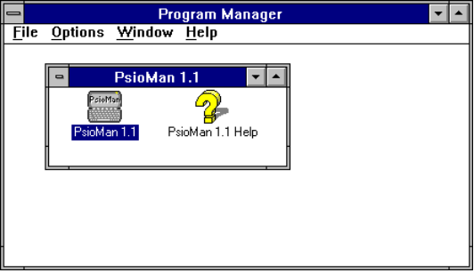
However, if you use a program manager equivalent, e. g. Norton Desktop or PC Tools for Windows, the installation program is not able to produce the program group or icons.
In this case, choose the menu command New from the File menu in your program manager equivalent. Follow the instructions of the program manager equivalent program to create the program group and the icons of the program psioman.exe and the help psioman.hlp.

Usage of the 3Link Interface
PsioMan assumes that you have a 3Link interface cable and are able to use it to transfer files. Please follow all directions in the Psion 3Link User's Guide.

Connection of the 3Link Interface
Make sure that both devices (the Psion organizer and the PC) are switched off. Otherwise the interface itself, the serial interface of the PC or the Psion computer, can be destroyed.
Please refer to the following chapter for the choice of the serial interface on the PC.

Serial Ports and Windows
Most serial I/O cards only allow the connection of two devices at once over the PC’s serial ports.
Consequently, the serial port COM1: is only permitted (because of the non-conflicting interrupts) to run at the same time with the ports COM2: or COM4:. The serial port COM2: is correspondingly only permitted to run at the same time with COM1: or COM3:.
Because a serially connected mouse constantly needs the used port under Windows, only one additional serial device can access one of the other available ports when a usual port card is used. This is only the case if you use a mouse with a serial interface.
For the usual combination of mouse, modem and 3Link interface, for example, the following connection possibilities result from the explanatory problems:
 | Mouse | Modem | 3Link
I | COM1: | COM2: * | COM2: *
II | COM1: | COM2: | COM4:
* By a serial data switch box switchable
Possible remedial measures for these problems are a bus mouse which uses its own interrupt or an a 16-bit interface card with separately configurable interrupts.

Usage of the Psion Link Function
PsioMan can work as a 'communication-server' for the Psion 3a. That means that PsioMan makes the file system of PC available to the Psion by the 3Link interface.
Therefore, you can apply all Psion file operations from the menu of the System area to the files and directories of the computer. During this time PsioMan is not available for other functions.
The Psion function File backup is important for PsioMan. The whole file structure with its subdirectories can be transferred with it from the Psion to the PC into a directory that you specify. That means that after the file backup all Psion files are on the PC (in the same directories). The Psion file backup can additionally be adjusted so that only the changed files (archive bit set) are transferred.
You can find further explanations for the Psion file operations in the user's guide of the Psion Series 3a and the 3Link interface.
The Psion Link function depends on certain preconditions with regard to the stability of the Windows surroundings, the speed of your computer and the serial interface cards. If no communication is possible between the Psion computer and the Windows PC with the help of the Psion Link function, use the DOS communication program that has been included with the 3Link interface.

Program Usage

Directions for Usage
It has been important for the programming of PsioMan to keep the usual Windows usage standards. You should therefore be able to handle PsioMan with a little bit of Windows experience.
Please look for further details on the usage of the different program elements in the help system of the program. You can bring up Help anywhere by pressing F1.
Starting with the contents of the help system you can also read the help files like a book. Simply click on the different colored theme names to display a chapter of the help.
Please note that some menu commands, icons and functions, are only available under specific conditions.

Starting the Program
If PsioMan has been installed successfully, the program group PsioMan with the PsioMan 1.1 and PsioMan Help icons has been created in the program manager.
Simply activate that program group and double click on the PsioMan 1.1 icon.
If the original Windows Program Manager has not been activated during the installation, the icons could not be created. In this case you should create the above mentioned icons yourself (see chapter 3.3, 'Creating the Program Icons' on page 9).

First Steps
Before you can open Psion files with PsioMan, you have to do a file backup from Psion to the PC:
1 Connect the PC to the Psion with the 3Link cable.
2 Switch on the Psion.
3 Verify that the link function on the Psion is activated.
4 Check and correct the settings for the Psion Link function, if necessary, and confirm these with OK (menu command Utilities, Customize.
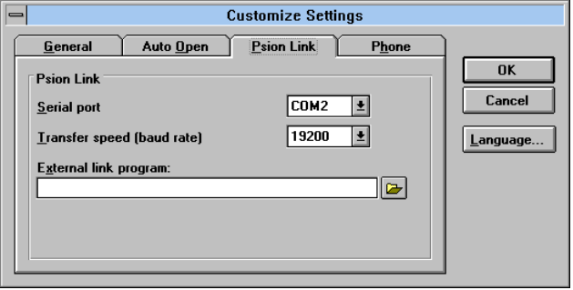
5 In PsioMan, start the Psion Link function with the menu command Psion Link from the File menu.
6 After the connection has been created (as shown on the screen) the menu command File Backup can be chosen from the Psion File menu (For further information look at the 3Link user's guide).
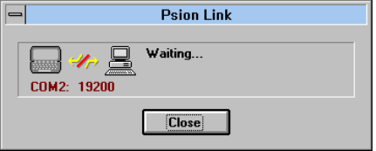
Important:
If the Psion Link function of PsioMan does not operate under Windows, please use the original Psion 3Link communication program for data communication and the production of the file backup.
It is not necessary to run the file backup with the help of the Psion Link function of PsioMan.
7 After you have finished the file backup on the Psion, close the Psion Link dialog by choosing the Close button.
Important:
Never close the Psion Link dialog, if files are still being transferred.
PsioMan is now able to access the files that have been copied to your hard disk.
With the help of the Psion System dialog you can easily open a file.
8 Simply choose the menu command Psion System from the File menu.
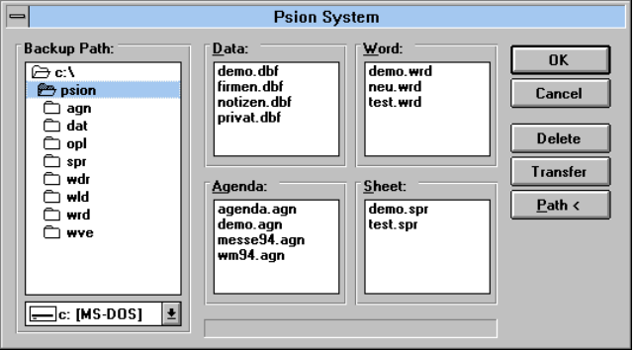
9 If you open this dialog for the first time, you have to choose the backup drive and the backup path on the PC which you initially entered for the file backup destination directory on the Psion.
PsioMan saves this backup path and uses it later automatically..
If you have found a valid backup path with the subdirectories \agn, \dat, \spr and \wrd, the corresponding file names are displayed in the four file windows.
10 Choose a file name from these file lists and confirm the choice with OK.
The chosen file will be displayed in a file window.

Functions of the Different File Windows
Each of the four Psion file types (Data, Agenda, Word and Spreadsheet) is displayed in a special file window with its own menu and icons.
There is a similar, but not identical, set of functions available for each file window.
These are the file window types, their functions, and descriptions:
No file windows open
• Support of the 3Link connection for file transfer and file backup starting from the Psion (the PC is the passive communication server)
• 'Auto open' function for the automatic opening of constantly needed Psion files when starting the program
Database file window
• Displaying the database in database and list views
• Text search for database
• Filtering of database with the same search text
• Creation, editing and deletion of database(s)
• Automatic transfer of all or only modified files to the Psion
• Export of all or filtered database in ANSI or DOS text format or in dBASE III format
Agenda file window
• Displaying the events in day or week view
• Forward and backward browsing to the next or previous day with an entered event
• Text search for events (alternatively also in the notes of the events)
• Permanent display of the due tasks in day view (alternatively all tasks, those of a task list or the choice that has been defined on the Psion for the day view)
• There is also a choice of displaying the crossed-out tasks
Word file window
• Displaying the text contents in a text window
• Text search in all documents
Spreadsheet file window
• Displaying the spreadsheet results in a spreadsheet screen
• Copying of the whole spreadsheet or the marked spreadsheet range
• The columns can be resized manually with the cursor
General functions
• All files which are in the four Psion standard file formats are available for opening in the Psion System dialog.
• The proportions of the window elements can be changed with the split bars in the database and the agenda file window. The cursor changes its appearance and indicates where this is possible.

Please look for detailed information on the available icons and menu commands in the help system (see chapter 5.1, 'Directions for Usage' on page 12).

Updates
To be able to satisfy your wishes and to correct problems, new program versions of PsioMan are issued at varying intervals.
These versions can be copied (superscribed) over the presently installed version of PsioMan.
You can find the latest original version in the Palmtop Forum of the on-line service CompuServe or in our service mailbox. Furthermore other mailboxes are endeavored to have the latest version ready (see also the topic 'Updates' in the help system).
This free update offer is valid for all versions with the same version main number (1.x). Thus you can for example replace the version 1.0 with the version 1.1 or the version 1.2.
Important:
At any rate, make a backup copy of your present PsioMan program directory before installing a new update.

The License Key
This update process is possible , because the issued version becomes a full version by means of the license key which is saved during the installation into the psioman.ini file. Without the license key this version remains a test version.
In the same way your installed licensed version becomes a test version when you delete the license information from the psioman.ini file (or delete the psioman.ini file).
In this case you should repeat the installation with the setup program. If the dialog for the path is displayed after licensing, simply choose the Exit Setup button. Thus, only the license information has been saved in the psioman.ini file and no file of the setup disk has been copied to the hard disk.

Service and Help for Problems
If a problem occurs when installing or running PsioMan, please contact us in writing via the following methods:
• E-Mail to CompuServe ID 100024,333
(Internet: 100024.333@compuserve.com)
• Fax: + 49 - 2 03 - 37 25 70
• Mail:
Lansing Systems
PsioMan Service
Krengelstraße 16 c
D-46539 Dinslaken
Germany
Please keep in mind that it is often useful to install the latest version of the software before reporting problems (see chapter 6, 'Updates' on page 17).

Displaying Problems
If problems with the screen presentation (of PsioMan or of other program) occur after having started the program, please install the original Microsoft Standard VGA driver. If the problem is eliminated in this way, you should order the latest version of the driver for your graphics adapter card or you should switch to the original Microsoft Super-VGA driver (Windows for Workgroups 3.11).

IBM OS/2
It is possible that problems with the link function (Psion Link function) occur. These cannot be eliminated at this time.

