Guitar Suite Instruction Manual
By Christopher Claxton

Thank-you for downloading this piece of shareware software - please register!

This software is especially useful for those of you who obtain music from the Internet and want to know how some exotic chords are fingered.

Chords include: - major
- minor
- minor-seventh
- sixth
- seventh
- ninth
- major seveth
- suspended fourth

for chords from A to G! Total of 56 chords.

To install the application:

1) Copy guitar.opa to the APP directory and the gtr.pic to the OPD directory.
2) Goto Apps - Install and select guitar.opa

Using the Chord Chart

Select the 'Guitar' application and press any key when the title screen appears. When a box appears asking which part, select 'Chord Chart' and press Enter.

A screen will appear with a fret board on the main screen and the letters (of the chord) will appear on the right, along with an 'Exit' button. To see the 'A' chords, press A and so on.

Suppose, you want to know the fingering for a B seventh chord (B7), press B and a box will appear. Press 'Tab' and select 'seventh' and then press 'Enter'. The chord will then appear in the main screen.

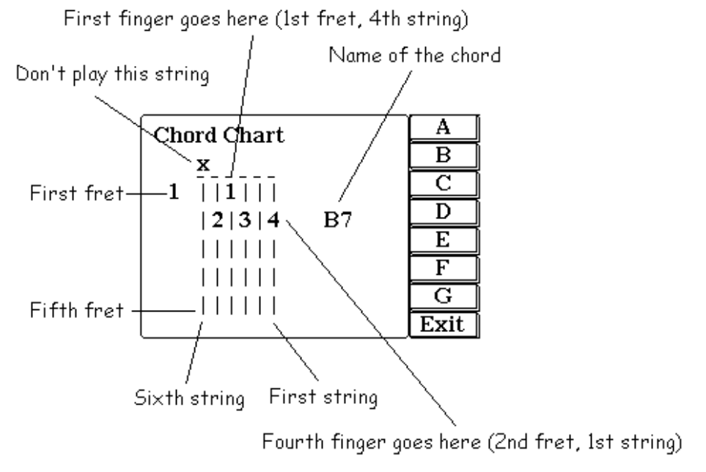
To play the chord:
- Place your first finger on the 4th string, 1st fret
- Second finger on the 5th string, 2nd fret
- Third finger on the 3rd string, 2nd fret
- Fourth finger on the 1st string, 2nd fret

Now, suppose you want to play the D suspended fourth chord (Dsus4). Press any key and the screen will clear. Press D and then select 'suspended fourth'.

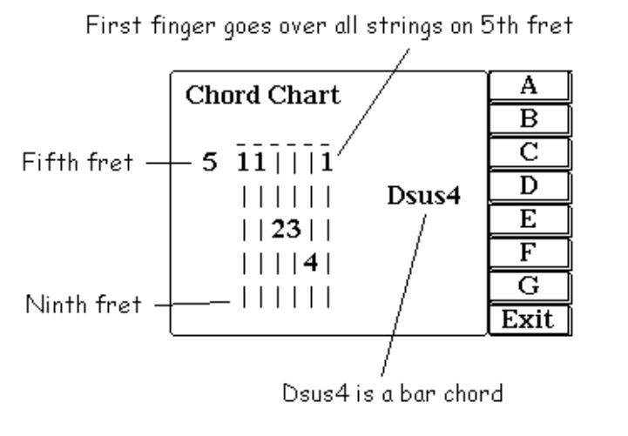

The 3 1's on the fifth fret (!) show that the chord is a bar chord.

Using the Metronome

On the title screen, press a key, and then select 'Metronome'. The screen will clear and you will be prompted to enter the number of beats per minute (i.e. how fast the music is). If you wish to exit, just type 0. Once the metronome is running, press any key to stop it.

How to Register

Shareware is not free, and thus after an evaluation period, the product must be registered. What you will get from registering:
- Technical support via e-mail
- Free updates (no need to register again)
- Knowledge that you have helped the author continue their work

When I fist programmed this software, I thought that I would put loads of 'nag' screens to get people to register and reduce the features considerably so that you had to register to get any use out of the software. However, I realised that this would probably annoy users
and did not let them evaluate it effectively and does not go with the shareware concept. For that reason, the downloaded software is complete, with NO restrictions - it is the fully working software.

I do not think that £5 UK pounds sterling is a lot considering that the source code runs to 31 A4 pages and that I have spent months working every weekend on it, whether doing research (for the chords), programming, bug checking or testing.

To register, send a cheque made payable to Christopher Claxton for 5 pounds uk sterling to:

Christopher Claxton
7 Swansgate
Old Catton
Norwich
Norfolk
NR6 7HT

Please enclose your name, address and e-mail address so that I may be able to keep in touch and send you the latest versions. Rememeber that you only need to register once! If you have any comments or suggestions about how to improve the software, please send them as well and I will try to incorporate them into later versions.

Future versions may include: - More chords
- Visual metronome
- Example chord progressions

I am also working on a program that will allow the user to define their own chords.

The Small Print (the legal stuff)

1) Disclaimer: I do not accept any responsibility for damage to your psion from running this program - although I cannot see how this could possibly occur given the source code. I also do not accept any responsility for any loss of files or data - again extremely unlikely.

2) This program must not be reverse engineered.

3) This software is copyright and must not be altered in any way.

4) 'Guitar Suite' may be distributed freely provided that all the files exist intact and none have been removed, i.e. the following files MUST be in the zip file:

readme.txt - text help file
help.doc - this file
reg.doc - registration form
guitar.app - the 'Guitar Suite' application
gtr.pic - the icon

