Conversion Suite
Instruction Manual
By Christopher Claxton

Thank-you for downloading Conversion Suite!

To install the application:

1) Copy Convert.opa to the APP directory and the Conv.pic to the OPD directory.
2) Goto Apps - Install and select Convert.opa.

How to use Conversion Suite:

This software has been developed because I often found myself converting from Imperial to metric units. I hope you find this easy and enjoyable to use.

Suppose, you want to convert 100 cubic feet to litres:

Firstly, select the 'Convert' application, and a title screen will appear. Press any key and a new screen will appear with Conversion Suite written at the top.

Press 'Menu' and go down to Volume on the Conversion menu, or alternatively, press Psion+V. When the small menu shows, press 'Tab' on the 'Choose:' part, go down using the cursor and choose 'Cubic feet - Litres'.

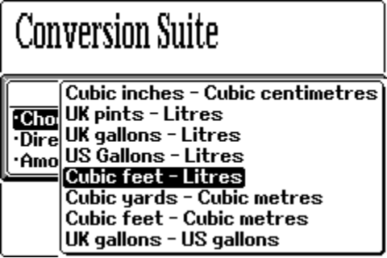

Change the direction over so that the conversion is from Cubic feet to Litres (->). In amount, type 100. Then press 'Enter'.

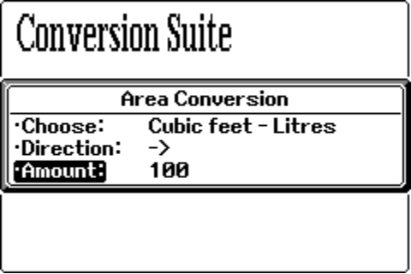

The program will then show that 100 cubic feet is equal to 2831.7 Litres.

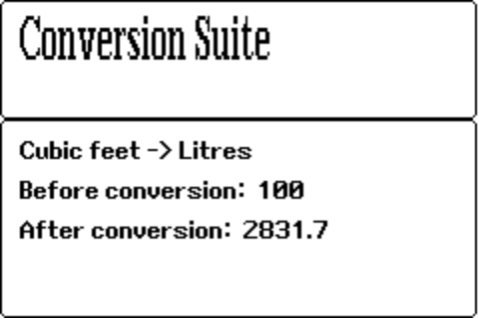

HOW TO REGISTER...

If you use this application a lot for work or otherwise, then after an
evaluation period, the software must be registered for 5 UK pounds
sterling by sending a cheque payable to Christopher Claxton to:

Christopher Claxton
7 Swansgate
Old Catton
Norwich
Norfolk
NR6 7HT

Small print: (the legal stuff)

1) Disclaimer: I do not accept any responsibility for damage to your
psion from running this program - although I cannot see how this
could possibly occur given the source code. I also do not accept
any responsility for any loss of files or data - again extremely
unlikely.

2) This program must not be reverse engineered.

3) This software is copyright and must not be altered in any way.

4) 'Conversion Suite' may be distributed freely provided that
all the files exist intact and none have been removed, i.e. the
following files MUST be in the zip file:

readme.txt - textfile
help.doc - this file
reg.doc - registration form
convert.opa - the 'Conversion' application
conv.pic - the icon

Versions:

1.0 Conversion suite first developed

