
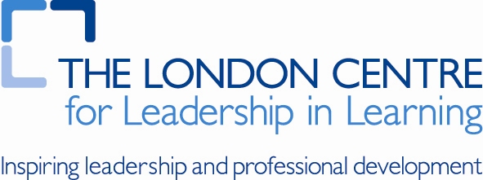
xxxx Lesson Study: Research Lesson Planning
Date: | 24.11.14 | Year group: | 4
School: | Hitherfield
People present: | John and Erica

Date of research lesson: |  | Permission to video lesson: | Yes: | No:
Research lesson title: |  | Place of lesson in the sequence: | 2nd
Year and ability group | 4 | Number of children | 30

Impact focus (from Impact Framework): | I want my focus group pupils to approach problems and activities with confidence. I want them to independently identify the steps they need to take to be able to attempt and solve mathematical problems. | Initials of focus children (from Impact Framework): | Abbie  Ella  Jada  Kalesha  Naomi  Tesneem

Lesson description:
In this lesson the children will explore sharing values into equal groups and describe those groups as fractions of the whole. Some children may describe equivalences. Cakes shared into equal number of pieces of will give the context.

Phases within the lesson, purpose, and neriage: | Research Questions:  How do different children respond to the different elements of this lesson? ie: practical equipment, teacher modelling of language and representation, paired discussion and pupils’ own representation and discussion.  Lesson objectives  I am learning to understand fractions. I am learning to explain what I have discovered in words and diagrams.  Phase A  Pupils will match representations of fractions to each other. For example half a cube to the word half and 1/2. This will give the children a resource to support them in the lesson.  Timing: 10 minutes  Phase B  Teacher says Father Christmas is planning a party for his elves. He has two elves and three mince pies. How many cakes will each elf get? Teacher poses question to class and assess how they record their answers on white boards. Teacher uses best examples to model recording the answer using the numerator and denominator.  This is then repeated with a problem selected by one of the children.  Timing: 15 minutes  Phase C  Working in pairs children solve differentiated division problems.  Timing: 10 minutes  Phase D  Mini plenary, explaining that if you find something out on your table, write it on the piece of paper that says ‘discoveries and questions’. Take two or three comments from different groups.  Timing: 5minutes  Phase E  Teacher revisits earlier work on dividing using calculators. Using an equivalence chart can the children show their answers using decimal notation and check their work with a calculator.  10 minutes  Phase F  Children fill in and reflect upon their discovery sheets. 10 minutes  Timing: x minutes

Materials:

Planned teacher – student interaction
Key questions that the teacher will pose | Anticipated student responses
Phase A  Do the fractions need to be in order? | Yes – and the bigger the number (unspecified) the bigger the piece.
Phase B  If I share one cake between six people what fraction do I make? | Children are unsure of the terminology may still refer to halves.
Phase C
How do I show a cake shared between six people?
Can I share an odd number of cakes?
Phase D

Phase E

Key discussion points (question stems for guidance only) | Decisions made / how points were resolved
How to support children who are HA? | Children will move away from using multi links and use bigger numbers.

Focus for observers (should relate closely to Research Question)

