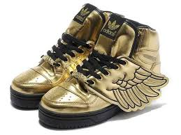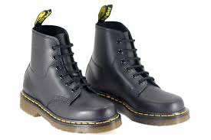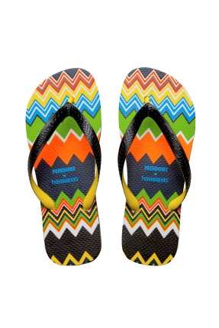

Flip flops: £8.99

Boots: £15.80

Trainers: £12.98

|  |  |  |  |
| --- | --- | --- | --- |
| Question | Bar | Number sentence | Answer |
|  |  |  |  |
|  |  |  |  |
|  |  |  |  |